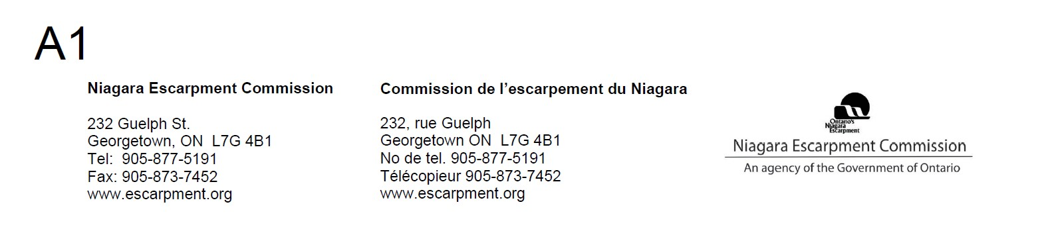

January 21, 2021

STAFF REPORT

DEVELOPMENT PERMIT APPLICATION H/R/2019-2020/201

(Owner)

9196 Sixth Line Nassagaweya Part Lot 6 & 7
Town of Milton, Region of Halton

SUMMARY
PROPOSAL: To construct the following for private use only, on a 15.2 ha (37.5 ac) lot:
Single Dwelling ± 2,534 sq m (± 27,280 sq ft), ± 12.6 m (± 44 ft) high
Septic System/Bed (Size to be determined)
Indoor Swimming Pool ± 325 sq m (± 3,500 sq ft), ± 10 m (± 34 ft) high Sports Building ± 504 sq m (± 5,430 sq ft), ± 11.7 m (± 38 ft) high Tennis Court ± 36 m x ± 18 m (± 120 ft x ± 60 ft)
Detached Garage ± 232 sq m (± 2,500 sq ft), ± 9 m (± 33 ft) high Solar Panel Array ± 372 sq m (± 4,000 sq ft)
Power Transformer ± 100 sq m (± 1,074 sq ft)
Extended Asphalt Drive ± 330 m (± 1,083 ft) long by ± 7.6 m (± 25 ft) wide Precast Concrete Cistern 50,000 litres

Note: the application also includes the paving of an existing gravel drive on the adjacent property at 9300 Sixth Line Nassagaweya, which is also owned by the applicant.

DESIGNATION: Escarpment Protection Area and Escarpment Natural Area

LOT SIZE: 15.2 ha (37.5 ac)

ISSUES:
- The number of accessory facilities proposed for a single dwelling exceeds what is permitted elsewhere in the Town of Milton’s rural area;
- There are potential policy concerns regarding Part 2.2.1 and the cumulative impact of development;
- A similar application by the same landowner was previously refused by the Commission.

RECOMMENDATION: Partial approval, subject to conditions. Staff is recommending approval of the dwelling, extended driveway, cistern and asphalt paving of the gravel driveway at 9300 Sixth Line, but not the accessory facilities. The accessory facilities are not consistent with what is permitted elsewhere in the Town of Milton’s rural area.

REASON:

The visual impact of the scale of the dwelling can be mitigated, but the Town of Milton has a more restrictive standard than what is contained in the NEP in relation to permitted accessory facilities.

RECEIVED: September 20, 2019

SOURCE: (Agent)

RELATED FILES:

- Development Permit #4221/H/C/1989-1990/315 (AS BUILT)—Approval was granted to recognize the re-alignment and re-location of seven golf course holes (including development of tees, greens and fairways). The relocation of holes was a result of changes to the course layout due to lands being acquired by adjacent quarry expansion (Halton Crushed Stone Ltd.).

- Development Permit #11657H/D/2018-2019/451—Approval was recently granted for the demolition of structures associated with the former golf course use.

- Development Permit Application H/R/2018-2019/140 for a 2,980 sq m
(± 32,080 sq ft) single dwelling and multiple accessory structures was refused by the Commission in June 2019 for the following reasons: the proposed development conflicted with the Purpose and Objectives of the Niagara Escarpment Plan; it was not consistent with the Provincial Policy Statement, specifically Section 1.1.5.4 (compatibility with the rural landscape); it failed to meet Development Criteria 2.2.1 (cumulative impacts), 2.2.10 b and d (home occupations), 2.5.2 (slope setback), 2.5.4 (slope stability), and 2.13.5 (landform conservation).

SITE DESCRIPTION:

The subject 15.2 ha (37.5 ac) property is designated as Escarpment Natural and Protection Area. The property is located within the Town of Milton, above the brow of the Escarpment on the north side of Highway 401, directly across from Kelso Conservation Area and adjacent to the Hilton Falls Conservation Area. The Escarpment brow traverses the eastern-most part of the property.

The subject property was formerly known as the Halton Country Inn Golf Course, which was established in 1958 and operated until the property was put up for sale several years ago. The golf course included a banquet facility and dining room in the large barn-style club house. The property also contains a dwelling and ruins associated with

a former agricultural use. The ground floor area of the barn/clubhouse is approximately 1000 sq m (10,764 sq ft), and the ground floor area of the existing dwelling is approximately 157 sq m (1,690 sq ft). Prior to the completion of the 2015 NEP review and the updating of land use designations, the golf course fell within the Escarpment Rural Area designation and was a Permitted Use. The golf course ceased operating more than two years ago, and the golf course cannot be re-established in the new Escarpment Protection Area designation.

The current owner (1980971 Ontario Ltd.) acquired the property in 2017. At the same time, the adjacent Halton Crushed Stone quarry, for which the aggregates licence was surrendered in 2015, was acquired by an affiliated numbered company: 1980090 Ontario Ltd. The former quarry is now filled with water. The north and southwestern property boundaries correspond with the top-of-slope of the former quarry walls, which were graded to a 2:1 slope as part of rehabilitation.

A portion of the property has been identified by the Region of Halton as an Environmentally Significant Area: the Hilton Falls Complex. (See Map 2.) This area roughly coincides with the portion of the property designated as Escarpment Natural Area. A small portion of the property (southwestern corner of the lot) is part of the Halton Forest Provincial Area of Natural and Scientific Interest (Life Science).

All proposed development is located in the less restrictive designation of Escarpment Protection Area. This area is open field with sporadic tree plantings. A swale traverses the property from north to south, directing flow over the Escarpment brow. It is not a natural channel. When the quarry was active, water was pumped from the quarry floor, across the subject property, and over the Escarpment brow. The drainage swale is partially regulated by Conservation Halton, but all development is proposed to be located outside the regulated area.

The majority of the property is located on a highly vulnerable aquifer and is within the Wellhead Protection Area (WHPA) Zone ‘B’ for the Town of Milton’s municipal wellhead, located across Highway 401 in the Kelso Conservation Area. (See Map 3.) A WHPA is the area around a municipal wellhead where land use activities have the potential to affect the quality of water that flows into the well. Zone ‘B’ refers to the time of travel to the well, which is up to and including two years.

The bedrock on the property is known to be dolomitic limestone, and overburden depth is thought to be less than one metre on most parts of the property, with bedrock visible at several locations. The subject lands are also identified by the Province as an area of “inferred karst.” (See Map 4) This means that karst bedrock formations may be present. There is known karst on abutting lands in the Hilton Falls Conservation Area and on the east side of Sixth Line Nassagaweya along the Escarpment brow, adjacent to the CRH Canada (Dufferin Aggregates) Milton Quarry operation.

As noted in the Related Files section of this report, the landowner previously applied for a similar development, but it was refused by the Commission. The original proposal involved importing a significant amount of fill (± 17,000 cubic metres) onto the property to create a walk-out style basement. This represented a significant change to the topography/landform on the site, and was therefore not in keeping with Part 2.13 –

Scenic Resources and Landform Conservation. In addition, a significant number of technical studies were required to determine if other policies in the NEP could be satisfied. The applicant has returned with a new proposal that requires very minimal grading and no importation of fill.

PROPOSAL:

A two-storey dwelling, having a total floor area of approximately 2,534 sq m (27,280 sq ft) and a maximum height of 12.6 m (44 ft), is proposed to be constructed at the northwest edge of the property. Multiple accessory structures are also proposed:

- Indoor Swimming Pool (325 sq m) in a separate building connected to the main dwelling via a breezeway;
- Sports Building (504 sq m);
- Tennis Court (36 m x ± 18 m);
- Detached Garage/Equipment Shed (232 sq m);
- Solar Panel Array (372 sq m);
- Power Transformer Structure (100 sq m)
- Extended asphalt driveway (330 m x 7.6 m)
- Precast Concrete Cistern (50,000 litres)
- Asphalt paving of an existing gravel drive at 9300 Sixth Line Nassagaweya.

The dwelling also contains a home office and meeting room measuring 85 sq m (913 sq ft) in floor area, which has been factored into the gross floor area of 2,534 sq m. The total floor area of accessory buildings (excluding tennis court, solar panels and power transformer) is 1,061 sq m (11,420 sq ft). Thus, the total floor area of all buildings on the subject property will be 3,595 sq m (38,700 sq ft). The applicant has stated that the dwelling and accessory facilities are for personal use only.

The location of the dwelling at the northwest corner of the lot will necessitate an additional ± 330 m of driveway. The existing laneway on the property is approximately 380 m in length and is unpaved. The applicant is proposing to pave the driveway, for a total paved length of 710 m.

The Development Permit Application also seeks to install a new septic system and cistern to support the dwelling and multiple accessory structures. Based on the number of fixtures in the dwelling and accessory buildings, the sewage flow rate exceeds 10,000 litres a day and requires approval from the Ministry of Environment, Conservation and Parks (MECP).

AGENCY CONSULTATIONS:

Region of Halton: The Regional Official Plan identifies the property as being within the Regional Natural Heritage System. Single detached dwellings, accessory structures and incidental uses are permitted within the Regional Natural Heritage System.

Regional staff has no objection, provided the applicant address certain technical matters. Given the location of the proposed development in relation to the Regional

Natural Heritage System, the Region’s Environmental Impact Assessment (EIA) requirements are triggered. Terms of reference for the EIA was prepared by the applicant’s consultant. After reviewing the terms, Regional staff considered it appropriate to waive the EIA requirement since the proposed development will be set back sufficiently from and sensitive natural features, and will not likely result in any impacts on the features or ecological functions.

Regional staff also requested terms of reference for a hydrogeological study to assess the viability of water and sewage services given the extensive size and nature of the proposal. Subsequent to reviewing the terms of reference, Regional Public Health staff waived the need for the hydrogeological study provided that the applicant ensures that the swimming pool be filled by trucked-in water (see note #3 on Conditions of Approval); that a well record or yield test and testing for contaminants be conducted prior to the issuance of a building permit; and that unused wells and existing septic systems be decommissioned in accordance with provincial standards.

The Region’s source water protection staff reviewed the proposal for possible threats to drinking water given the location within the WHPA-B Zone. Regional staff noted that any septic system with a capacity of more than 10,000 litres/day requires an approval from MECP; the onus is on MECP to consider the vulnerability of the aquifer and ensure that appropriate design, monitoring and maintenance are included in a risk management plan. The Halton-Hamilton Source Protection Plan also directs the municipal planning authority to require the proponent, where possible, to locate the septic system outside the vulnerable area.

Regional staff also provided comments on land use compatibility in relation to provincial and regional land use guidelines. Regional staff will not provide comment on third party legal agreements and therefore has no comment on the proposed agreement between CRH Canada and the landowner. However, the Region’s Land Use Compatibility Guidelines recommend a minimum separation distance of 300 metres between a sensitive land use and a major facility. Regional staff therefore has no concerns given that the dwelling is set back from the quarry by more than 300 metres, and that there will be a legal agreement in place between CRH Canada and the landowner.

Town of Milton: The Town of Milton’s Official Plan places the subject property within the Escarpment Protection and Escarpment Rural Areas. (N.B. The Town of Milton’s Official Plan has not been updated to reflect changes to land use designations that occurred as a result of the Co-ordinated Land Use Planning Review.) Single dwellings and associated accessory structures are permitted on existing lots of record. Planning staff reviewed the application and has no objection to the issuance of a NEC Development Permit.

Town staff requested that the applicant be encouraged to comply with the Town of Milton “A2” zoning requirements, even though the Zoning By-law does not apply in the NEP Area. Staff notes that the A2 zone permits a maximum building height (measured at the midpoint) for residential uses of 11 metres, whereas the applicant proposed
13.04 metres. (13.04 metres is the height at the roof midpoint. The maximum height was proposed to be 14 4 metres, and has since been revised to 12.6 metres due to visual impact concerns.) Accessory structures in the A2 zone shall not exceed a height

of 5.5 metres and shall not exceed a maximum gross floor area of 93 square metres. A separate permit will be required for each separate structure. Details are required for the home office and if a business is proposed the applicant shall comply with the provisions of the Zoning By-law. Town staff noted that the zoning by-law does not permit cooking facilities in an accessory structure since it would then be considered an accessory apartment. The Town does not allow accessory apartments outside of the urban area.

Town staff has also requested that certified drawings detailing the construction for each building be provided, and that the landowner provide a signed and dated letter declaring that the dwelling and all accessory structures are for private use only.

Conservation Halton (CH): CH staff notes that the subject property contains a tributary of Sixteen Mile Creek and the associate meander belt and floodplain hazards. CH staff understands that the proposed works are located outside of the regulated area. A “no objections” letter will be required prior to commencing work. CH staff noted that there is tremendous restoration potential for this property. Should the applicant be interested in any restoration work, they can contact CH’s stewardship team for further information.

NEC staff requested additional advice from CH staff regarding the inferred karst conditions on the site and the potential instability of quarry slopes. CH staff advised that considering the scale of the development being proposed and the proximity of known karst, it is recommended that the proponent undertake an investigation by a qualified professional in accordance with the MRNF Hazardous Sites Technical Guide. The level of investigation ultimately required will be dependent on the findings of each previous step and cannot be pre-determined at this time.

Ministry of Natural Resources and Forestry (MNRF): MNRF staff note that the site is located south of an aggregate resource extraction. (N.B. the licence has been surrendered and it is no longer operational.) Rehabilitation on the faces adjacent to the subject property is complete.

MNRF staff advised that all trees, including small seedlings, within 25 metres from proposed works should be checked for the presence of endangered Butternut, which if found should be reported to the MNRF Aurora District office. No butternut trees were identified within the vicinity of the proposed development.

NEC staff also sought comment from MNRF on the inferred karst. MNRF staff advised that defining hazardous sites (as per the PPS) with karst formations includes a site- specific process. In the event that karst is present, the development of safe foundation solutions for the proposed building structures may or may not be possible depending on economic and safety factors and would entirely be dependent on the magnitude and characteristics of the karst feature.

Ministry of Environment, Parks and Conservation (MECP): the forested habitat supports protected species at risk including Jefferson salamander, unisexual Ambystoma (Jefferson salamander dependent population) and may also support species at risk bats. However, it appears there will not be any impacts on the forested habitat.

Some of the existing buildings on the site may provide habitat for protected species at risk including barn swallow and species at risk bats. Surveys should be undertaken by a qualified professional to confirm presence/absence of species at risk prior to removing the buildings.

In its review of the Environmental Compliance Approval for the proposed Class 4 wastewater treatment system, MECP staff had no concerns, noting that the new system is replacing one that was previously in use for the golf course and banquet hall; that the new tile bed will be located over a clay layer so it is unlikely that septic effluent will impact the underlying sandy aquifer; and that the septic system is unlikely to have any impact on the Town of Milton’s municipal wells given the distance from the municipal wells and the lack of vertical connection between the surficial materials above the Escarpment and the Campbellville re-entrant valley deposits in which the wells are located.

CRH Canada (Dufferin Aggregates): Given the proximity of the proposed development to a large quarry operation, NEC staff requested comments from CRH Canada to ensure land use conflicts would not affect the pre-existing quarry use. CRH staff requested that the applicant complete a noise and vibration study to ensure that a newly proposed residential use would not result in land use conflicts.(Note: CRH staff later waived this request when the applicant proposed an agreement on title absolving the quarry operator of any responsibility for property damage and loss of enjoyment of the property.)

PLANNING ANALYSIS:

Niagara Escarpment Plan: Purpose and Objectives

The Purpose of the NEP is “to provide for the maintenance of the Niagara Escarpment and land in its vicinity substantially as a continuous natural environment and to ensure only such development occurs as is compatible with that environment.”

Associated with the overall Purpose of the NEP are seven Objectives. The most pertinent Objectives relating to this application are:

- To maintain and enhance the open landscape character of the Niagara Escarpment in so far as possible, by such means as compatible farming or forestry and by preserving the natural scenery;

- To ensure that all new development is compatible with the purpose of the Plan.

7. To support municipalities within the Niagara Escarpment Plan Area in their exercise of planning functions conferred upon them by the Planning Act.

The original proposal that was refused by the Commission was found not to meet the Purpose and Objectives of the NEP. The degree of site alteration that was proposed,

multiple large accessory structures, and need for additional technical studies1 led staff to recommend refusal. While single dwellings are generally compatible with the Purpose and Objectives, the cumulative impact of the proposed development exceeded what could reasonably be considered a single dwelling, and was more akin to a private resort or club development. In contrast, staff is recommending partial approval of the new proposal, given that technical studies have demonstrated no negative impact on the hydrological, natural heritage, and scenic resources of the Escarpment. However, the number and scale of accessory structures remains a concern.

The analysis in this report will demonstrate that the natural scenery can be preserved, but the number and scale of accessory facilities does not conform to the standards applying to the surrounding countryside, and therefore does not uphold municipal standards, and is in conflict with Objective #7 of supporting municipalities in their planning function.

Part 1.1: Interpretation

Part 1.1.1 states that the NEP “is not intended to limit the ability of municipal official plans, secondary plans and by-laws to set standards and policies that are more stringent than the requirements of the NEP, unless doing so would conflict with the NEP.”

As noted in the Town of Milton’s comments, the proposed development does not comply with the Town’s A2 zoning standard. However, it is important to note that the Town’s zoning by-law does not apply in the NEC’s Area of Development Control.
Nevertheless, the Town has requested that the applicant be encouraged to comply with the A2 zone standards.

In similar situations where a proposed development does not meet municipal policies regarding lot line setbacks, roof elevations, or other measurements, NEC staff has often recommended approval provided that the difference is minor and does not introduce he potential for land use conflicts. NEC staff recognizes that under the Planning Act, the applicant would have the opportunity to pursue a minor variance or zoning by-law amendment to allow the development to proceed as proposed. There is no similar mechanism available under the NEP and NEPDA, and staff and the Commission must use sound judgment and experience to determine if such variances are acceptable within the context of the NEP.

What is significant in this case is that the Town has stated a desire to uphold its A2 zoning standard, and it is duty of the NEC “to support municipalities within the Niagara Escarpment Plan Area in their exercise of planning functions conferred upon them by the Planning Act.” Although the proposed development does not require Planning Act approvals, it is concerning that the NEP and NEC, having less restrictive policies than what would otherwise apply elsewhere in the Town of Milton, could be used to allow development that is a significant departure from what is allowed elsewhere in the A2

¹ Staff advised the applicant against incurring costs on technical studies because the extensive site alteration that was required could not be justified through technical studies, given the policies in Part 2.13: Scenic Resources and Landform Conservation.

zone. Staff does not believe that zoning standards should be completely disregarded simply because the zoning by-law does not technically apply. It also sets a dangerous precedent that “anything goes” in the NEP Area.

The Town’s zoning standard does not conflict with the NEP. The A2 standard does not completely prohibit accessory structures (which would be a conflict with the NEP), but instead has more specific standards than what is contained in the NEP.

Part 2.2: General Development Criteria

Part 2.2.1 of the NEP states that “the Escarpment environment shall be protected, restored and where possible enhanced for the long-term having regard to single, multiple or successive development that has occurred or is likely to occur.”

With regard for the long term, staff has considered the scale of the proposed development and the likelihood that it will be maintained as a single dwelling/residential use over the long term. Single dwelling and accessory facilities are permitted uses in Escarpment Protection Area, and the NEP does not place restrictions on the size of single dwellings, nor does it limit the number or size of accessory facilities, provided they are “naturally and normally incidental, subordinate, and exclusively devoted to the principal use located on the same lot.” As noted above, the cumulative total of accessory facilities is 1,061 sq m (buildings only) and 2,181 sq m when the solar array, transformer station, and tennis court are factored in. By comparison, the proposed two- storey dwelling measures 2,534 sq m. Thus, the cumulative total area of accessory structures is subordinate to the principal dwelling’s gross floor area, albeit not by very much. It is also questionable whether such extensive indoor recreational facilities are “naturally and normally” incidental to the principal residential use of the property.

While the dwelling and accessory facilities are ostensibly for the exclusive enjoyment of the landowner at this time, future interest in the property may attract institutional or commercial uses that are not permitted in the NEP Area. While this is speculative observation, NEC staff regularly field inquiries related to converting estate-sized dwellings to non-residential uses that are not permitted in the NEP Area. Staff is therefore requesting that the future potential demand for the property for commercial or institutional uses be quelled by means of an agreement on title that limits the use of the property to a single-dwelling residential use and/or conservation use in perpetuity. (See Condition #11 in the Conditions of Approval.) The agreement on title should also prohibit the use of any accessory facilities for human habitation, commercial, or industrial uses. (Note that secondary dwelling units are not permitted in Escarpment Protection Area, and that the Town of Milton does not permit accessory apartments outside of the urban area.) Such an agreement also addresses the Town’s concern that accessory structures may be used as accessory apartments.

Part 2.2.2 states that the site shall not be prone to natural hazards, and the development will not impact the control of these natural hazards including erosion hazards and hazard events associated with unstable soil or bedrock. Given the potential for karst in the area, and on the advice of CH staff, NEC staff requested that a geotechnical investigation be completed. The geotechnical investigation did not reveal any telltale signs of karst on the property. The investigation also included an

assessment of the quarry slopes, and there was no indication that these slopes are unstable. However, the report does state that it is imperative that a soils engineer be retained to observe bedrock conditions during excavation should any karst features be encountered, and to recommend remedial works if necessary. Staff is satisfied that there is no evidence of unstable bedrock or slopes, and that Part 2.2.2 has been satisfied.

Part 2.2.10(b) requires that home occupations be located within the single dwelling or in an addition to the dwelling in the Escarpment Protection Area unless the need to locate it within an accessory facility can be justified. Part 2.2.10(d) limits the maximum area of a home occupation to 100 square metres. As proposed, the home occupation/office is located within the main dwelling and occupies a floor area of 85 sq m (913 sq ft). Therefore, staff finds that the proposed development meets the criteria in Part 2.2.10(b) and (d).

Part 2.5: Development Affecting Steep Slopes and Ravines

Part 2.5.2 requires the implementing authority (i.e., the NEC) establish a minimum development setback from the brow or crest of a slope. Several of the proposed accessory facilities and structures are located approximately 11 metres from the top of slope associated with the former quarry walls. The geotechnical investigation did not express any concern with this setback. Furthermore, NEC staff confirmed with Conservation Halton (CH) that human-made slopes are not regulated by the Conservation Authority, and therefore CH staff has no concern. Given the findings of the geotechnical investigation, NEC staff has no concern.

Part 2.6: Development Affecting Water Resources

Part 2.6.9 requires that development shall protect the quality and quantity of groundwater and surface water. To assist in determining if Part 2.6 policies could be met, NEC staff requested that a hydrogeological investigation be conducted. The previous golf course and banquet hall use required a relatively high consumption of water. The hydrogeological investigation included a well yield test that confirmed adequate groundwater is available, although an in-ground water storage cistern (50,000 litres) is necessary to meet peak-demand and fire protection requirements. With regard to water quality, the sewage system requirements were reviewed by MECP and through the hydrogeological investigation. The proposed Class 4 wastewater treatment system does not pose any concerns, even when considering source protection requirements.

Part 2.6.12 requires the implementing authority to consider source protection plans developed under the Clean Water Act. As noted in the site description, the majority of the subject property is located within the WHPA Zone B for the Town of Milton’s municipal well located across Highway 401 in Kelso Conservation Area. Within Zone B, threats to the quality of drinking water are anticipated to reach the well in approximately two years.

The Halton-Hamilton Source Protection Plan has a policy (Policy T-10-C) that directs municipal planning authorities to require the proponent, where possible, to locate the septic system outside of the vulnerable area. The only location where this would be

possible on the subject property is on the eastern half of the property closest to Sixth Line Nassagaweya. This is impractical given the desired location of the dwelling. As proposed, the septic system is located within an area with the highest vulnerability (i.e., a surface-to-well advection time score of “10”). However, the hydrogeological investigation confirmed that there is not a direct connection between the municipal well and the overburden on top of the Escarpment and therefore there is minimal risk of affecting water quality in the municipal wells.

The surface water feature, a drainage channel that conveyed pumped water from the adjacent quarry over the brow of the Escarpment, is at a sufficient distance from the proposed development that it should not be impacted. It should also be noted that the watercourse was dry on the two occasions staff was on site, and since water is no longer pumped from the quarry, it is likely that the channel only conveys surface run off following rain events or during the spring thaw. There was no evidence of it being groundwater-fed.

Part 2.7: Development Affecting Natural Heritage

As noted in the comments from Conservation Halton and the Region of Halton, there are no concerns regarding the impact on environmentally sensitive areas as the siting of the dwelling and accessory structures avoids the woodlands and Escarpment slopes associated with the Escarpment Natural Area designation.

There are records of barn swallow (a Threatened species) in the Natural Heritage Information Centre database. Staff also observed multiple avian species while on a site visit on May 31, 2019, including bobolink (Threatened) and swallows. The grasslands on the subject property are also suitable habitat for eastern meadowlark, although none were observed. Impacts to these species can be mitigated by avoiding site disturbance, tree removal and demolition of existing structures during sensitive timing windows.
Condition #12 addresses this concern. The notes reference that demolition must occur in accordance with the previously issued demolition permit. (N.B. A permit has already been issued for the demolition of the existing golf club house and derelict dwelling on the property. Prior to demolition, a biologist is required to confirm that none of the structures is being inhabited by barn swallow. The applicant has also been informed of his responsibility regarding registering of activities under the Endangered Species Act.)

A tree inventory and vegetation protection plan was prepared by Terrastory Environmental Consulting Inc. Trees likely to be impacted by the development were inventoried and assessed. Species included both native and exotic species. None of the native species is identified as a species at risk. A total of 15 trees are identified for removal, however, the new trees proposed for planting exceed what is proposed for removal. For retainable trees, tree protection fencing and/or erosion and sediment control fencing will remain in place and be maintained in good condition through construction. Adherence to the vegetation protection plan and tree removal restrictions are addressed in Conditions of Approval #12 and #13.

A concern with the proposed design of the dwelling is the expanse of windows on the front and rear of the dwelling, but especially on the rear, which faces the quarry lake and Hilton Falls Conservation Area (see Appendix C for elevation drawings). Part 2.7.3

of the NEP speaks to maintaining and enhancing the connectivity between key natural heritage features to enable the movement of native plants and animals across the landscape. Given the avian species identified on site, and the surrounding Life Science ANSI/Environmentally Sensitive Area, NEC staff recommends that bird-friendly glass be used on all windows. More information can be found at birdsafe.ca. Condition of Approval #9(e) requires the applicant to provide final construction details, including the specifications of the bird-friendly glass to be used.

Part 2.9: Mineral Aggregate Resources

Part 2.9.12 of the NEP states that “new development adjacent to extractive operations should only be permitted where the new development incorporates suitable methods to minimize land use conflicts (e.g., site design, berming).” Given the proximity of the subject property to the active CRH Canada (Milton Quarry) operation, CRH Canada staff was consulted on the application. In accordance with the MECP’s D6 Industrial Compatibility Guidelines, locating a sensitive land use (e.g., residential land use) within 1000 metres of a Class III industrial facility (e.g., a quarry) raises land use compatibility concerns that must be assessed.

CRH Canada requested a noise and vibration study to determine if quarry operations would negatively impact the residential use. Following further discussion, it was established that an agreement on title would be sufficient to limit the ability of the landowner to take action against CRH Canada should there be damage or loss of enjoyment of the property as a result of the quarry. Structural enhancements are also part of the agreement and include windows rated at STC (Sound Transmission Class) 35 or higher and exterior walls rated STC 54 or higher.

The Region of Halton was also consulted regarding the applicability of its Land Use Compatibility Guidelines, and Regional staff is satisfied that its policies and guidelines regarding land use compatibility have been addressed.

Part 2.10: Cultural Heritage

The Town of Milton’s comments on the original Development Permit application noted that the subject property is on the Town’s Heritage List. In discussions with Town staff, it was confirmed that the property was on the Heritage List only because of the age of the existing buildings. There are no historic or architectural reasons why the existing structures should be conserved. Therefore, the Town did not object to the previously- issued demolition permit.

On a site visit, NEC staff noted that stone fencerows are found on several places on the property. These are not proposed for demolition. NEC staff informed the applicant’s agent that these stone fencerows likely do have cultural heritage significance and should be preserved. Since they were not proposed for demolition and will not be impacted by the development as proposed, staff is not requiring confirmation or documentation of their cultural heritage significance. However, a note has been added to the Conditions of Approval to ensure the landowner consults with the NEC should he decide to remove these fencerows.

Part 2.13: Scenic Resources and Landform Conservation

The objective of Part 2.13 is to ensure that development preserves the natural scenery and maintains escarpment-related landforms and the open landscape character of the Escarpment.

The NEP definition of “open landscape character” speaks to a system of rural features, both natural and human-made, that make up the rural environment. In the definition, these features are stated to be of a “similar character and scale.” The character and scale of the proposed dwelling and accessory buildings are not consistent with the surrounding natural landscape and nearby land uses (the active Milton Quarry, the closed quarry adjacent to the subject property, and the Hilton Falls Conservation Area). Visual compatibility with the natural scenery has been addressed in the visual impact assessment discussed below.

The nearest residential uses are located at a distance of 600 and 900 metres at the toe of the Escarpment, and at 3.5 kilometres farther north on Sixth Line Nassagaweya.
There is no pre-established community character or existing built form in the vicinity that would necessitate visual compatibility of the proposed built form. However, as noted in the Town of Milton’s comments above, Town staff has requested that the applicant be encouraged to comply with the A2 zoning requirements. As previously noted, the maximum roof height difference between the A2 standard and the proposal is not a concern to staff based on the findings of the visual impact assessment discussed below. However, the scale of the multiple accessory structures is not consistent with what is permitted elsewhere in the Town of Milton’s A2 zone.

Part 2.13.1 directs that development shall ensure the protection of the scenic resources of the Escarpment. Part 2.13.2 requires a visual impact assessment (VIA) when a visual impact on the scenic resources is identified as a concern by the implementing authority. The site plan proposed multiple large structures including a very large dwelling at an elevated location creating the potential for long-range visibility. The dwelling was originally proposed at 14.4 m (47.33 ft) high. Based on viewshed mapping and field checks, there was strong evidence that the proposed dwelling would “skyline” above existing vegetation at the Escarpment brow and interrupt the iconic, scenic vista as viewed from the Bruce Trail lookout at the top of the Escarpment in Kelso Conservation Area. The dwelling would also be visible intermittently along Sixth Line Nassagaweya and from a side trail within Hilton Falls Conservation Area. For these reasons, NEC staff requested a VIA to assess the extent of the impact from Kelso, along Sixth Line Nassagaweya, and from within Hilton Falls Conservation Area.

In the VIA, Seferian Design Group investigated seven receptor points and the four receptor points noted above were confirmed to have visibility of the proposed development (see Map 4).

At receptor point #2, it was estimated that 2.8 to 3.0 metres of the roof would skyline above the vegetation at the Escarpment brow with visibility exacerbated during leaf-off conditions (see Figure 1). Figure 1 is representative of a portion of the view from the Kelso Summit. In actuality, a wider panoramic view is visible to the human eye, and there are currently no other buildings disrupting the view along the brow.

Although farm buildings are visible at the toe of the Escarpment, these buildings do not interrupt the continuous natural environment along the brow, they are characteristic of the rural environment, and are at a smaller scale than the proposed dwelling. For these reasons, NEC staff deemed the visual impact to be unacceptable from this receptor point.

Several mitigation measures were explored, including planting of additional evergreens in proximity to the Escarpment brow to provide additional screening. These mitigation measures proved insufficient, and ultimately it was agreed to lower the maximum roof height from 14.4 to 12.6 metres. Staff is satisfied that the visual impact at this receptor point has been mitigated.
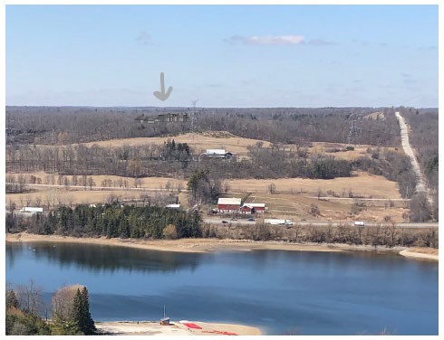
Figure 1: Visibility of proposed dwelling and accessory structures from Kelso viewing point. (Photo simulations provided by Seferian Design Group)

There is some visibility of the dwelling in off-leaf conditions from receptor point # 4, which is located along the Hilton Falls Side Trail of the Bruce Trail within Hilton Falls Conservation Area (Figure 2). It is suggested that the landowner work with Conservation Halton to provide funding for the planting of native evergreen species at this location to mitigate views.

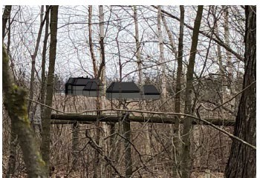
Figure 2. Enlarged view of dwelling in off-leaf conditions from Hilton Falls Side Trail

Receptor point #6 is located at the entrance to the adjacent closed quarry (now owned by the applicant.) As per Figure 3, there is visibility from this location, however, the existing barn-style club house (to be demolished) is also visible under existing conditions. Proposed plantings will be sufficient to mitigate this visual impact, and has been included on the Landscape Plan, adherence to which is Condition of Approval #10.

Receptor point #7 is located immediately in front of the property along Sixth Line Nassagaweya. Again, under existing conditions, the clubhouse is visible from this location. In addition, the accessory buildings will be partially screened by existing vegetation (see Figure 4). Proposed plantings will be sufficient to mitigate this visual impact, and has been included on the Landscape Plan, adherence to which is Condition of Approval #10.

Proposed visual impact mitigation measures include a reduced dwelling height and planting vegetation for screening, and are consistent with the measures suggested in Part 2.13.4. In addition, an exterior lighting plan that indicates dark-sky compliant lighting will be used has been provided. Additional mitigation measures proposed include non-reflective roofing materials and exterior cladding in a subdued, natural colour. These measures have been incorporated into the Conditions of Approval #9 and #10 and are consistent with the direction provided in Part 2.13.4 of the NEP.

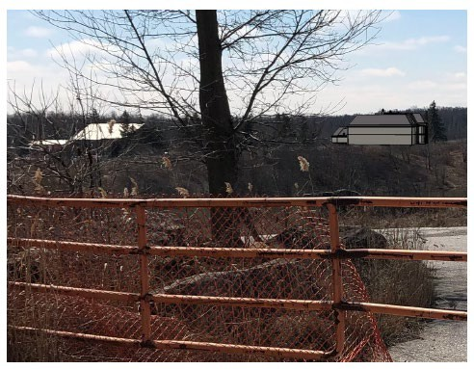
Figure 3: Receptor point #6 at entrance to former quarry. Image is enlarged 200%.
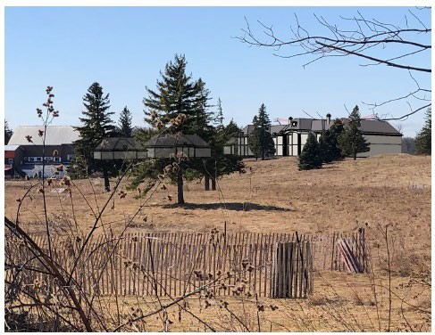
Figure 4: View from Sixth Line Nassagaweya

Part 2.13.6 of the NEP suggests that impervious surfacing should be minimized and limited to areas of the site where it is necessary to the Permitted Use (e.g., driveways, walkways, patios, parking, recreational surfaces). Staff agrees that impervious surfacing has been kept to a minimum given the scale of the proposed development; however, the large accessory structures—if at their proposed scale are not be considered “naturally and normally incidental to” the primary residential use of the property—could be reduced to further minimize the development footprint. For example, the solar panel array could be eliminated by taking advantage of the extensive roof area of the proposed development, thereby eliminating 4000 sq ft of the development footprint.
Additionally, the detached garage/equipment shed could be significantly reduced in size from its 2500 sq ft footprint, considering that the dwelling design incorporates a six-car garage.

Provincial Policy Statement, 2020 (PPS)

On rural lands in municipalities, Section 1.1.5.2 of the PPS permits “residential development… that is locally appropriate.”

Section 1.1.5.4 of the PPS directs that development “compatible with the rural landscape and sustained by rural service levels” should be promoted on rural lands. In the context of the immediate surroundings, including conservation lands and mineral resource extraction, the property and proposed development are unique. As noted earlier in this report, there is not a cohesive rural community character and the property is not within a rural residential or farming area.

However, as noted in the Town of Milton’s comments, Town staff has requested that the applicant be encouraged to comply with the A2 zoning requirements. NEC staff did not receive a response from the applicant’s agent when asked if the zoning requirements could be addressed. It should be noted that if the Planning Act applied to this application, the variation in height difference between the A2 zoning by-law and the proposed reduced roof height could likely be addressed through a minor variance request. Given that NEC staff agree with the VIA findings that the height is not a visual concern, staff does not take issue with the variance in roof height. However, the A2 standard also limits each accessory structure to 93 sq m and a roof elevation of 5.5 m. Each proposed accessory structure grossly exceeds this limit. If the property were subject to zoning, the applicant would have the opportunity to pursue a zoning by-law amendment. Since no such opportunities exists through the NEC, it is up to the Commission to determine if the proposed development is problematic based on municipal, NEP and PPS policies.

It is staff’s finding that the number and scale of accessory structures is excessive for a single dwelling and are not “naturally and normally incidental” to a single dwelling residential use. In accordance with the PPS policy that speaks to development that is compatible with the rural landscape, the NEP definition of accessory facilities, and the Town’s comment that the applicant should be encouraged to adopt the A2 rural zoning standards, NEC staff does not support the accessory structures as proposed.

Another concern with compatibility is the impact on rural estate housing on rural affordability and the future of agriculture in ex-urban areas. While the lands in question are not within a Prime Agricultural Area, a large portion of the Region of Halton is, and there is concern about the viability of agriculture in general in the Region. Although rural estate subdivisions are mostly a thing of the past, a new trend of large estate dwellings on significantly sized parcels of land is increasingly transferring rural land into the ownership of those who do not have a direct tie to the rural economy. In general, this does create land use conflicts when agricultural and natural resource development occurs. Despite the lack of explicit policy on this, Section 1.1.5.7 of the PPS states that, “Opportunities to support a diversified rural economy should be promoted by protecting agricultural and other resource-related uses and directing non-related development to areas where it will minimize constraints on these uses.”

Section 1.2.6.1 states that major facilities (e.g., resource extraction activities) and sensitive land uses (e.g., residential development) should be planned to ensure they are appropriately designed, buffered and/or separated from each other to prevent or mitigate adverse effects. This PPS policy is similar to Part 2.9.12 of the NEP, and has been addressed above.

Section 2.2.1(e) directs planning authorities to protect, improve or restore the quality and quantity of water by implementing necessary restrictions on development and site alteration to i) protect all municipal drinking water supplies and designated vulnerable areas; and ii) protect, improve or restore vulnerable surface and groundwater, sensitive surface water features and sensitive ground water features and the hydrologic functions. These policies are addressed in Part 2.6 of the NEP, and have been addressed above.

Section 3.1.1 and 3.1.7 generally direct development to areas outside of hazardous sites, but where the risks are low, mitigation of these risks is possible as long as new hazards are not created and existing hazards are not aggravated, and no adverse environmental impacts will result. The potential for karst and hazardous slopes has been addressed through the analysis of Part 2.2.2 and 2.5.2 of the NEP.

Section 3.2.1 addresses human-made hazards, noting that development on, abutting or adjacent to lands affected by mineral aggregate operations may be permitted only if rehabilitation or other measures to address known or suspected hazards have been completed. The potential for hazardous slopes due to the previous adjacent quarry operation has been addressed through the geotechnical investigation conducted by the applicant.

CONCLUSION:

There are no policies specifically limiting the size of single dwellings in the NEP. However, the scale of dwellings such as this would not have been anticipated during preparation of the NEP (unlike other uses, such as institutional, where specific size limits have been established). Therefore, NEC staff must assess the impact of large dwellings by considering the site-specific context, including impacts on the natural environment and the natural Escarpment scenery. The unique nature of the site and the technical studies have demonstrated that these impacts can mitigated, and the

Conditions of Approval will ensure that the mitigation measures are incorporated into the construction of the dwelling and landscaping.

NEC staff does not support the accessory structures as proposed, given the comments of the Town of Milton staff, and the NEP policy that requires accessory structures to be “naturally and normally incidental, subordinate… to the principal use located on the same lot.”

Staff’s understanding of the Purpose and Objectives of the NEP is that the NEC is obligated to support upholding municipal standards such as the Town of Milton’s A2 zoning standards. This will enable consistency across the Town’s rural landscape whether it is in or outside of the NEP Area. In staff’s opinion, the less restrictive policies in the NEP should not be used as an opportunity to disregard local standards, even if they are contained within a legally non-applicable zoning by-law.

Therefore, staff is recommending that the Commission conditionally approve the construction of the dwelling and landscaping plan, but not the accessory structures. The applicant is encouraged to revise plans for the accessory structures so that they are more in keeping with the Town’s A2 zoning requirements, including reducing the number and footprint of the facilities to limit impervious surfacing. The partial approval will allow the applicant to proceed with constructing the dwelling. Revised accessory facilities and structures can be applied for through a new Development Permit Application.

The Conditions of Approval are contained in Appendix A.

RECOMMENDATION:

- That the Commission approve construction of the ± 2,534 sq m (± 27,280 sq ft) dwelling, septic system, water storage cistern, extended asphalt driveway, and re-surfacing of the gravel drive (at 9300 Sixth Line Nassagaweya), subject to the Conditions of Approval on Appendix A.

- That the Commission not approve the proposed accessory structures and facilities including the indoor pool, solar array, transformer structure, detached garage, sports building, and tennis court.

Prepared by: Approved by:

Original signed by:
_
Original signed by:
Kim Peters, MCIP, RPP Debbie Ramsay, RPP, MCIP
Manager (A) Director (A)

Appendices:
Appendix A – Conditions of Approval Appendix B – Site Plan
Appendix C – Elevation Drawings Appendix D – Landscape Plan Appendix E – Site Photos
Map 1: NEP Land Use Designations
Map 2: Orthophoto & Natural Heritage Features Map 3: Town of Milton Wellhead Protection Area Map 4: VIA Receptor Points

APPENDIX A

Conditions of Approval H/R/2019-2020/201

- Development shall occur in accordance with the Site Plan, Development Permit and Conditions as approved.

- The Development Permit shall expire three years from its date of issuance unless the development has been completed in accordance with the Development Permit.

- The landowner shall advise the Niagara Escarpment Commission in writing of the start and the completion date of the development. This notice shall be provided to the NEC 48 hours prior to the commencement of development, and within 14 days upon completion.

- No site alteration of the existing contours of the property including the placement or stockpiling of fill on the property is permitted except for that identified within the development envelope in accordance with the approved Site Plan.

- No vegetation shall be cut or removed from the development envelope except for that identified within the development envelope in accordance with the approved Site Plan.

- All disturbed areas shall be re-vegetated and stabilized, in accordance with the approved Site Plan, by the end of the first growing season following the completion of site grading and building construction. All trees, shrubs and nursery stock shall be native to Ontario except those where approved under the Development Permit. Native plant material should be sourced from local plant nurseries when available; bush dug plant material is not acceptable.

- Appropriate erosion/sediment controls and tree protection measures (e.g., heavy-duty silt fencing and tree hoarding) shall be installed around the
development site, prior to commencing development. Photographs verifying the installation of the silt fencing and tree hoarding shall be submitted to the Niagara Escarpment Commission prior to commencing construction of the accessory building. The controls shall be maintained until the works are completed and the site is stabilized.

- Prior to the issuance of a Development Permit by the Niagara Escarpment Commission, an accurate and detailed final site plan shall be submitted for Niagara Escarpment Commission approval. The Plan shall include but not be limited to the following:

  - All drawings submitted must be drawn to scale (bar scale shown), reference the application number and address of the proposal, be dated (revisions as well) and denote the relevant consultant;
  - An accurate delineation of the approved development envelope with temporary fencing;

  - The accurate location of all structures, sewage disposal system and driveway within the development envelope showing setbacks from the property lines, wooded areas, etc.;
  - Extent of all disturbed areas;
  - Extent and amount of fill removal or placement. Grading and drainage design including the areas of excavation and temporary or permanent fill placement. The type, quantity, quality and source location of any imported fill material must be accurately identified. Any fill material approved for importation under this Permit shall conform to the definition of “inert fill” per Ontario Regulation 347 and Table 1 of the Soil, Groundwater and Sediment Standards for use per Part XV.1 of the Environmental Protection Act, dated March 9, 2004;
  - Erosion and sediment control measures;

The approved Final Site Plan shall form the Site Plan referred to in Condition #1 and development shall proceed in accordance with the details of the approved Final Site Plan.

- Prior to the issuance of a Development Permit, the applicant shall submit final construction details for the dwelling and any approved accessory facilities and structures, including:

  - exterior elevations, floor area, height above existing and proposed grades, number of storeys;
  - roofing materials and colour;
  - exterior cladding and colour;
  - all exterior lighting related to the dwelling and any approved accessory structures, which shall be designed to be minimal, subdued, of low height and downward facing. No soffit lighting to be used above the first storey of the dwelling or accessory structures.
  - All fenestration on the dwelling and accessory structures, which shall consist of bird-friendly glass, the specifications of which are to be noted on the construction drawings; and
  - final construction drawings shall note that blasting is not permitted. Excavation is to be done by mechanical means only.

Upon approval, these plans will be stamped “NEC Approved” and shall form part of the Development Permit referred to in Condition # 1.

- Prior to the issuance of a Development Permit, a final landscape plan shall be prepared by a qualified person. The Plan shall address all landscape lighting, planting, screening requirements associated with screening and mitigation as well as amenity areas and details. Stipulations:

  - The lighting plan shall be prepared by a qualified person in accordance with Dark Sky principles. The lighting design goal is minimal use of exterior lighting and lighting fixtures that are consistent with dark sky principles.

  - All new tree and shrub species shall be native to Ontario except where otherwise approved by the Niagara Escarpment Commission. Plant material shall be sourced from local plant nurseries; bush dug plant material is not acceptable.
  - Planting and the rehabilitation of all disturbed areas shall be completed, by the end of the first growing season following the completion of site grading, servicing and building construction to the satisfaction of the Niagara Escarpment Commission.
  - All plant material shall be guaranteed for 24 months following installation. All plant material found during this time to be dead or dying must be replaced with a size and species to the satisfaction of the Niagara Escarpment Commission.
  - Subsequent to the completion of the works a letter certifying the work has been completed in accordance with the approved plan shall be provided to the Niagara Escarpment Commission by a qualified person.

The approved Final Landscape Plan shall form part of the Site Plan referred to in Condition # 1 and development shall proceed in accordance with the details of the Final Landscape Plan.

- Prior to the issuance of a Development Permit, the landowner shall (at the landowner’s expense), enter into an Agreement (to be registered on title) with the Niagara Escarpment Commission pursuant to Section 24(2.1) of the Niagara Escarpment Planning and Development Act, that shall ensure that the principal dwelling shall only contain one dwelling unit, and shall not be used for commercial, institutional, , or industrial purposes.

- Site preparation (i.e., grubbing, tree and vegetation clearing, excavation) shall not occur between March 1 and August 15 inclusive, of any given year, within the migratory and breeding season of avian species at risk to ensure protection of breeding habitat. These details shall be noted on the final construction drawings and landscaping plans. If tree removal is necessary within this timing window, a survey shall be conducted by a qualified biologist within two days of tree removal activities to determine if any nesting birds or roosting bats are present. The results of this survey and any necessary mitigation plans shall be provided to Niagara Escarpment Commission staff prior to the removal of trees.

- Development shall occur in accordance with the Vegetation Protection Plan prepared by Terrastory Environmental Consulting Inc., dated October 8, 2020. The Vegetation Protection Plan shall form part of the Site Plan referred to in Condition #1.

- This conditional approval expires one (1) year from the date of confirmation of the decision to approve the Development Permit Application. Condition Nos. 8, 9 10 and 11 of this conditional approval shall be fulfilled before the expiry date.

Notes/Advisories:

- This Development Permit does not limit the need for or the requirements of any other approval, license or certificate under any statute (e.g., Ontario Building Code, Town of Milton Site Alteration By-law, Conservation Authorities Act, Endangered Species Act, etc.).

- The Regional Municipality of Halton advises: should deeply buried archaeological remains/resources be found on the property during construction activities, the Ministry of Heritage, Sport, Tourism & Culture Industries should be notified immediately. In the event that human remains are encountered during construction, the proponent should immediately notify the police.

- The swimming pool (if approved) must be filled with trucked-in water and not ground or surface water.

- The stone fencerows on the subject property are not approved for removal. Should the landowner wish to demolish or otherwise modify them, their cultural heritage value and interest should be assessed through the evaluation of a new Development Permit Application.

- Development Permit #11657H/D/2018-2019/451 was previously issued for the demolition of existing structures on the property. The landowner is advised that demolition must occur in accordance with the conditions of said permit.

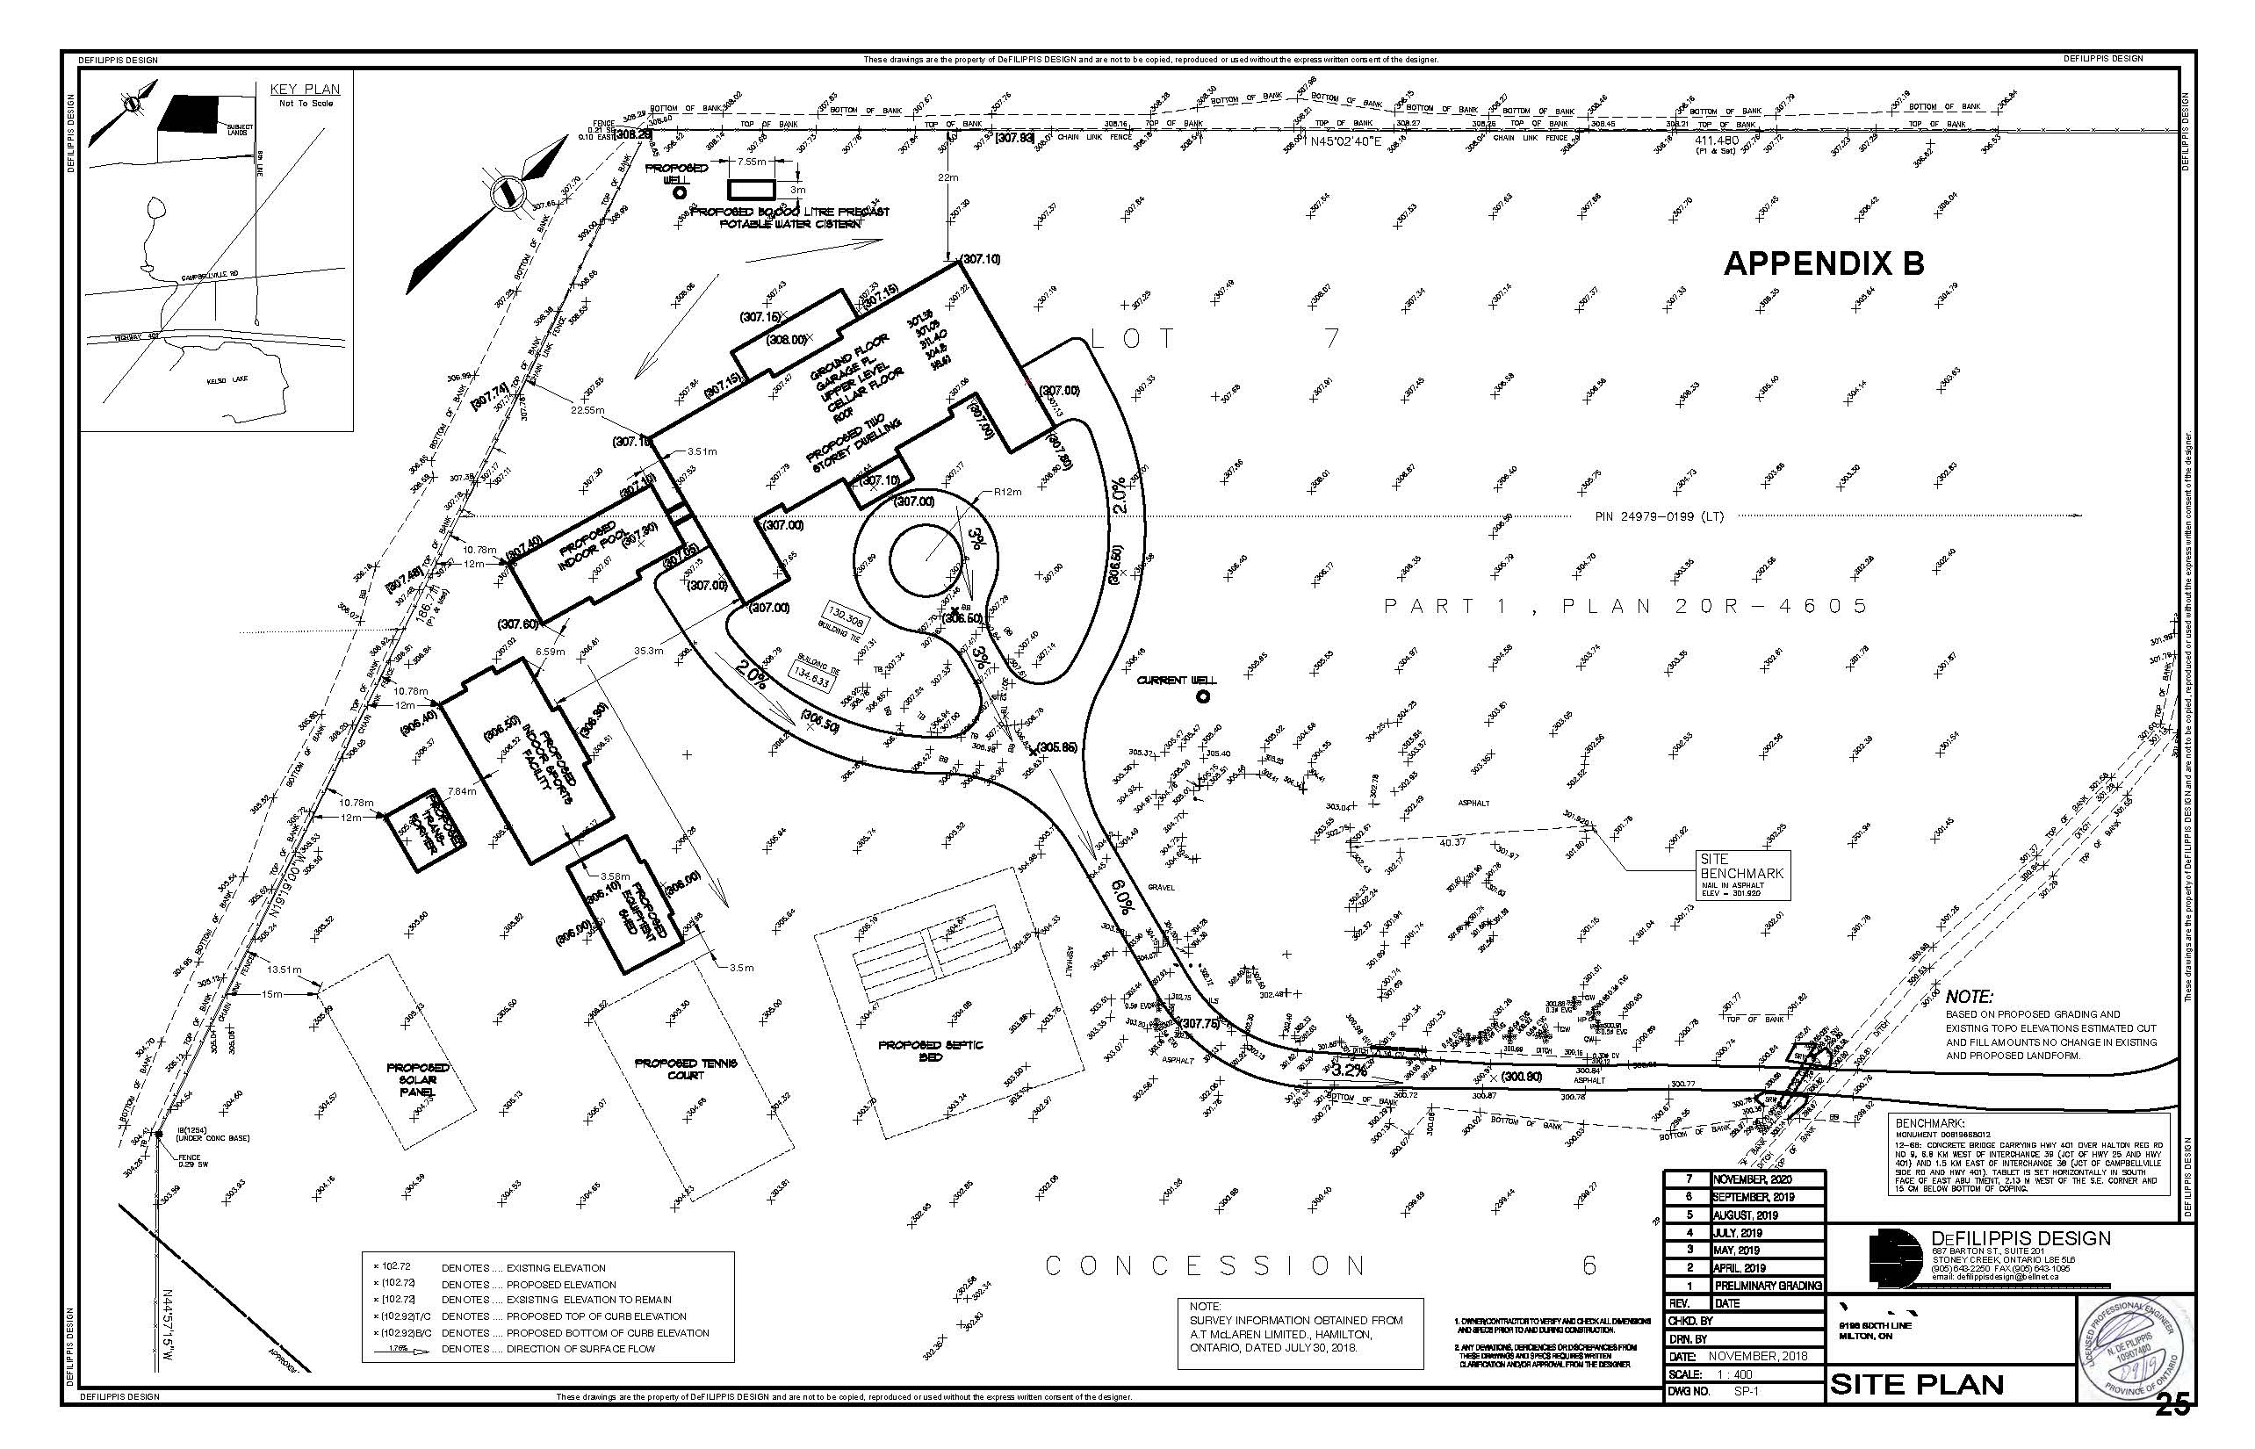

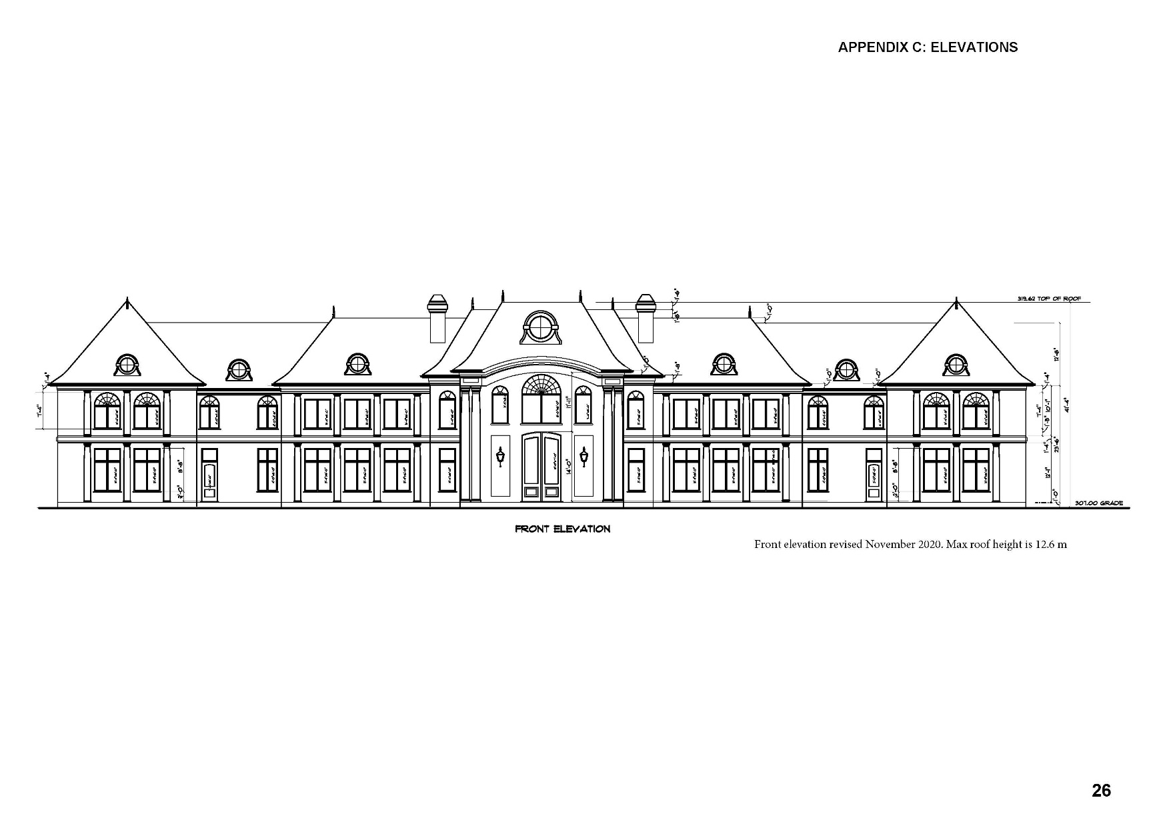

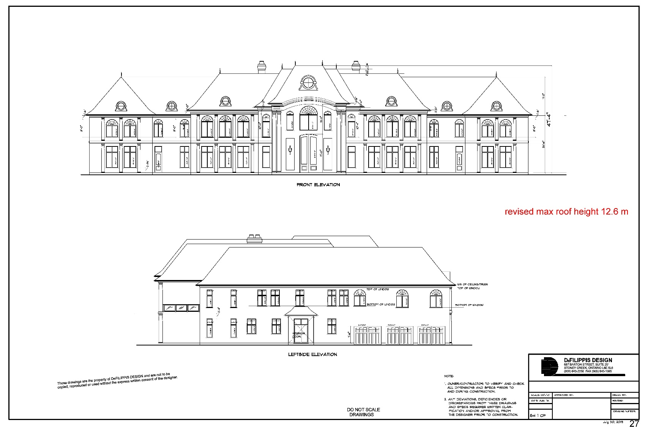

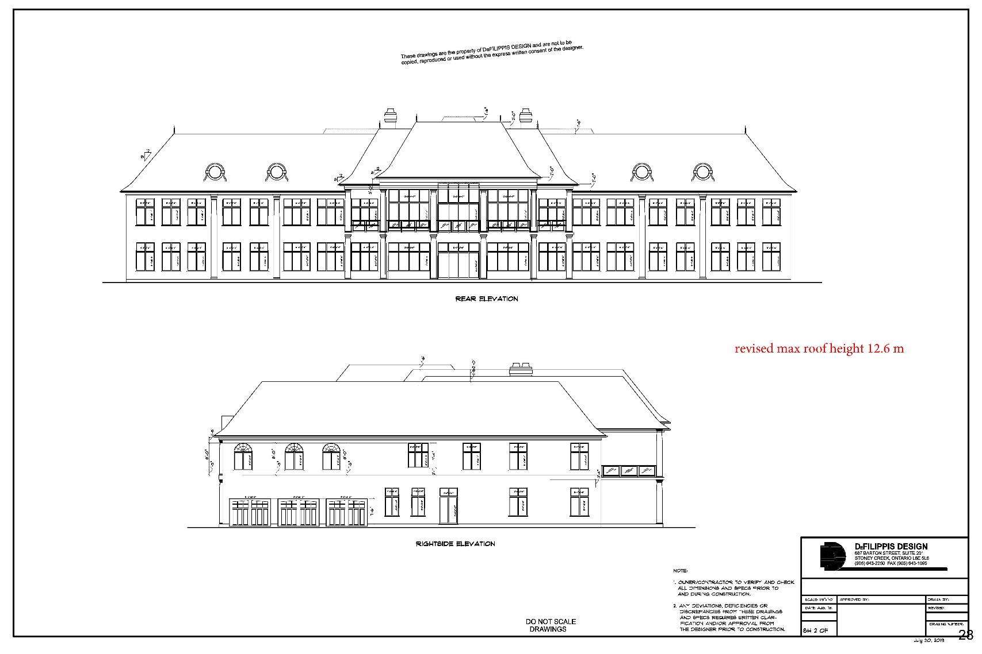

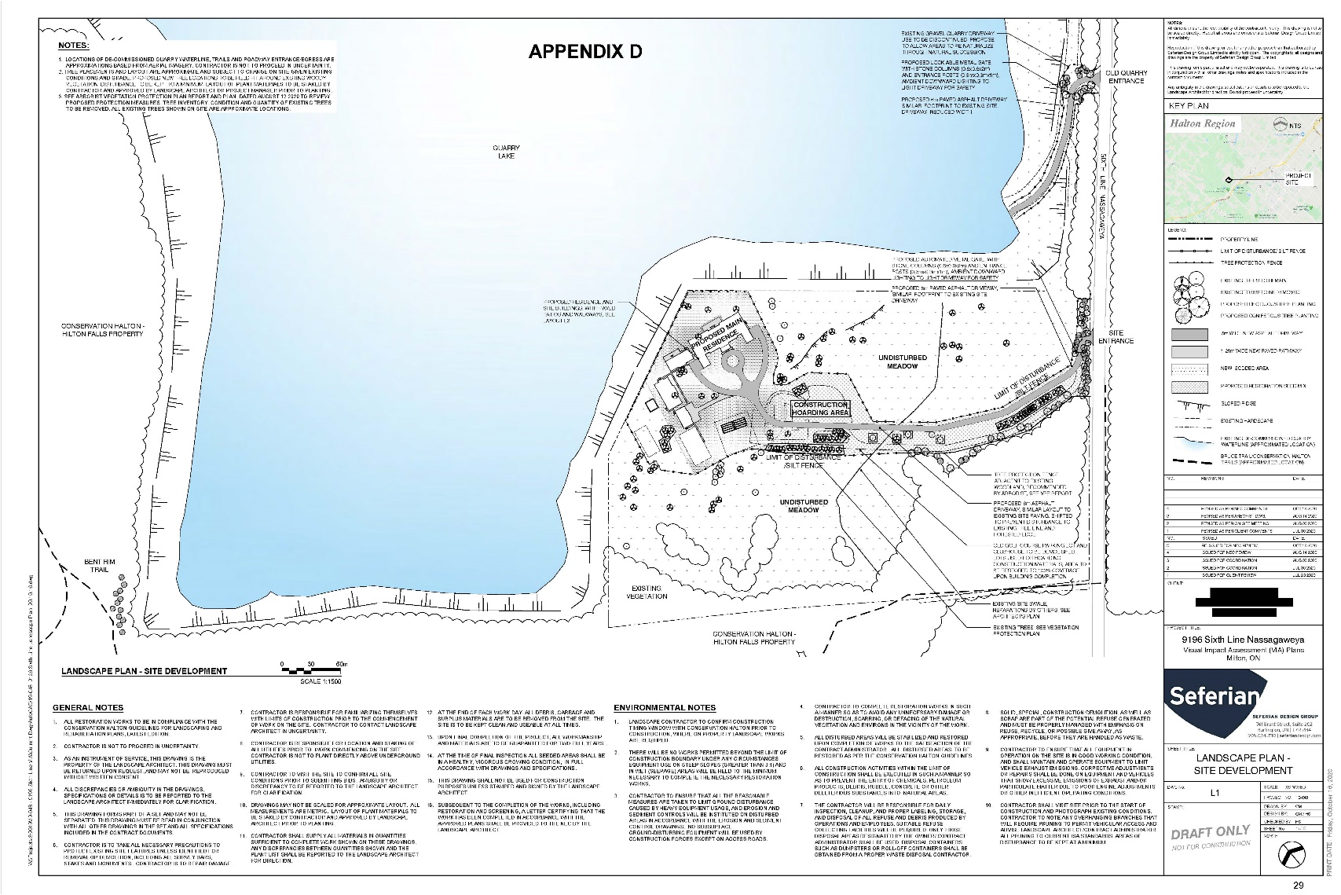

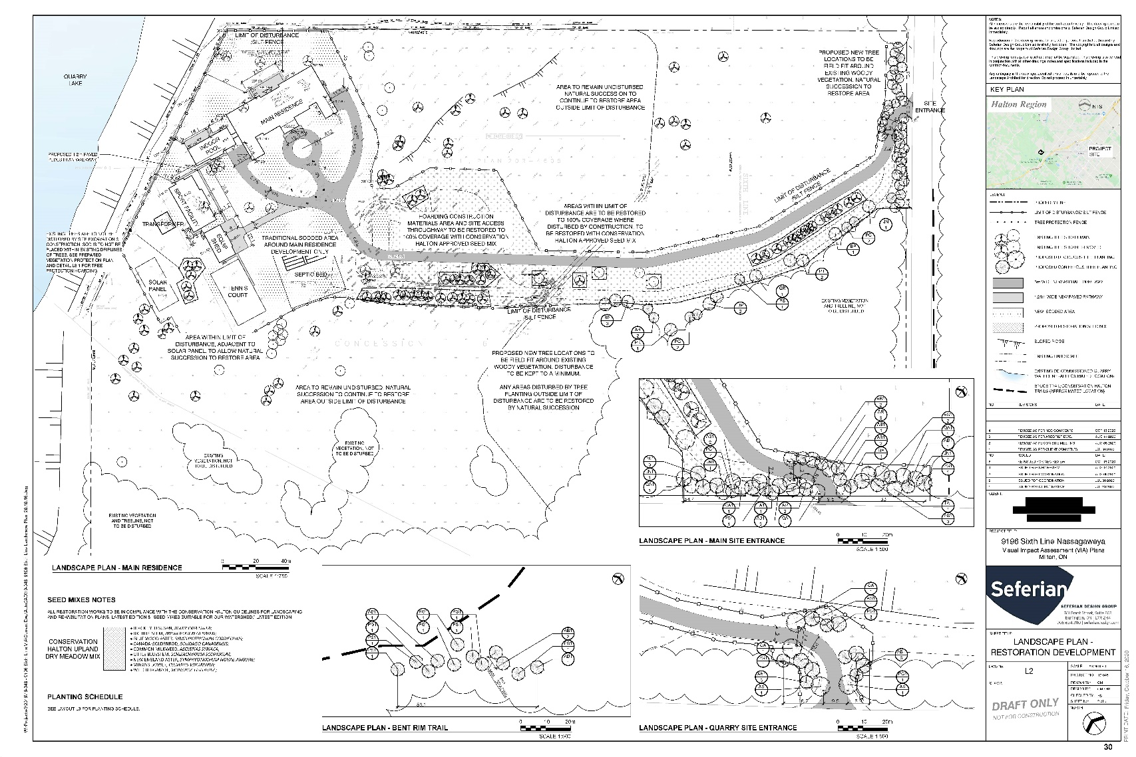

Appendix E – Site Photos
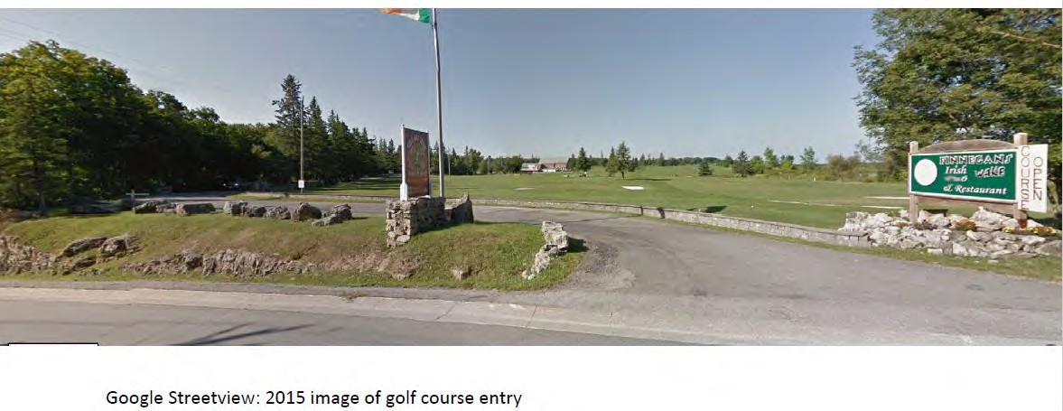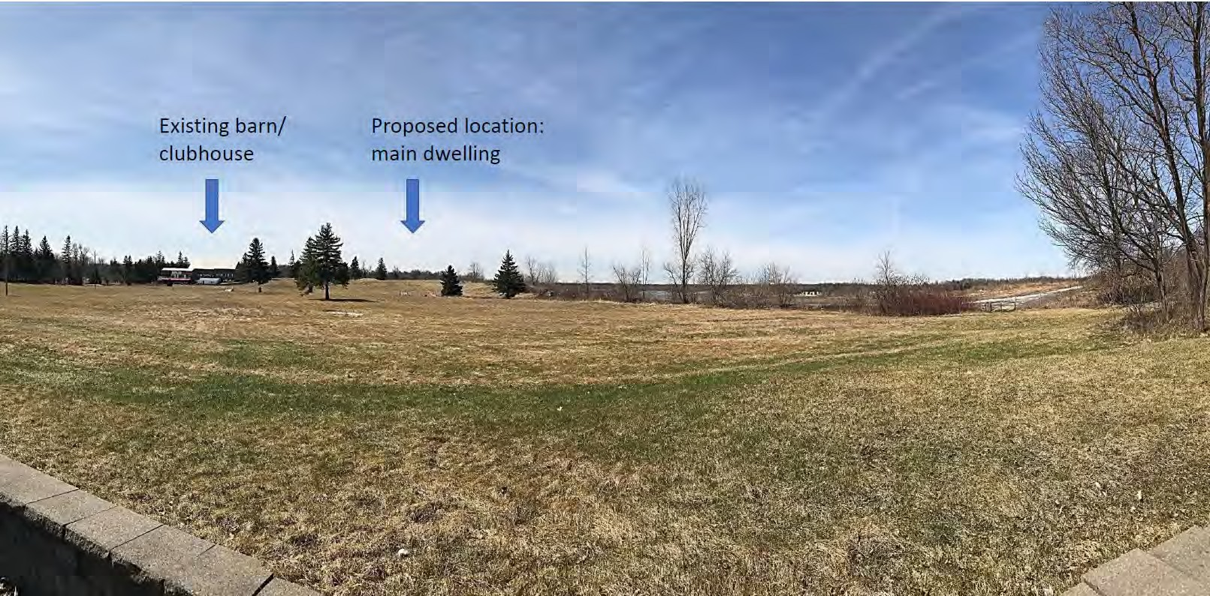

View to the property looking southwest from Sixth Line Nassagaweya

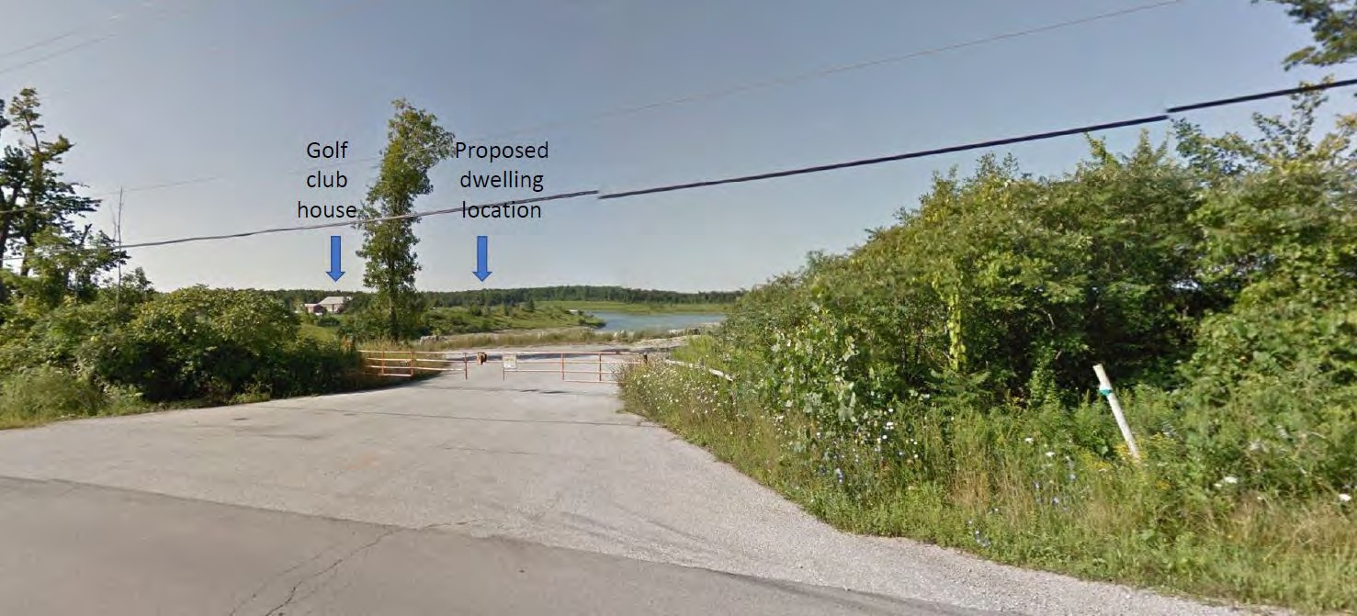
Partial view of quarry lake, existing clubhouse, and proposed dwelling location
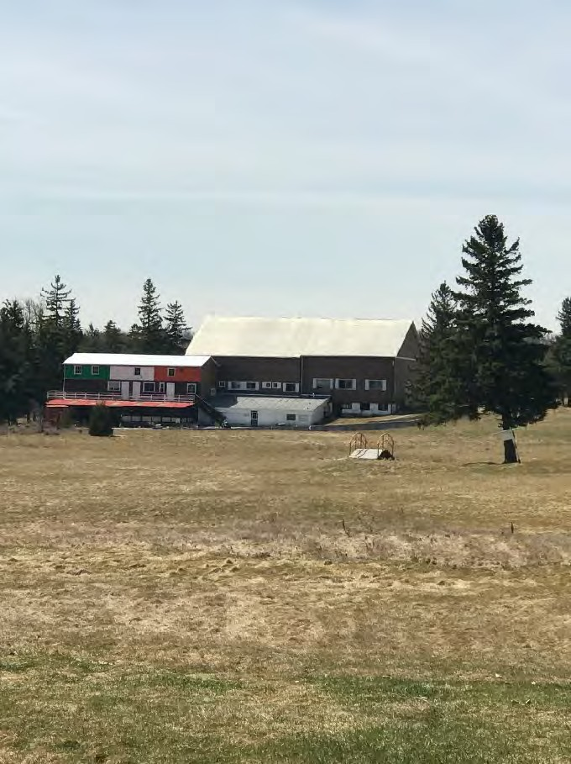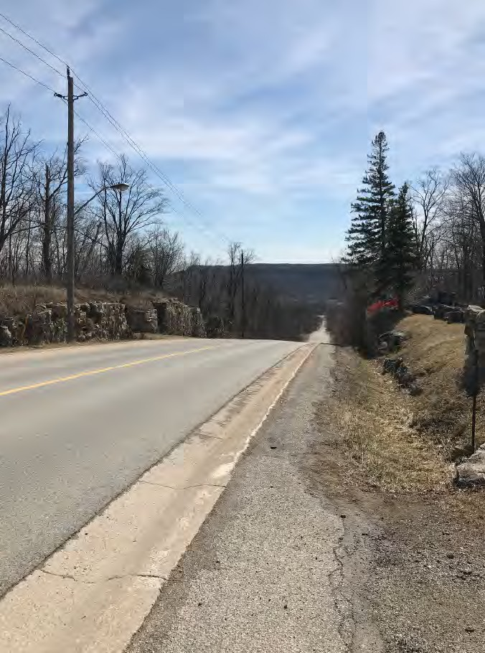
Existing golf course clubhouse View to south descending the Escarpment along Sixth Line Nassagaweya. Kelso scarp visible on the horizon

