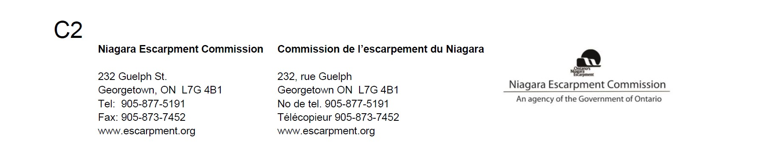

December 17, 2020

Endangered Species Act (ESA) Government Review Team Species at Risk Branch
300 Water Street
5th Floor, North tower Peterborough, ON K9J 8M5

Re: Environmental Registry posting 019-2636: Species at Risk Conservation Fund and streamline authorizations for certain activities that impact species at risk, while maintaining protections for species at risk.

Niagara Escarpment Commission (NEC) staff have reviewed the above-noted Environmental Registry (ER) posting regarding the proposal of new regulations to enable the use of a Species at Risk (SAR) Fund and proposal to amend Ontario Regulation 242/08 to streamline the Endangered Species Act (ESA) by amending certain conditional exemptions.

Staff is of the understanding that recent changes have been made to the ESA allow for the use of a new option by proponents that are authorized to undertake activities that impact species at risk. Instead of completing beneficial actions for species impacted by those activities (“overall benefit”), proponents will have the option of contributing to a fund that allows a new provincial agency to pool the resources and determine how best to implement long-term, large-scale and strategic protection and recovery activities that benefit eligible species.

The NEP contains strong objectives and policies providing for the protection of Species at Risk (SAR) habitat in the NEP Area. Part 2.7 Development Affecting Natural Heritage specifically identifies the objective to protect and where possible enhance natural heritage features and functions, including requirements to avoid, protect, maintain and enhance and minimize impacts to SAR habitat. Staff notes that the Province has identified that municipalities and proponents will still be required to avoid and minimize impacts (to SAR/SAR habitat), where possible. However, this new system would offer some opportunities for habitat removal where reasonable alternatives for avoidance or mitigation cannot be achieved. It is staff’s understanding that the MECP is proposing to include six species in the initial stages of the new approach, all which staff notes are found within the NEP Area.

NEC staff will continue to undertake consultation with MECP staff when assessing NEC development proposals affecting SAR/SAR habitat, in order to understand the requirements and considerations under the ESA, and for MECP staff to be aware of the requirements under the Niagara Escarpment Planning and Development Act (NEPDA) and NEP. Including Section 24(3) of the NEPDA which requires that NEC approvals be obtained prior to any other approvals, decisions, permits are issued under another Act.

Proposed development in the NEP Area is assessed against the NEP Purpose, objectives and policies which, with respect to natural heritage features (including SAR habitat) emphasize an avoidance first principle. Habitat loss and degradation are key threats to the decline of many SAR. The NEP contributes to the persistence of these species through its purpose and objectives which are implemented through the Development Control process. NEP policies speak to avoiding, protecting, maintaining and enhancing key natural heritage features rather than compensating. Enhancement (which may include creation of new habitat), may be considered, when all other requirements of the NEP have been met and consistent with the ESA. As such, when development impacting SAR habitat is being considered in the NEP Area, there may be cases where the NEC will continue to require that enhancements to address impacts to or loss of SAR habitat be undertaken in vicinity of, or same watershed as the proposed development. When this cannot be achieved consideration may be given to implementing enhancement on other identified NEP Area lands, as part of an approval.

Staff requests that the Niagara Escarpment be recognized as a unique land use planning area in Ontario when implementing the Species at Risk Conservation fund, and that when the ESA allows for use of the fund to address development in the NEP Area that impacts habitat of the eligible species, that opportunities for investments in protection and recovery activities be focused and maintained in the NEP Area. This will ensure the overall purpose and objectives of the Plan are achieved, while provide opportunities for supporting protection in a strategic and coordinated manner.

Thank you for the opportunity to comment on the proposed ESA regulatory changes. The NEC would like to continue to be informed of this matter going forward and looks forward to continuing to support the long-term protection of SAR.

Regards,

Original signed by:

Lisa Grbinicek, MCIP, RPP Senior Strategic Advisor

