January 21, 2021

INFORMATION REPORT

RE: NIAGARA ESCARPMENT PLAN AMENDMENT PP 213 18
Blueland Farms Ltd. (McCormick Pit)
17736 Heart Lake Road
Part of Lot 12, Concession 2 EHS Town of Caledon, Region of Peel

BACKGROUND:

The purpose of this report is to provide an update to the Commission on the status of the Blueland Farms Niagara Escarpment Plan (NEP) Amendment application for a new mineral resource extraction operation (sand and gravel pit) in the Town of Caledon. The Amendment was initiated by the Commission on June 21, 2018. The proposal is described as follows:

To amend the Niagara Escarpment Plan (NEP) designation of Escarpment Rural Area to Mineral Resource Extraction Area to permit mineral aggregate resource extraction both above and below the water table within a 26-hectare area on a 40.5-hectare property located at Part Lot 12, Concession 2 East of Hurontario Street, Town of Caledon, Region of Peel.

UPDATE ON AMENDMENT PROCESS:

To date, NEC staff has received and reviewed initial submissions that included a planning justification report, site and rehabilitation plans, natural environment technical report, visual impact assessment, and a hydrogeological assessment. NEC staff provided comments on these submissions in January 2019 (see Appendix A).

The application was circulated to government agencies and neighbouring landowners for comment on March 5, 2019, concurrent with notices placed in the Orangeville Banner and Caledon Enterprise newspapers and a posting on the Environmental Registry. As result of the 60-day commenting period, 12 objections were received from local residents, including the PitSense community-based group. The Town of Caledon’s official plan amendment is being processed in tandem with the NEP Amendment application. The Town has not yet taken a final position on the OPA or NEP Amendment.

POLICY ISSUES:

A significant NEP policy issue that is still under consideration is Part 2.9.1, which prohibits mineral resource extraction in wetlands and parts of significant woodlands. There are several wetlands in proximity to the extraction area, but they have been excluded from the extraction footprint (see Maps 1 and 2). However, there are outstanding concerns regarding the impact that extraction will have on these wetlands.

With regard to woodlands, there is a mix of forest types on the subject lands, including early successional and mature deciduous forest. Portions of the woodland are significant wildlife habitat as well as the habitat of Endangered and Threatened species, given the presence of eastern small-footed myotis (a bat) and possibly eastern wood pewee. Records of bobolink and eastern meadowlark (Threatened species) also exist in the area. It should be noted that there is nothing in the NEP that strictly prohibits aggregate extraction in significant wildlife habitat, or in Endangered species habitat, provided it complies with the Endangered Species Act (see Part 2.7.8(b)).

Initially, NEC staff took the position that the woodland on the subject property was significant, based on its connectivity with a larger forested area, and that it met the criteria in the Ministry of Natural Resources and Forestry’s (MNRF) Natural Heritage Reference Manual (2010), as well as the Region of Peel’s criteria for significance1.
However, the Region of Peel has a policy exception in its Official Plan that allows for extraction in a woodlands that are 30 hectares or less, even when they meet the technical criteria for significance. NEC staff did not think that the policy exception should apply to aggregate extraction in the NEP Area, especially when the Region’s technical criteria are consistent with the criteria for significant woodlands established in the Natural Heritage Reference Manual. In staff’s opinion, technical criteria should stand as measurable indicators that can be objectively observed or quantified. Policy exceptions should not be confused with technical criteria. And given that there is no such policy exception in the NEP, NEC staff took the position that aggregate extraction could not be permitted as proposed, since extraction would encroach into areas that met the criteria for significance.

After this position was taken by staff, the MNRF provided direction on what criteria the NEC should be using to determine the significance of the woodland in this context. In the attached letter (Appendix B), MNRF notes that “the NEP requires that ‘significant woodlands’ within the NEP area are to be identified using criteria established by Ministry of Natural Resources and Forestry.” This statement is found in the definition of “significant” in Appendix 2 of the NEP. In the letter, MNRF recommends that the Region of Peel’s Official Plan policy exception for aggregate extraction in Core Woodlands be applied as part of the criteria for significance as an interim approach, unless and until significant woodlands technical criteria specific to the NEP are developed.

1 The criteria that are met are: i) it is a woodland =/> 16 ha, and supports species designated by COSSARO as Endangered or Special Concern.

Prior to finalizing a position on the significance of the woodland and the extent to which extraction can occur on the subject lands, NEC staff is waiting for the applicant to submit a revised Natural Environment Technical Report that incorporates discussions that have occurred between the applicant, the Town, Credit Valley Conservation, and the NEC.

CONCLUSION:

In the end, regardless of staff’s final recommendation, the Amendment will be referred to the Niagara Escarpment Hearing Office unless the 12 objections can be resolved. Under section 10(3) of the Niagara Escarpment Planning and Development Act, an Amendment must be referred to a hearing if written objections are received.

No action is required by the Commission at this time. The Commission is requested to receive this report for information, in anticipation of a final staff recommendation coming later in 2021.

RECOMMENDATION:

- The Commission receive this report for information.

Written by: Approved by:

Original signed by: Original signed by:

Kim Peters, MCIP, RPP Debbie Ramsay, MCIP, RPP
Manager (A) Director (A)

Attachments:

Map 1: Natural Heritage Features Map 2: Proposed Extraction Area
Appendix A: NEC staff comment letter, January 2019 Appendix B: Letter from MNRF, July 2020

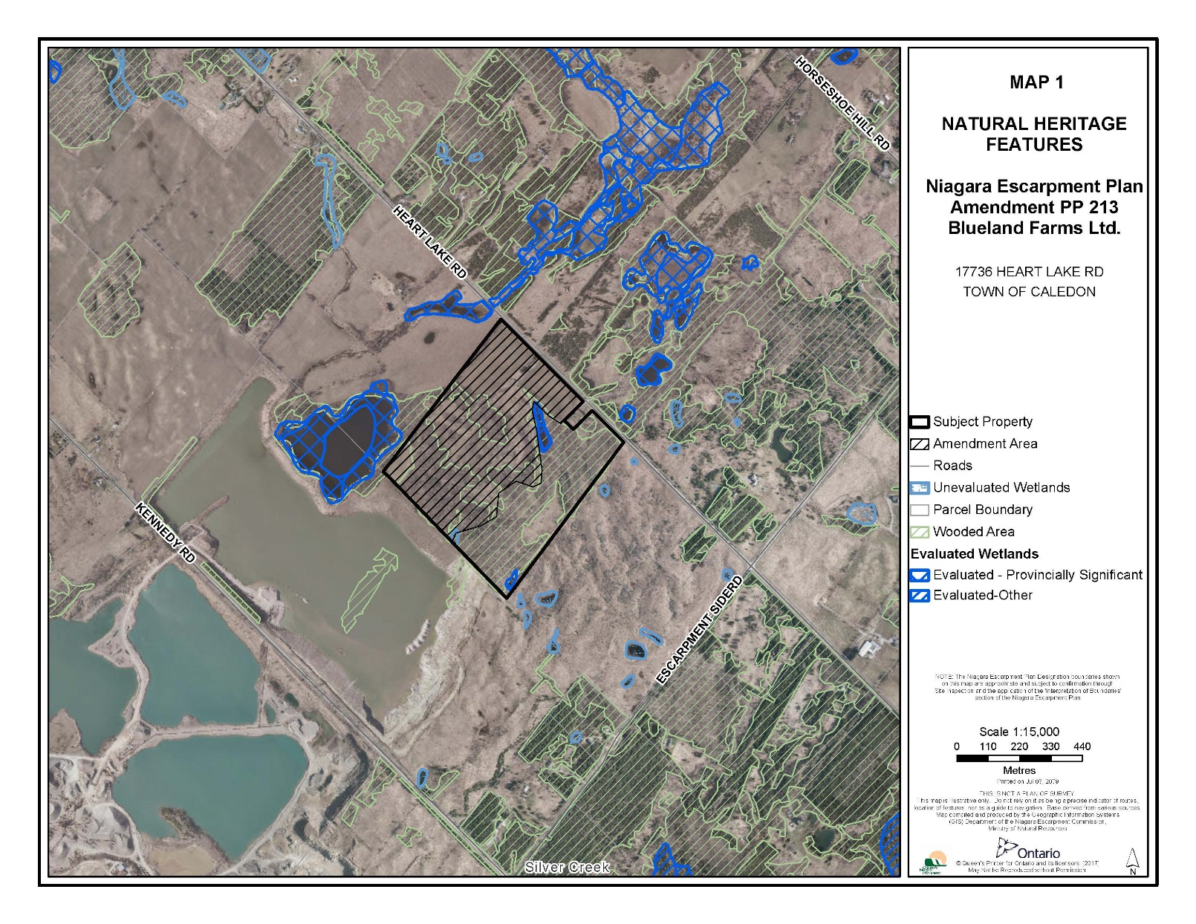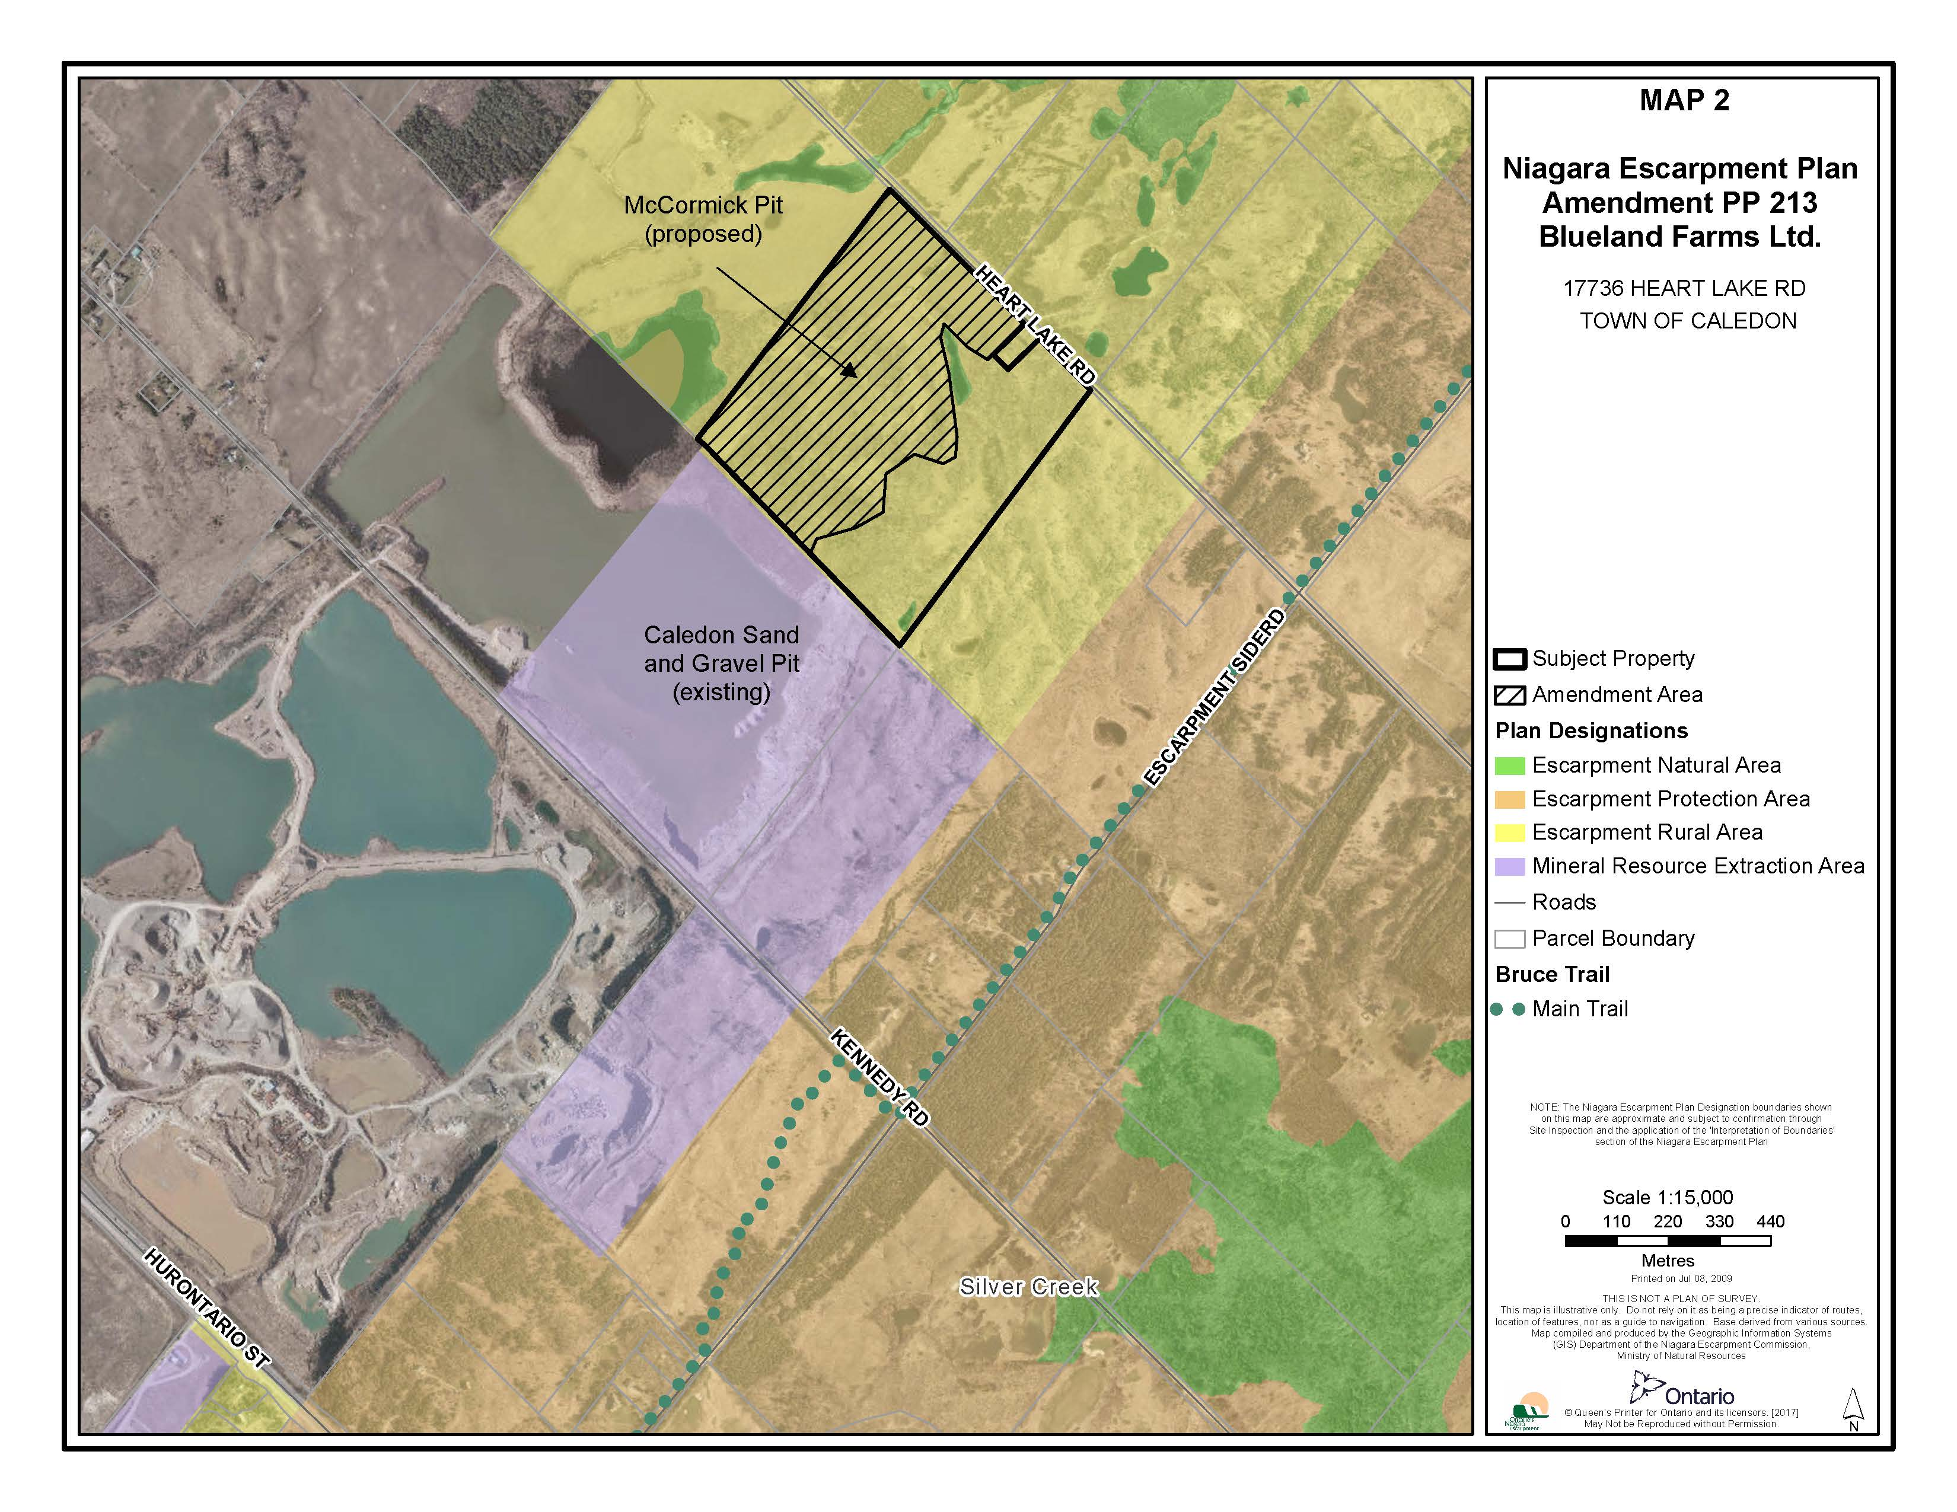

APPENDIX A

BY EMAIL
January 31, 2019 Stephanie McVittie
Senior Development Planner Community Services Department Town of Caledon

Re: Proposed Official Plan Amendment 13-02 & Niagara Escarpment Plan Amendment PP 213 18
Blueland Farms Ltd. (McCormick Pit)
17736 Heart Lake Road

Part Lot 12, Concession 2 EHS Town of Caledon, Region of Peel

Thank you for providing Niagara Escarpment Commission (NEC) staff with a copy of the proposed Official Plan Amendment (OPA) to permit a mineral aggregate extraction use of the above-noted property. As you know, an Amendment to the Niagara Escarpment Plan (NEP) and NEC Development Permit must be approved prior to the Town approving the OPA, in accordance with Section 24(3) of the Niagara Escarpment Planning and Development Act. However, the NEC and Town of Caledon review processes can take place concurrently.

The NEC is preparing an Environmental Registry posting for a 60-day consultation period on the applicant’s NEP Amendment application, in accordance with the Environmental Bill of Rights. An Environmental Registry posting is also required for the application under the Aggregate Resources Act. NEC and Ministry of Natural Resources and Forestry (MNRF) staff are endeavouring to co-ordinate the timing of these postings. The Town of Caledon and other affected agencies will be notified when the 60-day consultation begins. The NEC’s final position on this OPA cannot be provided until the NEC has reviewed the NEP Amendment application for conformity with the NEP, and considered all comments received during the 60-day consultation period. Once the Commission takes a position on the Amendment, it is sent to the Minister of Natural Resources and Forestry for a decision. If there is opposition to the NEP Amendment, or if the Commission recommends refusal, the Act requires that a Hearing be held before the matter is referred to the Minister for a decision.

Preliminary Comments

Based on a preliminary review of the technical documents provided for both the OPA and NEP Amendment applications, NEC staff has the following comments:

- Area Subject to OPA

On Town of Caledon documents, it appears that the area subject to the OPA is limited to the area proposed for extraction, whereas the NEP Amendment area has been mapped as the entire licensed area. For consistency, NEC staff recommends that the OPA apply to the entire licensed area.

- 2017 NEP Policy Analysis

NEC staff notes that the Natural Environment Technical Report (NETR) does not use the most recent mapping of the Niagara Escarpment Plan land use designations. NEP policies and land use designations were updated during the Co-ordinated Provincial Planning Review and came into effect on June 1, 2017. NEC staff requests that the NETR be updated to contain the correct mapping.

Section 8 of the NETR should also be revised to reference the correct policies in the 2017 NEP. Section 8 makes non-specific references to NEP policies that appear to be based on the 2005 NEP.

The Planning Justification Report prepared states that development is not proposed within significant woodlands (page 9, Appendix B). NEC staff fundamentally disagrees with this statement and finds that the woodland is significant based on technical criteria. This is further explained below.

On page 11 of Appendix B of the Planning Justification Report, it states that the use of off-site materials for rehabilitation is not proposed. Immediately above that, it states that some soils from the adjacent site may be used for rehabilitation and mitigation on this site. The applicant should clarify this apparent contradiction.

Page 13 of Appendix B states that the preparation of the Visual Impact Assessment was guided by the policies and guidelines of the NEP. There are multiple deficiencies in this regard that are outlined below.

- Significant Woodlands

Section 4.7.1 of the NETR notes that the area of contiguous woodland overlapping the subject is 23 hectares, and it is smaller in size than the 30-hectare threshold for significance as a Core Woodland in the Region of Peel Official Plan, which is applied when mineral aggregate extraction uses are being proposed. Otherwise, any contiguous woodland of 16 hectares or greater in the rural area would be considered a Core Woodland. In contrast, the NEP bases the significance of woodlands solely on criteria

established by the MNRF. Unlike the Region’s Official Plan, there are no policies in the NEP that allow for the downgrading of the significance of a woodland for the purposes of mineral resource extraction. As per Part 2.9.1 of the NEP:

Notwithstanding Part 2.7.2 and subject to compliance with all other relevant policies of this Plan, mineral aggregate operations, wayside pits and quarries and any accessory use and accessory facility thereto, may be permitted in key natural heritage features and any vegetation protection zone associated therewith, except for

  - wetlands;

  - significant woodlands, that are not young plantation or early successional habitat (as defined by the Ministry of Natural Resources and Forestry).

Based on a desktop review of the NETR and a review of the Region of Peel’s criteria for identification of Core Woodlands (Table 1, Section 2.3 of the Region’s Official Plan), the NETR demonstrates that the woodland on the property meets the Table 1 criteria1 for Core Woodlands. Furthermore, NEC staff finds that the Core Woodlands criteria are consistent with the technical criteria for significant woodlands established by MNRF in the Natural Heritage Reference Manual (MNRF, 2010). Therefore, the Region of Peel Official Plan appears to conflict with the NEP in that it has a less restrictive standard in that it allows for a policy exception for mineral resource extraction in significant woodlands. This is a policy exception, and not a technical criterion. As noted in the Region’s Official Plan, in the event of a conflict, provincial plans (including the NEP) take precedence over the Official Plan. Thus, the woodlands on the subject property should be considered as significant woodlands under NEP policies.

As per Part 2.9.1 of the NEP, mineral aggregate resource extraction and any accessory uses can only take place in the portions of a significant woodland that are shown to be young plantation or early successional. NEC staff therefore requests a more detailed analysis that specifically identifies the portions of the woodland that are young plantation/early successional and can therefore be considered for aggregate extraction. Mature woodlands (e.g., FOD5-7 and selective portions of FOD3-1) should be excluded from the extraction area. The selective removal of young plantation/early successional woodland on the property must still be consistent with the objective of Part 2.7: to protect and where possible enhance natural heritage features and functions in order to maintain the diversity and connectivity of the continuous natural environment.

The information provided by the applicant also proposes reforestation of a portion of the subject property that is outside of the area to be licensed. NEC staff’s understanding is that this is being proposed as a mitigation strategy for the removal of 3.65 hectares of significant woodland that is also significant wildlife habitat/habitat of an endangered

1 The criteria that are met are: i) it is a woodland =/> 16 ha, and supports species designated by COSSARO as Endangered and Special Concern.

species. NEC staff advises that there are no policies in the NEP that allow for on or off- site compensation in exchange for the removal of significant woodland and destruction of the habitat of an Endangered species. However, staff supports this as an enhancement to the existing woodland on the subject property. Furthermore, NEP Part 2.7.8(b) requires that development within the habitat of an Endangered species in Escarpment Rural Area comply with the Endangered Species Act (ESA). NEC staff will require confirmation from the Ministry of Environment, Conservation and Parks that the proposed destruction of Endangered species habitat complies with the ESA.

NEC staff will be seeking the advice of Credit Valley Conservation, the Region of Peel, and the Ministry of Natural Resources and Forestry to confirm the size of the significant woodland and to determine what areas can be extracted based on technical criteria.

- Wetlands

NEC staff notes that wetlands #4 and #5 on the subject property are excluded from the proposed extraction and licensed area. However, staff requests a clarification regarding wetland #3. The Operations Phase A drawing indicates there will be an internal access gate on or adjacent to wetland #3. Extraction and/or accessory uses (including ingress and egress from the licensed area) are prohibited in wetlands, in accordance with Part 2.9.1(a).

- Visual Impact Assessment (VIA)

On May 24, 2017, NEC staff met with the applicant’s consultants to discuss the 2013 VIA submission and areas of concerns, information needed, scope of work and other related matters. It was noted that the 2013 study was prepared to address the Town of Caledon’s requirements and not those of the NEP. At this meeting NEC staff recommended that terms of reference be provided prior to the commencement of additional work. NEC staff followed up with an email on June 6, 2017 to the consultants reiterating the matters to be addressed. These June 2017 comments have not been addressed. In summary, NEC staff’s concerns are:

- No terms of reference for the VIA were ever submitted to the NEC;
- Parts of the VIA are not in accordance with the NEC’s Visual Assessment Guidelines;
- The area examined in the VIA does not address the parameters identified by NEC staff;
- Baseline information on photographs and viewpoints, and the methodology used to produce photographic simulations are not included in the information submitted thereby making it difficult for NEC staff to assess the accuracy of the findings of the VIA;
- In general, photographs are not representative of the full viewshed and are of poor resolution;
- The line-of-sight cross sections are not to scale and the location on the plan is not provided.

NEC staff is also concerned with the statement that the existing view of the Escarpment environment would be reinstated and unobstructed at the end of the rehabilitation phase. The view would be to a substantively altered Escarpment environment. The site plans and rehabilitation plan show the proposed pit would result in significant landform change, removal of wooded areas, the creation of an expansive void in place of the existing topography and ultimately a pond with minimal planting. As such the view to the open landscape character and scenic resources would be altered significantly.
Fundamentally this does not address the NEP objective of maintaining and enhancing the open landscape character by preserving the natural scenery.

In summary the VIA does not at this time set out a process that is clearly tied to the NEP, fulfill the NEC Visual Assessment Guideline steps and does not address those matters identified in the June 2017 correspondence with the consultants. It is recommended a Terms of Reference be prepared by the consultant outlining the process proposed to address the matters identified and be reviewed and approved by NEC staff prior to the commencement of further work.

- Site Plan Drawings 1 to 5

- Operations Plan Phase A (drawing #2) indicates that a gate for internal access is proposed adjacent to and/or within wetland #3. It is unclear why an internal access gate is needed in this location. Furthermore, Part 2.9.1(a) of the NEP prohibits aggregate extraction and accessory uses in a wetland. The applicant is requested to clarify and revise the Operational Plan accordingly.

- On drawing #2 (Phase A), an “existing fence” is illustrated to coincide with the boundary of the area to be licensed. This “existing fencing” is not shown on drawing #1 (Existing Features). The applicant is requested to clarify. NEC staff questions why the licence limit and fencing are delineated inside the wooded area to be retained. Fencing should be placed along (not through) vegetation zones to be retained. It is therefore recommended that the licence fencing and vegetation protection fencing be combined and located, at a minimum, along the natural environment operational limit shown on the site plan drawings. The applicant should also clarify the reference to Figure 10, Appendix A in the technical recommendations on drawing #3. Should the correct reference be Figure 9, Appendix A in the NETR?

- Prior to the NEC issuing a development permit (if the NEP amendment is approved), the applicant will be required to submit a complete vegetation protection plan and landscape/planting plan, prepared to the satisfaction of the NEC. The vegetation protection plan should address the following issues:

  - Potential impacts to the following areas: FOD5-2, FOD3-1, FOD6-5 and vegetated zones abutting Wetlands 4 and 3 as well as the hedgerow extending north of Wetland 4 all appear to be subject to impacts due to clearing;

  - As above for wooded areas on abutting property(s) to the north. See FOD6-5 / FOD3-1 and FOD5-6/CUM1-1/FOD3-1;
  - Existing vegetation / hedgerow along Heart Lake Road and northern property line of R5;
  - Existing boundary line trees along the northern property line; a setback zone may be required between the toe of the 4-meter-high acoustic berm to ensure the tree/shrub survival. Note: If the trees/vegetation are entirely on the subject lands then they are not boundary trees.

- Note #2 on drawing #2 indicates berms shall be sculpted to include variations in slope to simulate hummocky topography, but the details on drawing #3 do not identify parameters for a sculpted berm with variations. Additional detail or notes on the Operational Plans are necessary. The photographic simulations in the VIA report show what appears to be dike-like berms with no topographic variations. The applicant is requested to clarify the berm structure and address the policies in Part 2.9.6 of the NEP requiring that berms be of varied heights and widths, supplemented with native tree, shrub and vegetative plantings.

- Drawing #3 notes that prior to Phase 4 (D?), a berm should be constructed along the east perimeter. Drawing #3 shows this berm being constructed during Phase
B. The applicant is requested to clarify.

- The site plan drawings show a 15-metre buffer between the extraction limit and the natural environment operational limit. The applicant is requested to clarify whether this area is to be cleared all or in part.

- The proposed seeding of the berms does not meet NEP policies regarding vegetation screening. As noted above, Part 2.9.6 requires that berms be supplemented with native tree, shrub and vegetative plantings. The proposal to limit vegetation to the seeding of grasses does not achieve this policy. To better comply with NEP policy, staff recommends the following: A minimum 10-metre band in the 30-metre buffer abutting the property line be planted in a continuous manner, as permanent screening that will remain in place as part of rehabilitation. This screen should be planted prior to commencing extraction.
  - Planting should be comprised of a minimum of 50 percent caliper/potted stock and 50 percent seedling and sapling stock.
  - Planting should include only native, non-invasive species found within the local area.
  - The required berms should be constructed within the remaining 20 metres of the buffer.
  - Inspections during planting and warranty periods and yearly monitoring must be undertaken by the applicant.

- Clarification is needed as to why the berm along Heart Lake Road (to be constructed during Phase B) extends to the northern lot limit for the residence/building #5. Based on the noise report, it appears the 4-metre high acoustic berm is required along the southern limit of extraction area #4, and to the east of area #4 only. Restricting the berm to the southern limit of extraction would still provide visual and noise screening while minimizing the length and visual impact of the berm along Heart Lake Road. The applicant is requested to address this issue.

- The applicant is requested to clarify the source of materials to commence rehabilitation of area 4 during Phase E. The site plan does not specify the source of the materials.

- Drawing #5, the rehabilitation plan, does not adequately reflect NEP policies regarding rehabilitation. Part 2.9.11 of the NEP sets out expectations regarding rehabilitation, including enhancements to natural heritage and hydrologic features, and an overall enhancement of the ecological value of the site. NEC staff finds that the proposed tree plantings are scant at best, and planting clumps should be expanded to cover most of the pond perimeter to establish connectivity to the forested areas to be retained. Additional detail regarding the plant material, sizes, quantities and densities should also be provided by the applicant. While no planting sizes appear to be noted, staff advises that limiting planting to saplings and seedlings is insufficient and planting of caliper stock is also needed. The rehabilitation plan should also include a plan for monitoring of vegetation.

- NEC staff also notes that only two turtle nesting areas are proposed. The applicant should clarify why only two are proposed. Is the number of nesting areas based upon known areas/hectares needed per nesting site or could more be constructed in concert with a more robust rehabilitation plan? The applicant should also address opportunities for the creation of habitat for other wildlife species, especially Species at Risk.

- Hydrogeologic Assessment

NEC staff is concerned that the study does not sufficiently address the cumulative impacts of below the water table extraction in the area. Cumulative impacts must be addressed as per Part 2.2.1: the Escarpment environment shall be protected, restored and where possible enhanced for the long term having regard to single, multiple or successive development that have occurred or are likely to occur.

The Hydrogeologic Assessment does not address Part 2.9.11(j): in areas with below- water table extraction, mineral aggregate operations requiring perpetual water management after rehabilitation is complete should be avoided but may be considered where it can be demonstrated that such actions would support other public water management needs. The need for a hydraulic barrier to protect groundwater inputs to Warnock Lake and Caledon Creek is a form of perpetual water management, and there

appears to be no benefit in terms of other public water management needs. This policy should be addressed by the applicant.

- Built Heritage and Cultural Heritage Landscape Assessments

NEP Part 2.10—Cultural Heritage sets out the objective of conserving the Escarpment’s cultural heritage resources, cultural heritage landscapes, and archaeological resources. 2.13—Scenic Resources and Landform Conservation seeks to ensure that development preserves the natural scenery, maintains Escarpment-related landforms and the open landscape character of the Escarpment.

NEC staff notes that the Assessment incorrectly references the 2013 NEP. It is the 2017 NEP policies that apply; most relevant to this analysis are the policies Parts 2.10 and
2.13. Staff requests that the Assessment be expanded to specifically address these policies.

Page 9 of the report states that the study area is located “northwest of the escarpment.” In fact, the study area is on the Escarpment since the Escarpment landscape in this area consists of hillocky terrain. (The Escarpment brow and toe are buried by sand and gravel deposits in this area.) Given the extensive aggregate extraction that has already taken place in the general area, staff is concerned that the natural scenery and Escarpment landforms are not being adequately preserved and maintained. This should be assessed in accordance with the policies in Part 2.13 and Part 2.2.1 of the NEP: the Escarpment environment shall be protected, restored and where possible enhanced for the long term having regard to single, multiple or successive development that have occurred or are likely to occur. The large pond that will remain post-extraction is not part of the Escarpment’s natural scenery, and little of the natural terrain will remain.

NEC staff is aware of the extensive work the Town of Caledon has done on identifying cultural heritage landscapes, and in developing guidelines to support the identification of additional cultural heritage landscapes. NEC staff will look to Town staff to ensure Town policies in this regard are upheld, as the Town’s policies on cultural heritage landscapes are more robust than those in the NEP. However, NEC staff expects that there be additional analysis of the significance of the Escarpment landscape and related landforms in the study area. The rolling terrain may not be typical of the classic cuesta landform associated with the Niagara Escarpment, but is still part of the Escarpment’s varied topography and natural history and should be discussed in this context.

Summary

NEC staff does not support the OPA at this time. As noted, a NEP amendment and development permit application must receive approval prior to the Town approving the OPA.

The NEP policy that defines significant woodlands based on technical criteria is more restrictive than the Region of Peel policy that makes a policy exception to allow for

aggregate extraction in Core Woodlands less than 30 hectares in size. NEC staff will be consulting with Credit Valley Conservation, MNRF and the Region of Peel to confirm the size and significance of the woodland. However, even measured at 23 hectares, it is NEC staff’s position that the woodland is significant, and the applicant will need to make substantial revisions to demonstrate that extraction will occur only in young plantation and/or early successional wooded areas. Other comments relating to the site plan as proposed will need to be reconsidered when changes to the proposed extraction area are modified to conform to NEP policies.

For additional clarification, please contact the undersigned at 905-877-6425 or kim.peters@ontario.ca.

Sincerely,

Kim Peters, MCIP, RPP Senior Strategic Advisor

c. Melanie Horton, Harrington McAvan Ltd. Wayne Koethe, Region of Peel
Liam Marray, Credit Valley Conservation

APPENDIX B

Ministry of Natural Resources and Forestry

Resources Planning and Development Policy Branch
Policy Division 300 Water Street
Peterborough, ON K9J 3C7 Facsimile: 705-755-1971
Ministère des Richesses naturelles et des Forêts

Direction des politiques de planification et d'exploitation des ressources Division de l’élaboration des politiques 300, rue Water
Peterborough (Ontario) K9J 3C7 Télécopieur : 705-755-1971

Sent by email July 28, 2020

Debbie Ramsay
A/Director, Niagara Escarpment Commission 232 Guelph Street
Georgetown, ON L7G 4B1

RE: Blueland Farms Ltd. application in Caledon for a new pit under the Aggregate Resources Act, Niagara Escarpment Planning and Development Act, and the Planning Act

Dear Debbie,

I am writing to inform you of MNRF’s interim advice regarding the application of technical criteria for the identification of significant woodlands. This interim advice is specific to the Blueland Farms Ltd. applications for a new pit in Caledon, including a development permit application and Niagara Escarpment Plan (NEP) amendment application under the Niagara Escarpment Planning and Development Act and a license application under the Aggregate Resources Act. The NEP requires that “significant woodlands” within the NEP area are to be “identified using criteria established by Ministry of Natural Resources and Forestry”.

As you know, MNRF has not yet released technical criteria for the specific purpose of identifying significant woodlands in the NEP area. In the interim, in the case of the Blueland Farms Ltd. application, MNRF recommends the application of the Region of Peel Official Plan policy exception for aggregate extraction in Core Woodlands (policy 2.3.2.3) as an interim approach, unless and until significant woodlands technical criteria specific to the NEP have been released (i.e., this Regional Official Plan policy constitutes the criteria established by the Ministry for the identification of significant woodlands in this instance).

We thank you and your team for your patience and understanding as we work towards providing additional clarity through the future development of NEP implementation technical criteria. Please feel free to contact me if you would like to discuss.

Original Signed

Jennifer Keyes Director
Resources Planning and Development Policy Branch

c: Sharon Rew, Director, Southern Region, Regional Operations Division, MNRF

