June 17, 2021

A1: STAFF REPORT

DEVELOPMENT PERMIT APPLICATIONS:

W/R/2014-2015/289
519 Jerseyville Road West
Part Lot 28, Concession 2
(Former) Town of Ancaster, City of Hamilton

SUMMARY

PROPOSAL:
To recognize the demolition of a one-storey, ±138 square metres (±1,485 square feet) single dwelling, and to construct a two-storey, ± 716.28 square metres (± 7,710 square feet) single dwelling, which includes a ± 50.91 square metres (± 548 square feet) covered patio (loggia) in the rear of the dwelling and a ± 102.57 square metres (± 1,104 square feet) attached garage, having a height to peak of ±10.5 metres (± 34.5 feet) on a .40 hectare (1.0 acre) lot.

DESIGNATIONS:
Escarpment Rural Area

ISSUE:
The proposed connection to sewer services conflicts with Parts 2.12.7 and 2.2.1 of the Niagara Escarpment Plan (NEP).

RECOMMENDATION:
Refusal

REASONS:
The proposed development conflicts with Parts 2.12.7 and 2.2.1 of the NEP as it would entail the extension of municipal sewer services into the Escarpment Rural Area. It has not been demonstrated that the proposed connection to services is required to address failed on-site services or to ensure the protection of public health.

RECEIVED:
Originally received on March 11, 2015. The most recent revised proposal was received in February 2021.

SOURCE:
William Hicks (agent/applicant), Elena Corrado (owner).

BACKGROUND:
A development permit application was initially submitted in 2015 to construct a single dwelling larger than the one currently proposed with a swimming pool and tennis court. At that time, the subject site (the “site”) supported a one-storey, 138 square metre (“m²”) dwelling with two small accessory structures. Following a site inspection in the summer of 2015, NEC staff noted that all three structures had been demolished. The demolition of the two smaller outbuildings were exempt from the requirement for a NEC Development Permit as per Ontario Regulation 828/90, however the demolition of the dwelling was not exempt as it exceeded the maximum total floor area of 93 m² specified in the exemption regulation, and therefore has become part of this application proposal.
Following the initial submission, there was little progress in the application from 2017 through to August 2019 when a revised application was submitted with the driveway moved to west side of the site and the removal of the pool enclosure and tennis court. Again, following the 2019 submission, the application sat idle until a second revision was received in February 2021.

SITE DESCRIPTION (APPENDIX 1):
The site is now a vacant, 0.4-hectare lot. It is designated as Escarpment Rural Area by the Niagara Escarpment Plan, 2017 (NEP). The property is located on the north side of Jerseyville Road West, approximately 540 metres to the east of Shaver Road.
The site is located at the southwestern edge of an area known as the Dundas Valley and sits along the boundary (Jerseyville Road West) of the Niagara Escarpment Plan (NEP) area. The property is located above the slope of the Niagara Escarpment.
To the north of the site, the NEP land use designation is partly Escarpment Natural Area and contains both Earth and Life Science Areas of Natural and Scientific Interest (ANSIs) of provincial significance, a Significant Woodland and watercourses, which are within the Dundas Valley Conservation Area, part of the Niagara Escarpment Parks and Open Space System (NEPOSS).
In addition to the noted uses above to the north of the site, there are a mix of land uses including agricultural uses to the west on larger rural lots, rural residential lots of a similarly size to the east and a large community centre and sports park beyond the rural lots. To the south is an area of urban/suburban character, supporting mainly single detached residences.
Note: there is a Union Gas right-of-way on the site, which has been accounted for in the applicant’s layout and it is noted on the submitted site plan.

PROPOSED DEVELOPMENT (APPENDIX 2):
This application will require the recognition of the demolition of the previous one-storey, ±138 square metres (±1,485 square feet) single dwelling that was demolished without the approval of the Niagara Escarpment Commission (NEC) in addition to the proposed construction of a two-storey dwelling with living space of ± 552.87 square metres (± 5,951 square feet). In addition, the proposal includes a ± 102.57 square metres (± 1,104 square feet) attached garage, a ± 50.91 square metres (± 548 square feet) covered patio (loggia) attached to the dwelling in the rear yard, with a ±45.75 square metre (±492.45 square feet) inground pool surrounded by a ±160 square metre (±1,722.23 square feet) pool deck/patio. The dwelling will have a height to the roof peak of ±10.5 metres (± 34.5 feet).

PLANNING ANALYSIS:

Part 1 Land Use Designations:
The site is designated Escarpment Rural Area by the Niagara Escarpment Plan, 2017 (NEP), which permits single dwellings and accessory structures, subject to meeting the applicable Development Criteria policies in Part 2 of the NEP. NEC staff do not have a concern that the proposed use is incompatible with rural land uses. Additionally, the prior use of the land was for residential purposes.

Part 2 General Development Criteria:
Part 2.2.1 of the NEP states that the Escarpment environment shall be protected, restored, or where possible enhanced having regard to single, multiple or successive development. NEC staff are of the opinion that the extension of municipal services conflicts with this policy as it could allow for more intense future development of the site and the surrounding area, as well as set a precedent for the extension of full municipal services into the NEP Area in other locations.

Part 2.12 (Infrastructure):
Part 2.12.7 of the NEP does not permit municipal water and wastewater systems nor private communal water and wastewater systems into Escarpment Rural Area unless it is being extended to address failed individual on-site sewage or water services, or for public heath, which would be determined by a medical officer of health (or health authority).
Part 2.12.8 of the NEP states that notwithstanding Part 2.12.7, where municipal water and wastewater systems already exist, existing development within an approved service area boundary may be connected to these systems.
Full municipal services are available within the Jerseyville Road right-of-way. The City has indicated that the following infrastructure is located along Jerseyville Road: 300 millimeter (“mm”) watermain, 250 mm sanitary sewer, 375 storm sewer and a 100 mm sanitary force main. However, these services serve the urbanized area to the south of Jerseyville Road. In accordance with Part 2.12.7, these services cannot be extended into Escarpment Rural Area.
It is NEC staff’s understanding that municipal water services may have been extended to the site with the previous dwelling however, wastewater services are a separate service. Additionally, since the previously dwelling was completely demolished, one could argue that 2.12.8 does not apply to the site since the connection would be “new” not “existing development”.
NEC staff have not been provided with any evidence that the requirement for the extension into the Escarpment Rural Area meets Part 2.12.7.
In staff’s opinion, a NEP amendment would be required to permit the proposal. The policies of the NEP prohibit the extension of urban services outside of urban boundaries and Section 6.2.3 of the Niagara Escarpment Planning and Development Act restricts amendments to the NEP for urban uses until such time that a review of the NEP is being undertaken. Therefore, an urban amendment cannot be processed at this time.

Other Development Criteria:
If the application were supportable, notwithstanding Parts 2.2.1 and 2.12.7, this section of the report will review the remaining Development Criteria.
The site does not contain any key natural heritage or hydrologic features. However, as noted above, there are features located to the north. The proposal is sufficiently distanced to avoid the requirement for a natural heritage or hydrologic evaluation and therefore the policies of 2.6 (Water Resources) and 2.7 (Natural Heritage) are generally satisfied.
Despite note requiring a natural heritage evaluation, the does have vegetation on the site and trees along the site’s boundaries therefore, NEC staff would recommend a landscape plan and vegetation protection plan to demonstrate that the trees are not injured during construction. It is NEC staff’s understanding that there are no trees that require removal to accommodate construction but this should be confirmed with a vegetation protection plan, which is also being requested by the City of Hamilton’s Natural Heritage staff.

Provincial Policy Statement, 2020 (PPS)
Section 1.6.6.2 of the PPS states that municipal services are the preferred form of servicing in settlement areas. The subject property is not within a settlement area. Section 1.1.5.4 of the PPS directs that development that is compatible with the rural landscape and that can be sustained by rural services should be promoted. NEC staff are of the opinion that the proposed connection to municipal services is not consistent with the PPS, and that rural servicing (i.e., a private on-site sewage treatment system) is appropriate for the site.

Local Official Plan
Within the Rural Hamilton Official Plan (RHOP) the subject lands are designated as “Rural” on Schedule D – Rural Land Use Designations.
Per 5.3.2, the City may allow existing lots and existing uses that front on a rural/urban boundary road, to connect to existing municipal water and wastewater systems, provided all the following conditions are met:
- The area shall remain outside the urban area and shall be designated Agriculture, Specialty Crop or Rural in the Rural Hamilton Official Plan; and
- Sufficient supply and capacity are available to service the existing development.

AGENCY CONSULTATIONS:

City of Hamilton:
Hamilton staff are in support of the application subject to the submission of a Grading Plan that shows that all the drainage from the site shall be taken to a suitable outlet and a tree preservation/enhancement plan (i.e. vegetation protection plan) showing the location of the existing trees (drip lines, edges) and the method employed to retain and protect them. This shall include a Verification of Tree Protection Letter.

Grand River Conservation Area (GRCA):
GRCA staff have no objections. This property is not regulated by the GRCA. No permit or permission are required from the GRCA to redevelop this property.

CONCLUSION:
The Development Permit Application proposes to recognize the demolition of the previous dwelling and to construct a new dwelling that would be municipally serviced.
The application should not be approved as the proposed extension of services conflicts with Parts 2.2.1, 2.12.7 and 2.12.8 of the NEP.
If the proposal were revised to propose that the new dwelling continue to be supported by a private sewage disposal system, NEC staff would be able to recommend approval of the application, subject to conditions.

RECOMMENDATION:
The application be refused for the following reasons:
- The connection to urban services outside an urban area conflicts with Section 1.6.6.2 of the PPS;
- The application conflicts with Parts 2.2.1, 2.12.7, and 2.12.8 of the NEP, which do not permit the extension of urban services into Escarpment Rural Area

Prepared by:

Original signed by:
______________________
Johnpaul Loiacono
Senior Planner

Approved by:

Original signed by:
_________
Debbie Ramsay, MCIP, RPP
Director (A)

Appendix 1 – Orthophoto of the subject site
Appendix 2 – Site plan

APPENDIX 1
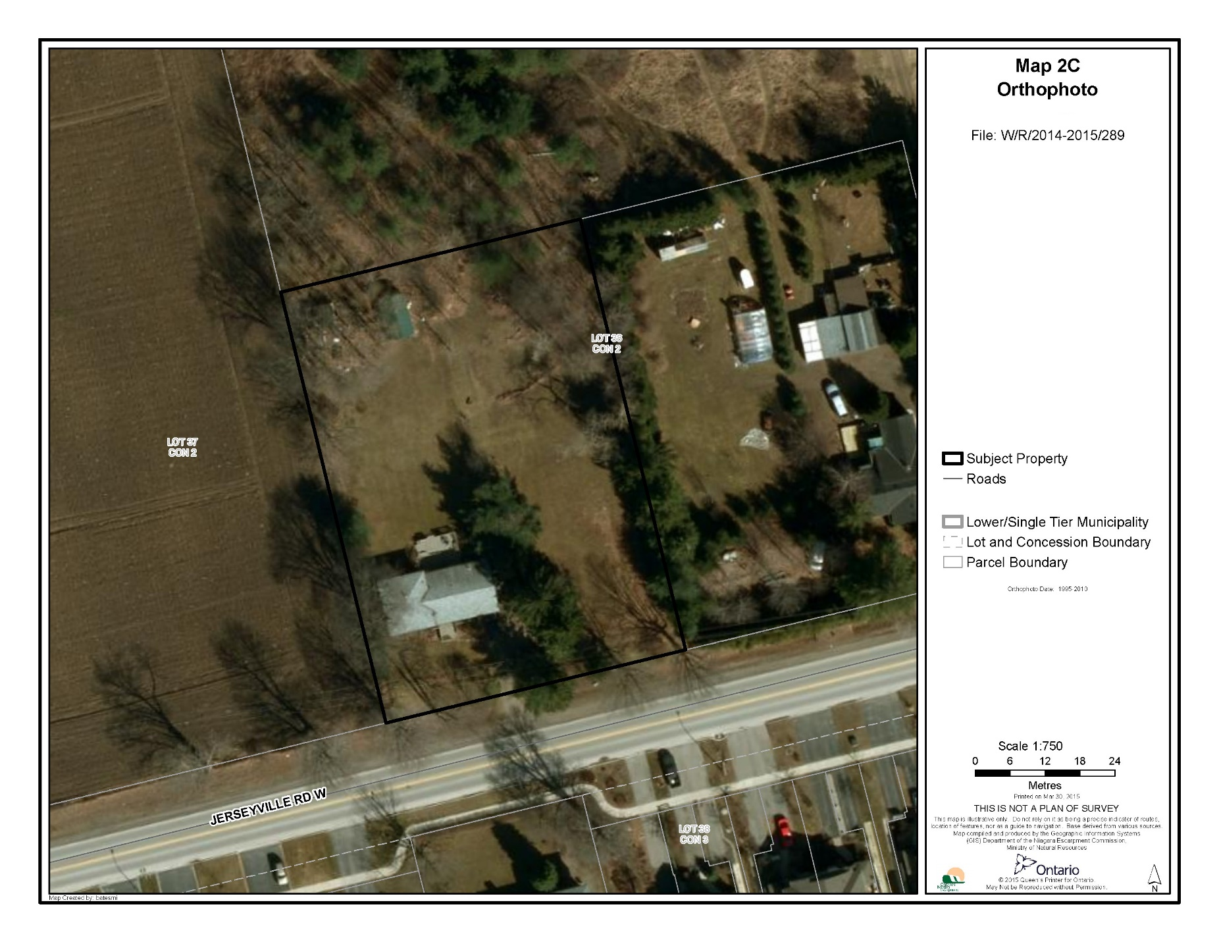

APPENDIX 2
