May 20, 2021

STAFF REPORT

DEVELOPMENT PERMIT APPLICATIONS:

N/A/2019-2020/317
Applicant: Ezra Institute of Contemporary Christianity c/o REDACTED
76 Ridge Road West
Part Lot 10, Concession 2
Town of Grimsby, Region of Niagara

SUMMARY

PROPOSAL:

To establish the following within existing buildings on a 9.5-hectare property supporting a newly established farming use (orchard):
- An administrative office for the proposed on-farm diversified use within the ±1,663.58 square metre single dwelling
- A four (4) bedroom bed & breakfast within the ±1,663.58 square metre single dwelling as part of the proposed on-farm diversified use
- An event space, as part of the proposed on-farm diversified use, for up to 100 people within the existing ±267.6 square metre accessory structure, retaining a portion of this structure to be used for the farming use
- An office space for the farming use in a ±23.8 square metre accessory structure
- A five (5) bedroom area for full and part-time farm labourers and volunteers who tend to the orchard and/or take part in the agri-tourism/educational component of the on-farm diversified use

A walking trail is also proposed throughout the site.

DESIGNATIONS:
Escarpment Protection Area and Escarpment Natural Area

ISSUE:
The newly established farming use (orchard) is not the primary use on the site and therefore the uses presented as on-farm diversified are not permitted. The combination of uses on the site includes uses that are not permitted or cannot be considered subordinate to a residential and/or farming use. The primary use on the site appears to be an institutional use, which is not permitted in prime agricultural areas.

RECOMMENDATION:
Refusal (Note: the proposal is not supported by the local and regional municipalities.)

REASONS:
The proposal conflicts with policies found within the Niagara Escarpment Plan and does not meet the intent of the Provincial Policy Statement.

RECEIVED:
July 16, 2019

SOURCE:
Ezra Institute for Contemporary Christianity (EICC; applicant) and REDACTED

BACKGROUND:

The applicant is a registered charity known as the Ezra Institute for Contemporary Christianity (EICC). It is described as a Christian thinktank. They produce research papers and hold educational seminars and conferences and fundraisers to support the charity; there are no weekly sermons. The ownership of the property is under the charitable organization.
The site was purchased by EICC in 2017. EICC submitted a prior application (N/P/2018-2019/134) to the NEC following the purchase of the property, which requested the conversion of the residential use on the site to an institutional use to support the charitable organization. However, this application was withdrawn as the applicant reassessed their plans for the site following comments from the Town of Grimsby, the Region of Niagara and NEC staff, which were generally not supportive of a conversion to institutional given the site designation of prime agricultural area (more specifically, speciality crop area).

The revised application now before the Commission no longer proposes the conversion of the site to an institutional use only. Given that the site permits farming, the applicant revised their approach and subsequently established an orchard, now fully planted, to allow for the permitted use of on-farm diversified uses (OFDU). There are still works required to fully operationalize the orchard including irrigation work, which will not be completed unless approval is granted by the Commission due to the cost associated with the system.

The charitable organization continues to operate on the site as intended in their 2018 application, which leads NEC staff to the opinion that EICC is primarily an institutional use. Staff considered whether EICC’s operations could be considered a home occupation, but if the primary use is institutional, it cannot be considered a home occupation because a home occupation must be an accessory use associated with a single dwelling, not a primary use. Therefore this report concludes the following:
- EICC, an institutional use, is the primary use and it is not permitted given that this is a prime agricultural area. Further, institutional uses are usually not permitted as an OFDU even if this site was not within a prime agricultural area
- There is a lack of clarity on the specifics of each activity on the site and a lack of justification for certain components, like the farm labourer quarters, which as proposed are not permitted. There is insufficient information about the agri-tourism component of the OFDU
- The size of the assembly spaces and the intensity of the bed and breakfast would need to consider additional building code provisions and would therefore require a separate review to consider traffic, sewage and other considerations associated with large gatherings and commercial operations
- The proposal does not meet the policies within the NEP and does not meet the intent of the PPS nor the provincial guidelines on permitted uses in prime agricultural areas.

PROPOSAL:

The applicant proposes alterations to the site by adding a farming use (orchard) and by repurposing portions of the single dwelling and the two accessory structures for uses not directly associated with the residential use (the site plan is attached as Appendix 1). Conversion of the space includes the following:
- An administrative/research office and room for seminars/gatherings (commons) for EICC
- A four (4) bedroom bed and breakfast with associated washroom facilities
- An event space for up to 100 people, anticipated to occur 2-3 times yearly, within the existing 267.6 m² accessory structure and the commons; smaller gatherings may take place for seminars with less than 30 people on a more frequent basis. Both events are associated with the EICC for fundraising and/or education
- A portion of the 267.6 m² accessory structure would be for the farming use
- An office in the 23.8 m² accessory building for the farming use
- Five (5) farm labourer beds for full and/or part-time help, associated with the farming use but which may also be used for volunteers who are part of the agri-tourism/educational component of the OFDU
- A walking path/trail is also proposed that runs through the Escarpment Protection Area and into the Escarpment Natural Area.
  - This is an existing granular roadway that was established by the previous owner. The road previously led to a pavillion on the site in the woodlot that is almost fully removed. EICC is intending to convert the road into a pathway with wood chips. The pathway runs partially along the Escarpment edge and then farther into the site in the woodlot.

The main farming use revenue source is intended to be the orchard consisting of seed and stone fruit trees. There is also a vegetable garden that will contribute. The applicant has considered an apiary, to support the orchard, and/or animals such as sheep and goats as another revenue source however this will only be full realized if there is a Commission approval of the application given the cost of establishing these additional components.

Prior to the purchase of the site by the EICC, the primary use of the site was residential. Permissions notwithstanding, the large dwelling on the site could potentially support the uses as proposed, with the exception of the large 100+ people conferences that would require traffic, parking, noise and sewage considerations. The proposed OFDUs are all to be managed within the existing buildings on the site (the dwelling and two accessory structures), with the exception of some components of agri-tourism (proposed generally as educating students on permaculture, ecology and farming practices through the farm and the woodlot on the site) and therefore no new structures are being proposed. The applicant has suggested any renovations needed to the buildings to support the uses will be interior renovations, which are exempt from requiring an NEC development permit if it is determined the proposed use is permitted.
A floorplan of the dwelling and accessory structures have been provided by the applicant (found in Appendix 2) to demonstrate the percentage dedicated to each of the proposed uses (as defined by the applicant). The floor plan for the uses within the dwelling and the accessory structures are divided into three categories: the residential use, farming use and OFDU.
Structure | Total  GFA (m²) | Residential use (m²) | Farm use (m²) | On-farm diversified uses (m²)
Dwelling | 1,663.58 | 1,231.38 (74%) | 251.41 (15.1%) | 180.79 (10.9%)
Accessory Structure | 267.6 | 0 | 70.17 (26.2%) | 197.42 (73.8%)
Accessory Structure (shed) | 23.8 | 0 | 23.78 (100%) | 0
Total  GFA (m²) | 1,954.98 | 1,231.38  (63%) | 345.36 (17.7%) | 378.21 (19.3%)

The residential use portion of the dwelling is proposed to include a bedroom suite, kitchen, laundry facility, living and dining, study, garage and sunroom on the main floor. On the upper level, the residential area is composed of seven (7) bedrooms, two bathrooms, a library and storage area. The total area of the residential use is 1,231.4 sq m.

The OFDU portion within the dwelling is proposed to include both EICC related space (office), a gathering area (commons) and the four (4) room bed and breakfast with two washrooms for a total of 180.8 sq m. Within the accessory structure, the OFDU share a common space which includes two washrooms and an open space for large gatherings and a dining area for a total of 197.4 sq m.

The area dedicated to farming within the dwelling is proposed to include five (5) bedrooms, washroom and change areas for full-time and/or part-time workers. The shed is solely dedicated to the farming use. A portion of the larger accessory structure is dedicated for equipment storage for the farming use. These farm-related uses total 345.5 sq m.
EICC intends to employee four (4) full-time staff working Monday through Friday from 9:00 am – 5:00 pm. Currently they operate on volunteers and part-time staff. Additional volunteer work is proposed to occur to support the farming operation and as a proposed educational component by providing an agri-tourism program and permaculture projects. EICC will be running the program. It is anticipated this will be a six (6) week per year program for students. These volunteers, students (and any full-time farm labourers) will be housed within the farm labourer quarters of the dwelling as shown in Appendix 2.
The four (4) bedroom bed and breakfast within the dwelling will operate as a spiritual retreat and for short-term stays for guests and guest speakers of EICC, pastors and EICC Fellows. It will also be a traditional bed and breakfast hosting stays not associated with EICC. The same spaces, beyond the bedrooms, dedicated to the bed and breakfast, will also be used for meals and symposia for all OFDU.
From the proposal, it is NEC staff’s opinion that the primary use on the site is an institutional use. EICC is a not-for-profit that runs on donations, fundraising (through seminars and conferences) and additional volunteer work beyond their full-time staff resources. This is the central operation on the site and the reason for the purchase of the site by EICC, which superceeds the farming use. The intention of OFDU policies is to provide additional economic opportunities for the farming community in prime agricultural areas. However, in this proposal, the farming use is presented as a benefit to the institutional use on the site; a way to raise funds and attract people (students and volunteers) to EICC.

SITE DESCRIPTION:
The subject site (the “site”) is a 9.5-hectare (“ha”) irregular-shaped lot, located on the north side of Ridge Road West adjacent the brow of the Escarpment. The southern half of the site and the portions immediately surrounding the dwelling are designated as Escarpment Protection Area and the northern portion of the site is designated Escarpment Natural Area by the 2017 Niagara Escarpment Plan (NEP). The site is fully captured in the NEP area and the Niagara Escarpment Commission’s (NEC) Area of Development Control.
The site is flat with the majority of it being an orchard (±3.6 ha), previously a manicured lawn and residential area (±2.8 ha), which includes a ±1,663.58 m² dwelling plus additional paved areas for the driveway and parking. About one third of the site is a woodlot. There are two accessory structures (267.6 m² and 23.8 m²), a walking trail and a tennis court. There is a pond on the site at the eastern boundary. To the north and east of the site is a woodland and a regionally-designated environmentally sensitive area associated with a Provincially-significant Life Science Area of Natural and Scientific Interest (ANSI). Forty Mile Creek runs through this area.
An approximate breakdown of the footprints of the various proposed and existing uses on the site, including outdoor amenity spaces, as proposed:
Use/structure | ~Area (ha)
Residential | 2.80 (29.5%)
Woodlot | 2.63 (27.7%)
Farm | 3.63 (38.2%)
Buildings | 0.22 (2.3%)
Proposed for OFDU space (includes walking trail, paved walkways/patios, tennis court and parking) | 0.22 (2.3%)
Total | 9.5

Surrounding the site are rural residential lots of varying sizes and larger agricultural properties.

PLANNING ANALYSIS:

Policy Interpretation
There are two parts to the policy analysis: understanding the primary use (considering the intensity of the use, the definitions and the permissions in the NEP) and assessing the proposed OFDU.

The proposed orchard meets the criteria for an agricultural use; this is not being questioned by NEC staff. Additionally, Ontario Ministry of Agriculture, Farming and Rural Affairs (OMAFRA) has established a minimum threshold of $7,000 of revenue to be considered a farm, which the applicant has reported they will meet next year if not this coming season. They will provide a farm registration number as soon as it is received.

On-farm Diversified Uses (OFDU)
The NEP and Provincial Policy Statement (PPS) both define an OFDU as “uses that are secondary to the principal agricultural use of the property and are limited in area. OFDUs include, but are not limited to, home occupations, home industries, agri-tourism uses, and uses that produce value-added agricultural products.” OMAFRA has also produced a document, Guidelines on Permitted Uses in Ontario’s Prime Agricultural Areas (“Guideline”), that similarly defines an OFDU (all five (5) of the criteria below must be met to qualify):

- Located on a farm
- Secondary to the principal agricultural use of the property
- Limited in area
- Includes, but is not limited to, home occupations, home industries, agri-tourism uses and uses that produce value-added agricultural products
- Shall be compatible with, and shall not hinder, surrounding agricultural operations

Although a broad range of uses could be included under the definition of an OFDU, the underlying policy intent, as made clear through provincial policy, is to provide the farming community with the services and income-generating opportunities to ensure the on-going viability of agricultural uses. The Guideline states that institutional uses are not typically permitted as OFDUs (see page 23 of the Guideline).

OFDUs are permitted uses in Escarpment Protection Areas within prime agricultural areas but not within Escarpment Natural Areas unless the use qualifies as an existing use. In this instance, there are no existing uses on the site (as defined in the NEP) therefore any permitted OFDU must be contained to the Escarpment Protection Area.

It is also important to note at the outset that NEC staff have been consistent in their interpretation of the policy in previous reports presented to the Commission on large event venues (i.e., wedding venues or conferences, as proposed in the application in question): large event venues do not qualify as OFDUs and are generally incompatible with rural land uses outside of settlement areas. Considering the cumulative impacts these event venues could have and the opportunity for the potential commercialization of the NEP area, it would not be consistent with the General Development Criteria (2.2) of the NEP. OMAFRA’s guidelines also suggest that these “large-scale” event venues should be directed away from prime agricultural areas to other rural lands, settlement areas, community centres or other more appropriate areas. Therefore, the conferences and proposed large gatherings in this application do not meet the objectives of the Escarpment Protection Area nor the General Development Criteria. NEC staff have had a discussion with the applicant, and they are willing to remove this component of their application as they have the ability to hold these events elsewhere.

Guidelines on Permitted Uses in Ontario’s Prime Agricultural Areas
Although staff does not believe that the intention of provincial policy is to allow institutional uses as OFDUs, staff has examined the OFDU criteria to determine if there is general alignment between the proposed institutional use and OFDU in general. Of the five (5) criteria listed above, the proposed OFDU meet criteria 1, 4 and 5. Criteria 2 (criterion to be secondary to the agricultural use) and 3 (limited in area) should be reviewed together given evaluating the use as a secondary use must consider the spatial aspect.
This analysis of spatial impact is challenging because this proposal adds agricultural land so that the institutional use can be classified as an OFDU; it is usually more of a concern when a large amount of land is being taken out of production to permit an OFDU. However, the criterion that OFDU not occupy more than 2% of the site area and no more than 20% of the gross floor area of the buildings is exceeded, as follows:
The total size of the lot is 9.5 ha and the total size of all the structures is a GFA of 1,954.98 m². The proposed OFDU account for 378.21 m² of indoor space and an additional 0.22 ha of outdoor space totalling 0.26 ha. The proposed OFDU account 2.7% of the site area and 19.3% of the total GFA within the buildings.
While three of the five criteria may appear to be met, the intention of the “limited in area” criterion, which, among other things, was intended to “achieve the balance between farmland protection required by the PPS and economic opportunities for farmers” (Guideline, p. 19) was not the purpose of this application. Considering the NEC application that preceded the one in question, as noted above, it can be surmised that the farming use (orchard) was established to develop an opportunity for OFDU and in particular to permit EICC to theoretically meet the policies of the NEP, which make it difficult for NEC staff to interpret the farming use as the primary use.

NEP

Part 1 – Land Use Designations:
The site is located in both the Escarpment Protection Area and the Escarpment Natural Area. The dwelling, accessory structures and the orchard are found within the Escarpment Protection Area. The wooded area, which is proposed to support agri-tourism (partial components of the education related to ecology) and a walking path as part of the OFDU is located within the Escarpment Natural Area.
Part 1.3.1 and 1.4.1 of the NEP provide the objectives of the Escarpment Natural Area and Escarpment Protection Area land use designations respectively. Notwithstanding the proposed conference gatherings, NEC staff are of the opinion that the proposed alterations to the site do not conflict with the applicable objectives of the Escarpment Natural Area and Escarpment Protection Area designation as the proposed development will re-establish farming, does not encroach into sensitive ecological features and will not have an impact on the scenic resources and open landscape character of the Escarpment given that it will use the existing buildings on site. However, the intensity of the proposed activities, some of which are not well defined, may not be consistent with Objective 3, which requires the protection and enhancement of the natural heritage system especially being adjacent to an ANSI.
Whether the objectives of the designations are met is questionable, the proposal is not fully in line with the permitted uses and the General Development Criteria in the NEP. Before analysing the development criteria, the permitted uses and definitions are provided below.
Part 1.4.3 of the NEP lists agricultural uses, on-farm diversified uses (in prime agricultural areas), institutional uses (outside prime agricultural areas), and bed and breakfast as being permitted within the Escarpment Protection Area, subject to meeting the applicable Development Criteria policies in Part 2 of the NEP.
The NEP defines bed and breakfast uses as:
Sleeping accommodation (including breakfast and other meals, services, facilities and amenities for the exclusive use of guests) for the travelling or vacationing public within an existing single dwelling that is the principal residence of the proprietor. A bed and breakfast in an existing single dwelling of local heritage value or interest must retain the features that cause it to be designated of local heritage value or interest
The NEP defines agricultural uses as:
The growing of crops, including nursery, biomass, and horticultural crops;
raising of livestock; raising of other animals for food, fur or fibre, including poultry and fish; aquaculture; apiaries; agro-forestry; maple syrup production; and associated on-farm buildings and structures, including, but not limited to livestock facilities, manure storages, value retaining facilities, and accommodation for full-time farm labour when the size and nature of the operation requires additional employment.
The NEP defines on-farm diversified use as:
Use that is secondary to the principal agricultural use of the property
and is limited in area. On-farm diversified uses include, but are not limited to, home occupations, home industries, agri-tourism uses, and uses that produce value-added agricultural products
The NEP defines institutional use as:
Use of land, building or structure for some public or social purpose that may
include governmental, religious, educational, charitable, philanthropic, hospital or other similar use, including cemeteries, to serve the immediate community
Agricultural uses and on-farm diversified uses are permitted in this case. However, agri-tourism uses are not permitted in Escarpment Natural Area, and institutional uses are not permitted in prime agricultural areas. Moreover, the accommodation of farm labour is permitted only when the size and nature of the operation requires the additional employment, which has not been demonstrated in this application. Since some of the uses are not permitted, the Development Criteria in Part 2 are not a consideration since they only apply to uses that are permitted in Part 1. Therefore, any institutional use and agri-tourism use (in Escarpment Natural Area) will not be assessed against Part 2 policies.

Part 2.2 General Development Criteria

The objective of Part 2.2 of the NEP is “to permit reasonable enjoyment by the owners of all lots that can sustain development.” This objective and the policies of 2.2 that will be assessed below, will only consider the permitted use, which is a bed and breakfast. The intensity of the use is a component in assessing whether the site can sustain the development and whether it is appropriate for the site. If the use becomes larger than the intent permitted in the policies, a bed and breakfast use can be considered a commercial use, and therefore a business not intended to operate within a single dwelling. Such a development would require additional public safety measures for construction and other planning considerations (e.g., parking, traffic, fire exits).

Part 2.2.1 further expands on the objective by requiring the protection, restoration and, where possible, enhancement of the Escarpment environment, which provides parameters for “lots that can sustain development” A site that can sustain development must consider the Escarpment environment as well as the impact of single, multiple or successive development. The cumulative impact of so many proposed uses on this site is a concern, based on its proximity to sensitive Escarpment features.

The bed and breakfast use is generally understood to be limited to three-bedrooms to be in keeping with a home-based business that is subordinate to the primary residential and agricultural use on the property. This limitation is also generally accepted because it is a public safety issue. Larger operations are required to meet additional measures found in the Ontario Building Code and Ontario Fire Code. These codes speak to additional fire separation and egress and ingress measures, among other requirements. Although these are not policies in the NEP, other legislation and/or regulation should be considered if it is known that a proposed development is unlikely to achieve other regulatory requirements.
Part 2.1 of the NEP also sets out that the development criteria in Part 2 are minimum standards, meaning that municipalities can have more restrictive policies. As stated in the Town of Grimsby’s comments, the proposed bed and breakfast exceeds their allowance of three bedrooms. Based on the proposal for a four-bedroom bed and breakfast, the analysis presented, NEC staff are not satisfied that Part 2.2 of the NEP is met.

Bed and breakfast uses will be further contemplated below as an OFDU under Part 2.8 of the NEP.

Part 2.8 – Agriculture

The objective of Part 2.8 is stated as:

To encourage agricultural uses in agricultural areas, especially in prime agricultural areas, to permit uses that are compatible with farming and to encourage accessory uses that directly support continued agricultural uses
A farming use is being added to prime agricultural areas therefore the objective of 2.8 is generally met.
Part 2.8.5 specifies policies related to dwelling units accessory to agricultural areas, which relates to the proposed five (5) bedrooms and washroom facilities planned in the single dwelling for farm labour. This policy permits temporary dwelling units that shall be mobile or portable or may be located within a farm building or structure, which, in this case they are (i.e., the dwelling associated with the farm). Given the scale of the farming operation (newly planted orchard), there is no evidence that farm help is required at this stage. These units are also intended to support volunteers, agri-tourism farmers and others on EICC courses for up to 6 weeks per year; they are not solely dedicated to full-time or seasonal farm labour. The Town of Grimsby also expresses the concern that the scale of the farming operation does not require the level of support proposed.
Part 2.8.7 specifies OFDU policies. There are several criteria for OFDUs that the proposed development does not meet, as follows:
2.8.7(b) the use is secondary to the principal agricultural uses of the farm;
Staff maintains that the principle use is an institutional use, which is not permitted in a prime agricultural area. The OMAFRA Guidelines are not supportive of institutional uses as OFDUs.
2.8.7(d) the use is appropriate to available rural services and infrastructure;
The applicant is proposing multiple uses on a site that previously supported only a residential use. Technical studies, including a traffic impact study, hydrogeological study, as well as additional development that may be required to meet the Fire Code, etc.
The bed and breakfast component of the proposal, if it were re-scoped to be limited to three bedrooms, could likely be supported as an OFDU given the limited agricultural use on the property. Likewise, a better-defined agri-tourism business that provides training and education on permaculture or other agriculture would likely also be supportable. But the proposed use for conferences, events, and accommodations associated with the institutional use are not consistent with the OFDU criteria and appear to overtake agriculture as the principle use on the property. Based on the analysis presented above, NEC staff are not satisfied that the proposal meets Part 2.8 (Agriculture).

Provincial Policy Statement 2020 (PPS):

The site is located on prime agricultural land, which makes applicable some of the “rural areas” policies (1.1.4) in the PPS. The proposal satisfies 1.1.4.1 by promoting diversification of the economic base and employment opportunities (f), by providing opportunities for sustainable and diversified tourism (g) through the agri-tourism component and by providing opportunities for economic activity on prime agricultural areas (i), however, the OFDU proposed, specifically the charitable organization, does not build upon the rural character (1.1.4.1(a)). Part 2.3 requires compatibility (2.3.3.1) of any OFDU on prime agricultural areas and that all types and sizes of agricultural uses are promoted (2.3.3.2). NEC staff have considered the fact that the orchard is small and just being established. However, the institutional components of EICC suggest an intensity of use that is not in keeping with the character of the surrounding rural residential and farming uses.

Considering the above, NEC staff are not satisfied that the proposed development is consistent with Sections 1.1.4 and 2.3 of the PPS.

AGENCY CONSULTATIONS:

Within the Town of Grimsby’s Official Plan (2019 Consolidation), the subject property is designated as ‘Escarpment Protection Area’ and ‘Escarpment Natural Area’ on Schedule A –Land Use. Within Schedule A – Municipal Structure – the area is designated both Countryside and Natural Heritage System and would likely be zoned Specialty Crop (SC) had zoning been applicable.

Within the Region of Niagara’s Official Plan (2014 Consolidation), the property is designated as ‘Unique Agricultural Area’ on Schedule B – Agricultural Land Base.

Both Town and Regional staff were of the same opinion: the proposed development does not qualify for OFDU given that the primary use cannot be justified to be the farming use. Further, they suggested that the maximum number of beds within a bed and breakfast is three, they expressed that justification was not provided for the requirement for five beds for farm labour and ultimately that this application is still an attempt to permit an institutional use within a prime agricultural area, which is not a permitted use.

The Region also noted that the site contain portions of the Regional Core Natural Heritage System and an Environmental Protection Area (EPA) associated with the Provincial Section Escarpment Area of Natural and Scientific Interest (ANSI) as well as Environmental Conservation Areas (ECA) associate with Significant Woodlands and Significant Valleylands. Therefore, an environment impact statement (EIS) could be required to support development adjacent to the ECA, particularly the proposed walking trail, and further that no development or site alteration is permitted within the ANSI.

RECOMMENDATION:
As currently proposed, notwithstanding the large conference aspect of the proposal, the bed and breakfast (at three rooms) and agri-tourism (outside Escarpment Natural Area) aspects of the development could be consistent with the objectives of the NEP and the land use designation. However, not all the proposed uses are permitted uses within an Escarpment Protection Area designation found within a prime agricultural area. EICC is proposing four full-time staff and is a charitable organization that depends on volunteers, seminars and other fundraising initiatives and is therefore an institutional use, not an OFDU. Given the proposed activities and intentions of EICC, it is NEC staff’s opinion that the use is an institutional use. Moreover, the intent of the PPS and OFDU Guideline are not met: this proposal presented as a farming use established to legally permit an institutional operation as an OFDU. OFDU are an opportunity to diversify the rural economy and protect farming as the primary land use in prime agricultural areas.
The proposed development is not supported by the Town of Grimsby nor the Region of Niagara, and conflicts with the permitted uses and Part 2.2 and 2.8 of the NEP. Additionally, the proposal does not meet part 1.1.4.1 and 2.3 of the PPS nor the intent of the Guidelines of OFDU in prime agricultural areas.
The Development Permit Application should therefore be refused.

Prepared by:
______________________
Johnpaul Loiacono
Planner

Approved by:

______________________
Kim Peters, MCIP, RPP
Manager (A)

Appendix 1 – Site plan
Appendix 2 – Floor plans

Appendix 1
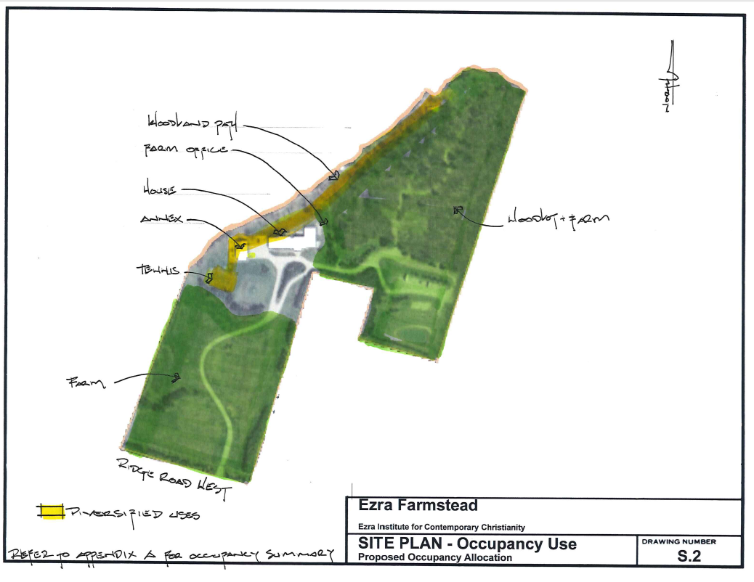Site plan
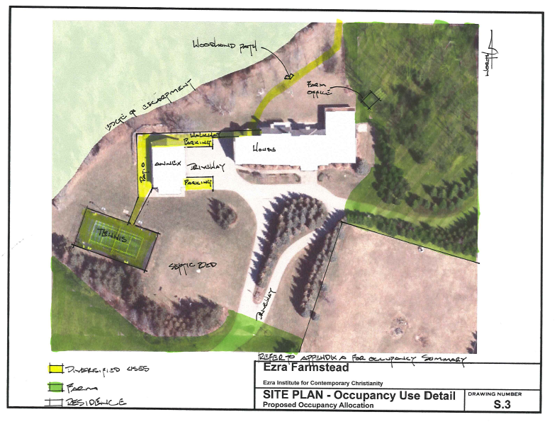

APPENDIX 2

First and second floor plans of the dwelling and floor plans of the two accessory structures
