May 20, 2021

STAFF REPORT

Re: Lost Forest Park
4449 Milburough Line
Part Lot 24, Concession 2 North of Dundas Street (Nelson)
City of Burlington, Region of Halton
______________________________________________________________________

PURPOSE

The purpose of this report is to determine if a property known as Lost Forest Park (see Map 1) is operating in compliance with the Niagara Escarpment Plan (NEP) and the Niagara Escarpment Planning and Development Act (NEPDA).

There are several considerations that must be taken into account, including NEP Amendment No. 8, the Development Permit history of the property, the City of Burlington’s licensing of the property, the definition of “campground” in the NEP and the Development Permit exemption regulation (Ontario Regulation 828/90). Staff’s main concern is that the NEP’s limited permissions regarding seasonal campgrounds and trailers have been exceeded in Lost Forest Park, where camping trailers have been replaced with park model trailers and manufactured homes over the past decade.

This policy interpretation is necessitated by the landowner’s desire to sell the property and enter retirement. Potential purchasers have requested confirmation that the property is in compliance with the NEP; however, due to complexity of the situation, NEC staff feels that it is necessary to bring the issue before the Commission.

SUMMARY RECOMMENDATION

A restoration order is required to remove the unauthorized manufactured homes from the campground and bring the property into compliance with the NEP.

PROPERTY DESCRIPTION

Lost Forest Park is located in the rural area of the City of Burlington. The campground is accessed from Milburough Line, which forms the boundary between the Cities of Burlington and Hamilton. The property is designated as Escarpment Natural, Protection, and Rural Area under the NEP (see Map 1). The campsites are limited to the Escarpment Protection and Rural Area designations. The wooded areas on the property are considered environmentally sensitive and are part of the Medad Valley Provincially Significant Area of Natural and Scientific Interest (ANSI). A portion of the property is within the Medad Valley Provincially Significant Wetland Complex, which is suitable habitat for several species at risk, including Jefferson salamander (Endangered) and snapping turtle (Special Concern). The campsites and campground amenities are located outside of the environmentally sensitive area. In 2017, the current landowner contributed to the enhancement of the wooded area by voluntarily relocating 78 campsites. The property sits at the brow of the Escarpment. Map 2 illustrates the natural heritage features on site.

The campground now contains 150 campsites (Maps 3 and 4), all of which are serviced and support a combination of manufactured (“mobile”) homes and park model trailers. The campground’s private sewage system was approved by the Ministry of Environment, Conservation and Parks through an Environmental Compliance Approval.

NEC APPROVAL HISTORY

Establishment of the Campground
The establishment of the campground dates to 1974 when the property was under different ownership. Based on the Development Permit (DP) history, the NEC recognized the 63 campsites that existed at that time through DP H/L/C/75/34. Fifty of the 63 campsites were serviced. These 63 campsites have always been recognized and were included in all future approvals. Throughout the 1970s and 1980s, there were multiple contraventions of the NEPDA on the property as a result of unauthorized development undertaken by the previous owner. In 1986, a NEP Amendment application was submitted to expand the campground and permit additional serviced campsites in the Escarpment Protection Area designation. An Amendment was required because the NEP did not permit serviced campsites in Escarpment Protection Area.

NEP Amendment No. 8
The Minister of Municipal Affairs partially approved the Amendment in 1988.The approval did permit some expansion of serviced campsites into Escarpment Protection Area, but the approval was more limited than what the previous landowner had proposed. As a result of the Amendment, the campground is now a permitted use in the NEP (see Part 1.4.3.21). The Amendment did not specify a maximum number of campsites; however, the City of Burlington’s Official Plan Amendment (OPA) 130, which was processed concurrently with the NEP Amendment, allowed for a maximum of 150 campsites, and allowed for the campground to operate between April 1 and November 30 (eight months) each year. Similarly, the definition of “campground” in the NEP prohibits permanent year-round use. Further, “campground” is of limited type of development (“a range of overnight camping experiences, from tenting to trailer sites… but not including the use of mobile homes or trailers on a permanent year-round basis).

Development Permits: 1990 to 2012
DP #4316/H/L/1989-1990/39 was issued in June 1990 to undertake the campground expansion in accordance with OPA 130 and NEP Amendment No. 8. Since then, there were four additional permits for campground-related development issued between 1990 and 2012. Several of these permits expired prior to any development being undertaken. Of the permits that were issued, the conditions were clear that the campground was to operate in accordance with NEP Amendment No. 8 and OPA 130 (i.e., open from April 1 to November 30 of each year). Campsites were not to be used on a full-time, year-round basis.

2012 Operating Season Extension
In 2012, NEC staff was approached by the City of Burlington to determine if the NEC had any objections to the City amending its business licensing by-law so that campgrounds (specifically Lost Forest Park) could extend its operations from eight to ten months, from March 7th to January 7th. Staff communicated that they had no concerns about the extended operating season.

Development Permit #11141/H/L/2015-2016/155
A permit was issued in January 2017 to relocate 78 existing seasonal campsites, extend water and sewage servicing, and construct new internal roads within the campground. The proposed development was viewed positively by NEC staff since the 78 campsites were being removed from an environmentally-sensitive area and there was no proposal to increase the number of sites established on the property (150). A condition of this DP was that “the campground/trailer sites shall not be used on a permanent, year-round basis.”

Development Permit Application H/L/2018-2019/91
This DP application was submitted to the NEC in May 2018 to permit the occupancy of up to 150 trailers/trailer sites for a maximum time period of 11 months per year. NEC staff was not supportive of an additional extension to the camping season. The application was withdrawn.

Compliance Issues 2019-2020
In 2019, a member of the public contacted the NEC upon discovering that a manufactured home within Lost Forest Park was listed for sale on the realtor.ca website. The complainant was concerned there was no mention in the listing that the campground was limited to seasonal recreational use. A second complaint was received by the NEC in 2020, noting that “large prefabricated homes” were being delivered to Lost Forest Park.

In October 2019, the NEC was requested to provide a “compliance report” indicating that development on the property was consistent with the NEP and NEPDA. NEC staff prepared a letter that stated the following concerns:

The Niagara Escarpment Commission has concerns regarding development activities on this recreational property that may not be in compliance with the Development Permits, particularly in regard to the duration of site occupancy (the current allowable seasonal occupancy for all campground/trailer sites is a maximum of ten months) and the extent of development occurring on some or all of the approved seasonal trailer sites (e.g., pre-fabricated dwellings, additional structures, formal driveway construction, concrete pads, etc.).
NEC staff are concerned that the use and development on the property is not in compliance with the requirements of the Niagara Escarpment Planning and Development Act. Also, be advised that no other approval (including any approval from the City of Burlington) can be issued unless there is a valid Development Permit from the NEC.
The foregoing has not been verified and would require site inspections by NEC compliance staff. However, any purchaser of the property should be informed by the current landowner of the NEC’s concerns and the terms/limitations associated with all Niagara Escarpment Development Permits for this property, including seasonal occupancy.

Following the issuance of this letter, the property owner contacted the NEC, disagreeing with some of the statements in the compliance report. The property owners have expressed that they believe they have complied with all DP conditions and City of Burlington licensing requirements. The landowners are requesting a new letter stating that the property is in compliance with the NEP/NEPDA. After reviewing the file history and considering the types of structures that have been added to the campground, staff is of the view that it cannot support the issuance of such a letter.

CITY OF BURLINGTON & REGION OF HALTON APPROVALS

As noted above, the City of Burlington approved OPA 130 in the late 1980s, permitting the operation of a seasonal campground with a maximum of 150 campsites. The current Burlington Official Plan defines a campground as “an area used for a range of overnight camping experiences, from tenting to trailer sites, including accessory facilities such as administration offices, laundry facilities, washrooms to support the use, but not including the use of mobile homes, trailers or other forms of moveable shelter on a permanent year-round basis.” This is identical to the NEP definition.

Until 2018, Lost Forest Park was required to hold a business licence issued by the City of Burlington. By-law 42-2008 required the licensing of tourist/trailer camps, and identified that camping vehicles were to be used as temporary accommodations at such a camp. The definition of camping vehicle included travel trailers, slide-in campers, chassis-mounted campers, tent trailers, and motorized homes. This by-law also limited the operation of a tourist/trailer camp from April 1 to November 30 in any given year. Camper vehicles could be stored on-site from December until the end of March, but the camper vehicles were not to be occupied during that time.

In 2012, the Business Licensing By-law was amended (by By-law 104-2012) to change the permitted dates of operation from April to November, to March 7 to January 7 the following year. This new extended season was to apply to “park model trailers” only. When this change to the by-law was under consideration, NEC staff was approached by City staff to determine if the NEC had any concerns about the extended season. Correspondence indicates that the NEC planner assigned to the file did not have any concerns about the extended season.

In 2016, the Business Licensing By-law was amended again (by By-law 30-2016) to include a definition for “park model trailer.” The by-law’s definition of a park model trailer is, “a manufactured building designed and used or intended to be used as temporary seasonal recreational building of residential occupancy.” Park model trailers were added to the list of permitted camping vehicles in the by-law.

In 2018, the Business Licensing By-law was again amended (by By-law 60-2018) by deleting any reference to campsites, camping vehicles, and tourist/trailer camps, the effect being that tourist/trailer camps were no longer required to obtain a business licence.

Earlier this year, City of Burlington staff confirmed that building permits were issued in 2020 to recognize both the park model trailers and manufactured homes established at Lost Forest Park. It was also determined that Development Charges were owed to the Region of Halton for both park model trailers and manufactured homes, which the landowner has paid.

POLICY INTERPRETATION ISSUES

NEP Definitions

In the NEP, a campground is defined as follows:

An area used for a range of overnight camping experiences, from tenting to serviced trailer sites, including accessory facilities, such as administration offices, laundry facilities, washrooms to support the use, but not including the use of mobile homes or trailers on a permanent, year-round basis.
The NEP does not contain a definition of trailer or mobile home. However, since both are listed separately, the assumption can be made that they are not the same. In the definition, the range of overnight camping experiences, from “tenting to serviced trailer sites,” does not include mobile homes.

Development Permit Exemptions: O. Reg. 828/90
As of 2013, the NEC does not require DPs for “the establishment, placement or removal of a portable recreational trailer or vehicle on an existing site within a seasonal campground or trailer park.” This exemption is found in Section 5.33.1 of O. Reg. 828/90. This Regulation also defines “seasonal” as operating for six months or less in a calendar year. Prior to 2013, O. Reg. 828/90 did not contain any specific exemptions regarding campgrounds or trailer parks; however, it was unlikely that staff would have required a DP to replace a trailer on a campsite, given that the use of the campsite itself was not changing. However, the expansion, intensification or permanent occupancy of a campground does change the nature of the campground use and would therefore require a DP from the NEC. The regulation is also clear that is applies to “portable recreational trailers or vehicles” and not manufactured homes.

Park Model Trailers and Mobile Homes
As noted, there are no definitions for a “trailer” or “portable recreation trailer”, or “mobile home” in the NEP or O. Reg. 828/90. However, the Ontario Building Code (OBC) does provide some guidance on the differences between these structures.

In the OBC (O. Reg. 332/12), there are different provisions for manufactured homes and park model trailers. The use of “mobile home” in the OBC was discontinued in 2009 and was replaced by the term “manufactured home.” The OBC policies on these structures are based on standards provided by the Canadian Standards Association (CSA):

- CSA Standard CAN/CSA-Z241 defines a park model trailer as:
a recreational unit that meets the following criteria:
- it is built on a single chassis mounted on wheels;
- it is designed to facilitate relocation from time to time;
- it is designed as a living quarters for seasonal camping and may be connected to those utilities necessary for operation of installed fixtures and appliances;
- it has a gross floor area, not exceeding 50m2 when in the set-up mode, and has a width greater than 2.6m in the transit mode.

- CSA standard Z240 MH Series-16. In this standard, a manufactured home is defined as:
a single- or multiple-section, one-storey dwelling that
- is designed and constructed for year-round occupancy;
- is designed to be transported to its installation site; and
- is ready for occupancy when it is installed in accordance with the manufacturer’s installation instructions.

Based on these definitions, it is staff’s interpretation that a park model trailer could be permitted use within a seasonal, serviced campground, but not a manufactured home. Park model trailers are considered “trailers,” which is consistent with the range of camping experiences permitted by the NEP, whereas a manufactured home, since it is designed and constructed for year-round occupancy, is not consistent with the range of experiences permitted in a NEP Area campground.

Year-round Occupancy v. Seasonal Occupancy
As noted, Lost Forest Park, in conjunction with NEP Amendment No. 8, was approved as an eight-month (April 1 to November 30) seasonal campground. In 2012, NEC staff informally supported the extension of the camping season from eight to ten months, from March 7 one year to January 7 the next. The NEC has no record of explicitly accepting any change to these parameters after this informal approval was granted in 2012.

When DP #11141/H/L/2015-2016/155 (described above) was issued in 2017, a condition of this DP was that “the campground/trailer sites shall not be used on a permanent, year-round basis.” NEC staff has confirmed that it was not the intention of the planner, in crafting this condition, to change the previous authorization that allowed for a ten-month operating season.

The City of Burlington’s deletion of campgrounds from its business licensing by-law in 2018 probably caused further confusion as to the approved operating season, since it was no longer part of an issued business licence. However, conditions contained within a NEC DP would still apply.

Validity of Permits
A concern associated with the building permits issued by the City of Burlington in 2020 is that it is unclear if one or more NEC DPs were first required to recognize the replacement of conventional travel trailers with park model trailers and manufactured homes.

Based on the parameters by type set out in O. Reg. 828/90, the replacement of a trailer with a manufactured home is not exempt from the DP requirement set out in the NEPDA. Furthermore, the camping season at Lost Forest Park exceeds the six months or less set out in the Regulation. Therefore, NEC staff finds that each travel trailer that was replaced with a manufactured home should have been subject, at minimum, to a DP application. Therefore, it is staff’s opinion that Lost Forest Park has undertaken development without a valid DP, which is a contravention of Section 24(1) of the NEPDA. In addition, building permits should not have been issued by the City of Burlington in the absence of a valid NEC DP (i.e., the City’s building permits were premature, contrary to s. 24(3) of the NEPDA).

Despite this compliance issue, NEC staff has not issued a ticket to the landowner, nor is prosecution being considered at this time. The complexity of the regulatory requirements and the apparent lack of coordination between the NEC and the municipality have made it difficult for the landowner to navigate the required approvals.

NEXT STEPS: RESTORATION/APPROVAL OPTIONS

In the absence of a DP that would address the manufactured homes or their prolonged use, staff has considered the following options to work with the landowner to bring Lost Forest Park back into compliance:

Option 1: Restoration Order

Staff is proposing a restoration order issued under Section 24(6) of the NEPDA, the result of which would be the removal of the unauthorized manufactured homes from the campground. In fairness to the landowner and occupants, NEC staff will recommend a generous timeframe for this to occur. Staff recognizes that some of the current occupants have chosen to live there for affordability reasons, and may have health or other concerns that would make vacating their homes difficult without sufficient lead time.

The details of the restoration order will need to be worked out through additional consultation with the landowner to ensure that the order is reasonable. Staff anticipates that the order will address the following:

- A generous but specified timeframe for the landowner to see to the removal of all unauthorized manufactured homes (e.g., five years);

- Immediate notification of the occupants that a restoration order has been served on the current owner, including clear explanation of the timeframe for removing manufactured homes from the campground;

- Provision of a detailed inventory and site plan specifying the number and location of manufactured homes that will be subject to removal;

- Clarification of the need for future DPs and possibly NEP Amendment if the replacement of any of the identified manufactured homes with an authorized structure cannot meet the exemption criteria set out in O. Reg. 828/90;

- Annual compliance inspections to be undertaken by NEC staff, to ensure the conditions of the restoration order and any subsequent DPs are adhered to.

This is the option recommended by staff. Since the owner intends to sell the property, failure to disclose the restoration order to a potential purchaser would amount to a fraudulent conveyance. Therefore, by way of the sale process it is understood that any potential purchaser would be made aware of these constraints on the property. A restoration order can also be prepared relatively quickly compared to other options.

The required removal of manufactured homes (intended for year-round occupancy) from a seasonal campground also sends a strong message that the NEC does not support the intensification of campground uses in the NEP Area, which should serve as a significant deterrent to others. Conversely, failing to address the situation at Lost Forest Park may lead other similar facilities to follow their lead.

Option 2: Development Permit Application
For the reasons outlined above, staff finds that the introduction of manufactured homes has exceeded what can be considered a campground according to the NEC definition. For this reason, staff would recommend refusal of a DP if it were submitted as a means of recognizing as-built development. Manufactured homes and year-round residential occupancy are not permitted in campgrounds in the NEP Area.

The Commission is also bound to uphold the NEP in accordance with the NEPDA: Section 25(4) states that, “Where the Minister has delegated his or her authority… the delegate… may make a decision in accordance with the Niagara Escarpment Plan to issue the development permit or refuse to issue the permit…” In other words, the Minister has not delegated authority to the Commission (the “delegate”) to make a decision (e.g., issue a DP) that is NOT in accordance with the NEP.

Option 3: NEP Amendment and DP Application
Given that a refusal of a DP is likely, an application for a NEP Amendment might be seen as a possibility. This option would allow the landowner to pursue authorization of all existing development as-is. However, the NEPDA states that “urban uses” can only be considered at the time of a NEP review (i.e., every ten years). Staff would consider the acceptance of manufactured homes designed for year-round occupancy to be an urban use. In staff’s opinion, it would cease to be a campground and would become a permanent residential development, i.e., an “urbanized” trailer park.

Staff also finds that approval of manufactured dwellings is not consistent with the Purpose and Objectives of the NEP. Even if not determined to be an “urban use,” staff cannot support this option and anticipates recommending refusal of the proposed Amendment. In terms of precedence and cumulative impacts of development, it is problematic in that it sends a message that a proponent only needs to obtain a NEP Amendment to approve unauthorized development, without penalty. This is clearly not in the public interest. A NEP Amendment may also trigger municipal official plan amendments, which could be costly to the applicant. The time required to process an Amendment is lengthy and would require public consultation.

CONCLUSION:
Staff recognizes that the regulatory requirements set by the municipality and the NEC have been difficult to navigate, which is why staff is recommending that the Commission endorse Option 1: a restoration order, and is not recommending enforcement action at this time. The landowner has made efforts over the years to improve Lost Forest Park by upgrading servicing and enhancing the environmentally-sensitive areas on the property. However, the NEC was never approached by the landowner for permission to establish manufactured homes on the property, and some of the units have been marketed as “single family” homes, and not seasonal campground lodging.

To protect the Escarpment’s natural environment and maintain a level of development that is consistent with the objectives of the NEP, it is important that the Commission send a strong message that campgrounds are intended for recreational, seasonal use, and are not intended to become permanent residential developments.

RECOMMENDATION:

That the Commission direct NEC staff to return with a restoration order for Commission consideration, containing the following provisions:

- A generous but specified timeframe for the landowner to see to the removal of all unauthorized manufactured homes (e.g., five years);

- Immediate notification of the occupants that a restoration order has been served on the current owner, including clear explanation of the timeframe for removing manufactured homes from the campground;

- Provision of a detailed inventory and site plan specifying the number and location of manufactured homes that will be subject to removal;

- Clarification of the need for future DPs and possibly NEP Amendment if the replacement of any of the identified manufactured homes with an authorized structure cannot meet the exemption criteria set out in O. Reg. 828/90; and

- Annual compliance inspections to be undertaken by NEC staff, to ensure the conditions of the restoration order and any subsequent DPs are adhered to.

Prepared by: Approved by:

Original signed by: Original signed by:
_____________________ ____________________
Kim Peters, MCIP, RPP Debbie Ramsay, MCIP, RPP
Acting Manager Acting Director

Attachments:

Map 1: Lost Forest Park, Location and Land Use Designations
Map 2: Lost Forest Park, Natural Heritage Features
Map 3: Lost Forest Park, Site Plan (2017)
Map 4: Orthophoto (Google Earth, 2018)

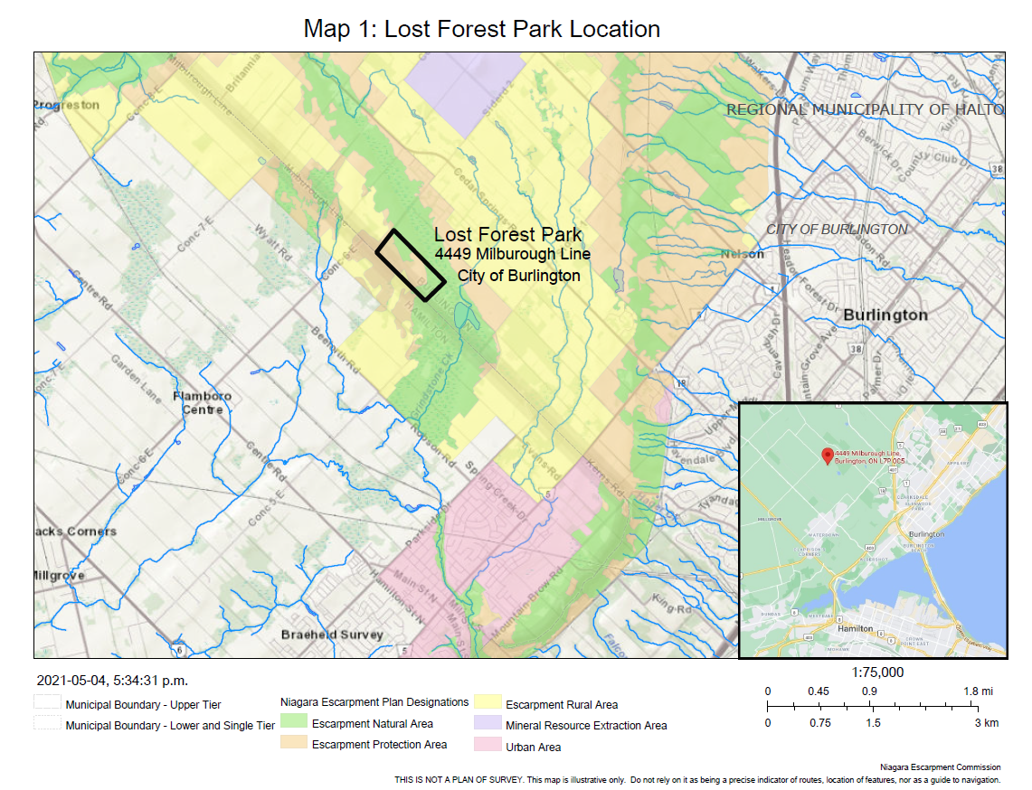
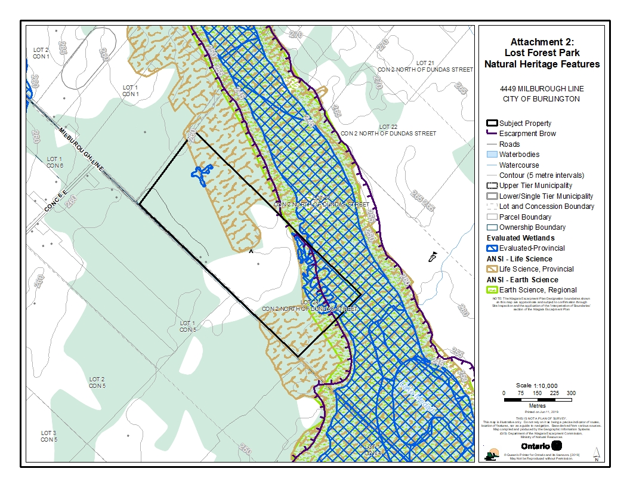

Map 3: 2017 Approved Site Plan
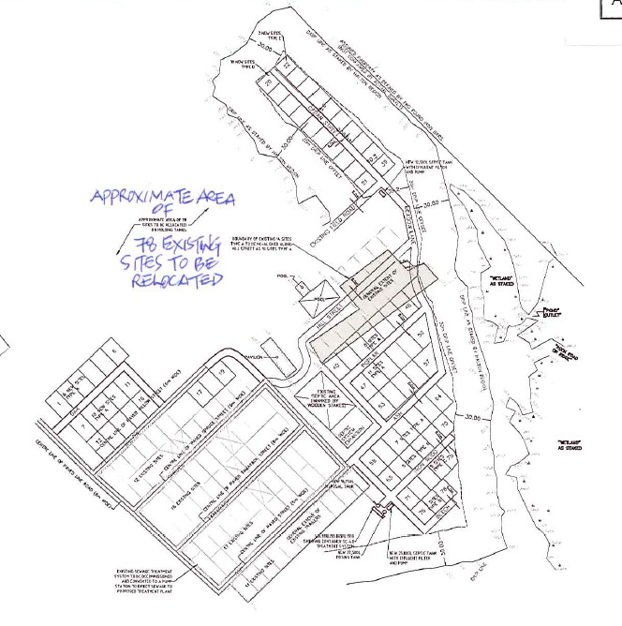
N
¿

Map 4. Orthophoto: 2018
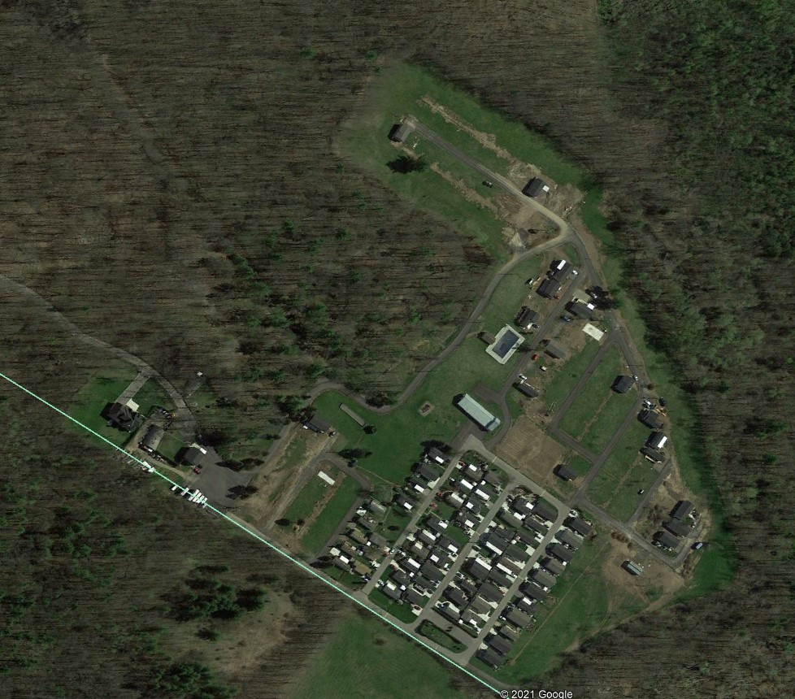

The changes to the licensing by-law do not impact any requirements or conditions imposed through a NEC DP.
Development Charges were calculated based on the non-retail development rate, which includes short-term accommodations such as hotels, bed and breakfasts, campsites, and vacation rentals.
Once conveyed to a new owner, a new restoration order would have to be served on the new owner since restoration orders are specific to the person that undertook the unauthorized development. Since ongoing use of the manufactured homes after sale of the property would be a continuing offence, the new owner would be undertaking unauthorized development, too.

