July 15, 2021

A3: STAFF REPORT

Development Permit Application:

W/R/2020-2021/689
193 Weir’s Lane
Part Lot 4 Concession 1
City of Hamilton (former Town of Dundas)

Summary

Proposal:
To re-create a lot resulting in a ±0.61 hectare (±1.5 acres) severed lot and a ± 14.03 hectares (±34.675 acres) retained lot.

Designations:
Escarpment Natural Area, Escarpment Protection Area and Escarpment Rural Area

Issue:
The proposed severance is being requested to re-create two lots that have merged on title. The Niagara Escarpment Plan (NEP) does not permit correcting conveyances for lots that have merged on title in Escarpment Natural Area, Escarpment Protection Area or Escarpment Rural Area.

Recommendation:
Refusal

Reasons:
The proposal is not a correcting conveyance as it attempts to re-create merged lots and therefore it is not permitted under 1.3.4, 1.4.4 and 1.5.4 of the Niagara Escarpment Plan (NEP).

Received:
March 5, 2021

Source:
REDACTED (Trustee), REDACTED (applicant/agent)

Background:
REDACTED is the trustee of REDACTED’s estate, the deceased owners of the subject sites (the “sites”) known as 169 Weir’s Lane and 193 Weir’s Lane (Appendix 1 & 2). A brief history of the purchases and transfers of the sites will be described below.

As noted in the legal opinion provided by the applicant (Appendix 3), in the 1960s, the late REDACTED purchased four abutting parcels. In 1977, these four parcels were transferred to the late REDACTED; they did not include William on title. In 1978, REDACTED solely purchase a final parcel, which abutted the original four parcels purchased in the 1960s.

In 1987, REDACTED transferred, to REDACTED, the previous four parcels except for a smaller retained piece known as 169 Weir’s Lane. The transfer and conveyance stipulated a one-time only consent that would merge the previous purchased parcels from the 1960s with the land already owned by REDACTED (the final parcel he purchased in 1978 as noted above). At this point in the timeline, the parcels are now merged under REDACTED’s ownership to makeup the site known as 193 Weir’s Lane and REDACTED is in ownership of 169 Weir’s Lane.

Later that year, REDACTED transferred 193 Weir’s Lane to include REDACTED as a joint tenant. The parcel known as 169 Weir’s Lane remained in REDACTED’s name only. In 2008, the sites merged when the parcel known as 169 Weir’s Lane was transferred to have REDACTED and REDACTED as joint tenants. At this point in time, each site was under the same ownership on title.

In September 2020, the sites were sold to separate buyers but following the signed purchase and sale agreements it was discovered at that time by the seller and purchasers that the sites had merged on title in 2008. The two purchasers are still pursuing the agreed upon sales.

Proposed Development:
The proposal is a request to sever 193 Weir’s Lane to re-create two building lots, which would result in a ±0.61 hectare (±1.5 acres) retained lot (169 Weir’s Lane) and a ± 14.03 hectares (±34.675 acres) severed lot (193 Weir’s Lane) in order to finalize the pending sale of the sites.

Site description:
The sites are both located west of Weir’s Lane and between Highway 8 to the north and Governor’s Road to the south. 169 Weir’s Lane is abutting 193 Weir’s lane to the south.
The sites currently support a dwelling each, which are understood to be in a reasonable state of repair and habitable. Each dwelling is serviced by its own well and septic system. There is also an accessory structure on 193 Weir’s Lane.

The sites are both designated Escarpment Natural Area, Escarpment Protection Area and Escarpment Rural Area in the Niagara Escarpment Plan (NEP) 2017 (Appendix 2). The sites are also found within Core Areas (environmentally sensitive area/significant woodland) per the City of Hamilton’s (the “city”) rural official plan. These areas coincide with the Escarpment Natural Area. A watercourse also traverses the Escarpment Natural Area. The majority of both 169 and 193 Weir’s Lane are regulated by Hamilton Conservation Authority due to the hazards associated with the watercourse and the Escarpment slope. A portion of 193 Weir’s Lane was under agricultural production (field crops).

Planning Analysis:

Provincial Policy Statement (2020)
The sites are within rural areas, more specifically rural lands, defined as lands located outside settlement areas and prime agricultural areas. Since the sites are not within a settlement area, the recreation of two separate lots is not supported by the Provincial Policy Statement (PPS), which directs lot creation to settlement areas. Section 1.1.4.2 of the PPS directs growth and development to designated settlement areas.
Considering the above analysis, policy 1.1.4 is not met.

Niagara Escarpment Plan (2017)

The anticipated uses of the sites will remain residential. Farming may continue on the portion of 193 Weir’s Lane that is designated Escarpment Rural Area, which is a permitted use. The concern in this proposal, however, is the re-creation of a lot. The purpose of the NEP is to ensure that development, including the creation of lots, occurs in a manner that is compatible with the natural environment. Each designation therefore has appropriate policies and objectives to protect sensitive natural features found within the Escarpment. The Escarpment Natural Area, Escarpment Protection Area and Escarpment Rural Area designations have similar objectives and lot creation policies to protect environmentally sensitive features and to ensure there is appropriate and compatible growth.

The lot creation policies found within each of these designations are restrictive. Considerations is given to the appropriate amount of development (including the necessary infrastructure and services required to support development) therefore Settlement Area (including Urban Area) policies are less restrictive than Rural Area policies as guided by the PPS. Severances are generally not permitted in Escarpment Natural Area, Escarpment Protection Area and Escarpment Rural Area designations with certain exceptions.

In Parts 1.3.4, 1.4.4 and 1.5.4, the lot creation policies for Escarpment Natural Area, Escarpment Protection Area and Escarpment Rural Area respectively, new lots are generally only permitted in cases where original township lots or half lots remain relatively intact. Otherwise, consents are only permitted for:
- the purpose of enlarging existing lots or public body acquisitions or the creation of a nature preserve (1.3.4.2, 1.4.4.2 and 1.5.4.2)
- the purpose of an agricultural use provided the lot is of a certain size (1.3.4.3, 1.4.4.3 and 1.5.4.3) or for agricultural-related uses provided that the new lot(s) are not used for residential purposes (1.3.4.4, 1.4.4.4 and 1.5.4.4).
These exceptions are not applicable to this application.

Additionally, NEP lot creation policies also allow for correcting conveyances (1.3.4.2(a), 1.4.4.2(a) and 1.5.4.2(a)). “Correcting conveyance” is defined as “the granting of a consent under the Planning Act for purposes, such as easements, correcting deeds, quit claims and minor boundary adjustments for legal or technical reasons that do not result in the creation of a new lot or the re-creation of a merged lot.” (Municipalities may also similarly accept applications like this referred to as technical severances).

Staff acknowledge that the sites were previously two distinct lots. However, the policies 1.3.4.2(a), 1.4.4.2(a) and 1.5.4.2(a) explicitly contemplate the re-creation of previously merged lots. Merged lots cannot be corrected in the NEP and are not considered an appropriate exception and use of the ability to correct a conveyance.

Part 2.4 of the NEP addresses lot creation. However, the policies in Part 2 of the NEP can only be considered if the proposed development is clearly a permitted use as listed in Part 1 of the NEP. Since Part 1 explicitly prohibits the re-creation of merged lots in all three land use designations on the property, the policies in Part 2.4, specifically those policies in Part 2.4.15 relating to multiple dwellings on the same lot, cannot be considered. Part 1 does not reference Part 2.4.15 as an exception to the prohibition on unmerging merged lots nor does 2.4.15 reference that it is a reason for unmerging merged lots.

Rural Hamilton Official Plan (RHOP):
The subject property is designated as “Rural” and “Open Space” on Schedule D of the RHOP – Rural Land Use designations.

The RHOP policies prohibit severances for the purposes of creating a new lot for residential uses (F.1.14.2.1) and policy C.1.1.6 further reiterates that no new lots shall be created in Escarpment Natural Area or Escarpment Protection Area. The exceptions found within these policies are similar to those within the NEP noted above. Furthermore, there are specific city requirements found in C.5.1 associated with private water and wastewater services that must be met prior to approval to ensure sufficient size and availability.

It is also NEC staff’s understanding this this proposal could require an official plan amendment to permit the severance.

Agency Consultation:
The proposal was circulated to the City of Hamilton however their comments have still not been received. This report was prepared without their comments given urgency in arriving at a decision from the Commission because of the pending sale. As the senior land use plan, any policies that the City of Hamilton may have that would allow for the re-creation of two lots do not apply, since provincial plans prevail over municipal plans to the extent of any conflict.

Conclusion:
The proposal does not meet the objectives of the NEP as a new lot is being created within prohibited areas of the NEP area. The NEP specifically provides policies to prohibit severances where properties have merged on title and therefore this is not a scenario where the criteria for a correcting conveyance is met. Further, this proposal would very likely not be supported by city staff and could require an official plan amendment if the Commission were to approve the re-creation of the lots.

Recommendation:
That the application be refused because:
- The proposal to re-create merged lots is not permitted under 1.3.4, 1.4.4 and 1.5.4 of the Niagara Escarpment Plan

Prepared by:
Original signed by:
______________________
Johnpaul Loiacono
Senior Planner

Approved by:
Original signed by:
______________________
Kim Peters, MCIP, RPP, A/ Manager

Appendix 1 – Orthophoto of the subject site
Appendix 2 – Land Use Designations and Natural Heritage Features
Appendix 3 – Legal Opinion by Sidney Troister, Torkin Maine

APPENDIX 1
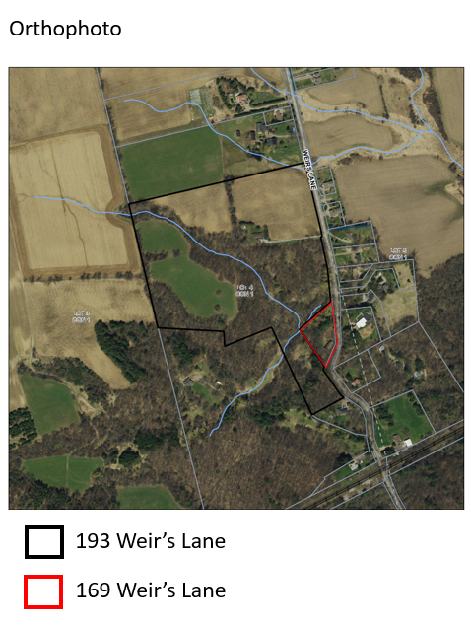

APPENDIX 2
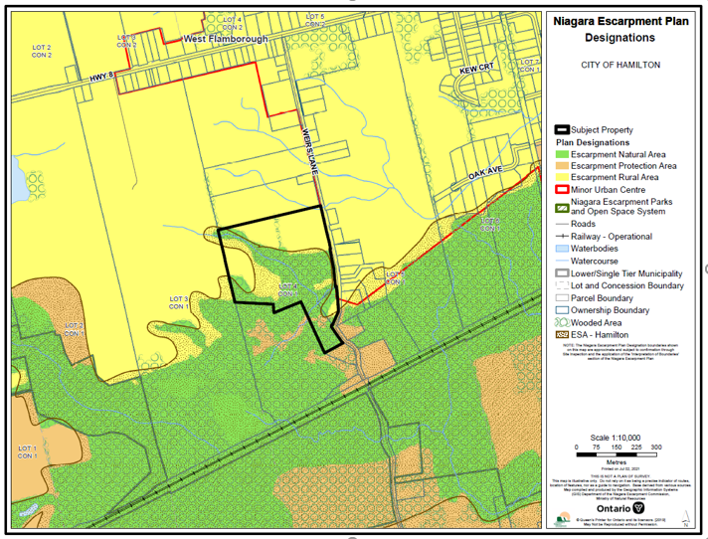

APPENDIX 3 available in separate PDF file.

