July 15, 2021

A4: STAFF REPORT

DEVELOPMENT PERMIT APPLICATION:

D/P/2015-2016/291
Fung Loy Kok Institute of Taoism
248305 5th Sideroad
Part Lot 6, Concession 7 (East of Hurontario)
Town of Mono, County of Dufferin

SUMMARY

PROPOSAL:
To revise the approved site plan for an existing 2.01 ha cemetery to include 1,277 columbarium niches and 298 burial plots on an existing 42.3 ha lot. The proposal also includes construction of a 7.45 m tall, 8.6 m wide vehicular entrance archway, landscaping, and tree planting (+/- 239 trees).
Note: In 1987, the NEC approved a 1,575-plot cemetery (flush grave markers only) on the subject lands.

DESIGNATIONS:
Escarpment Rural Area (cemetery located within this designation)
Escarpment Protection Area
Escarpment Natural Area

ISSUE:
Some local opposition to what was initially proposed as an expansion of the cemetery; Niagara Escarpment Plan (NEP) definition of institutional use/cemetery specifies that uses are “to serve the immediate community.”

RECOMMENDATION:
Approval, subject to conditions.

REASONS:
- The cemetery is already an approved use on the subject lands;
- The subject development permit application (DPA) is for a reconfiguration of the existing approval; any future intensification or expansion of the cemetery will need to be evaluated through a new DPA.

RECEIVED:
October 27, 2015

SOURCE:
Fung Loy Kok Institute of Taoism

PROPOSAL:
To revise the approved site plan for an existing 2.01 ha cemetery to include 1,277 columbarium niches and 298 burial plots on an existing 42.3 ha lot. The proposal also includes construction of a 7.45 m tall, 8.6 m wide vehicular entrance archway, landscaping, and tree planting (+/- 248 trees).
Note: In 1987, the Niagara Escarpment Commission (NEC) approved a 1,575-plot cemetery (flush grave markers only) on the subject lands.

BACKGROUND:
The institutional use on the subject property was established by the Therafield Foundation prior to the passing of the Niagara Escarpment Planning and Development Act (NEPDA) in 1973. The Taoist Tai Chi Society of Canada (now the Fung Loy Kok Institute) took ownership of the property in 1984. In 1986, the Institute applied to the NEC to introduce a cemetery on the property. The cemetery was approved by the Commission in 1987 (Development Permit #3479/D/P/1986-1987/389), but this decision was appealed by the Town of Mono. The Town did not support the cemetery for several reasons: potential conflicts with surrounding rural and farm uses; the visual impact; responsibility for maintenance if the Institute ceased to exist; the pressure for future expansion; and the loss of land from the tax base. Ultimately, the hearing officer upheld the Commission’s decision to approve a 1,575 plot cemetery with flush grave markers. The site plan for the 1987 approval is found in Appendix 3.
In 1996, the Institute filed a NEP amendment application to allow for the expansion of a temple building. Multiple buildings already existed on the site; an amendment was needed because it was a major expansion of the use. NEP Amendment No. 117 was approved in 2001. This Amendment did not affect the existing cemetery approval.
The DPA currently under consideration was submitted in October 2015 and proposed to reconfigure and intensify the cemetery, as well as to introduce an archway at the entrance to the property. The proposal has evolved significantly since the application was originally submitted. Initially, 15,134 columbarium niches were proposed, with the number of burial plots reduce to 124. A public meeting was held in February 2016. Significant concerns were raised given the intensification of the cemetery use. Following this public meeting, 12 local landowners made submissions to the NEC. Their concerns included:
- Lack of justification of need for the significant increase in units
- Visual impact on the Escarpment landscape
- Groundwater contamination
- Nuisances including noise, traffic and garbage
- Negative impact on property value
- Not intended to serve the local community.
In March 2016, Town Council passed a resolution opposing the proposal, but providing recommendations on what could be supported. (See Town of Mono comments below.) In response, the applicant proceeded with exploring different configurations.
In September 2020, a revised concept was presented to the community at an open house hosted by the Institute. A master plan concept was presented, with the intention of implementing it in a phased approach. Four phases were proposed of approximately 25 years each, with the cemetery reaching a maximum capacity of 4,522 niches and 1,212 graves in approximately 100 years. The community expressed concerns regarding impacts on groundwater, traffic, and justification for the expansion. The revised proposal was also presented to Council at a November 2020 Council meeting. Council gave conditional support for the application, with conditions as outlined in the Town of Mono comments below.
After further discussions, the proposal currently before the Commission is what the applicant is requesting. This, too, was presented to Town of Mono Council in June 2021 since it differed from what they had endorsed in November 2020. (1,277 niches are now proposed, and Council previously endorsed only 365 columbarium niches.) Council has endorsed this latest proposal in that the 1,277 niches and 298 graves meet the intent of the original 1987 proposal and is therefore acceptable to the Town. The conceptual plans for this final proposal are found in Appendix 4.
The applicant is agreeable to a set of conditions that are intended to address the concerns of both Council and the community, including an approval that only covers what was originally proposed as Phase 1 of the master plan, landscaping, and the entrance archway. As stated in the conditions of approval, final approval is contingent on an updated hydrogeological investigation that supports the reconfigured cemetery. The conditions also make it clear that the need for and impact of additional graves and niches beyond Phase 1 will have to be evaluated through future DPAs.

SITE DESCRIPTION:
The 42-hectare property is located within the Town of Mono at the northeast corner of Airport Road and 5th Sideroad (see mapping in Appendix 2). Approximately 30 hectares of the site is designated Escarpment Rural Area, with Escarpment Protection Area and Escarpment Natural Area occupying the remainder. The terrain is somewhat flat, but starts to slope downwards towards the east of the property. The Bruce Trail crosses the property parallel to the eastern property line. There is an unevaluated wetland (marsh) in the southwest corner of the property. Approximately 50 percent of the property is forested, most of which is conifer plantation. Along both Airport Road and 5th Sideroad, hedgerows provide screening so there is limited visibility into the subject lands. The cemetery is located in the Escarpment Rural Area designation, and occupies approximately two hectares of the site. There is no proposed expansion in cemetery area. The cemetery is located outside of the area prone to natural hazards (wetland and watercourse).

PROPOSED DEVELOPMENT:
The Institute is proposing to reconfigure the lay-out of the cemetery to allow for columbaria, upright headstones on burial plots, landscaping, and significant tree planting in and around the cemetery. They are seeking these changes to reflect burial preferences, and to enhance the aesthetic value of the site. An archway entrance feature at the property entrance on 5th Sideroad is also proposed.
As noted, there is already an approval in place for the cemetery. The original 1987 approval and 2021 proposal are compared below:
Approval | Graves | Columbarium Niches | Grave Markers | Total
1987 | 1,575 | 0 | Flush to ground | 1,575
2021 | 298 | 1,277 | Headstones | 1,575
Note: columbaria will be a maximum of 2.4 m in height. 1,277 niches will be divided between 10 columbaria structures.
The proposed development also includes introduction of an entrance archway at the entry to the property on 5th Sideroad.

PLANNING ANALYSIS:

Part 1.5 Escarpment Rural Area: Permitted Uses
Part 1.5 of the NEP sets out the objectives, designation criteria and permitted uses for the Escarpment Rural Area designation. Among the objectives of the designation is to provide for compatible rural land uses. Institutional uses, which include cemeteries, are listed as a permitted use in Escarpment Rural Area, but only outside of prime agricultural areas. According to the province’s Agricultural Land Base mapping, the subject property is not within a prime agricultural area, and the predominant soil class on the subject lands is Canada Land Inventory Class 7. Thus, based on the policies of the NEP, the cemetery is a permitted use.
Some concern has been raised that the Institute’s cemetery is intended to serve a wider community than just the local area, which may not be consistent with the requirement that institutional uses “serve the immediate community,” as per the NEP definition. However, “serve the immediate community” has been generously interpreted in the past. In the report of the hearing officer regarding the 1987 approval of the cemetery, it was noted that the Institute is open and accessible to the local community, and it does not exclude the local community.
Through public consultation, community members and Town Council raised concerns about noise, traffic, garbage, visual impact and property values, which suggest that the expanded cemetery might be an incompatible rural land use and therefore not in keeping with Escarpment Rural Area objectives. However, these concerns were raised in relation to the initial expansion proposal (i.e., 15,134 columbarium niches) and not the scaled-down proposal that is presently before the Commission. Since there is no proposed change in the intensity of use under the current proposal, the amount of traffic and noise is not likely to be a factor beyond the initial period of site alteration and construction.

Part 2.2 General Development Criteria
Part 2.2.1 states that the Escarpment is to be protected, restored and where possible enhanced having regard for single, multiple or successive development. Since the proposal is consistent with the intensity of the existing cemetery proposal, staff is not concerned about cumulative impacts, including traffic impacts. The applicant provided a traffic impact study that did not anticipate a significant increase in volume of traffic in conjunction with the cemetery expansion as proposed in September 2020 four-phase plan. As explained, the requested approval has since been revised to restrict it to the number of burial units proposed in what is Phase 1 of the master plan. In addition, the conditions of approval make it clear that any future expansion of the cemetery must demonstrate the need for additional graves and/or niches, and must be evaluated through a new DPA.
Part 2.2.9 specifies that institutional uses are not to exceed 500 square metres, unless it can be demonstrated that a larger size is compatible with the site and the surrounding landscape. As noted above, NEP Amendment No. 117 approved the expansion of institutional use, which exceeded what could be considered “small scale,” which is what the policies permitted at the time. Therefore, the institutional use, including the cemetery, is an established permitted use at its current scale. Since there is no intensification of the cemetery (i.e., the overall number of units and cemetery area are remaining the same), there is no concern that the scale of the use is no longer compatible with the site or surrounding landscape. While the change from flush grave markers to allow columbaria and headstones will result in a visual change to the site, existing and new planting along 5th Sideroad will limit views into the property. The changes made to the site will not be visible for public vantage points.

Part 2.6 Development Affecting Water Resources
The southwest corner of the property contains an unevaluated wetland and is traversed by a watercourse, a tributary of the Humber River. At its closest point, the area designated for the cemetery is +/-230 metres from the wetland. Given this distance, staff has no concern that the proposed changes to the cemetery will impact the wetland and watercourse.
With regard to groundwater, a hydrogeological investigation conducted for the 1987 cemetery approval revealed that there is a perched water table in the northeast quadrant of the subject property. This area was not recommended for cemetery use. The cemetery is located outside of this area, in a location where the water table is estimated to be 3 metres below ground. The proposed change from entirely graves to mostly columbaria will reduce the overall risk to groundwater. To confirm that the groundwater conditions have not changed significantly over time, an updated hydrogeological investigation is required as a condition of approval.
Although the subject lands are located within a significant groundwater recharge area, there is no concern from a source water protection perspective as there is no municipal wellhead nearby. There is no water taking proposed as part of this application that would impact the quantity of groundwater, but the scope of the hydrogeological investigation will include identification of wells in vicinity of the property to ensure adequate setbacks to mitigate any potential risk to groundwater quality, in keeping with comments received from the Ministry of Environment, Conservation and Parks (see below).

Part 2.7 Development Affecting Natural Heritage
An unevaluated wetland and portion of a significant woodland are found on site. The cemetery is not located in or near these features. The Natural Heritage Information Centre database contains records of three avian Species at Risk: eastern meadowlark, bobolink and wood thrush. Eastern meadowlark and bobolink preferred breeding habitat is long grasses and agricultural fields of at least five hectares in size. Since the lawn within the cemetery area is manicured and less than five hectares, it is not ideal habitat for these birds. Wood thrush prefer coniferous-deciduous forests. The cemetery does not contain suitable habitat, although other parts of the subject property do. The extensive tree planting proposed (+/- 239 coniferous and deciduous trees) will contribute to improved habitat on the site. Thirty-seven trees are proposed for removal to accommodate new landscaping; the additional tree planting will more than compensate for this loss. A final landscaping plan with planting details is required as a condition of approval.

Part 2.13 Scenic Resources and Landform Conservation
From a scenic resource perspective, there was initial concern from NEC staff and Town Council that the entrance archway would have a negative visual impact. The surrounding landscape is ranked as “very attractive” in the NEC’s Landscape Evaluation Study. Given the potential for visual impacts, the applicant was requested to submit a visual impact assessment (VIA). The VIA revealed that views of the archway and interior cemetery development are limited, and could be further mitigated by supplemental tree planting along the 5th Sideroad property boundary, and by reducing the size of the archway. Initially, the archway was proposed at a height of 8.45 metres and width of 10 metres. The height and width were subsequently reduced to 7.45 metres and 8 metres respectively. Screening the archway completely from public view would defeat its purpose; it is intended to clearly mark the entrance to the property. The form and size of the archway pillars will be consistent with the surrounding landscape.

Part 2.11 Recreation/Part 2.14 The Bruce Trail
As noted, the Bruce Trail traverses the property roughly parallel to the eastern property boundary. The Institute will continue to host the Bruce Trail, and the changes to the cemetery will not require rerouting of the trail.

AGENCY CONSULTATIONS:

Town of Mono
In response to the original proposal to expand the cemetery to include 15,134 columbarium niches and 124 graves, Town Council passed the following resolution (March 2016):
THAT Council does not support the NEC Applications applied for by Fung Loy Kok Institute of Taoism, owners of 248305 5th Sideroad, being Part of the West Half of Lot 6 Concession 7 EHS, at this time. Council would request the following modifications to the application be considered:
Archway Application
- That the proposed pedestrian archway at the west side of the property be removed from the application;
- Thar the size and scale of the vehicular archway be reduced;
- That the archway be constructed of earth tone materials; and that,
- No lighting of the archway be permitted.
Columbarium Application
- That the maximum number of niches permitted should be limited to the existing approved plots on the property (1,507);
- That a detailed Landscape Plan for the lands along 5th Sideroad should be submitted to minimize the visual impact of the columbarium features and driveway improvements from neighboring residents and vehicular traffic; and that,
- No lighting be permitted.
In response to the revised, four phase proposal presented in November 2020, Town Council passed the following motion:
The Town of Mono supports the Fung Loy Kok, (2015-2016/291) NEC Application with the following conditions:
- The Town of Mono is concerned that the Applicant has not met the tests to date regarding the benefit to the local community of the amount of columbaria proposed. Adherence to this policy must be clarified in any decision made by the Niagara Escarpment Commission;

- The upset limit of burial sites on site should be limited to the current amount permitted on the property by the existing 1987 Development Permit (DlPl86-87/389) (i.e., 1,575 plots). A maximum of 365 columbaria would be supported within the existing limits. Any increase beyond the approved 1987 Development Permit should require an amendment to the Niagara Escarpment Plan;
- The proposed landscaping should be enhanced along 5th Sideroad between the burial sites and the residential uses to the south and east;
- The Town supports the archway design and location as proposed.
In response to the final proposal being presented to the Commission today, Town Council agreed that the limiting of the niches to 1,277, with 298 graves, meets the intent of the original approvals and would be acceptable.

County of Dufferin
The Building Department has no comments at this time.
The Planning Department’s consultant provided the following comment:
The development permit application is consistent with the Countryside Area designation and the related policies in the Dufferin County Official Plan. It is recommended that:
- Consultation occur with the Province to confirm the proposal conforms with the Greenbelt Plan (2017);
- Consultation occur with the Town to ensure appropriate mitigation measures be implemented as recommended in the Ministry of Natural Resources and Forestry’s “Wildland Fire Assessment and Mitigation Standards” due to the presence of hazardous forest types for wildland fire;
- Consultation occur with the Province to confirm the significance of the mineral resources on the subject property;
- Confirmation be provided as to whether the woodlands located on and adjacent to the subject property are deemed significant;
- Confirmation be provided as to whether an Environmental Impact Statement (EIS) is required relative to the presence of woodlands and unevaluated wetlands on and adjacent to the subject property; and
- Consultation occur with the Town of Mono, the Nottawasaga Valley Conservation Authority (NVCA) and the Toronto and Region Conservation Authority (TRCA) related to the potential impacts to source water.

Ministry of Environment, Conservation and Parks (MECP)
As the cemetery use is permitted, MECP has no interest in how the cemetery plots and columbaria are arranged. MECP’s interest would be that of ensuring that the area’s water resources are protected. Accordingly, if within the scope of the NEC’s authority under its permitting, human remains should be buried above the groundwater table; should not be buried within 30 metres of any water well; and if possible, deep-root trees should be planted at a downgradient boundary of the burial area as a means to uptake groundwater.

Ministry of Government and Consumer Services (Bereavement Authority of Ontario)
A consent application to alter or increase the capacity of a cemetery must be completed and filed with the Registrar for approval. The application requires proof of municipal approval.

Toronto and Region Conservation Authority (TRCA)
The entrance archway is located within TRCA’s regulated area, adjacent to a stream corridor associated with the Humber River watershed. On this basis, a permit pursuant to Ontario Regulation 166/06 is required from TRCA.

DISCUSSION:
NEC staff is satisfied that the reconfigured cemetery is consistent with the intent of the existing 1987 approval, and does not represent an intensification of the existing institutional/cemetery use. The comments received from the public and the Town of Mono’s initial concerns have been addressed through the revisions to the original proposal, as well as through the conditions of approval, including a condition that requires an updated hydrological evaluation to ensure groundwater conditions remain acceptable for the cemetery use. Future expansion of the cemetery beyond the 1,575 burial units proposed as Phase 1 will require demonstration of need and evaluation through a new DPA.

RECOMMENDATION:
That the proposal be approved, subject to the conditions in Appendix 1.

Prepared by:
Original signed by:
______________________
Kim Peters, MCIP, RPP
Manager (A)

Approved by:
Original signed by:
________________
Debbie Ramsay, MCIP, RPP
Director

Appendix 1 – Conditions of Approval
Appendix 2 – Property Location
Appendix 3 – 1987 Cemetery Plans
Appendix 4 – 2021 Cemetery Concept Plans

APPENDIX 1

CONDITIONS OF APPROVAL

D/P/2015-2016/291
Fung Loy Kok Institute of Taoism
248305 5th Sideroad
Part Lot 6, Concession 7 (East of Hurontario)
Town of Mono, County of Dufferin

- Development shall occur in accordance with the Terms and Conditions of the Development Permit.

- All construction, grading, landscaping, and tree planting shall be completed within three (3) years of the date of Development Permit approval. Any/all disturbed areas of land or soil shall be re-vegetated and stabilized to the satisfaction of the Niagara Escarpment Commission.

- No site alteration of the existing contours of the property including the placement or stockpiling of fill (i.e., excess or imported soil) on the property is permitted with the exception of that identified within the development envelope in accordance with the Final Site Plan.

- No vegetation shall be cut or removed from the development envelope except for that identified within the development envelope in accordance with the Final Site Plan.

- Prior to the issuance of a Development Permit by the Niagara Escarpment Commission, an accurate and detailed Final Site Plan prepared by a qualified person shall be submitted for Niagara Escarpment Commission approval. The following stipulation shall be included directly on the Plan:
- All drawings submitted must be drawn to scale (bar scale shown), reference the application number and address of the proposal, be dated (revisions as well), and include the name of the relevant individual or consultant who prepared the drawing;
- Outline of the approved development envelope, extent of all disturbed areas;
- Location of all existing and proposed structures, laneways, construction access / haul routes, etc. showing setbacks from the property lines, any watercourses or water features, top / bottom of slope, wooded areas, etc.;
- Building materials and colours to be used for the entrance archway and landscape features associated with the cemetery;
- Grading, drainage, and fill management details including the areas of excavation and temporary or permanent fill placement. The type, quantity, quality and source location of any imported fill material must be accurately identified.
Development shall proceed in accordance with the details of the approved Final Site Plan.
- Prior to the issuance of a Development Permit by the Niagara Escarpment Commission, a Final Landscape Plan shall be prepared by a qualified person, for Niagara Escarpment Commission approval. The Plan shall address all vegetation retention and planting requirements in accordance with the standard practices of the implementing authority. The following stipulations shall be included directly on the Plan:
  - Identify the areas of existing vegetation to be retained, areas of vegetation to be removed, and the location of proposed plantings. Quantities of plantings, species, and size must be indicated. The location, species and number of trees to be removed must be specified;
  - Tree protection and vegetation protection measures where there is the potential for construction to damage existing vegetation;
  - All new tree and shrub species (including seed mixes) shall be native to Ontario except where otherwise approved by the Niagara Escarpment Commission. Plant material shall be sourced from local plant nurseries; bush dug plant material is not acceptable;
  - Planting and the rehabilitation of all disturbed areas shall be completed on or before the date of expiry of the Development Permit to the satisfaction of the Niagara Escarpment Commission;
  - All plant material shall be guaranteed for 24 months following installation. All plant material found during this time to be dead or dying must be replaced with a size and species to the satisfaction of the Niagara Escarpment Commission;
  - Once the development has been completed, a letter certifying the landscaping / planting work has been completed in accordance with the approved Landscape Plan shall be provided to the Niagara Escarpment Commission by a qualified person.
Development shall proceed in accordance with the details of the Final Landscape Plan.
- Prior to the issuance of a Development Permit by the Niagara Escarpment Commission, the applicant must complete a new hydrogeological evaluation confirming that in-ground graves can be accommodated above the water table. The locations of all drinking water wells on adjacent properties are to be identified and confirmation shall be provided that groundwater conditions are such that the quantity and quality of groundwater will not be negatively impacted by the cemetery.

- Tree removal is not to occur during the breeding bird season of April 1st to August 31st of any given year.

- The cemetery is not to exceed a total of 1,575 burials, with +/-1,277 niches in 10 columbaria structures, and +/-298 graves. Any expansion of the cemetery beyond 1,575 burials and/or beyond the 2.01-hectare area currently identified for cemetery use will require a new Development Permit from the Niagara Escarpment Commission.

- Conditions 5, 6 & 7 must be fulfilled within eighteen months from the date of confirmation of the Commission’s decision or this conditional approval shall lapse and a Development Permit will not be issued.
Advisory Notes
  - A Development Permit does not relieve the permit holder of any other permission (e.g., Ontario Building Code, Conservation Authorities Act, Bereavement Authority of Ontario, etc.). A Niagara Escarpment Commission Development Permit is required prior to the issuance of any other permission.

APPENDIX 2: Mapping
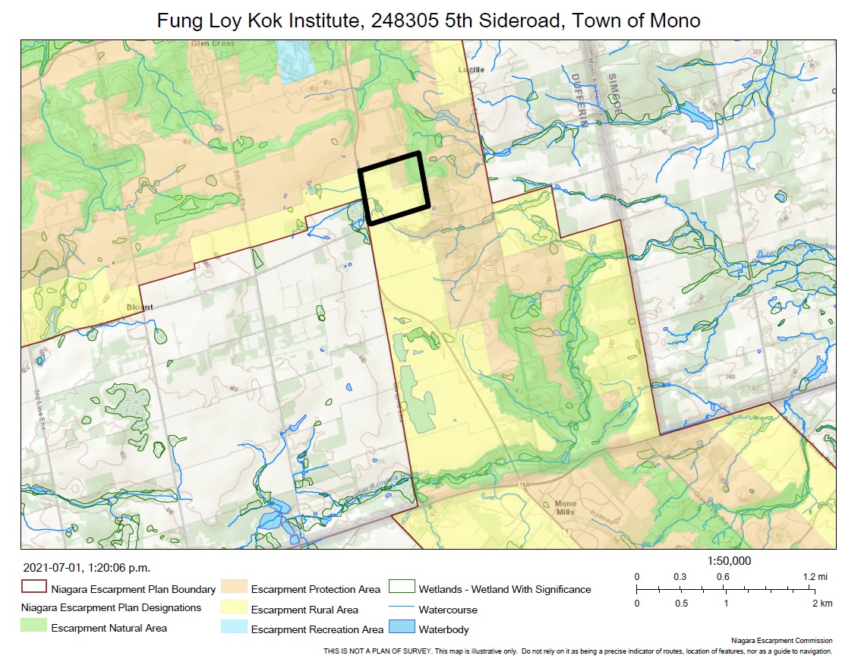

APPENDIX 2: Mapping

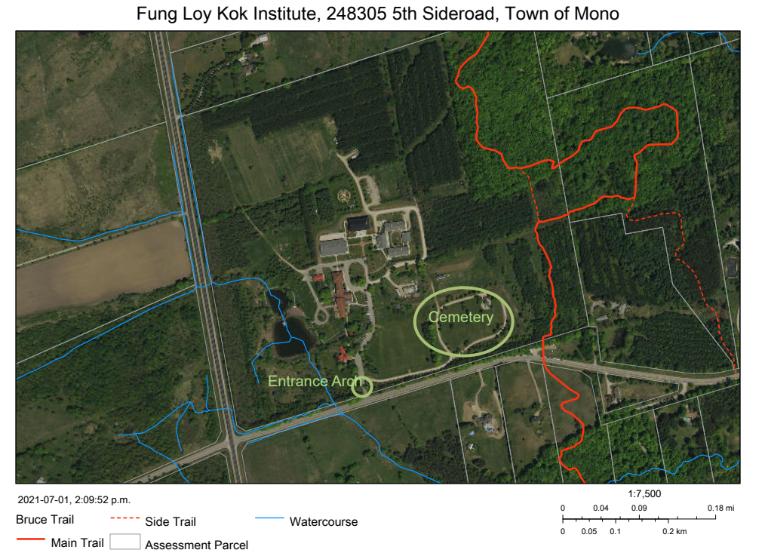

APPENDIX 3: 1987 Approval

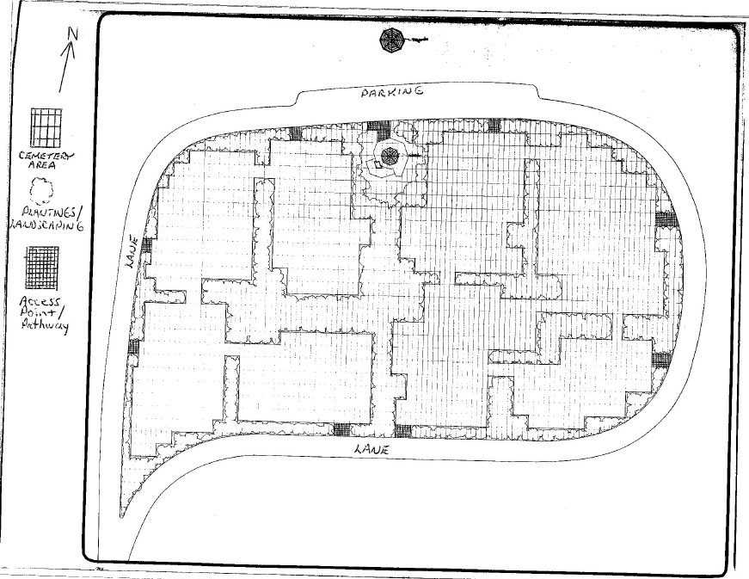
APPENDIX 4: 2021 Cemetery Concept Plans
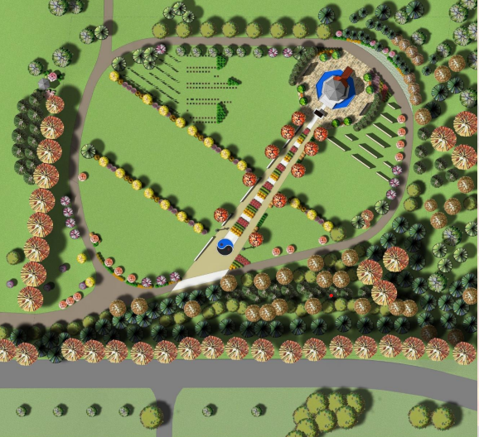
10 Columbaria with 1,277 niches
298 Graves
Landscaping and tree planting

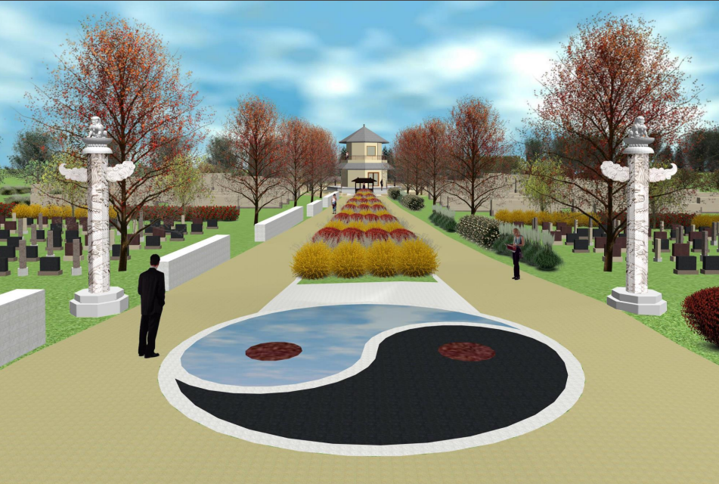
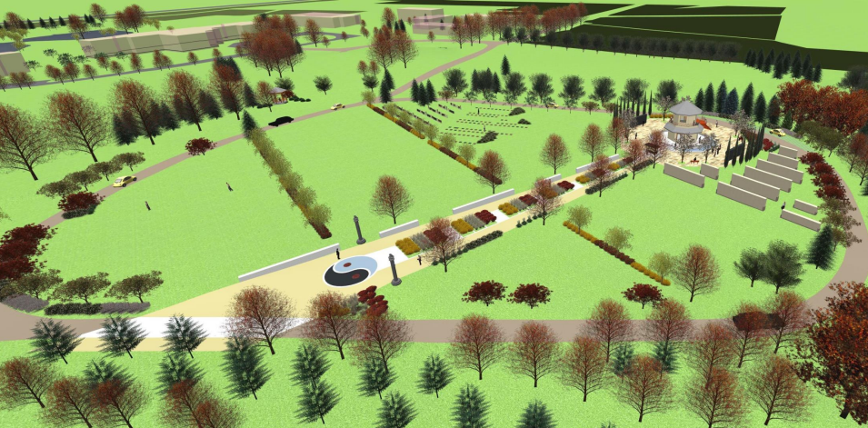

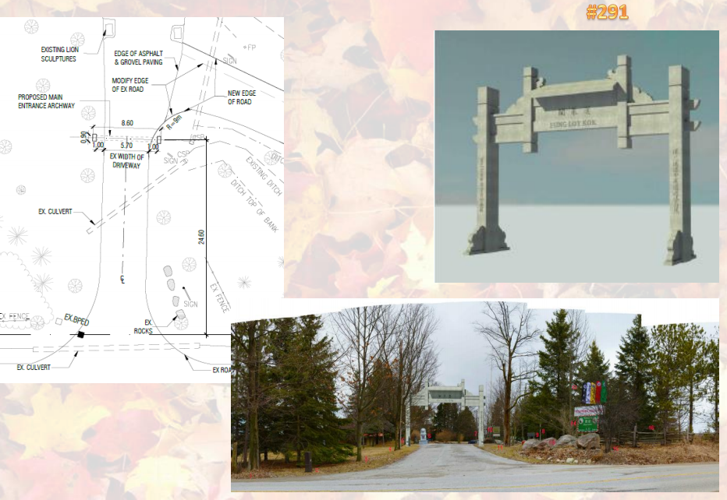
Entrance Archway

The number of graves proposed in the 1987 approval was 1,575.

