July 15, 2021

A6: STAFF REPORT

DEVELOPMENT PERMIT APPLICATION:

H/C/2021-2022/017
REDACTED
Kelso Lavender
8649 Appleby Line
Part Lot 5, Concession 6, Nassagaweya
Town of Milton, Region of Halton

SUMMARY

PROPOSAL:
To establish an on-farm diversified use (OFDU), agri-tourism, consisting of pick-your-own lavender, and viewing opportunities, and to establish a 2,571.14 sq m (27,675.52 sq ft), 45-car parking area, on an existing 8.44 ha (20.85 ac) lot that supports a lavender farm, farm produce stand, and single dwelling.
Note: NEC file H/C/2019-2020/408 is currently in progress, proposing a farm sign.

DESIGNATIONS:
Escarpment Protection Area, Escarpment Natural Area

LOT SIZE:
8.44 ha (20.85 ac) lot

ISSUE:
On-farm diversified uses (OFDUs), including agritourism, are not a permitted use within the Escarpment Protection Area designation outside of prime agricultural areas.

RECOMMENDATION:
Refusal

REASONS:
Part 1.4.3.2 specifies that on-farm diversified uses are only permitted in prime agricultural areas in Escarpment Protection Area. The subject property is not in a prime agricultural area.

RECEIVED:
04/07/2021

SOURCE:
REDACTED
Kelso Lavender

BACKGROUND:
H/C/2019-2020/408 – Current Development Permit Application (DPA) is in progress to install a ± 0.9 sq m (± 9.7 sq ft) non-illuminated sign, with a maximum height of ± 2.4 m (± 8 ft), on an existing 8.44 ha (20.85 ac) lot that supports a lavender farm and single dwelling.
H/X/2021-2022/216 – An exemption letter was issued June 18, 2021, to erect a ± 27.87 sq m (300 sq ft) farm produce stand and associated parking area on the 8.44 ha (20.85 ac) subject property.

SITE DESCRIPTION:
The 8.44 ha (20.85 ac) subject property is located along the north side of Appleby Line (Regional Road 20), approximately 1.5 kilometres north of the Minor Urban Centre of Campbellville. Surrounding land uses are rural residential, recreational, and natural environment. The subject property is directly adjacent to the King’s Highway 401.
The property is generally within Niagara Escarpment topography. The existing lavender field on the property is situated upon a hill that overlooks Kelso Conservation Area. The elevation on site ranges from 255 metres above sea level (masl) at the front entrance gate, upward to 265 masl at the top of the lavender field.
The northeast corner of the property is designated as Escarpment Natural Area and contains a natural feature connected to Kelso Lake in Kelso Conservation Area, part of the Niagara Escarpment Parks and Open Space System (NEPOSS). This section of the subject property is not within direct proximity to the area of proposed development (agri-tourism operation). The remainder of the subject property, designated as less-restrictive Escarpment Protection Area) contains a single detached dwelling (including swimming pool and on-site sewage waste disposal system), agricultural barn, shed, agricultural operation (lavender field, containing 17,000+ individual lavender plants) and farm produce stand (seasonal tent).
The Bruce Trail runs east-west directly across the road (Appleby Line) from the subject property. This section of the Bruce Trail serves as a linkage between Kelso Conservation Area to the east to Hilton Falls Conservation Area to the west.

PLANNING ANALYSIS:

1. Niagara Escarpment Plan (NEP 2017):
The property is designated Escarpment Protection Area (1.4) and Escarpment Natural Area (1.3) in the NEP. The area of proposed development falls within the less-restrictive Escarpment Protection Area portion of the property. An on-farm diversified use (OFDU) is not a permitted use on the subject property. OFDUs are only permitted in Escarpment Protection Area in prime agricultural areas. The subject property is not in a prime agricultural area.

The existing agricultural uses, including the on-site lavender farming operation, are permitted within the Escarpment Protection Area subject to satisfying the applicable Development Criteria in Part 2 of the NEP. General agricultural development is also defined in Ontario Regulation 8282/90 and includes field crops, such as the lavender produced at Kelso Lavender, and is therefore exempt from the requirement for a Development Permit.

However, the applicant proposes to host visitors to pick lavender and tour the existing crop fields. This constitutes an on-farm diversified use (OFDU), specifically an agri-tourism operation. An on-farm diversified use [bold added] is defined in the NEP as a use that is secondary to the principal agriculture use and is limited in area. On-farm diversified uses include, but are not limited to, home occupations, home industries, agri-tourism uses, and uses that produce value-added agricultural products. An agri-tourism use [bold added] is defined as a farm-related tourism use, including limited accommodation such as a bed and breakfast, that promotes the enjoyment, education or activities related to the farm operation. The proposed development meets the definition of agri-tourism.

It is notable that the processing and sale of farm products could still be permitted on the property, provided that it is done at a scale that is consistent with the NEP policies for home occupations and industries. Home occupations and industries are listed separately from OFDUs in the list of permitted uses in Escarpment Protection Area (Part 1.4.3.14) and are not limited to prime agricultural areas. Agri-tourism uses are included in the definition of OFDU, and are not separated out as being widely permitted in Escarpment Protection Area. Thus, it is staff’s conclusion that agri-tourism, as an OFDU, is not a permitted use in Escarpment Protection Area, unless it is also a prime agricultural area.

The intent of the Part 1.4.3.2 within Escarpment Protection Area is to be more restrictive than other NEP policies that apply to less restrictive designations, specifically Escarpment Rural Area. For example, in Escarpment Rural Area, Part 1.5.3.2 permits “agriculture-related uses and on-farm diversified uses” with no requirement that they be located in prime agricultural areas. Given the higher scenic value and environmental sensitivity of Escarpment Protection Area, the policy intent is to limit the intensity of land uses within this designation.

To better understand the context for OFDU policies, it is also important to articulate the difference between prime agricultural area and prime agricultural land, particularly as they relate to the subject property. Prime agricultural area is defined in the NEP is “an area where prime agricultural lands predominate. This includes areas of prime agricultural lands and associated Canada Land Inventory Class 4 through 7 lands, and additional areas where there is a local concentration of farms that exhibit characteristics of ongoing agriculture. Prime agricultural areas may be defined by Ontario Ministry of Agriculture and Food using guidelines developed by the Province as amended from time to time. A prime agricultural area may also be defined through an alternative agricultural evaluation system approved by the Province (PPS 2014).”

The term prime agricultural land [bold added] is defined in the NEP as “specialty crop areas and/or Canada land Inventory Class 1, 2 and 3 lands, as amended from time to time, in this order of priority for protection (PPS 2014).” This definition refers specifically to soil quality, whereas prime agricultural areas [bold added] take into account other factors that contribute to the economic viability of farming.

Canada Land Inventory (CLI) mapping of the subject property indicates the soil capability for agriculture as Class 3. This is the third highest quality on the scale of the seven classes. Class 3 is described as having moderately severe limitations that restrict the range of crops or require moderate conservation practices. Notwithstanding the presence of Class 3 soil on site, this ranking is not the only consideration when identifying prime agricultural areas.

The Agricultural Land Base for the Greater Golden Horseshoe Area identifies prime agricultural areas and candidate prime agricultural areas in Halton Region. No lands within the immediate vicinity of the subject property are designated as prime agricultural area. Prime agricultural areas within Halton Region were last identified in 2009 when the Halton Region LEAR study was completed, as guided by 2.3.2 of the PPS. LEAR studies consist of two parts: Land Evaluation (LE); and Area Review (AR). The LE considers the significance of the underlying soil type whereas the AR considers three regional factors that influence agriculture. The three factors are property fabric/ fragmentation, farm infrastructure, and conflicting land uses. The subject property has direct contact with conflicting land uses, for example, the King’s Highway 401.

Prime agricultural areas are not to be identified on an ad hoc basis, and must be done in a manner consistent with OMAFRA’s Implementation Procedures for the Agricultural System in Ontario’s Greater Golden Horseshoe:

Within the Greenbelt area, the provincial agricultural land base mapping of prime agricultural areas was in effect as soon as it was issued by the Province on February 9, 2018. Land use planning decisions made after that date need to conform to provincial mapping.

Like many other municipalities, the Region of Halton is currently undertaking a municipal comprehensive review and is refining the provincial agricultural land base mapping as part of this process, but this process is not yet complete. It is noted in the Implementation Procedures that municipal refinements of the agricultural land base mapping must be approved by the Minister of Municipal Affairs and Housing. Therefore, the NEC does not have the ability to determine if land should or should not be included in a prime agricultural area.

2. Provincial Policy Statement (PPS, 2020)
Section 1.1.5.2 of the PPS notes that agricultural uses, agricultural uses, on-farm diversified uses, in accordance with provincial standards, are permitted on rural lands in municipalities. Therefore, the proposed OFDU appears to be consistent with the PPS. However, Part III of the PPS addresses the relationship between the PPS and provincial plans, including the NEP. This section states that provincial plans (including the NEP) take precedence over the policies of the PPS to the extent of any conflict. Thus, the NEP’s policy limiting OFDUs to prime agricultural areas in the Escarpment Protection Area designation is consistent with the PPS in that it takes precedence over the PPS policy that allows for OFDUs more broadly.

3. Regional Official Plan
The subject lands are located entirely within the Regional Natural Heritage System (RNHS) designations in the Halton Region Official Plan (ROP), 2009.
Map 1 of the 2009 Regional Official Plan (ROP) identifies the subject property as having components within the Regional Natural Heritage System (RNHS) designation. Additionally, the lands contain or are adjacent to:
- Features identified as Key Features, as illustrated on Map 1G of the 2009 ROP, including:
  - Candidate significant woodlands;
  - Potential wetlands;
  - Potential habitat of endangered or threatened species;
  - Potential significant wildlife habitat; and
  - Potential Fish Habitat;
- Floodplain, wetland and watercourse regulated by Conservation Halton (CH);
- Areas identified as an enhancement area, linkage and buffer, as illustrated on Map 1G of the 2009 ROP;
- Areas identified as Agricultural System outside the Prime Agricultural Areas [bold added], as illustrated on Map 1E of the 2009 ROP;
- Areas identified as Well Head Protection Area, Significant Groundwater Recharge Areas and Highly Vulnerable Aquifer within the April 2015 Halton-Hamilton Source Protection Region Assessment Report;
- Areas identified as Greenbelt Protected Countryside on Schedule 4 of the provincial Greenbelt Plan (2017); and
- Areas identified as Escarpment Protected Area and Escarpment Natural Area in the Niagara Escarpment Plan (2017).

4. Local Official Plan
The subject property is designated as Escarpment Protection Area & Escarpment Natural Area (Schedule A) and Wellhead Protection Zone 2 (Schedule L) within the Town of Milton Official Plan. This designation permits agricultural operations and a commercial use that is associated with and located on a commercial farm. The commercial use can have a retail component with a gross floor area no greater than 250 square metres and the majority of the commodities for sale measured by monetary value, were produced or manufactured on the farm.

It should be noted that through Official Plan Amendment 31 (OPA 31), amendments were made to the Town of Milton Official Plan to achieve conformity with the Regional Official Plan. Some of the modifications include changes to the permitted uses in the Regional Natural Heritage System designation, which includes the Escarpment Protection Area (Section 4.9.2). These modifications do include the introduction to agriculture-tourism as a permitted use.

As OPA 31 is currently under appeal in the rural area, the Town has evaluated the proposal based on the current Official Plan policies in effect. Based on a review of the Town’s current Official Plan policies, the proposed agriculture-tourism use would not be permitted. However, once the policies of OPA 31 come into full force and effect, planning staff would be able to consider an agriculture-related tourism uses with a gross floor area not exceeding 500 sq m and if the above-noted criteria were satisfied as referenced in Section 4.4.2 (s) of OPA 31.

Further, Section 2.4.2.5 (d) of OPA 31 states that the Town recognizes the key role of agriculture in its economy and will facilitate the development of local agri-tourism and niche farming businesses such as pick-your-own-farms, market gardens, nurseries, Christmas tree farms.

Town planning staff also note that Section 4.1.1.13 of OPA 31 states that where permitted within the Agricultural Area as well as the Regional Natural Heritage System designation, small-scale businesses that provide supplementary income to the farming operation that are located on a commercial farm and secondary to the farming operation may be permitted subject to the policies of this Plan and provided that:
- a) Their scale is minor and does not change the appearance of the farming operation; Their impact such as noise, odour and traffic on surrounding land uses is minimal and will not hinder surrounding agricultural uses; and
- They meet all criteria as stated in the On-Farm Business Guidelines adopted by Regional Council.
It should be noted that Section 4.1.1.13 of OPA 31 provides some criteria for staff to evaluate an agriculture-tourism operation and that further discussion would be required to confirm if the proposed development would meet this policy.

5. AGENCY CONSULTATIONS:
- Bruce Trail Conservancy has no objection to the proposed development.

- Conservation Halton has no objection [bold added] to the proposed development. The subject property contains the valley associated with Sixteen Mile Creek. CH regulates a distance of 15 metres from the stable top of bank associated with the valley of Sixteen Mile Creek for this particular site. Permission is requiremend prior to undertaking any development within CH’s regulated and must meet CH’s Policies and Guidelines for the Administration of Ontario Regulation 162/06.

- Region of Halton still awaiting comments to be returned.

- Town of Milton Planning staff do not object to the issuance of a Niagara Escarpment Permit based on the most current Official Plan policies approved under OPA 31. As the Rural Land Use policies are currently under appeal however, the Town will defer to the Region of Halton to confirm if the proposed development meets the policies outlined in the Agricultural Area designation. Should the NEC approve the subject application, the Town requests the following conditions be included:
  - Site Plan Approval for the proposed parking lot be obtained
  - That the applicant confirm if any alterations or changes in use to the existing shed are proposed. Should any alterations or a change in use be proposed, a Building Permits must be applied for and received; and
  - That a Town of Milton Sign Permit be obtained for any signage on the property.

- Ministry of Transportation of Ontario awaiting comments.

CONCLUSIONS
NEC Staff is recommending that the development proposal be refused. Although NEC staff have not received comments from all interested agencies, the NEP does not permit OFDUs in Escarpment Protection Area unless they are in a prime agricultural area as per NEP Part 1.4.3.2. The NEP is the senior land use plan for the area, and in the event of any conflict, the NEP prevails over local and regional plans. Prime agricultural areas are designated by the province in consultation with municipalities and cannot be amended without the approval of the Minister of Municipal Affairs and Housing.

RECOMMENDATION:
That the application be refused [bold added] for the following reasons:
On-farm diversified uses (i.e., agri-tourism) are not a permitted use in Escarpment Protection Area unless within a prime agricultural area in accordance with Part 1.4.3.2 of the NEP.

Prepared by:

Original signed by:

__________________
Cameron Curran
Senior Planner (A)

Approved by:

Original signed by:
_________
Kim Peters, MCIP, RPP
Manager (A)

Appendix 1 – Orthophoto of the subject property
Appendix 2 – Prime Agricultural Areas
Appendix 3 -- Site plan
Appendix 4 – Business Plan

Appendix 1 Orthophoto
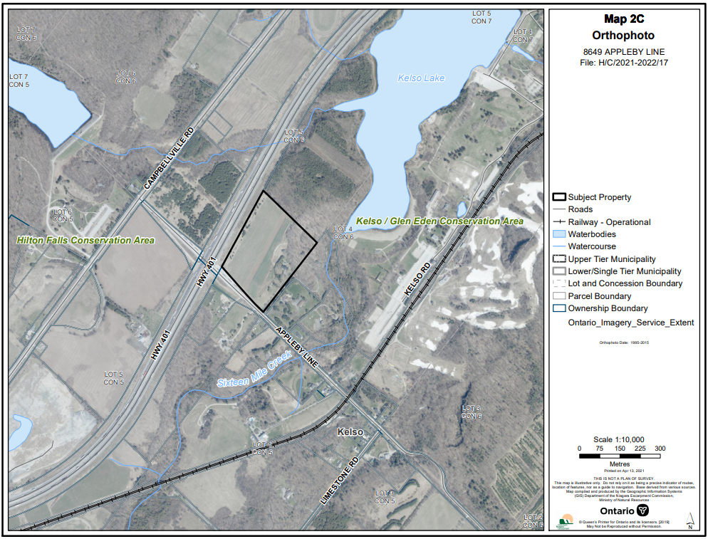

Appendix 2 Prime Agricultural Areas

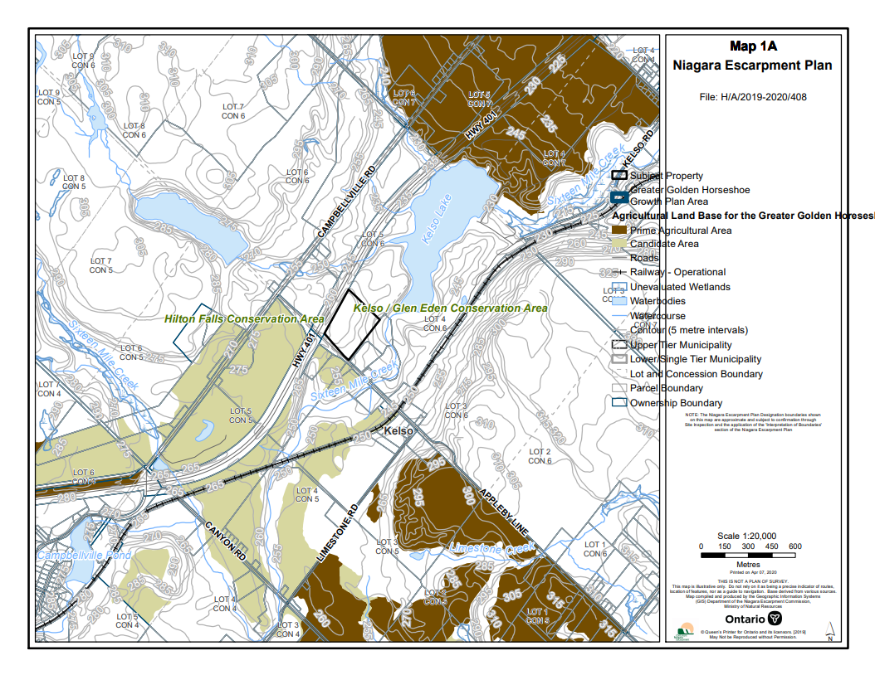

Appendix 3 – Site Plan
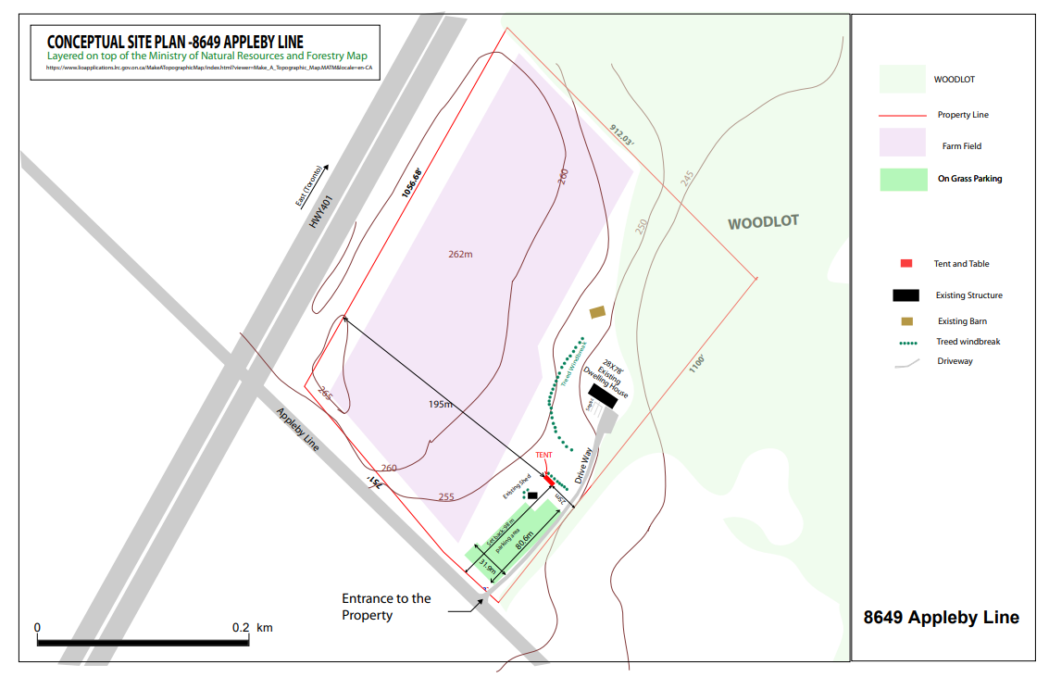

Appendix 4 – Business Plan, attached as a separate PDF

This is set out in O. Reg. 525/97 of the Planning Act. Within the GGH, any official plan amendment to designate, amend or revoke a prime agricultural area must come to the minister of Municipal Affairs and Housing for approval.

