September 16, 2021

A5: STAFF REPORT

DEVELOPMENT PERMIT APPLICATION:

N/A/2020-2021/748
360 Metler Road
Part Lot 7, Concession 6
Town of Pelham, Region of Niagara

SUMMARY

PROPOSAL:
To construct a 1.5 storey, ± 185.8 sq m (± 2000 sq ft) storage barn, with a height to peak of ± 6.1 m (± 20 ft), on an existing 3.48 ha (8.6 ac) lot to be reconfigured through a proposed boundary adjustment. Parcel A would be reconfigured from a 3.5 ha (8.6 ac) to ± 5.1 ha (± 12.7 ac) lot and would contain the existing dwelling, tree farm operation, and proposed barn. Parcel B would be reconfigured from a 2.1 ha (5.4 ac) to ± 0.6 ha (± 1.4 ac) lot and would remain vacant.

DESIGNATIONS:
Escarpment Protection Area; Escarpment Natural Area

ISSUE:
The property is within an Earth Science Area of Natural and Scientific Interest (ANSI), which is considered a key natural heritage feature by the Niagara Escarpment Plan (NEP). Agriculture is not listed as an exception to the prohibition on development within key natural heritage features.

RECOMMENDATION:
Refusal

REASONS:
Part 2.7.2 of the NEP states that development is not permitted in key natural heritage features with limited exceptions. The property is almost entirely within the Fonthill Kame Delta Earth Science ANSI. The barn is proposed within the ANSI, however agriculture is not listed as one of the exceptions to the prohibition on development within a key natural heritage feature.

RECEIVED:
March 17, 2021

SOURCE:
Arthur and Brigitta Cardin (owners)

PROPOSAL:
To construct a 1.5 storey, ± 185.8 sq m (± 2000 sq ft) storage barn, with a height to peak of ± 6.1 m (± 20 ft), on an existing 3.48 ha (8.6 ac) lot to be reconfigured through a proposed boundary adjustment. Parcel A would be reconfigured from a 3.5 ha (8.6 ac) to ± 5.1 ha (± 12.7 ac) lot and would contain the existing dwelling, tree farm operation, and proposed barn. Parcel B would be reconfigured from a 2.1 ha (5.4 ac) to ± 0.6 ha (± 1.4 ac) lot and would remain vacant.

BACKGROUND:

Related Files:
#3115/N/R/1988-1989/281 – A Development Permit was issued in May 1989 to construct a 1.5-storey, 7.3 m. (24 ft.) in height, 232.5-325.5 sq. m. (2500-3500 sq. ft.) single detached dwelling with septic system, and to remove an existing shed, on a 3.5 ha (8.6 acre) lot.
#7308/N/A/2000-2001/385 – A Devleopment Permit was issued in July 2001 to construct a 2 storey, 6.7 m (22 ft) high, 279 sq m (3000 sq ft) implement storage barn on an existing 3.5ha (8.6 ac) lot which supports a single dwelling. The construction did not occur.
#8139/N/A/2003-2004/358 – A Development Permit was issued in June 2004 to construct a 2 storey 279 sq m (3000 sq ft), 9 sq m (30 ft) high implement storage barn on an existing 3.48 ha (8.6 ac) lot. Note: this was an amendment (in height) to a previously approved application. The construction did not occur.

SITE DESCRIPTION:
The subject properties consist of two adjacent lots on the south side of Metler Road between Centre Street and Effingham Street in the Town of Pelham. Parcel A is a 3.5 hectare (ha) lot that currently supports a single dwelling and a Christmas tree farm operation. Parcel B is a 2.1 ha lot that is currently vacant. The properties are surrounded by rural residential properties and significant woodland to the southeast and agricultural operations to the north and west. The properties generally slope downward toward the northeast.
The rear of Parcel A contains significant woodland associated with the Short Hills/St. Johns Environmentally Sensitive Area. Two watercourses regulated by the Niagara Peninsula Conservation Authority (NPCA) traverse the property behind the dwelling.
The properties are almost entirely within the Fonthill Kame Delta Earth Science Area of Natural and Scientific Interest (ANSI), with the exception of the developed area around the existing dwelling. The Fonthill Kame Delta is a deposit of ice-contact and glaciofluvial sediment and is one of the most dominant landforms on the Niagara Peninsula. The Kame has been extensively impacted by previous development, most notably aggregate extraction and housing development.

PROPOSED DEVELOPMENT:
The applicant is proposing to construct an approximately 186 square metre implement storage barn for use in the tree farm operation and to reconfigure the existing lots through a lot line adjustment. Parcel A would increase in size from 3.5 ha to 5.1 ha and incorporate the proposed barn and additional agricultural land. The existing dwelling and accessory facilities would remain on Parcel A. Parcel B would decrease in size from 2.1 ha to 0.6 ha. No development is currently proposed for Parcel B. The proposed size of the lot would likely limit future development to a residential use.
The intent of the lot line adjustment is to construct the storage barn in the location that best benefits the existing tree farm operation. This location was selected as there is limited space on the currently configured Parcel A without taking land from the tree farm. The lot line adjustment would thus provide additional space for the construction of the barn and add additional lands to the existing agricultural operation. Additionally, the applicants intend to sell Parcel B in the future and as such want to ensure that the barn remains on the same property as the tree farm operation.

PLANNING ANALYSIS:

Niagara Escarpment Plan, 2017 (NEP)
The subject properties are designated as Escarpment Protection Area and Escarpment Natural Area by the NEP. Parcel A is largely designated as Escarpment Protection Area and the significant woodland at the rear of the property is designated as Escarpment Natural Area. Parcel B is entirely within the Escarpment Protection Area designation. The barn and lot line adjustment are proposed within the Escarpment Protection Area.
Part 1.4.3 of the NEP lists agricultural uses as a permitted use within this designation, subject to satisfying the Development Criteria in Part 2 of the NEP. An agricultural use is defined in the NEP as: “The growing of crops, including nursery, biomass, and horticultural crops; raising of livestock; raising of other animals for food, fur or fibre, including poultry and fish; aquaculture; apiaries; agro-forestry; maple syrup production; and associated on-farm buildings and structures, including, but not limited to livestock facilities, manure storages, value-retaining facilities, and accommodation for full-time farm labour when the size and nature of the operation requires additional employment (Provincial Policy Statement, 2014)”. The proposed use of the barn as implement storage for the tree farm operation meets the definition of an agricultural use in the NEP.
Part 1.4.4.2 of the NEP states that provided no new building lot is created, a severance may be permitted for the purpose of enlarging existing lots. No new building lot is proposed. The application is for a boundary adjustment to enlarge an existing lot associated with an agricultural operation.
Ontario Regulation 828/90 provides a definition for general agricultural development, which includes the cultivation of trees and nursery stock. General agricultural development may be exempt from requiring a Development Permit if certain criteria are met. While the cultivation of trees as part of a Christmas tree farm operation does not require a Development Permit, the proposed building does not meet the exemption criteria within Paragraph 9 of Section 5. The exemption criteria require that the lot is at least 20 ha (49.4 ac). A Development Permit is therefore required for the storage barn.
NEC staff note that the agricultural use on the property is existing and assessed whether the barn could be considered as part of the expansion of an “existing use”. However, the NEP definition of an “existing use” includes “the legal use of any land, building or structure for a purpose that is not otherwise listed as a permitted use under the applicable designation in the Niagara Escarpment Plan”. Given that agriculture is listed as a permitted use under the Escarpment Protection Area policies in Part 1, the development would not meet the definition of an existing use.

Part 2.2: General
Part 2.2.1 of the NEP states the Escarpment environment shall be protected, restored and where possible enhanced for the long-term having regard to single, multiple or successive development that have occurred or are likely to occur. The proposed barn and lot lines are located outside of the significant woodland on the property, however the development is proposed within the Fonthill Kame Delta Earth Science ANSI. The construction of the barn and lot line adjustment are unlikely to negatively impact the Kame feature. However, it is noted that the Kame has already been extensively impacted by development and the impact of successive development on the Kame needs to be considered.
Parcel B would be subject to future development and as such additional information is required to ensure that Parcel B is developable and that this development would not negatively impact the Escarpment environment. A hydrogeological study has been requested by Region of Niagara staff to determine any impacts on groundwater and environmental studies could be required at the time of a future application.
The barn and boundary adjustment are proposed within the Escarpment Protection Area designation, which is the least restrictive land use designation on the property. The site is not prone to natural hazards. Subject to additional studies, the development meets the General Development Criteria in Part 2.2 of the NEP.

Part 2.4: Lot Creation
Although no new building lot would be created by the boundary adjustment, a few of the development criteria in Part 2.4 are worth noting for the new lot lines.
Part 2.4.4 of the NEP requires that the size and configuration of new lots is subject to the requirements of official plans. The Region of Niagara Official Plan restricts the size of a residential lot within the agricultural area to 0.4 ha, except where additional land is deemed necessary to support private servicing. Regional staff thus request that Parcel B is as small as possible while still being able to sustain private servicing. The minimum size of the lot is to be determined through a hydrogeological study.
New lots must maintain and enhance the open landscape character of the Escarpment and protect and enhance existing natural heritage and hydrologic features and functions. The proposed lot is similarly sized to some of the nearby rural residential lots. The proposed lot line would not fragment the watercourses or significant woodland on the property, as these features would be entirely contained within Parcel A. A lot line through the Earth Science ANSI is existing and thus the proposed lot line would not further impact the feature. The proposal meets the Lot Creation Development Criteria in Part 2.4 of the NEP.

Part 2.6: Water Resources
All development is well setback from the watercourses and is outside of the NPCA Regulated Area. The property is located within a Highly Vulnerable Aquifer. Region of Niagara staff have concerns with the impact to groundwater and, as previously noted, have requested a hydrogeological study. The study would need to demonstrate that Parcel B is large enough to support the long-term operation of a private sewage system. This study would also determine the minimum lot size required for the operation of the system. The study has not yet been completed due to the conflict with the natural heritage policies. Subject to the completion of a hydrogeologic evaluation that demonstrates the lot size required to support private servicing, the proposal is consistent with Part 2.6 of the NEP.

Part 2.7: Natural Heritage
Part 2.7.1 of the NEP lists the key natural heritage features under the NEP. These include significant woodlands and Earth Science ANSIs. Part 2.7.2 of the NEP states that development is not permitted in key natural heritage features with a few limited exceptions. Agricultural uses are not listed as one of these exceptions. While the proposed storage barn is located outside of the significant woodland, it is located within the Earth Science ANSI. As such, the proposed agricultural storage barn is not permitted within the Earth Science ANSI and the proposal conflicts with the Natural Heritage Development Criteria in Part 2.7 of the NEP.
The barn is proposed within a disturbed area of the property that currently contains lawn and shrubs and is well set back from the significant woodland. A standard search of the Natural Heritage Information Centre database indicates the potential for Species at Risk (SAR) within a 1 km radius of the property. A number of endangered trees are listed within the area. The proposal does not include any tree removal and furthermore the trees near the proposed development site are associated with the tree farm operation. The nearby woodland would likely provide habitat for the listed species.
A checksheet for the Fonthill Kame Delta Earth Science ANSI created by the Ministry of Northern Development, Mines, Natural Resources and Forestry (MNDMNRF) identifies that much of the Kame is generally in agricultural use, which is typically not in conflict with the maintenance of the landform. The greatest concerns with development on the Kame are altering the contours and impacting viewscapes of important topographical features, removing natural vegetation on slopes, and grading in areas with important features. The barn is not proposed near any steep slopes that are susceptible to erosion and would not require tree removal or extensive grading. No negative impact to the key natural heritage features is anticipated as a result of the construction of the barn and lot line adjustment. However, it is noted that future development on Parcel B could require additional study, such as an Environmental Impact Study to ensure no negative impact on natural heritage or hydrologic features.
The proposal does not satisfy the Natural Heritage Development Criteria in Part 2.7 of the NEP, as the construction of an agricultural storage barn conflicts with Part 2.7.2.

Part 2.8: Agriculture
The Agricultural Land Base mapping for the Greater Golden Horseshoe Area identifies the property as within a Prime Agricultural Area, and specifically within a Specialty Crop Area. The proposed barn would support the existing agricultural operation on the property. The proposed lot line adjustment would increase the amount of land available for the tree farm operation and provide land for the barn outside of lands in active agricultural use. As discussed above, to ensure that as much land as possible is incorporated into the parcel associated with the tree farm (Parcel A), Parcel B would be just large enough to accommodate a single dwelling and private servicing. Parcel B is already undersized for an agricultural operation, thus the lot line adjustment guarantees that the additional land would be in agricultural production.
The proposed barn is to be used for storage and not livestock, and as such no Minimum Distance Separation (MDS) II calculation is required. Furthermore, the nearby barns do not have capacity for livestock. The proposed barn and lot line adjustment therefore satisfy the NEP policies for agriculture.

Part 2.10: Cultural Heritage
The subject lands exhibit potential for archaeological resources and are identified within the Town of Pelham Heritage Master Plan as having archaeological potential. Development is not permitted on lands containing archaeological resources or areas of archaeological potential unless significant archaeological resources are conserved. A Stage 1-2 archaeological assessment and any subsequent studies would be required to satisfy Part 2.10 of the NEP. The archaeological assessment has not been completed due to the natural heritage policy conflict.

Part 2.13: Scenic Resources and Landform Conservation
The property is within an area described as “Very Attractive” by the Landscape Evaluation Study. The proposed barn is located near the existing dwelling and is well set back from the road. The location of the barn is screened by vegetation at the front lot line and the trees that are part of the tree farm operation. Elevations for the barn have not been provided to date.
The Kame is considered an Escarpment Related Landform by the NEP and therefore planning, design and construction practices shall ensure that the Kame is maintained and enhanced. MNDMNRF’s Checksheet for the Kame states that natural vegetation on slopes should be maintained and grading in areas with important features should be avoided. The proposed site is located within a relatively flat area of the property. Any grading would only be to prepare a base for a floating pad. No tree removal is required. NEC staff do not anticipate a negative impact on the Kame and Part 2.13 of the NEP can be satisfied.

Region of Niagara Official Plan
The property is designated as Unique Agricultural Area within the Region of Niagara Official Plan. Agriculture, agriculture-related uses, on-farm diversified uses, single dwellings, existing uses, and accessory structures are permitted. Minor lot adjustments or boundary adjustments are permitted.

Town of Pelham Official Plan
The property is identified as within the Niagara Escarpment Plan Area by the Town of Pelham Official Plan.

Provincial Policy Statement (PPS)
Section 2.1 of the PPS states that natural features and areas shall be protected for the long term. The proposed barn and lot line adjustment are located outside of the significant woodland, however are proposed within an Earth Science ANSI. Although the proposed development is located within a disturbed area, development must not negatively impact the feature and function of the ANSI.
Section 2.2 of the PPS relating to water requires planning authorities to protect, improve or restore the quality and quantity of water. The Region of Niagara has requested a hydrogeological study to ensure that there would be no impact to groundwater, as the property is located within a Highly Vulnerable Aquifer.
Section 2.3 of the PPS states that prime agricultural areas shall be protected for long-term use for agriculture. The proposed barn and lot line adjustment would ensure that prime agricultural lands continue to be used for agriculture. As per Section 2.3.4.2, lot adjustments in prime agricultural areas may be permitted for legal or technical reasons. The proposed lot adjustment does not result in the creation of a new lot and can be considered a minor adjustment.
Section 2.6 of the PPS directs the conservation of archaeological resources. An archaeological assessment would be required to ensure that any potential archaeological resources have been conserved.
Subject to additional studies, the proposal appears to be consistent with the PPS. However, Part III of the PPS states that Provincial plans, such as the NEP, take precedence over the policies of the PPS to the extent of any conflict. Therefore, the NEP policy prohibiting agriculture within a key natural heritage feature takes precedence over the PPS policy that allows for development subject to demonstrating no negative impact.

AGENCY CONSULTATIONS:

Town of Pelham
The subject lands were zoned Agricultural 1 (A1) prior to the NEC having Development Control. A consent application for the proposed lot boundary adjustment must be applied for and granted to facilitate the construction of the barn. A building permit is required. Building elevations would help to illustrate the proposed use of the barn and how the development compliments the Escarpment character. If the proposed barn is to be used for livestock operation, the building must meet Minimum Distance Separation setbacks.
Town staff note the property is designated as a Provincial Earth Science ANSI and part of the property is regulated by the Niagara Peninsula Conservation Authority. The Town’s Heritage Master Plan identifies the property as having composite archaeological potential. The proposed footprint of the barn is quite significant and will extend beyond the previously disturbed site. A Stage 1-2 Archaeological Assessment and associated Ministry Clearance Letter is required.

Region of Niagara
The subject property is designated as Unique Agricultural Area by the Regional Official Plan (ROP). Permitted uses include agricultural, agriculture-related, on-farm diversified uses, a single dwelling on existing lots of records, and all existing uses. Accessory structures are also permitted, provided new municipal services are not required, and the use does not expand into a key natural heritage features or key hydrologic feature. The barn is considered to be an agricultural use and is therefore a permitted use.
The ROP permits minor lot adjustments or boundary additions provided these do not create a separate lot for a residential dwelling, and there is no increased fragmentation of a key natural heritage feature or key hydrologic feature. It appears that the majority of the agricultural land on Parcel A is in full agricultural production. The proposed boundary adjustment would increase the amount of land available for the tree farm operation on Parcel A and provide additional land to allow for the construction of the proposed barn. The subject property is located within a Highly Vulnerable Aquifer and as such a hydrogeological study is required to confirm that Parcel B will be large enough to support the long-term operation of a private sewage system without significant adverse impacts to groundwater quality. The size of Parcel B would likely limit any future development on it for residential use. The ROP restricts the size of a residential lot in the agricultural area to 0.4 hectares except where any additional land is deemed necessary to support private servicing. Regional staff will require that the area of Parcel B be limited to the minimum size needed to support sustainable private servicing as established through the required hydrogeological study. The reconfigured Parcel A contains sufficient usable land for a replacement sewage system.
The subject lands are impacted by the Region’s Core Natural Heritage System (CNHS), consisting of Significant Woodland. The subject lands are also part of the Fonthill Kame Delta Provincially Significant Earth Science ANSI. As the reconfigured lot lines and proposed barn will be greater than 50 metres from the Significant Woodland, Regional staff have no objections but note that any future development may be subject to additional studies.
The subject lands exhibit high potential for the discovery of archaeological resources due to their proximity to several past and present watercourses. The Town of Pelham has an approved Heritage Master Plan and therefore has jurisdiction on matters related to archaeological resources and the NEC should defer to Town comments.

Niagara Peninsula Conservation Authority (NPCA)
Both Parcel A and Parcel B are impacted by an NPCA regulated watercourse, but given the scope, nature and location of the proposed application, NPCA staff have no objections or requirements. If any works are proposed within 15 m of the subject watercourse, an NPCA work permit will be required.

Ministry of Northern Development, Mines, Natural Resources and Forestry (MNDMNRF)
The following natural heritage features are known to be in vicinity of the proposed work area: Fonthill Kame Delta Earth Science ANSI (provincially significant) and White Tailed Deer Wintering Area (Stratum 2) on adjacent property. Care should be taken to ensure that these features are not impacted by the proposed works.

CONCLUSION:
Agriculture is considered a permitted use in Part 1 of the NEP, subject to meeting the Development Criteria in Part 2 of the NEP. The existing tree farm and proposed implement storage barn is included in the definition of agricultural uses. Part 2.7.2 of the NEP limits development with a key natural heritage feature. Agriculture is not listed as an exception to the prohibition on development with a key natural heritage feature and the proposed barn is therefore not permitted within an Earth Science ANSI.
Subject to additional studies (i.e., hydrogeological study, archaeological assessment), the proposal appears to satisfy the Development Criteria relating to lot creation, water resources, agriculture, cultural heritage, and scenic resources and landform conservation. The applicant has not been asked to provide additional studies at this time, as the proposal conflicts with Part 2.7.2 of the NEP.

RECOMMENDATION:
That the application be refused because:
- Agricultural uses are not permitted within key natural heritage features (i.e., Earth Science ANSI), as per Part 2.7.2 of the NEP.

Prepared by:

Original signed by:
______________________
Cheryl Tansony
Senior Planner

Approved by:

Original signed by:
________________
Debbie Ramsay MCIP, RPP
Director

Appendix 1 – Orthophoto of the properties
Appendix 2 – Land use designations and natural heritage features
Appendix 3 – Site plans provided in a separate document

APPENDIX 1

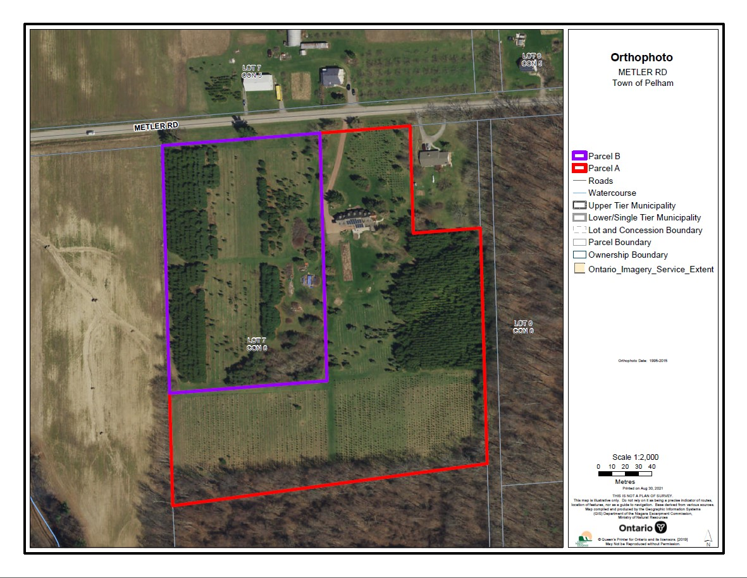

APPENDIX 2

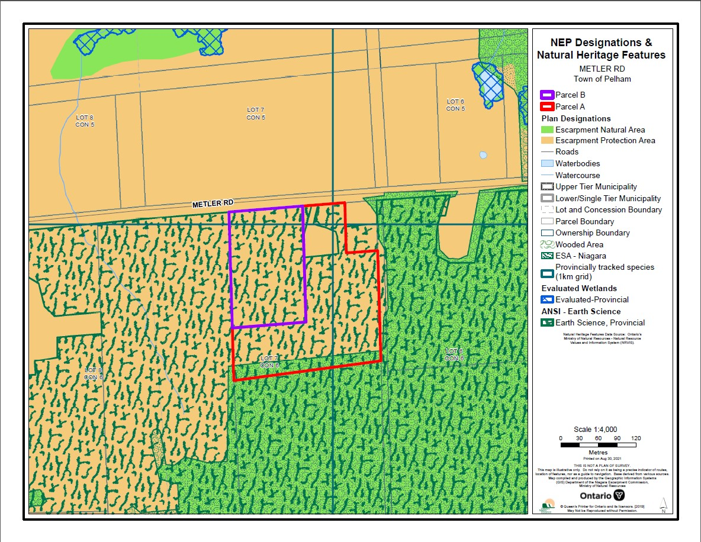

The 1994 NEP, which was in effect at the time of these Development Permits, permitted development within provincially significant Earth Science ANSIs, provided that development does not significantly alter the natural topography or geological features and methods are employed to minimize the impact of the use on the values for which the site has been identified.

