**2020 - 2021  
Annual Report**

Niagara Escarpment Commission





June 30, 2021

**THE MINISTER OF NORTHERN DEVELOPMENT, MINES, NATURAL RESOURCES AND FORESTRY**

I have the honour to submit to you the Annual Report of the Niagara Escarpment Commission for the year commencing April 1, 2020 and ending March 31, 2021.



Rob Nicholson

Chair, Niagara Escarpment Commission

Table of Contents

Introduction and Background 4

Chair’s Message 5

The Niagara Escarpment 7

The Niagara Escarpment Commission 8

The Niagara Escarpment Plan 9

Strategic and Operational Context 10

Purpose 10

Objectives 10

Operational Strategy 12

Operational Strategy Overview 13

NEC Operational Strategy – Core Elements 13

1. Business and Organizational Effectiveness 14

Team-Based Model 14

Recruitment and Succession Planning 16

Recruitment and Staffing 16

Succession Planning 16

Staff Training 17

Alternate Work Arrangements (Telecommuting) 18

Business Process Improvement 18

Database Renewal and Information Technology Enhancements 19

2. Promote the NEC 23

Enhancing NEC’s Digital Products 24

3. Streamline and Modernize Regulations and Legislation 26

Phase 1 - Modernization of Regulation 826 26

Phase 2 - Rationalizing the Development Control Boundary 26

Modernized Legislation 27

Activity Reports 28

Niagara Escarpment Plan Implementation 29

Development Permit Activity 31

Niagara Escarpment Plan Amendments 38

Niagara Escarpment Parks and Open Space System 41

Compliance Program 43

Environmental Monitoring 47

Niagara Escarpment Biosphere 48

Performance Measures 49

Financial Summary 53

Appendices 55

Appendix 1: Niagara Escarpment Commission OIC Appointments 56

Appendix 2: Niagara Escarpment Plan Map 57

Appendix 3: Municipalities in the NEP Area 58

Region of Niagara 58

City of Hamilton 58

Region of Halton 58

Region of Peel 58

County of Bruce 58

County of Dufferin 58

County of Grey 58

County of Simcoe 59

# Introduction and Background

## Chair’s Message

The focus of the Niagara Escarpment Commission’s (NEC) 2020-21 fiscal year was adapting to conditions associated with the COVID-19 pandemic and the related stay at home orders. Despite the challenges faced by the pandemic, the NEC demonstrated perseverance and still maintained growth throughout many areas of our organization.

The NEC achieved a high level of organizational resilience and effectiveness in adapting to circumstances over the past year. The ability to continue to deliver a high-quality, robust program is attributed to the dedication and professionalism of staff and the structure provided by our Operational Strategy. In this past year, staff continued to work remotely while dealing with record high numbers of development permit applications and inquiries. They are to be commended.

In 2020-21, the Commission attained a full complement of 17 appointments. Commissioners were provided with orientation sessions that included reviewing responsibilities outlined under the Agencies Appointments Directive and implementation of the Niagara Escarpment program. Further, all Commissioners were provided introductory training on Indigenous culture, engagement and the responsibilities related to the duty to consult. The Commission also met to advance preparation of Policy Guidance Material and Technical Criteria to support implementation of the Niagara Escarpment Plan.

In addition, the NEC continued to work with NDMNRF on modernization and efficiency measures aimed at further cost savings and streamlining of processes. The NEC’s need for a new database and IT solution is becoming a critical issue as we look to align with e-government initiatives, achieve effective streamlining and mitigate operational risks associated with the current, outdated system.

I am pleased to report that the NEC’s work with NDMNRF and the Ontario Surveyor General to digitize the area of Development Control is moving forward. The new regulation will be coming into effect July 1, 2021. This drastically improves the accuracy of maps in the area of Development Control, providing a more efficient process for NEC customers. This new digital regulation paves the way for the subsequent phase of the Development Control boundary project which starts a process to examine and potentially modify the Development Control boundary in urban areas where municipal zoning is in place and where specific criteria are met. In 2020-21, the Commission also restated its support for the City Hamilton’s interests in having the Pleasant View area included in the Development Control area.

The NEC’s 2020-2021 Annual Report highlights concrete measures that the agency achieved to ensure the continued delivery of its program during a world-wide pandemic.

**Original signed by**:



Rob Nicholson, Chair

## The Niagara Escarpment

Spanning 725 kilometers from the tip of Niagara Region to the top of the Bruce Peninsula, the Niagara Escarpment is one the world’s most magnificent natural landforms. More than 450 million years old, the Escarpment makes up almost one-quarter of Ontario’s Greenbelt and is home to Canada’s longest footpath, the Bruce Trail. As one of the last remaining bands of continuous forest cover and natural heritage linkages in southern Ontario, it provides vital habitat for numerous species at risk and is the source of many of the Greater Golden Horseshoe’s major river systems.

In 1973, the Ontario government passed the *Niagara Escarpment Planning and Development Act* (NEPDA) to protect the Escarpment. Through the NEPDA, a land-use planning process was put in place and the NEC was established.

In 1985, the Province created the Niagara Escarpment Plan (NEP), Canada’s first large-scale environmental land-use plan. The NEP area covers 195,000 hectares in portions of 23 local municipalities within seven regions and counties and the City of Hamilton. The plan establishes land-use designations, development criteria and related permitted uses. It also provides the framework for a string of more than 160 parks and open spaces linked by the Bruce Trail.

While the NEP contains a strong emphasis on environmental protection, its role in preserving the open landscape character of the Escarpment and supporting agriculture is also good for business in Ontario. Rural and agricultural communities on the Escarpment support thousands of jobs and produce food consumed by people locally and all over the world, contributing millions of dollars annually to the region’s economy. As well, the Escarpment contributes an estimated $100 million annually to local and regional economies through tourism.

In 1990, this visionary model of environmental protection established through the NEC and the NEP earned the Escarpment recognition as a United Nations Educational, Scientific and Cultural Organization (UNESCO) World Biosphere Reserve—one of 18 across Canada. This prestigious designation recognizes the Escarpment as an internationally significant landform that balances cultural and biological diversity with economic and social development.

With the Escarpment traversing the Greater Golden Horseshoe, today one of the most heavily developed and fastest growing regions in North America—with a population of more than 9.245 million—the preservation of this precious and world-renowned landscape has never been more challenging and important.

## The Niagara Escarpment Commission

The NEC was established in June 1973 as a non-board governed regulatory agency that operates at “arm’s-length” from the provincial government.

The NEC’s role is to administer the NEP by making decisions on proposed development permit applications and making recommendations to the Minister of Natural Resources and Forestry on proposed NEP amendments. The NEC is mandated to interpret and apply policies of the NEP in a way that achieves the purpose and objectives of the NEPDA and NEP. The decisions of the NEC are made independently, impartially and according to a risk management framework.

The NEC has 17 positions—16 Commissioners and a Chair—appointed by Order-in-Council. Nine members, including the Chair, represent the public-at-large and eight members represent the upper- and lower-tier municipalities within the NEP area. A full list of Commission members that served in 2020-21 is listed in Appendix 1. For the first time in several years, the NEC is functioning with a full complement of 17 appointees.

The Commission meets regularly to consider development permit applications and land-use proposals, development of policy guidance to support NEP implementation, deal with amendments, and to address compliance matters. For the entirety of 2020-21, the Commission met through ‘virtual’ meetings (via WebEx) due to the COVID-19 pandemic and closure of workplaces.

Meetings remain open to the public and were accessible through WebEx. The NEC is supported by 24 full-time and four seasonal staff positions.

## The Niagara Escarpment Plan

The Niagara Escarpment and lands in its vicinity are protected by the NEP. In 1985, the Ontario government adopted this visionary, environment-first plan, which aims to maintain the Escarpment “substantially as a continuous natural environment”. Any development that occurs within the NEP area must be compatible with this purpose.

The NEP area covers portions of 23 local municipalities within seven regions and counties, and the City of Hamilton. A map of the NEP area is found in Appendix 2 and a full list of the municipalities found within the NEP area is contained in Appendix 3.

The NEP outlines land-use designations and associated development criteria. The plan also provides the framework for more than 160 parks and open spaces linked by the Bruce Trail. As well, the NEP protects significant natural heritage features and ensures the maintenance of the Escarpment’s open landscape, conserving the Escarpment’s scenery, agricultural land and complementary rural activities.

The NEP is reviewed and amended on a regular basis. Legislated reviews of the NEP were completed in 1994, 2005 and most recently in 2017. In 2005, the NEPDA was revised to coordinate the review of the NEP with the 10-year review of the Greenbelt Plan. In May 2017, the most recent review came to a conclusion with the release of four revised provincial land-use plans: the Greenbelt Plan, the Oak Ridges Moraine Conservation Plan, the Growth Plan for the Greater Golden Horseshoe, and the NEP. The updated NEP came into effect on June 1, 2017.

The NEP (2017) includes updated mapping that reflects changes on the landscape, and new policies that provide stronger protection for natural heritage features and functions. New agricultural policies support the Province’s efforts to grow Ontario’s agri-food and rural sectors and ensure that farming continues to be a viable economic activity in prime agricultural areas. The NEP also enables the Commission, in consultation with NDMNRF, to prepare and issue guidance material and technical criteria to assist implementation. The section of this Annual Report entitled “Niagara Escarpment Plan Implementation” provides a summary of work initiated by the NEC in this regard.

## Strategic and Operational Context

As a provincial agency, the NEC functions in accordance with the following values of the Ontario Public Service (OPS): trust, fairness, diversity, excellence, creativity, collaboration, efficiency and responsiveness. The NEC’s strategic focus is rooted in NDMNRF’s vision as set out in its Strategic Plan, Naturally Resourceful, in which:

*Ontarians benefit from the health and wealth of the province’s natural resources, today and in the future.*

The mission is:

*To sustainably manage and promote the responsible use of our natural resources.*

The NEC is governed by the NEPDA, the provincial government’s Agencies and Appointments Directive, as well as a Memorandum of Understanding (MOU) and Delegation of Authority between the NEC Chair and the Minister of Natural Resources and Forestry. The NEPDA establishes the planning framework for the NEP. The role of the NEC is to implement the NEP and related program responsibilities in a way that achieves the purpose and objectives of the Plan and the Act:

### Purpose

To provide for the maintenance of the Niagara Escarpment and land in its vicinity substantially as a continuous natural environment, and to ensure only such development occurs as is compatible with that natural environment.

### Objectives

* To protect unique ecological and historic areas
* To maintain and enhance the quality and character of natural streams and water supplies
* To provide adequate opportunities for outdoor recreation
* To maintain and enhance the open landscape character of the Niagara Escarpment in so far as possible, by such means as compatible farming or forestry and by preserving the natural scenery
* To ensure that all new development is compatible with the purpose of the plan
* To provide for adequate public access to the Niagara Escarpment
* To support municipalities within the Niagara Escarpment Plan Area in their exercise of the planning functions conferred upon them by the Planning Act.

A new MOU between the NEC Chair and the Minister of Natural Resources and Forestry was prepared and signed in early 2021. In general terms, the MOU

provides additional detail to the NEC regarding its mandate and core functions, while the Delegation of Authority designates the power to approve Development Permit Applications and other responsibilities to the Commission and the Director, under certain circumstances. Taken together, the NEPDA, the NEP, the MOU and the Delegation of Authority define the governance structure of the NEC.

The operational context for the NEC in 2020-21 involved the continuation of work from home arrangements due to the COVID-19 pandemic. While working from home presented challenges, Commission staff continued to adapt, find efficiencies and solutions, and ensure objectives of the NEP would be met. In the later part of 2020 and early in 2021, Commission staff began to experience a significant upswing in the number of Development Permit applications triggered by soaring real estate markets. This presented challenges to staff and resulted in an increase in the timelines for issuance of Development Permits.

A significant strategic initiative is underway within NDMNRF involving the creation of the Recovery and Renewal Secretariat that was formed to oversee and support re-opening of the workplace, as well as influencing resumption and reimagination of effective and efficient service delivery. The NEC is engaging with the Secretariat to optimize its programs, leverage opportunities and to align with broader government and ministry initiatives.

Also, under the Agencies and Appointments Directive, the NEC is required to submit an Annual Report to the Minister of Natural Resources and Forestry for approval within 90 days of the end of the fiscal year. This report describes the activities in fiscal year 2020-21. Once approved by the Minister, the Annual Report is tabled in the Legislature before being made publicly available and posted to the NEC’s website at www.escarpment.org.

# Operational Strategy

# 

## Operational Strategy Overview

In June 2017, at the conclusion of the provincial government’s Co-ordinated Land Use Planning Review, the NEC began implementing a multi-year Operational Strategy to guide its mandate: the implementation of the 2017 NEP. This section of the Annual Report provides an update on the agency’s continued progress in 2020-21 toward implementing the agency’s Operational Strategy.

The need to adapt to working from home and addressing new program implementation tactics due to the COVID-19 pandemic impacted the execution of elements of the Operational Strategy. Notwithstanding, it has remained an important framework and was highly effective in supporting business continuity over the past year and made the Commission resilient and adaptable to the emergency situation.

Specific activities and achievements under each of the priorities are described in the sections that follow. Impacts of the Provincial Emergency Orders on implementing aspects of the Strategy are also noted.

## NEC Operational Strategy – Core Elements

1. **Business & Organizational Effectiveness**

* Develop and align resources (i.e. people, information, tools and space) and streamline business processes to continuously improve program implementation and customer service.

1. **Promote the NEC**

* Seek partnerships and collaboration with regulatory partners and stakeholders on the efficient and streamlined implementation of the NEP.
* Educate clients, regulatory partners, stakeholders and Indigenous communities on the 2017 NEP and the Niagara Escarpment’s UNESCO Biosphere Reserve designation.

1. **Streamline and Modernize Regulations and Update Legislation**

* Propose to the government changes to the NEPDA focused on process and program delivery efficiencies, and to modernize the legislative framework governing protection of the Niagara Escarpment.
* Propose to the government refinements to the NEC’s Development Control boundary and consider regulatory refinement to cut red tape and support more efficient approval processes and program delivery.

## Business and Organizational Effectiveness

### Team-Based Model

In 2020-21, the NEC relied heavily on the team-based service delivery model to support its operations while working remotely. Through this model, multi-functional teams are assigned to geographically based client groups to deliver the full range of NEC services. There are three teams – one for each of the southern, central and northern portions of the NEP area. As noted in the NEC’s Business Plan, the original driver for the team-based approach was to improve customer service by increasing collaboration, sharing workload through efficient and consistent triaging and providing a forum to facilitate knowledge transfer and collaboration amongst NEC staff and with regulatory partners. The benefits of the Integrated Team approach were highlighted throughout the COVID-19 pandemic and the requirement for staff to work from home. Regular Team meetings continued, and the approach ensured staff had a network of support, as well as a process to highlight issues and obtain assistance from colleagues. In addition, these highly functioning teams supported on-boarding of new staff and provided mentorship in a manner that may not otherwise have been possible.

Each Team consists of:

* Senior Strategic Advisor
* Senior Planners
* Planner(s)
* Administrative Support

In addition, support is provided across all teams by the following:

* Geographic Information System, Information Management and Information Technology Unit
* Compliance Unit
* Landscape Architect
* Marketing and Communications
* Commission Meeting and Administrative Support

Table 1 below compares the volume of development permit applications received by the NEC with the volume processed during the last six fiscal years, being the time period prior to introduction of the Operational Strategy to the end of 2020-21 (current year). The data shows that the number of applications received spiked after 2015-16 and continued to rise until 2018-19 when it levelled off. There was a slight decrease in applications received in 2019-20 over last year in part due to onset of the COVID-19 pandemic and general decrease in economic activity. However, the significant spike in 2020-21 is on par with the high volumes of 2017-18.

Notably, the data shows that the NEC’s output capacity—its ability to process this increased workload—increased significantly over the period of 2015-16 to 2017-18 (by 58%) and by 44 per cent in 2018-19. This increased output capacity is due to the implementation of the Operational Strategy, specifically the introduction of the new team-based service delivery model and establishment of additional positions to better align with the volume of work and need for improved customer service. Table 1 also shows the backlog of applications (comparison of number of applications received versus processed) increased in 2020-21. This can be attributed to applicants deciding to put their applications ‘on hold’, as well as reduced capacity and operational challenges due to working from home as well as staff turnover.

**Table 1**

|  |  |  |  |  |  |  |
| --- | --- | --- | --- | --- | --- | --- |
|  | 2015-2016 | 2016-2017 | 2017-2018 | 2018-2019 | 2019-2020 | 2020-2021 |
| Applications Received | 650 | 746 | 760 | 733 | 641 | 757 |
| Applications Processed | 519 | 644 | 823 | 748 | 656 | 534 |
| *Active Applications (as of March 31) | 521 | 633 | 585 | 488 | 445 | 649 |
| **Backlog +/- (as of March 31) | 131 | 102 | -63 | -15 | -15 | 223 |
| Average Processing Time (weeks) | 21 | 24 | 29 | 26 | 27 | 26 |
| * Due to a number of factors, some files carry over fiscal years. The Active Applications category represents the number of total open applications at any given point in time, regardless of when they were submitted. It is accumulative and is not dependent on any given fiscal year.   ** The Backlog category measures whether the total number of open applications (i.e. Active Applications) is growing or shrinking. If more applications are processed than received in a given fiscal year, the backlog is decreased. Conversely, if more applications are received than are processed in a fiscal year, the backlog grows. | | | | | | |

## 

## Recruitment and Succession Planning

Implementation of the NEC’s Operational Strategy in 2017 included several strategic actions to build internal capacity and support succession planning.

### Recruitment and Staffing

During this year, several significant staffing changes led to some organizational adjustment, which in turn contributed to delays in processing applications and impacted the NEC’s staffing complement. To build that critical internal capacity, the NEC undertook important recruitment and staffing actions that included hiring to the FTE limit of 24 staff, 4 seasonal positions and 4 summer students.

### Succession Planning

Succession planning is important to ensure the NEC continues to be a healthy and vibrant organization that has the human resources to effectively implement the Niagara Escarpment program. The NEC has experienced recent staff turnover due to individuals moving to positions outside of the Ontario Public Service, retirements of long serving staff, as well as through parental leaves and individuals being placed into more senior positions. The number of concurrent changes has resulted in a higher than normal number of vacant positions, temporary assignments and recruitment.

From a succession planning perspective, the NEC has significantly benefitted from having a “feeder group” of seasonal planners that have the experience and capacity to move into more senior positions. This approach minimized disruption to service delivery through a significant period of transition in the previous year which continued in 2020-21. The NEC’s staffing strategy has continued to result in an organization that is nimble and can more readily align its resources to emerging challenges. However, the number of individuals placed in positions on an acting or fixed term basis is creating disruption and an organization in transition. The situation will stabilize in 2021-22.

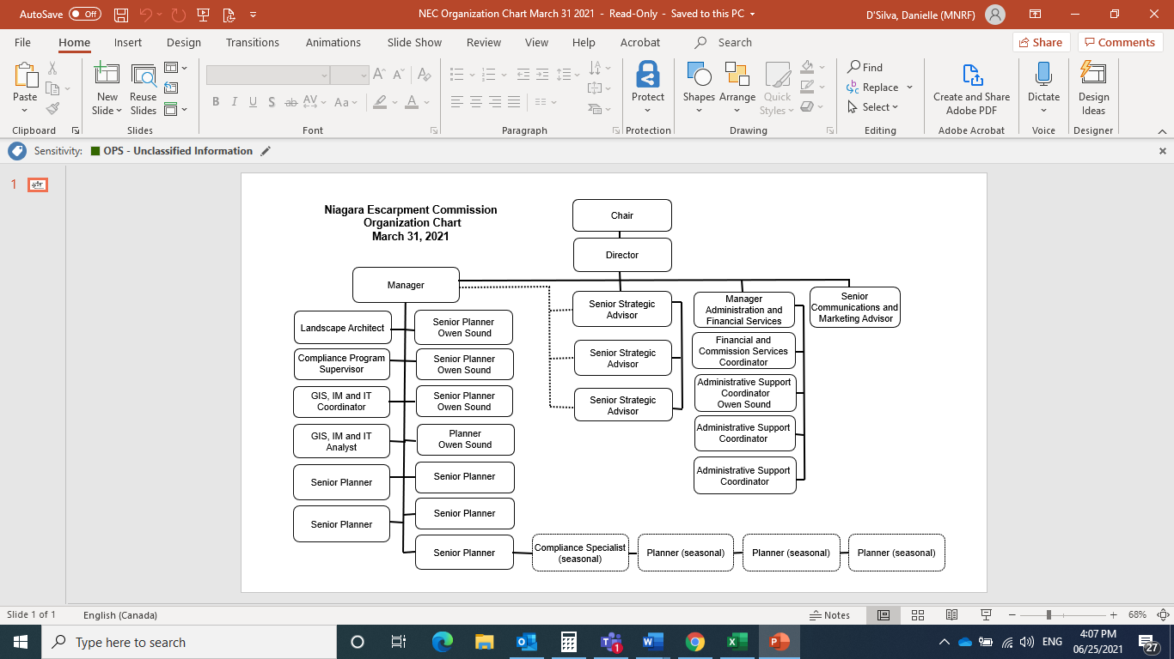

### Staff Training

Land use planning is an ever-changing and highly complex discipline. In Since 2017-18, the NEC had initiated a Learning Strategy to support staff kept pace with changes in this field and have the skills and knowledge they require to do their jobs effectively, and that learning opportunities are provided strategically and equitably across the NEC.

Previous fiscal constraints followed by the COVID-19 pandemic significantly decreased the staff training options available. However, staff were able to attend online training sessions.

NEC staff participated in the following online learning events during fiscal 2020-21 (in brackets is the organization that presented the training sessions):

* Indigenous Cultural Competency Training (OPS/San’yas Indigenous Cultural Safety Training Program
* Farmland Protection (Ontario Farmland Trust Webinar)
* Land-Use Planning in Niagara (hosted by Brock University)
* Black Bear Encounter Safety Training (NDMNRF)
* Weir Foulds Annual Seminar – Update on Planning Framework (OPPI)
* Latornell Conservation Symposium – Foundation and Evolution of Conservation Authorities (Latornell)
* MDS Fundamentals and Advanced Training (OMAFRA)
* Statement of Environmental Values Training (NDMNRF)
* Environmental Assessments Modernization (NDMNRF)
* Ergonomics on Working from Home
* Health and Safety Training specific to COVID-19
* Anti-racism Seminar (NDMNRF – Café 5)

### Alternate Work Arrangements (Telecommuting)

In 2018-19 the NEC launched a pilot program regarding alternative work arrangements. The program allows staff to work from home, or an alternate approved location, based on agreed-upon terms. In 2019-20 the NEC made a strategic decision to replace desktop computers with laptops and VPN capacity to facilitate working from home and further reduce the need for desktop computers.

This was extremely advantageous during the onset of COVID-19 when all staff were directed to work from home effective March 16, 2020 with little advance notice. Having alternative work arrangements in place meant that the NEC could make the transition in a seamless and highly effective manner. These alternate work arrangements continued in 2020-21.

## Business Process Improvement

In 2017-18, the NEC began an initiative to map its main business processes as a means of improving organizational effectiveness, both in terms of finding business efficiencies and enhancing customer service. Business process mapping involves documenting processes in a flowchart format and initiating an ongoing effort of continuous improvement by identifying redundancies, bottlenecks and opportunities to streamline.

The following table shows the processes that have been completed, those in progress and those that are planned for future.

**Table 2**

|  |  |  |
| --- | --- | --- |
| **Processes Mapped** | **Processing In Progress** | **Processes Planned** |
| * Development Permit Application (DPA) * Responding to DPA Inquiries * Responding to Property Inquiries * Preparing Property Information Reports * Processing Development Permit Exemptions * Notice of Decision & Appeals Process * Commission Meetings * Niagara Escarpment Plan Amendments | * Enforcement/Compliance Procedures | * Commission Staff Reports (Policy) * Commission Policy Meeting Procedures * Planning Act Applications |

In documenting business processes, NEC continues to identify efficiencies. This work is providing greater consistency of NEP implementation and is building a permanent record of how NEC business is done, which is an invaluable training and succession-planning tool. The process also identified the need for guidelines to support various process elements. Some of this work is still underway.

More significantly, the NEC was well positioned to on-board new staff in the midst of COVID-19 since all processes were clearly documented and accessible through collaborative IT platforms. Streamlined processes and efficiencies put in place during COVID-19 will inform changes to the Business Process Mapping.

## Database Renewal and Information Technology Enhancements

In 2020-21, the NEC’s priority remained on seeking to replace the outdated database. The database is critical in the NEC’s operation of processing Development Permit applications. The existing system was developed in the early 2000s and has reached the end of its life cycle. The current database lacks relational and search capabilities of modern applications, is prone to human error and cannot produce robust statistics to accurately measure performance and support continuous improvement. Further, it does not have the capacity for electronic submission and management of applications.

The following activities occurred in 2020-21 to address the NEC’s needs and align program implementation with NDMNRF’s Digital Strategy.

1. **Replacing the existing permit application database**

* The NEC submitted a project proposal for fiscal year 2021-2022 through the Ministry’s Committee on Information Management and Information Technology (MCIMIT) to replace the existing permit application database with a modern information management system.
* Phase 1 of the project was completed in 2019-2020. The NEC worked with LRC to examine existing application solutions utilized by the province and provide a blueprint for the development of a modern information management system. Out of this initial phase, three options were identified (.NET, Siebel and Java) with coarse level coast estimates for each.
* The Permission Enterprise Platform (PEP), an existing Java solution currently in use throughout the OPS, was identified as a potential option to replace the NEC’s existing development permit database.
* In 2019-20, the NEC, working with LRC Solution Designers, completed the work of identifying the core functionality of a PEP solution that would be required to meet the agency’s business needs. NEC staff tested the application and confirmed that it would support database needs and enable a comprehensive on-line application and process management.
* The NEC continues to work with NDMNRF regarding funding support for a PEP application and is participating in discussions regarding how NEC needs can be addressed through other similar projects occurring within the Ministry.
* At the end of 2020-21 the NEC submitted a project proposal to replace the database and achieve digital application/file management, streamline operations, align with e-government initiatives and apply LEAN[1] approaches.

1. **Enhancements to the existing permit application database**

* The existing development permit database is a critical application that is utilized by NEC staff daily. Until a new system is developed, the NEC has undertaken a process to clean up the data and to maintain and enhance the existing permit application database to ensure it is operating as efficiently as possible.
* Overall, the process has led to a better representation of current active applications within the database, which has supported the setting of priorities and the triaging of development permits. It has also enabled better oversight and quality control of the development permit process, thereby improving service delivery.

In 2020-21, the NEC also undertook the following information management and information technology initiatives:

1. **Enabling all staff to work from home**

* Hardware essentials, such as remote computers and VPNs, were provided to staff in a timely manner. New equipment needs were identified, including phones, headsets, and webcams, were ordered to be directly delivered to staff houses. Hardware set-up support was provided remotely and upon request by NEC’s GIS, IM and IT Unit.
* Office 365 allowed NEC staff to facilitate work from home during the COVID-19 emergency period. Microsoft Outlook on the web gave staff quick access to emails, calendar, and contacts from any location and on any device. Microsoft OneDrive and SharePoint provided secure cloud storage for files, giving staff the convenience of accessing files, sharing documents and collaborating with colleagues.
* Digital communication allowed efficient teamwork to take place while working remotely. Microsoft Teams played a major role in maintaining close communication and collaboration among staff through group chats, audio and video calls and file sharing. GIS, IM and IT team could remotely assist staff solving technical difficulties with ease. Reports, maps and other documents were shared and updated through Teams Group.
* In 2020-21, the NEC continued to adopt new process to improve remote work environment. ArcGIS Online web Map Viewer was developed as a more efficient alternative to ArcMap Desktop when NEC staff are working from home. It gave staff access to mapping information remotely without the need of a VPN. ArcGIS Online web Map Viewer also assisted NEC staff when dealing with telephone or email inquiries by being able to quickly pull up mapping information. The efficiencies gained freed up NEC staff time to focus on other areas of our core business.

1. **Adopting Virtual Commission Meetings**

* Due to restrictions related to COVID-19, the NEC was unable to convene regular in-person commission meetings in 2020-21. However, the NEC has implemented a successful process to host virtual Commission meetings via WebEx, a video conferencing platform, where commissioners were able to consider Development Permit Application and discuss policy items over the internet. Members of the public also had the ability to listen and/or watch meeting proceedings and participate, where appropriate.
* The NEC initially implemented virtual meetings to enable critical or time sensitive matters to be dealt through commission meetings. The success of WebEx and organization of the first virtual meeting led Commissioners to request a regular virtual meeting schedule through WebEx.
* Virtual commission meetings functioned in place of regular in-person meetings to the maximum degrees possible. Practical and technical challenges were carefully assessed, mitigated and resolved by NEC’s GIS, IM and IT unit prior to meetings. For instance, meeting participants were contacted by NEC’s GIS, IM and IT staff member via email to arrange a connectivity test prior to the meeting to ensure full participate.

1. **Geocortex Web Mapping Tool**

* In 2019-20, the NEC submitted and received approval for a project through NDMNRF’s IM & IT committee which replaces NEC’s existing Google Maps API Web mapping tool with a modern digital platform, such as the Geocortex framework.
* In 2020-21, the NEC worked with LRC to develop and implement the application using an agile and user-centred approach. After the application was launched as a beta for live testing in February, it underwent comprehensive testing for functionality and user experience. Usability and accessibility were improved based on user feedback.
* The application will be made available to the public through NEC’s website in 2021-22. The outcome of the successful launch of this application is a user-centric web mapping application which will provide advanced mapping functionality for external and internal users.
* The application will enable the public, applicants and agencies to self-serve and gain access to the information they require, thus reducing the amount of inquires the NEC receives and improving efficiencies to existing NEC’s business process. It will also allow the NEC to respond to inquiries in a timelier fashion thereby improving service delivery.

1. **Removal of Telephone Landlines**

* In 2020-21 the NEC made the decision to remove the majority of its landlines and shift all staff to cell phones. The central office inquiry phone lines remain in place. This shift is in line with broader OPS initiatives, supported remote work by staff and resulted in cost savings.

## Promote the NEC

With the updated NEP becoming effective June 1, 2017, a key focus of the NEC’s Operational Strategy has been to educate the agency’s customers, stakeholders and regulatory partners to ensure the efficient implementation of the NEP. The NEC’s new team-based approach is aimed at improving communication of NEC programs and services. The designated teams are the “one-stop shop” for assigned regions within the NEP area and are responsible for fielding inquiries and representing the NEC on local committees, working groups and other outreach opportunities.

In the past few years, the NEC hosted a series of larger multi-disciplinary events geared toward introducing the new policies of the NEP. In 2020-2021, the COVID-19 pandemic challenged the NEC to explore a more digital approach to outreach. NEC staff met “virtually”, in a limited capacity, with smaller groups on specific topics of focus. The following table lists the most significant educational/outreach sessions NEC staff held in 2020-2021.

| **TEAM** | **EVENT** | **PURPOSE** |
| --- | --- | --- |
| South | Bruce Trail Conservancy Land Acquisition Meeting | NEP Policies  DPA Process |
| South | Canadian Institute of Planning Webinar | Impacts of COVID-19 pandemic on land-use planning |
| General | Bruce Trail Conservancy | Discuss areas of collaboration and shared interest. |
| Central | Halton Natural Advisory Committee | Participated in a review and discussion of the 2021 Halton Natural Advisory Committee. |
| North | Town of Blue Mountains “Data Walk” | Participated in a workshop to establish a Blue Mountains Community Sustainability Plan. |
| Central | University of Guelph – Rural Planning | Presentation on Provincial Land Use planning policies. (NEP Policies) |
| Central | University of Toronto – Environmental Planning Program | Presentation on Provincial Land Use planning policies. (NEP Policies) |
| Central | Milton Quarry Community Advisory Panel | Discussion on Milton Quarry expansion. (NEP Policies) |
| North | Multiple Stakeholders: Bruce Trail Conservancy, Grey County, Grey Highlands, NDMNRF, and MECP | Discussion of plans to expand Bruce Trail system |
| General | Ontario Farmland Trust: Farmland 2021 | Panel discussions on building successful province-wide agricultural systems. |

### Enhancing NEC’s Digital Products

**NEC Website**

The NEC, with the support of NDMNRF’s Communication Services Branch, began a project to refresh its website and align it with Ontario.ca. This project will create a website that provides the NEC with an opportunity to create content based on its core operational goals and deliver better communications to clients and stakeholders based on their needs. By collaborating with NDMNRF, the new website will provide easier maintenance, faster technical support and better reliability with minimal costs involved. NEC is also working with NDMNRF staff to integrate software components available through the Ministry such as GIS mapping, in order to make accurate Niagara Escarpment information more readily available to the public and stakeholders. The new website is set to launch at the end of the first quarter of 2021.

**Interactive Mapping Application**

As noted in the summary of Information Technology, the NEC, with support from NDMNRF’s Land and Resource Cluster (LRC) received approval to begin working on an interactive mapping application designed to help clients, stakeholders and partners determine if their property was located within the Niagara Escarpment Plan Area and/or Area of Development Control. The purpose of this application was to minimize the number of client inquiries received and to provide a more modernized online mapping application that delivered more precise Niagara Escarpment information to the public and stakeholders. This project also supports NEC’s continued efforts at streamlining processes to realize resource efficiencies.

The interactive mapping application will launch in tandem with the new website during the first quarter of 2021.

**Accessibility**

As a government agency, the NEC needs to be compliant with OPS accessibility standards by 2021. The NEC has undertaken several measures to ensure AODA compliance of its digital products:

* The new website will be designed in compliance with the WCAG 2.0 Level AA standard.
* As part of its remediation plan, NEC used the vendor-of-record directory to contract an external Accessibility vendor for converting all existing PDFs housed on the website into an accessible format.
* Ongoing staff training to ensure all Commission reports are produced in an accessible format.
* Ongoing remediation support and consultation with both NDMNRF’s Communication Services Branch and I&IT’s Accessibility Centre of Excellence.

## Streamline and Modernize Regulations and Legislation

The NEP is implemented through a Development Control permit system. This process ensures that development is compatible with the Escarpment landscape, including its natural, physical and cultural environment.

With support from the NDMNRF, the NEC undertook a two-phased project that began in 2017-18 with the Office of the Surveyor General to develop electronic mapping of its Development Control boundary, which will provide a more accurate set of Regulation maps. Current mapping is based on “metes and bounds” word descriptions, which lacks precision and can present difficulties in confirming exact boundaries. A digital Development Control boundary is also a key element of the NEC’s enhanced website and is necessary for future IT solutions for electronic submission of applications.

The two phases of the project are described below.

### Phase 1 - Modernization of Regulation 826

* Working with the NDMNRF and the Office of the Surveyor General, this phase began in 2017 to create a new series of Regulation maps that will precisely define the Development Control boundary.
* The Minister’s regulation to amend Ontario Regulation 826 was approved in 2020-21. The digital maps come will come into force July 1, 2021.

### Phase 2 - Rationalizing the Development Control Boundary

* In Phase 2 of the project, the NEC, in partnership with NDMNRF, proposes to begin a process to consider reducing the Development Control area in certain Minor Urban Centres, Urban Areas and Escarpment Recreation Areas.
* The NEC would develop a set of criteria under which Development Control might be lifted in those specific designations. This second phase of the initiative would include consultation with municipalities, conservation authorities, stakeholders and landowners.
* Municipal zoning would have to be put into place to replace the Development Control system, but the policies of the NEP would continue to apply.
* By modifying the Development Control boundary, and potentially removing it in certain urban areas, this would streamline approvals for NEC customers without diminishing environmental protection.
* In addition, in 2019-20 the City of Hamilton passed a resolution that City staff work with the NEC to petition the Minister of Natural Resources to include the Pleasant View area in Development Control. The lands were added to the NEP in 2013 but have remained subject to municipal zoning. The City has experienced challenges in addressing the NEP through zoning. This request can be brought forward through Phase 2 of the Development Control Regulation. The NEC, NDMNRF and City of Hamilton are continuing to advance inclusion in Pleasant View in the area of Development Control throughout 2020-21.

### Modernized Legislation

The NEPDA is 46 years old and largely exists today as it was written in its original form. Through decades of experience in implementing the Niagara Escarpment program, the NEC has identified several parts of the Act and Regulations that, if amended, would incrementally help to further streamline NEC processes and improve customer service. In 2018-19, NEC submitted to NDMNRF a comprehensive list of proposed amendments to the NEPDA and Regulations for consideration.

The NEC and NDMNRF continue to review and modify the suggestions for legislative changes in consideration of alignment with e-government initiatives, modifications to other planning related legislation and contemporary best practices.

The list of proposed amendments includes a broad range of ideas including basic housekeeping changes that would clean up outdated and/or redundant processes, enhancing compliance tools to make the NEC less reliant on NDMNRF, increasing the number of exemptions permitted for environmentally benign forms of development and charging application fees to bring the NEC in line with its regulatory partners while serving to mitigate the agency’s structural budget deficit.

# Activity Reports

# 

## Niagara Escarpment Plan Implementation

In May 2017, the provincial government’s Co-ordinated Land Use Planning Review process came to conclusion with the release of four revised provincial land use plans: The Greenbelt Plan, the Oak Ridges Moraine Conservation Plan, the Growth Plan for the Greater Golden Horseshoe, and the NEP.

In 2020-21 the NEC continued to implement the updated NEP through its review of development permits, NEP amendments, and by commenting on a range of other applications (e.g. municipal planning applications under the Planning Act, environmental assessment, telecommunication proposals, parks and protected areas proposals, applications under the Aggregate Resources Act).

The 2017 NEP provides for the NEC, in consultation with NDMNRF, to prepare guidance material and technical criteria to assist with implementation of the NEP. Policy guidelines are intended to support the evaluation of development permit applications against a common set of considerations. They are intended to clarify, inform, and aid in the interpretation of NEP policies. On the other hand, technical criteria are more prescriptive in nature, and include instructional information and minimum information requirements necessary to properly evaluate development permit or amendment applications.

At its October 2018 meeting, the NEC passed a number of resolutions initiating the development of guidance material and technical criteria related to the following:

* Policy guidance material:
  + On-farm diversified uses
  + Dwelling units
  + Special events
* Technical criteria:
  + Complete application requirements
  + Visual impact assessments
  + Vegetation protection plans and landscape construction drawings

The timing of this work was impacted due to lapsing of appointments in 2019-20. Progress on Policy Guidance and Technical Criteria was made at the Policy Meeting in November 2020 which included:

* receiving updated background information and context on the topics of Policy Guidance Material
* establishing Commissioner working groups
* approving the Visual Impact Assessment Technical Criteria and launching their use
* directing staff proceed with development of the remaining Technical Criteria

Commission staff began utilizing the Visual Impact Assessment Technical Criteria, which provides guidance to applicants for situations where scenic resources are identified as a concern. The Commission’s Landscape Architect has worked closely with clients to successfully applied the Technical Criteria in several situations in a manner that supports new NEP policies dealing with Scenic Resources and Landform Conservation.

## Development Permit Activity

The NEPDA requires that a development permit be obtained from the NEC prior to undertaking development within the area of Development Control, unless it is exempt under Ontario Regulation 828/90. A permit is issued with terms and conditions to ensure development is implemented in a manner that minimizes impact to the Escarpment environment.

The continuation of emergency orders due to COVID-19 necessitated the NEC adapt some operational procedures due to address challenges experienced by the public. These changes are summarized below.

* Applicants have a prescribed amount of time (normally one year) to fulfill the conditions of approval prior to issuance of a development permit. This time period was extended to 1.5 years (18 months) for new Development Permit approvals in recognition of delays and complications in satisfying conditions.
* For applications that were already approved prior to onset of COVID-19, the NEC extended the timeline for conditional approval to the end of 2021, by which time it is hoped that the construction industry will be functionally normally, and emergency orders related to the pandemic will no longer be in place.

As indicated earlier in this report, and shown below in Figure 2, the number of development permits received by the NEC rose sharply since 2015-16 to a record level in 2017-18, with a slight reduction in 2018-19 and again in 2019-20. There was a significant increase in the number of new applications received in 2020-21 (an 18% increase over the previous year). This trend is consistent with broader real estate and development activity occurring in Southern Ontario. Within this same time period, the number of development permit applications processed has decreased. While this decrease is slightly lower than the previous year, the increase in backlog of applications appears to be connected more to the increase volume rather than staff capacity.

**Figure 2**

Figures 3 and 4 below show the distribution of development permit applications (DPs) processed in 2019-20 and 2020-2021 across upper-tier municipalities. While total number of applications received increase, the relative distribution across municipalities remained relatively consistent with the previous year. The only exception is a 3% increase in the portion of applications in Grey County. This can be attributed to the increase in real estate and development activity as people adapt to the ability to work from home and decide to relocate.

**Figure 3**

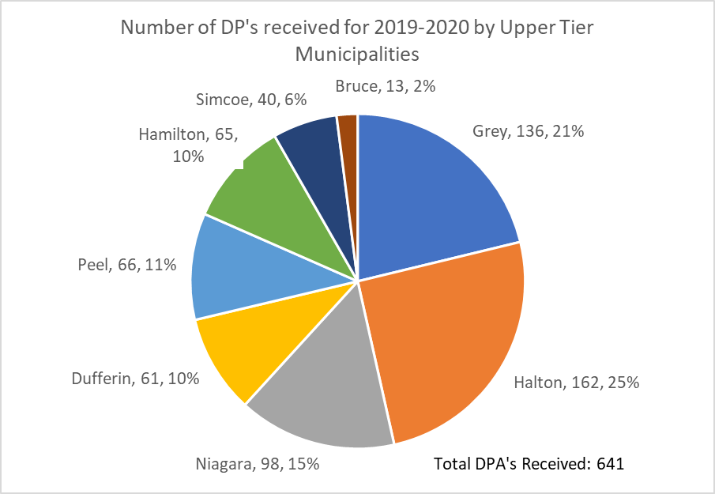

**Figure 4**

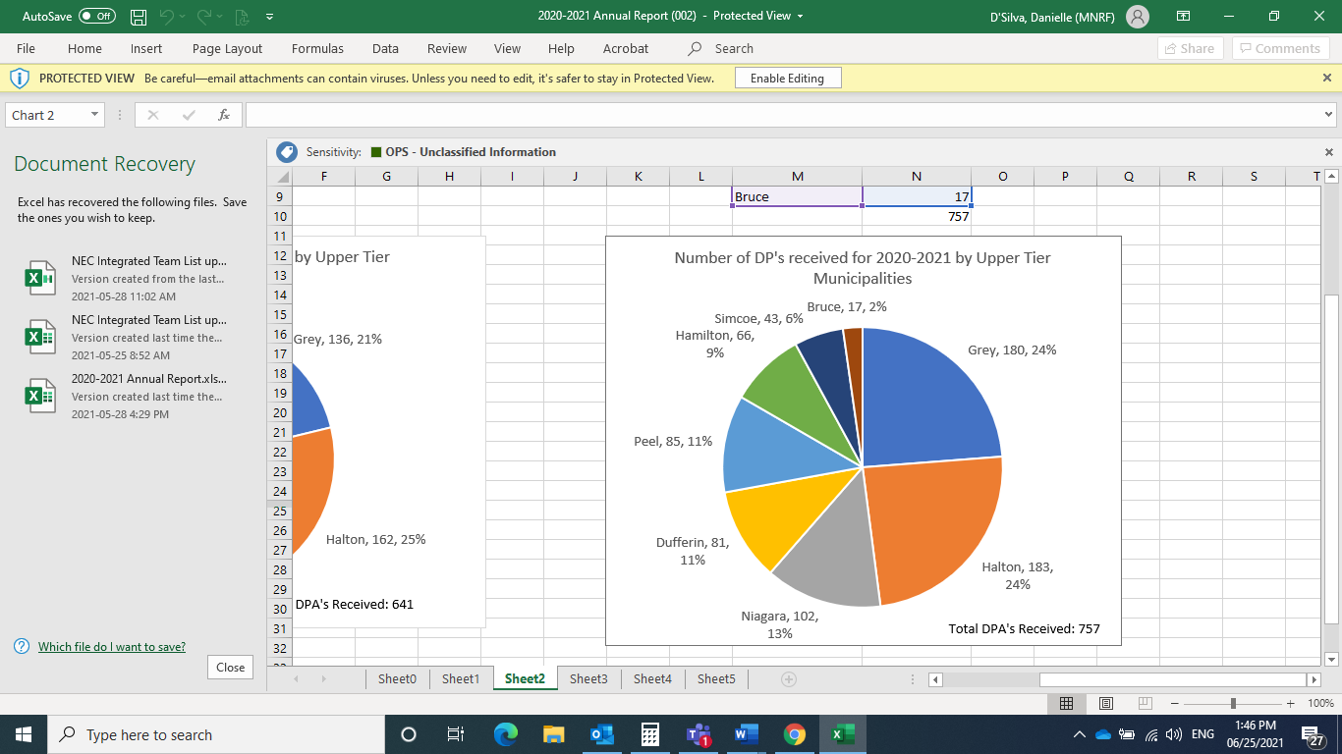

Figure 5 below illustrates the types of applications received and compares the previous two fiscal years. It is important to note that development permit applications received in one fiscal year can be processed in subsequent years. Therefore, there may be a discrepancy between the number of applications received and processed in a given year. The following are some key points:

* By far the highest number of applications continue to relate to residential development. While many applications relate to renovations and accessory structures associated with existing residential development, an increasing number involve demolition of an existing, smaller house to be replaced by considerably larger residences with large accessory buildings (with many residences ranging from 5,000 to more than 20,000 square feet).
* The number of agricultural-related applications remained relatively the same over the prior years. Many of these involve construction of accessory structures. Some relate to the establishment of “on-farm diversified uses” and “agriculture-related uses”, which reflects new policies contained in the updated NEP.
* Fill/change-of-grade applications decreased after 2018-19. The significant reduction may be attributed to new provincial regulations and controls regarding disposal of surplus soil. Inclusion of landform conservation policies in the NEP (2017) provides the NEC with additional tools to evaluate the compatibility of these types of development with the purpose and objectives of the NEP.

**Figure 5**

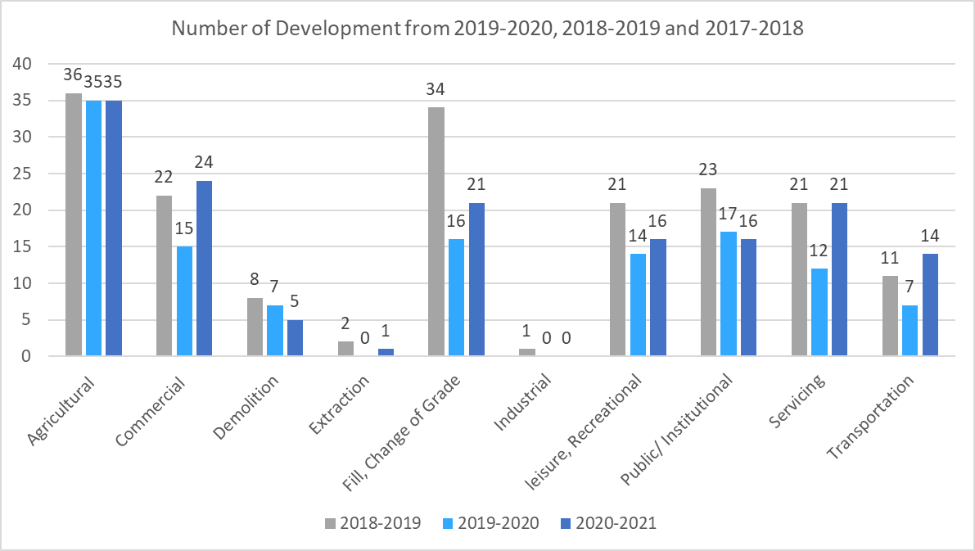

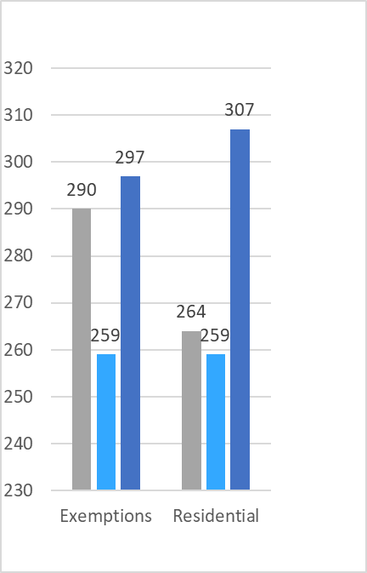

Under the NEPDA, the Minister of Natural Resources and Forestry has the power to delegate to the Commission the authority to approve development permits. Under the current Delegation of Authority, the power to approve certain types of development permit applications is, in turn, delegated to the NEC Director.

As illustrated in Figures 6 and 7, approximately 95 per cent of all NEC approvals (includes Directors’ approvals and exemptions) are approved at the NEC Director level. For an application to be approved by the Director, it must meet the following criteria:

* The application and supporting information must be complete
* There are no objections to the application from any consulted agencies
* NEC planning staff have completed a Staff Report recommending approval
* The Staff Report is accompanied by Conditions of Approval and the proposed development complies with the NEP and does not require a policy interpretation under the plan
* In the case of development that has taken place without a development permit:
  + It is the first time the applicant has undertaken development on the property without approval; and
  + The matter is not subject to a prosecution.

The total number of decisions is reduced over the previous year due may be attributed to impacts of COVID-19. Applicants may have put their application on hold or experienced delays in completing necessary studies. Limitations on staff (e.g.; limited site visits, operational challenges) may have also contributed to the reduced number of decisions on applications.

**Figure 6**

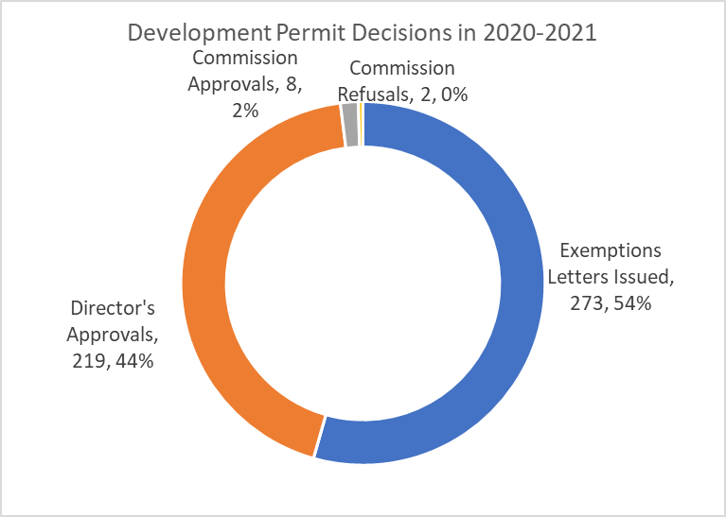

**Figure 7**

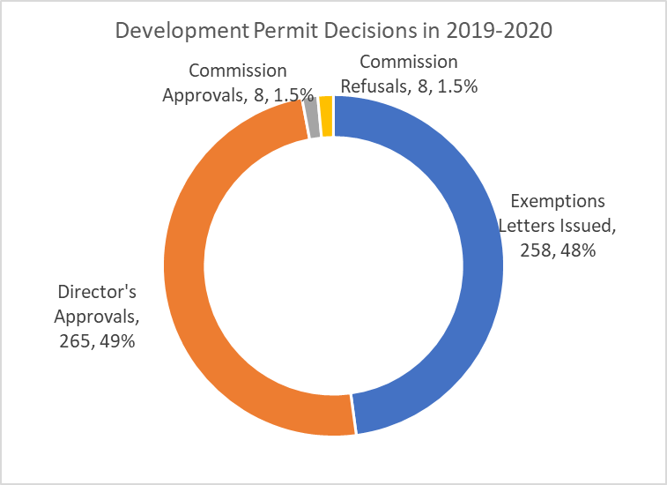

Figure 8 below illustrates the number of appeals of development permit decisions during the last two fiscal years.

**Figure 8**

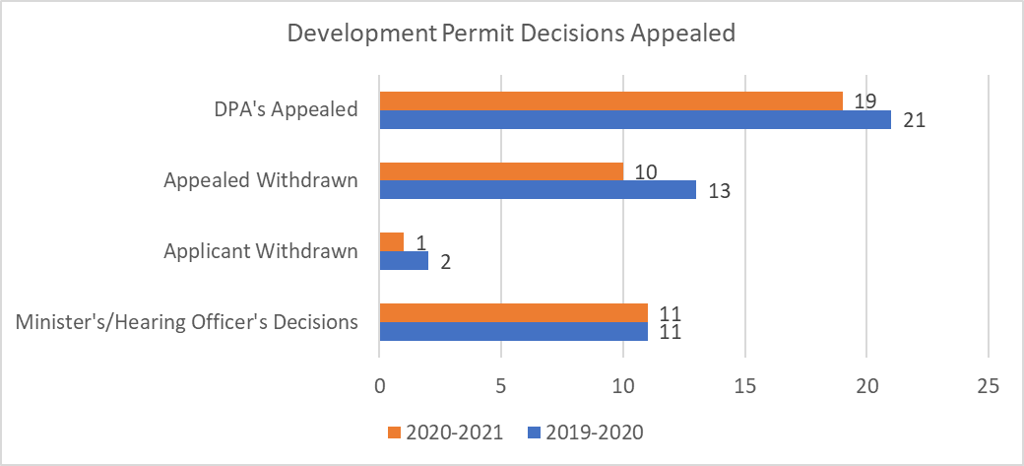

## Niagara Escarpment Plan Amendments

A decision on 6 urban amendment applications that had been submitted during the 2015 Co-ordinated Land Use Planning Review is still pending. There are currently 5 other active Plan Amendments in progress and 2 which received decisions by the Minister of Natural Resources and Forestry. The following is the status of active amendment applications in 2020-21:

**Plan Amendment PB 208 15 (Dyers Bay)**

The purpose of the amendment is to change the designation of lands in the Minor Urban Centre of Dyers Bay from Mineral Resource Extraction Area to Escarpment Natural Area and Escarpment Rural Area in recognition of the surrender of the licence under the *Aggregate Resources Act*. The proposed Amendment, initiated by the NEC on lands in the Municipality of Northern Bruce Peninsula, was the subject of a hearing in October 2019. A settlement was reached, and the Hearing Officer recommended approval of the proposed Amendment in March 2020. The Minister supported the Hearing Officer’s recommendation and the Amendment was approved by the Minister on July 27, 2020.

**Plan Amendment PP 213 18 (Blueland Farms)**

The purpose of this proposed Amendment is to change the designation of this property in the Town of Caledon from Escarpment Rural Area to Mineral Resource Extraction Area to permit a new mineral aggregate operation on a 26-hectare property in the Town of Caledon. The application was initiated by the Commission in 2018. The application is still under review.

**Plan Amendment PD 214 18 (Toronto District School Board)**

An application was submitted by the Toronto District School Board. The purpose of this proposed amendment is to include a site-specific policy exception in the NEP to allow the Boyne River Natural Science Centre, on lands in the Escarpment Natural Area designation, to be re-established as an outdoor education centre on a property in the Township of Mulmur. The Commission endorsed staff’s recommendation to support the proposed amendment at its meeting in May 2019. This application was approved by the Minister on August 12, 2020.

**Plan Amendment PS 215 18 (Sideroad 26/27)**

The purpose of this application by the Township of Clearview is to add site-specific policies to the Niagara Escarpment Plan to permit the re-development and upgrading of Sideroad 26/27 to make it a year-round paved road, notwithstanding the policy requirements to consider alternatives to the undertaking and whether the infrastructure is in the public interest. This amendment relates to a Development Permit application for the proposed road works already referred to the Niagara Escarpment Hearing Office. A staff recommendation report was presented to the Commission in October 2020. The amendment has been referred to the Environmental Review Tribunal (now Ontario Land Tribunal) due to objections to the proposed development. A hearing on both the Amendment and Development Permit has been scheduled, commencing in November 2021.

**PW 218 20 (Columbia Northcliffe Campus Inc.)**

The purpose of this application by Columbia College is to permit the use of the former convent on a property located in the Pleasant View Survey in the City of Hamilton as a day use private school. An upgraded septic system and gymnasium addition are also proposed on the subject lands. The initial staff report was presented to the Commission in May 2020. Comments from agencies and the public have been received, most in opposition. The applicant will be providing additional information in 2021.

**PH 219 20 (Nelson Aggregates)**

The purpose of this application by Nelson Aggregates Co. is to redesignate approximately 78.3 ha (193.5 ac.) of lands from Escarpment Rural Area to Mineral Resource Aggregate Area and to add a special policy under Part 1.9.3 of the NEP (2017) that would permit the continuation of the use of an office building, maintenance building, facilities for washing, processing and stockpiling of aggregate, truck washing facility, asphalt plant, recycling facilities, and entrance on the original Nelson Quarry lands. An initial Staff report was presented to the Commission on August 20, 2020. NEC Staff have been engaged in the Joint Agency Review Team (JART) protocol to review the lengthy technical submission and, with a couple of exceptions, have completed the review of the first submission. Public consultation through the ERO concluded April 26, 2021; agency comments on the NEPA application have been requested before May 14, 2021. The applicant and their consultants are currently addressing comments issued by JART with a response anticipated in the summer of 2021.

**PH 220 21 (Baghai)**

An application was made by Baghai Development Ltd. to amend the Niagara Escarpment Plan (NEP) by adding a special site-specific policy provision to the subject lands described as Lot 10, Concession 1 WHS, 2975 Escarpment Sideroad in the Town of Caledon, Region of Peel. The site-specific policy proposes to address exceptions to the NEP Part 1.4.4 Escarpment Protection Area, Part 2.4 Lot Creation and Part 2.10 Cultural Heritage policies, to permit the creation of three separate parcels, one of which contains a designated heritage dwelling, and by doing so facilitate the acquisition of approximately 21.8 ha of lands by a public body, for conservation purposes and securement of the permanent route of the Bruce Trail. The NEC initiated the proposed Amendment on March 18, 2021 and it has been circulated for comments and posted to the Environmental Registry.

## Niagara Escarpment Parks and Open Space System

The Niagara Escarpment Parks and Open Spaces System (NEPOSS), consisting of more than 160 parks and open spaces, with the Bruce Trail as the common linkage connecting NEPOSS lands. The NEPOSS seeks to achieve the NEP Part 3 objectives of providing opportunities for outdoor recreation, and appropriate public access to the Niagara Escarpment. Part 3 of the NEP contains policies that guide activities and development within the NEPOSS.

The NDMNRF coordinates the development and administration of the NEPOSS, including approval of master/management plans. The NEC works collaboratively with the NDMNRF to ensure that recreational activities and development within the NEPOSS are consistent with the objectives and policies of the NEP.

NEPOSS lands are owned by public agencies and conservation organizations that together comprise the NEPOSS Council. Council representatives work collaboratively to further NEPOSS objectives such as promoting land acquisition and public access. The Council, which is coordinated and administered by the NDMNRF in partnership with the NEC, meets at least two times a year to discuss matters related to parks and open spaces management issues.

NEPOSS Council members undertook significant effort to contribute to the objectives of NEPOSS in 2020-2021, including a continued effort to encourage a co-ordinated and strategic approach to member agencies’ land securement efforts.

Some of the highlights include:

* **Belfountain Conservation Area Management Plan** was approved in 2021. The Belfountain Conservation Area is renowned for its significant natural and cultural features. Large portions of the property are identified as part of a provincial Area of Natural and Scientific Interest (ANSI) and an Environmentally Significant Area (ESA), as well as a Cultural Heritage Landscape. The Belfountain area is one of the most challenging areas in the NEP to balance competing interests. The Management Plan attempts to respond to numerous challenges associated with the high level of visitation in the CA and the hamlet of Belfountain.
* Conservation Halton received final approval for the **Kelso Conservation Area and Glen Eden Master Plan** in early 2021. Conservation Halton completed a three phased process to update the previous 2002 Master Plan for what is considered its flagship park. The update recognizes that the visitation needs, population growth, infrastructure challenges, best management practices, planning principles and land use directions have evolved in the last 15 years, as well as the economic drivers. The complexity of developing a Master Plan for a large and popular park with multiple recreational opportunities and environmentally sensitive areas has been acknowledged. CH spent more than four years engaging with the community and stakeholders and building a relationship with the Mississaugas of the Credit First Nation in order to move the Master Plan forward.
* The **Bruce Train Conservancy** successfully acquired 13 properties comprising more than 1,074 acres and securing 6,055 meters of the permanent route of the Bruce Trail. Included in the acquisitions is 533 acres of the Maple Cross Nature Reserve at Cape Chin on the Bruce Peninsula, which represents the largest solo acquisition of land in BTC history, and 192 acres of the provincial Pine River Nature Reserve in Mulmur Township, which contains important wetland and climax forest habitats.

An ongoing challenge continuing to be faced by the Council member agencies is with respect to increased visitation, and the capacity issues and conflicts that arise as a result, including parking, traffic and need for additional infrastructure to support users. The Council is providing a forum to engage in dialogue on how to address these challenges and share positive solutions. For example, many members have identified collaborations with local municipalities to align “plan ahead” messaging, setting visitor area capacities, to plan and design infrastructure and manage trespass and other violations, including through education.

Acknowledging strong benefit in taking a “Two-eyed Seeing approach”, **Parks Canada** has been working with the Saugeen Ojibway Nation (SON) and other partners, to protect species at risk and of cultural importance, and culturally significant places and values. Parks Canada has also partnered with the Ministry of Transportation (MTO) to build eco-passages and fences along the busy main provincial highway accessing the Park, and has developed citizen science programs in multiple communities to protect nesting turtles, mitigating road mortality in high traffic areas.

The NEPOSS Council continues to participate in the update of the NEPOSS Planning Manual (2012), which is used by NEPOSS agencies to guide the management/master planning process.

## Compliance Program

The NEC Compliance Program is responsible for inspections, investigations and enforcement activities within the NEC's area of Development Control. The Compliance Program plays an important role in the successful implementation of the Niagara Escarpment program by ensuring compliance with the NEPDA and its regulations.

The Compliance Program is a shared responsibility between the NEC and the NDMNRF, and is guided by an Inspections, Investigation and Enforcement Protocol, which was last updated in January 2015. The Protocol lays out the various roles and responsibilities for staff and provides mechanisms for shared oversight of the program and resolution of issues. Through the protocol, the NDMNRF’s Conservation Officers assist with complex investigations, prosecutions and higher risk inspections.

The NEC has implemented a risk-based approach to compliance to make strategic, risk-informed decisions about priorities and responses. The NEC, in consultation with NDMNRF Enforcement Branch, uses this approach to determine the most appropriate response to compliance issues from a suite of options in the compliance continuum. Figure 9 below illustrates the range of approaches applied by the NEC.

Figure 9 illustrates the range of compliance approaches applied by the NEC**Figure 9**

To support a risk-based approach to compliance, the NEC maintains a system to document and track referrals of occurrences, follow-up inspections, investigations, and other enforcement activities and results. This information is reported annually and is used to: assess the efficiency and effectiveness of compliance operations; provide evidence in the evaluation of potential regulatory and policy changes; and, to adjust compliance operations as deemed appropriate.

The results for 2019-20 and 2020-21 are shown below.

|  |  |  |
| --- | --- | --- |
| **REACTIVE: GENERAL BREAKDOWN** | **2019-20** | **2020-21** |
| **Total # of occurrences received per fiscal** | **195** | **227** |
| Total # of occurrences that led to site inspections | 151 | 69 |
| Total # of occurrences assessed as high environmental risk | 35 | 62 |
| Total # of occurrences assessed as medium environmental risk | 79 | 99 |
| Total # of occurrences assessed as low environmental risk | 81 | 66 |
| Total # of occurrences received not subject to NEPDA | 7 | 7 |
| Total # of occurrences deemed exempt per O.Reg 828/90 | 13 | 13 |
|  |  |  |
|  |  |  |
| **Proactive: Development Permit Compliance Monitoring** | **2019-20** | **2020-21** |
| Inspections to assess adherence with development permits issued (per risk-based assessment process) | 22 | *Compliance*  *Inspections suspended due to COVID-19* |
| # of Development Permits in total compliance | 15 |
| # of Development Permits non-compliant | 7 |

The number of compliance occurrences received in 2020-21 was the most the NEC has recorded since it began tracking this data. This may be due to a couple of factors: more people staying at home and undertaking work, and more people reporting concerns of development without a permit. From 2019-2020 fiscal to 2020-2021 fiscal the number of fill complaints received doubled, being the most common type of complaint this year, closely followed by tree cutting, and the highest number of complaints on record regarding new accessory structures.

The NEC’s Compliance Program shifted in response to operational challenges associated with COVID-19, which included the following:

* Enhanced coordination with compliance staff in municipalities, conservation authorities and other ministries/agencies. This was necessary to optimize responsiveness, coordinate inspections and facilitate action by the most appropriate means.
* Enhanced triaging of occurrences to:
  + focus inspections and compliance action on the highest risk situations
  + optimize use of other compliance tools (e.g.; voluntary compliance; compliance notification letters)
  + utilize email and telephone to engage in lower risk situations.
* Increased focus on resolving compliance issues while working from home as opposed to visiting sites. This ultimately reduced the number of hours spent travelling in a vehicle, and more time for working on compliance issues.
* Revised processes relating to requests for compliance updates, handling of new complaints, property information reports, which streamlined processes and more effectively managed public interaction.

The NEPDA provides for administrative orders and offence provisions to address non-compliance. In support of the shared delivery of functions under the compliance protocol, and by applying an Informed Judgment Matrix (see Figure 10 below), the NEC identifies the need for NDMNRF support at any stage of preparing for or conducting an inspection or investigation. The request for support may be simply for advice on how to proceed on a compliance-related matter, or for the assistance of a Conservation Officer in an inspection, or for a Conservation Officer to take a lead role in the inspection or investigation. The NEC, in consultation with the NDMNRF, evaluates issues to determine the appropriate response from the suite of options in the compliance continuum. The options include encouraging voluntary compliance, using a development permit to gain compliance, an administrative order, a warning, and/or laying of a charge.

**Figure 10**

|  |  |  |  |  |  |
| --- | --- | --- | --- | --- | --- |
| Informed Judgement Matrix (IJM) | | Severity of Alleged Violations | | | |
| 1. Administrative | 2. Minor Operational / Environmental | 3. Medium Operational / Environmental | 4. Major Operational / Environmental |
| Compliance History | A. No history/good compliance history | Compliance Category I (Low Risk)  **2020-21**  **66 Occurrences** | |  |  |
| B. Previous Minor  Violation(s) |  |  |
| C. Previous Repetitive  Violations | Compliance Category II (Medium Risk)  **2020-21**  **99 Occurrences** | | |  |
| D. Obstruction or false information |  |
| E. Ongoing violation not resolved despite directions | Compliance Category III (High Risk)  **2020-21**  **62 Occurrences** | | | |
| F. Previous convictions or orders |
| Category I ‐ Encourage land owner to attain voluntary compliance. Recommend education and outreach to help the land owner understand regulatory obligations. Warnings or Inspection Reports may also be considered. | | | | | |
| Category II ‐ Refer to stronger mandatory application of tools such as orders, suspensions and possible charges. | | | | | |
| Category III ‐ Refer to the strongest mandatory compliance tools such as the laying of charges or the Restoration Orders. | | | | | |

## Environmental Monitoring

The NEC’s work regarding monitoring relates primarily to providing information on location of plots, providing information and orientation to students, and being the custodian of the monitoring data that is collected.  The monitoring field work is undertaken by university students. The NEC’s role in monitoring is derived from NEP policies that recognize the need for monitoring and development of performance indicators. In addition, the NEC’s monitoring work is an example of the collaborative relationships envisioned in functioning biosphere reserves.  Many biosphere reserves in Canada undertake similar monitoring, which provides a network of sites with data that can be used to assess impacts of sustainable development initiatives.

The purpose of these one-hectare plots is to collect quantitative data on forest biodiversity, growth, mortality and health to examine change over time in Niagara Escarpment forests. This information may be used to assess the impacts of development, recreational uses, tree disease, forest pests, invasive species and climate change on forest ecosystems.

As reported in previously, the monitoring partnership with the University of Waterloo was terminated in 2020 due to its changing academic program. The plot-based monitoring program is heralded as a resounding success and is among the longest running plot-based biodiversity monitoring in Ontario. The NEC is in currently looking into the development of alternative partnerships and agencies who may wish to continue the legacy of monitoring on these sites into the future.

## Niagara Escarpment Biosphere

**Developing a New Leadership Model for the NEB**

The Niagara Escarpment was designated a United Nations Educational, Scientific and Cultural Organization (UNESCO) World Biosphere in 1990. The Niagara Escarpment Biosphere NEB is one of 714 biosphere reserves across the world and one of 18 across Canada, which recognize interdisciplinary approaches to balancing conservation of cultural and biological diversity with economic and social development. The land-use planning regime provided by the NEP is the foundation for this prestigious designation.

The Transitional Leadership Committee (TLC) formed in 2019 continues to act as the interim convenor of the NEBR. The Committee is led by four (4) community individuals who were self-selected with the input of the NEB network. This interim Committee is tasked with finalizing a permanent governance structure for the NEB, developing a communications plan to better engage the overall network, and exploring options for a co-management/co-leadership model with indigenous communities.

The transition process has continued to move forward, aided significantly by post-graduate students from Niagara College's Environmental Management & Assessment Program. Focus has included developing stakeholder outreach tools and researching funding avenues, and in anticipation of the 2024 Periodic Review of the Biosphere, focusing on areas of improvement identified through the last Periodic Review.

**Indigenous Engagement and Participation in the NEB**

Indigenous communities have a long history and unique relationship with the Niagara Escarpment. Indigenous individuals and groups with Treaty lands and interests on the Niagara Escarpment are central to the NEB realizing the full understanding of its natural and cultural history.

The TLC of the NEB has at its core the objective to build meaningful and collaborative relationships with Indigenous communities. The TLC aims to achieve this by continuing to have conversations and listen to shared experiences and stories from the Communities. The NEB TLC has determined that consistent with the 2012 UNESCO Periodic Review recommendation to embark in a meaningful engagement with Indigenous communities, that it would be appropriate to have Indigenous co-management of the NEB Transition. The TLC is currently exploring how best to achieve this, along with Indigenous peoples, and guided by Indigenous Consultant Plenty Canada.

## Performance Measures

Performance measurement provides benchmarks for evaluation of agency effectiveness, efficiency, quality of service and accountability of action. The NEC has established performance measures to help provide important information on the time it takes to process applications, how access is provided to a variety of stakeholders and to what extent agency decisions are in conformity with NEP policies.

By monitoring performance, the NEC can evaluate the effectiveness of policies and quality standards and/or practices in meeting its approved performance goals. All of the following measures were met in 2020-2021. Program implementation has been further enhanced through the continuation of business process mapping and the continued implementation of the NEC’s Operational Strategy.

| Activity | Measure | Result |
| --- | --- | --- |
| Preparation and Posting of Memorandum of Understanding (MOU), Business Plan and Annual Report | 2019 Agency and Appointments Directive requires Memorandum of Understanding (MOU), Business Plans, and Annual Reports be prepared, approved and then posted on the NEC website. | * MOU between Chair and Minister of Natural Resources and Forestry was updated and signed by the Minister and Chair. It is posted on the NEC’s website. * NEC prepared the 2021-2024 Business Plan and submitted it to the Minister by December 31, 2020. It was approved by the Minister in March 2021. * 2019-20 Annual Report was submitted to the Minister in June, 2020. It was approved by the Minister in July 2020. * The currently approved plans and MOU are posted here:   <http://www.escarpment.org/commission/AgencyDirectiveReporting/index.php> |
| Commission Meetings | Minutes of Commission meetings are posted on the NEC website (www.escarpment.org).  Commission meetings are open to the public. Applicants and other stakeholders are provided opportunities to address the Commission in writing or in person. | * A total of 9 Regular Commission Meetings were held in 2020-2021, with 1 Policy Meeting in November, 2020. * All meetings are open to the public, except for in-camera agenda items. * Meeting minutes were posted following approval by the Commission. |
| Conflict of Interest (if any) by Commissioners or staff | Declaration to Chair or Director as required by OPS directives. | * OPS Directives met. * Three COI declarations were brought forward by a Commissioner. No declarations by NEC staff. * In each case, individuals did not participate in discussions or decisions. * Appropriate controls have been put in place to ensure integrity maintained in NEC program delivery. |
| Commission Decisions | Conformity with NEP policies and recommendations. | * Orientation provided for all new Commissioners regarding responsibilities to make decisions in accordance with the NEP. * All Commissioners trained on new NEP policies. * All staff reports effectively addressed NEP policies * Decisions made in conformity with the NEP policies. |
| Accessible Public Service | As per OPS Customer Service Standards, staff are available from 8:30 am to 5:00 pm at Commission offices (Georgetown and Thornbury) Monday to Friday and other times by appointment.  Annually, the NEC is required to attest compliance with the Accessibility for Ontarians with Disabilities Act (AODA). | * Offices remained closed for the entire fiscal year due to COVID-19. Staff were accessible through email or voicemail. * NEC completed attestation and complied with requirements of AODA. |
| Telephone | As per OPS Customer Service Standards, calls are answered by the third ring or sent to voicemail during business hours. Protocols in place to deal with inquiries. Calls returned within one business day. | * NEC complied with service standard the majority of the time. Due to office closures, there were some delays in responding to telephone inquiries. All NEC staff now have cell phones to ensure customer service standards can be met. |
| Correspondence (Written, Email and Fax). | OPS Customer Service Standards for emails and online messages require responses to be acknowledged within two business days and answered within 15 days. Best practice protocols in place for assisting staff in responding.  If a conclusive response is not possible, an interim response, along with an estimated date for a complete response, will be provided within 15 days. | * Achieved, with minor exceptions. NEC has protocols in place to respond to inquiries in timely manner. * NEC staff provide interim responses where conclusive response not possible. |
| Provide Relevant Information:  Application Guidelines, Forms, Maps, and Publications. | Current guidelines, maps and application forms are provided to clients and the public in both electronic (on NEC website) and printed formats. | * NEC information available to the public via website and on request. * Due to office closures printed materials were not available. |
| Development Permit Applications | NEC decision time varies depending upon the complexity of the application, the time required to obtain a complete application and comments from agencies.  The following measures reflect elements of the process within the NEC’s control:   * NEC follows process for Development Permits as set out in the NEPDA. * Agencies and municipalities are provided the opportunity to comment on applications. * Notices of Decision sent out within 2 business days of decision being made. * Development Permits issued promptly after clearance of conditions of approval. | * Total of 757 development permits received in 2020/21. NEC processed 534 permits. * Geographically based teams actively triaging applications to advance those ready to proceed to decision. * Additional staff and realignment of geographic areas among planning staff has provided a better balance of applications and enhanced time in which they are advanced. * Office closures due to COVID-19 resulted in delays in sending Notices of Decision. For safety reasons, staff restricted to specific times to copy/mail notices. |
| Niagara Escarpment Plan Amendment Applications | NEC staff follow *NEPDA* requirements for processing Plan Amendments.  Plan Amendments are posted on NEC website and on the Environmental Registry (ER) for public review. | * 3 new Amendment applications received. * 2 decisions by Minister. * All processing requirements met. |
| Review of municipal Official Plans,  consents,  zoning by-laws, etc. | NEC reply within due date (usually 30 – 60 days depending on complexity). | * Review of municipal official plans, zoning by-laws and consents took place within the specified due dates. * Commented on more than 200 Planning Act instruments and other planning-related initiatives by due date. |
| Reports of potential compliance issues. | Response within 48 hours of notification (call back, site inspection, or occurrence report logged). | Compliance Program significantly impacted by office closures and restrictions on staff conducting inspections. Reports were prepared for all occurrences, and high risk situations followed up based on Informed Judgement Matrix. |
| Public Access to Information | The NEC meets established timelines as set out by the NDMNRF, Information, Privacy and Records Management Unit in order to meet Freedom of Information and Protection of Privacy Act (FIPPA) requirements. | * There were four (4) FIPPA requests received and processed within the specified timelines. |

## Financial Summary

The following provides a summary of the 2020-2021 operating budget and expenses:

|  |  |  |
| --- | --- | --- |
| **Account Categories** | **2020-2021**  **Budget Allocation** | **2020-2021**  **Actual Expenditures** |
| Salary and Wages | 2,042,600 | 1,749,274 |
| Employee Benefits | 325,200 | 361,893 |
| **Total** | **$2,367,800** | **$2,111,167** |
| Transportation and Communication | 43,000 | 29,507 |
| Services | 205,200 | 225,017 |
| Supplies and Equipment | 31,000 | 19,025 |
| **Total** | **$279,200** | **$273,549** |
| Treasury Board Order |  | *$196,300* |
| **Grand Total** | **$2,647,000** | **$2,581,016** |

The NEC’s maximum staffing complement is 24 Full-Time Equivalent (FTE) positions. As of March 31, 2021, the NEC had 24 FTE employees, 19 within its main Georgetown office and 5 in its northern satellite office in Owen Sound. In addition, the Georgetown office had three seasonal Planning positions and a seasonal compliance position (which are not considered FTE positions).

The NEC’s non-salary or operating allocation is composed of several categories of funds. These categories include transportation and communication (e.g., telephones, cell phones, mail and staff and Commissioner travel expenses), services (e.g., computer leases, commissioner per diems, leased office equipment, staff development and education, vehicles, commission meetings, litigation costs) and supplies and equipment (e.g. office supplies).

As of March 31, 2021, the Commission had a full complement of 17 Commission members which includes the Chair. The total remuneration paid in 2020-21 was $116,190 which is financed from NEC’s operating budget. Commissioner travel expenses are posted on the NEC website quarterly. Due to COVID-19 the Commission met via WebEx from May 2020 to March 2021. During this time, there were no Commissioner expense claims and only a few expense claims for the Chair.

The NEC started 2020-2021 with a $2,647,000 operating budget which was based on the actuals from fiscal 2019-2020. This new budget saw an increase to the wages and benefits allocation at a level which allowed the Commission to staff to its complement of 24 FTEs and four additional seasonal positions. A couple of positions were vacant following a retirement and temporary assignments, and several positions were unfilled for brief periods while the NEC adjusted to working and hiring remotely. This, combined with many new and contract staff, led to additional funds in the wages and benefits allocation that were returned through a Treasury Board Order as noted in the chart above. The NEC anticipates that it will continue to hire to its FTE maximum in the coming fiscal.

The NEC was able to spend within its operating budget for 2020-21 due to operational savings associated the COVID-19 pandemic and resulting restrictions. Staff began the fiscal working remotely with access to the office limited for essential purposes only. This created a reduction in staff training options and minor travel for site visits. Outreach and Commission meetings were held virtually. The reductions in spending from previous fiscals combined with savings attributed to the COVID-19 pandemic led to a reduction in spending for fiscal 2020-21. This is an interim savings, and spending is expected to be normalized in the next fiscal year.

# Appendices

## Appendix 1: Niagara Escarpment Commission OIC Appointments

Niagara Escarpment Commission Members (As of March 31, 2021)

|  |  |  |  |
| --- | --- | --- | --- |
| Commissioner | Municipal | Region/County/City | Term Expires |
| Laurie Golden | Municipal | Bruce County | December 31, 2022 |
| Paul McQueen | Municipal | Grey County | December 31, 2022 |
| Barry Burton | Municipal | Simcoe County | December 31, 2022 |
| Janet Horner | Municipal | Dufferin County | December 31, 2022 |
| Johanna Downey | Municipal | Peel Region | December 31, 2022 |
| Gord Krantz | Municipal | Halton Region | December 31, 2022 |
| Brad Clark | Municipal | City of Hamilton | December 31, 2022 |
| Albert Witteveen | Municipal | Niagara Region | December 31, 2022 |
|  | Public at large |  |  |
| Rob Nicholson (Chair) | Public at Large | N/A | March 11, 2022 |
| Michael Curley | Public at Large | N/A | October 31, 2021 |
| Gord Driedger | Public at Large | N/A | April 23, 2022 |
| Ron Gibson | Public at Large | N/A | July 1, 2022 |
| David Hutcheon | Public at Large | N/A | April 23, 2022 |
| Ken Lucyshyn | Public at Large | N/A | April 23, 2022 |
| Bruce Mackenzie | Public at Large | N/A | April 8, 2023 |
| Duncan McKinlay | Public at Large | N/A | September 12, 2022 |
| Jennifer Vida | Public at Large | N/A | January 13, 2023 |

## Appendix 2: Niagara Escarpment Plan Map

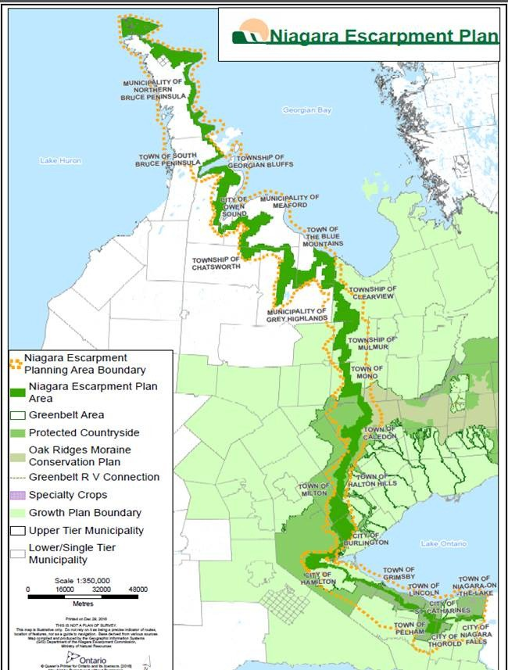

## Appendix 3: Municipalities in the NEP Area

## Region of Niagara

Seven local municipalities:

* Town of Grimsby
* Town of Lincoln
* City of Niagara Falls
* Town of Niagara-On-The-Lake
* Town of Pelham
* City of St Catharines
* City of Thorold

City of Hamilton

## Region of Halton

Three local municipalities:

* Town of Halton Hills
* Town of Milton
* City of Burlington

## Region of Peel

One local municipality:

* Town of Caledon

## County of Bruce

Two local municipalities:

* Town of South Bruce Peninsula
* Municipality of Northern Bruce Peninsula

## County of Dufferin

Three local municipalities:

* Town of Mono
* Township of Mulmur
* Township of Melanchthon

## County of Grey

Six local municipalities:

* Township of Chatsworth
* Municipality of Grey Highlands
* Municipality of Meaford
* City of Owen Sound
* Township of Georgian Bluffs
* Town of The Blue Mountains

## County of Simcoe

One local municipality:

* Township of Clearview

1. LEAN approach refers to reviewing programs and operations to optimize processes.