February 17, 2022

A1: STAFF REPORT

DEVELOPMENT PERMIT APPLICATION:

N/C/2020-2021/547
Applicant: REDACTED
Owner: REDACTED
140 Ridge Road West
Part Lot 11 and 12, Concession 2 and 3
Town of Grimsby, Region of Niagara

SUMMARY

PROPOSAL:

To establish a home occupation (physiotherapy and wellness practice) operating out of an existing 58 square metre accessory structure. Additionally, one 0.37 square metre sign is being proposed along Ridge Road West promoting the bed and breakfast and wellness practice.

Note: A three-bedroom bed and breakfast operates from the dwelling on the lot.

DESIGNATIONS:
Escarpment Protection Area and Escarpment Natural Area

ISSUE:
The policies in the Niagara Escarpment Plan (NEP) require that a home occupation operate within an existing dwelling or dwelling addition unless the need can be justified. Additionally, the NEP policies do not clearly contemplate whether both a home occupation and a bed and breakfast are permitted to operate together on a lot. Further, the meals, services, amenities and facilities of the bed and breakfast are to be limited to the guests of the bed and breakfast.

RECOMMENDATION:
Approval with conditions.

REASONS:
The proposal is located on a lot where the size and scale of the home occupation and bed and breakfast can operate without concern. The proposal meets the objectives of the Escarpment Protection Area and is consistent with the PPS.

RECEIVED:
January 20, 2021 (revised applications received July 29, 2021, September 24, 2021 and January 17, 2022)

SOURCE:
REDACTED (applicant and owner)

RELATED FILES

N/A/2018-2019/297
A development permit application was submitted to the NEC on October 28, 2018. The application proposed to recognize the operation of an event venue as an on-farm diversified use (OFDU) as follows:

- Use of ± 74.0 square metre (± 800 square feet) of the existing dwelling as a main event room;
- Use of ± 74.0 square metre (± 800 square feet) of an existing patio;
- Additional use of ± 204.4 square metre (± 2,200 square feet) outdoor space to be utilized periodically for temporary event tents;
- Maximum 50 guests;
- Parking area for ± 20 personal vehicles; and
- Operating May 1st to October 31st (inclusive) of any year with a maximum of four (4) events per month (24 events maximum).

To further recognize the operation of a Youth Retreat as an Agricultural Tourism use operating a maximum of twice per week (excluding weekends), year round, 8:30 am to 4:30 pm, on a ± 8.5 hectare (± 21.0 acre.) agricultural parcel supporting a dwelling, accessory structures, and a bed & breakfast use on a private well and septic.

This application was closed on December 31, 2018 at the request of the applicant and no permit was issued.

N/C/2004-2005/127
A development permit application was submitted to the NEC on August 3, 2004. The application proposed to construct a 2 storey, 9.1 m (30 feet) high, 281 square metre (3027 square feet) addition, plus new veranda and deck areas, to an existing 2 storey, 464.5 square metre (5000 square feet) single dwelling, convert part of the existing dwelling to a 3 room Bed and Breakfast, construct a 1 storey, 6 metre (20 feet) high, 18.5 square metre (200 square feet) sauna with a +/- 93 square metre (1000 square feet) swimming pool , and replace an existing barn with a larger 1 storey, 9.1 metre (30 feet) high, 55.7 square metre (600 square feet) dry storage barn, on an 8.9 hectare (22 acre) lot.

The application was closed on February 17, 2005 and permit no. 8310 was issued.

BACKGROUND:

The applicant previously ran a wedding venue business from the subject property, in addition to an authorized bed and breakfast. The wedding venue operation ceased voluntarily following intervention by the NEC’s compliance officers as no permits had been issued for such a use. The bed and breakfast has not been operating since March 2020 due to the COVID restrictions.

In response to the compliance-related concerns, the applicant submitted a development permit application to recognize the event venue as an on-farm diversified use. However, the application was not supportable due to concerns raised by the Town of Grimsby and the Region of Niagara, that the size and intensity of the event venue proposal was not appropriate given the limited agriculture on the property, and was therefore not consistent with Ontario Ministry of Agriculture Food and Rural Affair’s (OMAFRA) on-farm diversified use guidelines. In addition, there were multiple objections from surrounding residents. As a result, the applicants withdrew their application and are now proposing to establish a scaled-down home occupation in conjunction with the bed and breakfast.

The Town of Grimsby and the Region of Niagara once again raised concerns about the intensity of the proposed home occupation and the limited agricultural operation on the property. Through discussions with the applicant and the partner agencies the original application was revised two times throughout the review process. The original proposal consisted of physiotherapy and wellness services on a 1:1 service ratio within the accessory structure. The applicant also proposed indoor yoga classes within the existing single dwelling with up to 9 clients and outdoor yoga classes with up to 15 clients. The home occupation was intended to be operate seven days a week from 9:00am to 7:00pm. In order to address concerns regarding the scale and intensity of the home occupation, the applicant agreed to revise the application two times. The current proposal includes physiotherapy and wellness services on a 1:1 service ratio within the existing accessory structure. The yoga services were removed from the application completely and no space within the single dwelling will be dedicated to the home occupation. The hours of operation have been limited significantly.

The applicant is a registered physiotherapist with an interest in operating a business from the property. Given the nature of the business, there is a preference to operate the business separate from the dwelling to isolate clients (due to COVID proptocols) and for privacy.

While staff is generally supportive of the application, this application is before the Commission given the interpretation of policy staff has taken and the previous compliance issues on the site.

PROPOSAL:

The applicant proposes that an existing accessory structure on the property (a 58 square metre cabin) be used to operate the home occupation, which will allow the applicant to treat clients privately rather than using a dedicated room within the dwelling. This is particularly a concern of the applicant under the required COVID protocols of the College of Physiotherapists. Additionally, this allows the applicant to separate the bed and breakfast operation from the home occupation. The hours of operation are limited to Monday and Wednesday from 5:00 pm to 7:00 pm, Tuesday, Thursday and Fridays from 10:00 am to 3:00 pm, Saturdays from 9:00 am to 1:00 pm and will be closed on Sundays. Furthermore, visits to the practice will be by appointment only. The applicant is proposing that services will be provided to clients on a 1:1 basis.

There are no required modifications needed to the cabin or the property to accommodate the proposal. As will be described below, the site can sufficiently accommodate the proposal, including sufficient parking.
The immediate area outside of the cabin, which includes a sauna, will also be used for treatment and will be made available to the guests of the bed and breakfast.

SITE DESCRIPTION:
The subject property is a 8.5-hectare (“ha”) irregular-shaped lot, located on the north side of Ridge Road West adjacent the brow of the Escarpment. The southern half of the site and the portions immediately surrounding the dwelling are designated as Escarpment Protection Area and the northern portion of the site is designated Escarpment Natural Area in the NEP. The property is fully within the NEC Area of Development Control.
The property consists of relatively flat topography and is accessed by a driveway from Ridge Road West in the south-east corner of the property. The property currently supports a single dwelling (including bed and breakfast), detached garage, detached accessory structure (pool cabin), sauna and swimming pool. These structures are clustered within the south-east corner of the property. The property also supports limited farming that is for personal use: approximately 0.4 ha of Fredonia grapes, a pear tree orchard with 40 pear trees and a fir tree farm (Christmas tree). Approximately 3.2 ha of the property is also leased to a local farmer. The property is impacted by the presence of regionally significant Niagara Section Escarpment Life Science Area of Natural and Scientific Interest (ANSI) and Significant Woodland. A watercourse also traverses the property from north to south. The Significant Woodland is located along the watercourse and along the eastern lot line. The property is located within an area that qualifies as a Prime Agricultural Area, specifically, a Speciality Crop Area.

PLANNING ANALYSIS:
A policy interpretation is required since there are multiple uses on the same property, raising concerns about the intensity of use in Escarpment Protection and Natural Areas, as well as whether the definitions and development criteria related to home occupations and bed and breakfasts can be met. Given that there is agriculture on the property, an on-farm diversified use can also be considered as a permitted use, but the Region of Niagara’s comments on the various proposals from the applicant have made it clear that that an on-farm diversified use could only be supported at the scale of a home occupation. For this reason, staff is considering the NEP policies specific to home occupations, keeping in mind that a bed and breakfast is already operating on the property.

Niagara Escarpment Plan

Part 1 – Land Use Designations and Permitted Uses:
The site is located in both the Escarpment Protection Area and the Escarpment Natural Area. The dwelling, accessory structures and agricultural uses are found within the Escarpment Protection Area. The accessory structure that is intended for use by the home occupation is located within the Escarpment Protection Area.
Part 1.3.1 and 1.4.1 of the NEP provide the objectives of the Escarpment Natural Area and Escarpment Protection Area land use designations respectively. NEC staff are of the opinion that the proposed home occupation does not conflict with the applicable objectives of the Escarpment Natural Area and Escarpment Protection Area designation. The proposed development does not encroach into sensitive ecological features and will not have an impact on the scenic resources and open landscape character of the Escarpment given that it will use an existing building on site. The proposed home occupation is a permitted use within the Escarpment Protection Area (1.4.3.14).

Home Occupations
The NEP defines home occupations as:

An occupation that provides a service as an accessory use within a single dwelling, in an addition to the dwelling, or in an accessory facility, performed by one or more residents of the household on the same property. Such occupations may include services performed by an accountant, architect, auditor, dentist, medical practitioner, veterinarian, engineer, insurance agent, land surveyor, lawyer, realtor, planner, hairdresser, desktop publisher or word processor, computer processing provider, teacher or day care provider. Other occupations may also include dressmaking, upholstering, weaving, baking, ceramic-making, painting, sculpting and the repair of personal effects.

The applicant is a registered Physiotherapist that will be providing services similar to that of a medical practitioner. NEC staff are satisfied that the proposed physiotherapy/wellness practice is consistent with the definition of a home occupation.

Bed and Breakfasts
Bed and breakfasts are considered permitted uses within the Escarpment Protection Area (1.4.3.18). There is currently an approved bed and breakfast operation on the property which offers three rooms and a maximum of six guests.

The NEP defines bed and breakfasts as:

Sleeping accommodation (including breakfast and other meals, services, facilities and amenities for the exclusive use of guests) for the travelling or vacationing public within an existing single dwelling that is the principal residence of the proprietor. A bed and breakfast in an existing single dwelling of local heritage value or interest must retain the features that cause it to be designated of local heritage value or interest.

The definition for a bed and breakfast does not specifically restrict a bed and breakfast to exist in conjunction with a home occupation. Instead, the definition requires that facilities and amenities are for exclusive use of the guests of the bed and breakfast. In this case, the amenities of the home occupation (sauna) are also be made available to guests of the bed and breakfast, which is not consistent with the definition of bed and breakfast. The proposed home occupation will be located in a detached accessory structure which is intended to separate the use from the existing bed and breakfast operation.

Part 2.2 General Development Criteria
The objective of Part 2.2 of the NEP is “to permit reasonable enjoyment by the owners of all lots that can sustain development.” This objective and the policies of 2.2 that will be assessed below, will consider the home occupation in relation to the established uses on the property. The intensity of the use is a component in assessing whether the site can sustain the development and whether it is appropriate for the site. If the use becomes larger than the intent permitted in the policies, a physiotherapy/wellness practice can be considered a commercial use, and therefore a business not intended to operate within the accessory structure. Such a development would require additional public safety measures for construction and other planning considerations (e.g., parking, traffic, fire exits).

Part 2.2.1 further expands on the objective by requiring the protection, restoration and, where possible, enhancement of the Escarpment environment, which provides parameters for “lots that can sustain development”. A site that can sustain development must consider the Escarpment environment as well as the impact of single, multiple or successive development. The cumulative impact of the proposed use and established uses on this site was a concern that was identified by NEC staff and partner agencies. Through discussions with the applicant, the Development Permit Application was revised several times in order to reduce the size and intensity of the proposed home occupation. Changes were made to limit the hours of operation, the number of clients visiting the site and limiting the location of the home occupation to the accessory structure. The home occupation will be operated and managed by the applicant and the immediate family. Clients would be able to visit the practice during operating hours and by appointment only. The hours of operation have been limited to primarily regular working hours with the exception of Mondays and Wednesdays. The hours of operation were limited to ensure that the disturbance to local property owners is minimized. The operating hours and restrictions on numbers of clients (one at a time) are included as conditions of approval.

Part 2.2.10 Home Occupations and Home Industries

Part 2.2.10 requires that home occupations within the Escarpment Protection Area be located within the single dwelling unless the need to locate it within an accessory facility can be justified. Furthermore, home occupations should normally be limited to one per lot. The applicant is proposing that an existing accessory structure be used to operate the home occupation from, which will allow the applicant to treat clients privately rather than using a dedicated room within the dwelling. This is particularly a concern of the applicant under the required COVID protocols of the College of Physiotherapists. Additionally, this allows the applicant to separate the bed and breakfast operation from the home occupation. The applicant has brought up concerns that the bed and breakfast operation has not been operating since the start of the pandemic in March 2020. There is a need to establish a physiotherapy/wellness practice for the applicant to work. The bed and breakfast has not been in operation and has proven to be a vulnerable and sensitive business as a result of the successive lockdowns throughout the pandemic. However, once the pandemic ends, there is the potential for the applicant to run the bed and breakfast and physiotherapy home business simultaneously. Since the policy specifies that home occupations should normally be limited to one per lot, the co-existence of the bed and breakfast and home occupation is being raised as a potential policy conflict for the Commission’s deliberation.
Part 2.2.10 provides a variety of size limits for home occupations within dwellings and accessory structures. Where a home occupation is located within a single dwelling, not more than 25 per cent of the total floor area shall be devoted to the use. The total floor area of the single dwelling is 440 square meters. The existing bed and breakfast operation currently consists of 46 square meters within the existing single dwelling. This is approximately 10% of the total floor area of the home and well within the 100 square metre limit. Furthermore, NEP policies restrict the size of a home occupation within an accessory facility to no more than 100 square meters. The home occupation is being proposed in an accessory facility that is 58 square meters. This is well within the maximum allowable limit. Finally, Part 2.2.10 requires that there shall not be more than 125 square meters devoted to a home occupation. The cumulative area covered by both the proposed home occupation and the bed and breakfast would be within the maximum allowable coverage of 125 square meters.
NEP policies require that where a home occupation is located in an accessory facility the accessory facility must share a common driveway and where possible must share residential services. Although the accessory structure cannot be accessed by a vehicle the proposed parking for the practice will be located on the driveway that is shared with the existing single dwelling. The existing driveway is 60 metres long and 5.5 metres wide. This driveway is heavily shielded from surrounding property owners with mature trees on either side and can accommodate up to 15 cars with ample space to continue accessing or exiting the property. The accessory structure currently shares the private sewage system with the existing single dwelling. Private Servicing Staff from the Region of Niagara have conducted a site inspection and confirmed that the existing private sewage system can support 20 guests at a time. There are currently 5 individuals living in the house with the possibility of 6 guests from the bed and breakfast operation. The existing private sewage system can support the proposed home occupation when operating at full capacity.
Part 2.2.10 requires that home occupations:
- be secondary to the primary residential or agricultural use on the lot;
- be operated by residents of the household on the lot; and
- be located in a manner that considers potential land use compatibility issues, such as noise, odour and dust, with adjacent more sensitive uses (e.g., residential, daycare).
- municipal official plan policies and standards (e.g., lot size, parking, floor area, retail space) must be met.
NEC staff is confident that the proposal is consistent with the above noted criteria. The physiotherapy/wellness practice will be secondary to the primary residential use on the property. The practice and the bed and breakfast will be operated by the residents of the household. The accessory structure that is intended to be used for the home occupation is located in an area of the property that is treed and shielded from surrounding property owners. Potential land use compatibility issues such as noise and nuisance to local property owners have been addressed through several revisions to the application to reduce its intensity which will also be enforced through conditions. The most recent proposal has received no objection from the Town of Grimsby and the Region of Niagara.

Provincial Policy Statement 2020 (PPS):
The Growth Plan for the Greater Golden Horseshoe designates the subject property as within “Prime Agricultural Area”; more specifically as Specialty Crop Area (Niagara Peninsula Tender Fruit and Grape Areas). The PPS notes that Prime Agricultural Areas shall be protected for long-term use for agriculture. The PPS states that permitted uses within prime agricultural areas include agricultural, agriculture-related, and on-farm diversified uses, and that all types, sizes and intensities of agricultural uses and normal farm practices shall be promoted and protected in accordance with provincial standards. Given that the proposed home occupation will exist within an existing accessory structure, and no lands are being taken out of agricultural production, the proposed use is consistent with the PPS policies protecting Prime Agricultural Areas and Speciality Crop Areas.

AGENCY CONSULTATIONS:

Town of Grimsby
The Town of Grimsby Official Plan defines a home occupation as an occupation, which provides a service as an accessory use within a single dwelling or in an addition to the dwelling or in an accessory building, performed by one or more resident of the household on the same property. Town staff are of the opinion that the proposed uses of the wellness business would be appropriate for the site as an accessory use subordinate to the primary residential use. Staff raised concerns about the size of the proposed home occupation. The Municipal Zoning By-law restricts home occupations to 25 square meters, the proposed home occupation exceeds this limit by 160%. Furthermore, staff raised concerns about land use compatibility issues with surrounding uses. Since the accessory structure is pre-existing and with significant vegetative screening and the owner is operating at a 1:1 ratio Town staff consider the proposed home occupation acceptable in scale, intensity and compatibility.

Region of Niagara
The Region of Niagara Planning staff interpret this proposal as an on-farm diversified use (OFDU). Staff refers to OMAFRA’s guidelines on permitted uses in Ontario’s Prime Agricultural Areas. The guideline defines on-farm diversified uses as such that are secondary to the principal agricultural use of the property and that are limited in area. The revised application indicates that 13-15 acres of the property is dedicated to agricultural uses and Regional staff is of the opinion that the proposed OFDU is secondary to the principal agricultural use. Staff has raised concerns about the intensity of the proposed home occupation and its cumulative impact on surrounding land uses when considered in conjunction with the bed and breakfast. Staff has asked that the Commission consider the home occupation in conjunction with the bed and breakfast and its compatibility with surrounding residential and agricultural uses. In conclusion, Regional staff offer no objection to the proposed Development Permit Application, provided that the agricultural uses remain the primary use of the property and that the addition of the OFDU still aligns with the “limited in area” criterion of the OMAFRA guidelines.

SUMMARY:
The proposal seeks to change the use of the existing accessory structure to support a physiotherapy/wellness practice. The scale and intensity of the home occupation has been extensively reviewed by all approval agencies, and is determined to be appropriate to the scale of existing agricultural uses and bed and breakfast on the property. The proposed works would not require any physical changes to the accessory structure or property and would not have an impact on the existing agricultural use. The home occupation is consistent with the objectives of the Escarpment Protection Area and is considered a permitted use. In staff’s opinion, the combination of the bed and breakfast and physiotherapy occupation does not present any cumulative impact concerns given the scale of the proposed operation. The proposal is in keeping with the applicable policies of the Development Criteria in Part 2.2 of the NEP. Based on the analysis above, the proposal is consistent with the PPS and conforms with the upper and lower-tier official plans.

RECOMMENDATION:
That the Development Permit Application be approved, subject to the attached conditions.

Prepared by:

Original signed by:
______________________
Andrej Obradovic
Senior Planner

Approved by:

Original signed by:
______________________
Kim Peters, MCIP, RPP
Manager

Appendix 1 – Conditions
Appendix 2 – Site Plan
Appendix 3 – Floor Plan
Appendix 4 – Niagara Escarpment Plan Designations
Appendix 5 – Ortho Photo

APPENDIX 1

140 Ridge Road West

Town of Grimsby
CONDITIONS OF APPROVAL N/C/2020-2021/547
- Development shall occur in accordance with the Terms and Conditions of the Development Permit.

- No construction or site alteration is to be undertaken in association with this Development Permit.

- The accessory structure associated with the physiotherapy practice is not to be used for human habitation, as short or long-term rental accommodation, or for livestock purposes.

- The following restrictions shall apply to the home occupation (physiotherapy/wellness practice), in addition to those established by the other conditions of this Development Permit:

    - The applicant shall install only one sign not larger than 0.6 square metres.
    - No one other than the property owner may operate the physiotherapy practice.
    - Services shall be limited to a 1:1 service ratio (i.e., only one client at a time being served during operating hours).
    - The operating hours of the physiotherapy practice shall be limited to:
      - Monday and Wednesday from 5:00pm to 7:00pm
      - Tuesday, Thursday and Friday from 10:00am to 3:00pm
      - Saturday from 9:00am to 1:00pm.
      - Sunday closed.

- The development permit is not transferrable to a new owner should the subject property be sold.
Note:
This Development Permit does not limit the need for or the requirements of any other applicable approval license or certificate under any statute (e.g., Ontario Building Code, business licensing by-law, public health requirements, professional standards and practices, etc.). The Niagara Escarpment Commission Development Permit is required prior to the issuance of any other applicable approval, license or certificate.

APPENDIX 2
Site plan

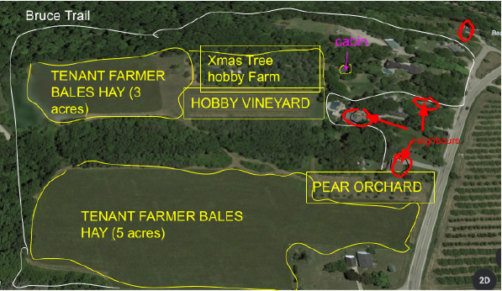
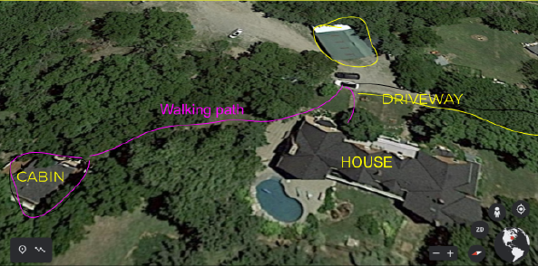

APPENDIX 3
Floor Plan

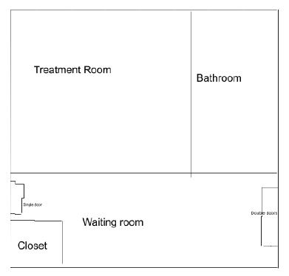

APPENDIX 4
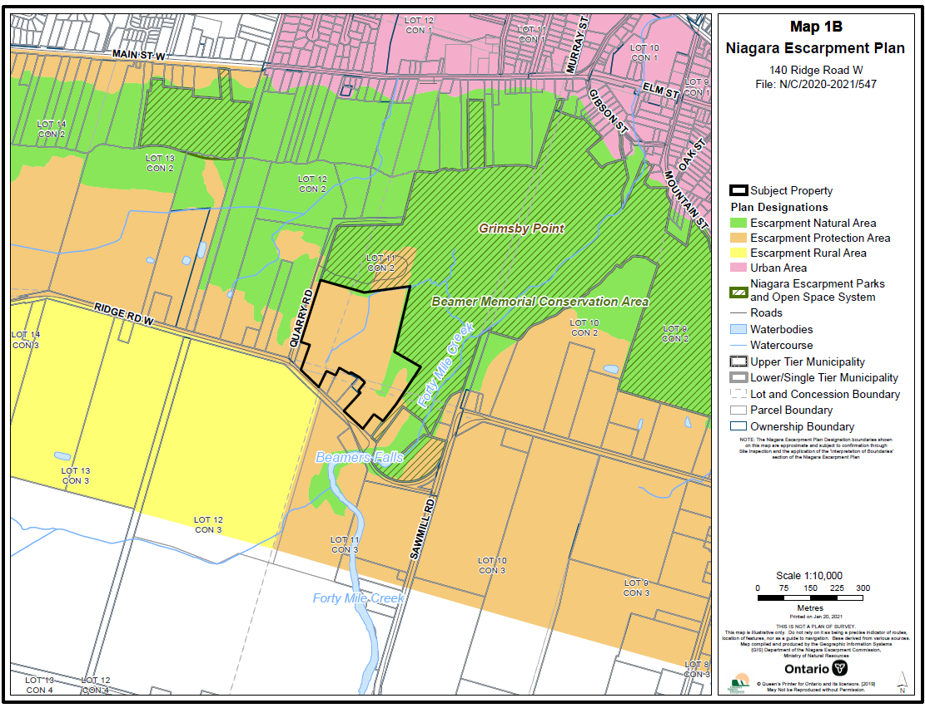
Niagara Escarpment Plan Designations

APPENDIX 5
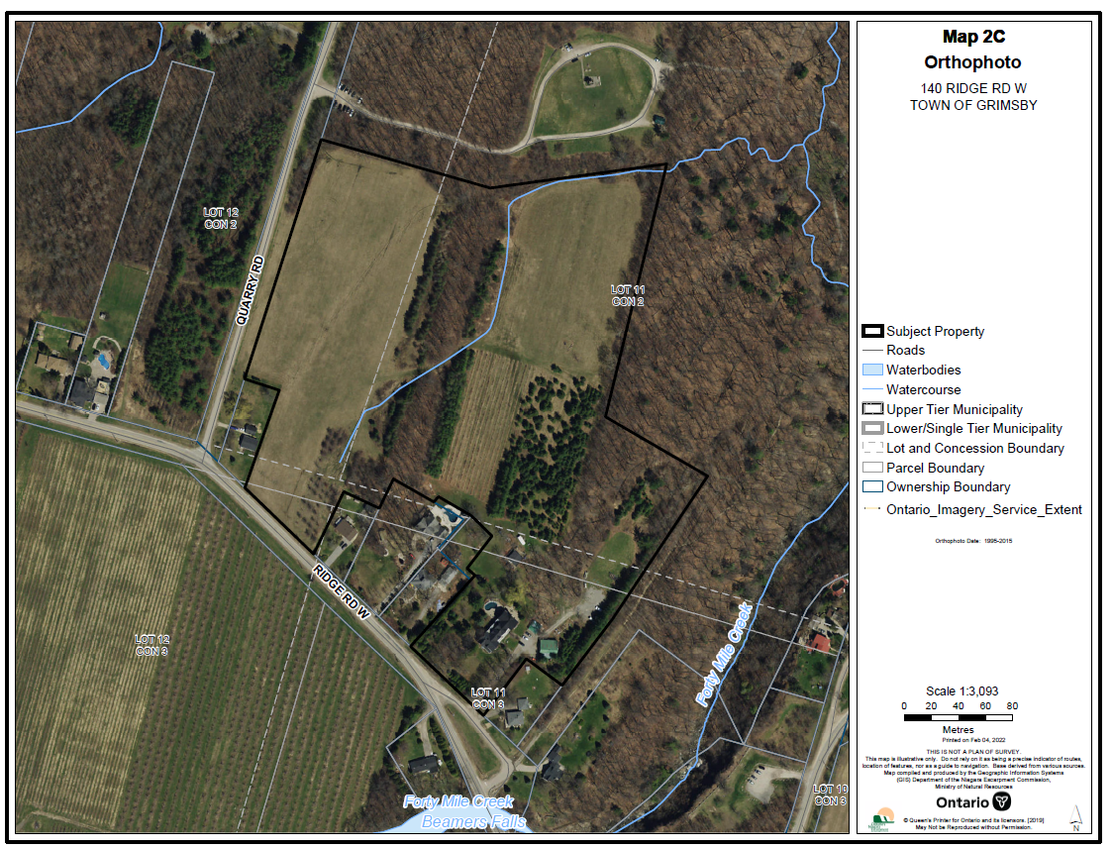
Ortho Photo

