March 17, 2022

A1: AS-BUILT STAFF REPORT

DEVELOPMENT PERMIT APPLICATION:

H/C/2020-2021/733
REDACTED
10708 Third Line
Part Lot 14, Concession 3, Esquesing
Town of Halton Hills, Region of Halton

SUMMARY

PROPOSAL:
To recognize the use of ± 63.79 sq m (± 686.63 sq ft) within an existing two-storey 526.84 sq m (5,670.86 sq ft) accessory structure (barn) for a personal training business (home occupation/on-farm diversified use) on an existing 35.56 ha (87.87 ac) lot that supports a single dwelling, on-farm help mobile home, and accessory facilities.

DESIGNATIONS:
Escarpment Protection Area, Escarpment Natural Area

LOT SIZE:
35.56 ha (87.87 ac)

ISSUE:
The personal training business is not a permitted use, and is not supported by the local and upper-tier municipalities.

RECOMMENDATION:
Refusal

REASONS:
The personal training business is not supportable under Niagara Escarpment Plan policies related to permitted uses in Escarpment Protection Area, and the proposal conflicts with the development criteria in Part 2.2.10 of the NEP. It is not support by both the lower and upper-tier municipalities.

RECEIVED:
03/24/2021

SOURCE:
REDACTED, Owner

RELATED FILES:
H/R/2010-2011/86 – NEC development permit #9671 was issued on August 23, 2010, to install a maximum 4.57 m (15 ft) high, 111.48 sq m (1,200 sq ft) mobile home on a 36.82 ha (91.0 ac) horse farm, connected to water and septic servicing from the existing residence. The mobile home is used as accommodation for full-time farm employees.
H/A/2008-2009/122 – NEC development permit #9280 was issued on October 7, 2008, for the construction a ± 325.2 sq m (± 3500 sq ft) accessory building (with hydro) on an existing 35.6 ha (88 ac) lot.
H/A/2007-2008/172 – NEC development permit #9053 was issued on December 14, 2007 to undertake the following work on an existing 38.05 ha (94.03 ac) lot:
1. to demolish existing dwelling, barn and sheds
2. to construct a new 2-storey, 418.0 sq m (4500 sq ft) single dwelling with an attached garage, a 167.2 sq m (1800 sq ft) garden shed, a new septic system and driveway
3. to construct a 2-storey, 836.1 sq m (9000 sq ft) barn including 20 stalls to be used for horse training/breeding and an apartment to accommodate farm help
4. to construct a ± 557.4 sq m (± 6000 sq ft) pond (excavated fill will be used to create berms and fill in other areas on the property).

BACKGROUND:
The applicant previously operated a horse boarding and training facility for racing horses on site until the industry collapsed approximately ten years ago. Subsequently, the principal use of the subject property is still agriculture. However, the agriculture on site has since changed from horse farming to solely cash crop farming.

The personal training business, Farm Girl Fitness, is currently operated on site in an existing accessory facility (equestrian barn) by the daughter of the landowner without an NEC permit. Farm Girl Fitness brands itself as “North Halton’s Premium Indoor and Outdoor Training Facility”, and according to the property owner, is geared for women. The business, originally focused on outdoor fitness classes, was started in the spring of 2020. Farm Girl Fitness offers one-on-one fitness programs, studio rentals, fitness classes, and sports team training. The business has grown over time to accommodate indoor fitness classes as well as physiotherapy exercise appointments in the existing equestrian barn, outdoor horse-riding ring, and grounds within the immediate vicinity of these structures. All classes have a capacity of 15 people and operate seven days per week from 8:00 a.m. to 8:00 p.m. At least four staff are employed by Farm Girl Fitness on site, including the business owner, assistant, and two part time staff. The business owner currently resides in the on-farm help mobile home. This structure was previously approved solely to support the former horse farming operation, and was to have been removed after three years (i.e., by August 2013), or re-applied for if still needed for farm labour. Since the equestrian use ceased approximately ten years ago, the mobile home should have been removed, or the landowner should have returned to the NEC for a new permit that justified its continued use based on a new agricultural use that required full-time farm help.

SITE DESCRIPTION:
The 35.56 hectare (87.87 acre) subject property has frontage on west side of Third Line, south of 15 Sideroad in the Town of Halton Hills, approximately nine kilometres north of the Town of Milton. The subject property currently supports one single dwelling, one mobile home (previously approved for on-farm help), several accessory structures, including a covered outdoor horse-riding ring, an existing two-storey equestrian barn, and associated parking lot. The existing equestrian barn was previously approved by the NEC for a horse farming operation and contains one washroom serviced by a holding tank septic system, separate from the single dwelling. Additionally, an existing pond is situated between, and separates, the single dwelling and the barn. The outdoor horse-riding ring is located at the north end of the pond feature. Approximately 28 hectares (70 acres) of the subject lands are actively leased out by the landowner for farming for soybeans and corn by a tenant.

The subject property is designated as Escarpment Protection Area, and Escarpment Natural Area in the Niagara Escarpment Plan. The personal training business is situated within the Escarpment Protection Area portion of the subject property. The subject lands are also designated as candidate prime agricultural area in the province’s Agricultural System for the Greater Golden Horseshoe. However, the Region of Halton does not include the subject property within its Official Plan mapping of prime agricultural area. Three watercourses traverse the subject property generally in a north to south direction. The middle branch of Sixteen Mile Creek and its associated wooded ravine is located at the west to northwest end of the property. The elevation on site ranges from 295 metres above sea level (masl) at the driveway entrance to the northeast, downward to 280 masl at the middle branch of Sixteen Mile Creek. The southwest corner of the subject property is designated as Escarpment Natural Area, contains a portion of a Life Science Area of Natural and Scientific Interest (ANSI), and is designated as an Environmentally Sensitive Area by the Region of Halton. Moreover, Scotch Block Reservoir is located approximately 600 metres southeast of the subject property and is fed by a tributary of Sixteen Mile Creek headwaters originating on the subject lands. Surrounding land uses include agriculture, rural residential, and natural environment.

PLANNING ANALYSIS:

1. Niagara Escarpment Plan (NEP 2017):
The property is designated Escarpment Protection Area (1.4) and Escarpment Natural Area (1.3) in the NEP. The area of proposed development falls within the less-restrictive Escarpment Protection Area portion of the property. The objectives of the Escarpment Protection Area designation include, but are not limited to, protecting Escarpment scenic resources, agricultural lands, and natural areas of regional significance. Commercial uses are generally not permitted in the Escarpment Protection Area. The entire property is within the Niagara Escarpment Area of Development Control.

Part 2.8.7 On-farm Diversified Uses
An OFDU is defined in the NEP as:

“a use that is secondary to the principal agriculture use and is limited in area. On-farm diversified uses include, but are not limited to, home occupations, home industries, agri-tourism uses, and uses that produce value-added agricultural products.”

To be permitted as an OFDU, the personal training business must be assessed against the development criteria in Part 2.8.7 of the NEP. It does appear to meet these criteria. Although the landowner leases out the farmland to someone else, the Commission has made a previous decision that allowed an OFDU on a property where the landowner was not a full-time farmer, being employed elsewhere, and leased out lands for a hay crop on his property. Note that the term “farmer” is not defined in the NEP.

However, on-farm diversified uses are not a permitted use in Escarpment Protection Area as per Part 1.4.3.2 of the NEP. This policy states that OFDUs are only permitted within prime agricultural areas within the Escarpment Protection Area land use designation. The subject lands are not identified as a prime agricultural area (“Agricultural Area”) in the Halton Region Official Plan, although they are identified as “candidate” prime agricultural area in provincial mapping. The intent of the Part 1.4.3.2 within Escarpment Protection Area is to be more restrictive than other NEP policies that apply to less restrictive designations, specifically Escarpment Rural Area. For example, in Escarpment Rural Area, Part 1.5.3.2 permits “agriculture-related uses and on-farm diversified uses” with no requirement that they be located in prime agricultural areas. Given the higher scenic value and environmental sensitivity of Escarpment Protection Area, the policy intent is to limit the intensity of land uses within this designation.

Thus, given the restriction that OFDUs are only permitted in prime agricultural areas in Escarpment Protection Area, the personal training business cannot be permitted as an OFDU.

Part 2.2.10 Home Occupations and Home Industries
Staff also gave consideration as to whether the fitness business could be considered as a home occupation. Part 2.2.10 of the NEP speaks to the requirement for home occupations, on lands designated as Escarpment Protection Area, to be located within a single dwelling, unless the need to locate it within an accessory facility can be justified. Given that an existing barn has been repurposed for the business, staff finds that locating it within an accessory facility is justified.

The submitted development permit application stated that the proposed fitness business would be located within the existing barn in four former horse stalls, an area which accounts for approximately 8.25% of the total floor space of the barn. NEC staff attended a site visit on November 24, 2021 and were provided a guided tour of the grounds and the four former horse stalls in the equestrian barn. Photos on the personal training business website indicate that other areas of the barn are used for fitness classes as well, however the landowner would not provide access to these areas in the barn. The use of additional barn space for the fitness business was not disclosed on the submitted development permit application.

Assuming that the ± 63.79 sq m (± 686.63 sq ft) is accurate, it does fit within the allowable area for a home occupation (personal training business). However, the development criteria for a home occupation requires that the business be operated by residents of the household on the lot (Part 2.2.10i). In addition to the owner/operator, the business employs at least four employees.

The fitness business is also not supportable based on Part 2.2.10.j), which states:

“municipal official plan policies and standards (e.g., lot size, parking, floor area, retail space) must be met.”

Particularly, the Town of Halton Hills Official Plan policy E1.4.4 c) states that a home occupation is permitted if the use is completely located in the principal residence of the person conducting the home occupation or cottage industry. Therefore, the applicant is advised that a Town Official Plan Amendment is required for the proposed personal training business to operate within an accessory structure. Furthermore, Town of Halton Hills Zoning By-law 2010-0050 (Sec. 4.1.1 b) states that “no accessory building or accessory structures shall be used for human habitation or an occupation for gain or profit except if specifically permitted”.
Similarly, the Region of Halton Official Plan requires that the home occupation activity takes place within a single detached dwelling, an addition to the dwelling or in an accessory building not more than 30 metres from the dwelling, and be performed by one or more residents of the household on the same property. The existing single dwelling and on-farm help mobile home are equidistant, 115 metres, from the existing equestrian barn where the fitness business is located, exceeding the 30 metre maximum distance set by the Region.
It should be noted that neither the Regional or Town official plans contain policies that support on-farm diversified uses. Given that the Town and Region do not support the personal training business, the criteria in Part 2.2.10 are not met, and staff recommends refusal.

2. Provincial Policy Statement (PPS, 2020)
Section 1.1.5.2 of the PPS notes that agricultural uses, and home occupations, in accordance with provincial standards, are permitted on rural lands in municipalities. Therefore, the proposed home occupation appears to be consistent with the PPS. However, Part III of the PPS addresses the relationship between the PPS and provincial plans, including the NEP. This section states that provincial plans (including the NEP) take precedence over the policies of the PPS to the extent of any conflict. Thus, the NEP’s definition and policies surrounding home occupations are consistent with the PPS in that they take precedence over the PPS policy that allows for home occupations more broadly.

3. Regional Official Plan
Objection
The subject property is entirely designated as Regional Natural Heritage System (RNHS) on Map 1 of the 2009 Regional Official Plan (ROP). The property is also mapped as being within the Region’s Agricultural System but located outside of the Prime Agricultural Area.
Map 1 of the 2009 Regional Official Plan (ROP) identifies the subject property as having components within the Regional Natural Heritage System (RNHS) designation. The lands contain or are adjacent to:
- Features identified as Key Features, as illustrated on Map 1G of the 2009 ROP, including:
  - Candidate significant woodlands;
  - Significant area of natural and scientific interest;
  - Potential significant valleylands;
  - Potential habitat of endangered or threatened species;
  - Potential significant wildlife habitat; and
  - Potential Fish Habitat
- Areas identified as an enhancement area, linkage and buffer, as illustrated on
Map 1G of the 2009 ROP;
- Watercourses, floodplain areas, wetlands and slope hazard regulated by Conservation Halton;
- Areas identified as Escarpment Protection Area and Escarpment Natural Area in the Niagara Escarpment Plan (2017).

Section 117.1 of the ROP outlines the permitted uses within the Regional Natural Heritage System designation. Section 117.1(13) permits home occupations with a gross floor area not exceeding 100 sq m or 25 per cent of the residential living area, whichever is lesser.

ROP section 248 defines the term “home occupation” and requires that the activity take place within a single detached dwelling, an addition to the dwelling or in an accessory building not more than 30 metres from the dwelling, and be performed by one or more residents of the household on the same property. This application seeks permission to use a building that is significantly farther than 30 metres from either of the residential uses on the property. The fitness business therefore does not meet the Regional requirements of a home occupation.

Regional staff also evaluated this proposed business based on other permitted uses within the Regional Natural Heritage System designation. While Regional policies allow for home industries and small-scale businesses within this designation, they need to be located on a commercial farm and secondary to the farming operation, along with meeting other criteria outlined in ROP policy and the associated On-Farm Business Guidelines. It is Regional staff’s understanding that the agricultural lands on this site are actively farmed but are leased out to a local farmer. Based on the information provided to date, it does not appear that the proposed business would conform to any of the permitted uses for this designation.

The Region of Halton is currently undertaking a Regional Official Plan review exercise and one of the components of that review is to evaluate the scope of on-farm diversified uses that could potentially be supported in the future. Since this exercise is still ongoing, the subject application needs to be reviewed in the context of the ROP policies which are applicable and in force at the time the application is filed.

If the applicant was able to propose a use that was in conformity to Regional Official Plan policies, the proposal would need to be evaluated to determine if there were any technical requirements related to private services for the use and any potential impacts to the Regional Natural Heritage System. However, Regional staff are not asking for any technical information or studies to be undertaken at this time, as the proposed use is not supported by Regional Official Plan policies.

Conservation Halton (CH) staff provide environmental advisory and technical review services to the Region in relation to the protection of certain natural heritage features and areas and natural hazard land management. As such, it is recommended that the relevant CH staff comments be addressed to their satisfaction.

Regional staff recommend refusal [bold added] of the application, as the proposed development does not conform to the policy direction of the Regional Official Plan.

4. Local Official Plan
Objection.

Under the Town’s Official Plan, the portion of the lot occupied by the existing barn is designated as Escarpment Protection Area. Home occupations are permitted under this designation in accordance with the criteria set out under Section E1.4.4: a) the use shall not have a negative impact on the enjoyment and privacy of neighbouring properties; b) the use is clearly secondary to the primary residential use in terms of floor space utilization and is compatible with surrounding uses; c) the use is completely located in the principal residence of the person conducting the home occupation or cottage industry [bold added]; d) the character of the dwelling as a private residence is preserved; e) adequate on-site parking facilities are provided for the use, in addition to the parking required for the principal use on the property, and such parking is provided in locations compatible with surrounding land uses; f) the use will not cause a traffic hazard; g) the use can be serviced with an appropriate water supply and an appropriate means of sewage disposal; and h) the signage advertising the use is to be designed and located in accordance with the Town's sign by-law and where applicable the development criteria contained in the Niagara Escarpment Plan.

Home occupations shall also not exceed 25 percent of the gross floor area of a single detached dwelling, to a maximum of 100 square metres.

The proposed home occupation within the existing barn does not conform to criteria c) of Section E1.4.4. Therefore, an Official Plan Amendment is required to allow such a use to occur within an accessory structure.

The Town understands that the Town’s Zoning By-law does not have an effect within the Niagara Escarpment but to ensure that there is alignment, the Town asks the NEC requires the applicant to comply/consider the following notes:
- Under the Town’s Zoning By-law 2010-0050 (Sec. 4.1.1)
- No accessory building or accessory structures shall be used for human habitation or an occupation for gain or profit except if specifically permitted in this By-law. Operating a personal training business out of the existing barn would constitute the use of an accessory building for gain or profit.

Given the above, the Town does not support this proposal. Should the Niagara Escarpment Commission wish to consider the issuance of a permit for the propose use the Applicant would first need to obtain an Amendment to the Town of Halton Hills Official Plan.

5. Conservation Authority
No objection.

SUMMARY
NEC Staff are recommending that the development proposal be refused. The proposed personal training business does not qualify as a permitted use, either as a home occupation or on-farm diversified use. There are at least four off-site staff members involved with this business, and it does not comply with municipal policies and standards related to home occupations, and both the Region and the Town object to the business. Furthermore, the NEP does not permit OFDUs in the Escarpment Protection Area unless they are in a prime agricultural area as per NEP Part 1.4.3.2. It is notable that a home occupation for a small-scale personal training business could still be permitted on the subject property, provided that it is conducted in a manner that is consistent with the NEP and municipal official plan policies regarding home occupations.

RECOMMENDATION:

That the application be refused for the following reasons:

On-farm diversified uses are not permitted outside of prime agricultural areas in Escarpment Protection Area;

The personal training business does not meet the development criteria for a home occupation since it employs more than just the residents of the household, and it does not meet municipal official plan policies and standards; and

The application is not supported by both the local and upper-tier municipalities (Region of Halton and Town of Milton).

Prepared by:

Original signed by:

__________________
Cameron Curran
Senior Planner

Approved by:

Original signed by:

__________________
Kim Peters, MCIP, RPP
Manager

Appendix 1 – Orthophoto of the Subject Property

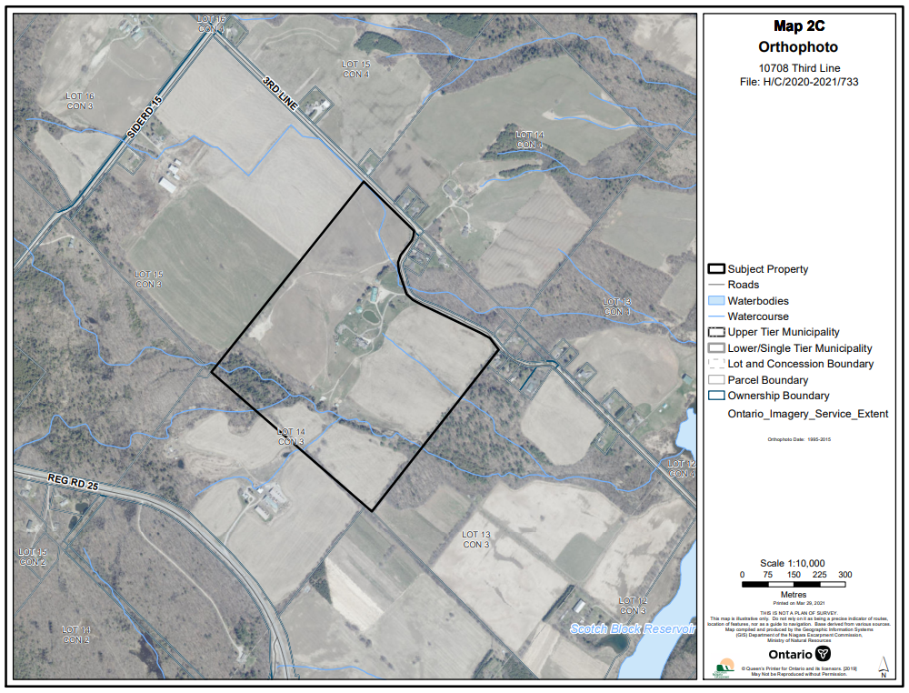

Appendix 2 – NEP Land Use Designations Map
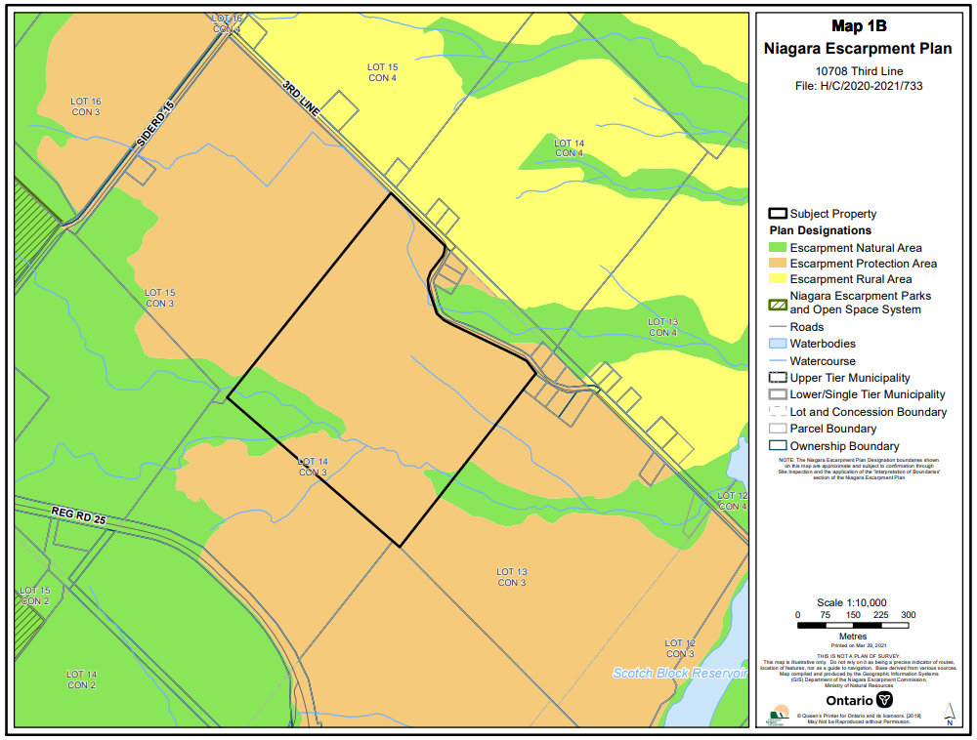

Appendix 3 -- Site Plan
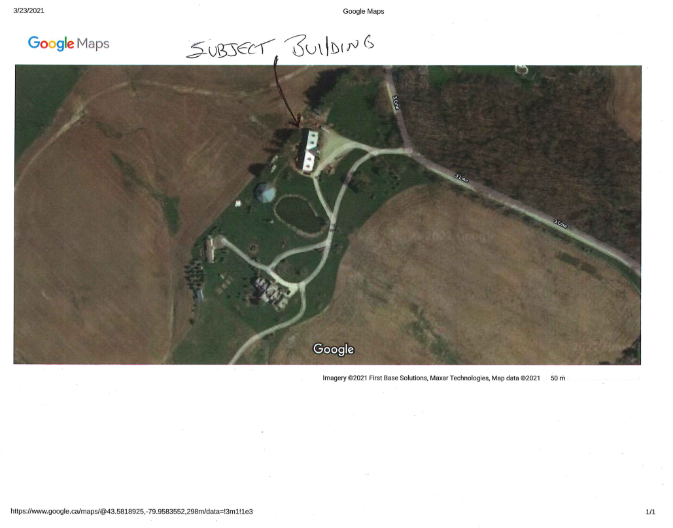

Appendix 4 -- Floor Plan
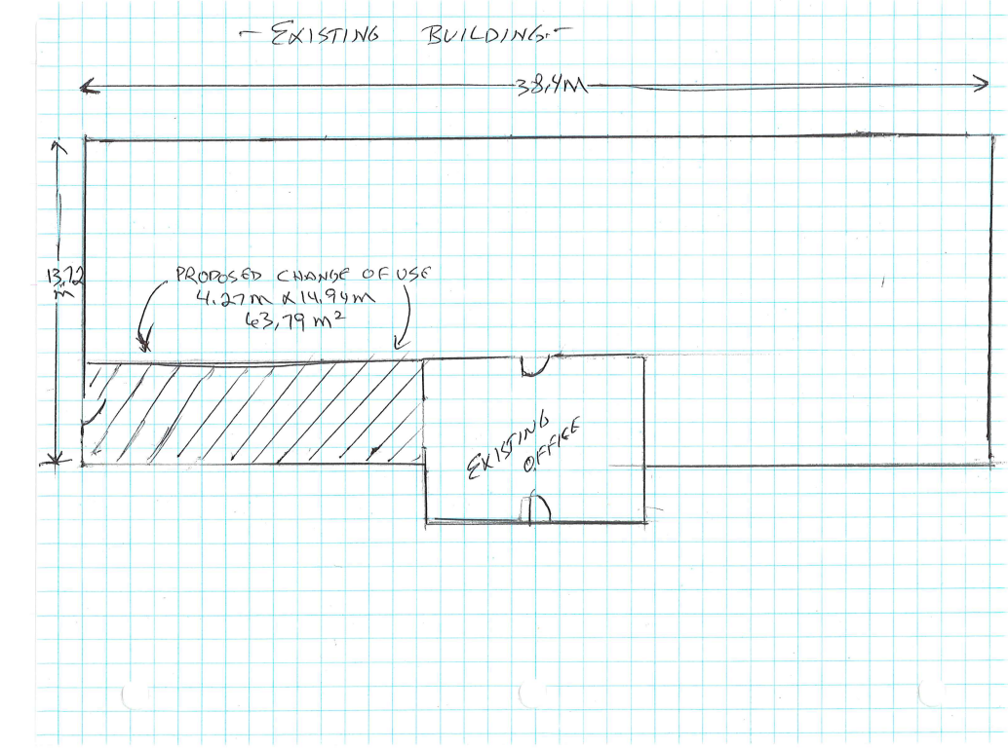

Appendix 5 -- Barn Photograph
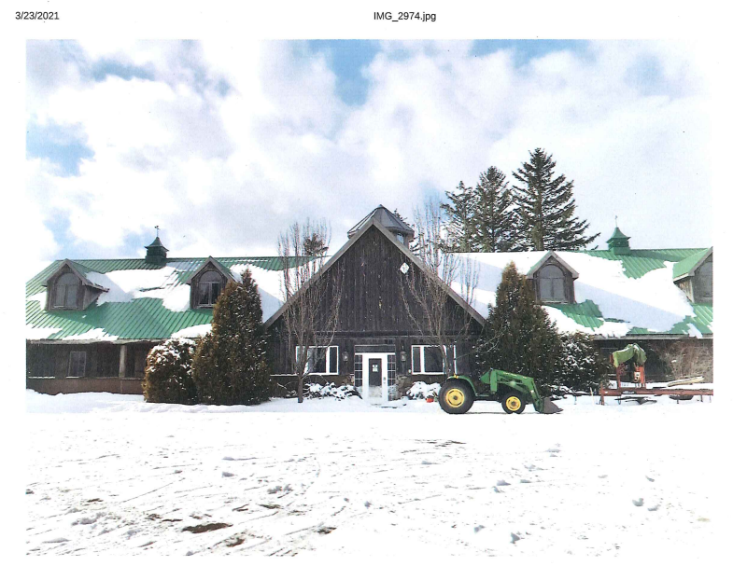

Appendix 6 – Justification Letter
