March 17, 2022

C1: STAFF REPORT

Re: Recent Concerns with Signage and Sign By-laws in the Niagara Escarpment Plan Area

SUMMARY

ISSUE:
Several large-scale signs with LED (light-emitting diode) displays and internally-illuminated components proposed or erected within the Niagara Escarpment Plan (NEP) Area have recently come to staff’s attention, and staff is concerned that these signs conflict with the Purpose and Objectives of the NEP, specifically with regard to protecting Escarpment’s natural scenery, open landscape character, as well as the community character and cultural heritage attributes of hamlets, villages and rural areas.

SUMMARY RECOMMENDATIONS:
- That the Commission direct staff to provide a copy of this report to the Region of Peel, the Town of Caledon, and the Town of Halton Hills.
- That staff engage in a review of the impacts of large-scale signs with LED displays and internally-illuminated components signage, as well as NEP Area municipal sign bylaws to determine if bylaws are consistent with NEP policies, with the objective of providing advice and encouraging all municipalities to bring their sign bylaws into alignment with the NEP.

BACKGROUND:
The Niagara Escarpment Plan (NEP) contains policies related to signs and billboards as a key means of achieving one of the seven Objectives of the NEP: preserving the natural scenery and open landscape character of the NEP Area. These policies are contained in Part 2.2.12 of the NEP, as follows:
12. The following additional provisions apply to signs where permitted as an accessory use and billboards where permitted as a principal use:
- a sign may be permitted where the sign and its information is accessory to the existing principal use located on the same lot (e.g., home occupation or home industry, agriculture-related use, etc.);
- signs and billboards shall not alter the natural features or cultural heritage landscape of the property and shall be compatible with the local topography, surrounding scenic resources and rural or residential community;
- signs and billboards shall have minimal negative impact on the Escarpment environment through compatible design, materials, colour, siting and landscaping;
- billboards are not permitted on prominent Escarpment slopes or in places where such billboards would obstruct views associated with prominent Escarpment slopes;
- illumination of signs and billboards is discouraged and, where permitted, shall be subdued (e.g., shielded, downward directional, not internally lit);
- signs shall be limited to one per lot and shall not exceed 0.9 square metres, unless it can be demonstrated that a larger sign or an additional sign would have minimal negative impact on the Escarpment environment;
- roof signs, signs attached to towers or other similar structures, animated or automated signs, and signs affixed to trucks and trailers adjacent to roads are not permitted; and
- municipal official plan policies and standards respecting signs and billboards must be met, including any municipal sign by-laws.
- with the exception of subsection h), the above restrictions do not apply to the following signs or billboards:
- election signs
- temporary real estate signs advertising the sale of the property on which they are located;
- temporary construction site signs;
- no trespassing or warning signs; and
- signs approved, sponsored or required by a public body.
NEC staff are currently processing three development permit applications (DPAs) related to signage proposed in the Town of Caledon: the Region of Peel is proposing a large, back-lit sign at the entrance to the works yard/recycling depot on Charleston Sideroad; there are also DPAs for lit signs related to Town of Caledon and Peel District School Board facilities in the Inglewood and Belfountain Minor Urban Centres.
Appendix A contains an illustration of these three signs compared against an average-height person.
In addition, NEC staff recently discovered a large commercial LED sign installed along Highway 7 in the Henderson’s Corners Minor Urban Centre in the Town of Halton Hills. A photo of this sign, as seen at night, is included in Appendix B.

POLICY CONSIDERATIONS

Niagara Escarpment Planning and Development Act (NEPDA)
As per Section 13 of the NPDA, all municipal bylaws must conform to the NEP:
13 (1) Despite any other general or special Act, when the Niagara Escarpment Plan is in effect…
(b) no municipality having jurisdiction in the Niagara Escarpment Planning Area, or in any part of the Area, shall pass a by-law for any purpose if it is in conflict with the Niagara Escarpment Plan. 2000, c. 26, Sched. L, s. 7 (6); 2002, c. 17, Sched. F, Table; 2009, c. 12, Sched. L, ss. 7, 12 (1).

Thus, there is general expectation that all municipal bylaws will conform to the NEP, where applicable.

Niagara Escarpment Plan
Despite Section 13 of the NEPDA, the NEP provides flexibility for public body signage, in recognition that such signage is usually not for commercial purposes, and that it may be required for public information or safety reasons.
As noted in Part 2.2.12 (i) of the NEP, “signs approved, sponsored or required by a public body” are not subject to the restrictions set out in (a) through (h). However, in the Development Objectives for Minor Urban Centres (Part 1.6.8), it is stated:
Municipalities are encouraged to pass sign by-laws to ensure that the cultural heritage resources, attractive streetscapes and scenic resources of Minor Urban Centres are conserved.
Similar provisions are provided in the objectives for Urban Areas (Part 1.7.5) and Escarpment Recreation Areas (Part 1.8.5). How this policy is applied depends on whether the Minor Urban Centre, Urban Area or Escarpment Recreation Area is subject to Development Control. This is discussed further under “Municipal Sign Bylaws” below.
Part 2.13 of the NEP contains more general policies about protecting the Escarpment’s scenic resources. All forms of development, including signage, are assessed against these policies.

Exemption Regulation (Ontario Regulation 828/90)
O. Reg. 828/90 facilitates the erection of important public-purpose signage by exempting the following signage from the NEC’s permitting process:
- Traffic, caution, directional and emergency street number signs erected by or on behalf of any government agency.
- Temporary public information signs erected by or on behalf of any government agency.
- Unlit signage, plaques or cairns identifying a site or feature as being of cultural local, provincial or national value or interest or of historical significance.
- A temporary and portable sign or banner within an area designated as a Minor Urban Centre or Urban Area in the Niagara Escarpment Plan, if the sign is subject to a permit from the municipality having jurisdiction.

NEC Development Control Area
In the NEC’s Development Control Area (as defined in Ontario Regulation 826/90), all signage other than that which is exempt requires a permit from the NEC. However, many Minor Urban Centres, Urban Areas, and Escarpment Recreation Areas are not subject to Development Control.
Other NEC Policy
In June 2012, the Commission endorsed the use of a brochure put together by NEC staff to promote protection of the night sky in manner consistent with the international “Dark Sky Community” movement, following the granting of a Niagara Escarpment Achievement Award to the Municipality of Northern Bruce Peninsula for becoming a Dark Sky Community in 2009. Together, Bruce Peninsula National Park and Fathom Five National Marine Park are designated as a Dark Sky Preserve. A copy of the brochure is included as Appendix C.
In addition to occasionally requesting detailed lighting plans as part of visual impact assessment, NEC staff has also instituted a practice of adding an advisory note to DPs to increase awareness of the negative impacts of excessive outdoor lighting, as follows:
The Niagara Escarpment Commission supports the protection of the night sky from excessive lighting and recommends the applicant obtain information on the use and operation of appropriate lighting fixtures in keeping with dark sky approaches.

Municipal Signage Bylaws
Municipal signage bylaws may also apply in the Area of Development Control, however, Section 24 of the NEPDA specifies that the NEC DP approval must precede any other approval, and that all other approvals (e.g., a municipal sign permit) must be consistent with the DP issued by the NEC. Thus, even if there is a conflict between the NEP sign policies and a municipal sign bylaw, the NEP policies must be upheld. This may work for signs of a commercial nature; however, as noted earlier in this report, public body signs are not required to meet the development criteria in Part 2.2.12 of the NEP.
In areas not under NEC Development Control (e.g., some Minor Urban Centres), there is the potential for municipal sign bylaws that are not consistent with NEP policies to be applied, as is the case with the sign in Henderson’s Corners. Indeed, municipalities are only “encouraged” to have sign bylaws consistent with the NEP. Staff has not yet done a comprehensive review of municipal sign bylaws to determine if there is general compatibility with NEP policies, but it is recommended that such work be undertaken. With the growing popularity of LED signage with full-colour, changeable or video imagery, it is very concerning to staff that such signage is being sponsored and/or approved by public bodies when it is a significant departure from the Purpose and Objectives of the NEP. Staff is also generally aware of the negative impacts of such signage on human health, traffic safety, and the night sky/nocturnal ecological processes, and that there is a growing body of literature addressing this. As part of such a review, staff can review this information, and also scan other jurisdictions to compare the NEC’s approach to signage and protection of Escarpment scenery and open landscape character and provide recommendations as appropriate.

Policy Summary
In summary, municipalities must pass bylaws that do not conflict with the NEP, but in the case of Minor Urban Centres, Urban Areas, and Escarpment Recreation Areas, the NEP only “encourages” municipalities to bring their sign bylaws into compliance with the NEP, and signs sponsored by a public body are not required to adhere to the restrictive NEP sign policies at all. In areas that are not under NEC Development Control, including some Minor Urban Centres, this potentially results in signage that is not compatible with the rural Escarpment environment, whether it be commercial or public body signage. Specific recent case studies are discussed below.

CASE STUDIES

Henderson’s Corner Minor Urban Centre (Town of Halton Hills, Region of Halton)
While commuting, the NEC’s Landscape Architect became aware of a recently erected LED sign in Henderson’s Corners (see Appendix B). The sign is approximately 2 metres tall and four metres wide and is raised about three metres off the ground. NEC staff noted that the glow of the sign is visible up to 2.8 kilometres away. Henderson’s Corners is outside of NEC’s Development Control Area, so a DP was not required for the sign. Approvals were required from both the Town of Halton Hills and the Ministry of Transportation (the sign is adjacent to Highway 7). The NEC was not provided with the opportunity to comment on the sign.
NEC staff consulted with Town staff to determine if the sign was legally erected. This was confirmed. NEC staff also did a preliminary review of the Town’s signage bylaw, and it appears to have been upheld. NEC staff was surprised to learn that the Town’s bylaw does contain restrictive signage provisions for the hamlets of Glen Williams and Norval, which are not in the NEP Area, but there were no restrictive policies applying to other hamlets within Town boundaries. Signs in Glen Williams and Norval are not permitted to have moving or stationary track lighting, and billboards and portable illuminated signs are not permitted. NEC staff is recommending that the Town be made aware of the NEP objectives and policies related to scenic resources and signage, and the Town should be encouraged to extend their restrictive sign provisions to Minor Urban Centres within Town boundaries, including Henderson’s Corners, Silvercreek, and Limehouse.
Henderson’s Corners is ranked as “average” in the NEC’s Landscape Evaluation Study Minor Urban Centres in the NEP Area, and is therefore not among the most significant scenic Escarpment communities. However, it should still be protected from declining farther into the “low” or “very low” scenic rankings. As noted by the NEC’s Landscape Architect, the glow of the sign has a significant impact on the surrounding countryside, not just the immediate surroundings.

Region of Peel Recycling Depot and Works Yard (Town of Caledon)
A DPA from the Region of Peel was recently submitted with a request to erect a large sign outside the recycling depot and works yard at a former landfill site, near the intersection of Charleston Sideroad and McLaren Road. The sign is illustrated in Appendix B. The original proposal was for an internally-lit sign 7.4 metres in height and three metres wide, with a two-sided LED high-definition display. The sign is proposed in a style consistent with the Region of Peel’s branding. Similar signs can be found at other Regional facilities.
Through discussions with NEC staff, the Region has offered to reduce the sign to six metres in height, with a width of 3 metres. The sign will still be internally lit, and the LED screen is proposed at a 2.2 wide, by 1.2 metres tall. Staff is still reluctant to support it given the almost complete absence of ambient lighting in the surrounding countryside, as well as it being a significant departure from the sign policies in the NEP. Since the works yard is on the outer boundary of the NEP Area, Regional staff has indicated that the sign can be moved to the opposite side of the road, where it will be outside of the NEP Area and will not require a permit from the NEC. While it may solve the issue of not being approvable by the NEC, staff’s finding is that this will result in a greater negative impact because it will not be screened by any vegetation and it is within a more open area.
NEC staff looked to the Town of Caledon’s sign bylaw to determine if such a sign would be permitted in a rural area. Section 4.10 of the Town’s sign bylaw states,
All signs placed, displayed, repaired, or altered within the Niagara Escarpment Development Control Area, in addition to being required to conform with the provisions this By-law, shall also conform to the requirements of the Niagara Escarpment Planning and Development Act
However, section 2.3 of the bylaw states that the bylaw does not apply to signs placed by a public authority, which would include the Region.
NEC staff maintains that any sign proposed at this size, with both internally-lit and LED displays, is incompatible with a rural setting, and does not uphold the protection of the Escarpment environment, including the Escarpment’s scenic resources and open landscape character. It is also not in keeping with the NEC’s promotion of Dark Sky principles.

Belfountain Public School Sign, Town of Caledon, Region of Peel
In a 2009 study done for the Town of Caledon, the hamlet of Belfountain, including Credit River Gorge, was identified as a cultural heritage landscape due its cultural heritage resources and outstanding natural scenery. The village is not designated as a Heritage Conservation District under the Ontario Heritage Act, but it does contain at least three properties designated on the Town of Caledon’s Heritage Register. The school itself is not a heritage building; it appears to have been constructed in the 1950s or 60s. The village is well-loved by the local population and is a popular day trip for Greater Toronto Area residents.
The Belfountain Minor Urban Centre remains within NEC Development Control. Thus, when the Peel District School Board wished to erect a new sign at the Belfountain Public School, the School Board submitted a DPA to the NEC in September 2021. An internally-lit sign with a full-colour message centre is proposed with a height of 3.4 metres and a width of 2.9 metres. The message centre is a high-resolution LED video screen measuring 0.9 metres high by 2.2 metres wide. The School Board has erected identical signs at other rural schools in Caledon. Staff has not yet made a recommendation on this application.
As noted above, the Town of Caledon sign bylaw does not apply in this case, since the sign is being erected by a public authority, and NEP signage policies also do not apply.

Inglewood Community Centre Sign, Town of Caledon, Region of Peel
The Town of Caledon has submitted a DPA to erect a sign for the Inglewood Community Centre that is 2.8 metres high, by 1.3 metres wide. The sign is proposed to include a LED message display measuring approximately 0.6 metres high, by 1.3 metres wide.
The Town submitted renderings of the sign in its context, alongside the existing, dilapidated sign. In evaluating this rendering, the sign appears to be similar in size to the existing sign, but is considerably sleeker in design, and the branding clearly identifies the community centre as a Town of Caledon facility. However, the two- dimensional rendering does not include an assessment of the night-time impacts of the LED display, as is the case with the other two sign proposals within the Town of Caledon.

SUMMARY
In summary, context is important in assessing the impact of signage on the landscape. The school and community centre signs are still under evaluation by staff and are generally less of a concern than the other two signs discussed in this report. However, the Commission is likely to have the Region of Peel works yard sign brought to it for a decision given its scale and the lack of compatibility with the rural landscape. Even though the sign policies in Part 2.2.12 do not apply to public bodies, the policies in part 2.13 regarding scenic resources still do apply.
Had the Henderson’s Corner sign been brought to staff’s attention prior to the Town of Halton Hills approving it, staff would have advised against it given the significant night-time visual impact on the surrounding landscape.
In follow up to this report, staff would like to proceed with doing additional research on the impacts of internally lit and high-resolution of LED signage, and to review potential inconsistencies with municipal sign bylaws as they apply within the NEP Area. It is staff’s intention to build awareness with its municipal partners on the impacts of these signs, and in keeping with the language in the NEP, “encourage” its municipal partners to work toward reducing the negative visual and environmental impacts of such signage. This should be viewed as an opportunity to provide value-added services to our municipal partners, rather than an attempt to impose mandatory requirements on them.

RECOMMENDATIONS:
- That the Commission direct NEC staff to send this report to the Region of Peel, the Town of Caledon and the Town of Halton Hills so that these municipalities are aware of the NEC’s growing concern about the use of LED signs within the NEP Area.

- That the Commission endorse NEC staff reviewing municipal sign bylaws in the NEP Area and doing additional research into the visual impacts of LED signage to identify appropriate policy approaches and provide this information and support to the NEC’s municipal partners.

Prepared by:

Original signed by:
______________________
Kim Peters, MCIP, RPP
Manager

Approved by:

Original signed by:
______________________
Debbie Ramsay, MCIP, RPP
Director

Appendix A: LED Signage in Henderson’s Corners
Appendix B: LED Signage Proposed in Town of Caledon
Appendix C: NEC Dark Sky Brochure (2012)

APPENDIX A: LED Sign in Henderson’s Corners, Town of Halton Hills
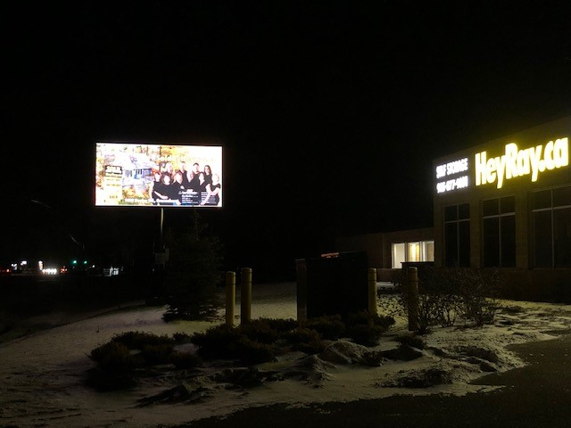
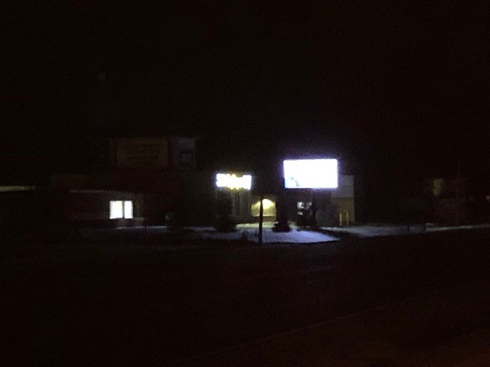
APPENDIX B: Signage Proposed in Town of Caledon
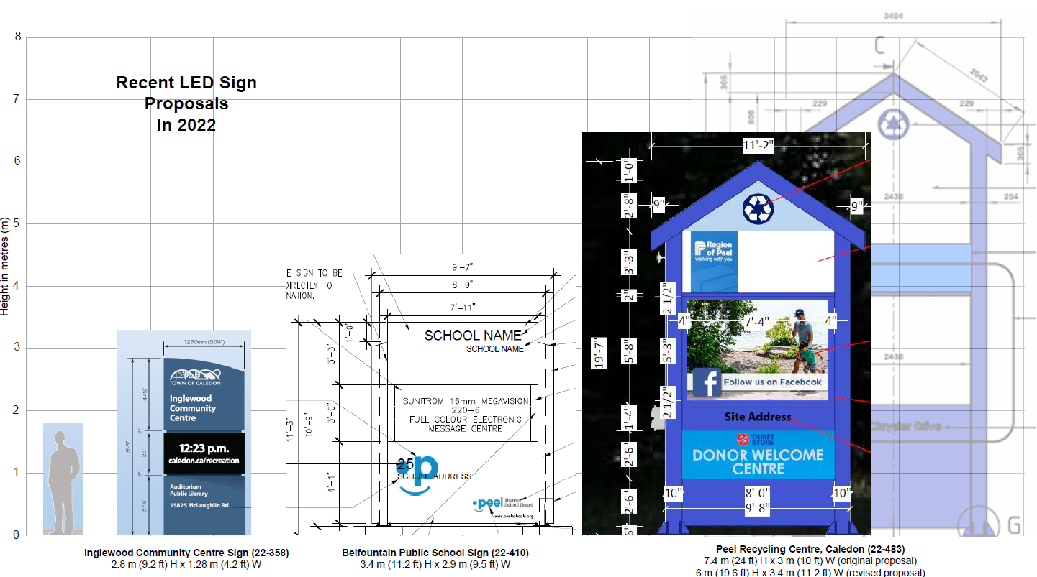

APPENDIX C: NEC Dark Sky Brochure (June 2012)