April 21, 2022

A3: AS-BUILT STAFF REPORT

DEVELOPMENT PERMIT APPLICATION:

H/F/2021-2022/095
Applicant: Region of Halton
Owner: Town of Milton
Tremaine Road and Steeles Avenue West
Part of Lot 1, Concession 1, Former Township of Esquesing
Town of Milton, Regional Municipality of Halton

SUMMARY

PROPOSAL:
To permit the retention of approximately 12,250 cubic metres of excess soil from nearby road work. Approximately 2,750 cubic metres of contaminated excess soil will be removed and disposed outside the Niagara Escarpment Plan Area: the site will then be graded and seeded, with the intention of being used as a passive recreation municipal park.

DESIGNATIONS:
Escarpment Protection Area

ISSUE:

Policies in Part 2.13.8 of the Niagara Escarpment Plan (NEP) stipulate that while excess excavated materials related to new development should be retained on site and integrated into the new site plan, any proposed land filling must be clearly shown on a proper grading plan. Land filling was carried out prior to obtaining a Development Permit: because of a prior compliance contravention under Development Permit 10721/H/T/2013-2014/85, this decision cannot be delegated to the Director.

RECOMMENDATION:
Approval with conditions.

REASONS:
The proposal to permit the as-built placement of excess soil does conform to the overall objectives of the Escarpment Protection Area for Infrastructure and Scenic Resources and Landform Conservation policies, and is consistent with the PPS, notwithstanding the applicant seeking retroactive approval for this development activity.

RECEIVED:

May 3, 2021 (revised submission received September 24, 2021).

SOURCE:

Regional Municipality of Halton and Town of Milton.

RELATED FILES:

Environment Assessment: ER HA 17: A Municipal Class Environmental Assessment was carried out for the realignment, extension and expansion of Tremaine Road (Regional Road 22) to a four-lane urban roadway corridor north from Steeles Avenue to 3 Side Road, including construction of an underpass below the Canadian Pacific Railway (CPR) line.
Development Permits:
11380/H/T/2016-2017/288
A development permit application was submitted to the NEC on November 28, 2016, for the above Class EA process for the extension and realignment of Tremaine Road (Regional Road 22) northerly from Steeles Avenue to the north of the CPR rail line, partial closure and decommissioning of the original Tremaine Road, providing for a park and utility access road. Placement of excess soil though land filling was not part of the approval of this permit.

The application was approved on January 31, 2018, and permit no. 11380 was issued.
10721/H/T/2013-2014/85
A development permit application was submitted to the NEC on August 16, 2013, for the widening of Tremaine Road (Regional Road 22) between Britannia and Derry Roads.
The Notice of Decision was issued on June 6, 2014, but construction had commenced on or before June 3, 2014, and on being informed the NEC ordered that work on the NEP Development Control portion of the property stop under compliance order 15-1039.
The proponent followed the direction to comply, the application was approved on June 23, 2014, and permit no. 10721 was issued.
1180/H/F/2015-2016/168
A development permit application was submitted to the NEC on August 12, 2016, for the removal of 1800 cubic metres of contaminated soil on a portion of the subject lands related to 9725/H/F/2009-2010/211 and place an equivalent amount of clean fill on the lands on the former aggregate site west of the original Tremaine Road.

The application was approved on March 28, 2017, and permit no. 1180 was issued.
9752/H/F/2009-2010/211
A development permit application was submitted to the NEC on November 13, 2009, comprised site restoration through removal of asphalt and permitting fill, grading, re-vegetation and fence construction to rehabilitate the former aggregate site west of the original Tremaine Road. Placement of excess soil was not part of the approval of this permit.

The application was approved on August 6, 2010, and permit no. 9752 was issued.
NEP Amendments:
NEC initiated amendment (PH 186) to change the Mineral Resource Extraction Area designation to Escarpment Natural Area and Escarpment Protection Area arising from the surrender of the ARA licence at the former aggregate site west of the original Tremaine Road. The Amendment was approved in March 2013.

Plan Amendments:

A Plan Amendment (UA 46) on the Town lands was approved as part of the Co-ordinated Provincial Plan Review to be added to the Niagara Escarpment Parks and Open Space System for a future municipal park with a possible connection to urban services. This amendment applied to both east and west of the original Tremaine Road, west and south of the CP Rail line. This amendment was approved on May 16, 2017.

PROPOSAL:

To allow the continued placement by the Region of Halton of approximately 12,250 cubic metres of the existing 15,000 cubic metres of excess soil remaining from the construction of the Tremaine Road extension on a property owned by the Town of Milton intended for use as a future passive recreation municipal park. The remaining 2,750 cubic metres of excess soil, which is not suitable for continued placement, will be disposed of at a soil receiving site outside the Niagara Escarpment Plan Area able to receive such soil. The site will be graded and terra seeded following removal of the excess soil.

BACKGROUND:

Tremaine Road is within an area designated as Escarpment Protection Area by the NEP 2017. Infrastructure is a permitted use in this designation (NEP Parts 1.4.3.10 and 2.12). The proposed extension and realignment project conducted by the Region of Halton was subject to an Environmental Assessment (EA) reviewed under Development Permit 11380/H/T/2016-2017/288.

During construction of the Tremaine Road underpass below the CP Rail line, approximately 15,000 cubic metres of excess soil from this excavation was dispersed on this adjacent field, an activity not covered under the approved Development Permit. While the Region of Halton carried out the EA for the realignment of this regional road, the subject adjacent property is owned by the Town of Milton, and the parcel subject to this unapproved fill activity is part of an area intended for future use as a passive recreation municipal park.

The unpermitted dispersal of excess soil was brought to the attention of NEC staff as a compliance matter. Following interagency discussions, the NEC agreed to the Region’s request that the contravention be addressed through a Development Permit Application for an “as built” development, subject to approval conditions to address NEC interests.

Subsequently, field testing of the subject excess soil determined that approximately 2,750 cubic metres contains concentrations of chemical parameters exceeding Provincial standards and is not suitable for retention on-site. This component of the excess soil is proposed for removal and remediation at one or more permitted soil receiving site(s) outside the Niagara Escarpment Plan Area.

The remaining 12,250 cubic metres of soil is suitable for retention if appropriately graded and seeded after removal of the unsuitable soil, resulting in a net elevation gain of 2.43 metres over the subject area. While not covered under the approved Development Permit for the overall project, within this context the proposal conforms to the NEP in minimizing the development footprint and changes to the existing topography (2.13.4.d) and retains excess excavated material on site as integrated into the site plan (2.13.8) with a proper grading and drainage plan (2.13.9).

All agency comments have been addressed. NEC staff has not received any comments from the public in opposition to the project. The proposal is consistent with the Provincial Policy Statement, 2020, and is not in conflict with the Niagara Escarpment Plan, 2017.

SITE DESCRIPTION:

The subject land comprises a small portion (approximately 0.75 Ha) of the above approved EA and Development Permit, bounded by the CP rail line to the north and the new Tremaine Road alignment to the southwest. Prior to construction and unauthorized fill activities this location and adjacent areas comprised a brick manufacturing and quarry site. When the active facility was closed, bricks and related industrial material was incorporated into the ground when the area was graded. Due to these prior activities, the previous industrial area is subject to a Certificate of Property Use issued by the Ministry of Environment, Conservation and Parks (MECP). The excess soil brought to this site has been graded.

PROPOSED DEVELOPMENT:

The land filling work using excess soil was carried out without a Development Permit. Prior compliance issues with the same proponent mean that while staff are recommending approval of the work retroactively through the development permit application as submitted, approval cannot be delegated through the NEC Director in accordance with the Minister’s Delegation of Authority.

PLANNING ANALYSIS:

Part 1.4 Escarpment Protection Area: Permitted Uses
The subject property is designated Escarpment Protection Area in the NEP and is wholly within the Niagara Escarpment Area of Development Control. The objectives of the Escarpment Protection Area designation include, but are not limited to, protecting Escarpment scenic resources, buffers to prominent features, and natural areas of regional significance. Infrastructure is a permitted use within the Escarpment Protection Area.

Part 2.2 General Development Criteria
The proposed retention of excess soil as part of an infrastructure project does not conflict with the General Development Criteria.

Part 2.11 Recreation
The deposition of clean excess soil does not hinder the proposed future use of this area as a passive recreation municipal park and does not offend the objectives of Part 2.11, which is to provides opportunities for outdoor recreation.

Part 2.13 Scenic Resources and Landform Conservation
The proposed retention and land filling using excess soil retained within the original infrastructure project as documented results in an increased elevation averaging 2.43 metres across the subject property, with a grading of slope around its boundaries to achieve a stable landform while maintaining natural drainage and minimizing contour changes as per Part 2.13.8. The excess soil originates within the overall road realignment and underpass projects. The removal of contaminated excess soils from the project area will ensure possible impacts on human health and the environment are addressed.
With regard to Part 2.13.10 of the NEP, soil being imported on to a site must meet or exceed existing on-site soil quality standards. In the case of the Tremaine Road project, the excess soil is being retained within the general project area (i.e., on or adjacent to the same property where the excavation occurred). Thus, it is not considered imported soil. Therefore, strictly speaking, Part 2.13.10 does not apply in this situation. Likewise, the relatively new Ontario Regulation 406/19 “On-site and Excess Soil Management” under the Environmental Protection Act only allows soils that meet Table 1 standards to be placed in an environmentally sensitive area. Escarpment Protection Areas and Escarpment Natural Areas are included in the definition of an “environmentally sensitive area” in the “Rules for Soil Management and Excess Soil Quality Standards” document that is part of this regulation. However, this regulation is also of limited applicability in this circumstance because it deals only with soils being “placed” within a project area, meaning soils brought in from elsewhere. However, the removal of the contaminated soil from the project area certainly meets the intent of these policies: contaminated excess soil should not be dispersed in a protected area.

PROVINCIAL POLICY STATEMENT (PPS):

Sections 1.1.1.b and 1.5.1.b of the PPS state that planning for healthy, liveable communities is sustained by necessary infrastructure including recreation, park and open spaces, and should be promoted. The proposed passive recreation space will contribute to these policy criteria.

Section 1.8 promotes development that addresses climate change. The proposed restoration of green space as accommodating passive recreation conforms to 1.8.1.g.

Section 2.1.2 encourages the restoration of natural features and areas. Although tree and vegetation were removed as part of the road work, new vegetation is being incorporated into the subject area and the subject lands are proposed for terra seeding.

Section 3.2 directs that development affected by hazards arising from mineral aggregate operations is permitted only if identification and mitigation of risks is undertaken, including on-site re-use of soil. The proposal retains the excess soil on site while removing the portion not suitable for retention.

The proposed development is consistent with Sections 1.1.1.b, 1.5.1.b, 1.8.1.g, 2.1 and 3.2 of the PPS.

LOCAL OFFICIAL PLAN:

The subject property is identified as Rural System and Greenlands System, Special Study Area (4.0), and recognized as Escarpment Protection Area with Niagara Escarpment Plan policies applying in the Town of Milton Official Plan. This local Official Plan defines permitted uses as Escarpment Protection and Escarpment Rural (4.1.1.17).

REGIONAL OFFICIAL PLAN:

The Region of Halton Official plan identifies the subject property as falling within the Regional Natural Heritage System, designated as Escarpment Protection Area (Map 1A), non-Prime Agricultural Area (Map 1E), and Key Feature within the Greenbelt and Regional Natural Heritage System (Map 1G), (Map 1E). Permitted uses within these designations are essential transportation facilities (139.3.7.d) and non-intensive recreation (139.3.7.e).

AGENCY CONSULTATIONS:

Region of Halton:
Regional staff are satisfied that the proposed works are a permitted use in the context of the Regional Natural Heritage System (RNHS) policies in the Regional Official Plan. The proposed work site is within and adjacent to the RNHS and would normally trigger the need for an Environmental Impact Assessment. However, this can be waived if the Development Permit application is subject to the installation of erosion and sediment control (ESC) fencing surrounding the fill/excavation, especially in any area that is within 10 metres of the woodland dripline, as a condition of the approval.

Regarding soil contamination, Regional Staff do not have any objection to the application so long as all Risk Management Measures from the Certificate of Property Use (CPU) and Risk Assessment (RA) are observed. Given that the main focus is on water quality, the CPU restriction on the use of groundwater on the site and monitoring requirements for offsite migration outlined in section 7.1.5 of the RA are noted. Regional Staff request to review any further work/reports done in relation to…?

Transportation planning have noted that the transportation logistics of the excess soil removal (i.e., heavy truck routing and load weight) needs to be coordinated with Road Operations.

Regional staff acknowledges that the area has been subject to prior disturbance but advises that the standard warning clause, providing guidance if deeply buried archaeological and/or human remains are encountered during development activity, should be applied to the application.

Regional staff has no objection to the issuance of a Development Permit for these works subject to the above mitigation measures being put in place, review of further work and reports arising from the CPU and comments by Conservation Halton.

Town of Milton:
The proposed use is permitted in the Official Plan, and there are no objections to the Development Permit.

Conservation Halton:
Staff confirms that the proposed development appears to be set back more than 30 metres from, but within 120 metres of, the limit of the nearby wetland greater than 2 hectares in size, thereby falling within and conforming to Conservation Halton regulatory policies. Compliance with these regulatory policies with be ensured through a subsequent permit obtained from Conservation Halton. Subject to receiving revised drawings in accordance with their permit process, Conservation Halton has no objection to the Development Permit application.
Ministry of Environment, Conservation and Parks (MECP):
Staff note that the lands are fall within and are regulated by an existing Certificate of Property Use (CPU), and that the excess soils all originated from within the CPU lands. MECP directed that soil excavation was conducted in accordance with the conditions of the CPU, including testing to determine their meeting the Property Specific Standards of the CPU, and soils not meeting the PSSs shall be disposed of off-site in compliance with the NEP and Provincial Excess Soil Regulation. WSP will provide a letter documenting the clean-up efforts and confirming that soil remaining on-site complies with the CPU requirements. If this is to the satisfaction of MECP the existing CPU will be amended, pending approval of this development permit.

Hydro One:
Staff have reviewed the documents concerning the noted Plan and have no comments or concerns at this time.

Canadian Pacific Railway (CPR):
Provided all necessary safety measures and precautions are taken during the removal of the soil in proximity to the rail line, CP has no further comments on this application.

DISCUSSION:
This as-built application is in part for retroactive approval of work conducted outside of the scope of a previously approved development permit issued, in addition to completion of the work proposed. It provides an opportunity to apply conditions prior to issuing the permit, and as a condition of approval, to address remaining concerns about the activity to date and development to be completed.
The development carried out to date, and proposed for completion, falls within the scope of permitted uses for Escarpment Protection Area as relating to infrastructure associated with the realignment of Tremaine Road.
The work conducted to date, and proposed for completion, also conforms to the General, Recreation, and Scenic Resources and Landforms Conservation policies under Part 2 of the Niagara Escarpment Plan, notwithstanding that the work was undertaken without a development permit.
In light of this situation, NEC staff are satisfied that the work conducted and proposed conforms to the permitted uses and development criteria of the NEP. However, due to one prior compliance issue with the Region of Halton, a decision on this development permit application cannot be delegated to the NEC Director.

RECOMMENDATION:

That the Development Permit be approved, subject to the conditions on attached Appendix 1.

Prepared by:

ORIGINAL SIGNED BY:

______________________
Joe Muller
Senior Strategic Advisor

Approved by:

ORIGINAL SIGNED BY:

_______________________
Kim Peters, MCIP, RPP
Manager

Appendix 1 – Conditions
Appendix 2 – Site Location
Appendix 3 – Orthophoto
Appendix 4 – Preliminary Proposed Site Plan

APPENDIX 1
CONDITIONS OF APPROVAL H/F/2021-2022/095

- Development shall occur in accordance with the Terms and Conditions of the Development Permit.

- The Development Permit shall expire three (3) years from the date it has been issued or once the development has been completed in accordance with the Development Permit.

- No site alteration of the existing contours of the property including the placement or stockpiling of fill (i.e., excess or imported soil) on the property is permitted with the exception of that identified within the development envelope in accordance with the Final Site Plan.

- No vegetation shall be cut or removed from the development envelope except for that identified within the development envelope in accordance with the Final Site Plan.

- If development has commenced under this Development Permit, any/all disturbed areas of land or soil shall be re-vegetated and stabilized to the satisfaction of the Niagara Escarpment Commission on or before the date of expiry of the Development Permit.

- Prior to the issuance of a Development Permit by the Niagara Escarpment Commission, an accurate and detailed Final Site Plan shall be submitted for Niagara Escarpment Commission approval. The following stipulation shall be included directly on the Plan:

  - All drawings submitted must be drawn to scale (bar scale shown), reference the application number and address of the proposal, be dated (revisions as well), and include the name of the relevant individual or consultant who prepared the drawing;
  - Outline of the approved development envelope / extent of all disturbed areas;
  - Location of all existing and proposed structures, construction access / haul routes, any watercourses or water features, top / bottom of slope, wooded areas, etc;

CONDITIONS OF APPROVAL H/F/2021-2022/095

Condition 6 continued:

  - Grading, drainage, and fill management details including the areas of excavation and temporary or permanent fill placement. The type, quantity, quality and source location of any imported fill material must be accurately identified.
  - The location and design of erosion and sediment control measures (e.g., fencing, blankets, rip-rap, temporary mulch / seeding), and limit-of-work construction or eco-protection fencing;
  - Identify the areas of existing vegetation to be retained, areas of vegetation to be removed, and the location of proposed plantings.

- Prior to the commencement of any development, erosion and sediment control measures (e.g., fencing, blankets, rip-rap), and/or vegetation protection fencing shall be implemented and maintained as shown on the Final Site Plan until all disturbed areas are stabilized. It is the responsibility of the landowner to implement, monitor and maintain all erosion and sedimentation control measures and vegetation protection fencing in good condition until vegetative cover has been successfully established and the development is completed.

- Any excess soil approved for retention under this Permit shall conform to Table 1 standards as per the “Rules for Soil Management and Excess Soil Quality Standards” under Ontario Regulation 406/19 (On-Site and Excess Soil Management) made under the Environmental Protection Act, R.S.O. 1990, c. E.19.

- All excess soil and materials generated from the remediation that exceeds Table 1 standards shall be completely removed from the property (e.g., taken to an approved waste disposal site or soil treatment facility with a valid Environmental Compliance Approval) and not otherwise stored or buried on-site. All disturbed areas shall be immediately stabilized / rehabilitated as per the approved Site Plan (Condition # 1).

- Conditions 6 (six) and 7 (seven) must be fulfilled within one (1) year from the date of confirmation of the Commission’s decision or this conditional approval shall lapse and a Development Permit will not be issued.

CONDITIONS OF APPROVAL H/F/2021-2022/095

ADVISORY NOTES:

- A Development Permit does not relieve the landowner/permit holder from the requirements of any other required approval, licence or certificate under any statute (e.g., Ontario Building Code, Planning Act, Aggregate Resources Act, Conservation Authorities Act, Endangered Species Act [specify which regulation – e.g., S. 23.2 of O. Reg. 242/08], etc.). The Niagara Escarpment Commission Development Permit is required prior to the issuance of any other applicable approval, licence or certificate.

- Should deeply buried archaeological materials be found on the property during any of the above development activities the Ontario Ministry of Heritage, Sport, Tourism, and Culture Industries (MHSTCI) should be notified immediately (416-314-7143). In the event that human remains are encountered during construction, the proponent should immediately contact both the MTCS and the Registrar or Deputy Registrar of the Cemeteries Regulation Unit of the Ministry of Government and Consumer Services (416-326-8392).

APPENDIX 2

Site location

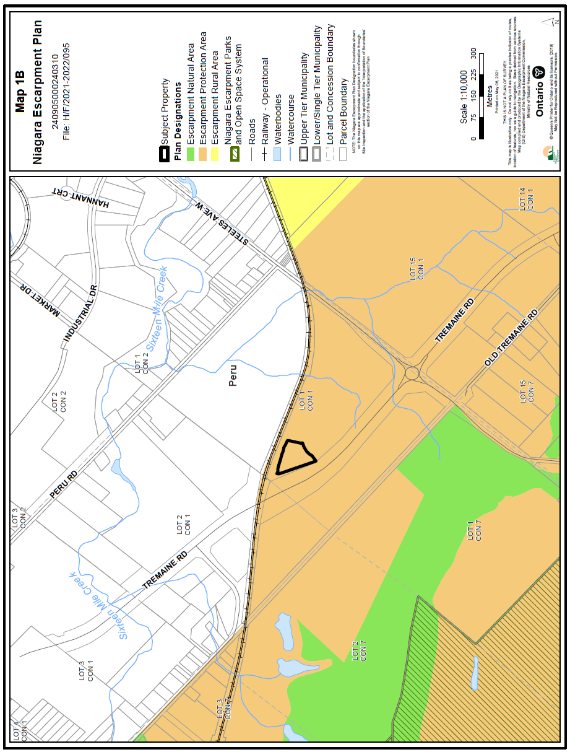

APPENDIX 3

Orthophoto

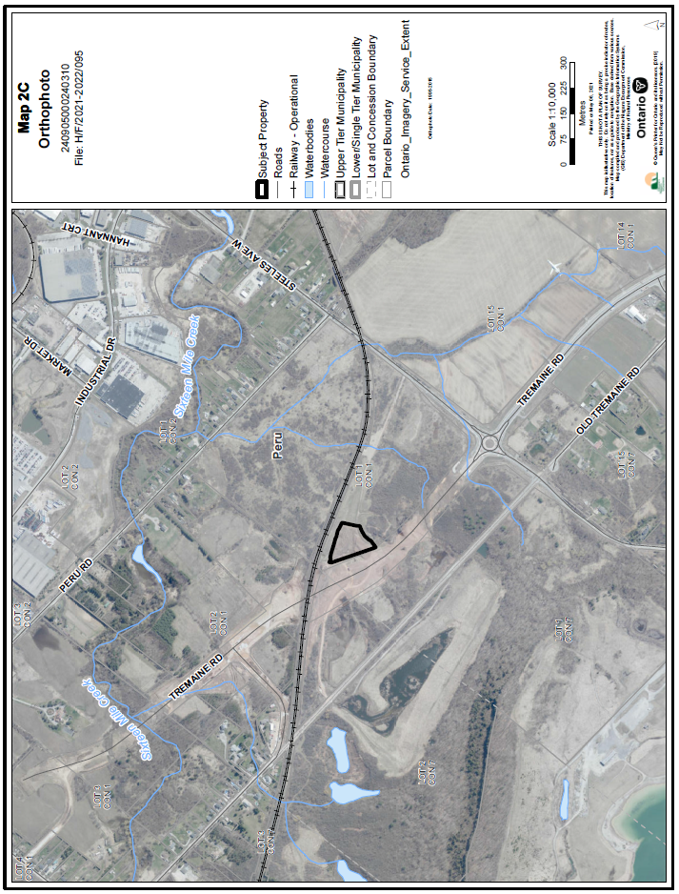

APPENDIX 4

Preliminary Proposed Site Plan

