April 21, 2022

A5 COMPLIANCE STAFF REPORT

ORDER TO DEMOLISH/RESTORE #2022.001
Land owners: REDACTED
11489 17 Sideroad
Lot 18, Concession 6, Equesing
Town of Halton Hills, Ontario

ALLEGED VIOLATION(S)

- Placement of an excessive amount of off-site fill material, asphalt paving, and associated grading in absence of an approved Development Permit from the Niagara Escarpment Commission (NEC).

REASONS FOR ORDER

- Successive deposits of off-site fill material onto the subject property have been observed by government employees on numerous occasions, including staff of the NEC.
- The deposit of fill material, asphalt paving, and grading amounts to “development” under the Niagara Escarpment Planning and Development Act (NEPDA).
- The development noted above was undertaken without a Development Permit from the Niagara Escarpment Commission (NEC) and cannot be recognized through the submission of an as-built Development Permit Application;
- The establishment of a trucking depot on the paved area is not a permitted use in the NEP.
- The deposit of off-site fill material and asphalt paving that is not associated with a permitted use is not permitted by the Niagara Escarpment Plan (NEP).
- The landowner(s) failed to comply with a stop work order that was issued on December 13, 2021.
- Development noted above poses a significant risk to the surrounding natural environment by negatively impacting water quality in Black Creek and a tributary of Sixteen Mile Creek in the absence of any stormwater management controls.

RELEVENT LEGISLATION

- Subsection 24(1) of the Niagara Escarpment Planning and Development Act, R.S.O. 1990, c. N.2 (NEPDA) states:

Despite any other general or special Act, if an area of development control is established by regulation made under subsection 22, no person shall undertake any development in the area unless such development is exempt under the regulations or unless the development complies with a development permit issued under this Act.

- Subsection 24(6) of the NEPDA states:

Where any person undertakes any development that is in contravention of subsection (1), the Minister may order such person to demolish any building or structure erected in connection with the development or to restore the site to the condition it was in prior to the undertaking of the development, or both, within such time as the order specifies.

The issuance of Demolition/Restoration Orders has been delegated to the Commission and is the subject of this staff report.

RELATED FILES

A search of the NEC Development Permit database confirmed that no Development Permits have been issued to the landowner that would authorize the recent placement of fill and asphalt paving, the last permit issued for this property dates to the early 2000s.

H/E/1998-1999/330 – Permit Issued.
To extend a sandstone quarry onto lands abutting the current licensed aggregate operation. The total maximum production will be 20,000 tonnes per year. The proposed licensed area will be 36.8 ha and, the area to be extracted is 25.7 ha.

H/I/1998-1999/35 – Permit Issued.
To construct a 297 square metre (3200 sq. ft.) shed to store stone cutting equipment on an existing lot. The building will have a maximum height of 7 metres (22 ft.).

H/R/1991-1992/343 – No Permit Issued.
To construct a single detached dwelling, septic system, and driveway on a proposed lot.

H/F/1986-1987/245 – Permit Issued.
To construct a pond.
H/E/1983-1984/279 – Permit Issued.
To construct a quarry building.

SUBJECT PROPERTY DESCRIPTION

The subject property, 11489 17 Sideroad, Halton Hills (“the property”), is within the NEP and is designated both Escarpment Rural Area and Escarpment Natural Area. The property is entirely contained within the NEC’s Development Control Area, as defined by Ontario Regulation 826/90.

Municipal Property Assessment Corporation (MPAC) information profiles the property as being 298.17 acres (120.67 hectare), a farm with a gravel pit.

The property is the site of a sandstone quarry known as the “Hilltop Quarry” or “Hilltop Stone and Supply”, the quarry remains a principal supplier of locally sourced, natural Credit Valley sandstone. The quarry is the licencee to two Class B licenses under the Aggregate Resources Act (ARA), with each licensed area to extract no more than 20,000 tonnes per year.

The northeast segment of the property is located outside of the ARA-licensed boundary (refer to mapping in Attachments A and B). This area is home to several natural heritage features, including the Black Creek, a tributary of the Sixteen Mile Creek, and two wooded areas. The unauthorized development addressed in this order took place in this segment of the property, in close proximity to the watercourses and wooded areas.

It should be noted that violations of the ARA licences (and related NEC Development Permits) have also occurred on the property. These compliance issues are primarily being addressed by the Ministry of Northern Development, Mines, Natural Resources and Forestry (NDMNRF). NDMNRF aggregates and enforcement staff are working with landowners to determine the best path forward in addressing these compliance issues. Thus, this restoration order only addresses the areas that are not subject to ARA licence requirements.

INSPECTION AND OBSERVATIONS

On October 2, 2021 NEC staff received a public complaint regarding alleged site grading and paving to create a parking lot at the property. The complainant stated that several dump trucks were delivering asphalt material and dumping it within the large open field next to the main entrance to the quarry. Furthermore, the complainant mentioned that work was occurring at all times of the day and an employee in the area told him that the landowners were paving the field for transport truck parking.

On October 22, 2021, NEC staff arranged a site visit with one of three owners of the quarry (REDACTED). REDACTED mentioned that he recently purchased the property with two other investors, who are also named on the restoration order. All three were also the only directors of the company that is licenced under the ARA to operate the quarry: Hilltop Stone and Supply Inc. (“the company”). During the site visit, NEC staff confirmed that a very large area of the property had been paved with asphalt regrind, and asphalt regrind was also being used to widen the primary laneway by approximately 2-4 feet. According to Conservation Halton staff, an existing culvert that transected the driveway was completely buried by the works. The landowner informed NEC staff that the asphalt pad was to be used as a foundation for a series of greenhouses for agricultural uses, and also for the storage of excess quarry stone. The landowner stated that they will stop all work on the property until informed of appropriate next steps by the NEC.

After the site visit, NEC staff continued to receive complaints that more fill material was brought into the property and that asphalt can be seen in piles from the public roadway. Furthermore, the complainants mentioned that more and more transport truck trailers were being stored in this area. A subsequent site inspection confirmed the storage of transport truck trailers on the asphalt pad, that more fill material had been imported to the property with asphalt being stored in piles, and it also appeared that the landowners had begun dumping and grading dirt fill material in a separate area adjacent to the asphalt pad.

On December 13, 2021 a stop work order was issued by the NEC under the authority of Section 24(6.1) of the Niagara Escarpment Planning and Development Act. The order was issued to the three landowners / directors of the company. The order required them to immediately stop development on the subject property relating to the importation of fill and asphalt, site grading and paving, and the storage of transport trucks and trailers. In response to the order, REDACTED asserted to NEC staff that he is no longer associated with Hilltop Stone and Supply Inc and that he has initiated legal proceedings against REDACTED and REDACTED, however he did not deny his involvement in the company at the time of unauthorized development.

A roadside site inspection by NEC staff took place on December 16th 2021 to confirm whether there was compliance with the issued stop work order. Upon arrival, heavy machinery noises could be heard and heavy construction equipment was observed working at the end of the primary driveway. During the observations, a series of dump trucks arrived at the subject property hauling fill material. The drivers mentioned that they were asked to dump fill material at the rear of the primary driveway (adjacent to the asphalt pad); they also mentioned that they had brought in multiple loads of material that day. NEC staff was approached by one of the landowners who was on site. REDACTED confirmed receipt of the order early that week, he denied all claims relating to fill importation and site alteration on the property, further stating that the dump trucks hauling in fill material were part of normal quarry operations.

NEC staff conducted another roadside inspection on December 21st, 2021 to confirm whether there was compliance with the stop work order. Several transport truck trailers associated with multiple logistical companies were observed on the property. A dump truck was observed dumping fill material towards the back of the primary driveway adjacent to the parking pad, contrary to the issued stop work order.

On January 26th, 2022 a comprehensive site inspection was conducted on the subject property in consultation with two NDMNRF Conservation Officers and an inspector under the Aggregate Resources Act. NEC staff walked through most of the quarry and documented the state of the property. Multiple areas of concern were identified related to the importation of fill and site grading. Three areas of concern remain outside of the licensed area and are subject to the contents of this order, please refer to areas “A”, “B”, and “C” within Appendix 1 of the Restoration Order. The first involves the large asphalt pad that is approximately 10 acres in size, at the time of the inspection all transport trailers had been removed from this area. The second involves the area adjacent to the asphalt pad at the rear of the driveway. It appeared that fill material had been imported to this area, graded flat, and is now being used as a place to store quarry stone in absence of necessary approvals under the NEPDA and ARA. The culvert referred to as area “C” within Appendix 1 is located outside of the ARA licensed boundary area, and is regulated by Conservation Halton. NEC staff will work with Conservation Halton staff to ensure the culvert is properly restored.

SUMMARY

The unauthorized development outlined above is development for which no Development Permit has been obtained nor has an application for a Development Permit been made. The placement of fill material, grading, and paving is not exempt from the need for a Development Permit under Ontario Regulation 828/90. None of the unauthorized development is associated with a permitted use within the NEP, and would fail to meet relevant development criteria in Part 2 of the NEP. NEC staff have not been provided any reasonable evidence that the fill material is inert and free from contamination. The unauthorized development continues to present significant concerns for the NEC, the public and other regulatory agencies due to potential impacts to the environment, public safety, and disregard for the stop work order. The proposed approach to achieving compliance is outlined below.

COMPLIANCE APPROACH

The intent of the compliance approach is to ensure the lands of the Niagara Escarpment are developed only in accordance with the NEPDA and its regulations and policies of other regulatory jurisdictions. Significant efforts have been made by the NEC and other regulatory staff to seek voluntary compliance on this site. Since the development fails to meet the policies of the NEP, the appropriate next step to address this situation is through the issuance of an Order to Demolish/Restore under the NEPDA. The intent of the Order to Demolish/Restore is to restore the disturbed areas to as close to the original condition as possible within a reasonable timeframe. The Order will also have the effect of acting as a deterrent against possible future non-compliance.

RECOMMENDATION

Based on the reasons outlined above, and pursuant to section 24(6) of the NEPDA, NEC compliance staff are seeking the NEC’s endorsement of Order to Demolish/Restore #2022.001 and conditions thereto that are attached.

Prepared by:

Original signed by:
__________________________
Kevin Toste
A/ Compliance Program Supervisor

Approved by:

Original signed by:

________________________
Kim Peters, MCIP, RPP
Manager

Original signed by:

________________________
John Dungavell
Director (A)

ATTACHMENTS:

A – MAPPING (Page 8-12)

B – AERIAL IMAGERY (Page 13-14)

C – ORDER TO DEMOLISH/RESTORE (Page 15-18)

APPENDIX 1 – AREAS SUBJECT TO ORDER TO DEMOLISH/RESTORE (Page 19)

APPENDIX 2 – SITE INSPECTION PHOTOS (Page 20-30)

ATTACHMENT (A) – MAPPING

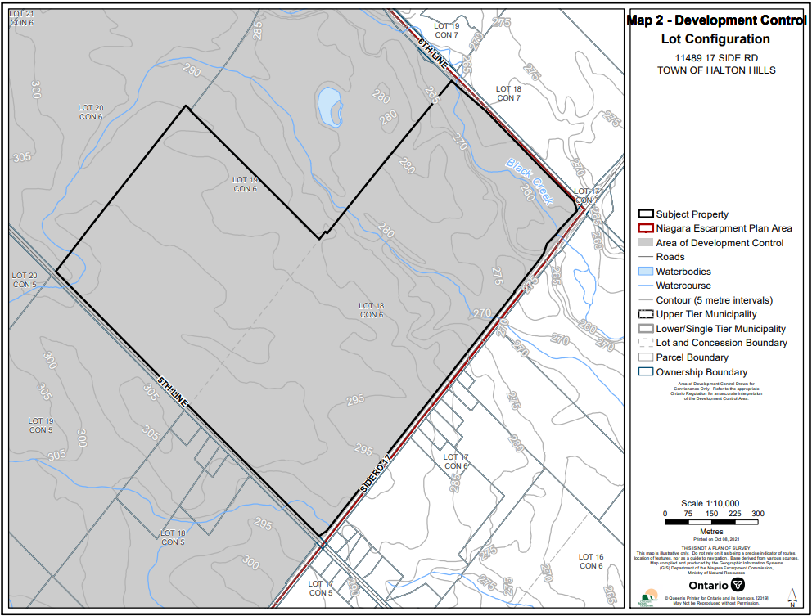

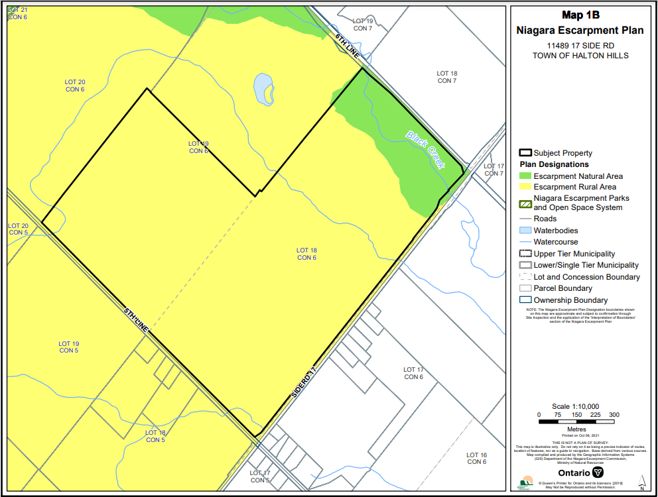

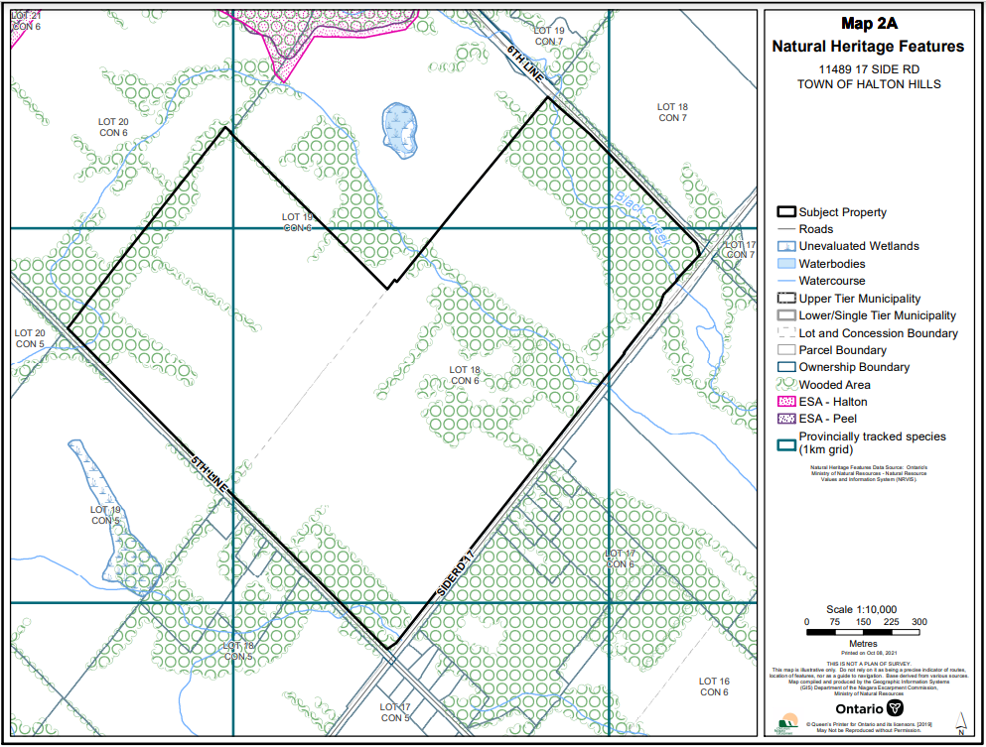

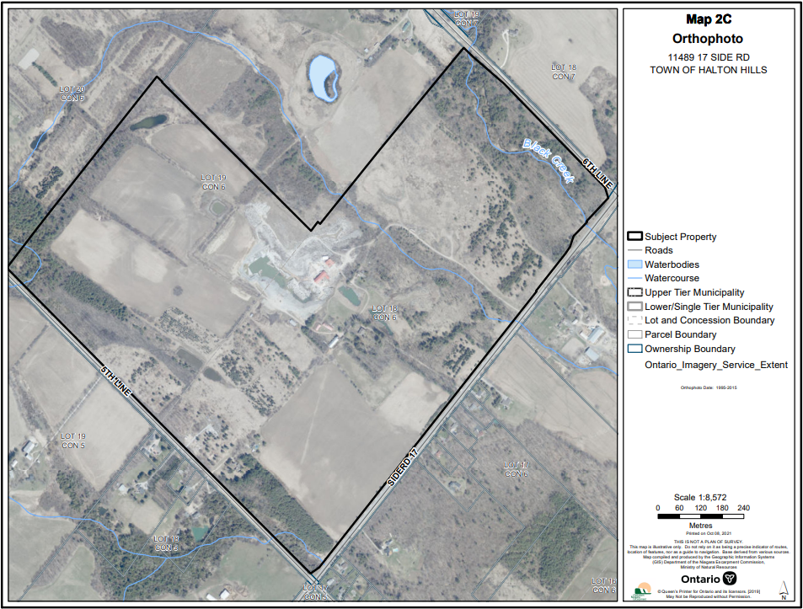

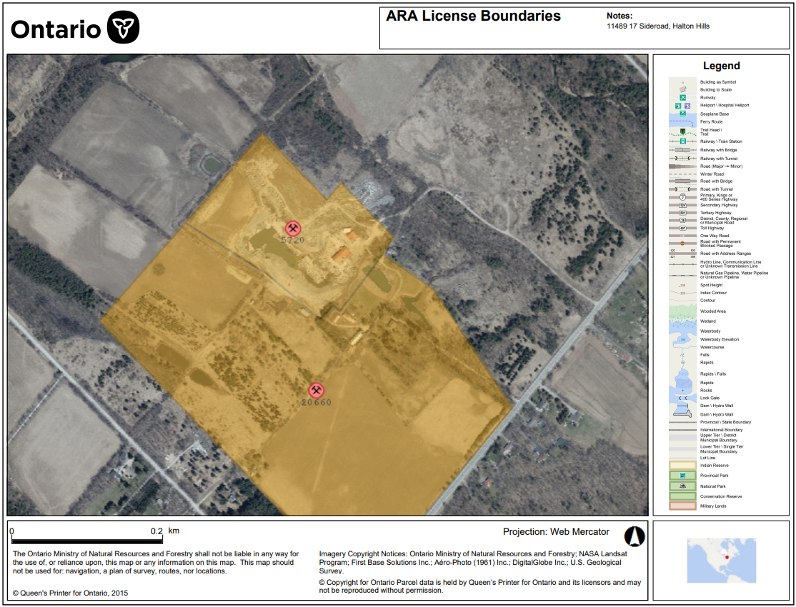
ATTACHMENT (B) – AERIAL IMAGERY
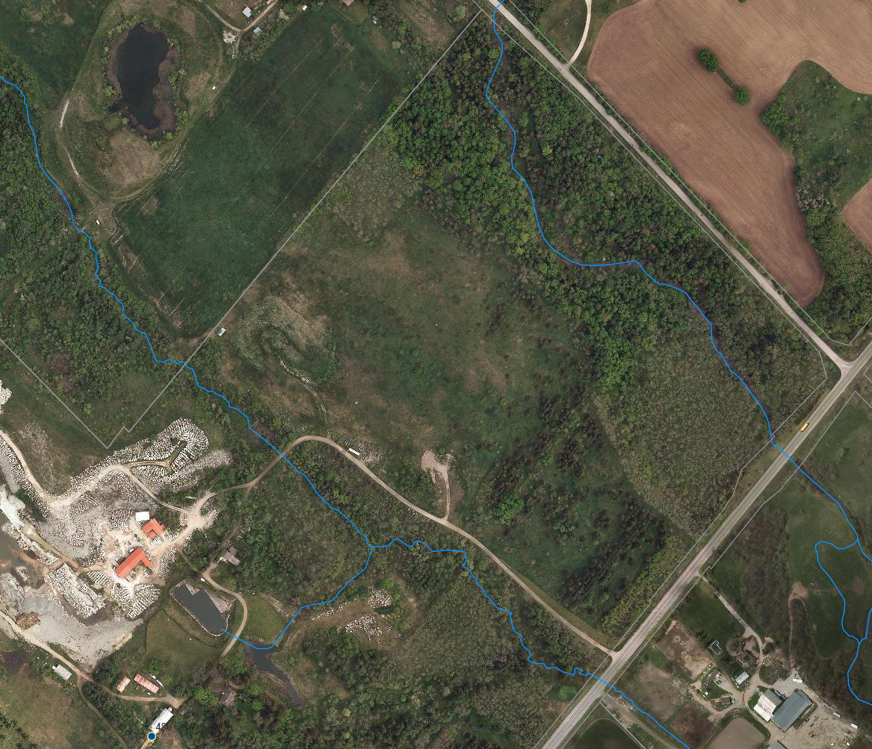
Esri Aerial Imagery captured on March 23, 2020.

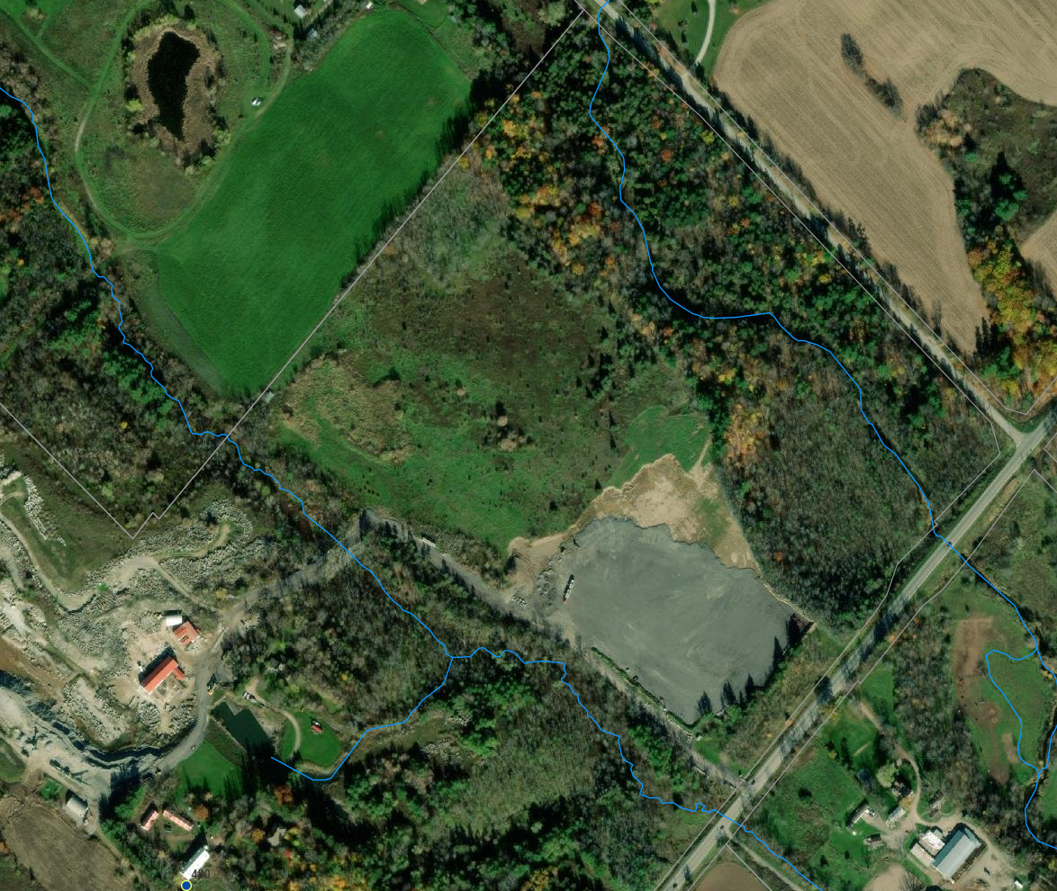
Maxar (Vivid) aerial imagery captured on November 7, 2021.

ATTACHMENT (C) – ORDER TO DEMOLISH/RESTORE

RESTORATION ORDER # 2022.01

Pursuant to section 24(6) of the
Niagara Escarpment Planning and Development Act, Chapter N.2, R.S.O. 1990

THIS ORDER is directed to:
REDACTED

REDACTED

REDACTED
WHEREAS development (“the development”) consisting of:

- Importation of fill and asphalt
- Deposit of fill and asphalt
- Site grading and paving with fill and asphalt
- Parking and storage of transport trucks and trailers

HAS OCCURRED on the property (“the subject property”) described as:

Hilltop Quarry
11489 17 Sideroad
Part Lot 18, Concession 6 (Esquesing)
Town of Halton Hills, Region of Halton, Ontario

IN PARTICULAR, in the locations as depicted in the attached marked aerial photography in Appendix 1, and as demonstrated in part in the photographs in Appendix 2.
AND WHEREAS the purpose of the Niagara Escarpment Planning and Development Act (“the Act”), as set out in Section 2, is to provide for the maintenance of the Niagara Escarpment and land in its vicinity substantially as a continuous natural environment and to ensure only such development occurs as is compatible with that environment;
AND WHEREAS Development Control is a land use control mechanism put in place to help fulfill the purpose of the Act;
AND WHEREAS Subsection 24(1) of the Act states: “Despite any other general or special Act, if an area of development control is established by regulation made under section 22, no person shall undertake any development in the area unless such development is exempt under the regulations or unless the development complies with a development permit issued under this Act”;
AND WHEREAS the subject property is within an area of Development Control as defined in Ontario Regulation 826/90 made pursuant to Section 22 of the Act;
AND WHEREAS staff have confirmed by inspection that the development has taken place on the subject property in the absence of a Development Permit;
AND WHEREAS the development is not exempt pursuant to Ontario Regulation 828/90 from the requirement for a Development Permit;
AND WHEREAS between July 2021 and December 2021 the development was undertaken on the subject property without a Development Permit from the Niagara Escarpment Commission (“NEC”).
AND WHEREAS the Orderees are connected to the development insofar as they were each in a position of management or control over the property as property owners and/or as directors of the corporate licencee aggregate company “Hilltop Stone & Supply Inc.” at the time of the unauthorized development.

NOW, THEREFORE, in accordance with the Act, Subsection 24(6), THE PERSONS TO WHOM THIS ORDER IS DIRECTED ARE JOINTLY AND SEVERALLY ORDERED TO COMPLETE THE FOLLOWING:
- Qualified professional(s) - Retain by May 21, 2022 a qualified person to the satisfaction of the Niagara Escarpment Commission to complete the reports/studies required below, and to oversee all aspects of the restoration required by this Order to the satisfaction of the Niagara Escarpment Commission.

- No later than June 30, 2022 complete to the satisfaction of the Niagara Escarpment Commission a soil sampling plan, prepared and undertaken by a qualified person to the satisfaction of the Niagara Escarpment Commission, that addresses the nature and quality of fill and asphalt placed on the subject property, with the exception of the areas licensed under the Aggregate Resources Act.

- No later than July 31, 2022, submit to the Niagara Escarpment Commission results of the soil sampling and a remediation plan that provides for the following:
- The results of the soil sampling plan and an interpretation of the results;
- Removal and lawful disposal off-site of all fill and asphalt deposited within area “A” noted in Appendix 1;
- Removal and lawful disposal off-site of all fill material deposited within area “B” noted in Appendix 1 that does not meet background soil conditions;
- Restore the crossing and culvert associated with Sixteen Mile Creek located within area “C” on Appendix 1 in a manner that reinstates the conveyance of the watercourse and removes any additional fill material beyond what existed previously;
- To the extent possible, restoration of original grade within areas “A”, “B” and “C” on Appendix 1;
- Appropriate vegetation protection and erosion and sediment control measures to be installed and retained in place until work is complete and stabilized; and
- Execute a planting plan to re-establish the pre-disturbance vegetation, including a vegetation monitoring plan;

- No later than August 31, 2023 complete all restoration works required by this Order to the satisfaction of the Niagara Escarpment Commission.

- No later than September 30, 2023 submit a letter prepared by the qualified person described in Item #1 demonstrating that all work required by this Order was completed in accordance with the Order.

- Vegetation survival monitoring shall be conducted by the qualified person described in Item #1 for three growing seasons following completion of the restoration works, confirming whether all required restoration works and plantings have been successfully completed in accordance with this Order.

- A vegetation survival monitoring report prepared by the qualified person described in Item #1 shall be submitted to the Niagara Escarpment Commission no later than November 30th in each of the three growing seasons noted above.

- Replacement vegetation shall be planted as necessary to achieve a minimum 70 percent survival rate at the end of the third growing season, using native plant species as recommended by the qualified person described in Item #1. Replacement vegetation species and planting locations shall be documented in the annual survival monitoring reports.

ADVISORY NOTE - Failure to comply with this Order may result in further enforcement action being taken NEC. Persons convicted under section 24(7.1) of the Act may incur penalties including a fine of not more than $10,000 a day or part of a day on which the contravention continued. In accordance with section 24(7) of the Act, failure to comply with an order within the time specified in it may result in the Minister causing the necessary work to be done and charge such person the cost thereof, which cost may be recovered with costs, as a debt due to Her Majesty, in any court of competent jurisdiction.
Dated the 21st day of April, 2022.

APPENDIX (1) – AREA SUBJECT TO ORDER TO DEMOLISH/RESTORE
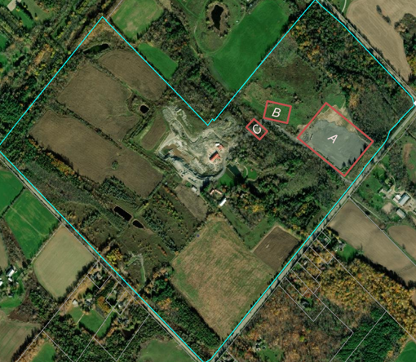
Maxar (Vivid) imagery captured on November 7, 2021. Area “A” represents the area of site alterations, fill importation, asphalt paving, and the location where tractor trailers are stored. Area “B” represents the area of site alterations, fill importation, and the location where quarry stone is being stored. Area “C” represents the location of the culvert that was negatively impacted by recent driveway works

APPENDIX (2) – SITE INSPECTION PHOTOS

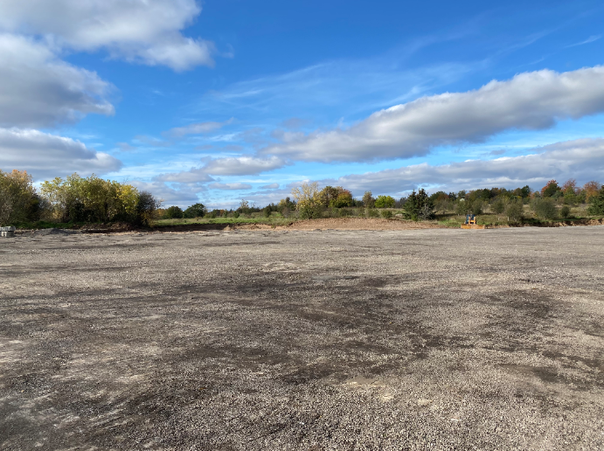
Area A: Captured on October 22, 2021.
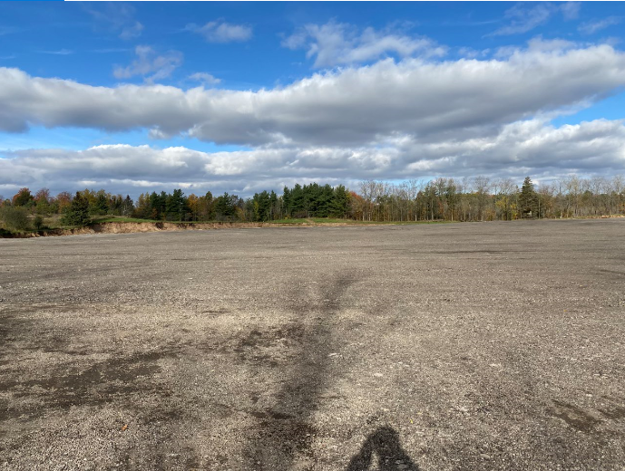
Area A: Captured on October 22, 2021.

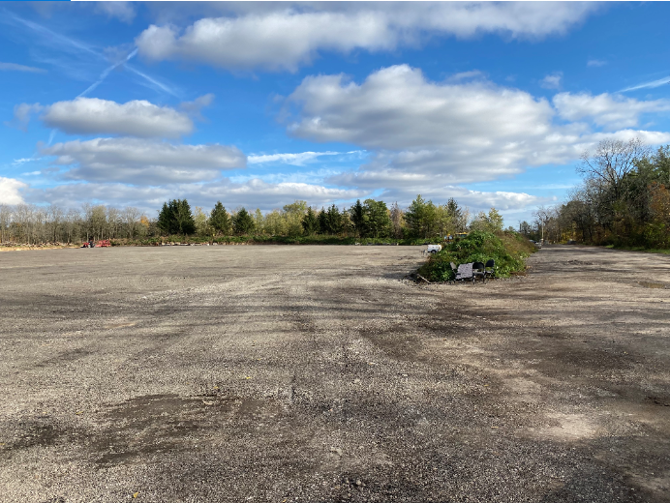
Area A: Captured on October 22, 2021.

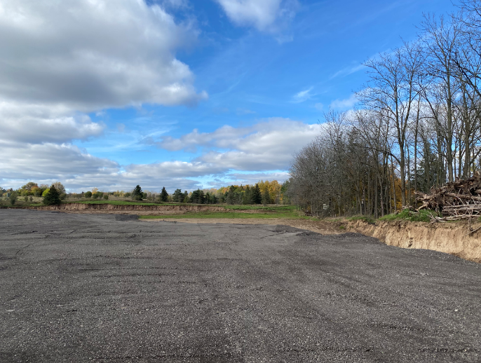
Area A: Captured on October 22, 2021.
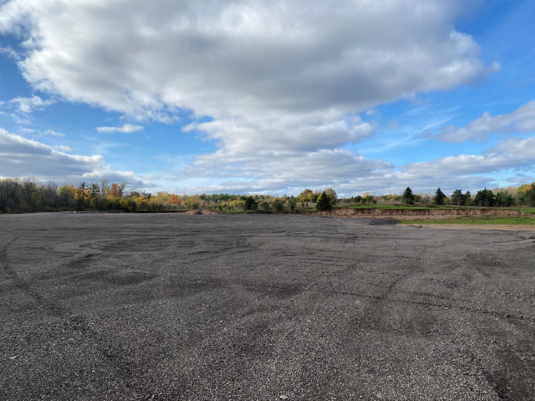
Area A: Captured on October 22, 2021.

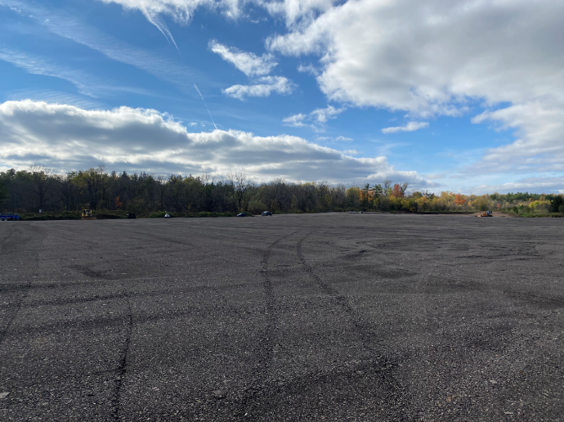
Area A: Captured on October 22, 2021.

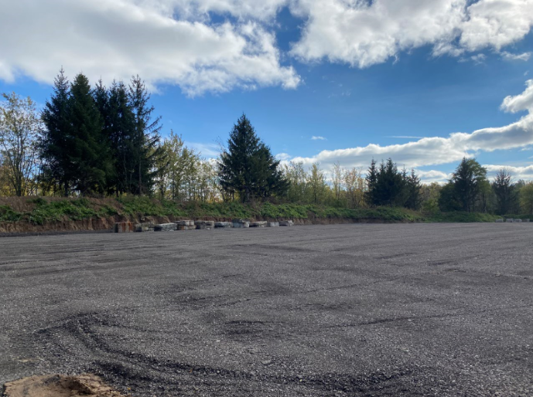
Area A: Captured on October 22, 2021.
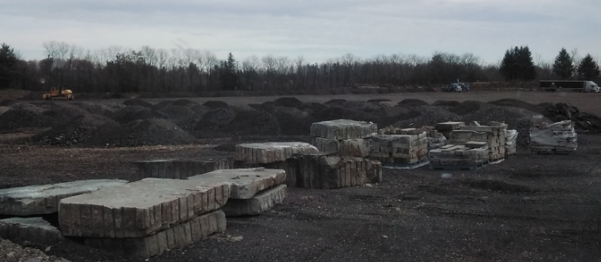
Area A: Captured on November 29, 2021.

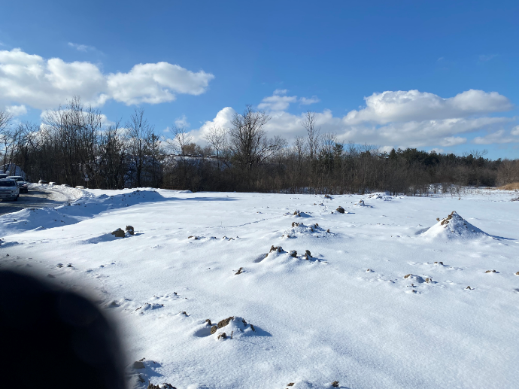
Area B: Captured on January 26, 2022.

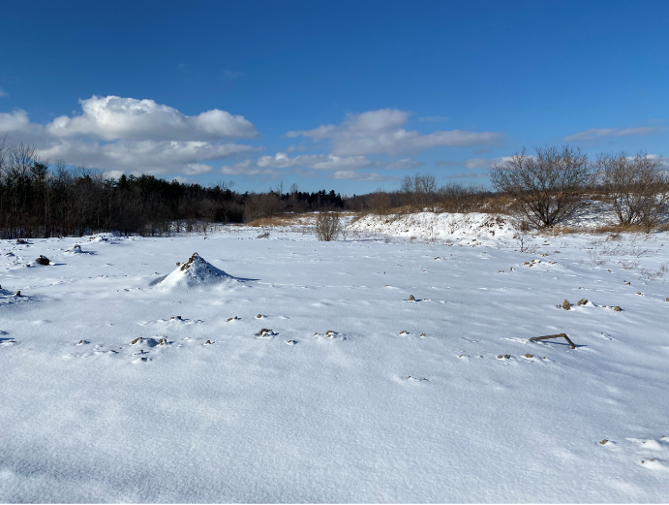
Area B: Captured on January 26, 2022.
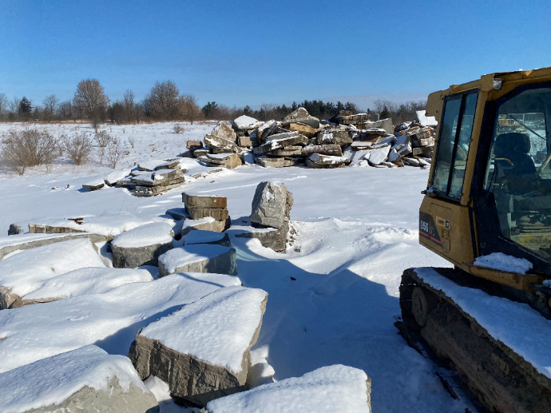
Area B: Captured on January 26, 2022.

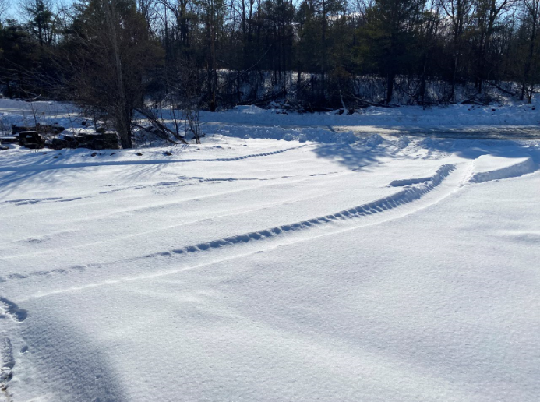
Area B: Captured on January 26, 2022.

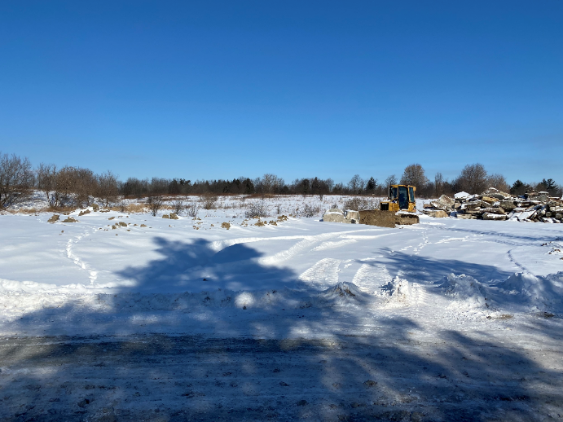

Area B: Captured on January 26, 2022.

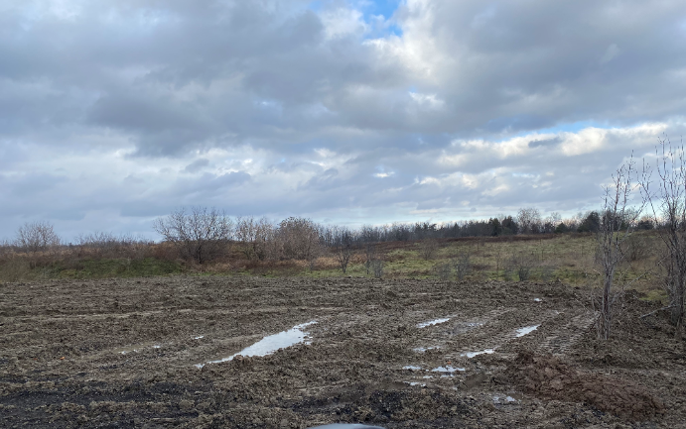
Area B: Captured Fall 2021.

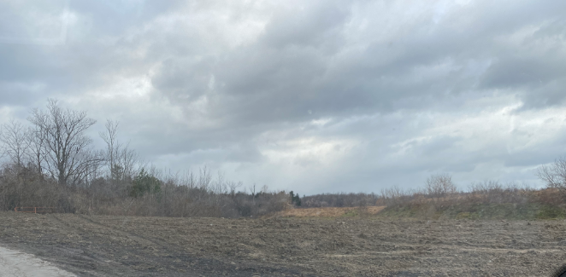
Area B: Captured Fall 2021.

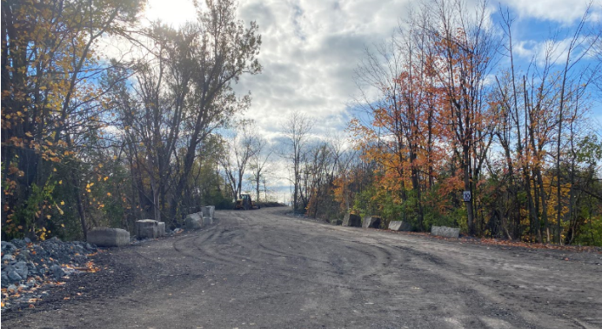
Area C: Captured on October 22, 2021.

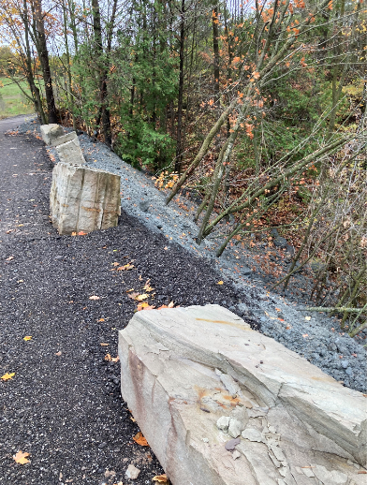
Area C: Captured by Conservation Halton on October 26, 2021

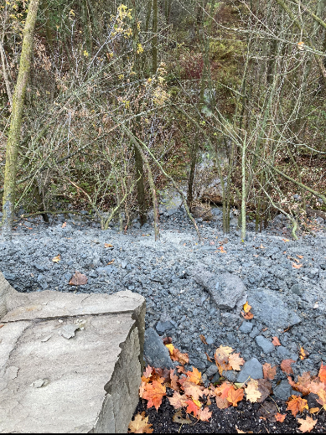
Area C: Captured by Conservation Halton on October 26, 2021.

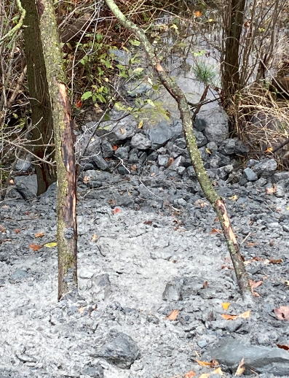
Area C: Captured by Conservation Halton on October 26, 2021.

