April 21, 2021

A6: STAFF REPORT

DEVELOPMENT PERMIT APPLICATION:

N/R/2020-2021/746
Applicant: REDACTED
Owner: REDACTED
56 Park Road South,
Part Lot 3, Concession 2; RP30R5220
Town of Grimsby, Region of Niagara

SUMMARY

PROPOSAL:

To construct within a ±825 square metre (±8,880.2 square feet) building envelope a single dwelling (size to be determined) with a height of ±12.5 metres (±41.01 feet), to construct an inground swimming pool with a surface area of ±168 square metres (±1,808.3 square feet), to construct a ±120 square metre (1,291.7 square feet) accessory structure, a new driveway and septic system on a vacant ±0.55 hectare (±1.36 acre) lot. The proposed dwelling, pool and accessory structure will be located within the proposed building envelope.

DESIGNATION:

Escarpment Protection Area

ISSUE:
The proposed connection to municipal water service conflicts with Parts 2.12.7 of the Niagara Escarpment Plan (NEP). Section 2.12.8 would permit a connection to water services for existing development; however, a policy interpretation is required from the Commission to determine whether the existing lot qualifies as existing development.

RECOMMENDATION:

Approval with conditions.

REASONS:

The subject property is located within an approved service area. Municipal services already exist along Park Road South. The subject property was created legally through a Municipal Consent application approved in 1986. A lot creation is considered development as per the Provincial Policy Statement (2020). This constitutes existing development, as such, the proposed water connection is in keeping with Section 2.12.8 of the NEP.

RECEIVED:
The application was recevied on March 16, 2021.

SOURCE:
REDACTED (agent/applicant), REDACTED (owner).

RELATED FILES:

B/1986-1986/666
The subject property was created as a result of a severance associated with the above noted Municipal Consent file. This approved severance created lots 54 and 56 Park Road South and 52 Park Road South was retained as the remnant lot.

N/R/2001-2002/244
A Development Permit Application was received on November 21, 2001, to construct a single family dwelling at 54 Park Road South (neighbouring property). Development Permit no. 7588 was issued in 2002. A connection to the municipal water services was part of the approval.

W/R/2014-2015/289
The above noted application at 539 Jerseyville Road, Hamilton was before the Commission on June 17, 2021. The proposal included the extension of municipal services from the Urban Area designation into the Escarpment Rural Area to service a new dwelling that replaced a demolished dwelling. Prior to demolition, the old dwelling had been partially connected to municipal services. The issue brought to the Commission was whether: i) municipal servicing, which existed within the Jerseyville Road allowance but within the Urban Area designation, could be extended to service the new dwelling in Escarpment Rural Area, and ii) whether the replacement dwelling could be considered “existing” development given that the old dwelling had been demolished. The Commission approved the connection to municipal services with conditions.

BACKGROUND:
A Development Permit Application was submitted on March 16, 2021, to construct a single family dwelling (size to be determined), swimming pool and accessory structure within a 825 square meter (8880.2 square foot) building envelope. Furthermore, the proposal included a driveway and a private sewage system on the vacant 0.55 hectare (1.36 acre) lot. It was also proposed that the single dwelling be connected to the municipal water supply. There is an existing 300 mm water supply pipe, which extends into the Escarpment Protection Area and runs along the west side of Park Road South, that was installed in 1956. This pipe services all of the properties along Park Road South from Bell Avenue to Highland Drive with the exception of the subject property.
Historically, the original lot served as the Deer Park Golf Club from 1919-1939. The golf course club house was used as a hospital from 1945 – 1948. A single dwelling was constructed on 52 Park Road South in 1970. The subject property (56 Park Road South) was created through a municipal consent application in 1986. Two properties (54 and 56 Park Road South) were severed off the original lot leaving one remnant lot (52 Park Road South). Both 52 and 54 Park Road South support a single dwelling and are connected to the municipal water supply. 54 Park Road South has remained vacant since the severance.

SITE DESCRIPTION:
The site is now a vacant, 0.55 hectare lot. It is designated entirely as Escarpment Protection Area by the Niagara Escarpment Plan, 2017 (NEP). The property is located on the west side of Park Road South between Main Street East and Ridge Road East. The lots immediately surrounding the site are relatively large, rural residential lots (outside the urban area boundary) and they are similarly designated Escarpment Protection Area and/or Escarpment Natural Area. Appendix 1 includes an orthophoto of the subject property.

The property has no mapped natural heritage features, however, there are key natural heritage features located adjacent to the property. As such, an Environmental Constraints Analysis (ECA) was required to be completed in order to identify if any significant environmental features are on the property. The report found:

- A hazard land area associated with an unstable top of slope feature along the west side of the property.
- The presence of Significant Woodland and an Area of Natural and Scientific Interest (ANSI) adjacent to the property.
- A regulated watercourse along the western lot line.
- Potential nesting habitat during bird breeding season.
- A small woodland was identified on the east edge of the subject property along the frontage on Park Road South.

There were no Species at Risk habitat or Significant Wildlife Habitat identified on the property.

PROPOSAL:
The proposal seeks to establish a ±825 square metre (±8,880.2 square feet) building envelope which will contain a single dwelling with a maximum height of 12.5 metres (floor area to be determined). The applicant is also proposing to construct an in-ground swimming pool with a surface area of ±168 square metres (±1,808.3 square feet) and a ±120 square metre (1,291.7 square feet) accessory structure within the proposed development envelope. An exact location for the dwelling, pool and accessory structure has not yet been determined by the applicant. A development envelope has been proposed in which these structures will be located (Appendix 2). The Environmental Constraints Analysis identified this proposed development envelope as being in a location with the minimal impact to surrounding natural heritage features. Conditions have been included (Appendix 3) which will require a final site plan and location for the proposed structures including the architectural drawings. Additional conditions include a tree protection plan and geotechnical engineering report. The applicant is seeking to connect to the municipal water supply, which exists on the street. A private sewage system and driveway is also being proposed. The site plan for the proposed development is included as Appendix 2.

PLANNING ANALYSIS:

Niagara Escarpment Plan (2017)

Part 1 Land Use Designations and Permitted Uses:
The site is designated Escarpment Protection Area by the Niagara Escarpment Plan, 2017 (NEP), which permits single dwellings and accessory structures, subject to meeting the applicable Development Criteria policies in Part 2 of the NEP. NEC staff do not have a concern that the proposed use is incompatible with surrounding rural land uses.

Part 2 General Development Criteria:
Part 2.2.1 of the NEP states that the Escarpment environment shall be protected, restored, or where possible enhanced having regard to single, multiple or successive development. An Environmental Constraints Analysis was completed by LCA Environmental Consultants. The findings scoped an appropriate location for the proposed structures that would minimize the impact and protect surrounding key natural heritage features. The connection to municipal water would not have a negative effect on the Escarpment environment and would not set a precedent in the neighbourhood since all of the properties along Park Road South (Highland Drive to Bell Avenue) are already connected.

Section 2.2.2 of the NEP states that a site shall not be prone to natural hazards, and the development shall not impact the control of these natural hazards including hazard events associated with unstable soil or unstable bedrock. The Niagara Peninsula Conservation Authority (NPCA) has identified an unstable top of slope in the western portion of the property. The proposed works will be setback 7.5 metres from the top of slope. This buffer will be left in a natural state and no development is permitted within it. Furthermore, the NPCA has required that a geotechnical engineer review final grading plans and prepare report to ensure conformity with the NPCA’s policies. This has been included as a condition of approval (Appendix 3).

Part 2.12 (Infrastructure):
Part 2.12.7 of the NEP does not permit municipal water and wastewater systems to be extended into the Escarpment Protection Area unless it is being done to address failed individual on-site sewage or water services, or for public heath, which would be determined by a medical officer of health (or health authority). However, in this case, municipal services already exist along Park Road South.
Part 2.12.8 of the NEP states that notwithstanding Part 2.12.7, where municipal water and wastewater systems already exist, existing development within an approved service area boundary may be connected to these systems.
As noted, municipal water services are available within the Park Road South right-of-way. The Town of Grimsby has indicated that a 300 millimeter (“mm”) cast iron water supply pipe runs along the east side of Park Road South directly across the subject property. Town staff has confirmed that the site is located within an approved service area boundary and that there is sufficient capacity and pressure to support the connection to municipal water. A connection to municipal water is only permitted to existing development as per Section 2.12.8 of the NEP. The issue in need of interpretation is whether an existing, but vacant lot counts as “existing development.”
The Provincial Policy Statement (2020) defines development as:
“Development means the creation of a new lot, a change in land use, or the construction of buildings and structures requiring approval under the Planning Act…”
The creation of a new lot is defined as development. It is staff’s interpretation that the creation of lot by means of the severance undertaken in 1986 counts as “existing development,” and that the connection of the proposed dwelling to existing municipal services should be permitted.

Other Development Criteria:
This section of the report will review the remaining Development Criteria that applies to the remainder of the proposal.

The site does not contain any mapped key natural heritage or hydrologic features. However, as noted above, there is a Regionally Significant Life Science Area
of Natural and Scientific Interest (ANSI), watercourse and significant woodland located adjacent to the property. There is also an unstable top of slope regulated by Niagara Peninsula Conservation Authority (NPCA) on the western portion of the property. The Environmental Constraints Analysis confirmed that the concept plans and location of the structures and private sewage system will be located in the least constrained portion of the property. The proposed works will be setback 7.5 meters from the unstable top of slope. The requirement for a tree protection plan has been included as a condition of approval to provide appropriate protection measures to trees located in proximity to the proposed works. The policies of Section 2.5 (Development Affecting Steep Slopes and Ravines) and 2.7 (Development Affecting Natural Heritage) are generally satisfied.

The former use of the property as the Deer Park Golf Course provides evidence that past site disturbance occurred through grading and filling which compromised the archaeological integrity of the property. A stage 1 and 2 archaeological assessment was conducted in the immediate vicinity of the subject property. The results of the assessments did not identify any archaeological resources. NEC and Region of Niagara staff did not require an archaeological assessment based on the above analysis. The proposal is consistent with Section 2.10 (Cultural Heritage) of the NEP.

Provincial Policy Statement 2020 (PPS):
The Provincial Policy Statement (PPS) designates the subject property as within the Prime Agricultural Area and more specifically, a Specialty Crop Area. The PPS states that Prime Agricultural Area lands shall be protected for long-term agricultural use with Specialty Crop Areas being given the highest priority for protection. In general, the PPS directs non-agricultural uses to settlement areas and discourages their location in the agricultural area. The property is also situated within a residential neighbourhood in close proximity to an urban settlement area. The subject lot was created prior to the existence of the PPS and agricultural lands did not receive the same level of protection as they do today. Residential uses surround the property to the north, east, south and west, as such, a proposal for a single dwelling is compatible with the existing land uses in the neighbourhood. The lot is not large enough to support an agricultural use.

Section 2.1 of the PPS directs the long-term protection of natural features and areas. The property is located adjacent to key natural heritage features and the proposal is supported by an Environmental Constraints Analysis. The report suggests mitigation measures to protect the natural heritage features of the area for the long-term. These have been included as conditions of approval.
Section 1.1.5.5 of the PPS requires that development within rural areas shall be appropriate to the infrastructure which is planned or available. The municipal water supply is available and has sufficient capacity to support a connection to the subject property. NEC staff are of the opinion that the proposal is consistent with the PPS.

AGENCY CONSULTATIONS:

Region of Niagara
Regional staff did not object to the proposal provided that a constraints analysis is prepared in order to determine whether a scoped environmental impact statement (EIS) is required. Additionally, an application is required for a new Class 4 sewage system. Regional staff did not require an archaeological assessment on the property. Based on the findings of the constraints analysis, Regional staff do not require an EIS and are not opposed to the proposed development.

Town of Grimsby
Town staff noted that the height of the dwelling (12.5 m) exceeds the height limit in the underlying zoning by-law (9 m). Town staff are agreeable to a maximum of two storeys on the subject property to maintain the character of the surrounding area. Staff indicated that all efforts should be made to minimize the removal of vegetation on the property. Town staff have no objection to the proposal and connection to the municipal water supply. Town engineering staff has confirmed that there is sufficient capacity to support the connection.

Niagara Peninsula Conservation Authority (NPCA):
NPCA staff identified a regulated hazardous slope on the subject property. Staff require confirmation from a qualified geotechnical engineer that development can be undertaken on this site in a manner that will not negatively impact the slope stability on this property. NPCA staff and the geotechnical engineer will need to review and approve the grading plans. (Note: this has been included as a condition of approval.)

SUMMARY:
The proposed works that include the construction of a single dwelling, accessory structure, swimming pool, driveway and private sewage system are permitted uses and are consistent with the applicable Development Criteria in Part 2 of the NEP. NEC staff are of the opinion that the connection to municipal water is in keeping with the intent of Section 2.12.8 of the NEP. The subject property is located within an approved service area and there is sufficient capacity to support the connection. The vacant lot, created in 1986, should be considered as “existing development.” Lot creation is defined as development in the PPS.

RECOMMENDATION:
The Development Permit Application be approved, subject to attached conditions.

Prepared by:
Original signed by:
______________________
Andrej Obradovic
Senior Planner

Approved by:
Original signed by:
______________________
Kim Peters, MCIP, RPP
Manager

Appendix 1 – Orthophoto of the subject site
Appendix 2 – Site plan
Appendix 3 – Conditions of Approval

APPENDIX 1
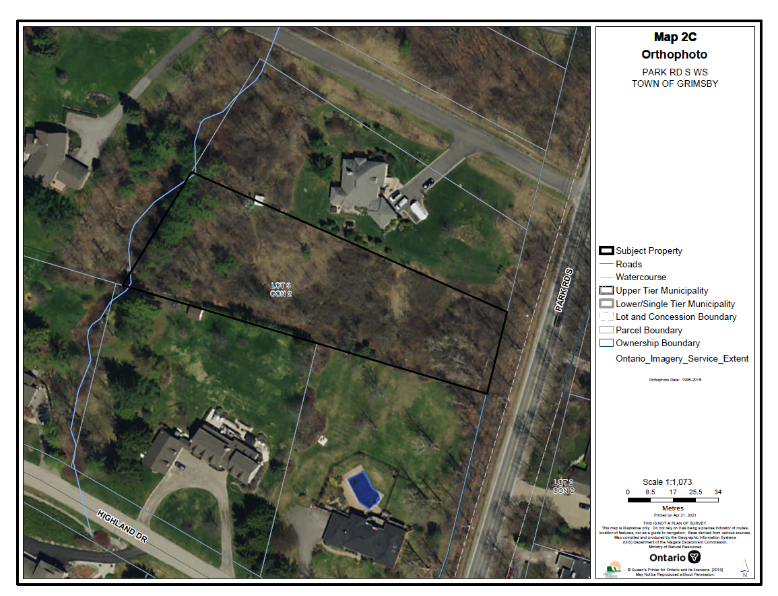
APPENDIX 2

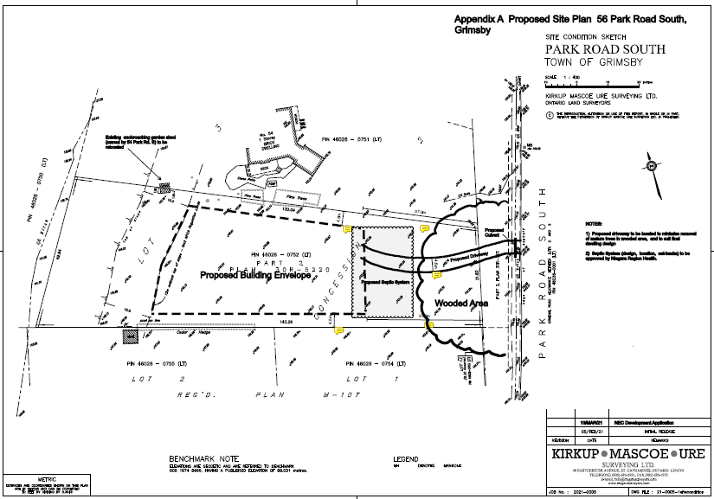

APPENDIX 3

56 Park Road South

Town of Grimsby
CONDITIONS OF APPROVAL N/R/2020-2021/746
- Development shall occur in accordance with the Terms and Conditions of the Development Permit.

- The Development Permit shall expire three (3) years from the date it has been issued or once the development has been completed in accordance with the Development Permit.

- No site alteration of the existing contours of the property including the placement or stockpiling of fill (i.e., excess or imported soil) on the property is permitted with the exception of that identified within the development envelope in accordance with the Final Site Plan.

- No vegetation shall be cut or removed from the development envelope except for that identified within the development envelope in accordance with the Final Site Plan.

- If development has commenced under this Development Permit, any/all disturbed areas of land or soil shall be re-vegetated and stabilized to the satisfaction of the Niagara Escarpment Commission on or before the date of expiry of the Development Permit.

- Prior to the issuance of a Development Permit by the Niagara Escarpment Commission, an accurate and detailed Final Site Plan prepared by a qualified person shall be submitted for Niagara Escarpment Commission approval. The following stipulation shall be included directly on the Plan:

  - The Final Site Plan shall be prepared by a qualified professional
  - All drawings submitted must be drawn to scale (bar scale shown), reference the application number and address of the proposal, be dated (revisions as well), and include the name of the relevant individual or consultant who prepared the drawing;
  - Outline of the approved development envelope / extent of all disturbed areas;
  - Location of all existing and proposed structures, sewage disposal system, well/cistern, driveway, construction access / haul routes, exterior lighting, etc. showing setbacks from the property lines, any watercourses or water features, top / bottom of slope, wooded areas, etc.;
CONDITIONS OF APPROVAL N/R/2020-2021/746
Condition 6 continued:

  - Grading, drainage, and fill management details including the areas of excavation and temporary or permanent fill placement. The type, quantity, quality and source location of any imported fill material must be accurately identified.
  - Identify the areas of existing vegetation to be retained, areas of vegetation to be removed, and the location of proposed plantings

- Prior to the issuance of a Development Permit by the Niagara Escarpment Commission, the landowner shall submit for the approval of the Niagara Escarpment Commission, final construction details for the proposed development, including exterior elevations, floor plans, height to roof peak from lowest grade, and any exterior lighting.

- Prior to the issuance of a Development Permit by the Niagara Escarpment Commission, a Final Tree Protection Plan shall be prepared by a qualified person, for the approval of the Niagara Escarpment Commission and the Region of Niagara, in accordance with the Region’s Woodland Conservation By-law. The Plan shall address vegetation protection and mitigation requirements and shall include but not be limited to a detailed inventory, assessment, protection and mitigation measures in accordance with the standard practices of the implementing authority. The Plan shall include the following stipulations:

  - Prior to commencement of any construction, protective fencing shall be installed and inspected by a qualified person and confirmation of this shall be provided to the Niagara Escarpment Commission.
  - Any vegetation noted for protection and damaged from the construction process shall be reported and replaced; trees 150mm and over DBH (diameter at breast height) shall be replaced on a per caliper basis. Replacement shall be to the satisfaction of the Niagara Escarpment Commission.
  - Once the development has been completed, including all required mitigation measures, a letter certifying that the work has been completed in accordance with the approved Plan shall be provided to the Niagara Escarpment Commission by a qualified professional.
  - Development shall proceed in accordance with the details of the approved Tree Protection Plan.

CONDITIONS OF APPROVAL N/R/2020-2021/746
- Prior to the issuance of Development Permit by the Niagara Escarpment Commission, the Landowner shall submit for the approval of the Niagara Escarpment Commission and the Niagara Peninsula Conservation Authority (NPCA), development plans and a grading plan and report from a Professional Geotechnical Engineer that ensures conformity with the NPCA’s policies.

- The landowner shall implement the mitigation measures and recommendations within Section 7 or the Environmental Constraints Analysis prepared by LCA Environmental Consultants in September 2021.

- The landowner shall remove any storage containers no later than 30 days following the completion of construction of the accessory structure.

- The dwelling shall contain only one dwelling unit.

- The accessory structure shall not be used for human habitation, as a short or long-term rental unit, or for commercial, industrial or livestock purposes.

- This conditional approval expires 18 months from the date of confirmation of the decision to approve the Development Permit application. Conditions 6, 7, 8 and 9 of this conditional approval shall be fulfilled before the expiry date.

Advisory Notes:
- A Development Permit does not relieve the permit holder of any other permission (e.g., Ontario Building Code, Conservation Authorities Act, Endangered Species Act, etc.). A Niagara Escarpment Commission Development Permit is required prior to the issuance of any other permission.

- The Niagara Escarpment Commission supports the protection of the night sky from excessive lighting and recommends the applicant obtain information on the use and operation of appropriate lighting fixtures in keeping with dark-sky approaches.

- Should deeply buried archaeological remains/resources be found on the property during construction activities, all activities impacting archaeological resources must cease immediately, notify the Archaeology Programs Unit of the Ontario Ministry of Heritage, Sport, Tourism and Culture Industries (416-212-8886) and a licensed archaeologist is required to carry out an archaeological assessment in accordance with the Ontario Heritage Act and the Standards and Guidelines for Consultant Archaeologists.

