May 19, 2022

A1 STAFF REPORT

Urban Hamilton Official Plan Amendment and Zoning By-law Amendment for Proposed Residential Development, 299-307 John Street South and

97 St. Joseph’s Drive, City of Hamilton
_____________________________________________________________________

RECOMMENDATION
That the Niagara Escarpment Commission obtain party status in Ontario Land Tribunal case OLT-21-001723 (official plan amendment) and OLT-21-001724 (zoning bylaw amendment) to oppose and/or seek to reduce the height of three 22 to 25 storey towers at 299-307 John Street South & 97 St. Joseph’s Drive in the City of Hamilton, to uphold the Niagara Escarpment Plan and reduce visual impacts on the Escarpment.

PROPOSAL
To amend the City of Hamilton Zoning By-law and the Urban Hamilton Official Plan to construct three mixed-use towers of 25, 24 and 22 storeys in height, connected by a podium varying between three and four storeys at 299-307 John Street South & 97 St. Joseph’s Drive in the City of Hamilton. The proposal includes 773 residential units, 708 parking spaces and 1,587 square metres of commercial area.

CONTEXT
The subject lands are designated Urban Area under the Niagara Escarpment Plan (NEP) and are outside of Development Control (see Attachment 1).
The subject lands are located on the lower Escarpment slope at a distance of approximately 280 metres from the brow. In this area, the upper Escarpment slopes are designated Escarpment Natural Area and the lower Escarpment slopes are designated Escarpment Urban Area (see Attachment 1).
Existing development on the subject lands include a low-rise residential building and associated parking lot and green space. The boundary of the site is treed and there is a four-metre wide landscaped setback along John Street South.
The lands front on John Street South, St. Joseph’s Drive, and Charlton Avenue East. John Street South is a major travel route that leads to Arkledun Avenue, which is a main route to the Upper Mountain in Hamilton.
Built form within the surrounding NEP Urban Area includes a mix of low-rise apartment buildings ranging from three to ten storeys and single-family dwellings ranging from one to two storeys. St. Joseph’s Hospital is located immediately to the west. There are four tall buildings in the surrounding NEP Urban Area that range from 18 to 32 storeys that were approved before the NEP came into effect.
The Bruce Trail follows the Jolley Cut to the Claremont Access in this area at a distance of approximately 200 metres from the subject lands. Bruce Trail access points are located at the south end of John Street and at the Jolley Cut in Sam Lawrence Park.
Public lands in the immediate area include Wolverton Park abutting the subject property on the east side, St. Joseph’s Park located across the street on St. Joseph’s Drive, and Sam Lawrence Park on the brow of the Escarpment at the top of the Jolley Cut. Sam Lawrence Park is a large park with pathways, scenic vista lookouts, gardens, interpretive signage about the Niagara Escarpment, and a Bruce Trail access point.
See Attachment 2 for a neighbourhood context map.

BACKGROUND
NEC staff have been engaged in this file commencing with pre-consultation in 2017 and continuing through to September 2021. The applicant has filed three submissions with the City of Hamilton. The first Official Plan Amendment and Zoning By-law Amendment were submitted to the City on December 22, 2017 proposing three towers consisting of 26, 30 and 36 storeys with a common podium of five storeys. This proposal was revised and in August 2019, the applicant reduced the podium height to four storeys and decreased the height of the proposed towers to 23, 25 and 26 storeys. The most recent proposal was submitted in October 2020, which proposed a further reduction in height of the three towers to 22, 24 and 25 storeys.
The applicant has filed an appeal with the Ontario Land Tribunal (OLT) on the basis that the City of Hamilton has failed to make a decision within the time frame in the Planning Act. The OLT has scheduled the first Case Management Conference (CMC) on May 11, 2022.
The examination of the visual impact associated with the proposed tall buildings at 299-307 John Street South & 97 St. Joseph’s Drive has been ongoing through a series of visual impact assessments (VIAs). Per NEC requirements, the proposed building heights were assessed in comparison to maximum allowable heights in the existing Urban Hamilton Zoning By-law No. 6593. In accordance with the zoning by-law, the subject property is divided into three parcels with different maximum allowable heights that step down towards the Escarpment from 18 storeys (near Charlton Ave) to 12 storeys (mid-block) to eight storeys (near St. Joseph’s Drive).
It is standard practice for the NEC to consider existing zoning heights for the purposes of comparison. The NEC Technical Criteria for Visual Impact Assessments require that the overall building height be assessed including any mechanical levels, parapets, or other structures on the roof. These structures are not included in the maximum allowable heights in the zoning by-law and can add significant height to a building and affect visual impacts. For assessment purposes, NEC requires that elevation values be provided for the top of structure (measured in metres above sea level) to account for grade differential across a sloping site and to allow for comparison against landform or other features such as the Escarpment brow.
As proposed, the overall height of the three towers represents a significant increase over the maximum allowable building heights for the subject property and exceed the relative height of the Escarpment brow (see Table 1 below).

Table 1: Assessed Building Heights
 | Proposed Building Height | Top of Structure (incl. 3.2 m high mechanical level) | Maximum Allowable Building Height in current zoning by-law | Escarpment Brow Elevation
Tower A | 25 storeys | 206.65 masl | 18, 12, and 8 storeys | 190-195 masl
Tower B | 24 storeys | 203.60 masl | 18, 12, and 8 storeys | 190-195 masl
Tower C | 22 storeys | 197.58 masl | 18, 12, and 8 storeys | 190-195 masl

A VIA was required by NEC staff for the purposes of examining visual impacts. Early submissions did not meet the standards laid out in the NEC Technical Criteria for Visual Impact Assessments and proposal changes resulted in the need for multiple VIA submissions between 2017 and 2021 (see Table 2 below). The latest VIA submission (September 2021) addressed all technical comments and the VIA was deemed complete.

Table 2: Visual Impact Assessment (VIA) Timeline
Date | Milestones in the VIA Timeline
December 2017 | VIA submission (RN Design)  Original building heights: 26, 30 and 36 storeys
July 2019 | VIA submission (SRN Architects)
August 2019 | Revised building heights: 23, 25 and 26 storeys
November 2019 | VIA methodology and supplement information (SRN Architects)
February 2020 | Preliminary submission (MBTW-Wai)
April 2020 | VIA submission (MBTW-Wai)
October 2020 | Revised building heights: 22, 24 and 25 storeys
June 2021 | VIA resubmission (MBTW-Wai)
September 2021 | VIA addendum (MBTW-Wai)

The VIA examined a series of viewpoints from public lands, streets, and the Bruce Trail. For each viewpoint, the following information was provided:
- a baseline photograph showing existing visual conditions
- a photo simulation of the maximum building envelope at the height permitted by the current zoning (shown in grey)
- a photo simulation of the proposed 25, 24 and 22 storey buildings
- analysis of visual impact of the proposed buildings
The as-of-right building envelope (shown in the photo simulations in grey) was modelled at the largest size made possible by the existing as-of-right permissions for the subject lands. As a building design could not be predicted, a three-dimensional building volume was modelled for comparison purposes only.
The consultant carrying out the VIA concluded that the proposed building heights are appropriate and that the three towers at 25, 24, and 22 storeys will not adversely impact the scenic resources of the Niagara Escarpment. NEC staff did not concur with the findings and are of the opinion that the proposed building heights and massing will result in visual impacts including:
- skylining of the built form above the distant Escarpment brow when viewed from Sam Lawrence Park (see Attachment 3)
- loss of visual access to the Escarpment brow and wooded slopes when viewed from John Street (see Attachment 4)
A reduction in the height of the towers is required to mitigate the skylining impact and a reduction in building massing (e.g., through setbacks, step-backs, openings, etc.) is required to increase visual access to the Escarpment. To date, no design changes to mitigate visual impacts have been undertaken.

STATUS
NEC staff informed City staff and the applicant that the current application is unsupportable. The proposal is in conflict with several sections of the Niagara Escarpment Plan, including the Purpose and Objectives, the intent of the Urban Area Land Use Designation (Part 1), and the Development Criteria (Part 2).
NEC Staff were informed on December 9, 2021 that the applicant had filed an appeal to the Ontario Land Tribunal (OLT) citing a non-decision by the City of Hamilton on the application. The first Case Management Conference (CMC) before the OLT was scheduled for May 11, 2022. NEC staff and legal counsel attended the CMC and requested party status, in anticipation of the Commission endorsing the recommendation in this report.
Being a party will enable NEC staff to serve as expert witnesses at the OLT hearing and present evidence as to why the proposed official plan and zoning bylaw amendments do not meet the policies in the NEP. Prior to proceeding to a hearing, there may also be opportunities to engage in settlement discussions with the applicant and City. In the alternative, if the Commission does not find that NEC staff’s participation in hearing or settlement discussions is warranted, the request for party status can be withdrawn. However, it is staff’s advice that the policies in the NEP do not support buildings of the proposed height in this particular area, and that the NEP policies should be upheld.

ANALYSIS

Niagara Escarpment Plan:
Plan Purpose and Objectives:
The NEP Purpose and the Objectives contain language that both directly and indirectly speak to its scenic resources, including public access to those scenic resources; that is:
The Purpose of the Niagara Escarpment Plan is: “…to provide for the maintenance of the Niagara Escarpment and land in its vicinity substantially as a continuous natural environment, and to ensure only such development occurs as is compatible with that natural environment.”
The Plan Purpose states the Niagara Escarpment is to be maintained substantially as a continuous natural environment. These words place emphasis on the physical characteristics and the scenery associated with those characteristics. Qualifying that development must be compatible with the natural environment is interpreted to mean it must, as part of the test, be compatible with the scenic resources.
Plan Objectives:
- Objective 5: To ensure that all new development is compatible with the purpose of the Plan;
- Objective 6: To provide for adequate public access to the Niagara Escarpment;
Objectives 5 and 6 bring focus to the importance of ensuring proposed development is compatible with the natural environment / scenic resources and that it maintains and provides for adequate public access to the Escarpment. Access may be physical access like the Bruce Trail or through the ability to view the landscape (visual access) from the roads, trails, land, and water within the public domain.
Visual access to the Escarpment landscape is an important part of Objective 6 as approximately 80 percent of the NEP is privately held and not accessible physically to the public. The ability for the public to access the Escarpment scenic resources is therefore largely visual access from roads, trails and lands in the public domain (e.g., parks and open space).
The size and configuration of the proposed towers presents a significant change to the existing built form on the site and within the surrounding area and blocks views of the Escarpment from viewpoints within the public realm. As such the proposal presents serious concerns associated with compatibility of the development and impact on the existing visual access for the public to the scenery of the Escarpment’s wooded slopes and brow.
Part 1.7 Urban Area:
This designation identifies Urban Areas in which the Escarpment and closely related lands are located. In some areas, the Escarpment is still largely undeveloped although surrounded by existing development (e.g., Hamilton). In other areas, urban growth already has encroached substantially on the Escarpment (e.g., former Town of Wiarton).
The subject lands are designated Urban Area and are located within an established residential area of the City of Hamilton. The wooded Escarpment slopes and brow form an integral part of the surroundings and these features are visible from roads, trails, and public parks in the area.
At 25, 24, and 22 storeys, the proposed towers will be visible from multiple viewpoints in the public realm and are significantly taller than existing residential buildings in the NEP Urban Area between the Plan boundary and the wooded Escarpment slopes. Only two other older buildings in the Plan Area skyline above the brow when viewed from an elevated position – the Arkledun and the Olympia Apartments. It is understood that the approval of these buildings pre-dates the NEP.
The objective of Part 1.7.1 seeks to minimize the impact and prevent further encroachment of urban growth on the Escarpment environment.
In the NEP, “Escarpment environment” is defined as the physical and natural heritage features, cultural heritage resources, and scenic resources associated with the Escarpment landscape.
The impact of the proposed towers does not minimize further encroachment of urban growth on the Escarpment environment (i.e., the scenic resources). At the proposed heights and with proposed massing, the towers encroach on views of the Escarpment environment, in particular, views to the wooded Escarpment slopes and views of the distant Escarpment brow.
Part 1.7.5.1 requires that all development shall be of an urban design compatible with the scenic resources of the Escarpment. Where appropriate, provision for maximum heights, adequate setbacks and screening are required to minimize the visual impact of urban development.
In the NEP, “compatible” is defined as follows: Where the building, structure, activity or use blends, conforms or is harmonious with the Escarpment environment.
In the NEP, “scenic resources” is defined as follows: The general appearance of a place or landscape, or the features of a landscape, taking into consideration the visual condition and scenic quality, which vary by location and are dependent on features such as geology, vegetation, landforms, and human developments. The heritage attributes of protected heritage properties may also include or be, in themselves, scenic resources.
In the NEP, “visual impact” is defined as follows: A change to the existing cultural and natural landscape from viewing points, usually associated with proposed development.
Due to the height and setbacks from the property line, the proposed buildings do not blend harmoniously with the existing natural scenery and Escarpment landscape. Design changes, to date, have been insufficient to minimize the visual impact of the buildings on the Escarpment environment. Screening is not a possible mitigation approach in this scenario, however, measures including a reduction in height and increased setbacks and building step-backs would minimize visual impacts.
Part 2.2 General Development Criteria:
Part 2.2.1 of the NEP requires that the Escarpment environment shall be protected, restored and where possible enhanced for the long-term having regard to single, multiple or successive development that have occurred or are likely to occur.
The introduction of towers into this area of the Plan does not enhance the scenic resources, rather it represents further degradation of the Escarpment environment. Further, should this proposal be implemented the potential exists for future development of the same scale to be brought forward. The result of a single development would not protect, enhance or restore the Escarpment environment, and multiple or successive development of similar scale would exacerbate the negative impact.
In the NEP, “negative impact” is defined as follows: d) in regard to scenic resources, a degradation to the natural scenery and scenic quality due to single, multiple or successive development.
Part 2.13 Scenic Resources and Landform Conservation:
The objective of this section is to ensure that development preserves the natural scenery and maintains Escarpment Related Landforms and the open landscape character of the Escarpment.
Part 2.13.1 requires that development shall ensure the protection of the scenic resources of the Escarpment.
Part 2.13.2 requires that where a visual impact on the scenic resources is identified as a concern by the implementing authority, a visual impact assessment shall be required.
Part 2.13.3 requires that a visual impact assessment shall:
- establish a baseline for existing conditions;
- identify the proposed physical changes; and
- assess the impact of the proposed change on the scenic resources of the Escarpment; and
- propose measures to minimize any visual impacts.
Part 2.13.4 requires that appropriate siting and design measures shall be used to minimize the impact of development on the scenic resources of the Escarpment, including:
- establishing appropriate setbacks and maximum building heights;
- changing the orientation and height of built form to reduce visibility and skylining;
- clustering buildings where appropriate;
- minimizing the development footprint and changes to the existing topography and vegetation;
- using natural topography and vegetation as screening for visual mitigation;
- where there is minimal existing screening or vegetation that cannot be retained, providing new planting of native species to screen development;
- using non-reflective materials on roofs and walls along with measures to reduce reflectivity associated with windows; and
- minimizing the effect from exterior lighting (e.g., lighting directed downward).
In the NEP, “natural scenery” is defined as follows: The existing scenery of the Escarpment environment associated with the continuous natural environment.
In the NEP, “visual impact assessment” is defined as follows: A study in accordance with the NEC Visual Assessment Guidelines.
In the NEP, “skylining” is defined as follows: Extending above the horizon line of the Escarpment brow, slope or other prominent landform and, where applicable, associated vegetation.
In the NEP, “height” is defined as follows: With respect to a building, means the greatest vertical distance between the point of lowest finished grade adjoining any exterior wall of a building and the highest point of the roof. With respect to a structure, means the greatest vertical distance between the point of lowest finished grade and the highest point or points of the structure.
While the technical aspects of the VIA study meet NEC standards, staff do not concur with the findings on visual impacts and no measures were proposed to minimize the visual impact. The VIA demonstrates that the proposed development would bring about significant change and would not preserve or protect the scenic resources of the Escarpment.
The use of appropriate design measures has the potential to minimize the impact of development on the scenic resources of the Escarpment, in particular, a height reduction and a minimized building mass would mitigate impacts on views from Sam Lawrence Park and John Street South. The building design, as proposed, does not minimize the impact of the development on the scenic resources of the Escarpment.

Ontario Regulation 826/90 (NEC Area of Development Control)
As noted above, the lands subject to this development proposal are designated Urban Area, and do not fall within the NEC’s Area of Development Control. However, the policies of the NEP still apply, and it is expected that NEP policies are reflected in municipal official plans and zoning bylaws. It is NEC staff’s opinion that the proposed amendments to the Urban Hamilton Official Plan and zoning bylaw are not consistent with the policies of the NEP.

A Place to Grow: Growth Plan for the Greater Golden Horseshoe
As the proposed development is taking place within an Urban Growth Centre, as identified in the Growth Plan, provincial policy directs that minimum intensification targets must be achieved to support complete communities, compact built form, and to protect agricultural and natural heritage systems from urban sprawl. While affordable housing and transit-oriented communities are provincial priorities, it is important to note that the Growth Plan also seeks to promote urban design and site design policies that support a high-quality public realm, as well as foster a sense of place by protection cultural heritage resources, including cultural heritage landscapes. Protecting views to the “ribbon of green” that surrounds urban Hamilton could be seen as a laudable objective that is consistent with these Growth Plan objectives, and furthermore, is mindful of the interdependencies that exist between provincial plans: where there is conflict between the Growth Plan and another provincial plan, including the Niagara Escarpment Plan, the Plan that provides more protection to the natural environment or human health prevails.

Provincial Policy Statement (PPS, 2020)
The Provincial Policy Statement (PPS) provides direction on matters of provincial interest and sets the policy foundation for regulating the development and use of land within the Province. It sets out policies for appropriate development while protecting resources of provincial interest, public health and safety, and the quality of the natural and built environment. The document itself is to be read in its entirety; there is no implied order of importance or weighting of the policies contained in the PPS. Many policies contained in the PPS refer to planning objectives that need to be considered in the context of a planning area or municipality as a whole and are not necessarily applicable to a specific site or development. The policies of the PPS represent minimum standards; planning authorities are permitted to go beyond these standards to address matters of importance to a specific community or planning area.
Provincial plans, such as the NEP, build upon the policies of the PPS by providing policies to address issues facing specific geographic areas in Ontario. These plans are read in conjunction with the PPS, however the Provincial Plan will take precedence over the policies of the PPS when a policy conflict arises.
Section 1.0 of the PPS puts forth the policies that relate to building strong and healthy communities. Within the context of the development proposal at hand, a number of policies of the PPS are relevant.
Section 1.1.1 identifies broad components that contribute to the creation and sustainability of healthy, liveable, and safe communities. Of note are the following items:
b) accommodating an appropriate affordable and market-based range and mix of residential types (including single-detached, additional residential units, multi-unit housing, affordable housing and housing for older persons), employment (including industrial and commercial), institutional (including places of worship, cemeteries and long-term care homes), recreation, park and open space, and other uses to meet long-term needs;
c) avoiding development and land use patterns which may cause environmental or public health and safety concerns
e) promoting the integration of land use planning, growth management, transit-supportive development, intensification and infrastructure planning to achieve cost-effective development patterns, optimization of transit investments, and standards to minimize land consumption and servicing costs;
Under section 1.1.3 (Settlement Areas) the PPS provides a number of policies specifically directed towards the promotion of intensification stating that settlement areas shall be the focus of growth and development and should be planned for a range of uses and opportunities for intensification and redevelopment in accordance with policy 1.1.3.3 which states:
Planning authorities shall identify appropriate locations and promote opportunities for transit-supportive development, accommodating a significant supply and range of housing options through intensification and redevelopment where this can be accommodated taking into account existing building stock or areas, including brownfield sites, and the availability of suitable existing or planned infrastructure and public service facilities required to accommodate projected needs.
The urbanized area of the City of Hamilton has been targeted as appropriate for intensification including, but not limited to, existing residential neighbourhoods. Applications proposing residential intensification must still be appropriate within the context of the site and surrounding neighbourhood. The existing official plan and zoning bylaw policies do allow for significant intensification of the site in a manner that could show greater sensitivity to views to the Escarpment and the unique sense of place that the Escarpment creates within the subject area.
Section 1.4 of the PPS reiterates many of the policies found within section 1.1.3 requiring the establishment of affordable housing by municipalities, as well as facilitating and permitting all forms of residential intensification and redevelopment. The proposed development on the subject lands is consistent with many of the goals and policies within Section 1 of the PPS.
Policies within Section 2.0 of the PPS must also be considered. Section 2.0 of the PPS relates to the wise use and management of resources, including natural and cultural heritage. Section 2.1.1 requires that: “natural features and areas shall be protected for the long term.” The Niagara Escarpment is the prominent natural area in close vicinity to the proposed development. Although the proposed development is within the Urban Area designation and may not result in direct physical degradation within the Escarpment Natural Area designation, the definition of “Escarpment environment” and policies providing for access to the Escarpment (both visual and physical) are part of the protection that is mandated in both the PPS and the NEP. Section 2.6 of the PPS speaks to conserving significant cultural heritage landscapes. The importance of the Escarpment to the scenic character of Hamilton (and southern Ontario more generally), its protection through a provincial land use plan, and its designation as UNESCO World Biosphere warrants the Escarpment’s conservation as a cultural heritage landscape.
NEC Staff consider the proposal for three 22, 24 & 25 storey residential buildings to be consistent with aspects of the PPS that address intensification and redevelopment, but the proposal is not consistent with PPS policies that protect natural and cultural heritage. The proposal also does not consider the precedence in provincial land use planning: that the NEP takes precedence over the PPS where there is a conflict, that the more specific policies of a provincial plan satisfy the more general policies of the PPS, and that land use planning decisions must conform or not conflict with provincial plans.

SUMMARY
The conclusions of the consultant who prepared the VIA are not shared by NEC staff. Staff is of the opinion that the photo simulations provided in the VIA demonstrate significant impacts on the scenic resources of the Escarpment environment. The proposal is not compatible with the surrounding residential area, represents further encroachment of urban development on the Escarpment environment, and does not protect, restore, or enhance the Escarpment environment. Successive developments of a similar scale would pose further impacts.
It is NEC staff’s opinion that the proposal for three towers at 25, 24, and 22 storeys in height (plus mechanical suite) on the subject lands does not meet the Purpose and Objectives of the NEP, the intent or purpose of the applicable Land Use Designation (Part 1), or the Development Criteria (Part 2) of the Niagara Escarpment Plan. Specifically, the proposal conflicts with Part 1.7.1, Part 1.7.5.1, Part 2.2.1, and Part 2.13 of the NEP. Re-designing the buildings, including a reduction in height and massing, has the potential to reduce visual impacts and bring the proposal into conformity with NEP policies. This approach is also supported by the Growth Plan in that the existing zoning bylaw allows for building heights that achieve significant intensification, but also allows for urban design that protects the scenic value of the Niagara Escarpment.

RECOMMENDATION
That the Niagara Escarpment Commission obtain party status in Ontario Land Tribunal case OLT-21-001723 (official plan) and OLT-21-001724 (zoning) to oppose and/or seek to reduce the height of three 22 to 25 storey towers at 299-307 John Street South & 97 St. Joseph’s Drive in the City of Hamilton, to uphold the Niagara Escarpment Plan and reduce visual impacts on the Escarpment.

Prepared by:
ORIGINAL SIGNED BY: ORIGINAL SIGNED BY:
________________________ _______________________
Andrej Obradovic Karen Bannister, OALA, CSLA
Senior Planner Landscape Architect

Approved by:
ORIGINAL SIGNED BY:
______________________
Kim Peters, RPP, MCIP
Manager

ATTACHMENTS
Attachment 1 NEP Land Use Designations Map
Attachment 2 Neighbourhood Context Map
Attachment 3 Views from Sam Lawrence Park (VIA excerpts)
Attachment 4 Views from John Street South (VIA excerpts)

ATTACHMENT 1
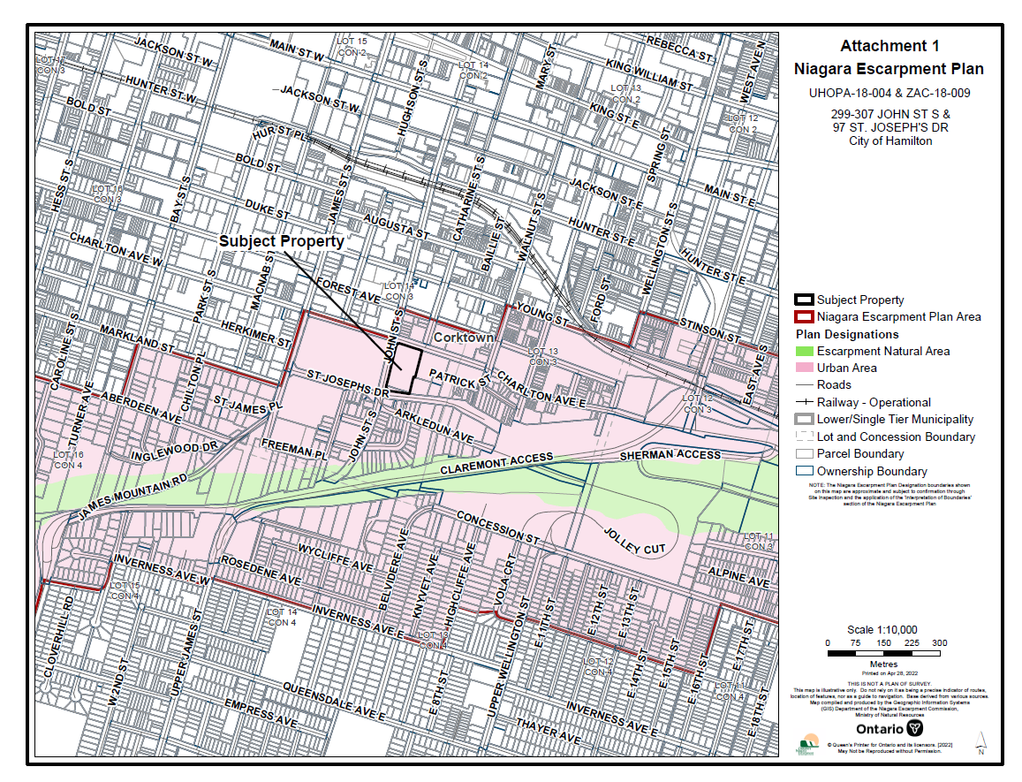

ATTACHMENT 2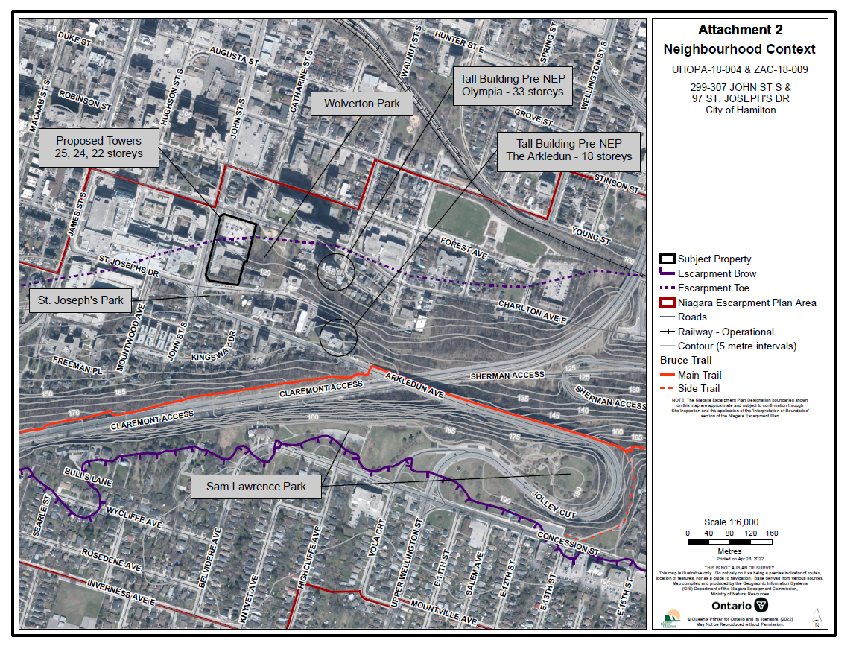

ATTACHMENT 3

VIEWS FROM SAM LAWRENCE PARK

Excerpted from Visual Impact Assessment (June 2021) 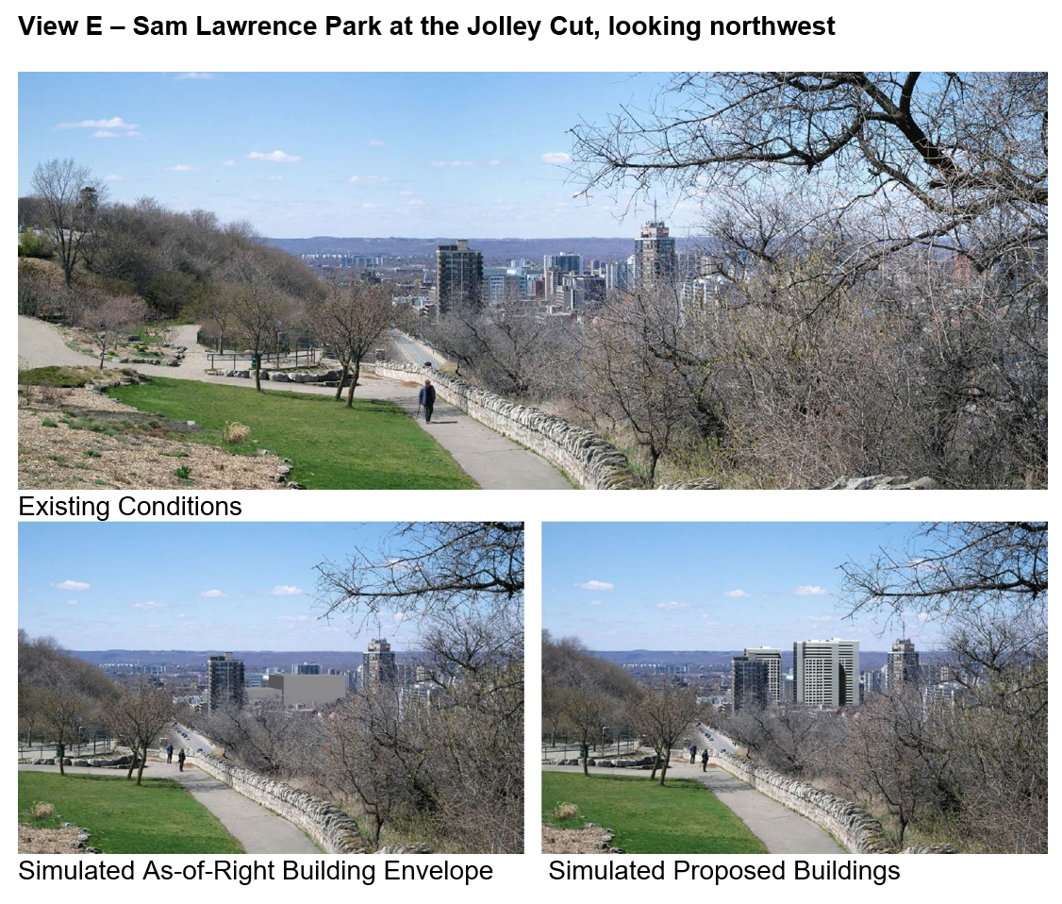
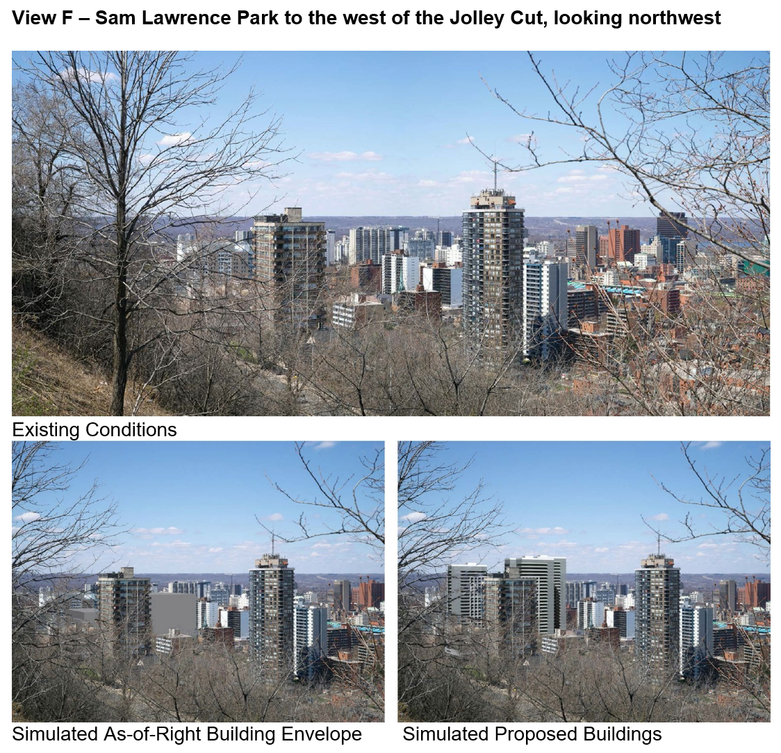
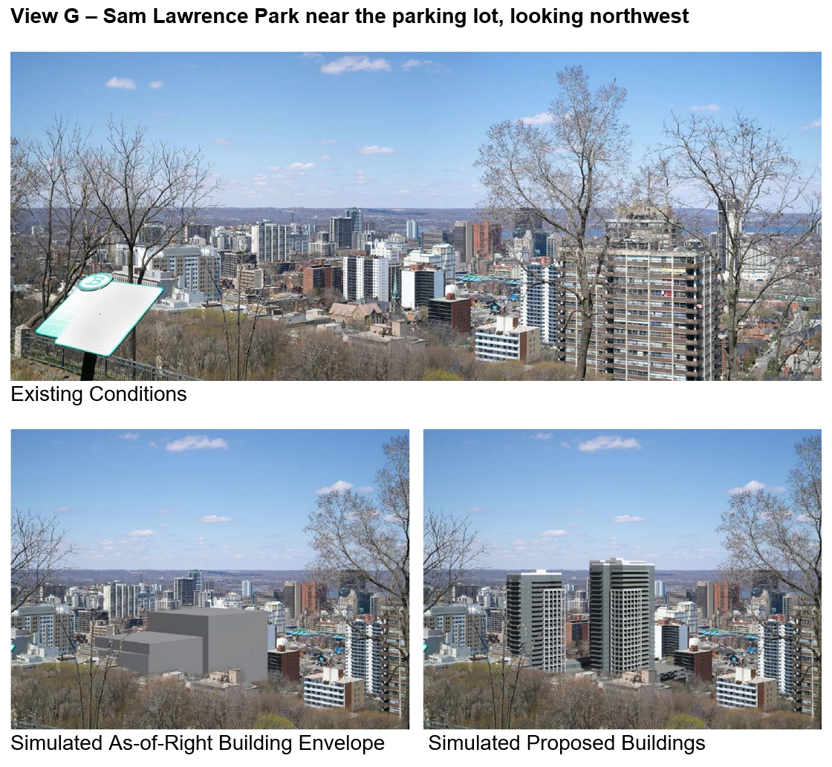

ATTACHMENT 4

VIEWS FROM JOHN STREET SOUTH

Excerpted from Visual Impact Assessment (June 2021)
