May 19, 2022

A2 STAFF REPORT

DEVELOPMENT PERMIT APPLICATIONS:

P/P/2021-2022/396 & P/P/2021-2022/398
1763 Quarry Road
Part Lot 15, Concession 3 WHS
Town of Caledon, Region of Peel

SUMMARY

PROPOSALS:

P/P/2021-2022/396:
To demolish a one storey 820 sq m (8,826.4 sq ft) salt dome with a maximum height to peak of 15 m (49.2 ft) and a one storey 65 sq m (699.7 sq ft) storage shed with a maximum height to peak of 3.5 m (11.5 ft), and to construct a one storey, ± 1,150 sq m (12,378.5 sq ft) salt dome with a maximum height to peak of ± 16 m (52.5 ft) and a one storey ± 65 sq m (699.7 sq ft) storage shed with a maximum height to peak of ± 3.5 m (11.5 ft), and to construct a driveway and parking area, on an existing 19.9 ha (49.17 ac) lot that supports a public works yard, waste management facility, and groundwater treatment facility.

P/P/2021-2022/398:
To partially demolish an existing 1,425 sq m (15,388 sq ft) maintenance building (public works yard) with a maximum height to peak of 6 m (19.7 ft), and to construct a 1 storey addition resulting in the structure being increased to ± 1,855 sq m (19,967.05 sq ft) with a maximum height to peak of ± 12.5 m (41 ft) to construct a one storey ± 340 sq m (3,659.7 sq ft) covered parking structure with a maximum height to peak of ± 6 m (19.7 ft), retaining wall, private sewage treatment system replacement, and parking expansion on an existing 19.9 ha (49.17 ac) lot that supports a public works yard, waste management facility, and groundwater treatment facility.

DESIGNATIONS:
Escarpment Natural Area, Escarpment Rural Area, Mineral Resource Extraction Area
LOT SIZE:
19.9 ha (49.17 ac)

ISSUE:
Institutional uses are typically restricted to a maximum area of 500 sq m, unless a larger size can be demonstrated to be compatible with the site and surrounding area. The applicant is proposing to expand a public works yard which already exceeds 500 sq m.

RECOMMENDATION:
Approval with Conditions.

REASONS:
The proposed development will be located within already disturbed areas of the property and there are no anticipated negative impacts to the site and surrounding environment as a result of the proposed development.

RECEIVED:
The applications were received on September 8th, 2021

SOURCE:
Town of Caledon, owner
Mettko Construction Ltd., applicant/agent

RELATED FILES:
- Development Permit 10368/P/S/2012-2013/105 was issued by the Commission in September, 2012 for the construction of a 1 storey, ± 165 sq m (± 1776 sq ft) addition to an existing building, having a maximum height of ± 9.5 m (± 31 ft), and a minor driveway extension, in conjunction with an upgrade to the existing groundwater treatment facility, on the19.8 ha (49 ac) Caledon Sanitary Landfill Site.

- Development Permit 9910/P/W/10-11/204 was issued by the Commission in April, 2011 for construction of a sewage treatment and disposal system in conjunction with the existing Caledon Compost Facility, consisting of ten (10) sub-grade tanks, a control building and leaching bed.

- Development Permit 10166/P/W/10-11/165 was issued by the Commission in December, 2011 for construction of a storage building associated with the existing public works yard. Issuance of a Permit is pending.

- Development Permit 8975/P/S/06-07/190 was issued by the Commission in September, 2007 for construction of a storm water management facility/pond to address surface runoff associated with the existing landfill site.

- Development Permit 8586/P/W/05-06/198 was issued by the Commission in April, 2006 for construction of re-use building, prefabricated Operator’s Control Booth, addition to an existing maintenance building for use as a household hazardous waste storage facility and gate relocation, all in conjunction with an established waste and recycling transfer station at the Caledon Sanitary Landfill site.

- Development Permit 7964/P/D/04-05/051 was issued by the Commission in November, 2003 to demolish an existing building (former residential structure consisting of a 2 storey dwelling and attached raised bungalow) and, a 2 storey (with storage loft) detached garage. The property, which is adjacent to the Caledon Landfill Site, is owned by the Region.

- Development Permit 8383/P/S/04-05/228 was issued by the Commission in June, 2005 to relocate and upgrade the existing public waste and recycling depot, relocate an existing scale house and scales, with related widening and closure of Quarry Road, replace an existing septic system, construct a waste and recycling transfer platform and, re-grading and landscaping, in conjunction with the potential closure of the existing compost window operation at the Caledon Sanitary Landfill site.
- Development Permit 7053/P/S/00-01/106 was issued by the Commission in September, 2000 to establish a groundwater collection and treatment system for the Caledon Landfill Site, consisting of a 135sq m (1450sq ft) building to contain related facilities.

- Development Permit 6199/P/S/97-98/249 was issued by the Commission in January, 1998 for final expansion of composting plant, consisting of 140 sq m (1500 sq ft) addition for shredding facility.

- Development Permit 6165/P/S/97-98/198 issued by the Commission in December, 1997 for expansion of composting plant, consisting of 558 sq m (6000 sq ft) new building and 279 sq m (3000 sq ft) roofed curing area.

- Development Permit 5648/P/S/95-96/201 was issued by the Commission in February, 1996 for expansion of composting plant, consisting of two additions to existing facility totalling 539 sq m (5800 sq ft).

- Development Permit 5342/P/S/94-95/75 was issued by the Commission in September, 1994 for construction of an enclosed biocell/composting plant, including installation of a methane gas collection system under the building foundation.

BACKGROUND
The subject property is known as the Caledon Landfill Site, a former landfill which has since been covered and stabilized by a soil layer. The Region of Peel has operated the landfill site since 1974 when they were delegated responsibility for waste management. The property was also at one time licensed for aggregate extraction (the license has been surrendered).

Historically, the property has supported several uses including a composting plant (operated by the Region of Peel), a recycling/waste transfer site (operated by the Region of Peel), a groundwater treatment facility to treat leachate from the closed landfill (operated by the Region of Peel), and a public works yard (operated by the Town of Caledon). The landfill use pre-dated the Niagara Escarpment Plan and is considered an existing use. NEC staff have been advised by the applicant that the composting plant is no longer in operation and that the groundwater treatment facilities have been closed since May 2021 and may be decommissioned in the future subject to additional monitoring. The Regional recycling/waste transfer site is a publicly accessible waste drop off area where recyclable materials are sorted before being taken off-site.

The Town of Caledon public works yard, which is the subject of the application, currently provides mechanical service to essential road vehicles including emergency vehicles, road maintenance and construction vehicles, Caledon parks vehicles, as well as offices for an administrative function. The public works yard also supports a salt storage dome (for winter road maintenance). The Town has indicated that these services are essential for continual maintenance of the Town of Caledon roads and emergency services.

SITE DESCRIPTION:
The irregular-shaped 19.9 ha (49.2 ac) subject property is located on the south side of Quarry Drive and is partially bounded by the Credit River. The subject property is located adjacent to a former sand and gravel pit owned by the Town of Caledon. Another Town of Caledon aggregate operation is located immediately east of the property and is nearing the end of its lifespan. The south-western portion of the property contains significant woodlands which continue south along the Credit River and into the Cataract Valley. The mapped Bruce Trail Main Trail is located approximately 1km south of the subject property while the mapped Escarpment brow is located 170 m west of the property on the other side of the Credit River. The Cataract Minor Urban Centre is located approximately 700 m south of the property. A storm water management pond is located directly west of the subject property and was constructed to address surface run-off associated with the existing landfill site (NEC Development Permit 8975/P/S/06-07/190).
The subject property is designated as Escarpment Rural Area, Escarpment Natural Area, and Mineral Resource Extraction Area by the 2017 Niagara Escarpment Plan. The existing public works yard, recycling/waste transfer site, and ground water treatment facility are all located within the Escarpment Rural Area. The composting plant is located within the Mineral Resource Extraction Area (for which NEC staff and the Town of Caledon are in consultation regarding a future Amendment to re-designate the property). A gravel parking area for the public works yard is located within the Escarpment Natural Area.
The public works yard development cluster consists of one central maintenance building (mechanical repair, office space, storage etc.), a detached accessory building (storage), a salt-dome, a small accessory building (associated with the salt-dome), parking areas, a private sewage treatment system, and a retaining wall.

PROPOSED DEVELOPMENT:
The applicant is proposing to expand the municipally-operated public works yard on the property. Originally, the applicant submitted two applications for the proposed work. Through further review, NEC staff are of the opinion that both applications should be reviewed together since they are directly related in terms of use and currently share the same development envelope.
Application P/R/2021-2022/396 proposes the removal of an existing salt dome and to re-locate the dome north of the current building cluster to a location that has been used for outside storage. The current salt dome is 820 sq m while the proposed dome will be 1,150 sq m. This location is reasonably flat and already has a driveway access along Quarry Drive. The building is being re-located because the vehicles that need to access the salt building need sufficient turn-around space and the current site is too constrained.
Application P/R/2021-2022/398 proposes to partially demolish the public works yard building, which is currently 1,425 sq m, to construct an addition to the building resulting in the structure being increased to 1,855 sq m, and to increase the maximum height of the building from 6 m to 12.5 m. Additionally, the project will construct additional parking spaces, a covered parking structure, expand and reconstruct a retaining wall, and relocate the private sewage treatment system. The applicant has informed NEC staff that the proposal will not increase the number of individuals on-site but will result in a more spacious building that can accommodate a broader range of vehicles (fire trucks). The applicant informed NEC staff that the current building is undersized for how it has typically operated, and the proposal will not result in an increase to the intensity of the use (more staff, more vehicles).

PLANNING ANALYSIS:

Niagara Escarpment Plan (NEP 2017)

Part 1 Land Use Designation and Permitted Uses:
The subject property is designated as Escarpment Rural Area (1.5), Escarpment Natural Area (1.3), and Mineral Resource Extraction Area (1.9) by the NEP. The proposed development will be located within the Escarpment Rural Area. Within this designation institutional uses are permitted outside of prime agricultural areas. NEC staff have reviewed the Agricultural Land Base for the Greater Golden Horseshoe mapping and confirmed that the subject property is not designated as a prime agricultural area and therefore the use is permitted.
The landfill on-site, which is no longer in operation, has been identified as an existing use since it was established prior to the NEP coming into effect. NEC staff have been informed by the applicant that recently the composting plant is no longer in operation, and that the groundwater treatment facility has closed; however, the groundwater is still being monitored from this site until it is determined that it is safe to be decommissioned. Thus, only the recycling/waste transfer site and the public works yard are fully operational. Recycling depots for paper, glass and cans etc., serving the local community are a permitted use in the Escarpment Rural Area designation.
There are presently four buildings on-site that contribute to the institutional use and include, the 1425 sq m (15,388 sq ft) maintenance building, the 820 sq m (8,826.4 sq ft) salt-dome, a 223 sq m (2,400 sq ft) accessory building (storage), and a 65 sq m (700 sq ft) accessory building (storage). The total area of buildings on-site which contribute to the institutional use is approximately 2,533 sq m (27,265 sq ft). The proposed changes to the site would result in an additional 760 sq m (8,180.6 sq ft) for a total area of 3,293 sq m (35,445.6 sq ft).
Part 2 General Development Criteria:
Part 2.2 (General) of the NEP provides general Development Criteria that need to be considered for all development permit applications. Specifically, Part 2.2.9 provides restrictions to the maximum size of institutional uses:
2.2.9 The gross floor area of buildings and related structures used for institutional uses shall not exceed 500 square metres, unless a larger size can be demonstrated to be compatible with the site and the surrounding landscape.

The application is currently before the Commission because the second clause of Part 2.2.9 allows consideration for expansions beyond 500 sq m provided the use can be demonstrated to be compatible with the site and surrounding area. It should be noted that this regional industrial/institutional site pre-dates the NEP and has existed at a size exceeding 500 sq m for quite some time. Thus, NEC staff are of the opinion that provided the proposal does not negatively impact the site and surrounding area that the proposal would not conflict with Part 2.2.9. In order to determine if the proposal is not in conflict with the NEP, NEC staff will review the remaining applicable Development Criteria.

Part 2.2.1 of the NEP states the Escarpment environment should be protected, restored, and where possible enhanced and that regard should be given to multiple or successive development that are likely to occur. NEC staff have typically interpreted this policy as a direction to consider the cumulative impact that development may have on a property and surrounding area. As discussed earlier, the property has supported several high-intensity uses that have recently ceased operation or are near the end of their lifespan. The proposed salt-dome will be located on top of the former landfill area, which has previously been heavily disturbed. Additionally, the applicant has stated that they are willing to restore the gravel parking area south of the maintenance building through a landscape planting plan. NEC staff note that this area is designated as Escarpment Natural Area by the NEP and that the surrounding woodlands have been designated as significant. NEC staff are satisfied through the cessation of the composting plant and the restoration of the Escarpment Natural Area, that the proposal does not conflict with Part 2.2.1 of the NEP.
The applicant submitted a geotechnical report for the location of the salt-dome, as well as the expansion are of the maintenance building (Terraprobe, 2021). This is particularly important for the salt-dome given that it will be sited on a former landfill. The study included drilling boreholes to determine the soil horizon and whether the site could support the proposed buildings and use. The location of the salt-dome was formerly a landfill and for this reason it has a high earth fill material layer underlain by the native soil. The study recommended that the building be constructed via slab-on-grade construction. The study determined that the site could accommodate the addition to the maintenance building and parking canopy, but that construction will need to utilize several methods to place footings on the undisturbed native soil. Lastly, the study found through a slope stability analysis that the location of the salt-dome will be setback 11 m from the long-term stable top-of-slope and that the construction of the building will not impact the overall stability of the slope. NEC staff are satisfied that the proposed development will not be prone to hazards and that the Development Criteria of Part 2.2 (General) are met.
Part 2.6 Water Resources Development Criteria:
Part 2.6 (Water Resources) of the NEP provides Development Criteria for protecting hydrologic features including quality and quantity of groundwater and surface water. To support the application the applicant provided NEC staff with stormwater management and servicing plans (SWMP) for the salt-dome and maintenance building (Pearson Engineering, December 2021), and the Town of Caledon’s salt management plan. The SWMP split the site into six (6) catchment areas for run-off. The proposed work will be in catchment zones 100 and 120, both of which run into the storm-water pond. The SWMP incorporates the MECP’s “Stormwater Management Planning and Design Manual” that has an objective to ensure enhanced level quality controls. The SWMPs indicated that the proposed private septic system that will be located south of the maintenance building will have a leaching bed designed for 5,000 L/day which will include tertiary treatment (waterloo biofilter). The proposed maintenance building will utilize an existing well, as well as an underground cistern. The proposed system will be distanced more than 50 metres from the Credit River.
The SWMP assessed the existing storm water pond and the changes to the impervious areas of the property. The study found that the 3.8 percent increase in impervious areas of the property will have a nominal effect on existing storm water pond. This is partially due to rain being captured on the roof of the maintenance building being stored in the underground cisterns which are to be used for firefighting protection and truck washing. The study found that the pond is expected to be able to function as per the pre-development design and that no additional quantity control measures were required. It should be noted that the original pond was designed using a 35 percent imperviousness capacity while the site as proposed will only being 30.3 percent impervious. Ultimately, the report concluded that there were no anticipated negative impacts to the quality or quantity of water. NEC staff are satisfied that the Development Criteria of Part 2.6 (Water Resources) have been met.
Part 2.7 (Natural Heritage) Development Criteria:
Currently, the public works yard is utilizing a parking lot within/adjacent to a significant woodland. The applicant has agreed to restore that portion of the property through a landscape planting/restoration plan in consultation with the NEC and CVC staff. The proposal will result in a 7.4-metre setback from the nearby significant woodlands. A Region of Peel Environmentally Sensitive Area (ESA) is located along the southern boundary of the property which overlaps the Credit River and portions of the significant woodlands. There will be no development within this area. All of the areas to be developed are already heavily disturbed (parking lots and a former land fill site). NEC staff do not anticipate any negative impacts to the surrounding key natural heritage features and are satisfied that the Development Criteria of Part 2.7 (Natural Heritage) have been met.
Part 2.13 (Scenic Resources) Development Criteria:
The proposed salt-dome will be constructed on a high elevation and will be visible along Charleston Side Road and McLaren Road. For this reason, NEC planning staff consulted the NEC landscape architect regarding potential visual impact concerns. Through this review it was determined that the vegetation along Quarry Drive would provide natural screening along the north, but that the building will be visible along several points along McLaren Road and the highpoint of Charleston Side Road. In order to minimize the negative visual impacts it was recommended that the structure either be re-located or that mitigation measures are implemented including: shifting the location of the salt-dome to the west to allow for a planting buffer along the east, west, and south side of the building, that exterior building finishes are chosen that are non-reflective and that roofing material is neutral colours (grey, dark green, brown), that light colours are avoided (white), and that all exterior lighting is downward directed away from building surfaces. The applicant has agreed to moving the structure to the west and implementing the above mitigation measures. NEC staff are satisfied that through the above mitigation measures that the impacts to the scenic resources of the Escarpment will be minimized and that the Development Criteria of Part 2.13 (Scenic Resources) have been met.
2. Provincial Policy Statement (2020)
Section 2.1 of the 2020 Provincial Policy Statement (PPS) directs the long-term protection of natural features and areas. The proposed development will be located within already disturbed areas and will be distanced from the key natural heritage features on-site. Portions of the site will be restored through enhancement planting to provide improvements to the surrounding significant woodlands. Part 2.2 of the PPS protects the quality and quantity of water. The applicant has submitted storm water management and servicing plans for the proposed development confirming that the existing storm water pond is adequately sized and that the private sewage treatment system can appropriately handle the use. NEC staff are satisfied that the proposed development is consistent with Part 2.1 and 2.2 of the PPS.

3. Consulted agencies
Town of Caledon
No objection, subject to the satisfaction of Credit Valley Conservation Authority. The subject property is designated as Environmental Policy Area (EPA), Waste Management Area, and Extractive Industrial Area. The proposed development is located within the Waste Management Area designation. The land use is not explicitly permitted within this land use designation; however, the use can be considered a Public Use. In accordance with Section 5.15.1 public utilities, commissions and other public institutional or quasi-institutional uses which provide services to the general community are permitted in this land use designation provided that:
- The use is necessary in the area; can be made compatible with its surroundings; and that adequate measures are taken to ensure this compatibility;
- That adequate off-street parking is provided; and,
- That no buildings or structures are erected in areas designated Environmental Policy Area, unless in accordance with the provisions of Section 5.7.
The Town recognizes that the proposed development is within an existing public works yard and replaces an existing dome and accessory building, there is sufficient off-street parking and the buildings are to be constructed outside of lands designated Environmental Policy Area within an already disturbed area of the property. The Town’s Site Plan Control By-law (2013-086) provides an exemption for Town of Caledon facilities and therefore site plan approval is not required.
Credit Valley Conservation Authority
No concerns. A Permit from Credit Valley Conservation Authority (CVC) will be required. Based on review of the mapping, the property is traversed by/adjacent to the Credit River and its associated floodplain and valley slope as well as wetlands internal to the woodland. The property is also located within the Peel Core Greenlands, the Brimstone Gorge Environmentally Significant Area (ESA), and Significant Wildlife Habitat (SWH) for Deer Winter Congregation Area. CVC staff understand that the final drawings for the stormwater management plan will be signed by an engineer. CVC staff have been in contact with Pearson Engineering and are awaiting final revised calculations for review and approval. CVC staff understand that the landscape plan will be a condition of the NEC approval and that a restoration plan will be prepared by the Town of Caledon. CVC staff would like to be involved and can provide support and technical guidance in preparation and review of these plans.
Region of Peel
The applicant must confirm if they are proposing to continue the existing waste collection point, and this must be depicted on a revised drawing for our record. If a new waste collection point is being proposed, it must adhere to the Waste Collection Design Standards Manual Section 2.0 and 4.0 and must be depicted and labelled on a revised submission. This property is within the vicinity of the Caledon Sanitary Landfill Site. The landfill stopped receiving waste on November 30, 2006. Leachate has been detected at the site and a remediation program was commissioned in 2000. An environmental monitoring program is in place and consists of routine groundwater, surface water and landfill gas monitoring. A Community Recycling Centre and Organics Composting Facility continue to operate at the site.

SUMMARY:
In reviewing the proposal, NEC staff took into consideration that the intensity of the uses on-site have been decreasing over time. The proposed expansion to the public works yard will primarily be located within already heavily disturbed areas that are either parking areas or former land fill sites. The applicant has provided studies demonstrating that the site can accommodate the expansion to the use without any negative impacts to surrounding key hydrologic features. Additionally, the applicant has agreed to undertake a restoration plan to rehabilitate a gravel area within/adjacent to a significant woodland feature. NEC staff are satisfied that the Development Criteria of Part 2 of the NEP has been met and that the proposal is a permitted use. There were no objections from consulted agencies regarding the proposal.

RECOMMENDATION:

The Development Permit Application be approved, subject to attached conditions.

Prepared by:

ORIGINAL SIGNED BY:
_____________________
Brandon Henderson
Senior Planner

Approved by:

ORIGINAL SIGNED BY:
_____________________
Kim Peters, MCIP, RPP
Manager

Appendix 1 – Orthophoto of the Subject Property
Appendix 2 – NEP Designations Map
Appendix 3 – Site Plan
Appendix 4 – Conditions of Approval

Appendix 1 – Orthophoto of the Subject Property
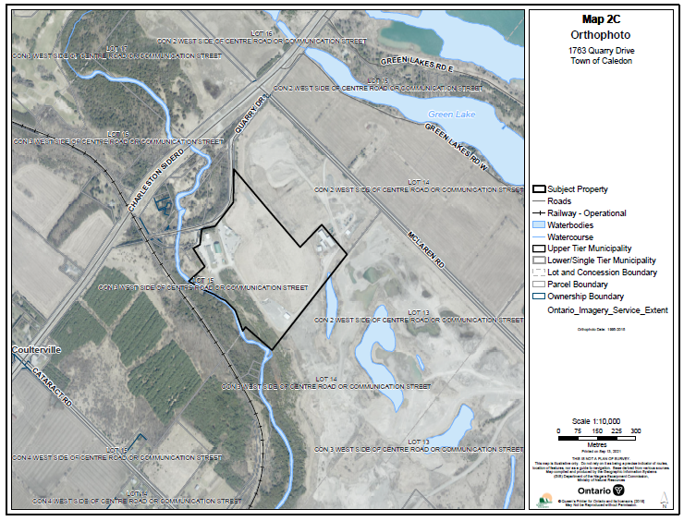

Appendix 2 – NEP Designations Map
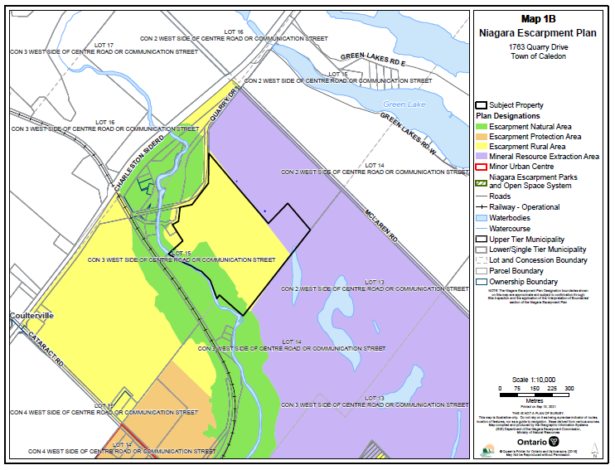

Appendix 3 – Site Plan
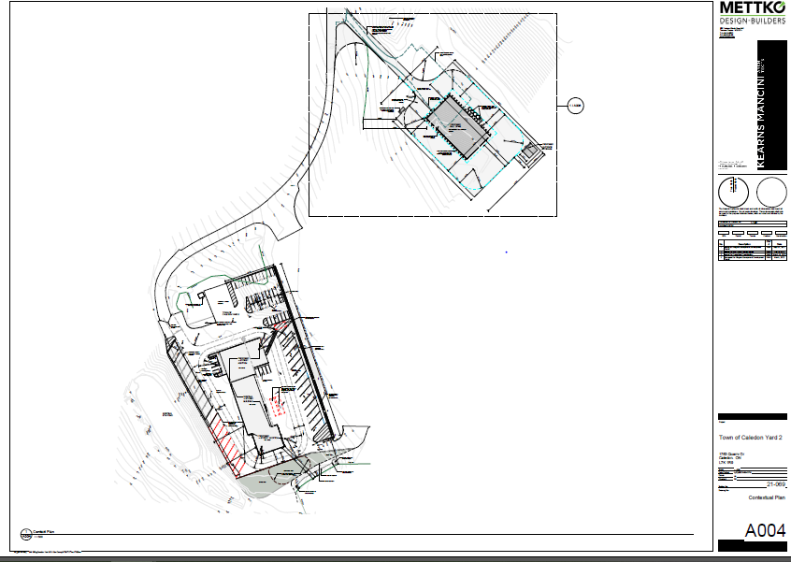

APPENDIX 4
Town of Caledon

CONDITIONS OF APPROVAL P/P/2021-2022/396 & P/P/2021-2022/398

- Development shall occur in accordance with the Terms and Conditions of the Development Permit.

- The Development Permit shall expire three (3) years from the date it has been issued or once the development has been completed in accordance with the Development Permit. [Note: alternate timeframes, more or fewer years, can be considered based on the proposed development.]

- Site alteration of the existing contours of the property including the placement or stockpiling of fill (i.e., excess or imported soil) on the property is NOT permitted with the exception of that identified within the development envelope in accordance with the Final Site Plan. All required erosion and sediment control fencing shall be maintained in good standing until the development envelope has been re-vegetated.

- No vegetation shall be cut or removed from the development envelope except for that identified within the development envelope in accordance with the Final Site Plan.

- If development has commenced under this Development Permit, any/all disturbed areas of land or soil shall be re-vegetated and stabilized to the satisfaction of the Niagara Escarpment Commission on or before the date of expiry of the Development Permit.

- Prior to the issuance of a Development Permit by the Niagara Escarpment Commission, an accurate and detailed Final Site Plan shall be submitted for Niagara Escarpment Commission approval. The following stipulation shall be included directly on the Plan:

- The Final Site Plan shall be prepared by a qualified professional;
- All drawings submitted must be drawn to scale (bar scale shown), reference the application number and address of the proposal, be dated (revisions as well), and include the name of the relevant individual or consultant who prepared the drawing;
- Outline of the approved development envelope / extent of all disturbed areas;
- Location of all existing and proposed structures, sewage disposal system, well/cistern, driveway, exterior lighting, etc. showing setbacks from the property lines, any watercourses or water features, top / bottom of slope, wooded areas, etc.;
- Grading, drainage, and fill management details including the areas of excavation and temporary or permanent fill placement. The type, quantity, quality and source location of any imported fill material must be accurately identified.

APPENDIX 4
Town of Caledon

CONDITIONS OF APPROVAL P/P/2021-2022/396 & P/P/2021-2022/398

- The location and design of erosion and sediment control measures (e.g., fencing, blankets, rip-rap, temporary mulch / seeding), and limit-of-work construction or eco-protection fencing;
- Identify the areas of existing vegetation to be retained, areas of vegetation to be removed, and the location of proposed plantings.

- Prior to the issuance of a Development Permit by the Niagara Escarpment Commission, the landowner shall submit for the approval of the Niagara Escarpment Commission, final construction details for the proposed development, including exterior elevations, total floor area, floor plans, height to roof peak from lowest grade, and any exterior lighting.

- Prior to the issuance of a Development Permit by the Niagara Escarpment Commission, a Final Landscape Plan shall be prepared by a qualified person, for Niagara Escarpment Commission approval. The Plan shall address all vegetation retention and planting requirements in accordance with the standard practices of the implementing authority. The following stipulations shall be included directly on the Plan:

- All new tree and shrub species (including seed mixes) shall be native to Ontario except where otherwise approved by the Niagara Escarpment Commission. Plant material shall be sourced from local plant nurseries; bush dug plant material is not acceptable.
- Planting and the rehabilitation of all disturbed areas shall be completed on or before the date of expiry of the Development Permit to the satisfaction of the Niagara Escarpment Commission.
- All plant material shall be guaranteed for 24 months following installation [this is flexible]. All plant material found during this time to be dead or dying must be replaced with a size and species to the satisfaction of the Niagara Escarpment Commission.
- Once the development has been completed, a letter certifying the landscaping / planting work has been completed in accordance with the approved Landscape Plan shall be provided to the Niagara Escarpment Commission by a qualified person.

- Any excess soil approved for importation under this Permit shall conform to Table 1 standards as per the “Rules for Soil Management and Excess Soil Quality Standards” under Ontario Regulation 406/19 (On-Site and Excess Soil Management) made under the Environmental Protection Act, R.S.O. 1990, c. E.19.

APPENDIX 4
Town of Caledon

CONDITIONS OF APPROVAL P/P/2021-2022/396 & P/P/2021-2022/398

- Prior to the commencement of any development, erosion and sediment control measures (e.g., fencing, blankets, rip-rap), and/or vegetation protection fencing shall be implemented and maintained as shown on the Final Site Plan until all disturbed areas are stabilized. It is the responsibility of the landowner to implement, monitor and maintain all erosion and sediment control measures and vegetation protection fencing in good condition until vegetative cover has been successfully established and the development is completed.

- All waste materials generated from the demolition shall be completely removed from the property and taken to an authorized receiving site (e.g., municipal landfill site, salvage / reclamation facility, re-used / recycled elsewhere) and not stored or buried on site. All disturbed areas shall be rehabilitated as per the Final Site Plan.

- Conditions 6, 7 & 8 must be fulfilled within eighteen-months (18) from the date of confirmation of the Commission’s decision or this conditional approval shall lapse and a Development Permit will not be issued.

Advisory Notes:

- A Development Permit does not relieve the landowner/permit holder from the requirements of any other required approval, licence or certificate under any statute (e.g., Ontario Building Code, Planning Act, Aggregate Resources Act, Conservation Authorities Act, Endangered Species Act.

- The Niagara Escarpment Commission supports the protection of the night sky from excessive lighting and recommends the applicant obtain information on the use and operation of appropriate lighting fixtures in keeping with dark sky approaches.

- Should deeply buried archaeological artefacts be found on the property during construction activities, the Heritage Operations Unit of the Ontario Ministry of Heritage, Tourism, Sport, and Cultural Industries shall be notified immediately. In the event that human remains are encountered during construction, the owner shall immediately notify the police.

