May 19, 2022

C1 STAFF REPORT

Official Plan Amendment, Zoning By-Law Amendment, Draft Plan of Subdivision Proposed Residential Development, City of Hamilton, Flamborough Power Centre, Iconnect
______________________________________________________________________

RECOMMENDATION
That the Niagara Escarpment Commission obtain party status in Ontario Land Tribunal case OLT-21-001345 (official plan), OLT-21-001355 (zoning) and OLT-21-001356 (Plan of Subdivision) to uphold the Niagara Escarpment Plan and reduce potential visual impacts on the Escarpment for the proposed development at 522 Highway 6, 3 & 50 Horseshoe Crescent and 30 Highway 5 East within the City of Hamilton.

PROPOSAL
To construct a mixed-use community with 2009 new housing units in a variety of residential built forms including townhouses, stacked townhouses, back-to-back townhouses, mid-rise and high-rise buildings ranging from three to 22 storeys in height on lands municipally known as 522 Highway 6, 3 & 50 Horseshoe Crescent and 30 Highway 5 East within the City of Hamilton (Former Town of Flamborough). The proposal also includes approximately 5.44 hectares of parkland and a seniors’ complex. See Attachment 1 for the Development Concept Plan.

CONTEXT
The subject lands are located outside of the Area of Development Control. The subject lands south of Highway 5 are located within the Urban Area Designation under the Niagara Escarpment Plan (NEP). The subject lands north of Highway 5 are located outside of the Niagara Escarpment Plan area (See Attachment 2).
The subject lands are located on the table land above the Escarpment brow at the north-east and south-east corner of Highway 5 and Highway 6. Lands are 25.5 ha in size and are bisected by Highway 5 (Dundas Street) in Waterdown. The portion of the subject lands within the Urban Area designation are located south of Highway 5. This area is approximately 6.5 hectares in size and consists primarily of previously cultivated agricultural lands and shrubs. The topography of the site is generally flat, draining from north-west to south-east. Surrounding land uses include commercial and retail uses and active agricultural land. The subject lands are visually prominent at a high elevation above the Lower Dundas Slope. The site is located within the Grindstone Creek Watershed and an un-regulated watercourse traverses the property from east to west. A 0.2-hectare isolated wetland is located on the southern portion of the subject property and is identified as a Core Area as per the Urban Hamilton Official Plan.

BACKGROUND

Application Details:
Official Plan Amendment (UHOPA-19-012) would provide a new area-specific policy framework that allows for the development of new housing (various forms), parkland, local services and commercial uses ranging from three to 22 storeys. The OPA also seeks to change the boundaries of the City of Hamilton Core Area (Schedule B within the Official Plan) to remove a wetland feature from the subject lands south of Highway 5.
Zoning By-law Amendment (ZAC-19-044) would only apply to the lands north of Highway 5, which are located outside of the NEP Area. The re-zoning would seek to change the current zoning to permit a range of residential uses including multiple dwellings, stacked townhouse dwellings, retirement homes and residential care facilities with a maximum height ranging from 15 metres to 71 metres.
Draft Plan of Subdivision (25T-2019005) applies to the lands north of Dundas Street East. The proposed Draft Plan of Subdivision lays out the configuration of streets, accesses, parks space, pathway connections and servicing requirements.

Niagara Escarpment Commission Involvement:
NEC staff have been involved in this application since it was circulated to the NEC in 2017 as a Formal Consultation (FC-17-108). Comments were provided in August 2017 outlining that the proposed structures exceed the height of the as-of-right zoning, as such, a visual impact assessment would be required. Planning applications for an Urban Hamilton Official Plan Amendment (UHOPA-19-012), a Zoning By-law Amendment (ZAC-19-044) and a Draft Plan of Subdivision (25T-2019005) were submitted to the City of Hamilton on June 7, 2019.
NEC staff provided comments on the Stage 1 Visual Impact Assessment (VIA) on January 17, 2020. It was noted that a total of 16 tall buildings on the site plan (ranging from 10 to 20 storeys) have a proposed height that is above the height currently permitted in the zoning bylaw. Other documents in the submission reference a proposed height of up to 22 storeys. Clarification on the proposed heights is required. A potential for a negative visual impact was identified, as such, NEC staff required a Stage 2 VIA to be prepared in accordance with a Terms of Reference to the satisfaction of the NEC. A Stage 2 VIA has not yet been submitted for staff review.

ISSUES
The Stage 1 VIA assessed potential visibility of the proposed development through digital visibility mapping, which accounted for topography, proposed building heights, and the mitigating effect of existing vegetation. Photos were provided to document baseline visual conditions.
This initial assessment raised concerns that the proposed tall buildings (on both the north and south side of Highway 5) will skyline above the Escarpment brow when viewed from the public realm on the Escarpment slopes and beyond. In consultation with NEC staff, several viewpoints in the public realm were identified as requiring further investigation in the Stage 2 VIA. The Stage 2 VIA will include a series of line-of-sight cross sections and photo simulations to demonstrate changes to those viewsheds of concern. The Stage 2 VIA is subject to any changes to the development concept, and as such, it has not been completed at this time.
Because the examination of visual impacts is ongoing, NEC staff have been unable to comment on the proposed building heights and cannot take a position on visual matters until the VIA is made available.

STATUS
NEC staff were informed on February 28, 2022 that the applicant has made an appeal to the Ontario Land Tribunal (OLT) on the basis that the City of Hamilton failed to make a decision within the time frame provided in the Planning Act. NEC staff attended the initial Case Management Conference (CMC) on March 21, 2022. NEC staff advised the tribunal that outstanding information and studies are required for staff to determine whether or not we would request party status. A second CMC has been scheduled for June 29, 2022.
NEC legal counsel will attend the second CMC with the intention of seeking party status. Becoming a party to the process will enable staff to uphold the policies of the NEP through settlement discussions and/or a contested hearing. Staff require direction and instructions from the Commission to support staff’s intention to seek party status.
Based on correspondence with the applicant’s consultant dated February 9, 2022, changes to the site layout are being made to address the agency comments. The work on the Stage 2 VIA has halted until the changes to the development concept have been made. As of now, NEC staff have not been notified of any changes to the site layout or proposal.

PLANNING ANALYSIS

Niagara Escarpment Plan:
The analysis that follows specifies the policies within the NEP that may be in conflict with the proposed development.

Designations:
Urban Area (Attachment 2).

Plan Purpose:
The Purpose of the Niagara Escarpment Plan is: “…to provide for the maintenance of the Niagara Escarpment and land in its vicinity substantially as a continuous natural environment, and to ensure only such development occurs as is compatible with that natural environment.”

Plan Objectives:
- To ensure that all new development is compatible with the purpose of the Plan;
Objective 5 brings focus to the importance of ensuring proposed development is compatible with the natural environment / scenic resources.
The Stage 1 VIA indicates that the skylining is likely to occur, but further investigation is required in a Stage 2 VIA to examine this. The proposal may be considered incompatible with the purpose of the Plan if the visual impacts are such that the continuous natural environment is interrupted by the skylining of built form.

Part 1.7 Urban Area:
The southern portion of the subject lands are within the Urban Area designation in the NEP. The objective of the Urban Area policies in Part 1.7 of the NEP is “to minimize the impact and prevent further encroachment of urban growth on the Escarpment environment”.
The development objectives in Part 1.7.5 require development to be of an urban design compatible with the scenic resources of the Escarpment by utilizing maximum heights, adequate setbacks, and screening to minimize the visual impact of urban development on the Escarpment.
The objectives include recognizing, protecting and where possible, enhancing the natural heritage system, conserving cultural heritage resources, encouraging compatible recreation, and maintaining and enhancing the scenic resources and open landscape character of the Escarpment.
The proposal includes a total of 16 tall buildings possibly ranging from 10 to 22 storeys. The Stage 1 VIA indicates that the buildings will be visible from several public realm vantage points. Further investigation is required in a Stage 2 VIA to understand the impacts on the scenic resources of the Escarpment and to assess if Part 1.7 can be met.

Part 2.13 Scenic Resources and Landform Conservation:
The objective of this section is to ensure that development preserves the natural scenery and maintains Escarpment Related Landforms and the open landscape character of the Escarpment.
Part 2.13.1 seeks to ensure that new development will not have a negative impact of the scenic resources of the Escarpment. Part 2.13.2-3 require that a visual impact assessment be completed. Furthermore, Part 2.13.4 requires that appropriate siting and design measures be implemented in order to minimize the impact of new development on the scenic resources of the Escarpment. These measures may include establishing’s setbacks and maximum heights, changing the orientation of a building or providing screening to shield new development from key viewpoints.
A Stage 2 VIA has not been submitted by the applicant. NEC staff are unable to determine the potential visual impacts of the proposed towers. A determination of the proposals consistency with policies in Part 2.13 can only be made upon the review of the Stage 2 Visual impact Assessment.

SUMMARY
In conclusion, NEC staff have identified the potential for a policy conflict with Part 1.7 and 2.13 of the Niagara Escarpment Plan. Staff requires the submission of a Stage 2 VIA in order to properly address any potential visual impacts as a result of the proposed development. Becoming a party will enable staff to uphold the NEP and to remain involved in the appeal process. NEC staff intend to request party status at the upcoming Case Management Conference. In the alternative, if the Commission does not want party status in the proceeding, or we find that the proposed development does not have a negative visual impact, NEC legal counsel will inform the OLT that the request for party status is withdrawn. If that occurs the pre-hearing and hearing process will take place without the NEC providing the OLT with evidence on the application of the NEP policies.

RECOMMENDATIONS
That the Niagara Escarpment Commission obtain party status in Ontario Land Tribunal case OLT-21-001345 (official plan), OLT-21-001355 (zoning) and OLT-21-001356 (plan of subdivision) to uphold the Niagara Escarpment Plan and reduce potential visual impacts on the Escarpment for the proposed development at 522 Highway 6, 3 & 50 Horseshoe Crescent and 30 Highway 5 East within the City of Hamilton.

Prepared by:

ORIGINAL SIGNED BY: ORIGINAL SIGNED BY:
________ ________________ _______________________
Andrej Obradovic Karen Bannister, OALA, CSLA
Senior Planner Landscape Architect

Approved by:

ORIGINAL SIGNED BY:
_______________________
Kim Peters, RPP, MCIP
Manager

ATTACHMENTS

Attachment 1 Development Concept
Attachment 2 NEP Land Use Designations Map

ATTACHMENT 1
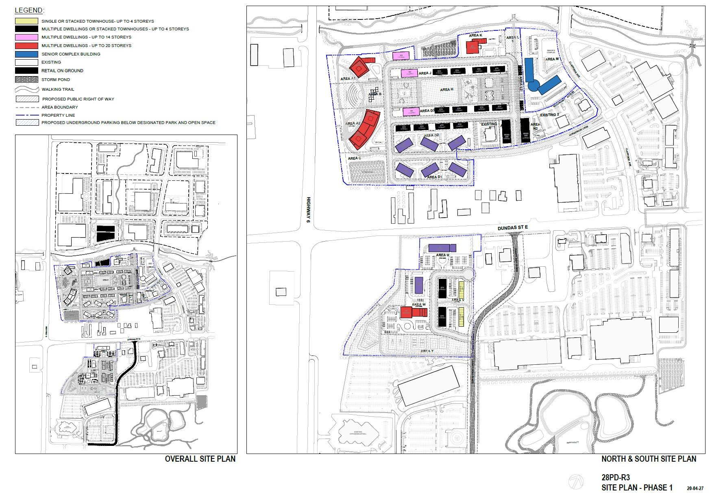
Source: WZMH Architects

ATTACHMENT 2
