July 21, 2022

# A1: STAFF REPORT

**DEVELOPMENT PERMIT APPLICATION:**

**H/C/2021-2022/787**

9459 Guelph Line

Part Lot 9, Concession 4

Town of Milton, Region of Halton

## Summary

### Proposal:

To implement a new use (warehousing and commercial storage) within an existing ±1,394 sq m (15,000 sq ft) vacant industrial building on an existing 4.82 ha (11.9 ac) lot that supports a single dwelling.

### Designations:

Escarpment Rural Area and Escarpment Natural Area

### Issue:

Warehousing and commercial storage uses are not permitted in the Escarpment Rural or Escarpment Natural Areas unless it is an Existing Use; the previous industrial use, approved by the NEC in 1975, lapsed approximately 10 years ago, and is not related to the proposed commercial use. The proposed uses are not supported by the local and upper-tier municipalities.

### Recommendation:

Refusal

### Reasons:

Warehousing and commercial storage uses are not supportable under the Niagara Escarpment Plan policies related to permitted uses in Escarpment Rural and Escarpment Natural Areas: it conflicts with lower tier and upper tier official plans; and, it is not consistent with the Provincial Policy Statement.

### Received:

April 13, 2022

### Source:

### REDACTED

### Related Files:

**H/S/2017-2018/358** NEC Development Permit #11666 was approved on June 5, 2019, to recognize the as-built installation of a new gas line service and associated site alterations and trench excavation. This permit replaced Development Permit Application H/S/2015-2016/289 below, after it lapsed.

**H/C/2016-2017/422** was filed February 6, 2017, to re-establish an industrial use in an existing building previously used for a welding shop and office, adding a second storey to the building for new office facilities, re-cladding the building, constructing a new industrial accessory storage building, constructing new parking areas, and establishing a large outdoor staging and storage area.The permit was refused: on appeal, the NEC’s decision of refusal was confirmed by the Niagara Escarpment Hearing Office on February 14, 2019.

**H/S/2015-2016/289** An NEC Development Permit was conditionally approved on July 25, 2016, to recognize the installation of a new as-built gas line service and associated site alterations and trench excavation. As the conditions of approval were not satisfied, the conditional approval lapsed, and no permit was issued.

## H/I/1975-1975/134 NEC Development Permit #74 was issued on October 14, 1975, to establish a light manufacturing facility including an assembly and office building, a future assembly building, a storage and supply depot, an outside storage area, and parking on the front half of the property. The Town of Milton supported the application as the Official Plan and Zoning By-law designating the lands as industrial then still applied.

## NEC staff recommended refusal because the proposal conflicted with the NEC objective of maintaining the open landscape character of the rural landscape and would be incompatible with the nearby Halton Region Forest. In addition, establishing an isolated industrial use at this location contradicted with local municipal efforts at the time to provide a planned industrial area closer to the former Town of Milton. The Niagara Escarpment Commission approved the application: this decision was made before Niagara Escarpment Plan policies were established. Ultimately, only one building of approximately 1,393.5 sq m (± 15,000 sq ft), was constructed and used for welding and office space, along with a less extensive parking area: operations at the facility closed on or about 2012.

### Background:

## An NEC Development Permit was issued in 1975 to establish a light manufacturing facility including an industrial assembly and office building, a future assembly building, a storage and supply depot, an outside storage area, and parking on the front half of the property. Only one building of approximately 1,393.5 sq m (± 15,000 sq ft), was constructed and used for welding and office space, along with some parking, and so the permit approval for the remaining work expired. This industrial activity continued until closing in approximately 2012, about the time that the subject property was listed for sale following the death of the previous owner in 2011.

## The property remained on the market until April 2015, when it was purchased: the new owner did so without documentation of prior consultation with the NEC on their intention to establish an industrial use and to carry out additional development on the property. The new owner submitted a development permit application in 2017 to reinstate the industrial use: this application was refused by the NEC on the basis that its status as an existing use (as defined in the NEP—see below) had lapsed and subsequently was not a permitted use, in addition to not being supported by the local or regional official plans and staff. This decision was appealed by the applicant to the Niagara Escarpment Hearing Office, which ruled in support of the NEC decision in 2019. Subsequently, the property’s ownership changed hands again: the application under consideration here has been submitted to implement a new use (warehousing and commercial storage) within the vacant former industrial building on the subject property, on which a single detached dwelling is also situated.

### Site Description:

## The property is located on the east side of Guelph Line, between Sideroad 10 and Campbellville Road. The Currie Tract of the Halton Regional Forest and Hilton Falls Conservation Area (Niagara Escarpment Parks and Open Space System) are located to the northeast of the property. The Mohawk Raceway is situated on the opposite side of Guelph Line.

## The lands are characterized by varied topography. The front or southwest portion of the property comprises gently rolling conditions with a modest slope facing west, made up of developed and disturbed areas with deciduous hedgerows. The rear of the property has more elevated and pronounced rolling conditions with forest, corresponding to the Escarpment Natural Area designated component of the property. A vegetated berm of moderate height extends along the lot frontage on Guelph line, with a low stone retaining wall established along parts of the berm, adjacent to the roadway, and alongside the driveway that runs along the northern boundary of the property.

## The approximate east third of the lot and the directly north abutting lands coincide with the Halton Forest South - Area of Natural and Scientific Interest (Provincially Significant Life Science ANSI) and the Hilton Falls Complex - Environmentally Sensitive Area (ESA) and Significant Woodland. These features are associated with the Sixteen Mile Creek Valley.

## The existing building previously used for industrial and office activities, and the related parking and exterior storage area, are situated close to the road, but are partially obscured from view by the berm feature. The area immediately surrounding the vacant building, including a small field to the south, is disturbed. An existing single dwelling is located farther back on the property from Guelph Line, northeast of and slightly elevated above the former industrial building location. The north gravel driveway provides access to both structures and lies parallel to the north lot boundary, until it veers southeast to the dwelling site. A second gravel driveway is located in the centre of the property.

### Proposed Development:

The proposal is to initiate a new use (warehousing and commercial storage) at the existing ±1,394 sq m (15,000 sq ft) vacant industrial building, and of the existing parking lot, on the subject 4.82 ha (11.9 ac) property. The single dwelling to the rear of this building and parking lot complex is proposed to be retained.

### Planning Analysis:

### 1) Niagara Escarpment Plan, 2017 (NEP)

### Purpose and Objectives of the NEP

The purpose of the NEP “is to provide for the maintenance of the Niagara Escarpment and land in its vicinity substantially as a continuous natural environment, and to ensure

only such development occurs as is compatible with that natural environment.” Specific applicable Objectives of the NEP include the following:

5. To ensure that all new development is compatible with the purpose of the Plan;

7. To support municipalities within the Niagara Escarpment Plan Area in their exercise of the planning functions conferred upon them by the Planning Act.

The subject proposal is to establish warehousing and commercial storage uses within an existing building. The proposal is not consistent with Objective 5 of the NEP, as introduction of a new use that is not permitted is not compatible with the purpose of the Plan. In addition, the proposal is not supported by the Region of Halton Official Plan or the Town of Milton Official Plan and so does not meet Objective 7.

The subject property is designated **Escarpment Rural Area** and **Escarpment Natural Area** in the NEP. The area of proposed development, the building previously used for industrial and office activities and the associated parking lot, is within the less-restrictive Escarpment Rural Area designation. The proposed development, to establish a commercial use in the above building and serviced by the parking lot, is located within the Escarpment Rural Area. However, the building and parking lot are immediately adjacent to a portion of the Escarpment Natural Area designation associated with a hedgerow that is contiguous with the Halton Forest South - Area of Natural and Scientific Interest (Provincially Significant Life Science ANSI) as well as the Hilton Falls Complex - Environmentally Sensitive Area (ESA) and Significant Woodland. Commercial uses are not permitted in the Escarpment Rural Area unless they are associated with agriculture or are a home occupation or industry. The entire property is within the Niagara Escarpment Area of Development Control.

### Part 1.5.3 Permitted Uses

The proposed warehousing and commercial storage are not permitted uses within the Escarpment Rural Area in which the existing building and parking lot are located. The objectives of the Escarpment Rural Area designation include, but are not limited to, protecting Escarpment scenic resources and agricultural lands, and providing for compatible rural land uses. In the NEP, Part 1.5.3 lists permitted uses in the Escarpment Rural Area designation, and neither warehousing nor commercial storage are identified in this list. The subject property contains an existing single dwelling, which is listed as a permitted use in the Escarpment Rural Area designation.

While the proposed warehousing and commercial storage uses are not the same as the previous industrial use, it is conceivable that an argument may be made to support the proposed uses as an extension of the prior existing use. Evaluation of whether the prior industrial existing use still applied to the property in 2017 was considered and rejected in the planning analysis and NEC decision for Development Permit Application H/C/2016-2017/422, as confirmed by the Niagara Escarpment Hearing Office ruling in 2019, as summarized below.

### Existing Use Provisions

The NEP contains provisions to deal with “existing uses.” A use may be legally recognized as an existing use, even if it is not listed as a permitted use under the applicable designation in the NEP, if it was:

1. existing on the day of approval of the Niagara Escarpment Plan, June 12, 1985;
2. approved in accordance with the provisions of the Niagara Escarpment Plan since June 12, 1985 but prior to the date of any amendment to this Plan under which the use ceased to be a permitted use; or
3. existing, in an area added to the Niagara Escarpment Plan at the date of the approval of the amendment to this Plan that added the lands to this Plan;

provided that the existing use has continued without interruption after the effective date as set out under a), b), and c). (Definition of Existing Use, NEP, 2017)

The former industrial use was approved in 1975 by the Commission and it is understood that the use continued until approximately 2012. Although the previous use would have met condition a) of the above definition, the existing use provision, it does not meet condition c) since the use has not continued without interruption; the industrial use ceased approximately ten years ago. The Commission considered the length of cessation of the industrial as a key reason for refusal since it no longer met the NEP definition of an “existing use.” In the staff report for DPA H/C/2016-2017/422 (Appendix 7), staff provided historical examples of how the Commission has consistently interpreted a cessation in use of more than two years as being an interruption of the use, thereby no longer qualifying as an existing use. On appeal, the NEC’s decision of refusal was confirmed by the Niagara Escarpment Hearing Office ruling in 2019. The Hearing Officer’s decision agreed that the cessation in use meant that it no longer qualified as an existing use.

### Part 2: Development Criteria

The development criteria in Part 2 of the NEP only apply if a use is determined to be permitted under Part 1 of the NEP. Thus, staff does not carry out Part 2 analysis when it is clear a proposed development is not a permitted use: on direction from the Commission with deferral of DPA H/C/2016-2017/422, staff confirmed in an addendum report (Appendix 8) that the property no longer met the existing use criterion, and evaluation of Part 2 Development Criteria confirmed that these were either not met or required further study (Appendix 8). Should the Commission disagree with previous interpretations and find that the proposal should be a permitted use, an NEP amendment would be the correct path to seeking approval. However, staff would likely advise that such an amendment application would be without merit, considering that a previous Hearing Officer decision confirmed that an industrial use on the subject lands is not consistent with NEP policies.

### 2) Provincial Policy Statement (2020 PPS)

Part 1.1.5.2 of the PPS states that within rural lands located in municipalities, permitted uses are:

a) the management or use of resources;

b) resource-based recreational uses (including recreational dwellings);

c) residential development, including lot creation, that is locally appropriate;

d) agricultural uses, agriculture-related uses, on-farm diversified uses and

normal farm practices, in accordance with provincial standards;

e) home occupations and home industries;

f) cemeteries; and

g) other rural land uses.

Warehousing and commercial storage uses are not listed as being permitted within rural lands. While commercial storage is not defined in the PPS, commercial use is associated here with employment land use patterns (e.g., PPS policies 1.1.1.b, 1.8.1.b), as are warehousing facilities in the PPS definition of employment area: the subject property is not identified as employment area in the Region or Town Official Plans. Home occupations and home industries are permitted, subject to their scope and scale being secondary to the primary use of a residential use on a lot (NEP Part 2.2.10.i), which this proposal does not meet on the grounds of scale.

Section 1.1.3.1 of the PPS states that settlement areas, including urban areas and rural settlement areas, shall be the focus of growth and development. The subject lands are not within a settlement area.

Based on the above, the subject proposal to establish warehouse and commercial storage uses within rural lands is not consistent with the PPS.

### 3) Regional Official Plan: Halton

Objection:

A portion of the subject lands on which the existing building is located is designated Agricultural Area by the 2009 Regional Official Plan (ROP). It is the objective of the Region’s Agricultural System to recognize agriculture as the primary activity and land use within the Agricultural Area, to maintain lands for existing and future agricultural use, and among other things, to protect farms from incompatible activities and land uses. Section 100 of the ROP outlines permitted uses in the Agricultural Areas land use designation and does not identify the proposed warehousing and commercial use as permitted.

The balance of the subject land is designated Regional Natural Heritage System (RNHS) by the ROP, containing and/or adjacent to candidate significant woodlands, significant areas of natural and scientific interest, potential habitat of endangered or threatened species, and potential significant wildlife habitat. Additional natural heritage enhancement, linkage and buffer areas on or adjacent to the subject property include, watercourses and floodplain areas, significant groundwater recharge area within the April 2015 Halton-Hamilton Source Protection Region Assessment Report, and Greenbelt Protected Countryside.

The RNHS is a systems-based approach to protecting and enhancing natural features and their functions across the Region. Subject to other policies of the ROP and applicable Provincial Plans, Section 117.1 outlines the permitted uses in the RNHS. The proposed warehousing and commercial uses are not permitted uses in the RNHS.

Regional Planning staff concluded that the proposed warehousing and commercial uses are not an appropriate use of the subject lands as they are not compatible with the Agricultural Area and RNHS land use designations applicable to the subject lands and surrounding area. Given the policy direction of the Regional Official Plan, Regional staff do not support the proposed development.

### 4) Local Official Plan: Milton

Objection: The subject property is designated partially as Escarpment Rural Area and Escarpment Natural Area on Schedule A - Land Use Plan of the Town of Milton Official Plan. Both designations do not permit industrial or commercial uses. Town Planning staff confirm that the proposed use is not considered to be permitted in the Town’s Official Plan. Further, Town staff are of the opinion that the proposed use is not considered to be an existing use or a legal non-conforming use.

Town Planning staff note that through Official Plan Amendment 31 (OPA 31), amendments were made to the Town of Milton Official Plan to achieve conformity with the Regional Official Plan. Some of the modifications include changes to the permitted uses in the Regional Natural Heritage System designation, which includes the Escarpment Natural Area and Escarpment Protection Area.

Town Planning staff also note that OPA 31 states that the Town shall apply a systems-based approach to implementing the Regional Natural Heritage System by not permitting the alteration of any components of the Natural Heritage System unless it has been demonstrated that there will be no negative impacts on the natural features and areas or their ecological functions.

At this time, OPA 31 minutes of settlement have been accepted by the Board on April 7, 2022, and a decision is anticipated in the near future. Town Planning staff note that the proposed use is not permitted in the Town’s Official Plan or OPA 31 and is not supported.

The property is currently under the land use control of the Niagara Escarpment Commission and has no zoning under The Town of Milton Zoning By-law 144-2003, as amended. However, Town Planning staff observe that should the lands be reviewed under Zoning By-law 144-2003, they would be considered to be A2 (Rural) Zone.

The Warehouse use is not a permitted use in the Rural (A2) Zone.

In summary, TownPlanning staff cannot support the proposed development as it is not considered a permitted use. Further, Town staff note that under OPA 31 policies that the proposed use would still not be considered a permitted use and not supported. It should also be noted that similar uses are directed to the Industrial Areas of the Urban Area of the Town.

### 5. Conservation Authority

No objection.

### 6. Ministry of the Environment, Conservation and Parks (MECP)

No objection.

### Summary

## NEC Staff are recommending that the development proposal be refused. The proposed warehousing and commercial storage uses do not qualify as permitted uses within the Escarpment Rural Area, nor as existing uses. While there is an existing building (formerly used for industrial activities) on the subject property, the former industrial use lapsed approximately ten years ago. Introducing new use as warehousing and commercial storage would be contrary to the listed permitted uses, and existing use provisions would not apply because there was an interruption in use for an extended period of time. In addition, both the Town of Milton and Region of Halton object to the proposal as it conflicts with their respective official plans and the proposal is contrary to the direction provided by the PPS.

### Recommendation:

That the application be **refused** for the reasons outlined in this report and summarized in the attached Appendix 1.

## Prepared by:

Original signed by:

**______________________**

Joe Muller, MCIP, RPP

Senior Strategic Advisor

## Approved by:

Original signed by:

**______________________**

Kim Peters, MCIP, RPP

Manager

APPENDIX 1 – Conditions of approval

APPENDIX 2 – Orthophoto of subject property

APPENDIX 3 – NEP Land Use Designations Map

APPENDIX 4 – Aerial photo of subject property

APPENDIX 5 – Site plan

APPENDIX 6 – Front (southwest) Building Elevation

APPENDIX 7 – Development Permit Application H/R/2016-2017/422

APPENDIX 8 – January 2018 Staff addendum report for file H/C/2016-2017/422

## APPENDIX 1

**REASONS FOR REFUSAL H/C/2021-2022/787**

1. The proposed development is not a permitted use in the Escarpment Rural Area or Escarpment Natural Area.
2. The subject proposal is contrary to the purpose and applicable objectives of the NEP.
3. The proposed development conflicts with Sections 1.1.3.1 and 1.1.5.2 of the Provincial Policy Statement.
4. The proposed development is not supported by the Town of Milton or the Regional Municipality of Halton.

## APPENDIX 2

## Orthophoto of the Subject Property

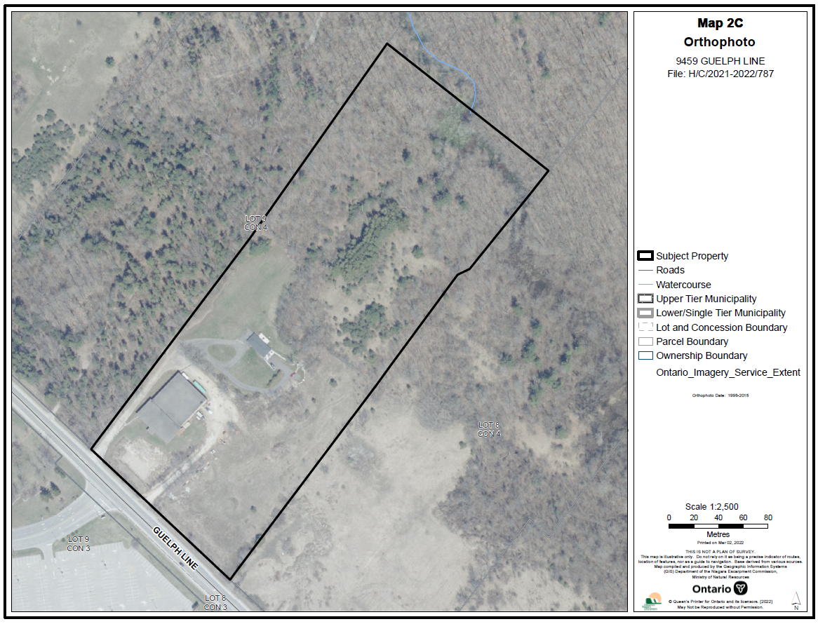

## APPENDIX 3

## NEP Land Use Designations Map

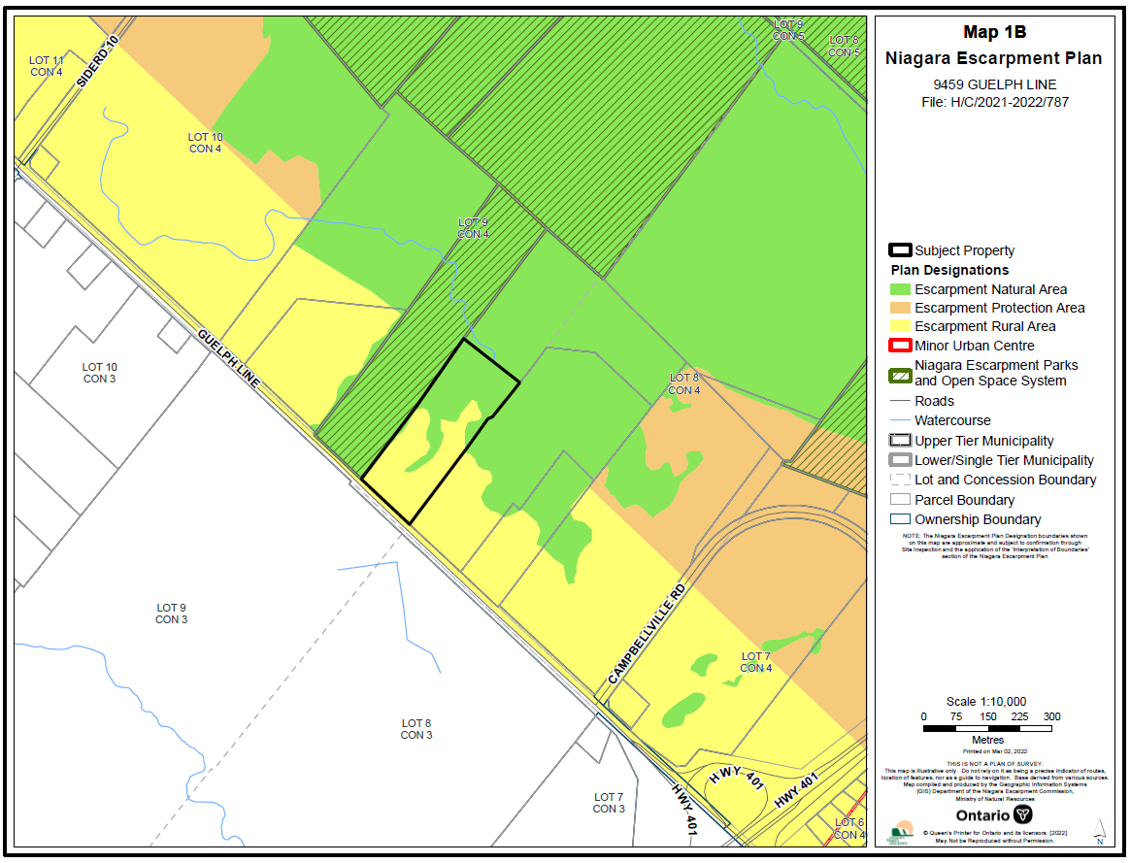

## APPENDIX 4

## Aerial View

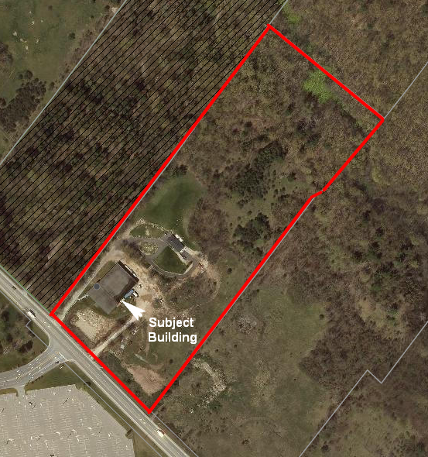

World Imagery (Wayback 2020-03-23)

## APPENDIX 5

## Site Plan

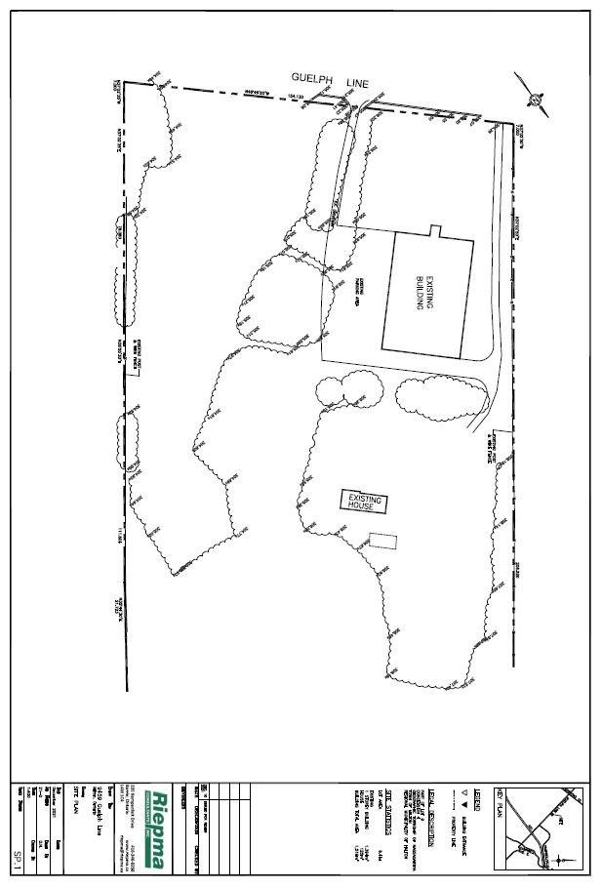

## APPENDIX 6

## Front (southwest) Building Elevation

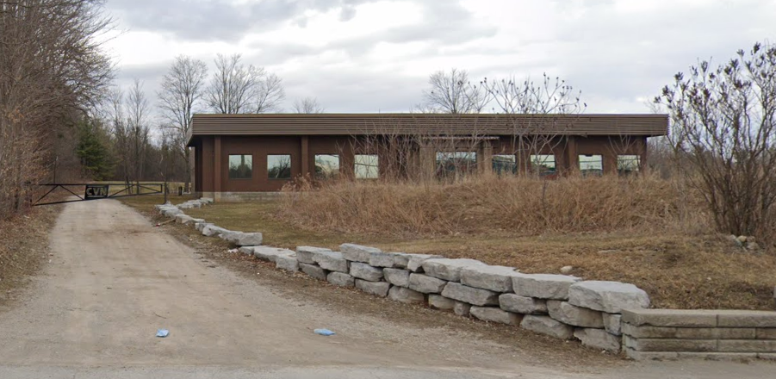

Google Streetview (March 2021)

## APPENDIX 7

**DEVELOPMENT PERMIT APPLICATION H/R/2016-2017/422**

**(**November 6, 2017**)**

Niagara Escarpment Commission letterhead.

November 6, 2017

**DEVELOPMENT PERMIT APPLICATION H/R/2016-2017/422**

**Scott Design Build Ltd.**

Part Lot 9, Concession 4

9459-9463 Guelph Line

Town of Milton, Region of Halton

**SUMMARY PROPOSAL**:

To carry out the following development on an existing 6.4 ha (15.8 ac) lot:

* To re-establish an industrial use (custom fabrication facilities) in conjunction with an existing building formerly used for a welding shop with office; to modify the building by adding a second storey addition for new office facilities; and, to increase the footprint of the building as a result of adding new exterior cladding
* To construct an industrial accessory building (industrial equipment storage)
* To construct a parking area(s) and establish a large outdoor worksyard/outdoor storage area

**DESIGNATIONS**: **Escarpment Rural Area** and **Escarpment Natural Area**

**LOT SIZE:** 6.4 ha (15.8 ac)

**ISSUES**: An industrial use is not permitted in the Escarpment Rural or Escarpment Natural Areas unless it is an Existing Use; the previous industrial use (approved by the NEC in 1975) lapsed greater than 5 years ago and therefore there is no Existing Use provision for an industrial use at the subject property.

**RECOMMENDATION**: Refusal

**REASONS**: The proposal is contrary to the Niagara Escarpment Plan, 2017 (NEP); it conflicts with lower tier and upper tier official plans; and, it is not consistent with the Provincial Policy Statement.

**DATE RECEIVED:** February 6, 2017

**SOURCE**: 24355991 Ontario Inc. (Sovereign Fusion) (owner – April 2016)

**DETAILED PROPOSAL**:

To carry out the following development on an existing 6.4 ha (15.8 ac) lot:

* To re-establish an industrial use (custom fabrication facilities) in conjunction with an existing 1,393.5 sq m (15,000 sq ft) building (former welding shop with office); to modify the building by adding a ± 561.9 sq m (± 6,048 sq ft) second storey addition (new office facilities), increasing the building height from 4.9 m to ± 9.1 m (16 ft to ± 30 ft ); and, to increase the footprint of the building by ± 139.4 sq m (± 1,500 sq ft) as a result of adding new exterior cladding
* To construct a ± 557.4 sq m (± 6,000 sq ft) accessory building (industrial equipment storage), to have a maximum height of ± 9.1 m (± 30 ft)
* To construct a parking area(s) with ± 50 parking spaces and establish a large outdoor worksyard/outdoor storage area

**RELATED FILES/BACKGROUND:**

**Development Permit #74/H/I/1975-1975/134 (A. Kayser Engine Co.)** was issued on October 14, 1975 to establish a light manufacturing building that, according to the final approved site plan, included an assembly and office building; a future assembly building; a proposed storage and supply depot; outside storage area; parking and visitor parking on the front half of the property.

The Town of Milton supported the application as the Nassagaweya Official Plan and Zoning By-law, which designated and zoned the lands as industrial, were still applicable at the time.

NEC staff recommended refusal of the application for the following reasons:

1. Conflicts with the Commission’s objective of maintaining the open-landscape character of the rural landscape, and would be incompatible with the nearby Halton Region forest; and,
2. There is no justification on planning grounds for the establishment of an isolated industrial use at this location, especially when major efforts are underway to provide a planned industrial area nearer to the former Town of Milton.

The Niagara Escarpment Commission made the decision to approve the application. It should be noted that the application and its decision preceded the Development Control legislation, the *Niagara Escarpment Planning and Development Act* and the Niagara Escarpment Plan.

Only a small portion of the overall proposed development was constructed. The constructed ± 1,393.5 sq m (± 15,000 sq ft) building and some parking were the only aspects of the original proposal constructed, and these were in use until several years ago as a welding shop and office. The building has been vacant for several years.

**Development Permit Application H/S/2015-2016/289 (2435991 Ontario Inc.)** to recognize the installation of a new gas line service and associated site alterations/trench excavation, having a depth of ± 1.5 m (± 5 ft) and a length of

± 144.7 m (± 475 ft) and backfilled with pipe bedding sand, on an existing 4.8 ha

(11.9 ac) lot was conditionally approved on July 25, 2016. As the condition was not satisfied, the conditional approval has now lapsed and no permit has been issued. Discussions with the applicant are required to identify options regarding the compliance issue.

**ANALYSIS**:

**1) Niagara Escarpment Plan, 2017 (NEP):**

NEP Designations

The property is designated Escarpment Rural Area and Escarpment Natural Area in the Niagara Escarpment Plan, 2017 (NEP), however it should be noted that the actual limit of these designations has changed since the filing of the Development Permit Application. With the new Niagara Escarpment Plan 2017, which came into effect June 1, 2017, and related updated designation mapping, the Escarpment Natural Area on the property has increased to reflect the existing key natural heritage features. The existing industrial building is within the Escarpment Rural Area designation. The proposed development, to establish an industrial use and construct additional industrial facilities, is located within the Escarpment Rural Area and Escarpment Natural Area designations. Specifically, the proposed outdoor storage/works yard is partially within a portion of the Escarpment Natural Area designation associated with a hedgerow that is continuous with the Halton Forest South - Area of Natural and Scientific Interest (Provincially Significant Life Science ANSI) as well as the Hilton Falls Complex - Environmentally Sensitive Area (ESA) and Candidate Significant Woodland.

It should be noted that the subject property is at the very edge of the NEP area and within 1200 metres of the Campbellville Minor Urban Centre to the east. The proposed use would be more suited to an appropriately zoned area outside of the Plan area or within the Minor Urban Centre.

Permitted Uses

The proposed industrial use is not a permitted use within the Escarpment Rural Area or

Escarpment Natural Area designation. Part 1.5.3 of the NEP lists Permitted Uses in the Escarpment Rural Area designation. Industrial uses are not a listed permitted use.

The subject property contains an existing single dwelling. A single dwelling use is listed as a permitted use in the applicable designations.

Existing Use Provisions

A use may be recognized as a legal use, even if it is not listed as a permitted use under the applicable designation in the NEP, if it was:

1. *existing on the day of approval of the Niagara Escarpment Plan, June 12, 1985;*
2. *approved in accordance with the provisions of the Niagara Escarpment Plan since June 12, 1985 but prior to the date of any amendment to this Plan under which the use ceased to be a permitted use; or*
3. *existing, in an area added to the Niagara Escarpment Plan at the date of the approval of the amendment to this Plan that added the lands to this Plan;*

*provided that the existing use has continued without interruption after the effective date as set our under a), b), and c).* (Definition of Existing Use, NEP, 2017)

The former industrial use was approved in 1975 by the Niagara Escarpment Commission (NEC) and it is understood that the use continued until approximately 2012. Although the previous use would have met condition a) of the above definition, the Existing Use provision, in staff’s opinion, would not apply to this property as the industrial use ceased several years ago and therefore has not continued without interruption.

Purpose and Objectives of the NEP

The purpose of the NEP “*is to provide for the maintenance of the Niagara Escarpment and land in its vicinity substantially as a continuous natural environment, and to ensure only such development occurs as is compatible with that natural environment.*” Specific applicable Objectives of the NEP include the following:

* *To maintain and enhance the open landscape character of the Niagara Escarpment in so far as possible, by such means as compatible farming or forestry and by preserving the natural scenery;*
* *To ensure that all new development is compatible with the purpose of the Plan;*

1. *To support municipalities within the Niagara Escarpment Plan Area in their exercise of the planning functions conferred upon them by the Planning Act.*

The subject proposal is to establish an industrial use within an existing building and to substantially expand the facilities. The proposal is not consistent with the above noted purpose or specific objectives of the NEP. Regarding Objective 4, the subject proposal would be a significant intensification of use on the subject property, which is not consistent with the maintenance and enhancement of the open landscape character of the Niagara Escarpment.

Regarding Objective 5, staff advise that the application proposes development that would result in a significant increase in impervious ground cover and is a use that is incompatible (*would not blend, conform or be harmonious with the Escarpment Environment* – NEP Definition of Compatible) with the natural environment and that would pose potential negative impacts to the surrounding Significant Woodlands. Therefore, staff find the proposal contrary to Objective 5.

Regarding Objective 7, the proposal is not supported by the Region Official Plan or the Town of Milton Official Plan. Therefore, municipal planning staff do not support the application, which is discussed later in this report.

**2) Local Official Plan:** The subject lands are designated in the Town of Milton Official Plan as Escarpment Rural Area and Escarpment Natural Area. The Escarpment

Rural Area and Escarpment Natural Area permit uses such as: agricultural uses; existing, legally established uses; single detached dwellings, accessory buildings,

structures and facilities, and other uses described under Section 4.2.3.3 (Escarpment Natural Area) and 4.2.3.8 (Escarpment Rural Area). The proposed industrial use is not a permitted use within either the Escarpment Rural Area or the Escarpment Natural Area.

**3) Regional Official Plan:** The subject property is located within the Agricultural

Area and Regional Natural Heritage System in the 2009 Halton Region Official Plan (ROP). The policies of both designations apply to this development permit application as the proposed works are within both designations. These ROP designations encourage and support the use of land for agricultural and other non-invasive incidental uses. An industrial use is not identified as a permitted use in either the Agricultural Area and Regional Natural Heritage System designations in the ROP. Industrial uses, including those that support the agricultural uses, are encouraged to locate in areas designated Urban Area or Hamlets.

**4) Provincial Policy Statement:** Part 1.1.5.2 of the Provincial Policy Statement, 2014 (PPS) states that within rural lands located in municipalities, permitted uses are:

1. *the management or use of resources;*
2. *resource-based recreational uses (including recreational dwellings);*
3. *limited residential development;*
4. *home occupations and home industries;*
5. *cemeteries; and*
6. *other rural land uses.*

Industrial uses are not listed as a permitted use within rural lands.

Part 1.1.3.1 states that Settlement areas, including urban areas and rural settlement areas, shall be the focus of growth and development. The subject lands are not within a settlement area.

Based on the above, the subject proposal to establish an industrial use within rural lands is not consistent with the PPS.

**5) Consultations:**

* **Town of Milton** – Town planning staff do not support the proposal as it conflicts with the Town of Milton Official Plan. Should the NEC support the proposed application, staff would ask that as a condition of the issuance of a Niagara Escarpment Development Permit, that the applicant receive Site Plan Approval from the Town of Milton and that the applicants obtain all required building permits from the Town of Milton prior to commencement of construction.
* **Region of Halton** – Regional staff do not support the application as it does not conform to the Region’s Official Plan, 2009.
* **Conservation Halton** – As the proposed development is outside of the area regulated by Conservation Halton, staff have no objection, subject to the applicant obtaining a No Objections Letter from Conservation Halton for the proposed work.
* **Ministry of Natural Resources and Forestry (MNRF)** – The MNRF advises that there are records of endangered species in the vicinity of the proposed development and the rear of the property contains significant habitat as well as the Halton Forest South Provincially Significant Life Science Area of Natural and Scientific Interest. The proposal appears to affect a treed (hedgerow) area. All trees proposed for removal should be identified by species and diameter at breast height. All tree species (including seedlings) within 25 metres of proposed site alterations should be listed.

**6) Site Description:**

The property is located on the east side of Guelph Line, between Sideroad 10 and

Campbellville Road. A portion of Hilton Falls Conservation Area (Niagara Escarpment Parks and Open Space System) is located directly north of the property and further east. The Mohawk Raceway is situated on the opposite side of Guelph Line.

The lands are characterized by irregular topography; gently rolling conditions and slightly west-sloping on the front portion (consisting of developed and disturbed areas, with some deciduous hedgerows), with more elevated/rolling conditions and forest area associated with the Escarpment Natural Area.

A vegetated berm of moderate height extends along the lot’s frontage, with a low stone retaining wall established along parts of the berm, adjacent to the roadway.

The approximate east third of the lot and the directly north abutting lands coincide with the Halton Forest South - Area of Natural and Scientific Interest (Provincially Significant Life Science ANSI) and the Hilton Falls Complex - Environmentally Sensitive Area (ESA) and Significant Woodland. These features are associated with the Sixteen Mile Creek Valley.

The aforementioned existing building (former industrial use), including related parking and exterior storage area, are situated close to the road, but are largely obscured from view by the berm feature. The area immediately surrounding the vacant building, including a small field to the south, is quite disturbed. An existing single dwelling is located on the property due east of and slightly elevated above this site. The north gravel driveway provides access to both structures and lies parallel to the north lot boundary, until it veers southeast to the dwelling site. A second gravel driveway is located in the centre of the property.

**CONCLUSION:**

The application to establish an industrial use on the site, is not a permitted use within either the Escarpment Rural Area or Escarpment Natural Area designations. The proposed expansion of industrial facilities does not meet applicable Development

Criteria or the purpose and objectives of the NEP. Staff are therefore recommending refusal of the application. Section 25(4) of the *Niagara Escarpment Planning and Development Act* requires Commission decisions on Development Permit Applications to be in accordance with the Niagara Escarpment Plan.

While there is an existing building (former industrial use) on the subject property, the formal industrial use lapsed greater than 5 years ago. Re-establishing the industrial use would be contrary to the permitted uses as existing use provisions would not apply where there has not been a continuation of use without interruption.

Both the Town of Milton and Region of Halton object to the proposal as it conflicts with their respective Official Plans and the proposal is contrary to the direction provided by the PPS.

**RECOMMENDATION:**

The proposal be **refused** for the reasons listed on the attached Appendix.

**Prepared by: Approved by:**

*Original Signed by: Original Signed by:*

________________ _________________________

Amaraine Laven Debbie Ramsay, MCIP, RPP

Planner Manager

**APPENDIX**

**Scott Design**

**REASONS FOR REFUSAL H/R/2016-2017/422**

* + - 1. The proposed development is not a permitted use in the Escarpment Rural Area or Escarpment Natural Area.
      2. The subject proposal is contrary to the purpose and applicable objectives of the NEP.
      3. The proposed development conflicts with Sections 1.1.3.1 and 1.1.5.2 of the Provincial Policy Statement.
      4. The proposed development is not supported by the Town of Milton or the Region of Halton.

**1 of 1**

## APPENDIX 8

**STAFF ADDENDUM REPORT**

**DEVELOPMENT PERMIT APPLICATION H/C/2016-2017/422**

**(**January 18, 2018)

Niagara Escarpment Commission letterhead.January 18, 2018

**STAFF ADDENDUM REPORT**

**DEVELOPMENT PERMIT APPLICATION H/C/2016-2017/422**

**Scott Design Build Ltd. For 2435991 Ontario Inc. (Sovereign Fusion)**

**Part Lot 9, Concession 4**

**9459-9463 Guelph Line**

**Town of Milton, Regional Municipality of Halton**

**INTRODUCTION**

At the November 16, 2017 Commission meeting, the Commission deferred the above noted application for further analysis by NEC staff on whether the proposal is in conflict with relevant Development Criteria in Part 2 of the Niagara Escarpment Plan, 2017 (NEP), for presentation to the Commission at the January 18, 2018 meeting.

This addendum is separated into three sections:

1. Information on the application and current site conditions;
2. Further analysis of Existing Uses, particularly when there has been a cessation of use;
3. Analysis of relevant Development Criteria, as requested by the Niagara Escarpment Commission.

Summary Recommendations

Staff recommend refusal of the application as it is not a permitted use. This opinion has not changed as a result of further analysis of information related to existing uses presented below. Based on the definition of Existing Use in the NEP, which states that to be considered an Existing Use, the use must have *continued without interruption*, staff are of the opinion that the Existing Use on this property has ceased and the proposed use is not a permitted use in the Escarpment Rural Area and Escarpment Natural Area designations. Where a proposal does not meet Part 1 (permitted uses) of the NEP, staff would not carry out analysis of relevant Development Criteria in Part 2; however, the Commission has directed staff to provide an analysis of relevant Development Criteria in Part 2 of the NEP.

It should be noted that while some relevant Development Criteria are clearly not met based on information provided in the application, staff would require additional information and studies (see Appendix 6) in order to determine the proposal’s compliance with other Development Criteria. Development proposals must meet all NEP policies – including Development Criteria –in order to not be in conflict with the NEP. Given the proposal is not a permitted use and does not meet all relevant Development Criteria, staff would not recommend the applicant to carry out the studies that would be required to test the remaining relevant Development Criteria as it is staff’s opinion that the proposal is in conflict with the NEP.

1. **Application and Current Site Conditions**

The subject application proposes to carry out the following development on an existing 6.4 ha (15.8 ac) lot:

* To establish an industrial use (custom fabrication facilities) in conjunction with an existing ± 1394 sq m (± 15,000 sq ft) building formerly used for a welding shop and office;
* To construct a ± 562 sq m (± 6,048 sq ft) second storey addition for a new office;
* To increase the footprint of the building by ±139 sq m (± 1,500 sq ft) as a result of adding new exterior cladding;
* To construct a ± 557 sq m (± 6,000 sq ft) industrial accessory building (industrial equipment storage); and,
* To construct a ± 2,000 sq m (± 21,528 sq ft) parking area(s) and establish a ± 3,200 sq m (± 34,445 sq ft) outdoor worksyard/outdoor storage area.

The applicant has told NEC staff that the subject property was listed for sale following the death of the previous owner in 2011. The property remained on the market until April, 2015, when the current owner purchased the property. NEC staff understands that the current owner purchased the property without prior consultation with the NEC on their intention to establish an industrial use and to carry out additional development on the property.

The applicant submitted a Development Permit Application proposing to establish an industrial use and additional development on February 6, 2017, which is almost two years after purchasing the property. From aerial imagery available on *GoogleEarth* and *Google StreetView*, it is possible to observe significant site alterations to have taken place on the property[1], after the current owner had taken possession. Changes due to site alteration include:

* removal of large swaths of trees from the hedgerow, a portion of which is designated as Escarpment Natural Area;
* placement of fill material in multiple locations;
* upgrades to a decommissioned access;
* construction of a walkout at the existing dwelling;
* grading at the front of the property adjacent to the existing berm, at the rear of the single dwelling, and along the formerly decommissioned access; and,
* placement of storage structures.

The development noted above is alleged to be unauthorized (no prior approval in the form of a Development Permit). Unauthorized activity does not constitute reasonable intent to continue/establish a use; rather it is a circumvention of a legislated approval process. The applicant has referred to this work as ‘maintenance’ and therefore proof of intention to establish an industrial use. However, the above noted development far exceeds what staff would consider to be maintenance. Accordingly, the matter of unauthorized development has been referred to NEC’s Compliance Specialist.

Following the November 16, 2017 Commission meeting, staff reached out to the applicant to obtain additional information regarding the use of the property. Based on information provided by the applicant via email dated December 4, 2017 (see Appendix 3), the property was for sale for over 4 years and no industrial use was in operation during this time. The information provided does not demonstrate that the industrial use on the property has been continuous and without interruption, as the definition of Existing Use requires. Staff have considered the following in coming to this conclusion:

* During the four years the property was for sale, there was no effort to continue the use by the owner at the time and the property would have been considered vacant (i.e. not industrial).
* The current owner did not consult with the NEC regarding their intention to establish an industrial use and carry out a major expansion to the existing building prior to purchasing the property.
* The current owner did not make a timely application for the proposed industrial use and allowed an additional almost two years to pass before submitting an application.
* It is a longstanding practice of the NEC to use two years as the benchmark for when a use has been discontinued. Intent alone would not extend this time allowance; actual continuation of the use during the 2 year timeframe has generally been required. From the time the former industrial use ceased and the application was submitted, over 5 years have passed.

For the reasons listed above, staff are of the opinion that the Existing Use has lapsed and the proposed use is not a permitted use in the applicable designations.

Regarding the proposed expansion to the existing industrial facilities, the applicant has referenced a prior approval dating back to 1973. The Development Permit issued at that time was indeed for a much larger operation than what was actually built, but the approval would have lapsed after three years and any development after that time would require approval and would be assessed against policies of the day. The prior approval has no bearing on the application currently under consideration. The application must be considered under the current legislation and policies.

The application proposes to relocate an existing industrial operation currently located off of Highway 401 (See Appendix 4). The existing site hosts multiple buildings and significant outdoor storage, and is located within the Minor Urban Centre of Campbellville, within the Plan area but outside of Development Control. The existing site is zoned ‘Village Residential’ with a special provision to permit the business of a contracting yard with motor vehicle repair facilities and related outdoor storage. The existing site is immediately across the road from a property zoned ‘Employment’ with a special provision which permits an industrial use, outdoor storage, motor vehicle and equipment storage, service and repair shop, warehouse distribution centre, and a dwelling for an employee. Staff note that the current location within Campbellville is within a site that appears to have appropriate zoning and policies in place to accommodate the use. Further, the Town of Milton has significant industrial lands designated for this type of development outside of the Niagara Escarpment Plan area, within its urban area.

In comparison, the proposed site is surrounded by rural residential estates to the north and south, key natural heritage features to the rear and north, lands within the Niagara Escarpment Parks and Open Space System (NEPOSS) to the immediate north, and agricultural (equine) properties to the north and south. In staff’s opinion, the proposed industrial use and major expansion would not be compatible with any of the surrounding land uses or landscapes within the proposed site in the Escarpment Rural and Escarpment Natural Area designations.

The proposed expansion to the industrial building and proposed new outdoor storage areas are significant and beyond the small scale intent underlying many of the policies in the NEP. The following table demonstrates the proposed relative increase:

|  |  |  |
| --- | --- | --- |
| **Existing**  (Current site development) | **Proposed**  (information from application) | **Percentage Increase** |
| Building ± 1393.5 sq m (± 15,000 sq ft) | ± 2513 sq m (± 27,048 sq ft) *inc. proposed storage building | +80% |
| Parking ± 1300 sq m (± 13993 sq ft) | ± 5200 sq m (± 55972 sq ft) | +300% |

Combining the percentage increase of the proposed building area, parking, and outdoor storage areas, the result is a ± 380% increase. This is a major expansion and far exceeds what would be allowed under the Existing Use Development Criteria, if this could be considered an existing use (which in staff’s opinion it is not). A further analysis of the proposed development against the relevant Development Criteria will take place later in this Addendum Report.

1. **Background of Existing Use and Cessation of Use**

This section provides context for staff’s interpretation of the definition for *Existing Use*, specifically when an existing use provision is considered to have lapsed due to a cessation of use. An Existing Use is a use that would not otherwise be a permitted use under the current NEP policies, but was lawfully in existence prior to the coming into force of the NEP policies. The NEP allows for the continuation and expansion of an existing use provided it has continued without interruption. Once interrupted, the use is no longer permitted as an Existing Use.

2015 Plan Review

During the recent Plan Review, NEC staff identified a need for greater clarity on the overarching purpose of existing uses, opportunities for expansion to existing uses, and when an existing use had lapsed (Discussion Paper, Topic 11 – Existing Uses, August 15, 2013, prepared by Nancy Mott, Senior Strategic Advisor, NEC). The discussion paper raised issues with a lack of defined terms and lack of clarity about the overall intent of the existing use policies.

Cessation of use triggers the need for a Development Permit to re-establish the use. The NEC has had to determine when a use has ceased without explicit guidance in the NEP. The discussion paper put forward a recommendation that time limits be stated explicitly in the Development Criteria for Existing Uses. Staff proposed two options for the Commission to consider for making a recommendation to MNRF on the new NEP. The options proposed:

* Option 1 – *where it cannot be sufficiently demonstrated that an existing use has been continuously operating up to and including a date within* ***one year*** *prior to the date the application for a Development Permit, no development should be permitted based on the status of the use as an existing use*;
* Option 2 – proposed a **two year** time limit.

While the Commission endorsed the second option above, it was not accepted and the NEP 2017 (as approved by the government) does not include this in the Development Criteria. However, the definition of existing use changed in the 2017 NEP to include that, in addition to meeting criteria previously listed in former versions of the NEP, it must also have *continued without interruption*. The issue of when a use has ceased or been interrupted continues but the consequences are different under the NEP 2017 because the existing use once interrupted is no longer a permitted use and a development permit to re-establish it cannot be issued in accordance with the NEP.

The new language in the definition of the term *Existing Use* must be interpreted in the context of this application. The fact that the phrase “continued without interruption” is used indicates an Existing Use status shall not continue in perpetuity. The use of the word “interrupted” may be taken to imply that if there is no physical activity consistent with the continuation of the use for a reasonable period of time, the use will be taken to have been interrupted and therefore lapsed. This is an objective test that it is hoped could be applied more easily in a consistent manner.

For the purpose of consistency, it would be possible for the NEC to continue to apply the 2 year rule that the NEC applied in the past, and that was endorsed by the Commission during the 2015 Plan Review. The onus would be on the applicant to show some physical continuation of the use during the 2 years following the cessation of use. This would appear to be a generous time frame for establishing whether the use is “interrupted” as compared to some approaches by various municipalities, which is explored later. A 2 year time limit would allow for reasonable attempts to market the property for sale or lease in a current market. Stale or longer term listings producing no takers would indicate that the use has failed to find a current market. There would in such an instance be no need to assess the subjective intention of property owners to continue a use since the use has not continued within a reasonable time and is arguably not desirable or appropriate for the site.

The discussion paper also covers situations where staff have had to deal with remnant structures after an Existing Use has ceased. In these situations, it has been practice to recommend that existing buildings and structures be considered for re-use (by permitted uses) and that any new uses should be the subject of an amendment to the NEP if they are not Permitted Uses.

The relevance of the discussion paper in the context of the subject Development Permit Application is that it provides a framework within which existing uses have been treated in the past and continue to be treated. The issue of cessation of use was raised during the 2015 Review and the new language is a response to this issue. It would allow for the Commission to require objective evidence of the use continuing but may also allow for the Commission to continue the longstanding practice of interpreting the lapsing of a use to have occurred after two years of objective, physical non-use.

In staff’s view, the current policies are consistent with the past Commission practice of applying a 2 year time limit to determine when an existing use has lapsed and imposes reasonable and objective limits on the timeframe within which an Existing Use can be determined to continue to exist without interruption.

NEC Development Permits dealing with Cessation of Use

Under the NEP, 2005, Staff have interpreted cessation of use to occur after a use has ceased for 2 years. There have been decisions made based on this interpretation which are included in Appendix 5. These examples demonstrate a consistent approach by staff in interpreting that a use is considered to have ceased after 2 years of interruption. While a majority of Commission decisions have upheld this interpretation, one example does involve an instance where the Commission approved a commercial use 5 years after the former commercial operation had lapsed, but in this instance, the use was approved on a temporary basis only, and was of a temporary nature (food truck), with significantly less impact than the former use (gas station). This use has since ceased and the property is no longer considered to have Existing Use status.

Jurisdictional Review on Existing Uses Policies and Cessation of Use

Both the Town of Milton and Regional Municipality of Halton do not include an explicit time frame for when a use is considered to have lapsed in their respective Official Plans. However, they both have interpreted a cessation of use to have occurred with respect to the current application. Staff have canvassed other municipalities within the NEP area with respect to Existing Use and cessation of use. The following is a summary of Existing Use and cessation of use approaches for eighteen (18) municipalities within the NEP area:

* Eleven (11) municipalities in their Official Plans and Zoning By-laws explicitly clarify that the intent of the Existing Use or Legal Non-conforming policies are that such uses eventually be replaced with permitted or conforming uses (City of Burlington, County of Grey, Town of Lincoln, Town of Pelham, Municipality of Meaford, Township of Melancthon, Town of Milton, Township of Mulmur, City of Niagara Falls, City of St. Catharine’s, City of Thorold).
* Eleven (11) municipalities do not stipulate a specific time limit for consideration of a cessation of use, however, as is the case with the Region of Halton and Town of Milton, they do not consider Existing Use rights to be in place in perpetuity (see bullet above) and may interpret cessation of use based on internal practice (Bruce County, Township of Clearview, County of Grey, Municipality of Grey Highlands, Town of Grimsby, Region of Halton, City of Hamilton, Township of Melancthon, Town of Milton, City of Niagara Falls, City of St. Catharine’s).
* Seven (7) municipalities stipulate a time frame within their planning documents for when a use is considered to have ceased.
* Four (4) municipalities take the position that a use is considered to have ceased after **one year** of interrupted use (Town of Lincoln, Town of Pelham, Town of Niagara-on-the-Lake, City of Thorold).
* Of those municipalities that consider a use to have ceased after a one year interruption in use, two (2) provide for consideration of a longer interruption based on extenuating circumstances, however, it is unlikely that such circumstances would have the effect of significantly extending the stated timeframe (Town of Lincoln, City of Thorold).
* Two (2) municipalities consider a use to have ceased after **two years** of interruption of use (City of Burlington, Township of Mulmur).
* One (1) municipality considers a use to have ceased after **five years** of interruption of use (Municipality of Meaford).

The summary conclusion from the above jurisdictional scan of Existing Use and cessation of use policies is that a common intent behind existing use policies is to eventually phase them out. The phasing out of existing uses occurs after a cessation of use, which is commonly thought to have occurred after one or two years. Only in one instance is a longer timeframe in place.

1. **Analysis of Relevant Development Criteria**

This section will outline relevant Development Criteria as per direction from the Commission following the November 16, 2017 meeting. It should be noted that staff typically do not assess a proposal against Development Criteria in Part 2 if the proposal fails to meet Part 1 (permitted uses).

**Part 2.3 – Existing Use**

| **Relevant Development Criteria** | **Relevance to this Application** | **Analysis** |
| --- | --- | --- |
| **Objective** is to generally not disrupt existing uses and to provide for changes to such uses in conformity with the Purpose and Objectives of this Plan, the Objective of the applicable land use designation and the relevant Development Criteria, including compatibility with the *Escarpment environment* and surrounding land uses.  *Compatible* is defined in the NEP as where the building, structure, activity or use blends, conforms or is harmonious with the *Escarpment environment*.  *Escarpment environment* is defined as the physical and natural heritage features, cultural heritage resources, and scenic resources associated with the Escarpment landscape. | * Proposes to re-establish industrial use that lapsed almost 6 years prior to submission of application. * Involves much more intensive industrial operation than former operation. * Proposes to significantly expand existing facilities into areas designated Escarpment Rural and Escarpment Natural Area. | * Proposal is contrary to Purpose and Objectives of the Niagara Escarpment Plan (see analysis in Appendix 2). * Fails to meet any of the objectives of applicable land use designations for the subject property: Escarpment Rural Area and Escarpment Natural Area. * Escarpment Rural Area Objectives speak to maintaining scenic resources and open landscape character, and providing for compatible rural land uses. * Due to increased height, removal of vegetation, and site alterations, proposed second storey addition poses potential visual impacts * More intensive industrial use is incompatible with the surrounding land uses within the Plan area: large rural residential lots, equestrian facilities, natural heritage features, and NEPOSS lands. * While a large racetrack and casino (Mohawk Raceway) exists across the street, it is outside of the Niagara Escarpment Plan. * The scale of proposed development and its proximity to key natural heritage features poses potential negative impacts, An EIA would be required to determine the extent of impacts and whether they can be mitigated. * Staff have significant concerns regarding the compatibility of the proposal with the surrounding land uses, the Objectives of the NEP and applicable designations. |
| **Development Criterion 2.3.1** states an existing use may change to a similar use, or a more compatible use only if it can be sufficiently demonstrated that the objectives of the applicable designation of this Plan are met. | * Current proposal is for light-to-medium repair and manufacturing plant (as described by applicant), and proposes a significant expansion to the former industrial operation, which was considered to be a light industrial use, indicating a significantly greater intensity of use. | * Development Permit #74/H/I/1975-1975/134 (issued in 1975) was to establish an industrial building for light manufacturing. NEC staff understand that the plant was established for the manufacturing of small rotary-type engines. * Appendix 4 shows the existing site occupied by the owner in Campbellville and the proposed site, including aerial images from as early as 2005. * It is clear from these images that the proposal would entail a significant increase to the scale of industrial use by proposing outdoor storage where there currently is none, parking for a number of employees, and an expansion to the total gross floor area to be utilized by the proposed use. * As the subject proposal would intensify the industrial use compared to the former light scale industrial use, NEC staff are of the opinion that the proposal is not a similar or more compatible use compared to the former use, and therefore Development Criterion 2.3.1 is not met. * As the use is not similar or more compatible than the former use, the application must be dealt with as a new use for industrial activity – which is not a permitted use in the respective designations. |
| **Development Criterion 2.3.3** states that an existing use, or a building, structure or facility associated with an existing use, may expand or be replaced, when it can be sufficiently demonstrated that the objectives of the applicable designation of this Plan are met. | * The application is proposing a significant expansion to the existing facility associated with the former industrial use. | * As noted above, the proposal fails to meet any of the objectives of the applicable land use designations for the subject property: Escarpment Rural Area and Escarpment Natural Area. * Therefore, Development Criterion 2.3.3 is not met. |
| **Development Criterion 2.3.4** states that an expansion or enlargement of a building, structure or facility associated with an existing use shall be minor in proportion to the size and scale of the use, building or structure, including its related buildings and structures at the time it became an existing use as defined by the NEP. A minor expansion is considered to be 25% unless a greater expansion is compatible with site and surrounding landscape. | * The current application proposes a ± 380% increase to the existing industrial building and parking/outdoor storage area. | * Such a large expansion would not meet this criterion, given it is a significantly larger expansion than the 25% contemplated by the NEP. * In terms of scale of use, the number of employees or jobs associated with the former use are not known, but from aerial imagery it is clear that the site as of 2005 (see Appendix 4) had no outdoor storage, no formal parking lot and had the appearance of a very low intensity operation. * As the proposal is for significantly more than 25% increase compared with the former use, it would be necessary to determine if the proposal is compatible in *all* aspects with the site and surrounding landscape, which would require additional information in the form of reports and studies (see Appendix 6). * Staff have not requested additional information as the proposed use is, in the opinion of staff, not a permitted use. * It is also clear the proposal conflicts with the relevant Development Criteria and therefore staff recommend that additional information is not needed to determine that the proposal does not meet the purpose, objectives or Development Criteria of the NEP. |

**Part 2.2 – General Development Criteria**

| **Relevant Development Criteria** | **Relevance to this Application** | **Analysis** |
| --- | --- | --- |
| **Development Criterion 2.2.1** states that the Escarpment Environment shall be protected, restored and where possible enhanced for the long term having regard to single, multiple or successive development that have occurred or are likely to occur. | * Proposal includes development within the Escarpment Natural Area designation and removal of a hedgerow that is continuous with a Significant Woodland. | * NEC staff note that a natural heritage assessment (i.e. EIA) has not been carried out, however the proposed impact to the hedgerow is contrary to this criterion and staff are of the opinion that it is not met. * Staff further note that large swaths of trees have been removed from the area without prior approval. Therefore, consideration of development on the subject proposal must take into consideration site conditions prior to the unauthorized removal. * Additionally, no enhancement of the Escarpment environment is proposed. |
| **Development Criterion 2.2.5** states that where a lot is located in more than one designation, development shall be located within the least restrictive designation. | * The subject application proposes development within Escarpment Rural Area and Natural Area designations. | * Staff note that the proposal conflicts with 2.2.5 as the proposed development on this lot is not restricted to the Escarpment Rural Area only. |
| **Development Criteria** **2.2.10** provide the framework for considering a Home Industry, which is defined as a use, providing a service primarily to the rural or farming community and that is accessory to a single dwelling or agricultural operation, performed by one or more residents of the household on the same property. Criteria a) through j) stipulates that home industries be limited to a maximum of 125 sq m, are secondary to the primary residential or agricultural use, and that they be compatible with surrounding land uses. | * The subject application proposes to establish a light to medium scale industrial use to service customers in Ontario and internationally. | * The industrial use does not meet the definition of Home Industry as it is not intended to be run by one or more residents of the household on the property. * The scale of operation may involve numerous employees, which is beyond the small scale intent underlying Home Industry provision. * The operation is not intended primarily to service the local rural or agricultural community. * Proposed facilities far exceed the maximum allowed size for a Home Industry operation – which is 125 sq m – just 9% of the existing building. * Proposed industrial use is intended to be a second primary use in addition to the existing single dwelling, which entails an intensity of use that is not supported by these criteria. * On the matter of compatibility, staff are of the opinion that the proposal would not be compatible with the surrounding land uses in the Plan area. * Staff are of the opinion that Development Criteria under 2.2.10 are not met. |

**Part 2.7 – Natural Heritage – Halton Regional Forest Provincially Significant Life Science ANSI**

| **Relevant Development Criteria** | **Relevance to this Application** | **Analysis** |
| --- | --- | --- |
| The objective of **Part 2.7** is to protect and where possible enhance natural heritage features and functions, in order to maintain the diversity and connectivity of the continuous natural environment. | * Proposal involves development within hedgerow continuous with significant woodland and Provincially Significant Life Science ANSI, and adjacent to key natural heritage features. | * The subject proposal is not maintaining diversity and connectivity of the natural environment and is proposing to remove adjacent buffer areas. * It is the opinion of staff that the subject proposal does not meet the Objective of Part 2.7. |
| **Development Criterion 2.7.4** states that development in other natural features not identified as key natural heritage features or key hydrologic features should be avoided. | * Proposal includes development within a hedgerow that is continuous with a Significant Woodland and Life Science ANSI. | * The hedgerow is a wooded area that serves as a functional buffer to the key natural heritage features. As development within this feature should be avoided, this criterion is not met. |
| **Development Criterion 2.7.6** states that if a proposal for development within 120 metres of a key natural heritage feature has the potential to result in a negative impact on the feature and/or its functions, a natural heritage evaluation will be required. | * Development proposed adjacent to key natural heritage features and within a natural heritage feature. | * Staff are of the opinion that the proposal has potential for negative impact to the natural features on and surrounding the proposed development site. Therefore a natural heritage evaluation (i.e. EIA) would be required. As an EIA has not been provided, this criterion is not met. * NEC staff did not request an EIA be prepared as it is staff’s opinion that the use is in conflict with the NEP and it is known that the proposal conflicts with other Development Criteria. |
| **Development Criteria under 2.7.7** outline criteria for establishing a vegetation protection zone, which is a vegetated buffer separating development from a key natural heritage feature. | * Application proposes development adjacent to key natural heritage features and within an existing functional buffer to key natural heritage features. | * Application does not include a supporting natural heritage evaluation that identifies a vegetation protection zone and therefore these criteria are not met at this time. |
| **Development Criteria under 2.7.8** outline criteria for assessing development within the habitat of endangered species and threatened species. | * Application proposes development adjacent to key natural heritage features and within an existing functional buffer to key natural heritage features. | * Endangered species have been recorded in vicinity of subject lands and therefore further investigation is required in order to determine if the criteria under 2.7.8 is applicable and if it is/can be met. * Scope of investigation/field work would be confirmed during the scoping of the Environmental Impact Assessment. Until a natural heritage evaluation is carried out, it is unknown if Development Criteria under 2.7.8 can be met. |

**Part 2.8 – Agricultural – 2.8.6 – Agriculture-related Uses**

| **Relevant Development Criteria** | **Relevance to this Application** | **Analysis** |
| --- | --- | --- |
| The objective of **Part 2.8** is to encourage agricultural uses in agricultural areas, especially in prime agricultural areas, to permit uses that are compatible with farming and to encourage accessory uses that directly support continued agricultural uses. | * Application proposes to establish an industrial use on Prime Agricultural Lands, as identified by the Canada Land Inventory. | * While the subject property is not currently under agricultural use, it should be noted that the lands are assessed as prime agricultural lands in the Canada Land Inventory. Therefore, the proposed industrial use would not meet the objective of 2.8. Adaptive reuse of the existing building to support an agricultural use might meet the objective of encouraging agricultural uses in prime agricultural areas, subject to satisfying applicable development criteria. |
| **Development Criteria under 2.8.6** **– Agriculture-related uses**, outline applicable criteria. Agriculture-related uses are defined as, *farm-related commercial and farm-related industrial use that is directly related to farm operations in the area, supports agriculture, benefits from being in close proximity to farm operations, and provides direct products and/or services to farm operations as a primary activity*. | * Application proposes a general industrial use (not farm related). | * Proposed industrial use does not meet this definition as, based on information available on their website and provided in their application, the proposed use would provide direct products and services to a much broader geography than the local farming community (including regionally, province-wide, and internationally). * Is also a more diverse client base including the aggregate industry, industrial, institutional and commercial, as well as agricultural. Farm operations are not the primary activity of the proposed industrial operation. * From the Ontario Ministry of Agriculture, Food and Rural Affairs Guidelines on Permitted Uses in Ontario’s Prime Agricultural Areas, clarification is given on the criteria that agriculture-related uses must provide direct products and/or services to farm operations as a primary activity. The Guidelines state that, *General-purpose commercial and industrial uses that serve a broad customer base are not agriculture-related uses even if they have farm operators as customers* (pp. 14). Furthermore, *serving farm operations must be a primary function or main activity of the business. As a rule, general purpose commercial and industrial uses should be located outside of prime agricultural areas (i.e. in settlement areas or on rural lands)* (pp.15). |

**Part 2.13 – Scenic Resources and Landform Conservation**

| **Relevant Development Criteria** | **Relevance to this Application** | **Analysis** |
| --- | --- | --- |
| **Development Criterion 2.13.1** states that development shall ensure the protection of the scenic resources of the Escarpment. Scenic resources are defined as, *the general appearance of a place or landscape or the features of a landscape, taking into consideration the visual condition and scenic quality, which vary by location and are dependent on features such as geology, vegetation, landforms, and human developments*. | * Proposal includes a second storey addition to the existing industrial building, a large parking area to the front of the property, and a large outdoor storage area to the rear of the property. | * Proposal for increased height of industrial building poses potential negative impacts to the surrounding scenic resources. * Proposed outdoor storage and additional industrial storage building would require removal of vegetation. * Parking and outdoor storage areas are located adjacent to key natural heritage features. * Staff are concerned about lighting requirements that would pose potential visual and environmental impacts. * Until a lighting plan is submitted and a VIA is carried out it is unknown whether this development criterion can be met. |
| **Development Criterion 2.13.2** states that where a visual impact on the scenic resources is identified as a concern by the implementing authority, a visual impact assessment shall be required. | * Proposal includes a second storey addition to the existing industrial building, a large parking area to the front of the property, and a large outdoor storage area to the rear of the property. | * A lighting plan and VIA would be required to determine if the proposal will have a visual impact and how much. * The required information to meet this Development Criterion has not been provided and therefore 2.13.2 is not met. |
| **Development Criterion 2.13.4** states that appropriate siting and design measures shall be used to minimize the impact of development on the scenic resources of the Escarpment. | * Proposal includes a second storey addition to the existing industrial building, a large parking area to the front of the property, and a large outdoor storage area to the rear of the property. | * This criterion would be triggered following the review of a satisfactory VIA (given all other development criteria have been met) and alterations to the proposal would likely be required in order to meet this criterion. * At this time, Development Criterion 2.13.4 is not met. |

**CONCLUSION:**

1. Staff are of the opinion, that the application does not meet the definition of Existing Use in the NEP. This view is based on examination of the property and its history, the proposal put forward by the applicant, examination of historical application, and practices of other jurisdictions. The Existing Use status of industrial development on the subject property has lapsed. The proposed industrial use is not permitted in Part 1 of the NEP.
2. Staff’s review of the proposal in terms of the Part 2 Development Criteria in the NEP concludes that the application either does not meet the criteria (and therefore is in conflict with the NEP), or further information is needed in order to undertake further evaluation.

Section 25(4) of the *Niagara Escarpment Planning and Development Act* requires Commission decisions on Development Permit Applications to be in accordance with the Niagara Escarpment Plan. Since the proposal does not meet several policies in the NEP, requesting further information and evaluation is unnecessary.

**RECOMMENDATION:**

That the proposal to establish an industrial use, and to construct a second storey addition, an industrial storage building, a parking lot, and outdoor storage area be refused for the reasons outlined in this Report and summarized in the attached Appendix 1.

**Prepared by: Approved by:**

*Original Signed by: Original Signed by:*

________________ _________________________

Amaraine Laven Debbie Ramsay, MCIP, RPP

Planner Manager

1. Site alterations evident in GoogleEarth aerial imagery dated May 22, 2015 and additional site alterations evident in imagery dated August 7, 2016 and October 9, 2016.