July 21, 2022

A2: STAFF REPORT

DEVELOPMENT PERMIT APPLICATION:

H/A/2020-2021/489
6523 Milburough Line
Part Lot 9, Concession 1 NS
Burlington, Halton Region

SUMMARY

PROPOSAL:
To construct a ± 418 sq m (± 4,500 sq ft) agricultural accessory structure (storage of farm equipment and seed), with a maximum height to peak of ± 8 m (± 26 ft), to lengthen the existing laneway by ± 40 m (± 131 ft), and to recognize tree and vegetation clearing, on an existing 14.82 ha (35.6 ac) lot that supports an existing single dwelling, detached accessory structure (garage), and an agricultural use (field crop).

DESIGNATION:
Escarpment Rural Area

ISSUE:

A decision from the Commission is required because staff is recommending refusal. The Niagara Escarpment Commission (NEC) Director does not have the delegated authority to refuse a development permit application. The application proposes an agricultural accessory structure within a significant woodland, which is a key natural heritage feature. This conflicts with Part 2.7.2 of the Niagara Escarpment Plan (NEP) as agricultural accessory structures are not permitted within key natural heritage features.

RECOMMENDATION:
Refusal of the proposed agricultural accessory structure due to the conflict with Part 2.7.2 of the NEP. If refused, a restoration order is recommended to restore area that was cleared without prior approval.

REASONS:
The NEP includes significant woodlands as a key natural heritage feature under Part 2.7.1. Development Criterion 2.7.2 prohibits development within key natural heritage features, except for several types of development listed in 2.7.2 (a) through (e), which do not include agricultural accessory structures.
However, the quality of significant woodland in the location of proposed development is poor as it is dominated by aggressive and invasive species, as noted in a supporting arborist report and agency comments. Consideration of this area as a key natural heritage feature is based on the Region’s definition of significant woodlands, which does not take into account the quality of the woodland.

RECEIVED:
Development Permit Application received December 15, 2020
Revised Development Permit Application received June 25, 2021
Arborist Tree Report received July 16, 2021
Revised Site Plan received January, 17, 2022 (dated November 25, 2022)

SOURCE:
REDACTED

PROPOSAL:

To construct a ± 418 sq m (± 4,500 sq ft) agricultural accessory structure (storage of farm equipment and seed), with a maximum height to peak of ± 8 m (± 26 ft), to lengthen the existing laneway by ± 40 m (± 131 ft), and to recognize tree and vegetation clearing, on an existing 14.82 ha (35.6 ac) lot that supports an existing single dwelling, accessory structure, and agricultural uses.

BACKGROUND:
The subject property was purchased by the current owners in June 2010 and has prior to and since that time been under agricultural use (field crops). The proposed agricultural accessory structure would support the agricultural use as a storage building for farm equipment and seeds. At a site visit on June 17, 2022, NEC staff observed farm equipment being stored outside without cover from the elements. The applicant has expressed that in order to keep the current agricultural operation viable, they cannot lose any of the limited agricultural land to the building footprint of the proposed storage structure. Rather, they propose a location for the agricultural accessory structure at the end of a woodland node that is predominated by aggressive and invasive species of vegetation. For context, on the 14.82 ha property, the approximate area under cultivation (agricultural fields) is 2.3 ha (5.6 ac).
The applicants have shared the belief that the proposed development site, although currently vegetated, was previously farmed, and then left to grow wild. The basis for this belief is contained in the arborist Tree Report, dated April 6, 2021, prepared Contour Landscape Group Inc., which says the attending arborist located a metal farm implement in the area proposed to be cleared. The report explains that the presence of this farm implement and the fact that the area is dominated by invasive and aggressive species indicates that this area was likely previously under cultivation.
Despite the predominance of invasive species in this section of woodland, it is considered to be significant woodland, meeting regional (Halton Region) criteria under Policy 277 of the Regional Official Plan. The Region’s current definition for significant woodlands does not contemplate the presence of invasive species. The designation by the Region of the woodland as “significant” means that the woodland is to be treated as a key natural heritage feature under the Niagara Escarpment Plan, as directed by the PPS and Growth Plan.

SITE DESCRIPTION:
The subject property is located on the east side of Milburough Line, approximately 370 metres south of Kilbride Street in the City of Burlington. The property supports a residential development envelope containing a single dwelling, a garage, a driveway that includes a turning circle, and some amenity area in the front and rear of the dwelling; two agricultural fields, one in the front and one to the rear of the residence; and wooded areas in the rear and along two hedgerows, one of which partially divides the rear field, the other along the south property line leading to the residential driveway, the end of which is the location of the proposed agricultural accessory structure. The approximate area under cultivation (agricultural fields) is 2.3 ha (5.5 ac); and the approximate area that is wooded, including the two hedgerows, is 10.3 ha (25.5 ac).
Regarding the agricultural fields, available aerial imagery indicates that they have long been cultivated and their size has changed very little in the preceding decade. No aerial imagery was located that shows the proposed location of development being under cultivation.
Regarding the hedgerow or linear woodland that is proposed to be impacted by the development, it extends at a width of approximately 35 metres, westward from the main woodland in a linear fashion for approximately 186 m, where it terminates at the existing detached garage and driveway. Based on the Tree Report, prepared by a certified arborist with Contour Landscape Group, dated April 6, 2021, the eastern most area (70 m from the end), is dominated by aggressive and/or invasive species of mainly Morrow’s honeysuckle, which constitutes approximately 80 percent of this area and is invasive; staghorn sumac, which is native but also spreads quickly; wild grape vines, which is native and also aggressive; dotted hawthorne, which is native; and European buckthorne, which is invasive.
There are also some caliper size trees identified in the Tree Report as required to be removed to facilitate the extension of the driveway and construction of the accessory structure including the following:
- Scots pine (quantity – 1) – described to be in poor condition
- Balsam poplar (3) – described to be in poor condition
- American beech (3) – described to be in poor condition
- Black locusts (10) – invasive to Ontario
- Black cherry (6) – native to Ontario
- Sugar maple (1) – native to Ontario
- White spruce (4) – 3 of which are large caliper of 50 cm dbh – native to Ontario
- Manitoba maple (1) – invasive to Ontario
On a site visit on June 17, 2022, NEC staff observed that most of the area of proposed development had been cleared, with some ground cover already re-establishing in the area, and there had been some stockpiling of fill mixed with root balls placed at the limit of the dripline of the remaining woodland. The owners had explained that they removed the dead and dying trees as well as the invasive species from the area in late October and early November of 2021. It appears that the three large caliper white spruce trees noted above and in the supporting Tree Report were also removed.
The immediate surrounding land uses include rural residential lots and agricultural uses. The rear woodland is part of a larger woodland that encompasses areas to the north and east of the property. The Kilbride Minor Urban Centre is approximately 400 metres to the east of the subject property and there are two completely land locked parcels that abut the rear property line, with access through adjacent properties.

PROPOSED DEVELOPMENT:
The applicant is proposing to construct an approximately 418 sq m (± 4,500 sq ft) agricultural accessory structure for the storage of farm equipment and seed, and a driveway extension to connect the existing driveway to the proposed accessory structure. To accommodate this development, the Tree Report assesses that an area the size of 2,450 sq m (35m x 70m) is proposed to be cleared of vegetation. On a revised site plan (November 25, 2021), the area proposed to be cleared was reduced to approximately 1,715 sq m (35m x 49m). It is noted that based upon a site visit by NEC staff on June 17, 2022, that much of this area has already been cleared. Based on the submitted Tree Report which considered vegetation to be cleared in the larger area, it notes 29 trees as required to be removed, seven of which were assessed to be in poor condition (hazardous dead or dying).
The development permit application mentioned a potential future agri-tourism use; however, the agri-tourism use has not been contemplated under this process as the applicants are not pursuing it at this time. An agri-tourism use may be permitted as an on-farm diversified use, subject to meeting all applicable Development Criteria and requires prior approval in the form of a development permit.

PLANNING ANALYSIS:

Niagara Escarpment Plan, 2017 (NEP)
The subject property is entirely designated as Escarpment Rural Area by the NEP. Part 1.5.3 lists a single dwelling, agricultural uses, and accessory uses as permitted uses within this designation, subject to satisfying the Development Criteria in Part 2 of the NEP.
An ‘agricultural use’ is defined in the NEP as: “The growing of crops, including nursery, biomass, and horticultural crops; raising of livestock; raising of other animals for food, fur or fibre, including poultry and fish; aquaculture; apiaries; agro-forestry; maple syrup production; and associated on-farm buildings and structures, including, but not limited to livestock facilities, manure storages, value-retaining facilities, and accommodation for full-time farm labour when the size and nature of the operation requires additional employment.” The growing of crops, which is the principal use on the subject property, is acknowledged as an agricultural use under this definition. An accessory use is defined in the NEP as, “The use of any land, building, structure or facility that is naturally and normally incidental, subordinate, and exclusively devoted to the principal use located on the same lot.” An agricultural accessory structure to store farm equipment and seed is considered an accessory use under this definition.
It is noted that while the removal of the seven trees that were noted to be dead or dying is acknowledged as exempt from the requirement of prior approval in the form of a development permit under Section 5.13 of the Regulation, the removal of the other trees and vegetation is not. Subsection 5.13.2 exempts tree cutting in certain situations that do not include facilitating development. In this case, staff is in receipt of comments from the Species at Risk Branch of the Ministry of Environment, Conservation and Parks (MECP) that recommend that given the species of bats that may be present, trees should be removed only between December 1 to March 14. The applicants advised that trees were removed in late October and early November, so within the recommended MECP restricted window.
An agricultural accessory structure is only permitted if it can meet the development criteria in Part 2 of the NEP. As explained below, the proposed development does not meet the criteria in Part 2.7, and is therefore not a permitted use.

Part 2.2: General
The proposed development location is on an existing lot of record and outside of any natural hazards. Part 2.2.1 of the NEP states that “the Escarpment environment shall be protected, restored and where possible enhanced for the long-term having regard to single, multiple or successive development that have occurred or are likely to occur.”
The Escarpment environment is defined as “the physical and natural heritage features, cultural heritage resources, and scenic resources associated with the Escarpment landscape.” Consideration here is triggered due to the presence of the heavily vegetated area that is part of the larger significant woodland.
Although the proposed development is located within an area that is a key natural heritage feature, the proposed development site’s location at the very end of a woodland node and the dominance of invasive and aggressive species in this area means that the clearing of the invasive and aggressive species could protect the larger woodland. The applicants have also advised that they are planning to carry out invasive species management throughout the woodland and were receptive to the suggestion that it be formalized.

Part 2.7: Natural Heritage
Part 2.7.1 of the NEP lists the key natural heritage features under the NEP. These include significant woodland and significant wildlife habitat.
The woodland on the property is contiguous with a larger woodland located to the north and east. The broader woodland contains the Provincially Significant Kilbride Swamp Wetland Complex, other wetlands, a tributary of Bronte Creek (a key hydrologic feature), potential habitat of endangered species and threatened species, potential fish habitat, potential significant valleylands, and potential significant wildlife habitat
The NEP defines “woodland” as “a treed area that provides environmental and economic benefits to both the private landowner and the general public, such as erosion prevention, hydrologic and nutrient cycling, provision of clean air and the long-term storage of carbon, provision of wildlife habitat, outdoor recreational opportunities, and the sustainable harvest of a wide range of woodland products. A woodland includes treed areas, woodlots or forested areas and vary in their level of significance at the local, regional and provincial levels. A woodland may be delineated according to the Forestry Act definition or the Province’s Ecological Land Classification system definition for ‘forest’.”. The NEP defines “significant” in regard to woodlands as “an area that is ecologically important in terms of features such as species composition, age of trees and stand history; functionally important due to its contribution to the broader landscape because of its location, size or due to the amount of forest cover in the planning area; or economically important due to site quality, species composition, or past management history. These are to be identified using criteria established by the Ministry of Natural Resources and Forestry.” The definition of ‘significant’ with respect to woodlands is shared between the NEP, the PPS and the Growth Plan. The PPS and the Growth Plan additionally advise that criteria for determining significance for woodlands are recommended by the Province, but municipal approaches that achieve or exceed the same objective may also be used. Therefore, per standard practice, NEC staff consider the Region’s determination of whether a woodland is significant or not.
It is significant to note that the definition of “significant” with respect to woodlands in the NEP, PPS and Growth Plan, as well as the Natural Heritage Reference Manual for Natural Heritage Policies of the Provincial Policy Statement, 2005, does provide some flexibility to consider species composition, age of trees, and stand history, whereas Halton Region’s Official Plan (ROP) definition does not. Whether the assessment of the quality of this portion of the woodland under other definitions would result in not including the subject area (70m x 35 m at the eastern most end of the linear woodland) to be part of the broader significant woodland is unknown as no natural heritage evaluation was requested and one would have to be carried out by a qualified professional to perform such an assessment.
Halton Region identifies the subject woodland on Map 1G of the Region Official Plan as candidate significant woodland. In review of the subject development permit application, Halton Region staff attended the property and assessed the woodland. Through this site visit, it was confirmed that the area does meet the definition of significant woodland per Policy 277, which states that “significant woodland means a woodland 0.5 ha of larger determined through a watershed plan, a sub-watershed study or a site-specific environmental impact assessment to meet one or more of the four following criteria:
- The woodland contains forest patches over 99 years old,
- The patch size of the woodland is 2 ha or larger if it is located in the Urban Area, or 4 ha or larger if it is located outside the Urban Area but below the Escarpment Brow, or 10 ha or larger if it is located outside the Urban Area but above the Escarpment Brow,
- The woodland has an interior core area of 4 ha or larger, measured 100m from the edge, or
- The woodland is wholly or partially within 50 m of a major creek or certain headwater creed or within 150 m of the Escarpment Brow.”
In a clarifying email on February 1, 2022, Region staff advised that the Region’s current definitions for woodlands and significant woodlands do not contemplate the presence of invasive species. Therefore, despite the prevalence of invasive species in the area where development is proposed, it is still considered part of the significant woodland.
Under this application, the site plan proposes to clear a distance of approximately 49 m from the end of the linear woodland (proposed area of clearing was reduced from 70 m on revised site plan, dated November 25, 2021) where the proposed agricultural accessory structure would be constructed. The proposed access would connect the existing residential driveway to the proposed structure and therefore part of this access would be within the area currently supporting a linear feature that is part of a significant woodland.
The NEP defines ‘wildlife habitat’ as “areas where plants, animals and other organisms live, and find adequate amounts of food, water, shelter and space needed to sustain their populations. Specific wildlife habitats of concern may include areas where species concentrate at a vulnerable point in their annual or life cycle; and areas which are important to migratory or non-migratory species.” While the subject area was assessed to provide conditions suitable for SAR bats, the Species at Risk Branch of the Ministry of Environment Climate and Parks advised that an appropriate mitigation measure would be to time tree removals to be between December 1 to March 14.
Part 2.7.2 of the NEP states that development is not permitted in key natural heritage features with a few limited exceptions, including the development of a single dwelling and accessory facilities. Staff understand that the intention of ‘accessory facilities’ in the context of 2.7.2 (a) is associated with the single dwelling and is not intended to mean agricultural accessory facilities, as agricultural uses are not included in the list of exceptions. Therefore, agricultural, and agricultural accessory uses are not listed as one of these exceptions. As such, the proposed agricultural accessory structure is not permitted within the significant woodland, or potential significant wildlife habitat during the restricted window.
Although the agricultural accessory structure is not permitted within the significant woodland or potential significant wildlife habitat during the restricted window, further discussion of the natural heritage development criteria may be helpful to understand the potential impacts of the proposed development.
Part 2.7.6 states that if in the opinion of the implementing authority, a proposal for development within 120 metres of a key natural heritage feature has the potential to result in a negative impact on the feature and/or its functions, a natural heritage evaluation will be required. A natural heritage evaluation was not required in this instance. Consultation with Halton Region as well as consideration of the submitted Tree Report indicate that as the portion of significant woodland proposed for removal is dominated with invasive and aggressive species, the removal of these species would not have a negative impact on the woodland. Further, invasive vegetation management within the larger woodland along with key native plantings would present an enhancement to the broader feature. Additionally, none of the consulted agencies requested a natural heritage evaluation. Halton Region staff advised that they were able to waive the requirement of an environmental impact assessment (EIA) based on the following considerations on a revised site plan revised on November 25, 2021:
- A reduction to the proposed footprint of soil disturbance
- Timing and limiting the area of tree removals
- The proposed use of erosion and sediment control measures
Additionally, as part of ‘Halton Region’s Waiving Assessment Tool of the Region’s EIA Guideline’ (2020), staff were able to consider the prevalence of invasive species within the proposed development envelope and that their removal would result in no negative impact to the remainder of the significant woodland or the Regional Natural Heritage System.
Consultation with the Species at Risk Branch of the Ministry of Environment, Conservation and Parks directed that given the species of SAR bats that may be present, trees should only be removed between December 1 to March 14. Part 2.7.8 (b) of the NEP states that development within the habitat of endangered species and threatened species located within Escarpment Rural Area is not permitted unless it is in compliance with the Endangered Species Act, 2007. There is no way to determine if bats or their habitat were impacted by these removals.
Part 2.7.9 of the NEP states that “new buildings and structures for agricultural uses are not required to establish a condition of natural self-sustaining vegetation within a vegetation protection zone if the land is, and will continue to be, used for agricultural purposes provided that connectivity between features will be maintained. In all cases, agricultural uses should pursue best management practices to protect and/or restore key natural heritage features and functions.” NEC staff are aware that the owners of the property have an approved forest management plan under the Conservation Land Tax Incentive Program and through this are already engaged with best management practices for supporting the significant woodland in its natural state on their property. Additionally, the clearing of the end of this linear woodland will not impact connectivity to other key natural heritage features as there are none within more than 240 metres of this location. The proposal therefore does not conflict with the development criterion under Part 2.7.9 of the NEP.
Part 2.7.12 of the NEP states that “development where permitted in woodlands should protect and where possible enhance the woodland and associated wildlife habitat. All development involving the cutting of trees requires approval from the implementing authority, subject to the following criteria:
- “Cutting of trees and removal of vegetation shall be limited to the minimum necessary to accommodate the permitted use;”

NEC comment: the applicant has already reduced the proposed area of clearing to just what is necessary on their revised site plan, dated November 25, 2021. The Tree Report assesses that an area the size of 2,450 sq m (35m x 70m) is needed, whereas the revised site plan proposes approximately 1,715 sq m (35m x 49m). Staff note that the submitted site plan is not to scale and therefore these measurements may not be accurate.

- “Using tree-cutting methods designed to minimize negative impacts on the natural environment, including surface drainage and groundwater;”
NEC comment: tree removals have already taken place without consultation on methods.
- “Minimizing disruption to wildlife habitat in the area;”

NEC comment: tree removals have already taken place during the restriction window for SAR bats.

- “Retaining the diversity of native species;”

NEC comment: the removal of invasive species and introduction of appropriate native species will retain and enhance the diversity of native species within the broader woodland.

- “Aiming over the long term to protect and where possible to enhance the quality and biodiversity of the woodland;”

NEC comment: the removal of invasive species and an invasive species management plan can enhance the quality and biodiversity of the woodland over the long-term.

- “Protecting trees and vegetation to be retained by acceptable means during construction.”

The unauthorized tree clearing challenges the assessment of whether the proposal meets or could meet development criteria under Part 2.7 – Natural Heritage. Potential conflicts with development criteria relating to species at risk habitat (Part 2.7.8 (b)), minimizing disruption to wildlife habitat (2.7.12 (c)), and best management practices for tree cutting (2.7.12 (b)) should be noted in addition to the proposal’s more explicit conflict with 2.7.2, which does not permit agricultural or agricultural accessory development within the key natural heritage feature. Due to the nature of the unauthorized development, staff note that the potential impact cannot be confirmed, nor can it be undone; however, improvements/enhancements to the broader significant woodland feature would benefit wildlife habitat in the long run.
In summary, the proposal conflicts with one development criterion under Part 2.7, and with respect to the unauthorized development, potentially conflicts with three development criteria. Despite this, the quality of the portion of woodland proposed to be removed under this application is noted as poor, and its removal in conjunction with invasive vegetation management could provide an enhancement to the broader woodland.

Part 2.8: Agriculture
The stated objective of Part 2.8 – Agriculture is to encourage agricultural uses in agricultural areas, especially in prime agricultural areas, to permit uses that are compatible with farming and to encourage accessory uses that directly support continued agricultural uses. The Region Official Plan mapping does not designate this area as being within a Prime Agricultural Area; the ROP designates the lands as Agricultural System Outside Prime Agricultural Areas. The Agricultural Land Base for the Greater Golden Horseshoe identifies this property as a Candidate Area for consideration as Prime Agricultural Area, however the adjacent property to the north is designated as Prime Agricultural Area. It is noted that the Canada Land Inventory soils mapping shows this property to contain Class 2 soils, and the property is within an area where there is a local concentration of farms that exhibit characteristics of ongoing agriculture.
Staff notes that one of the objectives of the Escarpment Rural Area designation is to encourage agriculture and protect agricultural lands and prime agricultural areas. This encouragement, however, does not negate the requirement of development meeting all applicable development criteria, which this application does not.

Part 2.10: Cultural Heritage
In a clarifying email from Halton Region on June 23, 2022, they advise that the subject lands are not within the archaeological potential overlay of their mapping, which is consistent with the “Master Plan of the Archaeological Resources of the Regional Municipality of Halton 2008 Update”. As the Archaeological Master Plan is considered to be more detailed than the Ministry of Heritage Sport Tourism Cultural Industries “Criteria for Evaluating Archaeological Potential Checklist”, it should take precedence. Therefore, an archaeological assessment is not required as the site has already been determined not to have archaeological potential. There are no structures of cultural heritage value or interest on the property. The proposal therefore does not conflict with Part 2.10 – Cultural Heritage of the NEP.

Part 2.13: Scenic Resources and Landform Conservation
The proposed development would be setback approximately 160 metres from Milburough Line. As a farm accessory structure, the proposed development would not be incompatible with the surrounding rural landscape. The existing trees in the front portion of the property would provide screening and these trees are not proposed to be impacted. As the proposed development site is fairly level, staff do not anticipate significant grading to be required. The proposal therefore does not conflict with Development Criteria under Part 2.13 of the NEP.

Halton Region Official Plan 2009
The property is partially designated as Regional Natural Heritage System (RNHS) and Agricultural Area. The proposed development site is entirely within the RNHS land use designation. Additionally, the subject lands are identified as being located within the Agricultural System Outside Prime Agricultural Areas, per Map 1E of the ROP.

City of Burlington Official Plan
The subject property is located within the City’s “Rural Lands” designation, as per “Schedule A-Settlement”.

Provincial Policy Statement (PPS)
Section 2.1 of the PPS states that natural features and areas shall be protected for the long term. Subsection 2.1.5 further states that development shall not be permitted in significant woodlands unless it has been demonstrated that there will be no negative impacts on the natural features or their ecological functions. The proposed development is located within a portion of a significant woodland as defined by Halton Region Official Plan. Based on the submitted Tree Report, prepared by Contour Landscape Group, dated April 6, 2021, and agency comments, it has been determined that the portion of woodland proposed to be cleared for development is dominated by invasive and aggressive species and is considered poor quality woodland. It is the opinion of regional staff that the proposed clearing will not negatively impact the larger woodland. Additionally, invasive vegetation removal and native species plantings could enhance the woodland and ensure long term protection.
Subsection 2.1.7 prohibit development within the habitat of endangered and threatened species, except in accordance with provincial and federal requirements. Upon consultation with the Species at Risk Branch of the Ministry of Environment Conservation and Parks, site conditions are noted as favorable to species of bats; therefore, it is recommended to restrict clearing activities to take place only between December 1 and March 14 of any given year. As clearing has already taken place during the restricted window, i.e., before December 1, the development potentially does not conform to this particular subsection.
Section 2.3 of the PPS states that prime agricultural areas shall be protected for long-term use for agriculture. The proposal includes an agricultural accessory structure that is intended to support the agricultural use on the property.
Subject to additional plans, and with the exception of the unauthorized clearing, the proposal appears to be consistent with the PPS. However, Part III of the PPS states that provincial plans, such as the NEP, take precedence over the policies of the PPS to the extent of any conflict. Therefore, the NEP policy prohibiting agricultural accessory uses within a key natural heritage feature takes precedence over the PPS policy that allows for development subject to demonstrating no negative impact.

AGENCY CONSULTATIONS:

City of Burlington
City staff have no objection. Staff is satisfied that the proposed development is in keeping with the applicable OP policies and is a suitable development for this property. In this case, the proposed barn will provide storage to facilitate an agricultural use, and will not disrupt scenic values, nor jeopardize the open landscape character of the area. The proposed barn is adequately set back from the closest adjacent yard, as well as Milburough Line. Lastly, the construction of the proposed barn would result in the removal of some existing vegetation including trees. In the report prepared by Contour Landscape Group Inc. (April 6, 2021), a large population of aggressive and invasive species will be removed as well as a number of hazardous, dead or dying trees. Staff have no concern with those removals and defer to the NEC with respect to the balance of vegetative and/or tree removals identified in the report.
Staff is satisfied that the subject application is in general accord with the City’s OP objectives and policies for the “Escarpment Rural Area” designation, and does not object to the issuance of a Development Permit subject to the following: the structure not be used for any form of human habitation.

Halton Region
Regional staff’s initial objection has now been removed upon receipt of revised site plan and additional information.
The subject lands are located within the Regional Natural Heritage System (RNHS) and are designated RNHS on Map 1 of the 2009 ROP. Additionally, the subject lands contain or are adjacent to:
- Features identified as Key Features, as illustrated on Map 1G of the 2009 ROP and potential unmapped features, including:
  - Candidate significant woodlands;
  - Potential habitat of endangered or threatened species;
  - Potential significant wildlife habitat; and
  - Potential fish habitat.
- Areas identified as an enhancement area, linkage and buffer, as illustrated on Map 1G of the 2009 ROP.
- Areas regulated by Conservation Halton (CH), including watersheds.
- Areas identified as Greenbelt Protected Countryside on Schedule 4 of the provincial Greenbelt Plan (2017).
- Areas identified as Escarpment Rural Area in the Niagara Escarpment Plan (2017).
Initially, given the location of the proposed work in relation to the RNHS, the Region advised their Environmental Impact Assessment (EIA) requirements are triggered in accordance with Section 118(3.1)c) as the proposed agricultural building and laneway will be constructed within key features identified as candidate significant woodland and potential significant wildlife habitat. Staff advised they may be able to waive the requirement for an EIA if a revised site sketch that accurately illustrates the proposed development and includes/demonstrates the following is submitted:
- Minimize area of tree clearing as the building is proposed to be 15.24 m x 27.43 m (418m²) while the area of vegetation clearing, as cited in the Tree Report prepared by Contour Landscaping (April 6, 2021), is 35 m x 70 m. The area of clearing is not required to construct and access the building and should be minimized to the extent possible to permit the construction, access and maintenance to the building. The site sketch should be revised to show the limit of tree removal along the western linear woodlands and should include proposed dimensions/area of trees that will be removed.
- The applicant does not include any invasive species removal for the remainder of the western linear woodlands (outside of the building envelope) as part of this permit application as it would not be supported by Regional Planning Staff under this NEC Development Permit unless an Invasive Species Management Plan was prepared by a qualified professional and submitted with the application.
- Include a notation on the site sketch that vegetation removal between April 1st and September 30th is not to occur to avoid impacts to nesting birds and roosting bats.
- Include a notation on the site sketch that the soil disturbance will be minimized within the building envelope.
- Add the location of erosion and sediment control fencing to the site sketch along the limit of proposed disturbance and the adjacent woodlands. Include labels and notations to explain requirements to install erosion and sediment control fencing in accordance with the final approved site sketch prior to commencement of development and to maintain fencing in place until all disturbed areas are satisfactorily stabilized following construction.
Halton Region comments via email on December 20, 2021 advise that the revised site plan, dated November 25, 2021, provided by the applicant meets the waiving requirements and an EIA is therefore not required.
Regional staff note that the subject property is in proximity to records of an Endangered Species in the area, therefore Regional Planning staff recommend that consultation with the Ministry of Environment, Climate Change and Parks (MECP) be undertaken to determine if the regulated habitat of this species is on the property or if there are any requirements under the Endangered Species Act.
Regional staff included comments regarding a future on-farm diversified use for information to the applicant, however that is not a part of the current application and will not be included here.
Regarding archaeology, Region staff advise that based on the “Master Plan of the Archaeological Resources of the Regional Municipality of Halton 2008 Update” mapping overlay, the subject lands do not contain archeological potential. Regional staff therefore recommend inclusion of the standard advisory note regarding discovery of archaeological resources during construction activities.

Species At Risk Branch, Ministry of Environment, Conservation and Parks (MECP):
Comments dated January 31, 2022 confirm no SAR trees are proposed to be removed. Staff recommend confirming the presence/absence of SAR trees within 25-50 metres of the proposed development/ site alteration. With respect to SAR bats, given the species of bats that may be present, the trees should be removed between December 1 to March 14. Given the nature and scale of this particular undertaking and provided the above recommendations are addressed/implemented, impacts to species at risk can likely be avoided.

Conservation Halton (CH)
No objections. The property contains regulated areas; however, the proposed development is significantly set back from these areas.

CONCLUSION:
Agriculture and agricultural accessory uses are considered permitted uses for the subject designation, Escarpment Rural Area, in Part 1 of the NEP, subject to meeting the Development Criteria in Part 2. Part 2.7.2 of the NEP restricts development within a key natural heritage feature to very limited exceptions, which do not include agriculture and agricultural accessory uses. As the application proposes an agricultural accessory use within a key natural heritage feature, it is not permitted by Part 2.7.2 of the NEP. It should be noted that the site is dominated by invasive and aggressive species, as well as Halton Region staff’s comments that although they must consider the area part of the significant woodland, it is of poor quality and the proposal will not negatively impact the broader significant woodland.
The recommendation is for refusal of the application based on a conflict with Part 2.7.2 of the NEP and if refused, it would be appropriate to require restoration of the cleared area through a restoration order.
Staff notes the Commission has recently approved agricultural development in significant woodlands where it was found not to have any negative impacts on the woodland and has asked staff to investigate the need to amend the NEP to remove this restriction. While staff is recommending refusal based on the clear policies in the NEP, staff could return to the Commission with conditions of approval should the Commission find that the application should be approved.

RECOMMENDATIONS:
That the Niagara Escarpment Commission:
- Refuse the proposal to construct an agricultural accessory structure within a key natural heritage feature and require restoration of the cleared area through a restoration order.

Prepared by:

Original signed by:
________________
Amaraine Laven, MCIP, RPP
Senior Strategic Advisor

Approved by:

Original signed by:
________________
John Dungavell
Director (A)

Appendix 1 – NEP land use designation
Appendix 2 – Site plan (November 25, 2021) and extent of natural heritage features
Appendix 3 – Submission

APPENDIX 1
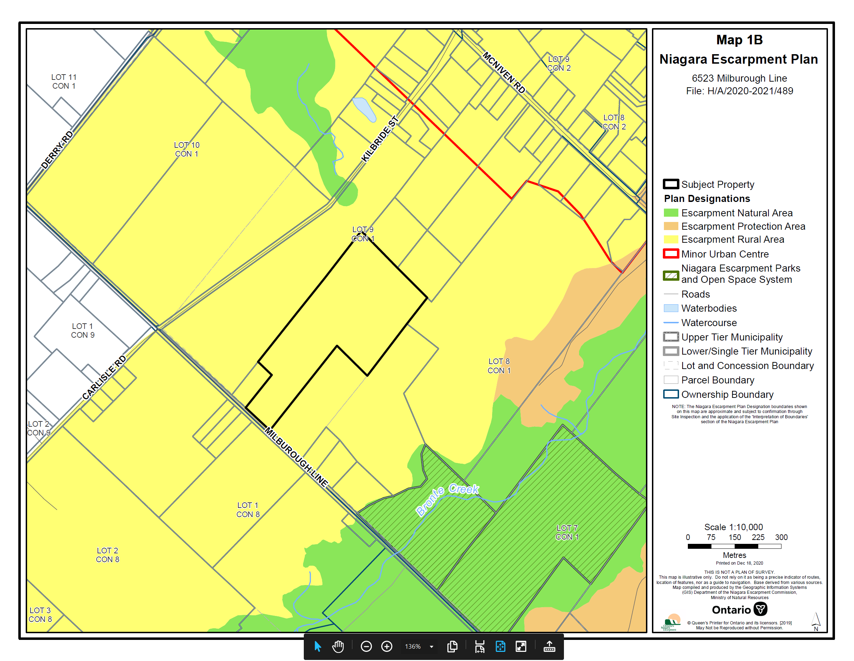

APPENDIX 2

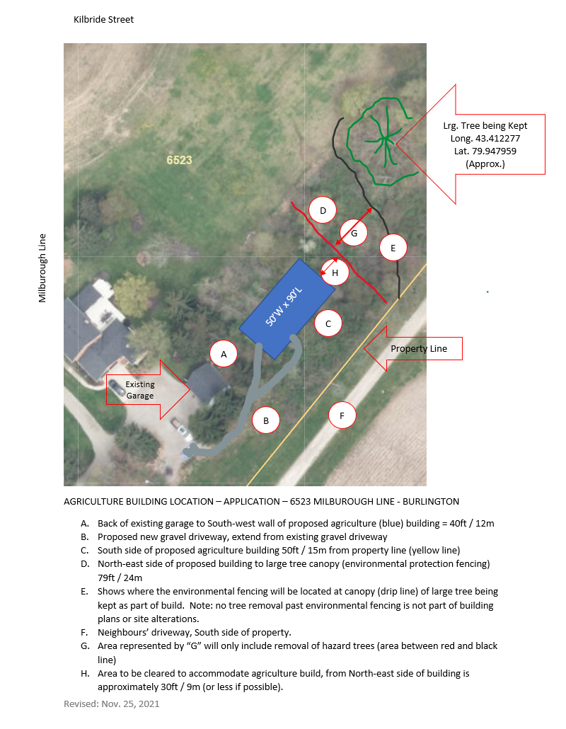

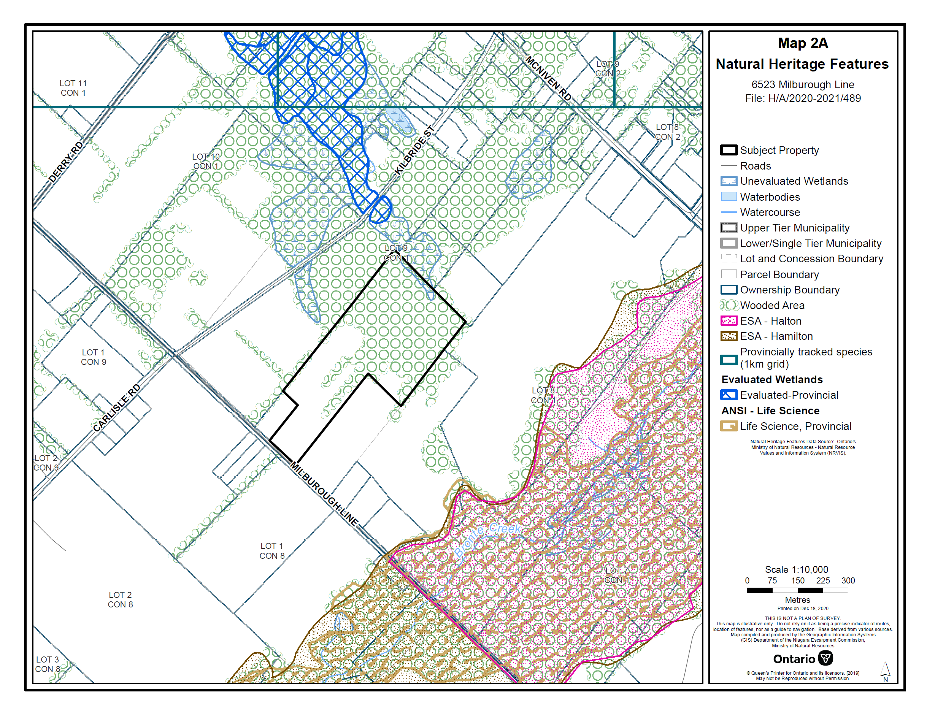

APPENDIX 3 AVAILABLE IN SEPARATE PDF FILE

