October 20, 2022

A2: STAFF REPORT

Development Permit Application:

G/R/2022-2023/025
569649 6th Sideroad
Part Lot 7, Concession 2, Collingwood Township
Town of the Blue Mountains, County of Grey

Proposal:
To construct a two storey ± 1,263.7 m² (13,603 ft²) accessory structure with a maximum height of ± 15 m (49.2 ft), including a new private sewage system and a ± 48.8 m (160 ft) water supply line, on the existing 10.1 ha (25 ac) lot with an existing two and a half storey ± 1,640 m² (17,552 ft²) single dwelling with a maximum height of ± 11.5 m (37.7 ft).

Received:
4/25/2022

Source:
REDATED - applicant
Same as Applicant - owner
Jasper Group Inc. – agent

Designations:
Escarpment Rural Area, Escarpment Natural Area

Issue:
Accessory uses and facilities are permitted under the Niagara Escarpment Plan (NEP) for lands within the Escarpment Rural Area. This proposal, however, is for a very large (>13,600 ft²), two storey accessory structure with a height of 15 m, as well as a new dedicated sewage disposal system solely to support the use of this structure. Although the existing dwelling exceeds the footprint of the accessory structure in total floor area, the definition of an accessory facility/structure in the NEP requires that the building be “naturally and normally incidental, subordinate, and exclusively devoted to the principal use located on the same lot.” It is not clear that this structure would be “normally incidental and subordinate” to the vast majority of single-family homes. In addition, the Town of Blue Mountains has expressed concerns about the size of the building and indicated that if the property was located within their zoning (i.e., Rural Zone), that the proposed structure would not be permitted due to its overall height.

Recommendation:
Refusal

Reasons:
The proposed structure does not meet the definition of an accessory structure, particularly in that the structure needs to be normally incidental and subordinate to the primary use on the lot (single family dwelling). Although the proposed structure is subordinate in size to the dwelling, it is much larger than what is normally approved by the NEC for an accessory structure and would not be normally subordinate to a typical dwelling except in the most exceptional circumstances where the home is larger than 14,000 ft². The proposed use also does not meet the criteria of normally incidental to, in that the proposed use would not be normal for the vast majority of dwellings (e.g., 4,300 ft²gym/yoga studio, 3,760 ft² “volleyball change room and storage” and an indoor pickleball/tennis court).
In addition, the Town of the Blue Mountains has expressed concerns over the size, indicating that it is substantially larger than what would be permitted if the property was subject to zoning. Per objective 7 of the NEP, the NEC is to support municipalities within the NEP Area in their exercise of the planning functions conferred up them by the Planning Act. Allowing this structure would result in more substantial development within the area of Development Control than what would be allowed within the rest of the municipality, contrary to Objectives 1, 2 and 4 of the NEP.

Related Files:
G/R/2010-2011/9152 - Conditional Approval issued for a 697.5 m² (7,500 ft²) dwelling with attached garage, covered patio and wrap-around verandah. Conditional approval lapsed; file closed with no permit issued.

G/R/2011-2012/9041 – Permit issued for a 2 storey, 1,116 m² (12,000 ft²) dwelling including the attached garage and exterior porch/roofed deck, having a maximum height of 12.2 m (40 ft).

G/R/2012-2013/9082 – Permit issued for 1 storey, 193.5 m² (2,081 ft²) addition (enclosed swimming pool), having a maximum ht of 7.6 m (25 ft), to the west side of dwelling.

Adjacent Lot to East (Owned by Helen Bambrough)
G/R/2009-2010/9099 – Permit issued for a 1½ storey, 403.5 sq m (4,339 sq ft) dwelling with partial walkout, having a maximum height of 10.2 m (33.3 ft); a private sewage disposal system, a new driveway entrance from the 6th Concession and a new driveway.
G/R/2010-2011/9020 – Permit issued (Director approval) for a 665 sq m (7,152 sq ft) accessory building, in four parts, which included a 436.6 sq m (4,695 sq ft) arena section having a maximum height of 8.5 m (28 ft), to be used as a private, multi-use arena for a three-on-three hockey rink in winter and tennis in summer; a 73 sq m (791 sq ft) utility room attached to the arena section to house the Zamboni, a 1½ storey, 120 sq m (±1,296 sq ft) storage barn section, having a maximum height of 8.5 m (28 ft), with an open loft, to be used for storage for ice making and maintaining equipment, and for a change room, two piece washroom, showers, and a steam room and a 34 sq m (370 sq ft) connecting section to be used as a bar and viewing area plus installation of a private sewage disposal system for the arena and an extended driveway to the accessory building.

G/R/2012-2013/9041 – permit to construct a 66.4 sq m (714 sq ft) deck on the southeast side of the existing dwelling.

Site Description:
The property is located near the hamlet of Gibraltar, and immediately north of Pretty River Valley Provincial Park. The frontage is well-treed, with most of the property screened from the road except for at the driveway entrance. The central portion of the property is open, consisting of open fields (unmanaged grassland), a small pond/wetland and the existing dwelling. The location of the proposed accessory structure and most of the northern and north-western portion of the property is within an abandoned aggregate pit that is dominated by grassy, weedy, and shrubby vegetation. This area is lower in elevation than the frontage and the area containing the dwelling. Forest (significant woodlands) is present less than 120 m to the east of the proposed building location.
Much of the proposed footprint of the accessory structure is currently used as driveway/parking area within the abandoned gravel pit, with numerous unapproved “sea can” storage units currently being used to store items that will be stored in the proposed structure if approved. An outdoor volleyball court and gazebo are located immediately beside the location of the proposed structure.
Background:
The subject property is located at 569649 6th Sideroad in the Town of the Blue Mountains, and is within two designations under the NEP: Escarpment Rural Area and Escarpment Natural Area. The proposed development is within the Escarpment Rural Area. Accessory uses are permited in this land use designation within the NEP (Section 1.5.3.11) subject to satisfying Development Criteria in Section 2.

An accessory structure/facility is defined in the NEP as “a detached building, structure or other installation that is not used for human habitation, the use of which is naturally and normally incidental, subordinate, and exclusively devoted to the principal use located on the same lot.”

Section B2.13 of the Town of Blue Mountains Official Plan provides that “the maximum height of all buildings and structures in the municipality shall generally be eleven (11) metres, except for those structures which by their nature, such as barns, silos, antennae, water towers, wind generators, drive-in theatre screens and bridges, require a greater height.” In addition, if the subject property were subject to zoning, the maximum height for an accessory structure would be 5 m (Section 4.3j of the Town of The Blue Mountains Zoning By-law 2018-65).
Objective 7 of the NEP is “to support municipalities within the NEP Area in their exercise of the planning functions conferred upon them by the Planning Act.” Although the NEP does not provide for a maximum footprint, floor area or height, consideration should be given to Objective 7 and the definition of an accessory structure being normally incidental and subordinate.

Planning Analysis:

Provincial Policy Statement
The proposal is not located within a hazard or within a natural feature. Although the proposed development is within 120 m of significant woodlands, Conservation Authority staff concur that there would be no negative effects to nearby features due to the proposed development.
Section 1.1.4 and 1.1.5 of the PPS speak to development in rural areas. These policies support development in rural areas that builds upon rural character and is compatible with the rural landscape. Although large buildings for agricultural purposes are part of the rural landscape, large buildings for non-agricultural uses are generally directed to settlement areas or rural industrial parks. In consideration of this, and that the Town of the Blue Mountains policies do not support large accessory buildings, it is questionable whether the proposed building meets the intent of the PPS.

General, NEP Part 2.2
Part 2.2.1 of the NEP directs that “the Escarpment environment shall be protected, restored and where possible enhanced for the long-term having regard to single, multiple or successive development that have occurred or are likely to occur.” Considering that an objective of the NEP is to maintain and enhance the open landscape character, the cumulative impact of structures that do not support this objective needs to be considered. Although the proposed storage building is not overtly visible from public viewpoints, the issue of precedence should be considered as large buildings proposed elsewhere may have significant visual impacts. It is also notable that large buildings in rural areas are usually intended to support agricultural uses, which is not the case here. Thus, the structure does not contribute to another of the NEP’s objectives, which is supporting compatible agriculture.
The subject property is located within both Escarpment Natural and Escarpment Rural designations. Development will be restricted to the Escarpment Rural Area per Part 2.2.5.
The proposed site of development is not prone to any natural hazards and the proposed structure will not be used for a Home Occupation, Home Industry or as a Secondary Dwelling Unit. The proposal complies with Part 2.2.
Water Resources, NEP Part 2.6
The proposed development is not located within or adjacent to a Key Hydrologic Feature and is compliant with Part 2.6.

Natural Heritage, NEP Part 2.7
The subject property contains Significant Woodlands as identified by Grey County. The proposed development is set back less than 120 m from the Significant Woodlands; however, the Nottawasaga Valley Conservation Authority and NEC Staff agree that there should be no negative impacts to the woodlands from the proposed development.
Although much of the property is in grassland or old field, the field in which development is proposed is not suitable habitat for Bobolink or Eastern Meadowlark. Neither of these species were noted on the property during the site visit. Other species at risk noted by the Natural Heritage Information Centre in the general area include butternut and American Hart’s-tongue fern. The site of the proposed development is an abandoned gravel pit and is heavily disturbed. No butternut were noted during the site visit. The site is not suitable for American Hart’s-tongue fern. No other Species at Risk are anticipated in the area of the proposed development. The proposal complies with Part 2.7.

Scenic Resources and Landform Conservation, NEP Part 2.13
Although the proposed development is for a two storey, 15 m high (50 ft) accessory structure, the proposed location is within the lowest area of the property, approximately 5 m lower than the dwelling and 8-9 m lower than the elevation of the road at the driveway entrance. The property is well screened from the road by mature trees, except at the driveway entrance itself. There is also a row of trees immediately in front of the proposed location for the accessory structure providing some additional screening.
Overall, the accessory structure will be well screened from the road except for the view from the driveway entrance. At this location, however, the viewer will have a much more direct view of the dwelling than of the accessory structure. From this perspective the accessory structure will look smaller and lower than the dwelling.
There are no direct views to or from the proposed building location to areas outside of the property other than at the driveway entrance. The proposed accessory building would not impact scenic resources and complies with Part 2.13.

Agency Consultations:
- County of Grey Planning and Development responded and indicated that provided positive comments are received from the local Conservation Authority regarding the Signficant Woodlands and the NHS Core Area, Couny planning staff have no concerns with the subject application.

- Historic Saugeen Métis responded indicating no objection.

- Métis Nation of Ontario did not respond.

- Nottawasaga Valley Conservation Authority responded indicating that the property does not fall within an area affected by O. Reg 172/06 (the Authority’s Development, Interference with Wetlands and Alterations to Shorelines and Watercourses Regulation). Further that NVCA staff have no natural hazard nor natural heritage concerns with the proposed development. NVCA has no objection to the approval of the NEC application.

- Town of The Blue Mountains Planning & Building Services Dept responded indicating that if zoning were in place, it would be zoned Rural. Accessory buildings in Rural zone have a maximum height of 5 metres to the mid-point between the peak of the roof and the eaves. The NEC should be satisfied that the proposed accessory building is at a height and built-form to remain accessory and subordinate to the main dwelling unit.

Discussion:
The NEP does not provide for a maximum footprint, floor area or height for structures within the NEP Area. It defines accessory structures as structures that are normally incidental and subordinate to the principal use (dwelling). In the absence of the word “normally”, this definition would be interpreted to mean that accessory buildings must be smaller than the dwelling. This interpretation would mean simply that the larger the dwelling, the larger the accessory structure can be. This approach would not seem equitable, in that individuals with a modest home would not be able to build an accessory facility anywhere near as large as individuals who have the means to build much larger homes.
One needs to consider what is “normally incidental” to a dwelling. It would be very rare that the proposed uses of this building would be normal uses for an accessory structure for a single-family dwelling. The proposed building layout includes 4,300 ft² for a gym/yoga studio, 3,760 ft² for volleyball change room and storage (supporting the existing outdoor volleyball court), an indoor pickleball/tennis court, as well as an area for recreational vehicle storage and a workshop. The need for a second complete sewage disposal system for the accessory structure also points to the use of the structure as atypical.
The NEP also does not direct the maximum number of accessory structures and does not have a maximum lot coverage limit. This could result in multiple large accessory structures on the same lot. In considering proposals, NEC staff need to consider cumulative effects, and the potential for future applications for additional accessory structures on the same lot or in the surrounding area. In addition, should the property be sold in the future, it will be difficult to ensure that the building is not used for commercial purposes unless an agreement on title is imposed, limiting future uses.
Objective 7 of the NEP directs the NEC to support municipalities within the NEP Area in their exercise of the planning functions conferred upon them by the Planning Act. Municipalities establish setbacks, maximum heights, lot coverage limits and other limitations within their compressive zoning bylaws to ensure that development is sustainable and compatible with other uses, maintains community character and protects the environment. Zoning does not apply within the NEP Area and the NEP does not provide for similar restrictions including setbacks, maximum heights, or lot coverage limits. For this reason, and in consideration of Objective 7, the NEC should seek to meet the provisions of the zoning bylaws by considering the limitations set out in the most comparable zone within the municipality. The lack of limitations, such as a maximum height or floor area, should not create a loophole where development within the NEP Area is less restrictive than within comparable lands outside of Development Control, which would be contrary to Objectives 1, 2 and 4 of the NEP. PPS policies that support preserving the rural landscape and character are also put into question by a proposal that clearly does not meet local planning policies.
Section B2.13 of the Town of Blue Mountains Official Plan provides that the maximum height of all buildings and structures in the municipality shall generally be eleven (11) metres, except for those structures which by their nature, such as barns, silos, antennae, water towers, wind generators, drive-in theatre screens and bridges, require a greater height. In addition, if the subject property were subject to zoning, the maximum height for an accessory structure would be 5 m (Section 4.3j of the Town of The Blue Mountains Zoning By-law 2018-65). Although the NEC measures the maximum height of a building to the peak, while the municipality measures it to the mid-point between the eaves and the peak, it is obvious that the proposed structure is substantially higher than what would be permitted if the property was within zoning.

Recommendation:
Staff recommend that the proposal be refused due to the significantly large size of the proposed structure, that it does not meet the NEP definition of “normally incidental and subordinate” to the dwelling, and the fact that permitting such a structure would vary substantially from what would otherwise be allowed within the municipality were it within zoning.

Prepared by:
Original signed by:
______________________
Sandy Dobbyn
Senior Planner

Approved by:
Original signed by:
_______________________
Kim Peters, MCIP, RPP
Manager

Attachments:
Appendix 1. Ortho Photo of Subject Property
Appendix 2. Proposed Site Plan
Appendix 3. Concept Drawing
Appendix 4. Main Floor Plans
Appendix 5. Second Floor Plans

APPENDIX 1
Ortho Photo of Subject Property
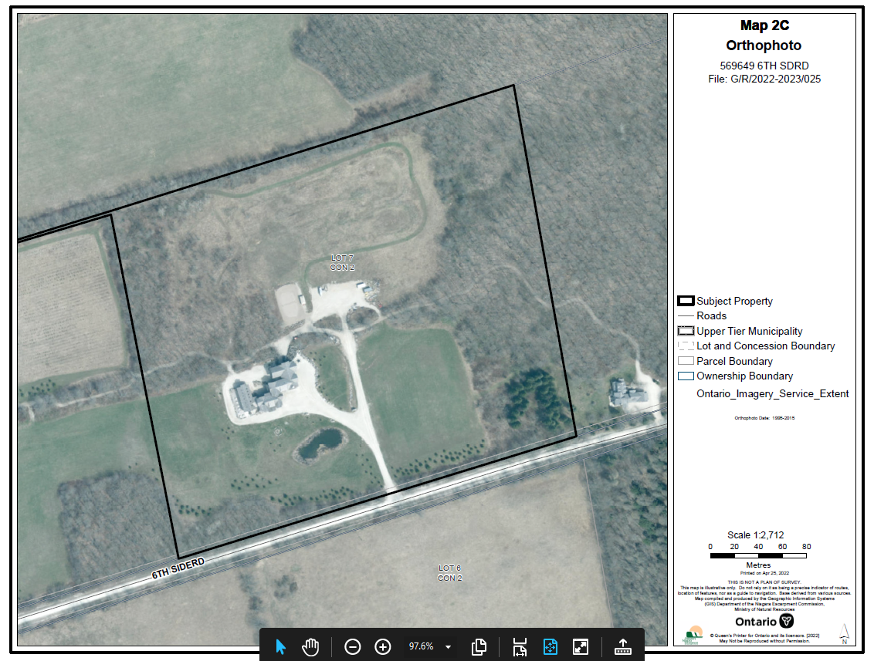
APPENDIX 2
Proposed Site Plan
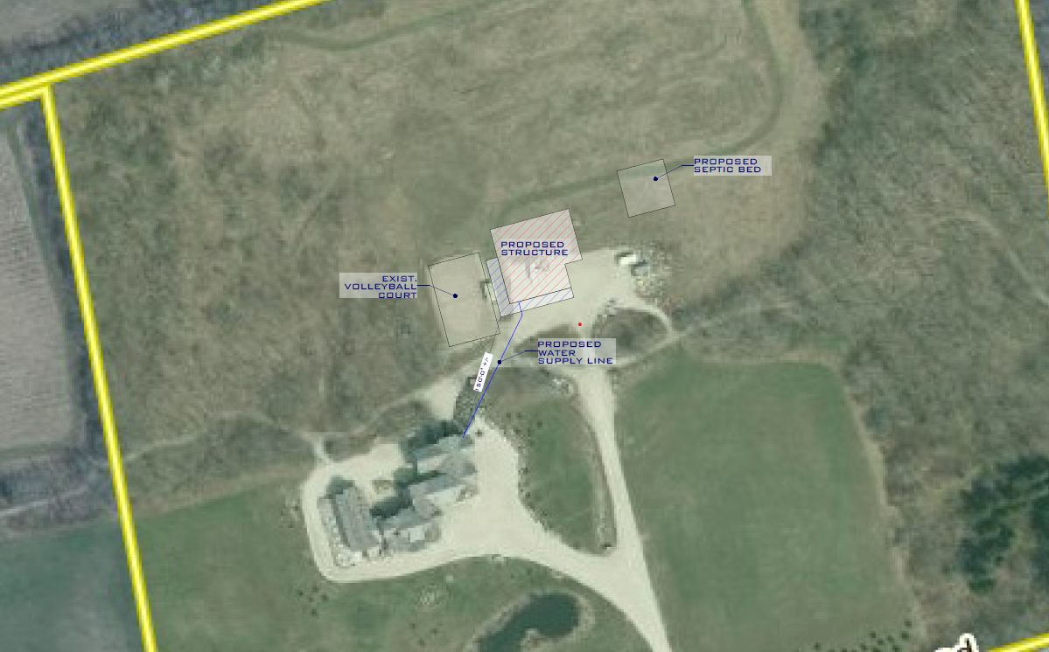
APPENDIX 3
Concept Drawings

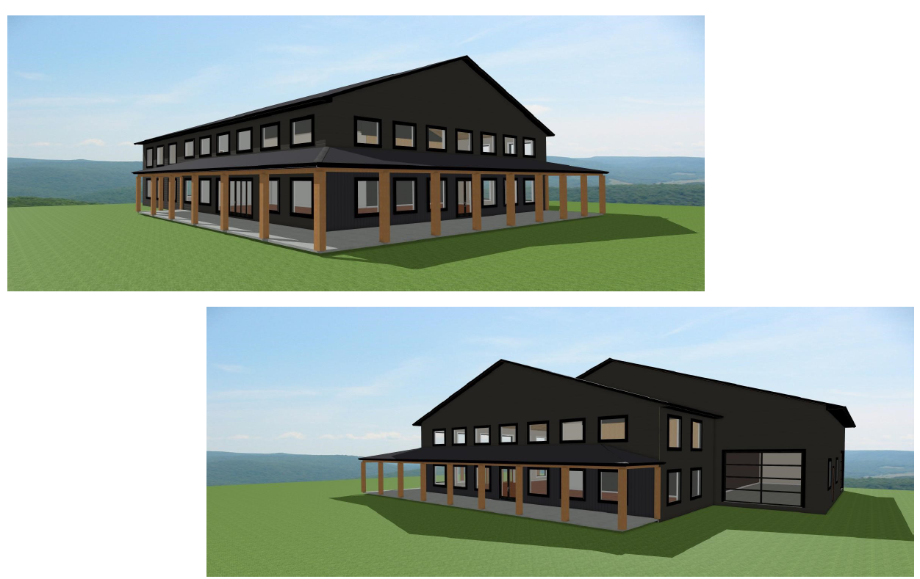
APPENDIX 4
Main Floor Layout
Main floor 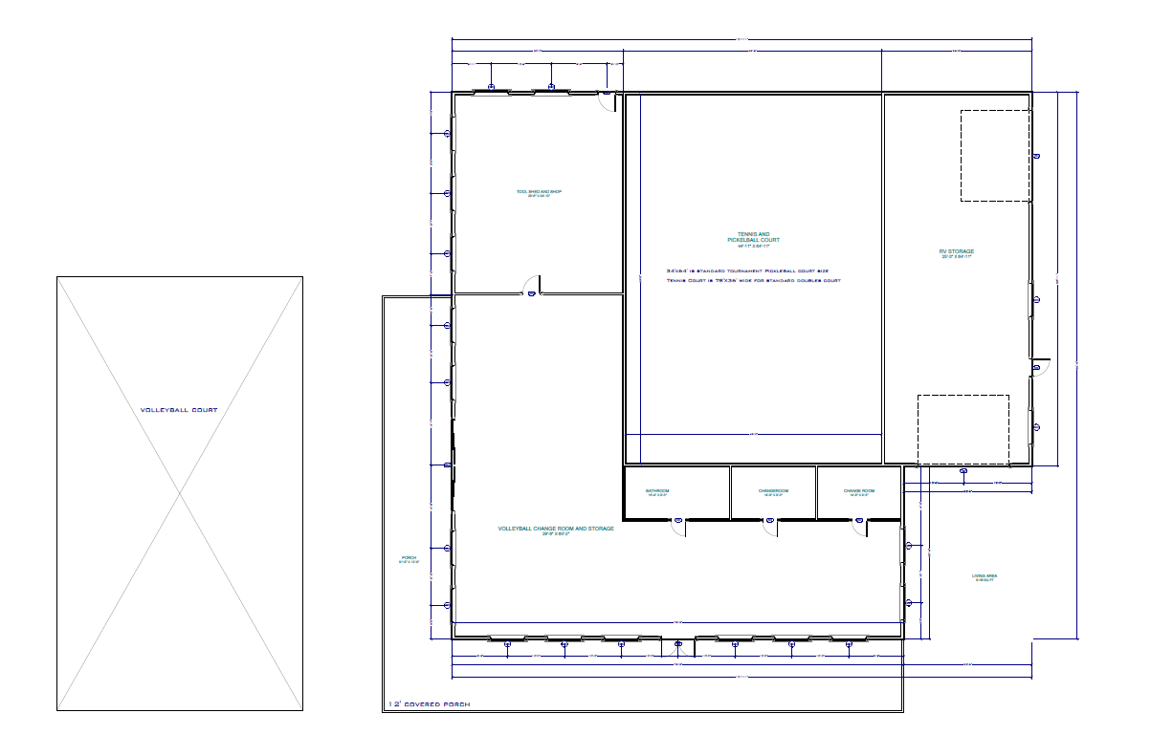

APPENDIX 5
Second Floor Layout

