July 21, 2022

A3: STAFF REPORT

DEVELOPMENT PERMIT APPLICATION:

G/R/2020-2021/606
235474 Grey Road 13
Part Lot 8, Concession 4 South
Municipality of Grey Highlands, Grey County

SUMMARY

PROPOSAL:
To establish a bed and breakfast within an existing ± 4,500 ft² (418 m²) structure that includes eight ± 180 ft² (16 m²) private rooms and a 520 ft² (48 m²) common area (kitchen / lounge), on a 0.23 ha (0.59 ac) existing lot supported by private servicing.

DESIGNATION:
Escarpment Natural Area

LOT SIZE:
0.23 ha (0.59 ac)

ISSUE:
A decision from the Commission is required because staff is recommending refusal. The NEC Director does not have the delegated authority to refuse a development permit application.

RECOMMENDATION:
Refusal

REASONS:
The proposal does not meet the applicable Niagara Escarpment Plan policies for bed and breakfasts, and existing use policies do not apply since the motel use was interrupted for several years. The proposed development is not supported by the municipality. Under the Ontario Building Code and Fire Code, the proposed use is classified as a hotel.

RECEIVED:
January 4th, 2021

SOURCE:
REDACTED

RELATED FILES:

G/C/2010-2011/9143
A development permit application was submitted to the NEC on January 5th, 2011 to establish and operate a ‘micro-brewery’ within a 89 m² (960 ft²) basement area of the existing motel operation on the subject lands. NEC staff recommended refusal on the proposal as the proposed micro-brewery was not a permitted use. Additionally, the Grey Sauble Conservation Area objected to the proposed use of the structure due to flooding and hazard concerns. The Commission deferred the decision on the proposal at a meeting held on June 16th, 2011, and the application was subsequently withdrawn. No permit was issued for the proposed use.

G/C/2000-2001/9128 (Permit Number: 5144)
A development permit was issued in 2001 to construct a 16-seat breakfast room addition with a new kitchen and two washrooms, a detached carport and shed, a gazebo and a new advertising sign for the motel. The expansion was not intended to accommodate additional guest rooms. Conditions of approval restricted meals to paying guests of the motel. The approved works were completed.

G/C/1989-1990/166
A development permit application was submitted to the NEC to construct a full second storey addition to the motel (a 100 percent increase in guestrooms from 8 to 16) on the property was refused by the Commission in 1989 as the proposal was a substantial expansion to the existing use, not in keeping with the Objectives of the Escarpment Natural Area designation.

BACKGROUND:
Historically, the structure on-site was used as a motel that supported eight separate rooms with a connecting three-piece washroom for each room. The motel was established prior to the Niagara Escarpment Plan coming into effect on June 12, 1985. A motel is not listed as a permitted use within the Escarpment Natural Area. As the motel was operating prior to the plan coming into effect, it was considered an existing use and permitted within the Escarpment Natural Area. Prior to the current applicant’s purchasing the property, the motel had not been in operation for at least three years. An existing use loses its status as a permitted use when the operation has ceased past a two-year timeframe. NEC staff advised the applicant to determine possible options and next steps.
NEC staff explored the possibility of a Niagara Escarpment Plan Amendment (NEPA) to amend the permitted uses and allow for the establishment of a motel on the subject lands. Section 6.1 (2.2) of the Niagara Escarpment Planning and Development Act (NEPDA) prevents the consideration of any request to amend the Niagara Escarpment for an urban use in the Escarpment Natural Area, where such an amendment proposes an urban use. A hotel or lodge is defined as an urban use in the NEC’s Policy for Urban Uses, which was approved by the Commission in June 2005. NEPA applications to permit an urban use may only be considered during the formal ten-year review of the NEP. The next review of the NEP does not begin until 2027.

The Municipality of Grey Highlands passed By-law No. 2019-122 (License to Regulate and Govern Short Term Accommodations), under the Municipal Act, in late 2019. This By-law permits Short Term Accommodation licences to a maximum occupancy of ten (10) persons. Short-term accommodation rentals are viewed by NEC staff as a land use that is distinct from standard residential use of a single dwelling; thus, the conversion of a single dwelling to short-term accommodation is a change in use and requires a development permit from the NEC. However, the only form of short-term accommodation that is permitted in the NEP is a bed and breakfast.

NEC staff requested a development permit application from the landowner to determine conformity with the policies of the NEP and consult with partner agencies on the proposed development.

SITE DESCRIPTION:

The subject property is located in the Beaver Valley approximately 1-km north of the village of Kimberley. The surrounding properties consist of rural-residential and agricultural uses, with large portions of vacant wooded lots in the vicinity. The former Talisman Ski Club and associated recreational development are located to the west of the property. The lot is located within the Beaver Valley and is nearby to the Beaver River, a Provincially Significant Wetland and an Area of Natural and Scientific Interest. The low-lying wetland complex that surrounds the property is owned by Grey Sauble Conservation Authority and is a part of the Beaver Valley Lowlands Niagara Escarpment Parks and Open Space System Park.

The 0.2 ha (0.54 ac) square-shaped lot has existing access on the west side of Grey Road 13. The subject lands contain the structure previously used as a motel, a parking area, a patio with lounging space and a manicured lawn surrounding the building. The property is adjacent to the Beaver River and surrounding Crown and conservation authority owned properties. The applicant proposes to establish a bed and breakfast within the existing structure on-site. The structure was previously operated as a motel and contains eight separate units that include sleeping accommodations and sanitary facilities. Additionally, a shared kitchen and lounging area is included within the main portion of the structure. The structure has undergone significant interior and exterior renovations and has adequate servicing capacity (e.g., well and septic) to support the eight units.

The existing structure has a total floor area of ± 4,500 ft² (418 m²), with each of the eight guest rooms being ± 180 ft² (16 m²) in size. The common area (lounge & kitchen) are ± 520 ft² (48 m²) and the outdoor patio is ± 1,500 ft² (139 m²). The parking pad near the frontage of the structure is ± 273 m² (2,940 ft²) with additional parking located along the exterior of the structure. The number of available rooms, and occupany limits, to be permitted within a bed and breakfast is typically restricted to three rooms, in accordance with the restrictions under the Ontario Building Code and Ontario Fire Code. More than three guest rooms would result in a Building Code classification as a hotel, and more extensive safety requirements, including fire separations around sleeping rooms, egress from guest suites, number of required exits, etc. The amount of rooms permitted within a bed and breakfast is not specifically defined in the NEP since other provincial legislation (i.e., Ontario Building Code and Fire Code) applies. The applicant has proposed to use four of the eight exsting rooms as part of the proposal. The structural layout and rooms proposed for use as part of the Bed and Breakfast establishment is identified on Appendix # 3.

PLANNING ANALYSIS:

Niagara Escarpment Plan (NEP 2017):
A motel is not listed as a permitted use within the Escarpment Natural Area. Therefore, the motel was permitted as an existing use. An existing use is defined in the NEP as the following:

Existing use: The legal use of any land, building or structure for a purpose that is not otherwise listed as a permitted use under the applicable designation in the Niagara Escarpment Plan, and that was:

- existing on the day of approval of the Niagara Escarpment Plan, June 12, 1985; or

- approved in accordance with the provisions of the Niagara Escarpment Plan since June 12, 1985 but prior to the date of any amendment to this Plan under which the use ceased to be a permitted use; or

- existing, in an area added to the Niagara Escarpment Plan at the date of the approval of the amendment to this Plan that added the lands to this Plan;

provided that the existing use has continued without interruption after the effective date as set out under a), b), or c).

The motel previously qualified as an existing use under scenario a) noted above. To maintain existing use status, and qualify as a permitted use, the use must continue without interruption after the effective date set out under a), b), or c). The applicant for a development permit bears the onus of providing evidence to support a contention that a use qualifies as an existing use. Prior to the applicant purchasing the motel in 2021, the motel had not been in operation for at least three years. The applicant provided this timeframe. The previous owner of the property has passed away, and it has been difficult to determine an accurate timeline for the cessation in use. Historically, NEC staff and Commission have interpreted an interruption in use of two years or more as resulting in disqualification as an existing use. This is consistent with how many municipalities deal with “legal non-conforming uses.”

As the existing structure has not been used as a motel (e.g., open to the public) for more than two years, staff contends that the motel has lost existing use status and is no longer considered a permitted use.

The property is designated Escarpment Natural Area by the NEP. The proposal to establish a bed and breakfast is a permitted use within the Escarpment Natural Area (1.3.13), subject to satisfying the applicable Development Criteria in Part 2 of the NEP. To qualify for a bed and breakfast, the applicant must demonstrate consistency with the definition of a Bed and Breakfast from the NEP.

A bed and breakfast is defined in the NEP as:

- Sleeping accommodation (including breakfast and other meals, services, facilities and amenities for the exclusive use of guests) for the travelling or vacationing public within an existing single dwelling that is the principal residence of the proprietor. A bed and breakfast in an existing single dwelling of local heritage value or interest must retain the features that cause it to be designated of local heritage value or interest.

A single dwelling is defined in the NEP as:

- A separate building containing not more than one dwelling unit and may include a chalet, cottage, mobile home or group home.

A dwelling unit is defined in the NEP as:

- One or more habitable rooms with a private entrance and designed for the use of one household in which sanitary and kitchen facilities are provided for the exclusive use of such household.

Given the above, a bed and breakfast must be located within a single dwelling that contains one dwelling unit. A dwelling unit includes one kitchen facility, sanitary facilities and habitable rooms accessed through a shared entrance. Additionally, the dwelling must be the principal residence of the proprietor and the owner / operator must remain on-site while the bed and breakfast is in use (i.e., when guests are present).

The applicant has provided a floor plan (Appendix # 3) that shows the layout of the existing structure. As shown on the site plan, the eight separate rooms are self-contained with private entrances and private washrooms accessed from the exterior. There is a kitchen and lounging area, which is accessible to all guests and intended to provide accommodation services for guests. Additionally, the second floor of the structure contains a separate dwelling unit, which the applicant currently resides within.

The proposed use to establish a bed and breakfast must satisfy the definition noted above. The structure is the proprietors full-time residence and will remain on-site should any guests be present on the property. The property is not designated under Section IV of the Ontario Heritage Act and the structure is not designated of local heritage value or interest. As the structure was previously operated as a motel, the layout of the structure includes private units designed to accommodate guests with their own sleeping accommodations, sanitary facilities and separate entrances. Additionally, a dwelling unit is located on the second floor of the structure. The layout of the structure does not meet the definition of a single dwelling as defined by the NEP. A Bed and Breakfast must be established within an existing single dwelling, and this requirement has not been met. As this policy non-conformance is resulting in a recommended refusal, a decision from the Commission is required.

Part 2.2.2 of the NEP requires that the site of development not be prone to natural hazards. The former motel lies within the flooding and erosion hazards associated with the Beaver River. Thus, there is a conflict with Part 2.2.2 of the NEP. Comments from the conservation authority acknowledge that the structure is located within a floodplain; however, as there is no new physical development proposed, it is not anticipated to aggravate the existing hazards. The conservation authority will not permit new structural development in areas subject to the floodplain. Despite the conservation authority’s position, reintroducing guest accommodation on this site after its has ceased also reintroduces a risk to public safety, which the conservation authority has not commented on. It has not been determined if guests and residents can safely enter and exit the site during times of flooding, erosion or other emergencies. NEC staff did not pursue this issue further since the policies of the NEP do not support the proposed use and given that staff is recommending refusal based on policy non-conformity, undertaking a hydrological analysis to determine depth and velocity of flood waters would place an unfair burden on the applicant at this point in time.

2. Provincial Policy Statement (PPS, 2020)
Section 3.1 of the PPS directs development outside areas of hazardous lands prone to flooding and erosion. The existing structure on-site is located within a floodplain associated with the Beaver River. Section 3.1.7 of the PPS permits development in hazardous lands where the effects and risks to public safety are minor or could be mitigated, including demonstration that vehicles and people have safe ingress and egress from the site during flooding. As noted above under staff’s analysis of NEP Part 2.2.2, it is not known if this is the case. More information is required to determine if PPS policies can be met.

3. Grey County Official Plan
County planning staff have reviewed the application to establish a bed and breakfast within an existing structure that was previously operated as an eight-room motel.
The subject property is designated as Niagara Escarpment Plan Area by the Grey County Official Plan (OP). The Niagara Escarpment Plan must be referred to for determination as to whether lands are affected by the various land use types and policies under the NEP. In the event of a conflict between the policies of the Grey County OP and the NEP, those of the NEP will prevail.
Schedule C of the County OP identifies the existence of ‘Core Area and Linkages’ on the subject property. Development proposed within Core Areas, their 120 metre adjacent lands, or Linkages will be required to undertake an environmental impact study (EIS), unless otherwise exempted by this Plan.
Appendix B of the County OP indicates that the subject property contains ‘Significant Valley lands’. No development or site alteration may occur within Significant Valley lands or their adjacent lands unless it has been demonstrated through an EIS that there will be no negative impacts on the natural features or their ecological functions.
Appendix B also indicates that the subject property contains streams (watercourse). No development will be permitted within 30 m from the banks of a stream, river, or lake unless an EIS is prepared that concludes setbacks may be reduced and/or where it has been determined by the conservation authority these setbacks may be reduced.
County planning staff recommend receiving comments from the Conservation Authority regarding the above noted natural heritage features and the requirement of an EIS.
The proposal includes the use of an existing entrance from Grey Road 13. County transportation staff have reviewed the application and have no further concerns. Provided that positive comments are received from the Conservation Authority regarding natural heritage, County planning staff have no further concerns.

4. Local Official Plan
Municipal planning staff have reviewed the subject application and distributed to municipal departments. Planning staff do not support the subject application as it does not meet the definition of a bed and breakfast or the necessary provisions of a home occupation that are required to permit the use.
The following comments were received from municipal departments:

Fire and Emergency Services: No concerns.

Planning Services:

The subject lands are designated Rural, Hazard lands and Niagara Escarpment Plan in the Grey Highlands Official Plan.

The rural designation allows for uses such as, agriculture, forestry, wayside pits and quarries, limited non-farm recreational (such as community halls), and single detached dwellings. The rural designation does not permit a motel or hotel as a permitted use.

Staff also note that section 4.2.2 (b) Rural Policies states that “Rural designated lands within the Niagara Escarpment, as identified on the land use schedules attached to this Plan, are also subject to the policies of the Niagara Escarpment Plan. Should instance of conflict arise, the most restrictive policies of either document apply.

Section 3.9 (General Provisions) provides direction for permissions for bed and breakfast establishments in all Residential, Agricultural and Rural Zones as established in the implementing Zoning by-law.

Planning staff note that the Grey Highlands zoning By-law 2004-50 defines a bed and breakfast establishment as the following:

- Sleeping accommodation for the traveling or vacationing public within a single dwelling which is the principal residence of the proprietor, to a maximum of four guest rooms, and may include the provision of breakfast and other meals and services, facilities or amenities for the exclusive use of the occupants. The guest rooms shall not have kitchen facilities, nor in any other way resemble a motel or inn, and guests should not have access to kitchen facilities.

- A bed and breakfast establishment shall be permitted in any zone in which a single-family residential dwelling is a permitted use; however, is not permitted in combination with any other type of accommodation such as roomers and boarders and accessory apartments. In addition, bed and breakfast establishments are considered a home occupation and governed according to the General Provisions of this By-law.”

Furthermore, the following provisions are provided for home occupations:
- Shall not be located in an outbuilding or accessory building or structure;
- Not more than 25% of the gross floor area of the dwelling house or unit is used for the purpose of home occupation uses, except in the case of a bed and breakfast which shall be limited to four guest rooms. In addition, where a bed and breakfast establishment and a separate home occupation exist in the same dwelling, a maximum of 25% of the gross floor area of the dwelling shall be used for these purposes.
- Only persons residing in the dwelling operate the home occupation.
- There is no display visible from outside the premises, other than a legal sign no larger than 1 square meter, to indicate that any part of the dwelling house, unit or lot is being used for a purpose other than residential, and shall not illuminate
- Such home occupation is clearly secondary to the main residential use and does not change the residential character of the dwelling house or unit nor create or become a public nuisance, particularly in regard to traffic, parking, noise, noxious odours, or emission of smoke;
- One additional off-street parking space is provided for every 24 square meters of floor space occupied for business or professional purposes, OR, in the case of a bed and breakfast establishment, one additional off-street parking space for each guest room.

The applicant has not demonstrated compliance with these provisions. As such, staff are not in support of the proposal to establish a bed and breakfast at 235474 Grey Road 13. Should NEC staff wish to proceed with the proposal, planning staff recommend that the applicant submit a detailed site plan, including elevations and a detailed parking plan, prepared by a qualified professional and demonstrate that the bed and breakfast is secondary to the main residential use and meets the definition of bed and breakfast in the Zoning Bylaw. If the proposal were outside of the NEP and in a rural designation, staff would require the applicant to meet the provisions for a bed and breakfast as outlined above or submit an official plan amendment. Generally, a use of this nature is directed towards a settlement area.

Building Services: The municipality of Grey Highlands currently permits STA licenses to a maximum occupancy of 10 persons. The applicant should be advised that a change of use permit will be required, other items should be taken into consideration: if the occupant load exceeds 10 persons, upgrades within the building may be required for life safety requirements. Building Permits will be required for the change of use and or any other construction. Verification of the existing septic systems will have to be addressed at that time.

5. Conservation Authority
Grey Sauble Conservation Authority has reviewed the application through the delegated responsibility from the province to represent provincial interests regarding natural hazards identified in Section 3.1 of the Provincial Policy Statement.

The property is entirely regulated under Ontario Regulation 151/06. The regulated area is associated with the engineered floodplain of the Beaver River and the meander belt of the southern adjacent watercourse. The natural hazards identified on the property include flooding and erosion associated with the floodplain of the Beaver River. The applicable PPS policies have been noted below:

    - b) Development shall generally be directed, in accordance with guidance developed by the Province (as amended from time to time), to areas outside hazardous lands adjacent to river, stream and small inland lake systems which are impacted by flooding hazards and/or erosion hazards;

    - c) and d) Development and site alteration shall not be permitted within areas that would be rendered inaccessible to people and vehicles during times of flooding hazards, erosion hazards and/or dynamic beach hazards, unless it has been demonstrated that the site has safe access appropriate for the nature of the development and the natural hazard and a floodway regardless of whether the area of inundation contains high points of land not subject to flooding.

GSCA staff identified flooding and erosion hazard associated with the floodplain of the Beaver River. The Beaver River extends through the west adjacent property. The majority of the property is within the Regional storm floodplain of the Beaver River. No new development is permitted within the Regional floodplain under the Provincial Policy Statement (PPS, 2020) or under Ontario Regulation 151/06. Further, the GSCA recommends that the existing building be floodproofed to a minimum elevation of 233 meters GSC, as such, no opening would be at an elevation lower than 233 m GSC.

As no new external development is proposed through the subject application, the GSCA is of the opinion that the subject application is generally consistent with Section 3.1 policies of the PPS.

Advisory Comments

The natural heritage features identified on the subject lands include potential fish habitat and potential habitat of threatened or endangered species. As no on-site development is proposed, GSCA is of the opinion that the subject application is generally consistent with Section 2.1 policies of the PPS.

The GSCA generally has no objection to the subject proposal as it is not anticipated to negatively impact the Ontario Regulation 151/06 area and/or natural heritage features on or within the vicinity of the subject property. No new development would be permitted within the regional floodplain under the PPS or under Ontario Regulation 151/06.

SUMMARY

NEC staff are recommending that the development proposal be refused. A bed and breakfast operation must meet the definition within the NEP. The existing structure does not meet the definition of a single dwelling due to the structural layout and design of the individual rooms with exterior access points. The structure was previously operated as motel and maintains a similar design concept that is not compatible with the policies required to permit a bed and breakfast. Municipality of Grey Highlands staff have also indicated that the proposal would not meet relevant official plan policies and zoning by-laws if the property were not subject to development control. By-law 2004-50 indicates that a bed and breakfast should be located within a single dwelling and in no way resemble a motel or inn. There are several discrepancies in policy between the prior use as a motel and the proposal to establish a bed and breakfast on-site. The Ontario Fire Code would classify the proposed use as a hotel, not a bed and breakfast. In addition, the existing use policies of the NEP do not allow for the reinstatement of the motel use.

RECOMMENDATION:
That the application be refused for the following reasons:
- The proposal does not meet the applicable policies to establish a bed and breakfast within the structure.

- Given the lengthy cessation of the motel use, the NEP existing use policies do not allow for the reinstatement of the motel use.

- The Municipality of Grey Highlands does not support the application.

Prepared by:

Original signed by:
________________
Nick Hayward
Senior Planner

Approved by:

Original signed by:
____________________
Kim Peters, MCIP, RPP
Manager

Appendix 1 – Orthophoto of the subject property
Appendix 2 – NEP Land Use Designations Map
Appendix 3 -- Floor Plan, Parking Area & Photos

Appendix 1 – Orthophoto of the Subject Property

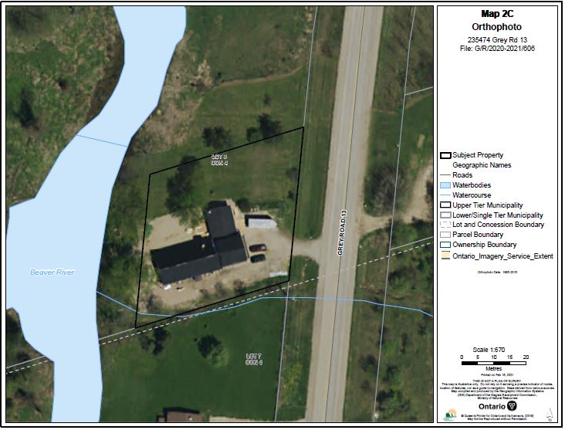

Appendix 2 - NEP Land Use Designations Map

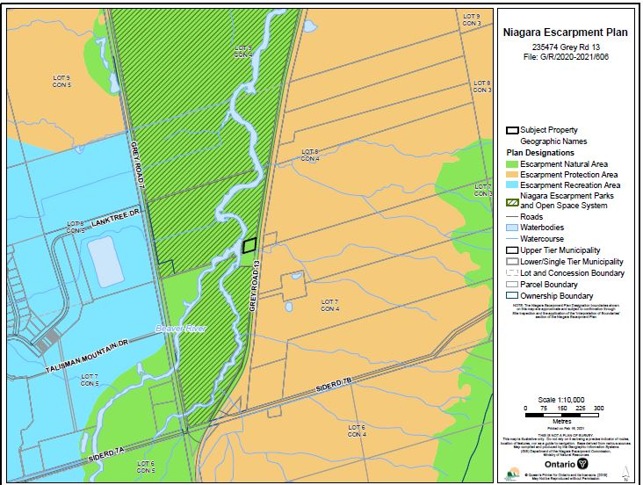

Appendix 3 – Floor Plan

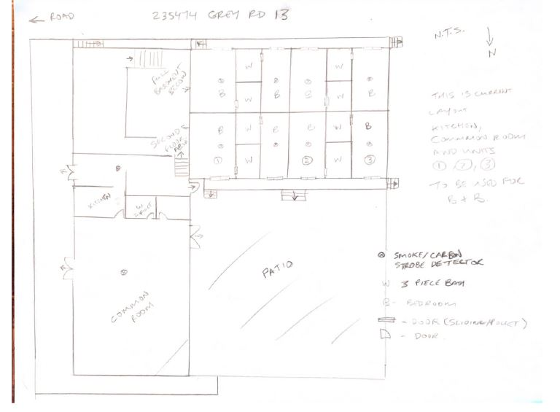

Appendix 3 - Parking

Appendix 3 - Photos
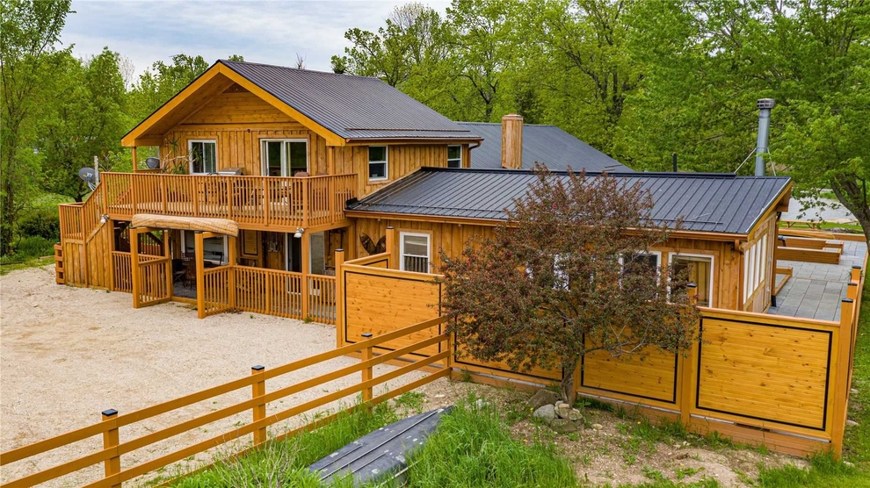

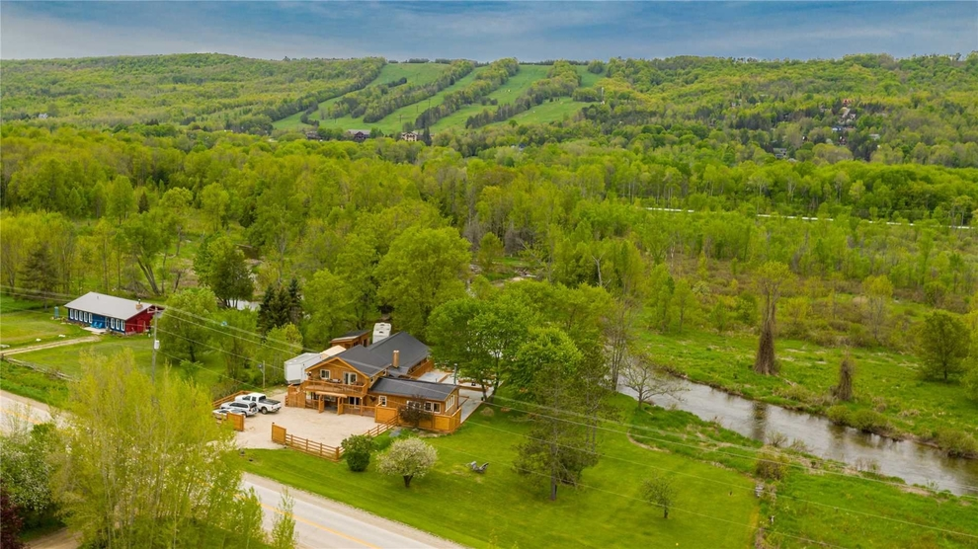

Ontario Regulation 213/07: Fire Code defines a hotel as, “hotel means floor areas, a floor area or part of a floor area containing four or more suites that provide sleeping accommodation for the travelling public or for recreational purposes.”

