October 20, 2022
C1: STAFF REPORT
Official Plan Amendment and Zoning By-Law Amendment, 442, 450, 454, 462 Wilson Street East, City of Hamilton
______________________________________________________________________

RECOMMENDATION
That the Niagara Escarpment Commission obtain party status in Ontario Land Tribunal case OLT-22-004156 to uphold the Niagara Escarpment Plan (NEP) by seeking to reduce visual impacts on the Escarpment from the proposed development at 442, 450, 454 and 462 Wilson Street East within the City of Hamilton (Ancaster).

PROPOSAL
To consolidate four lots and to permit either a seven-storey retirement home or a six-storey residential apartment building with commercial uses at grade on lands municipally known as 442, 450, 454, and 462 Wilson Street East within the City of Hamilton (Former Town of Ancaster). See Attachment 1,2 and 3 for the development concept and renderings.

CONTEXT
The site is located in the former Town of Ancaster and consists of four properties that are proposed to be consolidated: 442, 450, 454 and 462 Wilson Street East. The subject lands are located outside of the Niagara Escarpment Commission’s (NEC) Area of Development Control but are designated as Urban Area (See Attachment 4). The subject lands are situated at the intersection of Wilson Street East with Rousseaux Street and Old Dundas Road in Ancaster. The lands slope down towards the Escarpment brow, which is located approximately 70 metres to the north and overlook the Dundas Valley.

BACKGROUND

Application Details:
Urban Hamilton Official Plan (UHOP) Amendment (UHOP-21-023) is required to amend the Ancaster Wilson Street Secondary Plan to permit the proposed building height of seven storeys and the proposed retirement home use. The proposed amendment will modify the “Mixed Use – Medium Density” land-use designation of the Site in the Ainslie Wood Westdale Secondary Plan to a site specific “Mixed Use – Medium Density” exception.
Zoning By-law Amendment (ZBA) (ZAC-21-049) seeks to amend Zoning By-law 05-200 to permit a retirement home, as well as the requested height and other modifications. The site is currently zoned Mixed Use Medium Density – Pedestrian Focus (C5a, 570). The ZBA proposes to permit the following modifications:

- To permit the use of a retirement home;
- To permit a maximum building setback from a street line for the first storey of 4 metres along Rousseaux Street, whereas 3 metres is required;
- To permit a minimum rear yard of 1.5 metres for the existing heritage building, whereas 7.5 metres is required;
- To permit a minimum side yard abutting a residential zone of between 2.5 metres and 6 metres for a portion of the proposed building, whereas 7.5 metres is required;
- To permit a maximum overall building height of 24 metres, whereas 9.0 metres is required;
- To permit a minimum of 38 percent of the area of the ground floor façade facing the street to be composed of doors and windows, whereas 60% percent required; and
- To permit a maximum first storey height of 5.5 metres for the entrance along Rousseaux Street, whereas 4.5 metres is required.

Niagara Escarpment Commission Involvement:
NEC staff have been involved in this application since it was circulated to the NEC in 2020 as a Formal Consultation (FC-20-064). NEC staff identified a potential for negative visual impact due to the proposed height increase and, as such, required a Visual Impact Assessment (VIA) to be prepared in accordance with a Terms of Reference to the satisfaction of the NEC.
A Stage 1 VIA was submitted to NEC in July 2021. NEC comments were provided in August 2021 stating that the VIA was incomplete and that a Stage 2 VIA would be required.
Planning applications for the UHOP Amendment and a Zoning By-law Amendment were submitted to the City of Hamilton in September 2021. The original Stage 1 VIA was included in this submission. NEC comments were provided in December 2021 re-stating that the VIA was incomplete and a Stage 2 VIA would be required.
A Stage 2 VIA has not yet been submitted for NEC staff review.

ISSUES
Several viewsheds of concern, including views from Old Dundas Road, Wilson Street, Rousseaux Street, and Dundas Peak Lookout, were not adequately assessed in the VIA and require further investigation (e.g., updated camera locations, leaf-off photos, line-of-sight cross sections, and photo simulations). In addition, several technical issues were identified (e.g., use of out-of-date site plan and building plans and inaccuracies in the simulations and cross sections).
An initial digital visibility map prepared by NEC staff indicates the proposed building will be visible from the public realm on surrounding roads and from across the Dundas Valley. This assessment raises concerns that the height and mass of the proposed building may negatively impact views of the Escarpment landscape from the public realm and that the building may skyline above the Escarpment brow when viewed from across the Dundas Valley.
Because the examination of visual impacts is incomplete, NEC staff have been unable to determine if Niagara Escarpment Plan policies relating to scenic resources have been met and require a VIA resubmission that addresses these matters.

STATUS
NEC staff were informed on July 19, 2022 that the applicant has made an appeal to the Ontario Land Tribunal (OLT) on the basis that the City of Hamilton failed to make a decision within the time frame provided in the Planning Act. A Case Management Conference (CMC) has been scheduled for October 20, 2022.
NEC legal counsel will attend the CMC with the intention of seeking party status and advising the tribunal that outstanding information is required. Becoming a party to the process will enable staff to uphold the policies of the NEP through settlement discussions and/or a contested hearing. In the alternative, if the Commission does not find that NEC staff’s participation in hearing or settlement discussions is warranted, the request for party status can be withdrawn. NEC staff require a Stage 2 VIA to ensure that NEP policies are being upheld and seek that the Commission endorse staff’s request to become party to OLT Case 22-004156.
As of now, NEC staff have not been notified of any forthcoming VIA submission.

PLANNING ANALYSIS

Niagara Escarpment Plan:
The analysis that follows specifies the policies within the NEP that may be in conflict with the proposed development.

Designations:
Urban Area (Attachment 4).

Plan Purpose:
The Purpose of the Niagara Escarpment Plan is: “…to provide for the maintenance of the Niagara Escarpment and land in its vicinity substantially as a continuous natural environment, and to ensure only such development occurs as is compatible with that natural environment.”

Plan Objectives:
- To ensure that all new development is compatible with the purpose of the Plan;
Objective 5 brings focus to the importance of ensuring proposed development is compatible with the natural environment / scenic resources.
Further investigation is required in a Stage 2 VIA to examine this. The proposal may be considered incompatible with the purpose of the Plan if the visual impacts are such that the continuous natural environment is interrupted by the skylining of built form.

Part 1.7 Urban Area:
The southern portion of the subject lands are within the Urban Area designation in the NEP. The objective of the Urban Area policies in Part 1.7 of the NEP is “to minimize the impact and prevent further encroachment of urban growth on the Escarpment environment”.
The development objectives in Part 1.7.5 require development to be of an urban design compatible with the scenic resources of the Escarpment by utilizing maximum heights, adequate setbacks, and screening to minimize the visual impact of urban development on the Escarpment.
The objectives include recognizing, protecting and where possible, enhancing the natural heritage system, conserving cultural heritage resources, encouraging compatible recreation, and maintaining and enhancing the scenic resources and open landscape character of the Escarpment.
Further investigation is required in a Stage 2 VIA to understand the impacts on the scenic resources of the Escarpment and to assess if Part 1.7 can be met.

Part 2.13 Scenic Resources and Landform Conservation:
The objective of this section is “to ensure that development preserves the natural scenery and maintains Escarpment related landforms and the open landscape character of the Escarpment.”
Part 2.13.1 seeks to ensure that new development will not have a negative impact on the scenic resources of the Escarpment. Parts 2.13.2 and 3 require that a visual impact assessment be completed. Furthermore, Part 2.13.4 requires that appropriate siting and design measures be implemented in order to minimize the impact of new development on the scenic resources of the Escarpment. These measures may include establishing setbacks and maximum heights, changing the orientation of a building or providing screening to shield new development from key viewpoints.
A Stage 2 VIA is required for NEC staff review to determine if the proposal is consistent with policies in Part 2.13.

SUMMARY
In conclusion, NEC staff have identified the potential for policy conflicts with Parts 1.7 and 2.13 of the Niagara Escarpment Plan. Staff requires the submission of a Stage 2 VIA in order to properly assess any potential visual impacts resulting from the proposed development. Party status through the OLT process will enable staff to uphold the NEP by remaining involved in the appeal process. If, as part of pre-hearing discussions and additional submissions from the applicant, staff find that the proposed development does not have a negative visual impact, the NEC can withdraw from the hearing.

RECOMMENDATIONS
That the Niagara Escarpment Commission obtain party status in Ontario Land Tribunal case OLT-22-004156 to uphold the Niagara Escarpment Plan by seeking to reduce potential visual impacts on the Escarpment from the proposed development at 442, 450, 454, and 462 Wilson Street East within the City of Hamilton.

Prepared by:

Original signed by: Original signed by:
_____________________ _______________________
Andrej Obradovic Karen Bannister, OALA, CSLA
Senior Planner Landscape Architect

Approved by:
Original signed by:
_______________________
Kim Peters, RPP, MCIP
Manager

ATTACHMENTS

Attachment 1 Development Concept (Retirement Home Site Plan)
Attachment 2 Development Concept (Mixed Use Development Site Plan)
Attachment 3 Renderings
Attachment 4 NEP Land Use Designations Map

ATTACHMENT 1: Retirement Home Site Plan
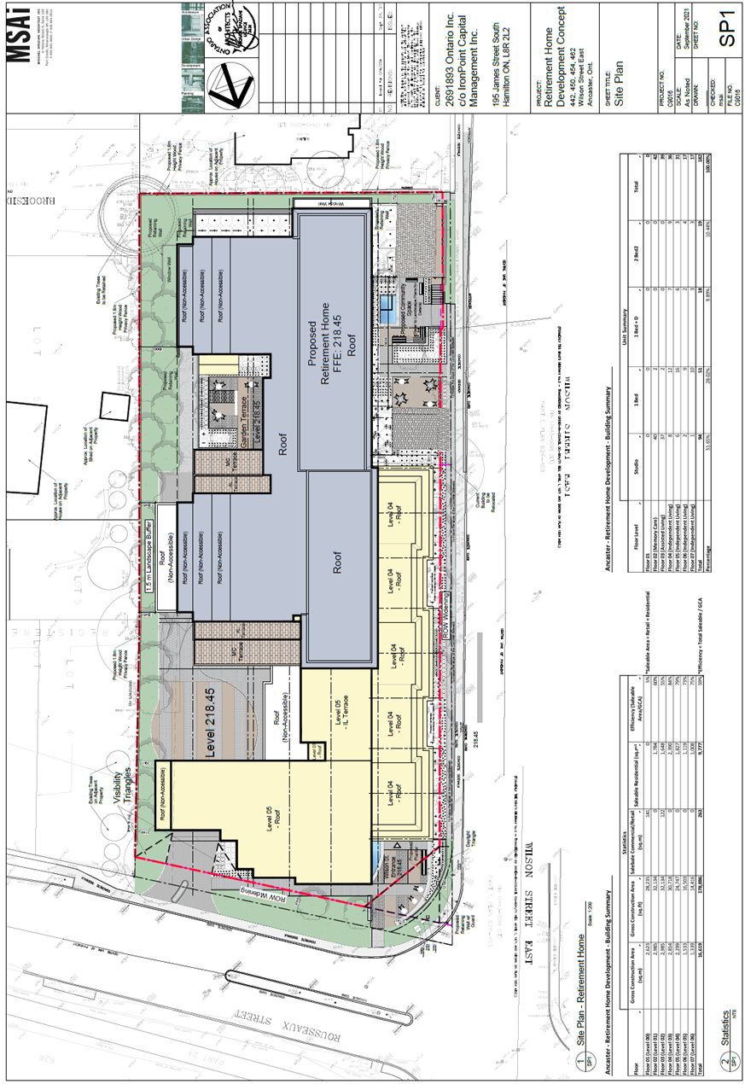

ATTACHMENT 2: Mixed Use Development Site Plan
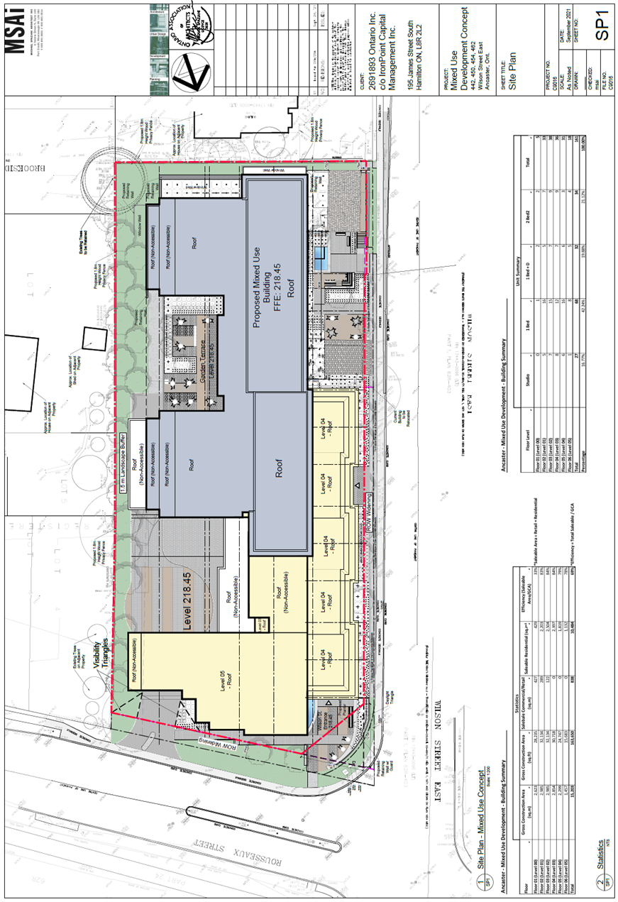

ATTACHMENT 3: Renderings

Rousseaux and Wilson Corner
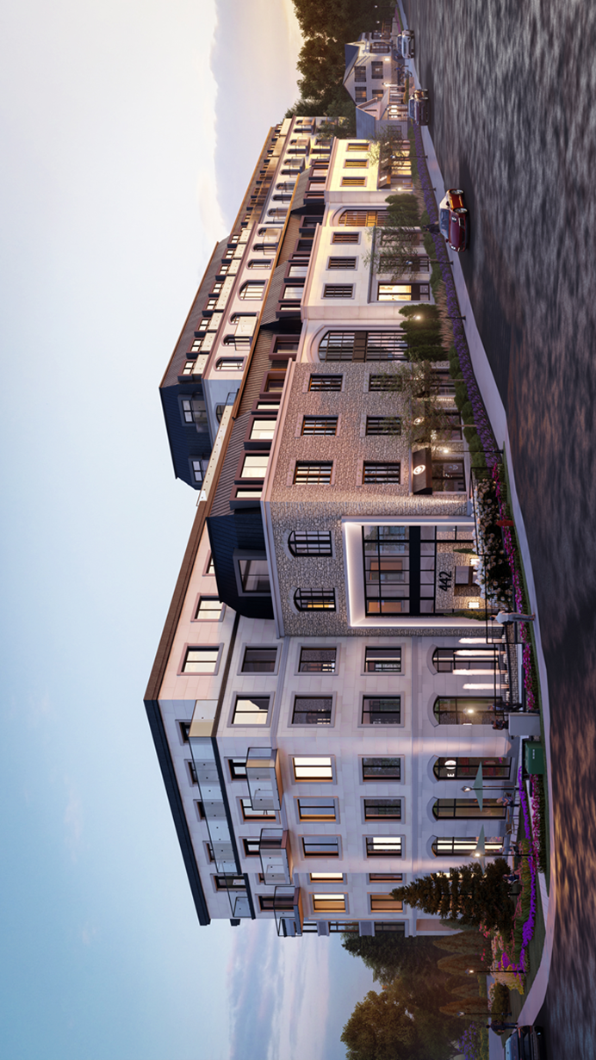

Wilson Street looking north
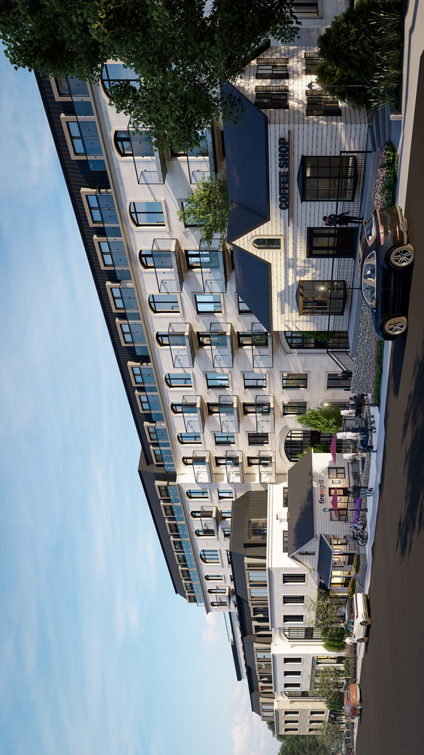

Rousseaux Street looking southwest

20 Rousseaux Street looking west
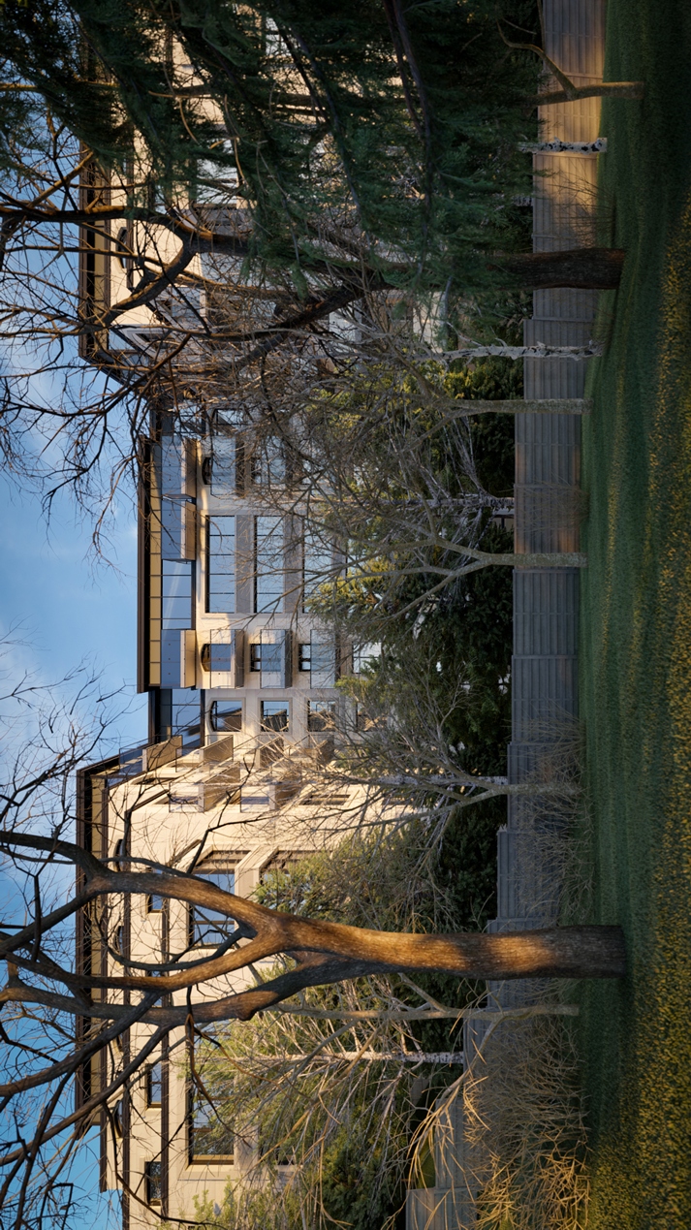

ATTACHMENT 4: NEP Land Use Designation Map
