September 15, 2022

A1: STAFF REPORT

Development Permit Application:

H/R/2021-2022/224
12688 Fourth Line
Concession 4, Part Lot 24
Town of Halton Hills, Region of Halton

Proposal:
To demolish a one storey ± 86 m2 (± 936 ft2) accessory building (detached garage) with a maximum height to peak of ± 4.5 m (± 15 ft), and one accessory storage building, to construct a one storey ± 241.5 m2 (± 2,600 ft2) accessory building (hobby workshop and carport but no associated driveway extension) with a maximum height to peak of ± 6.5 m (± 21.5 ft), to construct a one storey ± 77.2 m2 (± 832 ft2) accessory building (detached garage) with a maximum height to peak of ± 5.4 m (± 18 ft), adjacent to the dwelling, to decommission an existing septic system and construct a new septic system to service the existing dwelling and proposed workshop, and carry out related landscaping, on an existing 0.36 ha (0.91 ac) lot that supports a single dwelling and accessory facilities.

Received:
June 14, 2021

Source:
REDACTED, Owner/Applicant

Designations:

Escarpment Protection Area

Issue:
Accessory uses and facilities are permitted under the Niagara Escarpment Plan (NEP) for lands designated Escarpment Protection Area, but the proposed accessory workshop/carport does not meet the criterion of being subordinate to the principal use located on the same lot: this also conflicts with the Town of Halton Hills Official Plan policy stipulating that accessory use be subordinate to the principal land use.

Recommendation:

Approval with conditions.

Reasons:

The proposed development is in part located where two existing accessory structures (garage and storage building) are located, although the proposed workshop and carport footprint at this location extends south beyond the extant structures. While substantially larger than the existing accessory structures and dwelling, the proposed workshop and carport are situated to the rear of the property and are screened by the topography of the subject property, which rises above the adjacent road, along with the residence and vegetation. In general, there are no anticipated negative impacts to the site and surrounding environment resulting from the proposed development, and the construction of the replacement garage and workshop/carport will consolidate the contents of temporary shelters located in the rear yard, which will then be removed.

Related Files:

Development Permit Application (DPA) H/R/2020-2021/192 was submitted to construct a ± 160.5 sq m (± 1728 sq ft) accessory building (workshop) with an attached ± 26 sq m (± 280 sq ft) carport, with a height to peak of ± 6.6 m (± 21.5 ft); to construct a ± 77.3 sq m (± 832 sq ft) accessory building (garage), with a height to peak of ± 5.5 m (± 18 ft); to demolish an existing 87 sq m (936 sq ft) garage, with a height to peak of 4.6 m (15 ft); and to construct an ± 11 m (± 36 ft) long and ± 2.5 m (± 8 ft) high retaining wall, on an existing 0.36 ha (0.9 ac) lot. This DPA was replaced with the current one under consideration.

Site Description:
The property is located on the west side of Fourth Line, between Sideroad 22 and Glen Larson Road (See Appendices 1, 2, and 3). The rectangular shaped lot is accessed via an existing asphalt driveway along Fourth Line, including a crushed asphalt extension along a portion of the southwest lot line to top of slope that provides access to the rear yard. The existing single-storey, single detached dwelling of ±100 sq m (±1080 sq ft) is set back from the road on a rise and is modest in size, while the existing accessory structures (detached garage and storage building) are located behind the single dwelling at a slightly higher elevation. The interior of the property consists of manicured lawn area otherwise bordered by trees. The property consists of varied topography, made up of developed and disturbed areas with mature trees (Candidate Significant Woodlands) and cedar hedges screening the north, south and west lot lines. The existing accessory buildings (detached garage and storage building) are identified as being within 10 metres of the Candidate Significant Woodlands. Additional unpermitted temporary structures including a universal shipping container, frame storage and coverall building are also located in the rear yard.

Background:
12688 Fourth Line, in the Town of Halton Hills, Region of Halton, is an area designated as Escarpment Protection Area by the NEP 2017. Accessory uses are permitted uses in this land use designation within the NEP (Part 1.4.3.11. The proposed workshop and carport are adjacent to Candidate Significant Woodlands (NEP 2.7.2.a and Provincial Policy Statement 2.1), while siting of this structure has been adjusted to accommodate the proximity, and in consideration of scenic resources (NEP 2.13.4)

Accessory uses are permitted in Part 1.4.3.11 of the NEP for the Escarpment Protection Area. “Accessory” is defined by the NEP as being “naturally and normally incidental, subordinate, and exclusively devoted to the principal use located on the same lot”: accessory use and accessory facility are similarly worded.

The Town of Halton’s Official Plan policy states that an accessory use is naturally and normally incidental and subordinate to the principal use of the property, being residential. Objective 7 of the NEP directs the NEC to support municipalities in their exercise of planning functions under the Planning Act, and so consideration of this policy is warranted.

The Town of Halton’s comments are of remaining interest in this matter. NEC staff has not received any comments from the public in opposition to the project, while resolution of the NEP policy concerns introduced above and detailed below are the focus of this analysis and recommendations to ensure any Commission recommendation is not in conflict with the Niagara Escarpment Plan, 2017.

Planning Analysis:

Niagara Escarpment Plan (NEP 2017)

Part 1 Land Use Designation and Permitted Uses:
The subject property is designated as Escarpment Protection Area (1.4) by the NEP. Within this designation accessory uses are permitted, as defined by the NEP. However, conformity of the proposed construction with the NEP definitions of accessory, accessory use and accessory facility warrants further analysis. The NEP definitions of the terms accessory, accessory use and accessory facility are consistent in describing use and architecture that are “naturally and normally incidental, subordinate, and exclusively devoted to the principal use located on the same lot”. This is taken to mean that any additional use of the property is subordinate to the principal use, in this case habitation, and that any accessory structure is subordinate to the principal structure on the property, in this case a dwelling. While the proposed garage is in keeping with these criteria for “accessory”, the combined workshop and carport has a substantially larger ground floor area (241.5 sq m vs. 100 sq m) and height (6.5 m vs.1 storey) than the principal dwelling on the property, and so are not physically subordinate. In addition, servicing to the workshop and carport, along with the scale of the structure, has potential implications on future use, which can potentially be addressed through approval conditions or a restriction on title. In combination with mitigation of visual impact through amendment of the original proposed design and siting, and removal of the existing garage and storage building and temporary storage structures, it is opined that this net effect means that Part 1.4.3.11 of the NEP is met.
Part 2.2 General Development Criteria:
Part 2.2.1 of the NEP states the Escarpment environment should be protected, restored, and where possible enhanced and that regard should be given to multiple or successive developments that are likely to occur. NEC staff have typically interpreted this policy as a direction to consider the cumulative impact that development may have on a property and the surrounding area. The property has existing residential and accessory use, with the proposed garage location in a combined existing impermeable surface and leeching bed area, and the proposed workshop and carport partially covered by an existing garage and storage building: temporary structures also populate the rear yard that will be removed as part of this project, while an extension of the driveway to the workshop and carport is not proposed. This area is designated as Escarpment Protection Area by the NEP and abuts Candidate Significant Woodlands. As per the comments from Credit Valley Conservation below, the location is within an area regulated by the conservation authority, but it does not appear to be impacted by the hazard associated with the nearby provincially significant wetland. NEC staff are satisfied that with removal of the existing buildings and temporary structures, design, location and construction of the proposed structures, replacement of the septic and related landscaping do not conflict with Part 2.2.1 or 2.2.2 of the NEP and that the Development Criteria of Part 2.2 (General) are met.

Part 2.6 (Water Resources) Development Criteria:
The subject property is identified as being within a Significant Groundwater Recharge Area and Highly Vulnerable Aquifer. Based on the information provided by the applicant, the Region of Halton advised that this application is not subject to Section 59 under the Clean Water Act, 2006. NEC staff are satisfied that the Development Criteria of Part 2.6 (Water Resources) have been met.

Part 2.7 (Natural Heritage) Development Criteria:
The proposed detached garage and workshop with carport are to be located within existing manicured lawn areas. The existing accessory buildings (detached garage and storage building) are located adjacent to a Candidate Significant Woodland. The Region advised that the proposed workshop with carport accessory building is to be located no closer to the feature than the existing accessory structures. In consultation with NEC and Regional staff, the applicant agreed to move the location of the proposed workshop and carport accessory structure, private sewage disposal system, and associated grading so that they do not encroach any closer to the feature (Candidate Significant Woodlands) than the existing garage and storage building with foundations. A standard search of the Natural Heritage Information Centre (NHIC) database did identify species at Risk (SAR) within a 1 km square grid of the subject property, including, snapping turtle, midland painted turtle, and eastern meadowlark. No impacts to the aforementioned SAR are anticipated as the species prefer shallow stream and grassland habitats. The erection of erosion and sediment control fencing during construction will serve to exclude turtles that may be tempted to nest in excavated soils. NEC staff do not anticipate any negative impacts to the surrounding key natural heritage features and are satisfied that the Development Criteria of Part 2.7 (Natural Heritage) have been met.

Part 2.13 (Scenic Resources) Development Criteria:
The proposed garage is modest in size and sited close to the existing dwelling in an area previously disturbed and currently used for parking and septic servicing. Views of the proposed garage will be largely limited by existing vegetation on the lot lines and, although the garage will be visible from the road when viewed from directly in front of the house, the scale of the proposed garage is in keeping with the existing dwelling. The proposed workshop and carport has a larger footprint and height than the existing accessory garage and storage building. For this reason, NEC planning staff consulted the NEC landscape architect regarding potential visual impact concerns. Through this review it was determined that the proposed workshop is well set back from the road behind the existing dwelling. Views of the proposed workshop will be limited by the existing dwelling and existing vegetation at lot lines, aided by the elevation of the property above the road. There is potential for some of the workshop/carport structure to be visible above the existing dwelling and proposed garage from the road. This potential impact was mitigated by stepping back the double-height portion of the workshop roof, and reorientation of the building so that the tallest part of the building is perpendicular to and a shorter length of building visible from the road. NEC staff are satisfied that the impacts to the scenic resources of the Escarpment will be minimized and that the Development Criteria of Part 2.13 (Scenic Resources and Landform Insert any needed sub-headings using “Heading 4” (e.g., NEP Part x, PPS, etc.)

Provincial Policy Statement (2020)
Section 2.1 of the 2020 Provincial Policy Statement (PPS) directs the long-term protection of natural features and areas. The proposed development will be located largely within already disturbed areas and will be distanced from the potential key natural heritage features (Candidate Significant Woodland) on-site. NEC staff are satisfied that the proposed development is consistent with Part 2.1 and 2.2 of the PPS.

Agency Consultations:
Town of Halton Hills
Town Planning staff note that under the Town’s Official Plan (Sec. G13.6 Accessory Uses) whenever a use is permitted in the land use designation, it is intended that uses, buildings or structures normally incidental, and accessory to that use are also permitted. The Town defines an accessory building or structure as a detached building or structure, the use of which is naturally and normally incidental to, subordinate to, or exclusively devoted to the principal use or building, and located on the same lot and that is not used for human habitation. For the purposes of the proposed workshop and carport, the Town notes that the structure does not appear to be subordinate, or exclusively devoted to the principal use or building.
The property is under the land use control of the Niagara Escarpment Commission and has no zoning under the Town of Halton Hills Zoning By-law 2010-0050 (Sec. 4.1.1 b), which states that no accessory building or accessory structures shall be used for human habitation or an occupation for gain or profit except if specifically permitted by this By-law. Should lands be reviewed under Zoning By-law 2010-0050 (Sec. 4.1.1 b), a workshop/carport would not be permitted if this large structure is used for an occupation for gain or profit.
In summary, the intent of accessory buildings and structures is to ensure that they do not visually dominate the lot, are clearly accessory to the principal residential use (i.e. detached dwelling) and do not create impacts to surrounding properties. Town Staff are of the opinion that the intent of accessory buildings and structures is not being maintained as the proposed workshop and carport are not incidental and subordinate to the principal residential building.
Credit Valley Conservation Authority
No objection. A Credit Valley Conservation (CVC) permit will be required for the proposed development. The subject property is within a CVC Regulated Area as it is within proximity to the Provincially Significant Black Creek at Acton Wetland Complex on the adjacent property to the North. The subject property is partially located within the Credit River Watershed Natural Heritage System (CRWNHS). CVC staff note that the proposed workshop with carport is satisfactorily setback from the wetland but within approximately 10 metres of the dripline to the woodland.
Region of Halton
No objection. The area subject to this application is designated as Regional Natural Heritage System (RNHS) on Map 1 of the 2009 Regional Official Plan (ROP). Additionally, the lands contain or are adjacent to:
- Candidate significant woodlands;
- Potential habitat of endangered and threatened species; and,
- Potential significant wildlife habitat.
The subject lands are located within the jurisdiction of the Source Protection Plan. The property is located in a Significant Groundwater Recharge Area and Highly Vulnerable Aquifer. Based on the information provided by the applicant, this application is not subject to Section 59 under the Clean Water Act, 2006. Regional staff reviewed the site plan drawing, dated March 11, 2021, and revised and resubmitted on February 10, 2022. Regional staff note that the applicant has moved the proposed accessory structure and septic and associated grading so that they do not encroach any closer to the feature (candidate significant woodlands) on site. Regional staff find that this sufficiently addresses the Regional concerns.
It should be noted that the area is identified as having archaeological potential. Although an archaeological assessment is not required by Halton Region, the proponent is cautioned that during development activities, should archaeological materials be found on the property, the Ontario Ministry of Tourism, Culture and Sport should be notified immediately (416-212-8886 or archaeology@ontario.ca). In the event that human remains are encountered during construction, the proponent should immediately contact the appropriate authorities (police or coroner) and all soil disturbance must stop to allow the authorities to investigate and the Registrar of Cemeteries to be consulted.

Summary:
In reviewing the proposal, NEC staff took into consideration the existing structures and other features on the property in consideration of the proposed demolition of existing accessory structures and removal of unpermitted temporary storage features. NEC staff share concerns with the Town of Halton Hills over the issue of subordinate accessory use and facilities with respect to the proposed workshop and carport: this also encompasses NEP Objective 7, whereby the NEC is to support municipalities in their role making and implementing decisions under the Planning Act. NEC staff note that the Town of Halton provides advice to the applicant on their concern with the subordinate use matter, but have not formally raised an objection. In conjunction with a condition on the private and non-habitation uses of these new structures, in addition to their amended design and placement, NEC staff are of the opinion that the Part 1 criterion for accessory use has been met.
The proposed demolition of existing structures, removal of temporary storage facilities, replacement of septic, landscaping, lack of driveway extension to the workshop and carport, and construction of new structures largely on existing disturbed areas, in addition to the hydrogeological study, indicates that the property can accommodate these alterations and additions without negative impacts to the adjacent Candidate Significant Forest and hydrology. NEC staff are satisfied that the Development Criteria of Part 2 of the NEP has been met and that the proposal is a permitted use. There were no formal objections from consulted agencies regarding the proposal.

Recommendation:

The Development Permit Application be approved, subject to attached conditions.

Prepared by:
Original signed by:
____________________
Joe Muller
Senior Strategic Advisor

Approved by:
Original signed by:

_______________________
Kim Peters, MCIP, RPP, Manager

Attachments:
Appendix 1 – Conditions of Approval
Appendix 2 – Orthophoto of the Subject Property
Appendix 3 – NEP Designations Map
Appendix 4 – Natural Heritage Features Map
Appendix 5 – Site Plan

- Development shall occur in accordance with the Terms and Conditions of the Development Permit.

- The Development Permit shall expire three (3) years from the date it has been issued or once the development has been completed in accordance with the Development Permit.

- No site alteration of the existing contours of the property including the placement or stockpiling of fill (i.e., excess or imported soil) on the property is permitted with the exception of that identified within the development envelope in accordance with the Final Site Plan.

- No vegetation shall be cut or removed from the development envelope except for that identified within the development envelope in accordance with the Final Site Plan.

- If development has commenced under this Development Permit, any/all disturbed areas of land or soil shall be re-vegetated and stabilized to the satisfaction of the Niagara Escarpment Commission on or before the date of expiry of the Development Permit.

- All exterior site lighting associated with the accessory buildings shall be designed to be minimal, subdued, of low height and downward facing (no soffit lighting shall be installed above exterior wall height or at a height that exceeds 3.6 metres from finished grade).

- Prior to the issuance of a Development Permit by the Niagara Escarpment Commission, an accurate and detailed Final Site Plan shall be submitted for Niagara Escarpment Commission approval. The following stipulations shall be included directly on the Plan:
- The Final Site Plan shall be prepared by a qualified professional;
- All drawings submitted must be drawn to scale (bar scale shown), reference the application number and address of the proposal, be dated (revisions as well), and include the name of the relevant individual or consultant who prepared the drawing;
- Outline of the approved development envelope / extent of all disturbed areas;

Condition 7 continued

- Accurate size and location of all existing and proposed structures, sewage disposal system, well/cistern, driveway, construction access / haul routes, exterior lighting, etc. showing setbacks from the property lines, any watercourses or water features, top / bottom of slope, wooded areas, etc.;
- Grading, drainage, and fill management details including the areas of excavation and temporary or permanent fill placement. The type, quantity, quality and source location of any imported fill material must be accurately identified.
- The location and design of erosion and sediment control measures (e.g., fencing, blankets, rip-rap, temporary mulch / seeding), and limit-of-work construction or eco-protection fencing;
- Identify the areas of existing vegetation to be retained, areas of vegetation to be removed, and the location of proposed plantings.

Development shall proceed in accordance with the details of the approved Final Site Plan.

- Prior to the issuance of a Development Permit by the Niagara Escarpment Commission, the landowner shall submit for the approval of the Niagara Escarpment Commission, final construction details for the proposed development, including exterior elevations, total floor area, floor plans, height to roof peak from lowest grade, and any exterior lighting.
Development shall proceed in accordance with the details of the approved Final Construction Details.

- Prior to the issuance of a Development Permit by the Niagara Escarpment Commission, the Landowner shall enter into an Agreement under Section 24(2.1) of the Niagara Escarpment Planning and Development Act, in a form acceptable to the Niagara Escarpment Commission. The agreement shall be registered on title of 12688 Fourth Line (ARN 241507000614200), Concession 4, Part Lot 24 Town of Halton Hills, Region of Halton, at the Landowner’s expense, that the workshop and garage buildings shall not be used for human habitation (i.e., living space), as short or long-term rental accommodation, or for commercial, institutional, home business, industrial or livestock purposes, and, the Landowner shall provide proof satisfactory to the Niagara Escarpment Commission that the agreement has been registered against the lands, and that the Landowner under this Development Permit is the Landowner of the lands at the time of registration. The agreement
Condition 9 continued

shall not preclude the owner, or subsequent landowners, from applying for further development permits in future in accordance with the NEP as amended from time to time.

- All waste materials generated from the demolition shall be completely removed from the property (e.g., taken to an approved landfill site, savage/reclamation facility, re-used/recycled elsewhere) and not otherwise stored or buried on-site. All disturbed areas shall be immediately stabilized / rehabilitated as per the approved Site Plan (Condition # 7).

- Conditions 7, 8, and 9 must be fulfilled within eighteen (18) months from the date of confirmation of the Commission’s decision or this conditional approval shall lapse and a Development Permit will not be issued

Advisory Notes

- A Development Permit does not relieve the permit holder of any other permission (e.g., Ontario Building Code, Conservation Authorities Act, Endangered Species Act, etc.). A Niagara Escarpment Commission Development Permit is required prior to the issuance of any other permission, including but not limited to home occupation or home occupation.

- The Niagara Escarpment Commission supports the protection of the night sky from excessive lighting and recommends the applicant obtain information on the use and operation of appropriate lighting fixtures in keeping with dark sky approaches.

- Should deeply buried archaeological remains/resources be found on the property during construction activities, the Heritage Operations Unit of the Ontario Ministry of Tourism, Culture and Sport shall be notified immediately. In the event that human remains are encountered during construction, the owner shall immediately notify the police.

Appendix 2 – Orthophoto of the Subject Property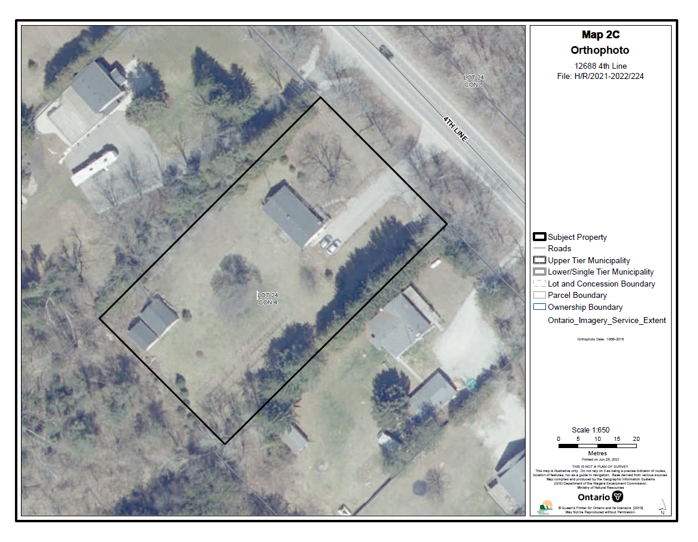
Appendix 3 – NEP Designations Map
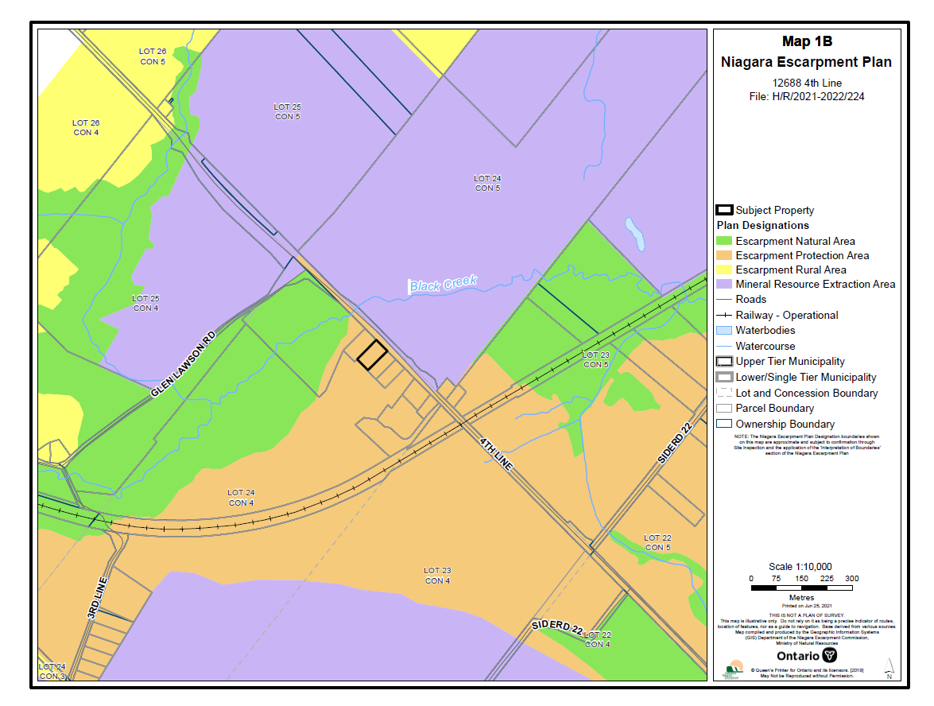
Appendix 4 –Natural Heritage Features Map
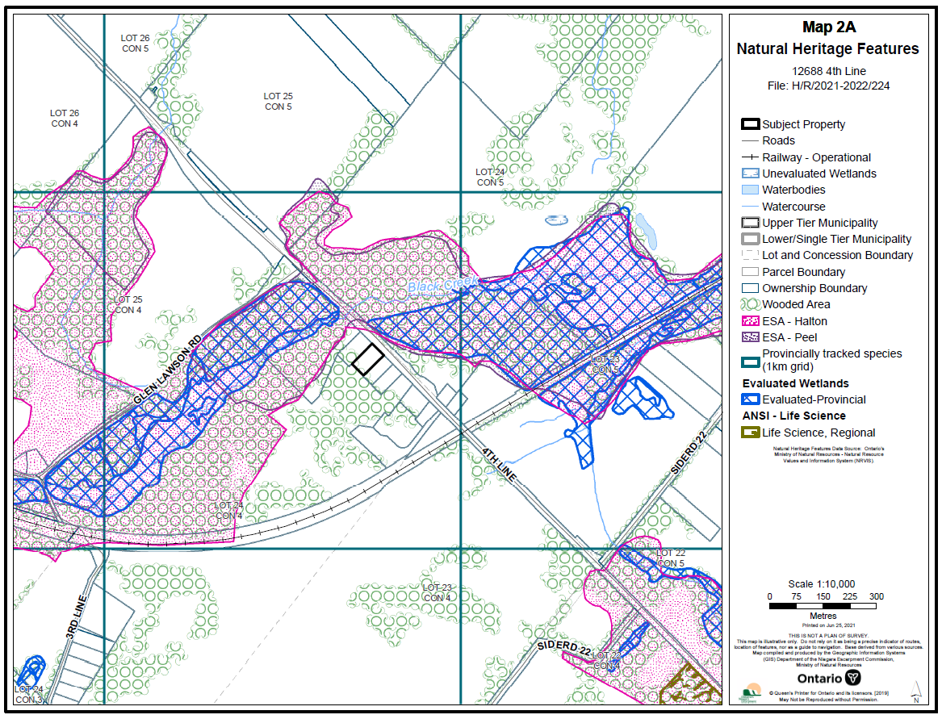
Appendix 5 – Draft Site Plan
