September 15, 2022

A3: STAFF REPORT

DEVELOPMENT PERMIT APPLICATION:

H/A/2021-2022/426
10268 Third Line
Concession 3, Part Lots 11 & 12
Town of Milton, Region of Halton

Proposal:
To construct a ± 1,508.7 sq m (± 16,240 sq ft) equestrian riding arena, a ± 192 m (± 630 ft) driveway and associated ± 348.4 sq m (± 3,750 sq ft) parking area on a 28.5 ha 70.48 ac lot.

Received:
August 10, 2021

Source:
REDACTED, Owner/Applicant

Designations:
Escarpment Rural Area, Escarpment Natural Area

Issue:
The Niagara Escarpment Plan does not contain policies that would support the riding area as proposed.

Recommendation:
Refusal

Reasons:

The riding arena does not contain a stable area to board horses and therefore does not meet the definition of an agricultural use in the Niagara Escarpment Plan (NEP). The riding arena is also not consistent with the policies related to accessory uses, on-farm diversified uses, agricultural-related uses, or recreational uses. It is therefore not a permitted use.

Related Files:
- Development Permit #8276/H/R/2004-2005/176 was issued to construct a 1 storey ± 200 sq m (± 2160 sq ft) private storage building and driveway extension on a 28 ha (70 ac) lot.

- Development Permit #7281/H/R/2000-2001/386 was issued to construct a 2 storey, 275.6 sq. m (2963 sq. ft) dwelling with septic system and driveway, and to construct a 1 storey, 93 sq. m (1000 sq. ft) storage barn on an existing 28.5 ha (70.5 ac) lot.

Site Description:
The 28.5 ha (70.5 ac) property is located on the west side of Third Line, between 10 Sideroad and 15 Sideroad in the Town of Halton Hills, immediately to the east of the Scotch Block Reservoir. The irregular shaped lot is accessed via an existing circular driveway along Third Line. Approximately 12 hectares of the property are wooded, containing swamp that is part of the Scotch Block provincially significant wetland (PSW) complex. Approximately 16 hectares of the property consists of agricultural fields, which have been under cultivation for many years. The existing single-storey, single detached dwelling of ±328 sq m (±3,534 sq ft) is set back from the road on gently rolling topography and the existing accessory structures consist of ±7 sq m (±80 sq ft) garden shed] and ±254 sq m (±2736 sq ft) storage structure. The appendices to this report contain mapping and an orthophoto of the subject property.
The application for a riding area was submitted by the landowner, who has stated that the riding arena will be used on an occasional basis by the landowner’s daughter. Horses will not be boarded on site and there is no pasture or paddock area indicated on the site plan.

Planning Analysis:

NEP Part 1: Land Use Designations
The subject property is designated as Escarpment Rural Area and Escarpment Natural Area by the Niagara Escarpment Plan, 2017 (NEP). All existing and proposed development is located within the Escarpment Rural Area.
Part 1.5.1 of the NEP lists the objectives of the Escarpment Rural Area designation. The following objectives are relevant to this application:
- To maintain and enhance the scenic resources and open landscape character of the Escarpment.
4. To provide for compatible rural land uses.
5. To encourage agriculture and protect agricultural lands and prime agricultural areas
6. To provide a buffer for ecologically sensitive areas of the Escarpment.
NEC staff have assessed the proposal against the listed permitted uses in Part 1.5.3 of the NEP to determine whether the proposed equestrian riding arena could be considered a permitted use in the Escarpment Rural Area.

Accessory use
An accessory use is defined in the NEP as “the use of any land building, structure or facility that is naturally and normally incidental, subordinate, and exclusively devoted to the principal use located on the same lot.” Given the scale of the proposed riding arena, it is not subordinate to the residential use on the property. Furthermore, its proposed occasional use as a riding facility for off-site horses and riders is not something that is normally incidental to a residential use.
In consideration of it being accessory to the existing agricultural (field crop) use on the property, a riding arena is also not normally incidental to crop production. Therefore, it should not be considered as accessory to the existing agricultural use on the property.

Agricultural use
An agricultural use is defined in the NEP as “the growing of crops, including nursery, biomass, and horticultural crops; raising of livestock; raising of other animals for food, fur or fibre, including poultry and fish; aquaculture; apiaries; agro-forestry; maple syrup production; and associated on-farm buildings and structures, including, but not limited to livestock facilities, manure storages, value retaining facilities, and accommodation for full-time farm labour when the size and nature of the operation requires additional employment.”
There is no proposal to raise animals (i.e., horses) as part of the riding arena use. A riding arena alone is not an agricultural use. Therefore, the proposed development cannot be permitted as an agricultural use. Discussion of the development criteria for agricultural uses in Part 2.8 of the NEP is included below, although the proposal does not fit with the definition of an agricultural use.

Agriculture-related use and on-farm diversified use
These permitted uses have been included on the list due to existing agricultural use (field crops) on the property. While this application specifically proposes the construction of an equestrian riding arena and associated driveway and parking area, it is important to consider the existing development on the property and context of the application.
An agriculture-related use (ARU) is defined in the NEP as “a farm-related commercial and farm-related industrial use that is directly related to farm operations in the area, supports agriculture, benefits from being in close proximity to farm operations, and provides direct products and/or services to farm operations as a primary activity.”
An on-farm diversified use (OFDU) is defined as “a use that is secondary to the principal agricultural use of the property and is limited in area. On-farm diversified uses include, but are not limited to, home occupations, home industries, agri-tourism uses, and uses that produce value-added agricultural products.”
The riding arena does not fall within the definition of an ARU. As an ARU, it does not provide farm-related services to farm operations in the local area, nor does it provide value-added agricultural processing.
In consideration of the OFDU definition, it is unclear on whether the riding area is secondary to principal agricultural use on the property. The total development footprint exceeds 1,914 sq m (20,600 sq ft) and therefore does not fit the definition of a home occupation or industry given its large size and unknown status in terms of its commercial use. As an agri-tourism use, no business plan or indication that the riding arena will be open to the public has been provided. No value-added agricultural products are being produced. Discussion of the criteria for ARUs and OFDUs is included below, although staff contends the proposal is not consistent with the definition of an ARU or OFDU.

Recreational use
As noted above, recreational uses are permitted in Escarpment Rural Area, outside of prime agricultural areas. “Recreational uses” were added to the permitted uses in Escarpment Rural Area in the 2017 NEP. However, a definition of “recreational use” was not added to the NEP to provide clarity on what a recreational use would include. In addition, the subject property is designated as being within a prime agricultural area in the Region of Halton’s official plan. Therefore, the riding arena is not permitted as a recreational use because the subject property is located in a prime agricultural area.

Part 2: Development Criteria:
The development criteria are usually only given consideration when a proposed use is a permitted use in Part 1 of the NEP. The language in Part 1 states that a use is permitted “subject to meeting the development criteria in Part 2.” Thus, if a proposed development is not listed as a permitted use, it does not matter if it meets the development criteria in Part. It is simply not permitted. Therefore, NEC staff does not normally consider whether a non-permitted use can meet the development criteria, unless it can help to clarify why the proposed use would not be permitted. The proper avenue to consider non-permitted uses is through a NEP amendment, through which more detailed analysis can be conducted, and can also address Planning Act approvals, such as official plan amendments, that are likely required.
However, the development criteria in this case are of assistance in determining why the proposed riding arena cannot be considered an agricultural use or an OFDU. Staff has therefore focused on the policies within Part 2.8 related to agriculture. Part 2.2 is also relevant: the objective of Part 2.2 is to permit reasonable enjoyment by the owners of all lots that can sustain development, but Part 2.2 also speaks to the cumulative impacts of development, which are a consideration.

Part 2.2 General Development Criteria
Part 2.2.1 requires that the Escarpment environment be maintained, restored and where possible enhanced for the long term having regard to single, multiple or successive development. The lack of a clearly identified permitted use in the case of this riding arena is a concern from a cumulative impact of development perspective. Approval of development that does not clearly meet the policies of the NEP sets a precedent for piecemeal decision-making inconsistent with the principles of good land use planning.

The allowance for very large structures that are not justified through association with a clearly permitted use can have a negative impact on open landscape character and scenic resources. Thus, their presence within the NEP Area should be discouraged.

Part 2.8 Agriculture
Part 2.8.1 states that prime agricultural areas shall be protected for long term agricultural use. The property is designated by the upper tier municipality as being within a prime agricultural area. An equestrian farm including horse husbandry and riding facilities would be considered an agricultural use that would not be excluded from a prime agricultural area. However, as per the NEP definition of agricultural use, a riding arena alone is not an agricultural use since there is no animal husbandry associated with it, nor is there a pasture or paddock area for horse grazing.
Part 2.8.2 states that development, including livestock facilities shall comply with the minimum separation distance (MDS) formulae. Although the riding arena is not proposed to house livestock, there is the potential to do so in the future. (Note: as per the floor plans in Appendix 5, the riding arena is not designed to accommodate horse boarding.) Thus, a MDS II calculation was requested. The calculation was done for two nutrient units, noting that no manure storage is required (manure is stored for less that 14 days). For reference, one medium-frame horse equals one nutrient unit, so the submitted MDS calculations would allow for a maximum of two medium-frame horses to be accommodated in the facility. At this limited scale of intensity, the submitted MDS calculation indicates that the proposed riding arena, if it contained a stable area and be used to raise or board a maximum of two medium-frame horses, would meet setback requirements.
Part 2.8.7 lists the criteria that on-farm diversified uses (OFDUs) must meet. Staff did consider whether the riding arena could be considered an agri-tourism use given that it is proposed to be used for non-resident riders and horses. The applicant did not indicate that there was an intended agri-tourism component, but it is the permitted use that most closely aligns with the proposal, other than a recreational use, which is not permitted. Like most riding arenas, the facility is large, consisting of the ±1,509 sq m equestrian riding arena, as well as a ±192 m driveway extension, and associated ±348 sq m parking area. In total, the proposed riding arena use would occupy a footprint of 2,049 sq m.
Parts 2.8.7 (g) and (h) speak to the size of OFDUs to ensure they remain spatially subordinate to the agricultural use on the lot. Part (g) allows an OFDU to occupy two percent of a farm lot, to maximum of 10,000 sq m. On the 28.5-hectare lot, two percent of the total area is 5,700 sq m. Thus, the total footprint of the use (2,049 sq m) does not exceed the maximum area allowable for an OFDU. However, Part (h) limits the gross floor area of any buildings used for the OFDU to a maximum of 20 percent of the total allowable area for the OFDU. Twenty percent of 5,700 sq m is 1,140 sq m. The riding arena, proposed at 1,509 sq m exceeds the allowable building size by 369 sq m.
The intent of ARU and OFDU policies is to ensure the viability of farming and protection of farmland by ensuring additional sources of income are available to farmers. Furthermore, limiting the scale of ARUs and OFDUs is intended to ensure that they remain subordinate to the agricultural use on the farm, and that the open landscape character of the Escarpment is protected. The proposed riding arena does not meet the intent of these policies.

Agency Consultations:

Town of Halton Hills
No objection.
The Town asks that the NEC requires the applicant to comply/consider the following:
- The Town requires a grading plan completed that demonstrates how grading and drainage shall function for the applicant’s proposal.
- The Owner/Applicant may need to acquire a Site Alteration Permit under Bylaw 2017-0040 for the proposed works through the Development Engineering Department prior to the issuance of the associated Building Permit.

Region of Halton
No objection.
The subject property is designated as Regional Natural Heritage System (RNHS) on Map 1 of the 2009 Regional Official Plan (ROP). The subject property contains Prime Agricultural Area as shown on Map 1E of the ROP. Additionally, the lands contain or are adjacent to:
- Candidate significant woodlands;
- Potential habitat of endangered and threatened species;
- Potential significant wildlife habitat; and,
- Potential fish habitat.

The Region’s Environmental Impact Assessment requirements were waived for this project as the proposed works will be setback sufficiently from any sensitive natural features or areas and will not likely result in any impacts on the features or ecological functions of the Regional Natural Heritage System. The subject property is also located within the jurisdiction of the Halton-Hamilton Source Protection Plan (SPP). Based on the information provided by the applicant, this application is not subject to Section 59 under the Clean Water Act, 2006.

Majority of the subject property is noted as having archaeological potential. Although an archaeological assessment is not required by Halton Region, the proponent is cautioned that during development activities, should archaeological materials be found on the property, the Ontario Ministry of Heritage, Sport, Tourism and Culture Industries should be notified immediately (416-212-8886 or archaeology@ontario.ca). In the event that human remains are encountered during construction, the proponent should immediately contact the appropriate authorities (police or coroner) and all soil disturbance must stop to allow the authorities to investigate and the Registrar of Cemeteries to be consulted.

Conservation Halton (CH)
No objection.
The proposed equestrian riding arena is located outside of CHs regulated limit, however, a portion of the proposed driveway and parking area appears to be within the 30 to 120 m limit of the Provincially Significant Wetland (PSW) on site. As such, a CH Permit will be required for these works.
CH provides ecological technical review services for all planning applications for conformity with the natural heritage policies of the Regional Official Plan (ROP). During a site visit completed on March 18, 2022, it was determined that the proposed development was outside and adequately setback from the Regionally Significant Woodland. The following advisory comments that should be considered and implement during construction were also provided:
- Construction of the equestrian riding arena should include erosion and sediment control measures to prevent sedimentation of the wetland feature adjacent to the property.
- Construction should avoid unusually wet, rainy or winter thaw conditions.
- Machinery is to arrive on site in a clean condition and is to be maintained free of fluid leaks.
- Stockpile materials and equipment outside of the natural heritage system.
- Install tree protection, construction and sediment fencing prior to construction commencing. Fencing should remain until all works are complete.

Summary:
NEC Staff are recommending that the development proposal be refused. The proposed riding arena is not permitted as an agricultural use given that it lacks an animal husbandry (e.g., horse boarding) component. Staff also considered the policies associated with other permitted uses, including accessory use, agriculture-related use, on-farm diversified use, and recreational use, but the proposed riding arena is not consistent with the definition of these uses and does not meet the development criteria associated with these uses.
Although commenting agencies have no concerns about the proposal, the NEP takes precedence over municipal policies. Given that the riding arena is not consistent with the policies of the NEP, staff must recommend refusal.

Recommendation:
That the application be refused for the reasons outlined in this report and summarized in the attached Appendix 1.

Prepared by:

Original signed by: Original signed by:
_______________ ________________
Julia Lomuti Kim Peters, MCIP, RPP
Senior Planner (Acting) Manager

Approved by:

Original signed by:
________________
Kathy Woeller
Director

Attachments:
- Reasons for Refusal
- Orthophoto
- Land Use Designation Map
- Site Plan
- Site Plan Enlarged
- Riding Arena Floor Plan

APPENDIX 1

REASONS FOR REFUSAL H/A/2021-2022/426
- The proposed riding arena does not meet the definition of an agricultural use given that it does not include animal husbandry.

- The proposed riding arena does not meet the definition of an accessory use to either the dwelling or existing agricultural use on the subject property.

- Recreational uses are not permitted in prime agricultural areas.

- The proposed riding arena does not meet the definitions of an agriculture-related use or on-farm diversified use and exceeds the allowable area for a building associated with an on-farm diversified use.

- The application of NEP policies should be done consistently across the NEP Area, to avoid piecemeal land use planning and avoid the cumulative impacts associated with inconsistent application of NEP policies.

APPENDIX 2

Orthophoto of Subject Property

APPENDIX 3

NEP Land Use Designations Map
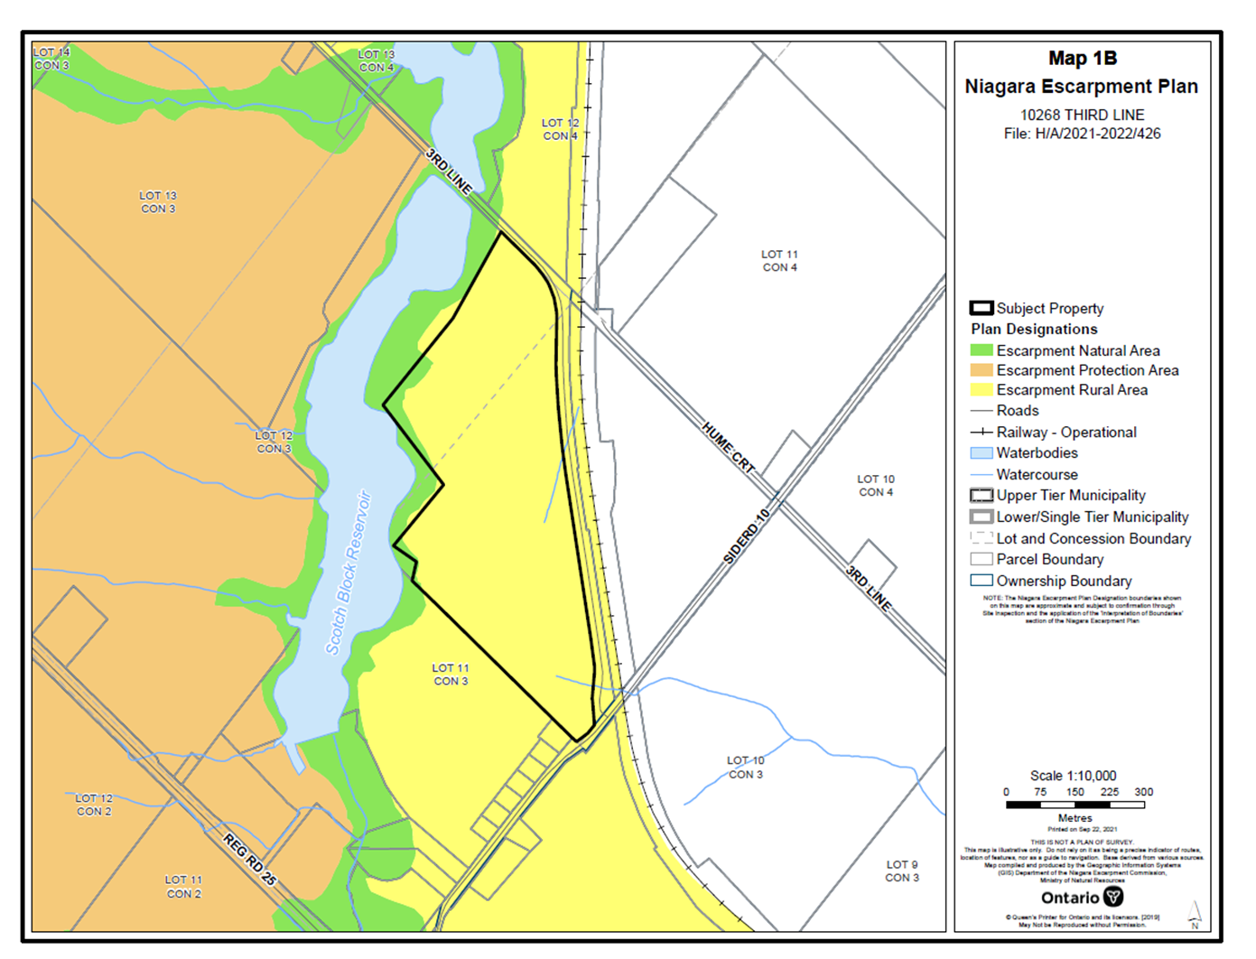

APPENDIX 4

Site Plan

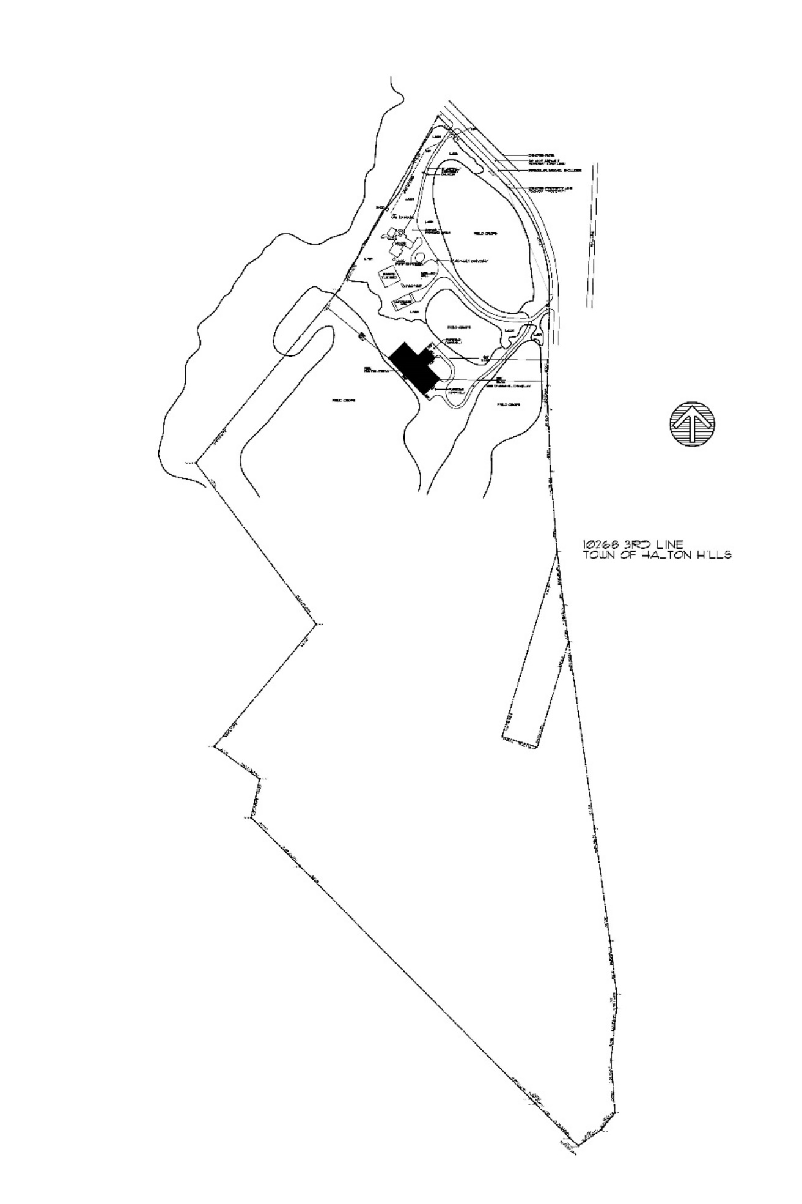

APPENDIX 5

Site Plan (Enlarged)

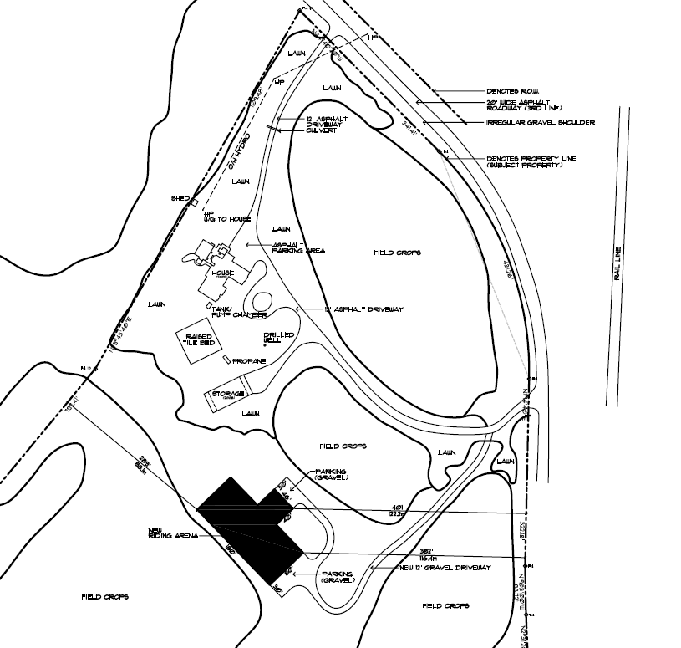

APPENDIX 6

Riding Arena Construction Details
