# Text Description automatically generatedNiagara Escarpment Commission

232 Guelph St.   
Georgetown, ON L7G 4B1  
Tel: 905-877-5191  
[www.escarpment.org](http://www.escarpment.org)­

September 15, 2022

# A4: STAFF SUMMARY POSITION REPORT

**RE: PROPOSED NIAGARA ESCARPMENT PLAN AMENDMENT PP 223 21**

**Redesignation of the former Pinchin Pit lands**

**Part Lots 13 & 14 Concession 5 WHS**

**Town of Caledon, Region of Peel**

APPLICANT: Credit Valley Conservation (CVC)

OWNER:Credit Valley Conservation (CVC) & AECON Construction Ltd.

DATE RECEIVED: August 9, 2021

## PROPOSAL SUMMARY:

To re-designate a portion of Pinchin Pit lands that are currently located in the Niagara Escarpment Plan Area (approximately 48.8 ha), from Mineral Resource Extraction Area to a combination of Escarpment Rural Area and Escarpment Natural Area, as it relates to the surrender of the *Aggregate Resources Act* (ARA) licence on the former gravel pit.

## SUMMARY RECOMMENDATION:

## 

That the Niagara Escarpment Commission (NEC) should endorse the amendment as set out in this report and attached as Schedule A, and request that the Minister of Natural Resources and Forestry approve the amendment pursuant to Section 10 (11) of the *Niagara Escarpment Planning and Development Act* (NEPDA).

### **BACKGROUND/OVERVIEW**

The subject property, known as the Pinchin Pit, is located on the west side of

Mississauga Road, south of Cataract Road (Wellington Road 124), north of the Cataract

Trail, in the Town of Caledon, Region of Peel. The entire site, including portions that fall outside of the NEP Area, is approximately 66 ha (165 ac) in size. The northern 17 ha (42 ac) of the former pit are outside of the NEP Area and identified as Protected Countryside in the Greenbelt Plan. On September 19, 2013, AECON Construction Ltd. transferred approximately 61.2 ha (153 ac) to the Credit Valley Conservation (CVC), and a remnant lot of approximately 4.8 ha (12 ac) was retained with the intention of being sold by the pit owner as a building lot. The current owner of this 4.8 ha parcel (which was never part of the extraction area), is AECON Construction Ltd.) The portion of the former Pinchin Pit lands subject of the NEP amendment is approximately 48.8 ha (109 ac) in size (and includes the 4.8 ha parcel owned by AECON).

The lands are currently designated Mineral Resource Extraction Area (MREA) in the Niagara Escarpment Plan in conjunction with sand and gravel extraction that operated for approximately 15 years. The extraction activities have ceased, and the licence (# 21666) has been surrendered, as confirmed by the Integrated Aggregates Operations Section of the Ministry of Natural Resources and Forestry (MNRF), on September 22, 2017. The subject property has been rehabilitated to the satisfaction of the Ministry of Natural Resources and Forestry (MNRF) at the time of the licence surrender.

### **B. SITE DESCRIPTION AND SURROUNDING LAND USES**

Five wetland features (kettle ponds), identified as being within the Provincially Significant Cataract Southwest Wetland Complex (PSW), traverse the property. A series of small pocket wetlands (marsh) have also formed on site post extraction. In addition, a woodlot is located along the western boundary of the property (outside the NEP Area).

The subject property neighbours the Brimstone Gorge Environmentally Sensitive Area

(ESA) to the east, and the Dufferin Lake ESA, Dufferin Lake Life Science Area of

Natural and Scientific Interest (ANSI) and Caledon Meltwater Deposits Earth Science

ANSI to the south (see Map 1). The Forks of the Credit Provincial Park is found

approximately half a kilometre to the southeast of the property.

### **C. PROCESS HISTORY**

On August 9, 2021, application for an amendment to the NEP was made by the CVC seeking to redesignate the portion of the subject lands within their ownership.

On November 21, 2021, the NEC initiated the amendment application (including the 4.8 ha parcel under separate ownership), pursuant to the provisions of the NEPDA, and provided notice to affected Indigenous communities, ministries, municipalities, agencies, stakeholders and the public, requesting comments within a 60-day period. Notification of the proposed amendment was also provided in a local newspaper and posted on the Environmental Registry (ER).

The circulation and notice period has ended, and the Commission is now required to consider the comments received, including the recommendation and comment from the NEC Public Interest Advisory Committee (PIAC), and take a final position of the amendment proposal, including any modifications to the amendment, as proposed.

#### D. CIRCULATION AND COMMENTS RECEIVED:

The proposed amendment was circulated by the NEC on December 23, 2021. The amendment proposal was posted on Ontario’s Environmental Registry on December 23, 2021, and notice was also placed in the Caledon Enterprise newspaper on January 6, 2021, inviting comment for a 60-day period. The application was also circulated to the Mississaugas of the Credit First Nation on Feb 2, 2022.

The following summary of comments and recommendations were received:

1. Mississaugas of the Credit First Nation

No comments received.

The Mississauga of the Credit First Nation (MCFN) have been informed of the proposed NEP amendment through both the NEC direct circulation and CVC communications. To date, communication with the MCFN – Department of Consultation and Accommodation (DOCA) has consisted of:

* Circulation of annual project engagement list to DOCA from CVC, which includes the Pinchin Pit amendment (January 25, 2022). This is CVC’s primary communication method for all projects that may be of interest to DOCA and is updated on an annual basis.
* Email to DOCA from NEC staff regarding Pinchin NEP amendment and request for comment (February 2, 2022)
* Email correspondence to DOCA from CVC staff highlighting the notification of the NEC circulated proposed amendment and request for comment, discussion of the related future Pinchin Pit Restoration Feasibility Study, and invitation to connect with any questions (February 2, 2022).

No comments were received by the NEC or CVC in response to the above correspondence. As a community-based and environmental organization, the CVC is committed to engaging with communities both within and surrounding the Credit River watershed. As part of Phase 2 of the project (enhanced restoration of the site), a Communications and Engagement Strategy will be developed by the CVC for the project. This strategy will outline how and when engagement with Indigenous communities will take place.

1. Town of Caledon

The Town supports the application and is the opinion that the proposal meets the intent of the Town’s Official Plan policies given that the aggregate extraction use has ceased, and the aggregate licence has been surrendered. Additionally, Town staff note the majority of the lands subject to the NEP amendment will be owned by the CVC.

1. Region of Peel

Region of Peel staff do not have any concerns regarding the re-designation of the lands within the NEP.

* The property is currently identified within the Rural System on Schedule D in the Regional Official Plan and is within an area of adjacent High Potential Mineral Aggregate Resource Area (HPMARA) shown on Schedule C to the Regional Official Plan. The proposed redesignation to Escarpment Rural Area would return the property’s designation back to the original Escarpment Rural Area designation that existed on the property prior to 1996. The proposed designations to Escarpment Rural Area and Escarpment Natural Area would not preclude or hinder potential establishment of new or expanded mineral aggregate extraction sites on adjacent HPMARA lands and is consistent with the objectives of the Niagara Escarpment Plan to redesignate lands to a land use designation consistent with existing land uses in the area.
* The proposed amendment is consistent with the policy directives respecting Recreation in Section 3.5 of the Regional Official Plan.
* The Regional Official Plan identifies significant wetlands as a component of the Regional Greenlands System. There are also mapped Core Area Woodlands associated with the provincially significant wetlands (PSW) on the property. Section 2.3.2.6 of the Official Plan prohibits development and site alteration within the Core Areas of the Greenlands System in Peel, with limited exception, including passive recreation.
* The CVC’s Strategic Plan contains a directive to manage, enhance or restore natural features in conservation lands including the former Pinchin Pit. These actions would be consistent with the policies of the Regional Official Plan. The proposed redesignation of the lands from Mineral Resource Extraction Area to Escarpment Natural Area to include the PSW wetlands and associated woodland would be consistent with the Region’s policy direction to protect, restore and enhance the long-term ecological function and biodiversity of the Greenlands System in Peel.

1. Glen Schnarr & Associates

Glen Schnarr & Associates, representing CMB Aggregates (a division of St. Mary’s Cement Inc.), indicated no immediate concerns with the proposal at this time and respectfully requested to be apprised of any future proceedings and/or correspondence publicly available, related to the redesignation of the former Pinchin Pit.

1. Ministry of Natural Resources and Forestry

No comments received.

1. Public comments

One public comment was received in response to the amendment notification. A member of the public made submission to the NEC requesting further information regarding a statement made in the CVC Planning Justification Report that accompanied the amendment application. The Report identified that a series of small pocket wetlands (marsh communities), that have formed on the subject lands post extraction, were a result of groundwater table interception during extraction operations. The member of the public requested confirmation that should this be the case, that the pit operator/owner had penetrated the water table during the operational phase, and in doing so was in contravention of the Site Plan Agreement (under the ARA licence).

*NEC comment*: In response to the above inquiry, NEC staff reached out to the MNRF, Integrated Resource Management Section, who have the responsibility for the implementation of ARA and oversight of licences issued under the ARA. MNRF technical staff responded directly to the member of the public indicating that while it is possible that these types of wetlands have potential to form from groundwater input, they could also develop from surface water runoff accumulation in low lying areas over time. A hydrologist would be required to fully assess this. Several site inspections were conducted in the years leading up to the surrender of this license, and no issues with extraction into the water table were identified. All rehabilitation requirements were also identified as being met.

NEC staff note that any conclusions respecting the formation of the wetlands on-site are not a determinative factor in the appropriate land use designations to be applied to the lands. The non-PSW features in question (identified as ELC communities G, H, J, O and P on Map 2), are proposed to be designated as Escarpment Rural Area, having been determined by staff to meet the NEP Land Use Designation Criteria in Part 1.5.2 Escarpment Rural Area. In contrast, PSWs and unevaluated wetlands greater than 20 hectares in size would warrant an Escarpment Natural Area designation, as per the Designation Criteria in Part 1.3.2 of the NEP.

Regardless, PIAC at their meeting on July 26, 2022 (further described below), requested further consideration of this matter, to the extent appropriate, and NEC staff requested an additional site visit by the CVC experts to lend support to, or provide alternate hypothesis to the statements provided in the Planning Justification Report. In response to the NEC and PIAC request, the CVC undertook two additional site visits on August 16, 2022 (with NEC staff in attendance), and August 26, 2022. A CVC ecologist with wetland evaluation certification attended and looked for evidence of surface water drainage into the wetland features (identified as Ecological Land Classification Communities (ELC) G, J, and P on Map 2 attached), as well as evidence of groundwater interception at the soil surface. The objective of the site visit was to look for signs of water movement on site to help identify the origins of these wetland features. Consistent with the MNRF response, CVC staff have noted that a more detailed study would be required to fully assess this matter. Again, NEC staff note that while a determination as to how the wetland features were formed has some benefit to the longer-term restoration and use of the lands, there are no implications for the amendment proposal to re-designate the lands to Escarpment Rural Area.

The site visit revealed that the non-PSW wetlands were found to have largely dried out since the initial ELC surveys were conducted in 2014, where standing water was once dominant. A review of historical air photos show that water started accumulating in these areas in 2007, which promoted the establishment of wetland vegetation such as cattail and bulrush and provided habitat for several waterfowl species. Over time, the volume of water has slowly decreased and by 2019 no standing water remained. As a result, there has been a significant shift in the composition of vegetation and wildlife using the wetlands.

While the results of the site visit were inconclusive, CVC provides that drainage features were observed, which may support the MNRF advice that surface water run-off accumulation formed the wetlands. These drainage features include a small human-made channel draining from east to west (into Community G), and a dip in the topography allowing for drainage to flow (from Community P to Community G). Soil samples from Community G found evidence (i.e., mottling of soil) suggesting that groundwater has fluctuated to the surface, but soils are not permanently saturated. Prominent mottling is indicative of periodic saturation and aeration suggesting that the extraction activities were carried out within the water table fluctuation zone, but not within the permanent saturation zone.

The CVC is currently undertaking a Water Resources Risk Assessment for the Pinchin Pit lands that should improve understanding of the formation of the wetland features on the property. CVC will also evaluate whether these areas need to be reclassified as part of the broader restoration feasibility study that is underway.

1. Environmental Registry

One comment was received in response to the Environmental Registry posting on January 6, 2022, as follows:

“The Pinchin Pit has been designated to receive fill. If this becomes part of the Niagara Escarpment, there must be strict policies to protect this environmentally sensitive area. Caledon is rife with pits and residents are concerned that this pit will become a fill operation.”

*NEC comment:* There are currently no NEP approvals in place for the Pinchin Pit lands to undergo further development or site alteration, including importation and placement of fill on-site. As described in the Initial Staff Report (November 17, 2021), the CVC has identified interest in pursuing enhanced rehabilitation of the Pinchin Pit lands and is currently in the process of developing a “Restoration Feasibility Study” to determine the feasibility of bringing in a large quantity of excess soil to support potential enhanced restoration efforts. The CVC proposes that the placement of this restoration material on site would facilitate tree planting, help maintain stable slopes and support native grassland management.

The intention is for the site to be included in the Niagara Escarpment Parks and Open Space System (NEPOSS), and to eventually provide a variety of year-round active and passive nature-based recreation opportunities. While the final vision for Pinchin Pit will be developed in conjunction with Indigenous communities, agencies, the public, and stakeholders, the CVC anticipates that it will be transformed into a publicly accessible conservation area featuring a restored landscape with unique interpretation, recreation and visitor experiences.

CVC staff have been in discussions with NEC staff respecting the process for considering proposed enhanced rehabilitation activities that would require the importation of large quantities of fill. Given that it is estimated that the Restoration Feasibility Study will take a minimum of 18 months to complete, it was CVC’s preference to move forward with the amendment for re-designation of the lands (in advance of considering the proposal for enhanced restoration), and to consider the enhanced restoration activities through a second phase (pending the outcome of the feasibility study). The current amendment being considered, to re-designate the lands to Escarpment Natural Area and Escarpment Rural Area, will enable select activities to be undertaken (subject to the NEC Development Permit Application process), that would address existing land management needs that are not permitted under the current MREA designation. Processing the amendment for the land use re-designation will also enable project planning to continue, should the results of the Restoration Feasibility Study indicate that there are constraints to the project, including that it is not feasible.

NEC staff have advised CVC staff that an additional NEP amendment application may be required to address Phase 2 (fill component).

1. Public Interest Advisory Committee (PIAC)

The PIAC is established by the Minister pursuant to S. 4(1) of the NEPDA*.* PIAC is an appointed advisory body of persons that the Minister determines are broadly representative of the people and interests in the Niagara Escarpment Planning Area, in order to make recommendations to the NEC and the Minister on amendments proposed to the NEP. The PIAC is specifically required to be consulted by the NEC, and to make comments on proposed amendments under S. 10(1) of the NEPDA. These comments then form part of the recommendations that must be considered by the NEC, Hearing Officers (if the matter is referred to a Hearing), and the Minister when a decision is being made.

The PIAC met on July 26, 2022, to review proposed amendment PP 223 21. The following motion was passed respecting NEPA PP 223 21:

Motion:

Part A: The PIAC recommends approval of the land use re-designations as proposed for the Pinchin Pit lands and to proceed with processing the amendment.

Part B: That the NEC staff seek further clarification from the MNRF and CVC respecting the formation of the wetland features on site and the potential for interference with groundwater table (to result in the formation of the wetland features), in response to a public inquiry (received through the Environmental Registry posting), and to follow up with the member of the public accordingly.

There was unanimous support for the amendment from the PIAC.

In their discussion of the amendment, the PIAC also commented on the importance for Indigenous community engagement throughout all stages of the project and in consideration of any future development of the lands.

#### E. DISCUSSION

The direction set out in the NEP is to see MREAs redesignated once extraction has been completed and the licence is surrendered. Such sites where extraction has been completed are expected to be rehabilitated and then redesignated to allow for other more compatible uses permitted by the NEP. Appropriate redesignation of the lands promotes the return of such lands to less intensive and more compatible rural land uses and removes the pressure to use a former licensed site for industrial processing facilities, or landfilling, or stockpiling, or as a disposal site for surplus fill.

The justification for the amendment was established in the NEC Initial Staff Report (November 17, 2021), and staff confirms that the planning opinion and discussion remains valid. One minor revision to the proposed amendment Schedule A map respecting the extent of the Escarpment Natural Area designation for the PSW wetlands is being recommended by NEC staff as follows:

The PSWs on site qualify as Escarpment Natural Area, meeting Part 1.3.2 Designation Criterion 4: Provincially Significant Wetlands. The CVC originally proposed the inclusion of a 30-metre buffer around the wetlands within the Escarpment Natural Area designation. Staff notes that the methodology used in the application of the Escarpment Natural Area Land Use Designation Criterion 4, does not typically include a buffer to the wetland feature and instead extends only to the identified boundary of the wetland. The Schedule A map proposed (Appendix 1), identifies the extent of the Escarpment Natural Area based on the wetland boundary as confirmed by the MNRF, which is derived from the Land Information Ontario (LIO) database. Any future development and site alteration proposed adjacent to the wetland features (including recreation and restoration activities), would be required to be evaluated and an appropriate setback to the wetlands established.

An assessment of the subject lands supports that the remaining portions of the site best qualify as Escarpment Rural Area, on the basis that the lands meet Designation Criterion 3*:* “Lands in the vicinity of the Escarpment which are of ecological importance to the Escarpment environment” and, Criterion 4: “Lands that have potential for enhanced ecological values through natural succession processes or due to their proximity to other ecologically sensitive lands, areas or features.” Although the site has been previously disturbed, it supports nearby natural systems, and the subject lands have the potential to further contribute to the surrounding Escarpment environment and support the broader natural heritage system, over the long-term.

The proposal includes that the CVC owned lands be identified with the Public Land (Parks and Open Space System) overlay and the future park identified, classified, and described in Appendix 1 of the Plan. Map 10 of the NEP will also need to be modified to add the lands into the NEPOSS. A Plan Amendment is not formally required to add lands to the NEPOSS.

The NEP Part 2 Development Criteria are not applicable to the proposal, given that the amendment is only seeking a change to the designation, and does not include any associated development or policy exceptions at this stage. Permitted uses on the subject lands will be informed by the new designation(s), once approved, and future development would require a subsequent Development Permit Application and possible Amendment, depending on the scope of what is proposed. .

The proposal has been determined to be consistent with the PPS and there are no conflicts with the municipal Official Plans. The Town of Caledon Official Plan will need to be amended as it currently identifies the subject lands as being designated Mineral Aggregate Resource Extraction Area. There are no implications respecting the Greenbelt Plan or Growth Plan.

#### F. CONCLUSIONS

NEC staff is satisfied that there were no objections received, all comments and recommendations were considered, and the amendment is justified and consistent with the Purpose and Objectives of the NEPDA and NEP. As no hearing is required, the Commission can proceed with making a recommendation to the Minister.

#### RECOMMENDATION

That the Niagara Escarpment Commission endorse NEP Amendment PP 223 21 dated September 15, 2022 and forward the Commission’s recommendation to the Minister of Natural Resources and Forestry for approval pursuant to Section 10 (11) of the *Niagara Escarpment Planning and Development Act.*

## Attachments

Map 1 : Natural Heritage Features

Map 2 : Ecological Land Classification

Appendix 1 : Plan Amendment Document (Schedule A)

**Prepared By:**  **Approved by:**

Original signed by: Original signed:

______________________ ______________________

Lisa Grbinicek, MCIP, RPP John Dungavell, A/Director

Senior Strategic Advisor 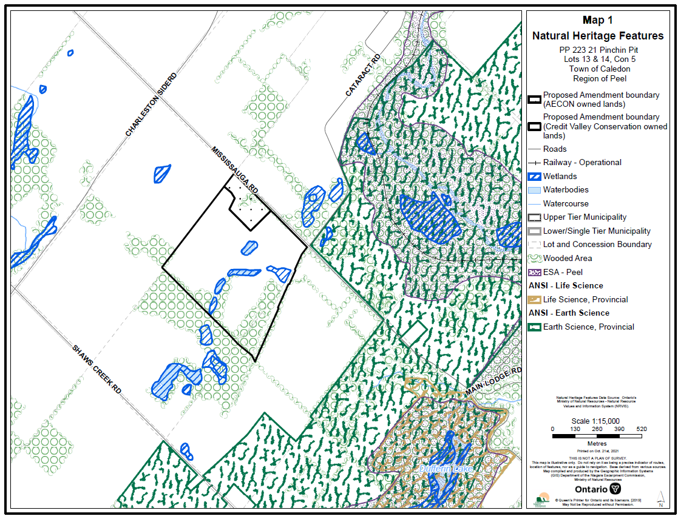

MAP 2: PINCHIN PIT ECOLOGICAL LAND CLASSIFICATION (2014) 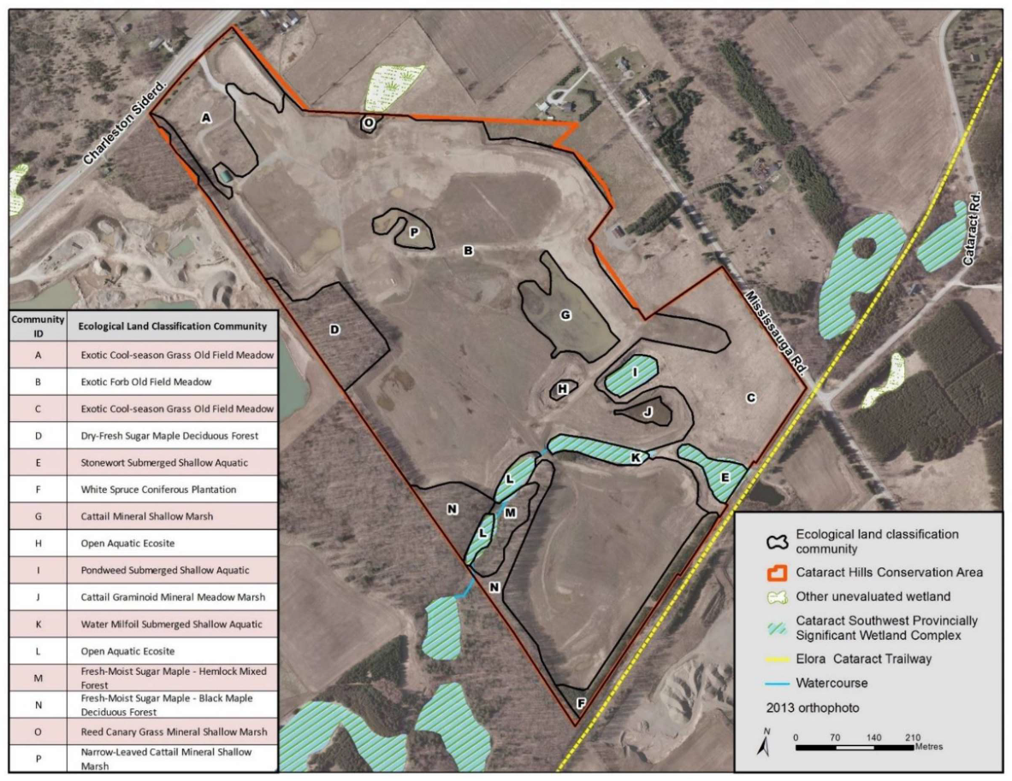

September 15, 2022

**AMENDMENT**

**RE: Proposed Niagara Escarpment Plan Amendment PP 223 21**

**Redesignation of former Pinchin Pit lands**

**Part Lots 13 &14 Concession 5 WHS**

**Town of Caledon, Region of Peel**

**Recommendation:**

That the Niagara Escarpment Commission circulate the attached Amendment as the Proposed Amendment for PP 223 21, Pinchin Pit.

**Prepared by: Approved by:**

Original signed by: Original signed by:

**_____________________ _______________________**

**Lisa Grbinicek, RPP, MCIP John Dungavell**

**Senior Strategic Advisor A/Director**

**PROPOSED NIAGARA ESCARPMENT PLAN**

**AMENDMENT PP 223 21**

**(Pinchin Pit)**

**September 15, 2022**

## TABLE OF CONTENTS

**PART A –** The Preamble

**PART B –** The Amendment

**PART C –** Schedule “A”

## Part A – The Preamble

## PURPOSE:

The purpose of the proposed amendment affecting the lands identified on Schedule A, attached hereto, is to amend the Niagara Escarpment Plan (NEP) to re-designate the subject lands (formerly known as “Pinchin Pit”), from Mineral Resource Extraction Area, to Escarpment Natural Area and Escarpment Rural Area, to reflect the surrender of the *Aggregate Resources Act* (ARA) licence.

## AREA:

The lands subject to the proposed Plan amendment consist of an area of approximately 48.8 ha (120 ac).

## LOCATION:

## Part Lots 13 & 14 Concession 5 WHS

Region of Peel, Town of Caledon

**APPLICANT/ OWNERSHIP:**

[1]Applicant: Credit Valley Conservation

Owners: Credit Valley Conservation / AECON Construction Ltd.

**BASIS:**

Under Section 6.1(2) of the *Niagara Escarpment Planning and Development Act* (NEPDA)*,* an amendment to the Niagara Escarpment Plan “*may be initiated by the Minister or the Commission, and application may be made to the Commission by any person or public body requesting an amendment to the Plan.”*

Part 1.2.1 of the NEP sets out provisions for an amendment to the NEP and this application satisfies Section 1.2.1.

Section 6.1 (2.1) of the NEPDA requires that an application to amend the NEP be supported by a “statement of justification” and Section 8 sets out the objectives to be addressed in consideration of an amendment to the NEP. The applicant has provided a Planning Justification Report (CVC, August 2021), which satisfies the threshold justification requirements of the NEPDA*.*

The amendment proposes to change the existing land use designation of Mineral Resource Extraction Area to Escarpment Natural Area and Escarpment Rural Area. NEC staff has assessed the proposal against the NEP Land Use Designation Criteria in Part 1 of the NEP and find that the lands meet the applicable Criteria, respectively.

The subject lands constitute the Escarpment and lands in its vicinity which fulfil the Purpose and Objectives of the NEPDA and therefore such lands should be properly designated within the NEP given that the land is no longer licensed under the ARA. The lands have been rehabilitated to the satisfaction of the Ministry of Natural Resources and Forestry (MNRF), and the surrender of the license has been accepted.

The amendment is consistent with the Provincial Policy Statement and supports the applicable Municipal Official Plans and Greenbelt Plan.

**PART B – The Amendment**

The Niagara Escarpment Plan is modified as follows:

Map 3 of the Niagara Escarpment Plan is amended as shown on Schedule A.

Map 10 of the Niagara Escarpment Plan is amended as shown on Schedule A (to reflect the lands being incorporated into the Niagara Escarpment Parks and Open Space System).

## Schedule A

Schedule A Map showing Amendment PP 223 21 Pinchin Pit

1. The amendment to redesignate the 4.8 ha (12 ac) portion of the subject lands still owned by ACEON is being initiated by the NEC.