September 15, 2022

A5: STAFF REPORT

DEVELOPMENT PERMIT APPLICATION:

G/A/2021-2022/264
Spruce Lane Farms Limited
596674 Concession 10
Concession 10 EGR, Part Lots 5 & 6
Township of Chatsworth, Grey County

PROPOSAL:
To create an Agricultural Purposes Only (APO) lot by severing a 2.2 ha (5.5 ac) parcel containing a single dwelling, agricultural structure (barn) and accessory structure (shed) from a 103 ha (254 ac) agricultural property.
Note: The agricultural operation consists of multiple lots totalling 305 ha (754 ac)

RECEIVED:
June 30, 2021

SOURCE:
Spruce Lane Farms Limited – Owner
REDACTED – Agent/Applicant
REDACTED – Agent

DESIGNATION:
Escarpment Rural and Natural Areas

ISSUE:
A decision from the Commission is required because staff is recommending refusal. The NEC Director does not have the delegated authority to refuse a development permit application.

RECOMMENDATION:
Refusal

REASONS:
The creation of an APO lot requires the proposal to conform to applicable Part 1 and Part 2 policies. The proposal does not meet the applicable development criteria identified in Part 2.4 of the NEP that apply to farm consolidations, surplus residences, and APO lots. The NEP applies a temporal limit of two years from the date the lands were acquired as part of a farm consolidation to permit the severance of surplus residence and APO lots. The applicant did not apply within the two-year timeframe, so a staff recommendation for refusal is necessary.

RELATED FILES:
Development Permit #9365/G/D/2018-2019/9256 was issued in October 2019 to demolish a two storey agricultural building (former livestock and storage barn), measuring 1,338 m² (14,404 ft²) with a height to peak of approximately 12.2 m (40 ft), on a 101 ha (250 ac) existing lot. The works approved by this development permit were not undertaken.

SITE DESCRIPTION:
Spruce Lane Farms is an agricultural operation located within the Township of Chatsworth. The total land holdings under the ownership of Spruce Lane Farms are 305 ha (754 ac). The agricultural operation consists of multiple contiguous lots that have been purchased by the applicant over time. The agricultural operation is bisected by Grey Road 40, south of which approximately 89 ha (220 ac) of farm holdings are located outside of the NEP Area. The northerly portion, sized approximately 202 ha (500 ac), is within an area of development control and subject to the policies of the NEP. Spruce Lane Farms operations include dairy and cash crop cultivation (e.g., winter wheat, soy and grain corn).
The subject property is located approximately 3-km southwest of the village of Walter’s Falls. The lot is located within a cluster of agricultural and rural residential uses. The property has rolling topography and is actively used for agricultural purposes (crop cultivation). A watercourse flows in a southerly direction parallel to Concession 10 and along the frontage of the property. A low-lying wetland complex, associated with the watercourse, encompasses the easterly portion of the property. A large stand of significant woodland that extends into several other properties is located on the westerly portion of the lot. The mapped Escarpment brow is located on the subject lands.
The 103 ha (254 ac) irregular shaped lot has existing frontage on Concession Road 10. The lot contains an existing dwelling, agricultural structure (barn), accessory structure (storage shed) and private servicing. The lot to be severed 2.2 ha (5.5 ac) has an existing driveway leading to the dwelling and outbuildings that are surrounded by a manicured lawn. The easterly portion of the proposed lot consists of a wetland and wooded area while the remaining area is surrounded by agricultural fields. The remnant lot 100.8 ha (249.1 ac) is predominately agricultural fields. A significant woodland is located to the rear of the yard and a wetland / watercourse traverses the frontage of the lot.

BACKGROUND:
In 2018 Spruce Lane Farms purchased the subject property, which was adjacent to lands owned and actively used for their current agricultural operation. NEC staff confirmed that the transfer deed was registered to Spruce Lane Farms on November 13, 2018. The applicant purchased the property as part of a farm consolidation to increase the amount of land available for crop cultivation and expand the ongoing agricultural operation. It was the original intent of the owners to sever the dwelling from the remaining agricultural land after purchasing the lot.
The subject property contains an existing dwelling, agricultural structure (barn), accessory structure (storage shed) and is supported by private servicing (well, septic). The existing dwelling is currently inhabited by tenants that rent from the landowners and the agriculture and accessory structures on-site are used for storage purposes only. According to the applicant, they originally applied to the NEC in 2018 for the demolition of the barn on-site to assist with the sale of the property. NEC staff received a development permit application from the landowners on June 30, 2021. To permit the creation of an APO lot, the application for severance must be filed with the NEC within two (2) years of the date that the lands were acquired as part of a farm consolidation. Therefore, to qualify for a severance, an NEC development permit application was required prior to November 13th, 2020. The application for severance was filed with NEC staff approximately seven months after the deadline for submission. As the application timeline exceeded the deadline for submission and consideration to create an APO lot in accordance with NEP policies, a staff recommendation of refusal is required.
The applicant proposes to create an APO lot by severing a 2.2 ha (5.5 ac) lot from the parcel with the remnant lot being sized at 100.8 ha (249 ac). The applicant originally applied for an 8 ha (20 ac) lot that included a small portion of agricultural lands. Through consultation with partner agencies, the applicant agreed to reduce the lot size. The lot configuration includes the dwelling, driveway, and accessory / agricultural buildings. The severed lot does not encroach into nearby agricultural uses and is limited to the minimum size needed to accommodate the use. The remnant APO lot will be retained by the applicant to remain in agricultural use post-severance.

PLANNING ANALYSIS:

Niagara Escarpment Plan (NEP):
The subject property is designated as Escarpment Rural Area and Escarpment Natural Area. The proposed severance is located in the less restrictive Escarpment Rural Area.
The Escarpment Rural Area policies permit the severance of a lot with a residence that has been rendered surplus to an agricultural operation as a result of a farm consolidation (Part 1.5.4.7). The applicable policies in Part 2.4 and 2.8 of the NEP also apply.

To qualify for severing a lot under Part 1.5.4.7 of the NEP, the property must have been acquired as part of a farm consolidation. The NEP defines a farm consolidation as the following: “The acquisition of additional farm parcels to be operated as one farm operation.”

The property was purchased by the applicant for the purposes of a farm consolidation. Spruce Lane farms owned 202 ha (500 ac) of farmland adjacent to, or nearby, the subject property prior to purchasing the property. The acquisition of the subject property is intended to be operated as one farm operation totaling in a size of 305 ha (754 ac). NEC staff are satisfied that the acquisition of this property qualifies as a farm consolidation as defined by the NEP.

Where a proposed severance involves a residence surplus to a farm consolidation, the remnant (retained) lot becomes an APO lot. An APO lot is defined as the following by the NEP: “The agricultural lot that is the remnant lot created following the severance of another lot containing a residence that is rendered surplus when associated with a farm consolidation. The permitted uses on APO lots are limited in accordance with the policies of this Plan.”

Part 2 of the NEP identifies the applicable criteria for the creation of new lots and potential constraints to lot development (e.g., natural heritage features, natural hazards). The development criteria specific to lot creation is found in Part 2.4 of the NEP. The policies within Part 2.4.22 – 2.4.30 apply to farm consolidations, surplus residences, and APO lots. The subject proposal is required to satisfy the relevant policies within these sections prior to approval.

NEC staff reviewed the policies within the sections noted above and determined that the application is in conformity with most of the applicable policies, as outlined below:

Part 2.4 – Lot Creation
Part 2.4.22 a) states: “ the lot shall be limited to the minimum size needed to accommodate the use, and appropriate to sewage and water services.”

The applicant has provided a site plan that demonstrates the lot configuration was designed solely to accommodate for the dwelling and structures on-site. The lot configuration will not encroach into the nearby agricultural lands or limit the agricultural viability of the remnant lot.

Part 2.4.22 b) states: “new residential dwellings are prohibited on any remnant lot of farmlands created by the severance using the approach recommended by the Province, or based on municipal approaches that achieve the same objective.” The applicant has previously indicated to NEC staff that they are amenable to an appropriate legal restriction registered against the property’s title demonstrating that the lot will not be used for any purpose other than agricultural uses (e.g., existing agricultural uses, existing on-farm diversified uses, existing agriculture-related uses). The policies of the NEP require that APO lots exclude any development other than the aforementioned uses.

Part 2.4.22 c) states: “the lot(s) shall not limit the agricultural viability or use of the remnant APO lot because of the location of the surplus residence or existing buildings (e.g., key-hole lot situations).” The lot configuration has been limited in size to accommodate for the existing structures on-site and provides minimal fragmentation to the surrounding agricultural lands. The proposed lot is surrounded by a wetland and wooded area that is not viable for agriculture. NEC staff are satisfied that the location of the surplus residence is suitable under the scenario and will not compromise agricultural viability.

Part 2.4.22 d) states: “the proposed surplus residence was not originally approved on the basis that it was for temporary use or as a dwelling unit accessory to agriculture.”
The existing dwelling on-site was not originally approved as a dwelling unit accessory to agriculture.

Part 2.4.22 e) states: “the proposed surplus residence is an existing single dwelling and has been determined to be habitable under the provisions of the Ontario Building Code at the time of the application for severance.” The surplus residence is an existing single dwelling and is currently inhabited by the existing tenants. The dwelling did not appear to be in a poor state of repair during NEC staff’s site visit.

Part 2.4.22 f) states: “the proposed surplus residence has been built and occupied for not less than ten (10) years, at the time of the application for severance.” The dwelling was constructed greater than ten years ago and has been continuously occupied.

Part 2.4.22 g) states: “the application for severance of the surplus residence must occur within two (2) years of the date that the lands were acquired as part of a farm consolidation.” The proposed APO lot creation is not able to meet this criterion. The application was received greater than two years after the lands were acquired, which was on November 13, 2018, and the application was received on June 30th, 2021. As such, the proposal is not in conformity with the APO lot creation policies of the NEP and therefore requires a recommendation for refusal.

The two-year timeframe indicated by Part 2.4.22 g) provides a limitation on the amount of severances that may be permitted for lots where the farm consolidation took place historically (e.g., 10 + years). Additionally, the policies are intended protect the integrity of agricultural lands and to minimize the fragmentation of such lands. NEC staff also considered the general lot creation policies that apply within Escarpment Rural Areas, as per Part 1.5.4 of the NEP. The applicant does have the opportunity to sever the original township lot (80 hectares) into two 40-hectare original township half lots, as per Part 1.5.4.1, but this would fragment the farmland and not meet the applicant’s objective of retaining the maximum amount of arable land as part of the farming operation.
Given the above, NEC staff are not in a position to support the proposal given that more than two years have passed since the farm consolidation occurred.

Part 2.4.26 states: “The lot to be severed for the surplus dwelling and the agricultural lot that is intended to be the APO lot must front onto or have access to an existing public road that is of a reasonable standard of construction and is generally maintained all year round.” NEC staff confirmed with Township Operations staff that both the severed lot and proposed APO lot have existing public road entrances that are compliant with entrance standards.

Part 2.8 – Agriculture
NEC staff also reviewed Part 2.8 of the, which addresses policies related to agriculture. Part 2.8.2 states that all development, including the creation of lots are required to comply with the Minimum Distance Separation (MDS) formulae. The proposed lot to be severed is retaining the existing agricultural structure within the lot configuration. MDS calculations would only be required if the agricultural structure were retained on the remnant APO lot. Additionally, Part 2.4.24 of the NEP requires a restriction on title ensuring the remnant APO lot does not contain a single dwelling. As such, MDS setbacks do not need to be met for this proposal. NEC staff are satisfied that the proposal is consistent with Part 2.8 of the NEP.

Other Part 2 Policies
As the proposal is solely to create a lot, and does not include any further site alteration, NEC staff did not identify any additional conflicts with Part 2 policies. The natural heritage features on-site are not being impacted as there is no physical development being proposed and no significant alteration to the lot lines. The significant woodlands located at the rear of the APO lot would not be impacted by the severance. A portion of the subject lands are identified as a hazardous area due to the existing watercourse and wetland. GSCA staff have indicated they do not have any concerns as there is no development being proposed within the hazardous area.

In summary, the policies in Part 2.4.22 – 2.4.30 are intended to ensure the integrity of APO lot creation policies. A lot created from a residence surplus to an agricultural operation must be the result of a farm consolidation where the dwelling has been on-site for a period greater than ten years, deemed to be habitable, limited to the minimum size necessary to accommodate the dwelling and accessory structures, and the application must be made within the identified timeframe. The policies related to APO lots ensure that the remnant lot will remain in agricultural use and does not promote other uses that are not directly related to agriculture. The application does not meet all of the applicable policies and therefore requires a staff recommendation for refusal.

2. Provincial Policy Statement (PPS, 2020)
Section 2.1 of the PPS directs the long-term protection of natural heritage features and areas. NEC staff do not anticipate any negative impacts upon the natural heritage features on-site as the application does not propose any structural development or site alteration. The lot configuration is not anticipated to further fragment any natural heritage features.
Section 2.3 identifies the permitted uses within prime agricultural areas and directs the long-term viability of agricultural operations. The Canada Land Inventory identifies the majority of the property as having Class 1 soils, which is the highest quality of soil under this classification. The subject property would qualify as prime agricultural land as defined by the PPS, which includes specialty crop areas and Canada Land Inventory Class 1, 2, and 3 lands. A prime agricultural area is defined by the PPS as areas where prime agricultural lands predominate. To qualify as a prime agricultural area, the review and mapping must be completed in accordance with provincial standards. The County of Grey does not designate prime agricultural areas within the NEP Area. As such, the property is not within a prime agricultural area in accordance with provincial standards.
Section 2.3.4.1 c) permits lot creation for the purposes of a residence surplus to a farming operation as a result of farm consolidation, within prime agricultural areas, provided that:
- the new lot is limited to a minimum size needed to accommodate the use and appropriate sewage and water services; and
- the planning authority ensures that new residential dwellings are prohibited on any remnant parcel of farmland created by the severance. The approach used to ensure that no new residential dwellings are permitted on the remnant parcel may be recommended by the Province, or based on municipal approaches which achieve the same objective,
The PPS identifies policies for the creation of a residence surplus to a farming operation in prime agricultural areas. Grey County and the Township of Chatsworth do not have any mapped prime agricultural areas that have been approved by the province within the NEP area. The NEP does not restrict the creation of lots for residences surplus to farm consolidations to areas within prime agricultural areas. It should be noted that the PPS is silent on lot creation on rural lands that are not designated as being within prime agricultural areas.

Agency Consultations:

County of Grey
The subject lands are designated Niagara Escarpment Plan, per Schedule A of the County OP. The policies of the Niagara Escarpment Plan apply.

Per Appendix B, the subject lands contain a mapped stream and significant woodlands. The proposed severance would appear to be outside of the significant woodlands but is within the immediate vicinity of the stream. It is recommended that further comments be received from the Conservation Authority.

The Provincial Policy Statement and the County's Official Plan limit lot creation on prime agricultural properties, with surplus farmhouse severances being one exception. Section 2.3.4.1 of the PPS notes that lot creation in prime agricultural areas may be permitted for: a residence surplus to a farming operation.

While the County would encourage the surrounding accessory buildings (including the barn) to be included within the proposed residential parcel in order to avoid MDS concerns, the current application proposes a residential lot of 8 ha in size, which would appear to be beyond the maximum size to be considered in this type of severance.

The County would suggest that the proposed severed lot be reduced in size to accommodate only the existing buildings and services (septic / well) on the property. It should be noted that these comments have been provided without input from other commenting agencies, including the Conservation Authority.

Provided the proposed lot fabric is reduced in size to accommodate only the existing buildings/services, and positive comments are received from the Conservation Authority, the County has no further concerns with the subject application.

(NEC Staff Note: the County’s comments were addressed by revising the proposal to limit the size of the surplus dwelling lot to that which was necessary to accommodate the surplus dwelling and accessory structures.)

Township of Chatsworth
(NEC Staff Note: The Township of Chatsworth does note have an Official Plan. The Township has a comprehensive zoning by-law intended to implement the policies of the Grey County official plan.)
Regarding the NEC Development Permit, which is intended to facilitate a severance at a later date (through the Township’s office) please note the following:

If the property is considered to comprise prime agricultural land, the PPS would only allow for a lot containing a surplus farmhouse to be severed where the size of the lot is limited to what is necessary to accommodate the intended use. The NEC should ensure that this policy is followed.

Typically, MDS does not apply to "surplus farmhouse severances" because no new land use conflict involving odour will occur given that a "no house" clause is placed on the zoning on the retained farmlands through a rezoning exercise. The Zoning By-law, however, doesn't apply to this property. As such, if the NEC can apply a similar "no house" restriction on the retained lands, with such restriction being legally binding over the long term, then MDS is not an issue. However, if imposing such a restriction is not possible, then the applicant must demonstrate compliance with the MDS Document.

The applicant will need to obtain an entrance permit as a condition of severance. The Township’s operations staff have identified an existing laneway on the retained parcel.

(NEC Staff Note: NEC staff confirmed with Township operations staff that the laneway is a permitted entrance. After inspection, Township staff confirmed that the laneway is a permitted entrance.)

Grey Sauble Conservation Authority (GSCA)
A portion of the subject property is regulated under Ontario Regulation 151/06: Regulation of Development, Interference with Wetlands and Alterations to Shorelines and Watercourses. The regulated areas are associated with a watercourse feature and a low-lying saturated area towards the eastern property line and a wetland feature towards the southern property line.

Under this regulation a permit is required from this office prior to the construction, reconstruction, erection or placing of a building or structure of any kind; any change to a building or structure that would have the effect of altering the use or potential use of the building or structures, increasing the size of the building or structure, or increasing the number of dwelling units in the building or structure; site grading; or, the temporary or permanent placing, dumping or removal of any material originating on the site or elsewhere, if occurring within the regulated area. Also, a permit is required for interference with a wetland, and/or the straightening, changing, diverting or in any way interfering with an existing channel of a river, lake, creek stream or watercourse.

The natural hazards identified on the subject property are associated with the flood and erosion risk of the watercourse features east side of the property as well as the above mentioned low-lying saturated area towards the northeast corner of the property. There is currently no development proposed within these areas, therefore the proposal is considered consistent with he Section 3.1 PPS policies.

Natural heritage features identified on the subject property include significant woodland, potential for fish habitat their adjacent lands. As there is no development proposed on the retained or severed portion of the property, an Environmental Impact Study is not required to satisfy the PPS policies and the County of Grey Official Plan. At this time, the proposal is considered consistent with the Section 2.1 PPS policies.

Proposal for development may result in the increase of site imperviousness. There is currently no development proposed within the retained or severed portion of the subject property, therefore the proposal is considered consistent with the Section 2.2 PPS policies.
GSCA staff have no objections to the proposal.

SUMMARY:
NEC staff are recommending that the development proposal be refused. The proposal does not meet the applicable development criteria identified in Part 2 of the NEP that apply to farm consolidations, surplus residences, and APO lots. The NEP applies a temporal limit of two years from the date the lands were acquired as part of a farm consolidation to permit the severance of surplus residence and APO lots. The policies are intended protect the integrity of agricultural lands and to minimize the fragmentation of such lands. The application was not filed with the NEC within the allotted and timeframe and necessitates a recommendation of refusal.

RECOMMENDATION:
That the application be refused for the following reason:
- The proposal does not meet Part 2.4.22 g) of the NEP, which states the application for a surplus residence must occur within two years of the date the lands were acquired.

Prepared by:

Original signed by:

_________________
Nick Hayward
Senior Planner

Approved by:

Original signed by:
__________________
Kim Peters, MCIP, RPP
Manager

Appendix 1 – Orthophoto of the subject property
Appendix 2 – NEP Land Use Designations Map
Appendix 3 – Existing and proposed lot configuration

Appendix 1 – Orthophoto of the Subject Property

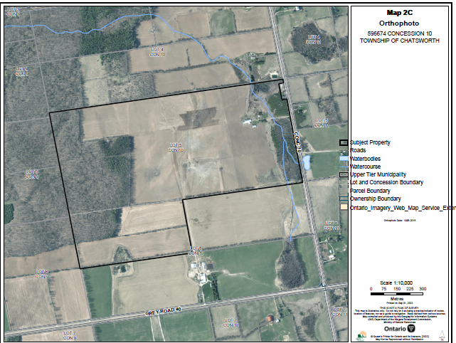

Appendix 2 - NEP Land Use Designations Map

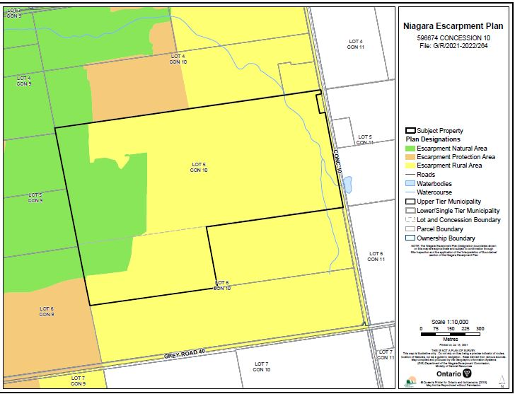

Appendix 3 – Lot Configuration & Layout

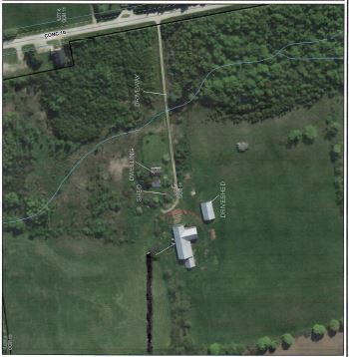

Proposed Lot Configuration
