Niagara Escarpment Commission
232 Guelph St.
Georgetown, ON L7G 4B1
Tel: 905-877-5191
www.escarpment.org

September 15, 2022

B2: STAFF REPORT (Addendum)

Development Permit Application:

H/A/2021-2022/426
10268 Third Line
Concession 3, Part Lots 11 & 12
Town of Milton, Region of Halton

Proposal:
To construct a ± 1,508.7 sq m (± 16,240 sq ft) equestrian riding arena, a ± 192 m
(± 630 ft) driveway and associated ± 348.4 sq m (± 3,750 sq ft) parking area on
a 28.5 ha 70.48 ac lot.

Updated Information:
After informing the applicant that staff would be recommending refusal of the development permit application due to the apparent lack of a related agricultural use on the subject property, the applicant proceeded to provide revised drawings that now indicated that horse boarding facilities (i.e., a stable/stall area), staff has reconsidered its recommendation of refusal, and now finds that the riding arena can be supported as an agricultural use. A copy of the revised floor plan for the riding arena is included in Appendix 1.

To support the proposed approval, staff has attached (Appendix 2) conditions of approval appropriate for an equestrian riding arena. These conditions include a final site plan to include all relevant detail, including any grading and servicing (e.g., septic system, well) required to support the riding arena.

Revised Recommendation:
The development permit be approved, subject to the attached conditions.

Prepared by:
Original signed by
______________________
Kim Peters, MCIP, RPP
Manager

Approved by:

Original signed by
_______________________
Kathy Woeller
Director

Attachments:
Appendix 1: Revised Riding Arena Floor Plans
Appendix 2: Conditions of Approval

Appendix 1: Riding Area Floor Plan
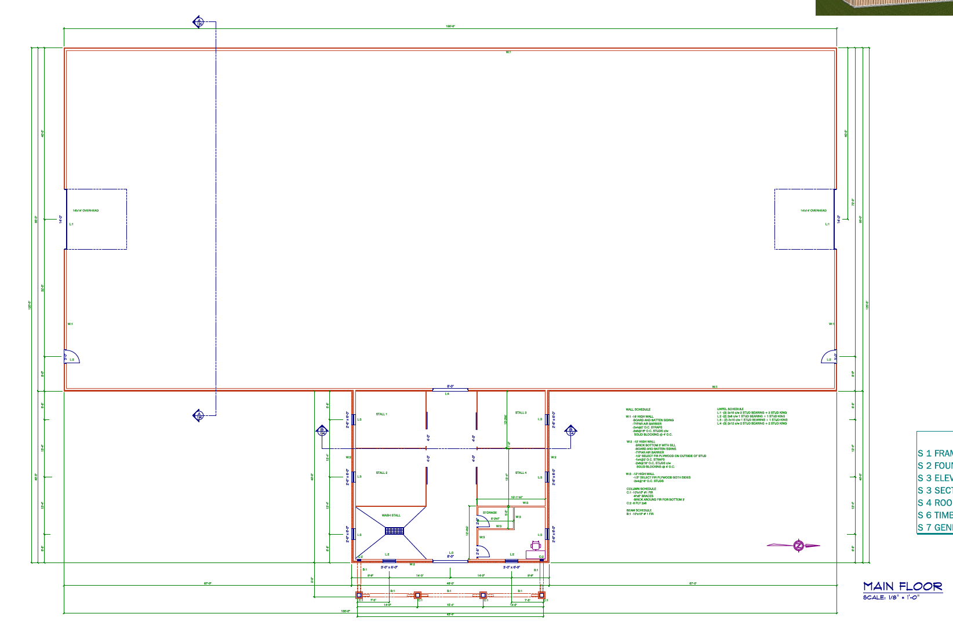
APPENDIX 2
10268 Third Line
CONDITIONS OF APPROVAL H/A/2021-2022/426

- Development shall occur in accordance with the Terms and Conditions of the Development Permit.

- The Development Permit shall expire three (3) years from the date it has been issued or once the development has been completed in accordance with the Development Permit.

- No site alteration of the existing contours of the property including the placement or stockpiling of fill (i.e., excess or imported soil) on the property is permitted with the exception of that identified within the development envelope in accordance with the Final Site Plan.

- No vegetation shall be cut or removed from the development envelope except for that identified within the development envelope in accordance with the Final Site Plan.

- If development has commenced under this Development Permit, any/all disturbed areas of land or soil shall be re-vegetated and stabilized to the satisfaction of the Niagara Escarpment Commission on or before the date of expiry of the Development Permit.

- The riding arena shall not be used for human habitation (i.e., living space), as short or long-term rental accommodation, or for commercial, industrial, or intensive livestock purposes.

- Exterior lighting on the riding arena shall be subdued and limited to only that which is necessary for safety.

- The floor of the riding arena shall not be paved.

- Prior to the commencement of any development, erosion and sediment control measures (e.g., fencing, blankets, rip-rap), and/or vegetation protection fencing shall be implemented and maintained as shown on the Final Site Plan until all disturbed areas are stabilized. It is the responsibility of the landowner to implement, monitor and maintain all erosion and sedimentation control measures and vegetation protection fencing until vegetative cover has been successfully established.

APPENDIX 2
10268 Third Line
CONDITIONS OF APPROVAL H/A/2021-2022/426

- Prior to the issuance of a Development Permit by the Niagara Escarpment Commission, an accurate and detailed Final Site Plan shall be submitted for Niagara Escarpment Commission approval. The following shall be included directly on the Plan:

- All drawings submitted must be drawn to scale (bar scale shown), reference the application number and address of the proposal, be dated (revisions as well), and include the name of the relevant individual or consultant who prepared the drawing;
- Outline of the approved development envelope / extent of all disturbed areas;
- Location of all existing and proposed structures, sewage disposal system, well/cistern, driveway, construction access / haul routes, exterior lighting, etc. showing setbacks from the property lines, any watercourses or water features, top / bottom of slope, wooded areas, etc.;
- Grading, drainage, and stockpile details. The type, quantity, quality and source location of any imported fill material must be accurately identified.
- The location and design of erosion and sediment control measures (e.g., fencing, blankets, rip-rap, temporary mulch / seeding), and limit-of-work construction or eco-protection fencing.

Development shall proceed in accordance with the details of the approved Final Site Plan.

- Prior to the issuance of a Development Permit by the Niagara Escarpment Commission, the landowner shall submit for the approval of the Niagara Escarpment Commission, final construction details for the riding arena, including exterior elevations, total floor area, floor plans, and height to roof peak from lowest grade.
- Condition 10 and 11 to be fulfilled within eighteen (18) months of the date of confirmation of the Commission’s decision or this conditional approval shall lapse, and a Development Permit will not be issued.
ADVISORY NOTES:
- A Development Permit does not relieve the permit holder of any other permission (e.g., Ontario Building Code, Conservation Authorities Act, Endangered Species Act, etc.). A Niagara Escarpment Commission Development Permit is required prior to the issuance of any other permission.

APPENDIX 2
10268 Third Line
CONDITIONS OF APPROVAL H/A/2021-2022/426

Advisory notes continued:

- The Niagara Escarpment Commission supports the protection of the night sky from excessive lighting and recommends the applicant obtain information on the use and operation of appropriate lighting fixtures in keeping with dark sky approaches.

- Should deeply buried archaeological remains/resources be found on the property during construction activities, the Heritage Operations Unit of the Ontario Ministry of Tourism, Culture and Sport (MTCS) shall be notified immediately. In the event that human remains are encountered during construction, the owner shall immediately notify the police or coroner, the Registrar of Cemeteries of the Ministry of Small Business and Consumer Services, and the Ministry of Heritage, Tourism, Sport and Cultural Industries.

