November 17, 2022

A1 AS-BUILT STAFF REPORT

Development Permit Application:

N/F/2022-2023/140
2400 Effingham St
Part Lot 6 S of Hydro Lands, Concession 3 Pelham
Town of Pelham, Region of Niagara

Proposal:
To recognize the importation of ± 50 truck loads (± 497 cu m / ± 650 cu yd) of fill for the purpose of improving drainage over a ± 929 sq m (10,000 sq ft) area; to recognize and complete construction of a ± 111.4 sq m (± 1200 sq ft) dwelling addition (attached garage), with a height to peak of ± 7.28 m (± 23.9 ft); and to recognize and complete construction of a driveway extension, on an existing 1.89 ha (4.68 ac) lot.

Received:
May 30, 2022

Source:
REDACTED (owner)

Designations:
Escarpment Rural Area

Issue:
There has been more than one development undertaken without a Development Permit on the property by the landowner. One of the requirements for an application to be processed as a Director’s Approval is that in the case of a development that has already commenced, it is the first time that the applicant has undertaken development on the property without approval under the Niagara Escarpment Planning and Development Act. The applicant has initiated these three developments at different times without first obtaining a Development Permit from the NEC.

Recommendation:
Approval, subject to conditions.

Reasons:
Notwithstanding that the development has already commenced, the development is a permitted use under the Niagara Escarpment Plan and meets the Development Criteria in Part 2 of the Niagara Escarpment Plan.

Related Files:
Development Permit #11274/N/R/2015-2016/103 was issued in August 2017 to construct a 2-storey ± 446 sq m (± 4800 sq ft) single dwelling on a vacant 1.89 ha (4.68 ac) lot, plus a driveway, private well, and an on-site sewage disposal system. The development has been completed.

Site Description:
The subject property is located on the west side of Effingham St between Roland Road to the north and Sixteen Road to the south in the Town of Pelham. The lands are adjacent to a hydro corridor to the north and an unopened road allowance to the west. The property is surrounded by agricultural lands. Short Hills Provincial Park is located approximately 900 metres to the northeast. The Escarpment Brow is located more than 520 metres east of the property and the lands are generally flat. There are no key natural heritage features within 120 metres of the subject property. The property currently supports a single dwelling and accessory facilities and the partially completed development subject to this application. There are no trees on the property and the lands are currently disturbed by the construction that has begun.

Background:
The application seeks to recognize the importation of fill, partial construction of an attached garage, partial construction of a driveway extension, and to authorize completion of the development. The existing single dwelling on the property was recently constructed in accordance with Development Permit #11274/N/R/2015-2016/103.
The fill importation came to the attention of NEC staff in April 2022 through communications with the Town of Pelham. Town staff had received a complaint and later visited the site and confirmed that fill had been deposited on the property. The applicant was asked to provide information regarding the purpose of the fill importation and to test the soil to determine whether the fill meets Niagara Escarpment Plan (NEP) policies, subject to a further assessment of the Development Criteria in Part 2 of the NEP. The applicant explained that the site alteration consisted of fill importation to level out the front yard area in a depression where water had been pooling and a soil report was submitted in May 2022. The applicant was then asked to submit a Development Permit Application to recognize the development, which was received in late May 2022.
In August 2022, during the review of the fill application, the applicant submitted drawings for an attached garage. NEC staff confirmed with the applicant that the intention was for the proposed garage to be added to the existing application and requested that the application be updated to reflect the addition. Town staff later advised NEC staff that construction of the attached garage had begun in the absence of permits. The application was updated to include the garage.
In October 2022, NEC staff became aware that the applicant had begun to pour concrete around the flower bed as a driveway extension. This site alteration was also not approved through a Development Permit. As such, the application before the Commission seeks to recognize three instances of development that occurred without approval of a Development Permit.

Planning Analysis:

Niagara Escarpment Plan, 2017 (NEP)
The subject property is designated as Escarpment Rural Area by the Niagara Escarpment Plan, 2017 (NEP). A single dwelling and accessory uses are permitted, subject to meeting the Development Criteria in Part 2 of the NEP. The attached garage and driveway are permitted as accessory to the single dwelling. The fill importation may also be considered as accessory to the single dwelling, as the site alteration was to fill a low spot on the property where water was pooling and is related to the grading of the driveway.
All the partially completed development is located within an existing disturbed area immediately adjacent to the recently constructed dwelling. The property does not contain any hazard land. Part 2.2.1 of the NEP requires that development protect, restore, and where possible enhance the Escarpment environment for the long term. The applicant will be required to restore the site and stabilize the disturbed area with vegetation as soon as possible. A condition for a Landscape Plan has been included to ensure that the site is stabilized, restored, and enhanced with native plantings. With this condition, the proposal meets the General Development Criteria in Part 2.2 of the NEP.
There are no watercourses on the property. The closest mapped watercourse is within 80 metres of the development site. NPCA staff have reviewed the application and do not have any concerns with the fill importation or garage addition. The grading and drainage plan will ensure that there is no adverse impact on adjacent properties and therefore no negative impact to the watercourses. The development is sufficiently set back from key hydrologic features and there is no conflict with the Water Resources Development Criteria in Part 2.6 of the NEP.
There are no key natural heritage features on or adjacent to the property. A standard search of the Natural Heritage Information Centre database identifies the potential for Species at Risk within 1 km of the property. Species include eastern flowering dogwood (endangered), American chestnut (endangered), broad beech fern (special concern), and wood thrush (special concern). These species all inhabit woodlands and as such no habitat is present on or adjacent to the property. There is no anticipated impact on species at risk habitat or natural heritage features. There is no conflict with the Natural Heritage Development Criteria in Part 2.7 of the NEP.
The property is designated as being within a Prime Agricultural Area (Specialty Crop) by the Agricultural Land Base for the Greater Golden Horseshoe mapping. The property is undersized for an agricultural operation and is not in active agricultural use. The property is not currently used as pasture or cropland and therefore the proposal meets the Agriculture Development Criteria in Part 2.8 of the NEP.
The lands are identified as having archaeological potential. No archaeological assessment was requested by the Region of Niagara or Town of Pelham, as the work has already begun. Additionally, the development is located adjacent to the dwelling which was recently constructed. An advisory note regarding archaeological potential has been included. With this note there is no conflict with the Cultural Heritage Development Criteria in Part 2.10 of the NEP.
As the property does not contain any trees, there is no visual screening of the existing dwelling. The proposed garage addition will increase the mass of the existing dwelling. A Landscape Plan is included as a condition of approval to integrate the development into the landscape and provide visual mitigation.
Part 2.13.10 of the NEP requires that any fill imported onto a site must meet or exceed existing on-site soil quality conditions, with the objective being that imported fill meets Table 1 of the Soil and Groundwater and Sediment Standards for Use under Part XV.1 of the Environmental Protection Act, R.S.O 1990, C.E.19. A soil report prepared by Fortis Environmental, dated May 16, 2022 has been submitted and confirms that the imported fill does not exceed Table 1 standards and is therefore suitable for use on site for grading and construction. As required by Part 2.13.9 of the NEP, a proper grading plan is requested as a condition of approval to the satisfaction of the NEC and Town of Pelham. Town staff have advised that there must not be any adverse drainage impacts on adjacent properties. This would include the municipal roadway and hydro corridor.
With these conditions, the proposal meets the Scenic Resources and Landform Conservation Development Criteria in Part 2.13 of the NEP.

Provincial Policy Statement, 2020 (PPS)
Section 2.1 of the PPS directs the long-term protection of natural heritage features and areas. The development site is located a minimum of 400 metres from the closest woodland and 80 metres from the closest watercourse and is therefore well separated from key natural heritage and hydrologic features. No impact to natural heritage features is anticipated and the development is consistent with Section 2.1 of the PPS.
Section 2.6 of the PPS directs the conservation of archaeological resources. The lands are within an area of archaeological potential; however, the construction has already begun. While no archaeological assessment is requested, an advisory note regarding the identification of archaeological resources is included to ensure the development is consistent with Section 2.6 of the PPS.

Agency Consultations:

Town of Pelham
The property is designated as Niagara Escarpment Plan Area by the Town of Pelham Official Plan. The property is identified as having composite archaeological potential. The grade alterations should not result in adverse drainage impacts on adjacent properties including the municipal roadway. The Town will require an updated comprehensive lot grading and drainage plan. A fill permit and building permit will be required.

Region of Niagara
The subject property is designated as Unique Agricultural Area by the Regional Official Plan. The property exhibits the potential for the identification of archaeological resources. Given that the structure has already been partially constructed, an archaeological assessment is not requested, however a standard advisory note is recommended. A new septic permit is required, and it appears the rear covered deck does not meet the required building code setbacks. There are no requirements for the fill importation.

Niagara Peninsula Conservation Authority (NPCA)
No objection. There are no NPCA regulated features on the property.

Discussion:
The subject application proposes to recognize the importation of fill and site alteration on the property, partial construction of an attached garage, partial construction of a driveway extension and to authorize the completion of this development. The completed and proposed work is considered a permitted use within the Escarpment Rural Area as accessory to the single dwelling. The development meets the Development Criteria in Parts 2.2 (General), 2.6 (Water Resources), 2.7 (Natural Heritage), 2.8 (Agriculture), 2.10 (Cultural Heritage), and 2.13 (Scenic Resources and Landform Conservation), subject to the conditions of approval. There were no agency objections to the development and the proposal meets the policies of the Provincial Policy Statement.
NEC staff are satisfied that the work conforms to the applicable policies. However, due to the number of times development occurred without a permit, a decision on the application cannot be delegated to the NEC Director and is before the Commission for a decision.

Recommendation:
That the Commission approve the application, subject to the conditions listed in Appendix 1.

Prepared by:
Original signed by:
______________________
Cheryl Tansony
Senior Planner

Approved by:

Original signed by:
_______________________
for Kim Peters, MCIP, RPP
Manager

Attachments:
Appendix 1 – Conditions of approval
Appendix 2 – Niagara Escarpment Plan designation
Appendix 3 – Orthophoto
Appendix 4 – Site plan for attached garage
Appendix 5- Site plan for fill importation

APPENDIX 1

Conditions of Approval

N/F/2022-2023/140

- Development shall occur in accordance with the Terms and Conditions of the Development Permit.

- The Development Permit shall expire three (3) years from the date it has been issued or once the development has been completed in accordance with the Development Permit.

- No site alteration of the existing contours of the property including the placement or stockpiling of fill (i.e., excess or imported soil) on the property is permitted with the exception of that identified within the development envelope in accordance with the Final Site Plan.

- No vegetation shall be cut or removed from the development envelope except for that identified within the development envelope in accordance with the Final Site Plan.

- Any/all disturbed areas of land or soil shall be re-vegetated and stabilized to the satisfaction of the Niagara Escarpment Commission on or before the date of expiry of the Development Permit.

- Prior to the issuance of a Development Permit by the Niagara Escarpment Commission, an accurate and detailed Final Site Plan and Grading/Drainage Plan prepared by a qualified professional shall be submitted for Niagara Escarpment Commission approval. The following stipulation shall be included directly on the Plan:
  - The Final Site Plan shall be prepared by a qualified professional
  - All drawings submitted must be drawn to scale (bar scale shown), reference the application number and address of the proposal, be dated (revisions as well), and include the name of the relevant individual or consultant who prepared the drawing;
  - Outline of the approved development envelope / extent of all disturbed areas;
  - Location of all existing and proposed structures, construction access / haul routes, any watercourses or water features, top / bottom of slope, wooded areas, etc.;

Condition 6 continued:

  - Grading, drainage, and fill management details including the areas of excavation and temporary or permanent fill placement. The type, quantity, quality and source location of any imported fill material must be accurately identified.
  - Identify the areas of existing vegetation to be retained, areas of vegetation to be removed, and the location of proposed plantings.

Development shall proceed in accordance with the details of the approved Final Site Plan.

- Prior to the issuance of a Development Permit by the Niagara Escarpment Commission, a Final Landscape Plan shall be prepared by a qualified person, for Niagara Escarpment Commission approval. The Plan shall address all vegetation retention and planting requirements in accordance with the standard practices of the implementing authority. The following stipulations shall be included directly on the Plan:
  - All new tree and shrub species (including seed mixes) shall be native to Ontario except where otherwise approved by the Niagara Escarpment Commission. Plant material shall be sourced from local plant nurseries; bush dug plant material is not acceptable.
  - Planting and the rehabilitation of all disturbed areas shall be completed on or before the date of expiry of the Development Permit to the satisfaction of the Niagara Escarpment Commission.
  - All plant material shall be guaranteed for 24 months following installation. All plant material found during this time to be dead or dying must be replaced with a size and species to the satisfaction of the Niagara Escarpment Commission.
  - Once the development has been completed, a letter certifying the landscaping / planting work has been completed in accordance with the approved Landscape Plan shall be provided to the Niagara Escarpment Commission by a qualified person.

- Conditions #6 and 7 must be fulfilled within six (6) months from the date of confirmation of the Commission’s decision or this conditional approval shall lapse and a Development Permit will not be issued.

NOTES:

- A Development Permit does not relieve the permit holder of any other permission (e.g., Ontario Building Code, Conservation Authorities Act, Endangered Species Act, Town of Niagara-on-the-Lake Urban Tree By-law, etc.). A Niagara Escarpment Commission Development Permit is required prior to the issuance of any other permission.

- The Niagara Escarpment Commission supports the protection of the night sky from excessive lighting and recommends the applicant obtain information on the use and operation of appropriate lighting fixtures in keeping with dark sky approaches.

- Should deeply buried archaeological remains/resources be found during construction activities, all activities impacting archaeological resources must cease immediately, and the proponent must notify the Archaeology Programs Unit of the Ministry of Tourism, Culture and Sport (416-212-8886) and contact a licensed archaeologist to carry out an archaeological assessment in accordance with the Ontario Heritage Act and the Standards and Guidelines for Consultant Archaeologists.

In the event that human remains are encountered during construction, all activities must cease immediately and the local police as well as the Cemeteries Regulation Unit of the Ministry of Government and Consumer Services (416-326-8800) must be contacted. In situations where human remains are associated with archaeological resources, the Ministry of Tourism, Culture and Sport should also be notified to ensure that the site is not subject to unlicensed alterations which would be a contravention of the Ontario Heritage Act.

APPENDIX 2

Niagara Escarpment Plan designation
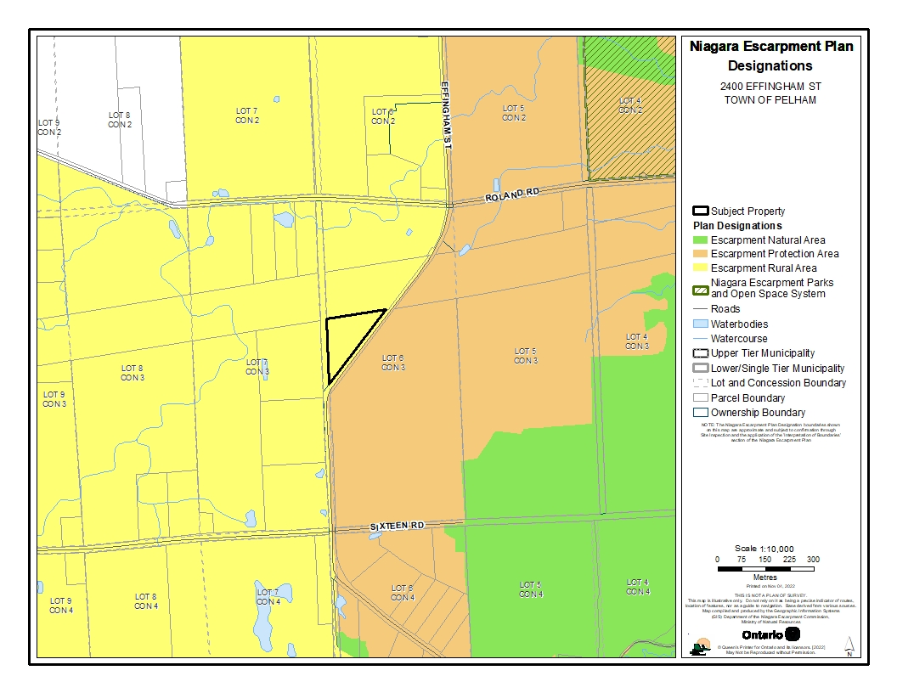

APPENDIX 3

Orthophoto of subject property
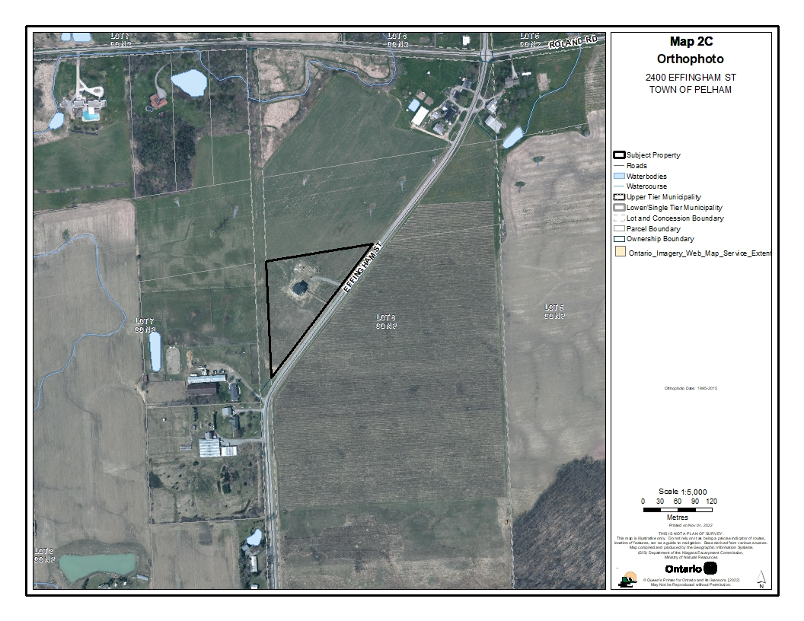

APPENDIX 4

Site plan for garage addition
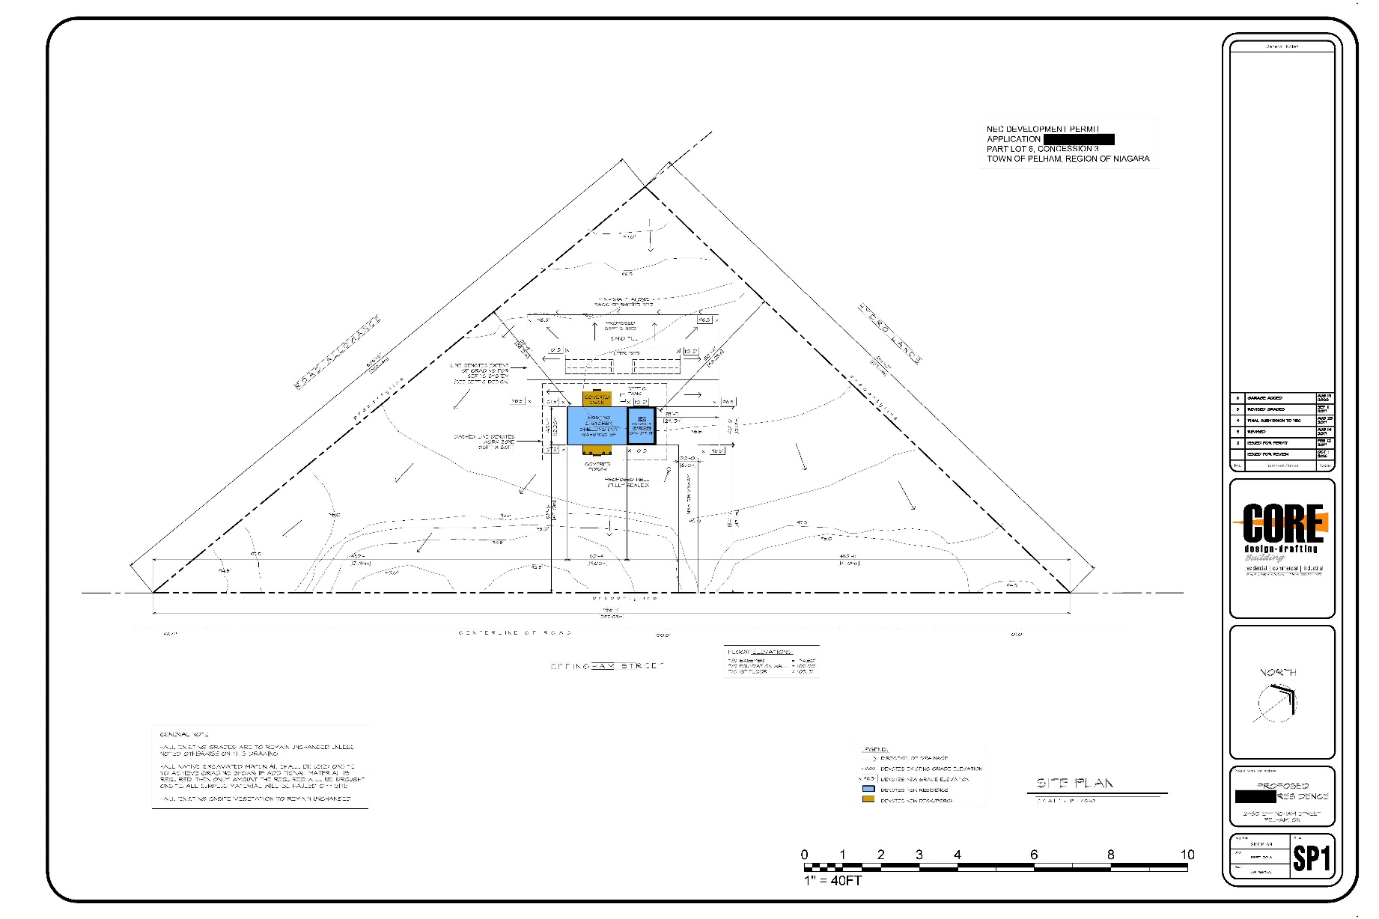

APPENDIX 5

Site plan for fill importation
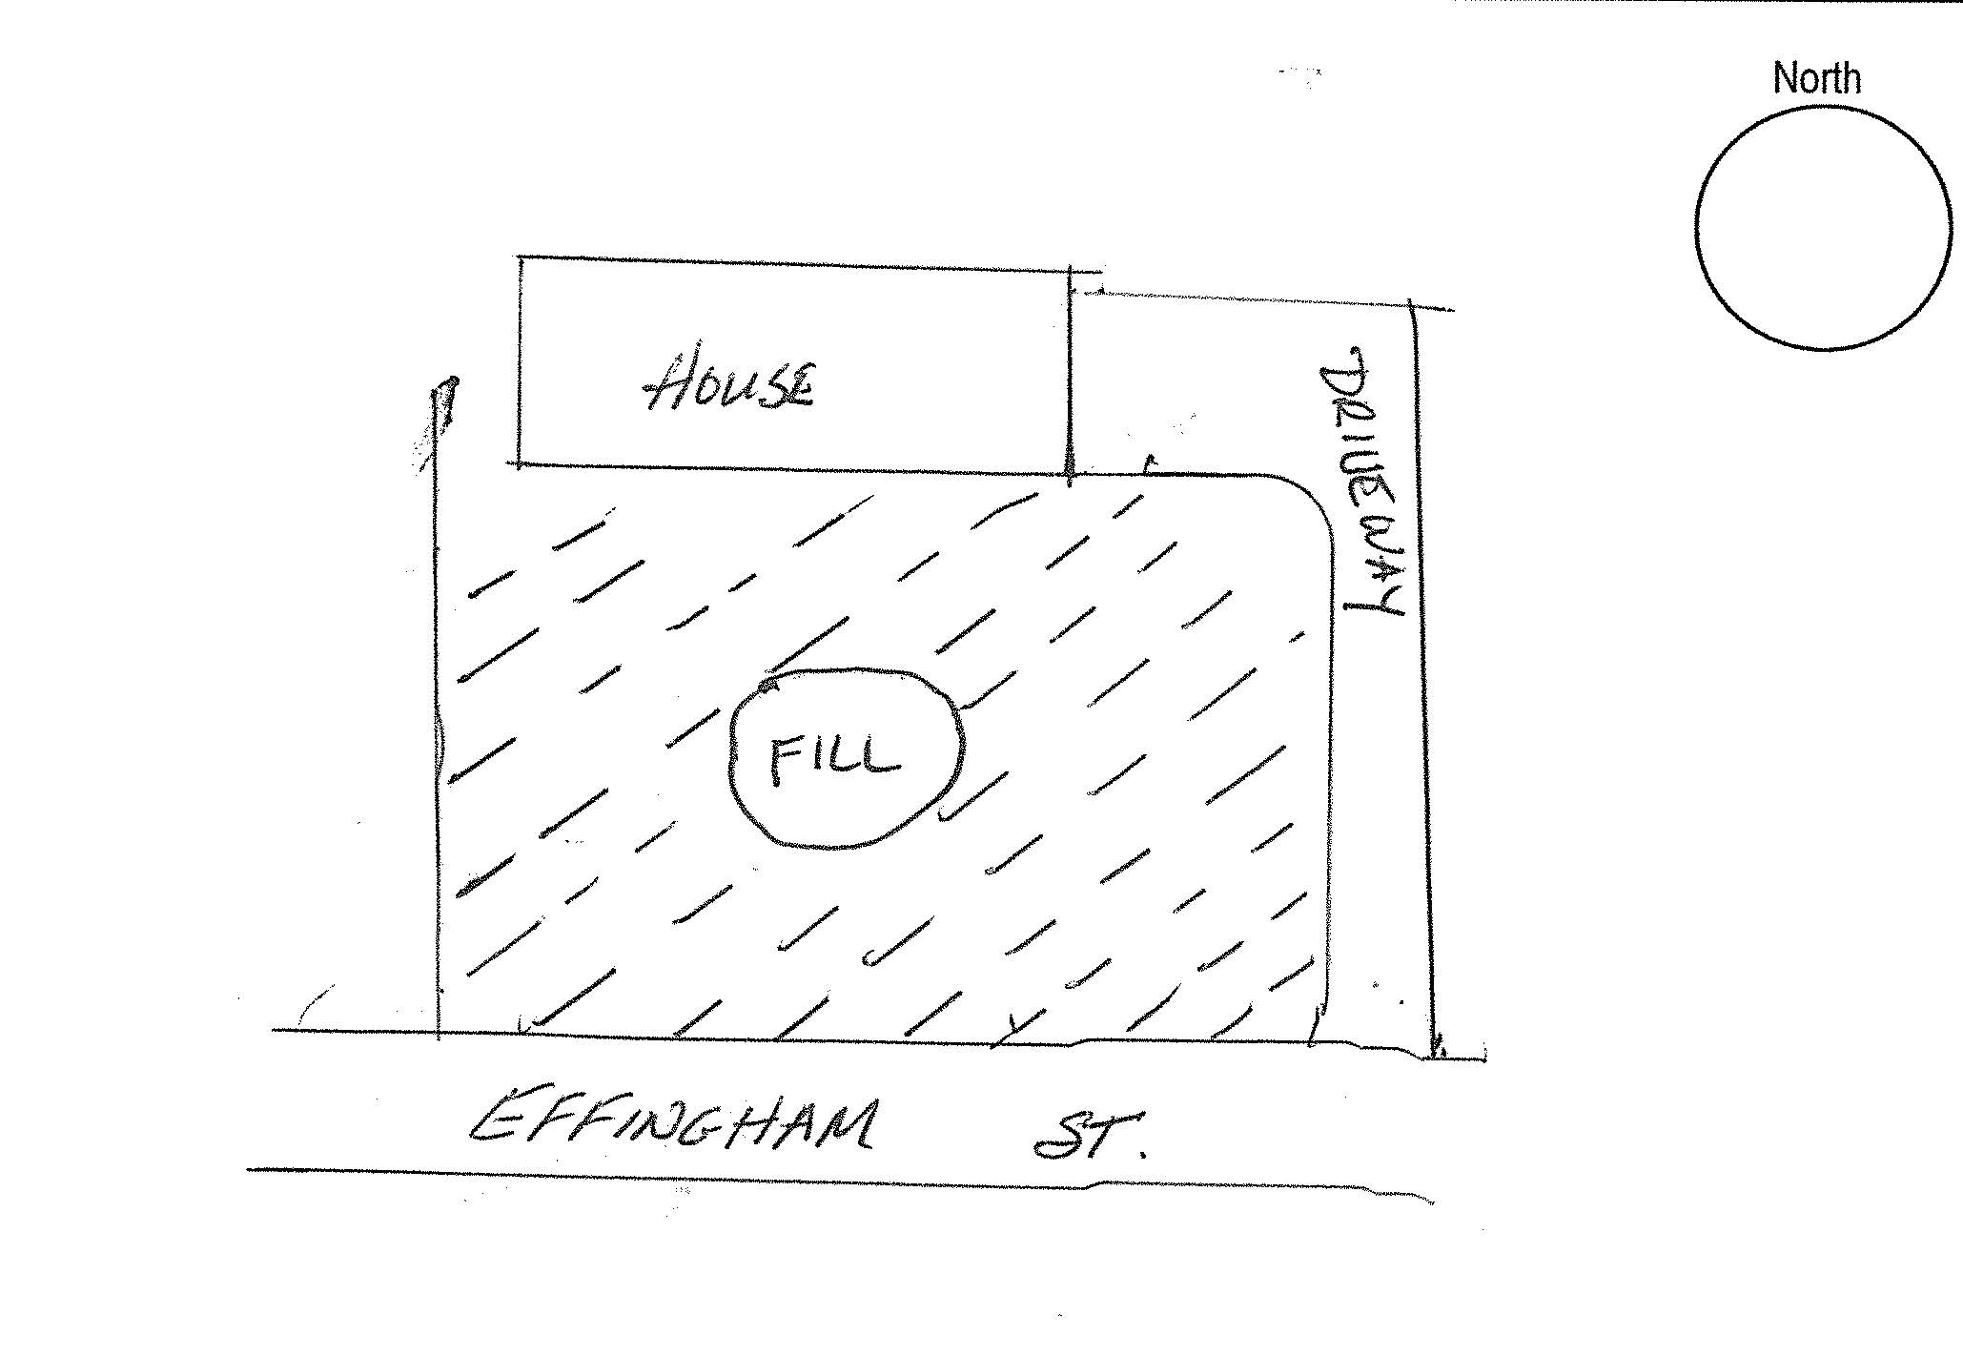

APPENDIX 6

Site plan for driveway extension
Driveway exte