November 17, 2022

STAFF SUMMARY REPORT

RE: PROPOSED Niagara Escarpment Plan Amendment PH 222 21
3475 Campbellville Rd (former Campbellville Sand and Gravel North Pit)
Part Lot 6 Concession 4 (Nassagaweya)
Town of Milton, Region of Halton

Initiated by: Niagara Escarpment Commission

Owner: 555816 Ontario Inc.

NEP Designation (current): Mineral Resource Extraction Area

Proposal Summary:

To undertake an amendment to the Niagara Escarpment Plan (NEP) to allow for a site-specific change to the Land Use Designation from Mineral Resource Extraction Area (MREA) to Escarpment Protection Area; as it relates to the surrender of the Aggregate Resource Act (ARA) licence (# 5479), on the former gravel pit operated by Campbellville Sand and Gravel.

STAFF SUMMARY RECOMMENDATION:

That the Commission endorses the Amendment as set out in this Report and attached as Schedule A, and requests that the Minister of Natural Resources and Forestry approve the Amendment pursuant to Section 10 (11) of the Niagara Escarpment Planning and Development Act (NEPDA).

- PROCESS HISTORY / BACKGROUND

At its meeting on July 15, 2021, the Niagara Escarpment Commission (NEC) decided to initiate and circulate the proposed amendment for comments.
The lands are currently designated MREA in the NEP (Map 1), in conjunction with a sand and gravel pit extraction operation that was established in the 1960s (pre-NEP/Development Control). The extraction activities have ceased, and the licence has been surrendered, as confirmed by the Integrated Aggregates Operations Section of the Ministry of Natural Resources and Forestry (MNRF).
Proposed NEP Amendment PH 221 21 for the adjacent lands at 4000 Campbellville Rd (South Pit) is being processed concurrently with the amendment application for the subject lands at 3475 Campbellville Rd (North Pit). While related, the proposed amendments are being processed as separate amendment files, given that the parcels operated under separate ARA licences, and are now under separate private ownership. Proposed amendment PH 222 21 (3475 Campbellville, North Pit) has been initiated by the NEC, while the application for amendment at 4000 Campbellville (South Pit) has been made by the landowner. The planning analysis for both proposed amendments is similar, given the proximity of the sites to each other on the landscape and that they are both seeking re-designations of a former MREA.

B. SITE DESCRIPTION AND SURROUNDING LAND USES

The subject property described municipally as Lot 6, Concession 4 in the Town of Milton is approximately 24.18 ha (59.76 ac) in size and is accessed from Campbellville Rd north of Highway 401 west of Appleby Line.
A Hydro One corridor bisects the subject lands through the middle and is also currently designated MREA. While the Hydro One lands were identified within the licenced area, they remained outside of the limit of extraction and were not extracted. Information submitted in support of a 2018 Development Permit Application by Hydro One (see below for more info), included an Ecological Land Classification (ELC) (Dillon Consulting, Draft Oct 2018). ELC communities in this portion of the subject lands are identified to include Deciduous Forest, Meadow Marsh, Fresh-Moist Forb Meadow, and Deciduous Swamp Forest. Individual Butternut trees were also identified along the unopened road allowance. Staff would describe the remainder of the subject lands as fallow fields and early successional meadows.
The subject lands are well screened from Campbellville Rd, with vegetated berms. The Escarpment brow traverses the lands across the eastern corner. Surrounding land uses include rural residential, agricultural, and conservation lands. The Halton Forest South Provincially Significant Life Science Area of Natural and Scientific Interest (ANSI) is located to the north and abuts the subject lands on the eastern and western boundaries of the subject lands. The boundary of the ANSI is largely coincident with the boundary of the Hilton Falls Complex Environmentally Sensitive Area (ESA). The Guelph Junction Provincially Significant Wetland (PSW) complex is situated to the south of Hwy 401, and to the west.
- CIRCULATION AND COMMENTS
On August 26, 2021, the NEC circulated the proposed amendment and requested comments from relevant Ministries, affected municipalities, stakeholders and interested parties, and the public. Comments were to be filed by October 25, 2021 (60-day circulation).
Notice was also placed in the Milton Champion on August 26, 2021, requesting comments be submitted to the NEC by October 25, 2021.
The proposed amendment was posted on the Environmental Bill of Rights Registry (EBR) on September 24, 2021, with a request for comments by November 23, 2021 (60-day commenting period). One comment was received through the Registry posting (discussed further below).
- Public Interest Advisory Committee

The Public Interest Advisory Committee (PIAC) was established by the Minister pursuant to S. 4(1) of the NEPDA. The PIAC is an appointed advisory body of persons that the Minister determines are broadly representative of the people and interests in the Niagara Escarpment Planning Area, to make recommendations to the NEC and the Minister on amendments proposed to the NEP. The PIAC is specifically required to be consulted by the NEC, and to make comments on proposed amendments under S. 10(1) of the NEPDA. These comments then form part of the recommendations that must be considered by the NEC, Hearing Officers (if the matter is referred to a Hearing), and the Minister when a decision is being made.
The PIAC convened a teleconference meeting on March 29, 2022, where the proposed amendment was presented by NEC staff and discussed by the PIAC members. The motion of the PIAC was as follows:
That the PIAC recommends support for proposed Amendment PH 222 21
The motion passed, all in favor.
- Agency / Public Circulation:

The following summary of comments and recommendations was received on the circulation and consultation of the proposal:

Ministries

Ministry of Transportation: The subject land is located within the Ministry’s permit control area and any development of this land requires ministry review and approval.
General information regarding MTO Permits: A MTO building and land use Permit is required prior to any construction, only once the applicant has received Site Plan approval can they apply for applicable MTO Permits, all signs related to the development that are visible from the Highway and its ramps will require MTO permit(s).
Staff comment: There is no development being contemplated as part of the amendment proposal. The amendment is for a change to the land use designation only. Future proposed development will require a subsequent Development Permit Application (unless determined to be exempt under O. Reg 828/90). Development Permit Applications would be circulated to the MTO, as appropriate.
Ministry of Natural Resources and Forestry (Land Use Planning and Strategic Issues Section, Southern Region)
Based on a review of the proposal, the MNRF confirmed the licence # 5479 issued under the Aggregates Resource Act for these lands has been surrendered. While no longer licensed, surrender (of the licence), does not necessarily mean that the resource is depleted. As such there may be aggregate deposits remaining on these lands. The most up-to-date information available is the Aggregate Resources Inventory Paper 47 (1982), for the Town of Milton which identifies this area as being within an area of sand and gravel deposit of primary significance. NEC may wish to request further information on the current state of the aggregate deposit on site prior to making a decision on the amendment.
Staff comment: staff has reviewed the Aggregate Resources Inventory Paper 47 (1982). While the general area which includes the subject property, is identified as being within an area of sand and gravel deposit of primary significance, the paper also notes that selected resource areas are not intended to be permanent, single land use units that must be incorporated in an official planning document, but rather they represent areas in which a major resource is known to exist. Such Resource Areas may be reserved wholly or partially for extractive development and/or resource protection within the context of the official plan.
This also must be considered in the context of the provincial land use plan. The NEP Part 1.5 Designation Criterion for Mineral Resource Extraction Areas identifies existing licensed areas as the criterion for the MREA designation. The aggregate extraction activities on the subject property have now ceased and are no longer licenced, and as such, it is not appropriate to maintain the MREA designation on the lands.
The direction set out in the NEP is to see MREAs re-designated once extraction has been completed and the licence is surrendered. Such sites where extraction has been completed are expected to be rehabilitated and then redesignated to allow for consideration of compatible uses permitted by the NEP. Appropriate redesignation of the lands promotes the return of such lands to less intensive and more compatible land uses and removes the pressure to use a former licensed site for industrial processing facilities, landfilling, or stockpiling, or as a disposal site for surplus fill.
As the agency that administers the NEP, the NEC has the responsibility to ensure that the NEP Objectives are being achieved and that the Plan is kept current and that mapping reflects the most accurate and appropriate land use designations, based on an assessment of the features on the ground against the NEP Land Use Designation Criteria and Objectives. It is in the public interest to ensure that MREAs be considered interim land uses and that once the operation has ceased the lands return to the appropriate land use designation(s) to allow for the consideration of compatible future land uses in support of the Purpose and Objectives of the NEPDA and the NEP. The lands are now in private ownership.

Halton Region Official Plan policy also considers mineral aggregate resource extraction as an interim use and requires the rehabilitation of all such sites to form part of the Greenbelt, Regional Natural Heritage System, or the Agricultural Area, with the proposed after-uses being in conformity with the applicable policies of that land use designation.

Municipalities

Region of Halton: The Region supports the NEC staff’s assessment and recommendation that the subject lands meet Criterion 2 of the Escarpment Protection Area Designation, considering their proximity to the Escarpment brow and related Escarpment slopes, and due to the Escarpment Protection Area designation of adjacent lands. In addition, the Region supports the NEC staff’s conclusion that the redesignation offers the opportunity for the subject lands to support and maintain the scenic resources and open space character of the Escarpment, and forms a buffer to adjacent Escarpment features, in accordance with the objectives of the Escarpment Protection Area designation.

The proposed amendment is consistent with the Regional OP. If approved, the Regional OP would be required to be updated to reflect the new designation and be brought into conformity with the NEP. The Region is currently undertaking a Regional OP Review, and staff noted that if the timing aligned, the conformity exercise could take place as part of the OP Review.
Town of Milton: The property is currently under the development control of the NEC and has no zoning under the Town of Milton Zoning By-law 144-2003, as amended. However, should the lands be reviewed under Zoning By-law 144-2003, they would be Rural (A2) Zone. The subject lands are designated as Mineral Resource Extraction Area on Schedule A – Land Use Plan of the Town of Milton’s Official Plan.
No objections to the proposed amendment.

Agencies, Partners, and Stakeholders

Conservation Halton: The subject property contains a wetland feature less than 2ha in size. CH regulates a distance of 15m from the greater of the flooding and erosion hazard limits associated with Sixteen Mile Creek and 30m from the limit of wetland features less than 2ha in size for this site. No objection to the proposed amendment application. A Permit from Conservation Halton will now be required for any development on the subject property within the CH-regulated area, as the licence under the ARA has now been surrendered.
Hydro One: No objections to the proposal
Staff comment: A NEC Development Permit Application was submitted in July 2018 by Hydro One to open an unopened road allowance and install a gravel driveway on the subject property to provide access to the Hydro One corridor. The DPA is currently in abeyance as Hydro One’s scope of work has changed. The re-designation of the lands to Escarpment Protection Area is not anticipated to impact the application.
Public

Environmental Registry: One comment was received through the Environmental Registry posting simply stating support for the proposal.
- DISCUSSION & ANALYSIS

The assessment of and justification for the amendment has been set out in the Initial Staff Report dated July 15, 2021.
The following discussion serves to confirm the original analysis as well as provide for any additional considerations that were undertaken by staff in coming to the final recommended amendment PH 222 21:
Niagara Escarpment Plan (2017)

The NEP Part 1.2.1 identifies that planning policies and land use designations may be changed by amendment to the Plan, provided that the proposed amendment is consistent with the Purpose and Objectives of the NEPDA and the NEP. The Development Criteria set out in Part 2 of the NEP are to be considered in the assessment of any amendment to the NEP. The Part 2 Development Criteria are not applicable in this instance, given that the amendment is only seeking a change to the designation, and is not seeking any associated development or policy exceptions. Permitted Uses on the subject lands will be informed by the new designation(s), once approved, and would require subsequent Development Permit Application(s).
Licensed aggregate sites in the NEP Area are intended to be interim uses, given that the extraction within approved MREAs will eventually cease. Such sites where extraction has been completed are expected to be rehabilitated and then re-designated to allow for other more compatible uses, which are identified as being permitted under the respective land use designation(s).
NEP Part 1.9.2 Criteria for Designation of a Mineral Resource Extraction Area states:

- Licensed pits and quarries producing more than 20,000 tonnes annually.

This Criterion is no longer applicable to the subject property following the completion of the aggregate extraction activities and surrender of the ARA licence.
The Objectives of NEP Part 1.9 Mineral Resource Extraction Area designation specifically state that after uses and rehabilitation should:
- Encourage rehabilitated mineral aggregate operations to be restored to a state that is of equal or greater ecological or agricultural value than the original characteristics of the site.
- Ensure that, after a licence is surrendered, the land is re-designated to a land use designation that is compatible with the rehabilitation of the site, the designation criteria of adjacent lands, the surrounding Escarpment environment, and existing land uses in the area.
- Encourage, wherever possible, the rehabilitated after uses of pits and quarries to be integrated into the Niagara Escarpment Parks and Open Space System.
The Permitted Uses within MREAs are limited, except for those directly related to aggregate extraction and subsequent rehabilitation, and generally reflect the interim nature of pits and quarries.
NEP Part 1.9.5 After Uses identifies that following the surrender of the licence, an amendment is required to change the land use designation of the lot from MREA to a land use designation that has designation criteria consistent with the rehabilitation completed on the property and be processed in accordance with NEP Part 1.2.1.

Part 1.4 Escarpment Protection Area
Escarpment Protection Areas are generally considered less sensitive than Escarpment Natural Areas, although this may not be the case in all instances. They are recognized as an important part of the natural and scenic Escarpment environment. Escarpment Protection Areas are important due to their visual prominence and environmental significance. These areas were delineated based on topography, vegetation, and visual landscape units, given they are often the more visually prominent areas. Included in this designation are Escarpment features that have been significantly modified by land use activities such as agriculture or residential development, but still exhibit significant aesthetic and ecological qualities. Additionally, these lands are required to buffer the more prominent Escarpment Natural Areas
Part 1.4.2 Criteria for Designation:

- Escarpment slopes and Escarpment Related Landforms where existing land uses have significantly altered the natural environment (e.g., agricultural lands or residential development).
- Areas in close proximity to Escarpment slopes that are visually part of the landscape unit.
- Areas of Natural and Scientific Interest (Life Science), or environmentally sensitive or environmentally significant areas identified by municipalities or conservation authorities.
The re-designation of the rehabilitated portion of the subject land to the Escarpment Protection Area is justified as the subject property meets Part 1.4. Designation Criteria considered land in close proximity to the Escarpment slopes which are visually part of the landscape unit.
The NEP Part 2 Development Criteria are not applicable to the proposal, given that the amendment is only seeking a change to the Land Use Designation, and does not include any associated development or policy exceptions at this stage. Permitted uses on the subject lands will be informed by the new designation, once approved, and future proposed development would require a Development Permit Application.
Provincial Policy Statement (2020)
The PPS (2020) is intended to provide direction on matters of provincial interest related to land use and planning. All land use planning decisions, including those of the NEC, must be consistent with the policies of the PPS; however, the PPS states that Provincial Plans take precedence over policies in the PPS to the extent of any conflict, except where relevant legislation provides otherwise. The NEP builds upon the policy foundation provided by the PPS and provides additional land use planning policies in support of the Purpose and Objectives.
The PPS provides direction for the rehabilitation and after-use of mineral aggregate resource sites in Section 2.5.3 Rehabilitation. Section 2.5.3.1 states that progressive and final rehabilitation shall be required to accommodate subsequent land uses, promote land use compatibility, recognize the interim nature of extraction, and mitigate negative impacts to the extent possible. Final rehabilitation shall take surrounding land use and approved land use designations into consideration. Further, Part 2.5.3.2 identifies that comprehensive rehabilitation planning is encouraged where there is a concentration of mineral aggregate operations
Section 2.0 of the PPS identifies the province’s objectives respecting the long-term protection of natural heritage, water resources and cultural heritage, and archaeological resources for their economic, environmental, and social benefits. Part 2.1 requires that natural features and areas shall be protected for the long term and Part 2.1.2 identifies that the diversity and connectivity of natural features in an area, and the long-term ecological function and biodiversity of natural heritage systems, should be maintained, restored, or, where possible, improved, recognizing linkages between and among natural heritage features and areas, surface water features and ground water features.
The proposed re-designation of the lands is consistent with the PPS (2020).
Greenbelt Plan (2017)
The Greenbelt Act authorized the preparation of the Greenbelt Plan, which was approved in February 2005 and updated in 2017 through the 2015 Co-ordinated Land Use Plan Review. The Greenbelt Plan Area includes all of the NEP Area. The policies of the NEP are the policies of the Greenbelt Plan for the NEP Area with the exception of the Open Space and Trails Policies set out in Section 3.3 of the Greenbelt Plan. The planning, construction, and maintenance of parkland, open space, and trails in the NEP Area must also comply with the policies in Section 3.3 of the Greenbelt Plan. Further, Section 5.6 identifies amendments to the NEP that remain governed by and are to be dealt with in accordance with the provisions of the NEPDA.
Growth Plan for the Greater Golden Horseshoe (2020)
A Place to Grow: Growth Plan for the Greater Golden Horseshoe (Office Consolidation, 2020) (the “Growth Plan”) applies to lands within the Greater Golden Horseshoe (GGH), which includes the Town of Milton, and provides direction on how to manage growth. Emphasis is placed on intensification and redevelopment in existing settlements and built-up areas rather than sprawl or haphazard expansion that requires new municipal services (e.g., sewers and water). The Growth Plan on its Map Schedules also identifies Urban Growth Centres within existing built-up areas. The subject lands are not identified as being part of an Urban Growth Centre or Built-up Area as designated in the Growth Plan (downtown Milton is identified as such).
The Growth Plan and Greenbelt Plan are intended to work together. Areas to be protected in the GGH were established first (in the Greenbelt Plan) and then areas, where development could be considered, were identified second (Growth Plan). Both the Growth Plan (Section 1.4) and its enabling legislation (Places to Grow Act, 2005), indicate that in considering the Growth Plan in relation to other Provincial Plans and Policies (e.g., the NEP), the planning direction to be followed is the one that “provides more protection to the natural environment or human health”. In considering the hierarchy of Provincial Plans and policies governing this area and the provisions within those documents, the greatest protection to the natural environment and human health (particularly the natural environment), is accomplished most effectively through the policies and appropriate land use designations of the NEP.
The Natural Heritage System of the Growth Plan is not identified in the area of the NEP.
The subject lands are included within the broader area identified as being “Candidate Area” within the identified Prime Agricultural Area of the Growth Plan.

Regional and Local Planning Context

Region of Halton Official Plan

The subject lands are designated as Mineral Resource Extraction Area on Map 1 Regional Structure, of the Halton Regional Official Plan (HROP, Office Consolidation, 2018). The Regional Structure, as shown on Map 1 to the OP represents the Region’s basic position on the use of land and natural resources within its planning area and is the framework within which Local Official Plans, amendments, and by-laws shall be prepared. Section 51 describes that the Regional Structure consists of several mutually exclusive land use designations including subsection (2.3) Mineral Resource Extraction Areas, where a valid licence has been issued under the ARA, and (3) Regional Natural Heritage System, a system of connected natural areas and open space to preserve and enhance the biological diversity and ecological functions within Halton

Map 1G Key Features within the Greenbelt and Regional Natural Heritage System identify the lands directly to the north of the subject property as “Key Features” and “Enhancement Areas, Linkages and Buffers”

Section 110(6) identifies that it is the policy of the Region to consider mineral aggregate resource extraction as an interim use and require the rehabilitation of all such sites to form part of the Greenbelt or Regional Natural Heritage System or the Agricultural Area, with the proposed after-uses being in conformity with the applicable policies of that land use designation. Further, Section (6.2) provides that any after use not permitted in Section 109 of the OP shall require an amendment to the Regional Plan and where applicable, the Niagara Escarpment Plan.

The proposal is consistent with the Regional OP.

Town of Milton Official Plan

The subject lands are identified as MREA and a very small sliver in the most easterly corner as “Greenlands A” in Schedule A (Land Use Plan) to the Town of Milton Official Plan (2008). Staff notes that the area identified as “Greenlands A” in the Town OP is not consistent with the current NEP land use designations assigned to the subject lands, which include the entirety of the property within the MREA designation. The Town OP appears to have taken the former licence boundary vs. limit of extraction into consideration in designating the lands, while the NEP has included all the former licence boundary in the MREA designation.

Section 4.7.1.1 of the OP identifies that the purpose of the MREA designation is: a) to protect legally existing pits and quarries, being those that are licensed under the Aggregate Resources Act, from incompatible land uses; b) to minimize the impact of mineral resource extraction operations on the Greenlands System, the Escarpment Natural, Escarpment Protection, and Escarpment Rural Areas; c) to provide policies and criteria for new licence applications for pits and quarries; d) to ensure the progressive rehabilitation of pits and quarries to appropriate after use in accordance with the rehabilitation plan within the time frame of the license, which is compatible with the permitted uses of this designation, the surrounding environment and existing uses; and, e) to encourage, where possible, the rehabilitated after-uses of pits and quarries to be integrated into the Niagara Escarpment Parks and Open Space System or the Greenlands A or B Area designations or for agricultural use.

Section 4.8 of the Town OP relates to the Greenlands A designation. Generally, the Greenlands A designation provides for the protection of the underlying environmental features. The Greenlands A designation includes land and water areas that meet one or more of the following criteria:

- Areas included in the Regulatory Flood Plains, as determined and mapped by the appropriate Conservation Authority, and refined from time to time, as shown on Schedule "B" of this Plan;
- Provincially Significant Wetland, as determined by the Ministry of Natural Resources and refined from time to time; and,
- Significant valley lands or significant portions of the habitat of endangered and threatened species, as determined by the Town, the Region, the appropriate Conservation Authority, and the Ministry of Natural Resources, as refined from time to time.

Staff suggests that it is likely that the very small portion of the subject lands identified as Greenlands A (in the most easterly corner of the property), maybe a result of the lands meeting Criterion a) the area is included within the conservation authority regulatory flood plain mapping, and/or b) endangered or threatened species habitat (associated with Sixteen Mile Creek).

Similar to the permitted uses of the NEP Escarpment Natural Area designation, permitted uses in the Greenlands A designation are limited to a) existing agricultural operations; b) non-intensive recreation uses such as nature viewing and pedestrian trail activities only on publicly owned lands or on the Bruce Trail; c) forest, wildlife and fisheries management; d) archaeological activities; e) essential transportation and utility facilities; f) uses permitted in Park or Open Space Master or Management Plans which are not in conflict with the Niagara Escarpment Plan if the subject land is located within the Niagara Escarpment Plan Area; and, g) essential watershed management and flood and erosion control projects carried out or supervised by a public authority.

- CONCLUSIONS

NEC staff is satisfied that there were no objections received, all comments and recommendations were considered, and the amendment is justified and consistent with the Purpose and Objectives of the NEPDA and NEP, PPS, and Official Plans. As no hearing is required, the Commission can proceed with making a recommendation to the Minister.
RECOMMENDATION:

That the Niagara Escarpment Commission endorse NEP Amendment PH 222 21 dated November 17, 2022 and forward the Commission’s recommendation to the Minister of Natural Resources and Forestry for approval pursuant to Section 10 (11) of the Niagara Escarpment Planning and Development Act.

Attachments

Map 1 : Current NEP Land Use Designation
Map 2 : Natural Heritage Features
Appendix 1: Final Plan Amendment Document (Schedule A)

Prepared By: Approved by:

Original signed by: Original signed by:
_____________________
Lisa Grbinicek, RPP, MCIP Kathy Woeller
Senior Strategic Advisor Director

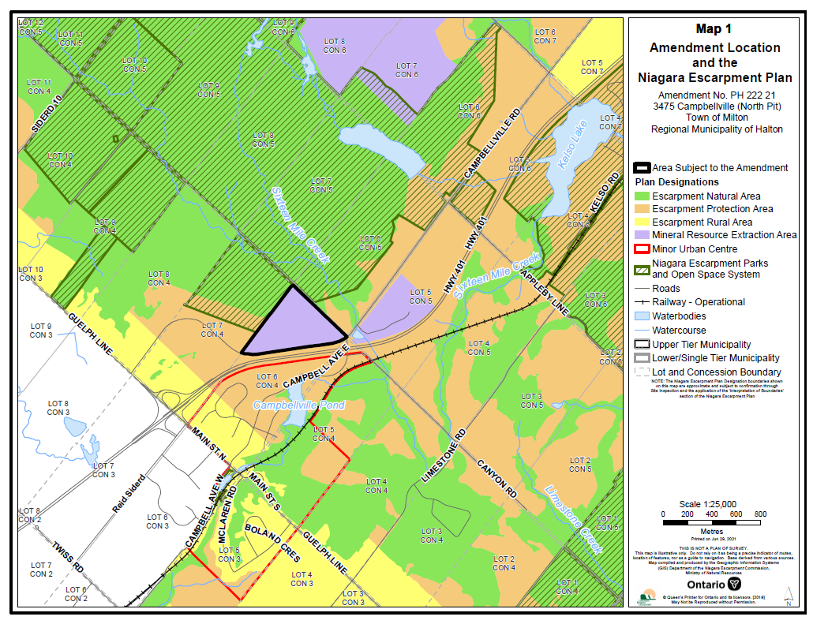
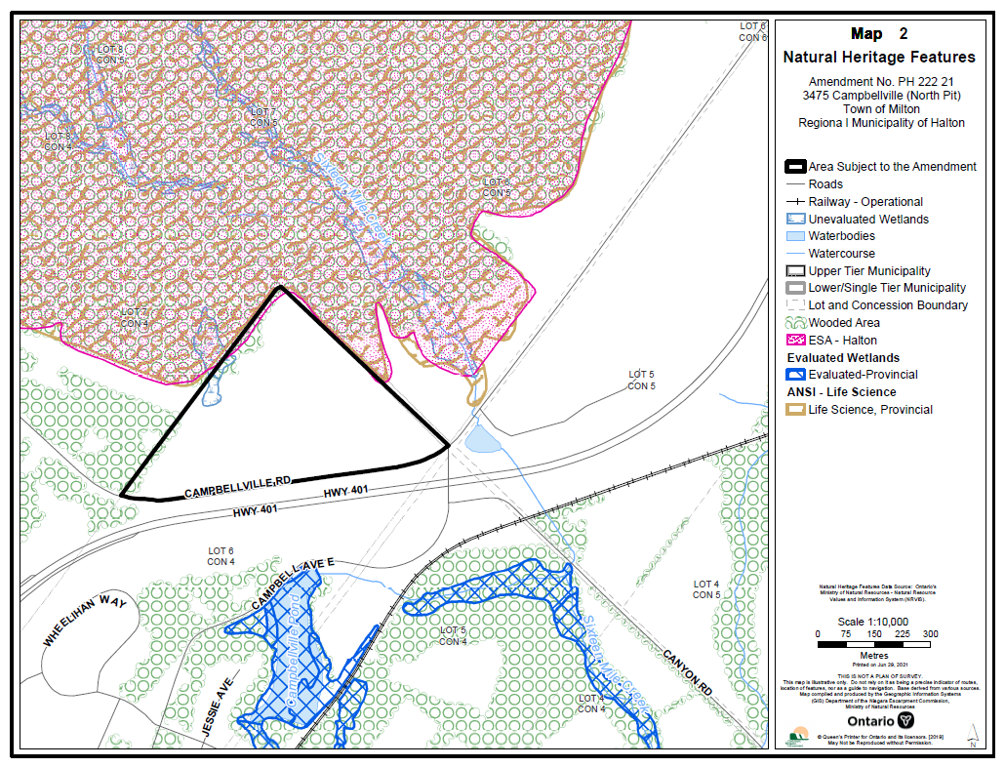

PROPOSED NIAGARA ESCARPMENT PLAN
AMENDMENT PH 222 21

(Former Campbellville Sand and Gravel “North Pit”)

November 17, 2022

TABLE OF CONTENTS

PART A – The Preamble
PART B – The Amendment
PART C – Schedule “A”

Part A – The Preamble

PURPOSE:

The purpose of the proposed amendment affecting the lands identified on Schedule A, attached hereto, is to amend the Niagara Escarpment Plan (NEP) to re-designate the subject lands (formerly the Campbellville Sand and Gravel Campbellville North Pit), from Mineral Resource Extraction Area to Escarpment Protection Area, to reflect the surrender of the Aggregate Resources Act (ARA) licence.

AREA:

The lands subject to the proposed Plan amendment consist of an area of approximately 24.18 ha (59.76 ac).

LOCATION:

Part Lot 6, Concession 4 (Geographic Township of Nassagaweya)
Region of Halton, Town of Milton

OWNERSHIP:

555816 Ontario Inc.

BASIS:

Under Section 6.1(2) of the Niagara Escarpment Planning and Development Act, an amendment to the Niagara Escarpment Plan “may be initiated by the Minister or the Commission, and application may be made to the Commission by any person or public body requesting an amendment to the Plan.”

Part 1.2.1 of the NEP sets out provisions for an amendment to the NEP and this application satisfies Section 1.2.1.

Section 6.1 (2.1) of the Niagara Escarpment Planning and Development Act requires that an application to amend the NEP be supported by a “statement of justification” and Section 8 sets out the objectives to be addressed in consideration of an amendment to the NEP. The applicant has provided a Planning Justification Report (MHBC, March 23, 2021), which satisfies the threshold justification requirements of the Niagara Escarpment Planning and Development Act.
The amendment proposes to change the existing designation of Mineral Resource Extraction Area to Escarpment Protection Area, the proposal has demonstrated the re-designation satisfies the applicable Objectives and Designation Criteria of the NEP.
The subject lands constitute the Escarpment and lands in its vicinity which fulfill the Purpose and Objectives of the NEPDA and therefore, such lands should be properly designated within the NEP given that the land is no longer licensed under the ARA. The lands have been rehabilitated to the satisfaction of the Ministry of Natural Resources and Forestry and the surrender of the licence has been accepted.
The amendment is consistent with the Provincial Policy Statement and supports Municipal Official Plans.

PART B – The Amendment

The Niagara Escarpment Plan is modified as follows:
Map 3 of the Niagara Escarpment Plan is amended as shown on Schedule A.

