November 16, 2022
STAFF DISCUSSION REPORT
Re: Niagara Escarpment Agricultural Policies
This report has been prepared to accompany Initial Staff Report PC 225 22, as background and to inform the Commission of recent submissions made by key agricultural stakeholders and seek further direction from the Commission respecting the scope of additional Niagara Escarpment Plan (NEP) agricultural policy topics to be considered.
The 2015 Coordinated Land Use Planning Review resulted in the 2017 NEP and included several changes to agricultural policies to better align with the Provincial Policy Statement (PPS), as well as the other provincial land use plans. In staff’s view, the 2017 NEP policies are generally more permissive in terms of the types and scale of uses related to agriculture than the previous NEP (2005). Notwithstanding these enhancements, key agricultural stakeholders have raised concerns that the NEP policies remain too restrictive in nature.
The Ontario Craft Wineries (OCW) is one specific stakeholder, that while expressing some degree of satisfaction that the Coordinated Land Use Planning Review resulted in a more objectives-based approach to wineries (e.g., the inclusion of on-farm diversified uses and value-added uses to reflect more broadly the reality of this agricultural sector), continues to maintain several concerns, as outlined in their most recent submission of October 25, 2022 (attached).

Similarly, concerns continue to be expressed by the Ontario Federation of Agriculture (OFA) (see attached). The OFA has expressed on record concern for the differential permissions for OFDUs and ARUs in the Escarpment Protection Area and Escarpment Rural Area designations of the NEP (proposed to be addressed through PC 225 22) and has also previously advocated for the removal of all winery-specific NEP policies, noting that while the other provincial planning documents appear to recognize wineries as an equal use to other ARUs and/or OFDUs, the NEP continues to place wineries under a different policy framework. The OFA has recently adopted a policy position on OFDUs (see attached), that appears directed towards municipalities in their development of policies and provisions guiding the development of OFDUs.
Staff continues to track agricultural Development Permit Applications (DPA) to assist in identifying the challenges and opportunities with the implementation of the 2017 NEP, and to contribute to evidence-based decision-making. Table 1 below summarizes the NEC DPA history for agriculture, ARUs, and OFDU development proposals since the 2017 NEP came into effect.
A total of one hundred and seventy-five (175) DPAs related to agricultural uses (including OFDUs and ARUs) have been submitted to the NEC for consideration since June 2017. Of the one hundred and two (102) applications that have completed the application process (forty-six applications are still under consideration, and twenty-seven applications were withdrawn/closed), one hundred were approved (Director’s Approvals and Commission supported). Only two DPAs were refused by the Commission (the first on the basis that the proposal was not determined to meet the definition of an OFDU but was determined to be an institutional use, the second on the basis that new agricultural uses are not permitted on lands within the Pleasant View Survey area, as set out in the Part 2.2.21 of the NEP).
Table 1: Development Permit Application History related to Agriculture
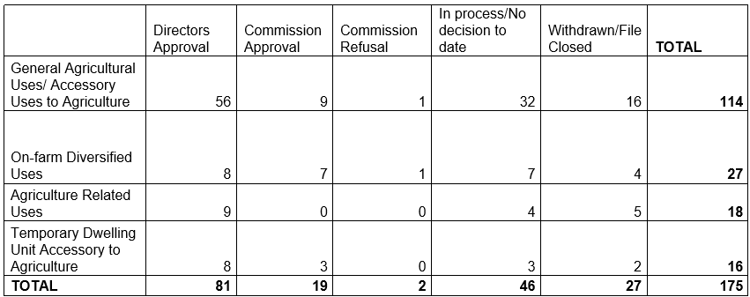
In addition to the policy review/amendment scoping exercise that staff has been undertaking, the Commission has also endorsed staff to proceed with the development of policy guidance materials to support some of the identified interpretation and implementation challenges associated with the agricultural policies (specifically dwelling units accessory to agriculture and OFDUs). However, it is unclear at this time if the agricultural guidelines will be able to address the full scope of issues and concerns to the satisfaction of the agricultural stakeholders. Updates to the Guideline development initiative will be provided through a separate staff report and discussion.

Staff is aware that the proposals presented in the attached Initial Staff Report for proposed NEP amendment PC 225 22 do not reflect or address the full extent of the agricultural policy amendments that key agricultural stakeholders are seeking. While the proposals presented do address significant targeted concerns (i.e., Part 1.4.3.2. policy respecting OFDUs and ARUs in prime agricultural areas), additional areas of interest remain regarding the ability of the current NEP provisions to support viable agriculture and agri-tourism in the NEP Area. As noted in the Initial Staff Report for PC 225 22, staff considers the current amendment proposals as ‘Phase 1’ and notes that advancing the amendment proposal would not preclude subsequent amendments from being considered by the Commission, provided adequate justification could be made.

Concerning the OCW request (October 25, 2022), to further consider a “full-integration of tourist amenities”, including food services and accommodations (e.g., on-site vacation establishments), beyond what the NEP currently permits (i.e., bed and breakfasts), staff have previously cautioned the Commission that consideration of a greater diversity of Permitted Uses in the NEP Area to accommodate and promote increased commercial tourism opportunities is contrary to the Purpose and Objectives of the NEP.
Compatibility and cumulative impact remain core fundamental principles that are essential to be considered in the context of discussions respecting intensifying such uses within the Escarpment Protection and Escarpment Rural Areas. Staff has maintained that opportunities for more intensive tourism-related facilities and development are available within and directed to the Escarpment Recreation Area, Minor Urban Centres, and Urban Area designations, and can also be directed outside the NEP Area.
Notwithstanding these considerations, staff also reminds that during the 2015 Coordinated Land Use Planning Review, in response to some of the stakeholder comments respecting tourist accommodations, “country inns” were identified and put forward by NEC staff as a separate category of development from bed and breakfasts, to allow for establishments with more than three guest suites. This recommendation was not adopted by the government.
Additionally, staff notes that some of the changes being sought by the agricultural stakeholders (i.e., related to events), may involve regulatory and or legislative changes, which are beyond the scope of the amendment process available at this time, and may also need to be evaluated concerning whether the urban use policy is triggered, meaning that such uses would be required to be addressed at the time of the next Plan Review.

The Commission will be presented with the submissions by the OCW and OFA through delegations at the November 16 Commission policy meeting. At the Commission’s direction, staff will continue to undertake a review and analysis of any additional agricultural policy areas identified by the Commission, including targeted consultation with ministry partners and a broader range of agriculture stakeholders.

As these discussions continue with agricultural stakeholders and depending upon the Commission’s direction to staff, it will also be necessary to engage with the Ontario Ministry of Agriculture, Food and Rural Affairs (OMAFRA), the ministry responsible for agricultural policy and guidelines in the province, as some issues may be subject to further research and development and should be addressed in a comprehensive provincial scale manner.
RECOMMENDATION:
That the Commission receive the delegations by the identified agricultural stakeholders at November 16, 2022, policy meeting and provide further direction to staff respecting the need for additional NEP policy analysis on the issues presented.

Attachments: Ontario Craft Wineries Submission (October 25, 2022)
Ontario Federation of Agriculture submission (November 15, 2021)
OFA Policy: On-farm diversified uses (August 23, 2022)

Prepared by: Approved by:
Original signed by: Original signed by:
______________________ ______________________
Lisa Grbinicek, MCIP, RPP Kathy Woeller
Senior Strategic Advisor Director

