January 19, 2023

A1: STAFF REPORT

Development Permit Application:

W/R/2021-2022/416
191 and 193 Mill Street South,
62R18447 PARTS 4 5 8 TO;10 AND 18
City of Hamilton (former Town of Waterdown)

Proposal:
To sever a ± 0.19 hectare (0.48 acre) lot from the existing 0.4 hectare (0.99 acre) lot, with a retained lot of 0.21 hectare (0.52 acre), and to demolish the existing dwellings and construct a new one and a half storey ± 204.4 square metre (2,200 square feet) dwelling on the severed lot and to construct a one and a half storey ± 260.1 square metre (2,800 square feet) dwelling and a one and a half storey ± 65 square metre (700 square feet) accessory building (detached garage) on the retained lot.

Designations:
Escarpment Protection Area

Issue:
A policy conflict with the Urban Hamilton Official Plan and zoning by-law exists; however, the City does not object to the application. Likewise, a lack of historical information has made it difficult to determine if the two single dwellings conform to NEP “existing use” policies, and if the two dwellings were on separate lots that eventually merged on title.

Recommendation:
Approval, with conditions

Received:
April 1, 2021

Source:
REDACTED (applicant)
REDACTED (owners)

Related Files:
Development Permit Application W/R/2017-2018/191 was submitted to construct a 1.5 storey, ± 71.9 sq. m (± 774 sq. ft.) detached garage with a maximum height to peak of ± 7.3 m (± 24 ft.) and associated driveway alterations on an existing 0.4 ha (1 ac.) lot that supports two single detached dwellings. The application was conditionally approved, however, the conditions were not fulfilled and the application was closed.
Development Permit Application W/S/2016-2017/241 was submitted to connect an existing single dwelling to municipal sewer services. Development Permit # 11551 was issued on November 16, 2018 to authorize the work.
Development Permit Application W/R/2016-2017/013 was submitted to demolish a 1.5 storey, ± 157.9 sq. m single dwelling, having a maximum height to peak of 7.31 m, and construct a new 2 storey, ± 266.1 sq. m single dwelling, having a maximum height to peak of ± 11 m, and to realign the driveway on the subject property. The Development Permit Application was conditionally approved; however the conditions were not fulfilled and the application was closed.

Background:
The subject property is located within the former Town of Waterdown and is designated as Escarpment Protection Area as per the Niagara Escarpment Plan. The one-acre lot currently supports two single-detached dwellings with separate municipal addresses accessed by a driveway off Mill Street South. The nearest structure to the road is a single storey dwelling that is municipally known as 191 Mill Street South. The second dwelling is a 1.5 storey structure that is in the rear portion of the property and is municipally known as 193 Mill Street South. The structure at 191 Mill Street South was constructed in 1929 and the second dwelling at 193 Mill Street South was constructed in 1956. Appendices 1 and 2 contain the mapping and aerial imagery for the property.
The application to sever the property and rebuild the existing dwellings was submitted in April 2021. The application was circulated to our partner agencies for comments including the City of Hamilton, Conservation Halton (CH) and the Bruce Trail Conservancy (BTC). Conservation Halton and the BTC do not object to the proposed development. City of Hamilton staff identified policy conflicts with the Urban Hamilton Official Plan and the City’s Zoning Bylaw. These conflicts will be explored further in the report. Ultimately, City staff supported the proposed development subject to the submission of additional studies including a tree protection plan, landscape plan, archaeological assessment and a cultural heritage impact assessment (CHIA). The applicant has provided an archaeological assessment and a cultural heritage impact assessment. The applicant has yet to submit detailed building plans as they want certainty that the severance can be supported prior to investing in detailed design. The requirements for detailed plans, including tree protection and landscaping, are included as conditions of approval.

Proposed Development:
The proposed development intends to sever a ± 0.19 hectare (0.48 acre) lot from the existing 0.4 hectare (1 acre) lot, with a retained lot of 0.21 hectare (0.52 acre). The proposed lot configuration is illustrated in Appendix 3. If the severance is granted, the proposal would include the demolition of the existing dwellings and the construction of a 204.4 square metre dwelling on the severed lot (191 Mill Street South) and the construction of a one and a half storey 260.1 square metre dwelling and an accessory building on the retained lot (193 Mill Street South). The dwellings are proposed to be located on the same footprint as the existing dwellings. The proposal also includes the removal of the private sewage system at 193 Mill Road with the intention to connect to the municipal sewage system.

Site Description:
The subject property is located at the bottom of a low section of Mill Street South at an elbow of the road with an irregular frontage of approximately 26 metres (refer to map in Appendix 1). The property is across the road from the Smokey Hollow Park (lands that are owned by the City of Hamilton and are part of the Niagara Escarpment Parks and Open Space System - NEPOSS). The NEPOSS lands in the vicinity of the subject property are located within a larger natural area that contains lands designated as provincially significant Grindstone Creek Earth and Life Science Areas of Natural and Scientific Interest (ANSIs). The subject property is located below the brow of the Escarpment, which is located approximately 30 metres to the north. In this location the Escarpment brow follows the top of the ravine associated with Grindstone Creek. The area surrounding the subject property is characterized by rural residential, suburban residential, and urban land uses, as well as natural areas associated with Grindstone Creek and the slope of the Escarpment. The subject property consists of lands that slope gently upward towards the north, away from the property’s frontage on Mill Street South. The subject property currently supports two single dwellings. These dwellings are accessed via two separate driveways which diverge from a common access onto Mill Street. The remainder of the subject lands are comprised of a manicured lawn and rows of coniferous and deciduous trees. These trees provide a visual barrier between the two dwellings, and also provide significant visual screening from Mill Street South.

The subject property is within the boundaries of the Urban Hamilton Official Plan (UHOP). The property is also listed as a non-designated property on the City of Hamilton’s Municipal Heritage Register and is part of the Village of Waterdown Cultural Heritage Landscape.

Planning Analysis:

Provincial Policy Statement (2020)

The proposed development does not present any conflicts with the PPS.

Niagara Escarpment Plan (2017)
Part 1.4.4 of the NEP contains the lot creation policies for the Escarpment Protection Area. New lots are generally only permitted in cases where original township lots or half lots remain relatively intact. The subject property does not constitute an original township lot or half lot. Otherwise, consents are only permitted for:
- correcting conveyances, provided the correction does not include the re-creation of merged lots (1.4.4.2a)
- enlarging existing lots (1.4.4.2b)
- public body acquisitions or the creation of a nature preserve (1.4.4.2c)
- the purpose of an agricultural use provided the lot is of a certain size (1.4.4.3) or for agricultural-related uses provided that the new lot(s) are not used for residential purposes (1.4.4.4).
As noted, NEP lot creation policies allow for correcting conveyances (1.4.4.2a). “Correcting conveyance” is defined in the NEP as “the granting of a consent under the Planning Act for purposes, such as easements, correcting deeds, quit claims and minor boundary adjustments for legal or technical reasons that do not result in the creation of a new lot or the re-creation of a merged lot.”
The status of the subject lot is the main reason the application has come to the Commission for a policy interpretation. The subject property currently supports two single dwellings, and there is an absence of information to demonstrate that: i) the lots were never merged on title, and ii) that the two dwellings (on one lot) meet the NEP definition of an “existing use.” However, staff is recommending approval because the proposed severance would not increase the density of the site, as two single dwellings already exist on the property. The proposed severance would result in the creation of a new lot (but not a new additional building lot), which will allow one dwelling to be legally conveyed to another owner.
The applicant provided a cultural heritage impact assessment (CHIA) that included an analysis of the chain of title for the property. The assessment determined that it was likely that at some point two separate properties did merge on title, however, this is not confirmed in the title records. Despite the restrictions on severances in Part 1.4 and the uncertainty regarding the lot merger, the Development Criteria in Part 2 provide further guidance as to when, under these circumstances, a severance may be permitted.

Part 2.3 Existing Uses
The policies in Part 2.3 of the NEP address existing uses and the expansion/ reconstruction of such uses. The objective of these policies is generally not to disrupt existing uses and to provide for changes to such uses to that are in conformity with the NEP.
In order for the severance to be permitted in accordance with the policies of Part 2.4 (discussed below), the two single dwellings on a single lot must meet the NEP definition of an existing use, as follows:
Existing use: the legal use of any land, building or structure for the purpose that is not otherwise listed as a permitted use under the applicable designation in the NEP, and that was: a) existing on the day of approval of the Niagara Escarpment Plan, June 12, 1985…
The dwellings were constructed in 1929 and 1956 and therefore existed prior to the approval of the NEP. However, there is no record of municipal approvals from that time to demonstrate that the two dwellings were legally constructed. The applicant was unable to provide documents relating to the municipal approval of the dwellings due to the lack of municipal records from that time. Given the length of existence of the two homes, and that the Municipal Property Assessment Corporation (MPAC) recognizes that two dwellings exist on the property, staff is recommending that the two dwellings be interpreted as existing uses.

Part 2.4 Lot Creation
Part 2.4 of the NEP contains lot creation policies. Part 2.4.4 requires that the size and configuration of new lots be subject to the requirements of official plans and where applicable, zoning by-laws and the objectives of the designation. As per the comments provided by City of Hamilton staff, the proposed lot configuration does not meet size and configuration policies contained in the City of Hamilton’s zoning bylaw. However, the zoning bylaw does not apply given that the subject property falls within the NEC’s Area of Development Control, and the City’s zoning policies are considered for comparative purposes only. In addition, it would be impossible to configure the lots in a manner that meets the zoning policies.
With regard to Part 2.4.5, which speaks to maintaining and enhancing community character, and protecting and enhancing natural heritage and hydrologic features, the proposed severance would not change the density of built form, which will continue to be screened from view from the street by existing vegetation. The CHIA submitted in support of the severance addresses this (see Part 2.10 discussion below).
Part 2.4.8 of the NEP requires that new lots shall front onto an existing public road that is of a reasonable standard of construction and generally maintained all year round. The existing frontage of the lot does not meet the minimum frontage required by the City of Hamilton zoning bylaw, however, the NEP does not provide a minimum lot frontage. The proposed severance, albeit small, would provide a frontage to each lot along Mill Street South which is a municipally maintained road. The proposal is consistent with Part 2.4.8.
Despite the restrictions on lot creation stated in Part 1.4, Part 2.4.15 permits a severance on lots where more than one single dwelling exists on the same lot provided that:
  - neither the dwelling on the new lot nor the dwelling(s) to be retained were approved on the basis that they would be for temporary use or as a dwelling unit accessory to agriculture
- all the dwellings on the property are existing uses as defined in this plan and have received approval from the municipality
- both the dwelling on the new lot and the dwelling retained are of a reasonable standard for habitation and have been used as a dwelling unit within the year before making the application to sever
- a severance of the existing dwelling does not conflict with Part 2.4.18; and
- a new lot is not to be created for a mobile or portable dwelling unit.
This policy permits severances on properties with multiple dwellings if the aforementioned criteria are met. With regard to the first criteria, there is no evidence to suggest that the existing dwellings were approved as a temporary use or dwelling units accessory to agriculture. As discussed above, there is also no record of the dwellings having been legally established, although this is not unusual for the age of the dwellings, and the MPAC records acknowledge that two dwellings exist. For this reason, staff is recommending that they been interpreted as “existing uses.” Information from the CHIA supports the third criterion as it concluded that both of the dwellings are structurally sound and are habitable. The proposed severance satisfies the fourth and fifth criteria as it does not conflict with Part 2.4.18 of the NEP and the proposed dwellings will not be mobile or portable. Ultimately, the proposal meets the criteria in Part 2.4.15 aside from the lack of municipal approval information.

Part 2.5 Development Affecting Steep Slopes and Ravines
As noted, the subject property is located below the brow of the Escarpment within the Grindstone Creek ravine. Comments were sought from Conservation Halton regarding natural hazards. Comments from Conservation Halton confirmed that neither existing dwelling (and hence future dwellings constructed on the same footprint) is within the regulated area, so they are not prone to the slope hazard associated with the ravine

Part 2.6 (Water Resources) and Part 2.7 (Natural Heritage)
Conservation Halton commented on natural heritage in accordance with their memorandum of understanding with the City of Hamilton. No concerns were raised given the existing development on the property. In addition, both dwellings will be connected to municipal water and sewer.

Part 2.10 Cultural Heritage
The property is listed as a non-designated property on the City of Hamilton’s Municipal Heritage Register and is part of the Village of Waterdown Cultural Heritage Landscape. The City of Hamilton recommended the completion of archaeological and cultural heritage impact assessments. The applicant provided a stage one archaeological report completed by Earthworks Archaeological Services Inc. dated July 13, 2022. A stage two archaeological assessment was also completed on October 27, 2022. The results of the assessments consider the subject property to be free of archaeological material and no further assessments were required. The applicant also submitted a cultural heritage impact assessment (CHIA) which was carried out by Bright Past Heritage Consulting Inc. and is dated August 2022. The CHIA provided important information pertaining to the history and condition of the structures, the subject property and its land transfers.
The single dwelling located at 191 Mill Street South was constructed in 1929. The CHIA identified the condition of the structure as poor to fair stating that there are signs of weathering and damage to the exterior of the building, which mostly appeared cosmetic. The dwelling is currently vacant; however, the dwelling appeared to be structurally sound and was recently inhabited by tenants. The single dwelling at 193 Mill Street South was constructed in 1956 and is currently inhabited. The CHIA provided an in-depth analysis of the chain of title for the subject lands since 1796. The CHIA indicates that the records for the subject property and its land transfers were broken for a certain period of time, as such, the CHIA does not guarantee a precise chain of title. Based on the available information, the CHIA suggests that it is likely that one of the legal land transfers listed the lots under the same ownership, thereby, automatically merging the two lots on record. It is important to note that this is an assumption based on the available title information, it is not clear whether the lots were in fact merged on title. Regardless of the merging on title, the policies in Part 2.4.15 permit a severance so that each of the two dwellings can be legally conveyed separately.
The proposed demolition of the existing dwellings was reviewed in the CHIA for potential loss of built heritage resources. The CHIA determined that is generally no heritage attributes associated with either existing dwelling on the property. The two single-detached structures have formed a part of the rural residential component of the Smokey Hollow area since 1929 and 1956 and are barely visible from the public realm due to existing vegetation and setbacks. The CHIA concluded that the existing dwellings are not important in defining, maintaining or supporting the character of an area, nor are they physically, functionally, visually or historically linked to their surroundings in any intrinsic way and it is not recommended that the dwellings be retained or designated under the Ontario Heritage Act.
Although retention of the two dwellings is not required, the CHIA contains recommendations regarding salvaging and reusing historic materials, avoiding tree removal, limiting the height of the new dwellings to 2 or 2.5 storeys, locating the new dwellings on the same footprint. These recommendations have been incorporated into the conditions of approval.

Agency Consultations:

City of Hamilton
City staff noted that the subject lands are designated “Open Space” in the Urban Hamilton Official Plan (UHOP) and noted that the Open Space designation in the Urban Hamilton Official Plan does not contemplate lot creation for new residential development. City staff acknowledged that there are currently two detached dwellings located on the property and defer to the NEC on whether the continued use is supported under the NEP. If the NEC requires an amendment to allow the proposal, City staff will also require the applicant submit an official plan amendment.
City staff also commented that if Flamborough Zoning Bylaw 90-145-Z were to apply, the Parkway Belt Open Space (O1) zoning requires a minimum lot frontage of 30 metres and a minimum lot area of 2,000 square meters. Neither lot meets the required frontage on Mill Street South, and the minimum lot area can only be met for the retained lot.
The City’s comments noted that the subject property meets several of the criteria for determining archaeological potential, and therefore an archaeological assessment was recommended. In addition, the subject property is listed as a non-designated property on the City of Hamilton’s Municipal Heritage Register (“the Register”) and was surveyed in 2020 as part of the Waterdown Village Built Heritage Inventory. It is part of the Village of Waterdown Cultural Heritage Landscape. Given that the demolition and re-build of the two dwellings was likely to affect the heritage attributes of the property, a cultural heritage impact assessment (CHIA) was recommended, to be completed in accordance with the City’s guidelines. The CHIA will be reviewed by the Hamilton Municipal Heritage Committee prior to acceptance of the report as being complete or the clearance of any conditions on any development approvals. Any recommendations for alternatives or mitigative measures coming out of the Cultural Heritage Impact Assessment shall be included as conditions of future development applications.
With regard to natural heritage, City staff commented that Core Areas have been identified adjacent to the subject property. These Core Areas have been identified as Grindstone Valley Environmentally Significant Area (ESA), Grindstone Creek Area of Natural and Scientific Interest (ANSI), Significant Woodland and watercourse. The watercourse is also regulated by Conservation Halton (CH). As per policy C.2.3 of the UHOP, any development or site alteration within or adjacent to Core Areas shall not negatively impact their environmental features or ecological functions. Since the area has been previously disturbed by the existing homes, it is anticipated that the proposed development will not further negatively impact the City’s Natural Heritage System.
Ultimately, the City of Hamilton comments supported the NEC Development Permit being issued and recommended that the application be approved with conditions.

Conservation Halton (CH)
CH staff note that a portion of the subject property is regulated by CH as it is within the valley associated with Grindstone Creek. The retained lot (193 Mill Street South) will be located entirely outside of CH’s regulated area, and the severed lot (191 Mill Street South) will be partially regulated. As the proposed severance will not create a new regulated lot it is consistent with CH policy. Provided that the new dwelling at 191 Mill Street is constructed on the same footprint as the existing building, it will continue to be outside of CH’s regulated area. However, the applicant is advised that specific delineation of the stable top of bank may be required depending on the nature of future works. (Note: an advisory note has been added to the conditions of approval.)
In commenting on natural heritage issues under their memorandum of understanding with the City, CH staff did not raise any concerns.

Bruce Trail Conservancy
Provided that it satisfies NEC policies, Bruce Trail Conservancy has no objection to the proposed development. Given the proximity of the Trail to the subject properties, should any temporary interruption or detour of the Trail be required due to the development, BTC requests being notified in advance so that appropriate adjustments to the Trail can be made and notice given to Trail users.

Conclusion:
The City of Hamilton’s Open Space designation does not contemplate lot creation for new residential development; however, City staff do not object to the severance given the pre-existing residential development on the property. Likewise, the proposed lot size and configuration does not meet zoning bylaw requirements, but the zoning bylaw technically does not apply since the subject property is in the NEC’s Area of Development Control. Despite these policy conflicts, City of Hamilton staff does not object to the application, subject to it meeting the policies of the NEP.
Furthermore, it is unclear if the subject property is the result of two lots merging, which could be a conflict with the lot creation policies in Part 1.4.4, and there is an absence of information to demonstrate that the two dwellings were “legally” established on one lot, which creates uncertainty that the dwellings can be considered “existing uses” as required by the NEP. Despite these uncertainties, staff is recommending approval, the proposal meets Part 2.4.15 allowing for lot creation when more than one dwelling exists on the same lot, to allow each dwelling to be legally conveyed separately. This proposed development is consistent with the overall policy direction set out in Part 2.4.15, while at the same time not being constrained by other Development Criteria in Part 2, including those related to natural hazards, natural heritage, water resources, or cultural heritage. The proposal is consistent with the existing community character as it does not increase the density of the site or change the location of the dwellings. Although architectural details remain outstanding, the CHIA did not present any concerns regarding potential loss of built heritage, and any new development will continue to be screened from public viewpoints. Finally, the NEC’s partner agencies do not object to the proposed development.

Recommendation:
That the application be approved with conditions.

Prepared by:

Original signed by:

______________________
Andrej Obradovic
Senior Planner

Approved by:

Original signed by:

______________________
Kim Peters, MCIP, RPP
Manager

Appendix 1 – Land Use Designations Map
Appendix 2 – Ortho Map of the Property
Appendix 3 – Site Plan
Appendix 4 – Conditions of Approval

APPENDIX 1

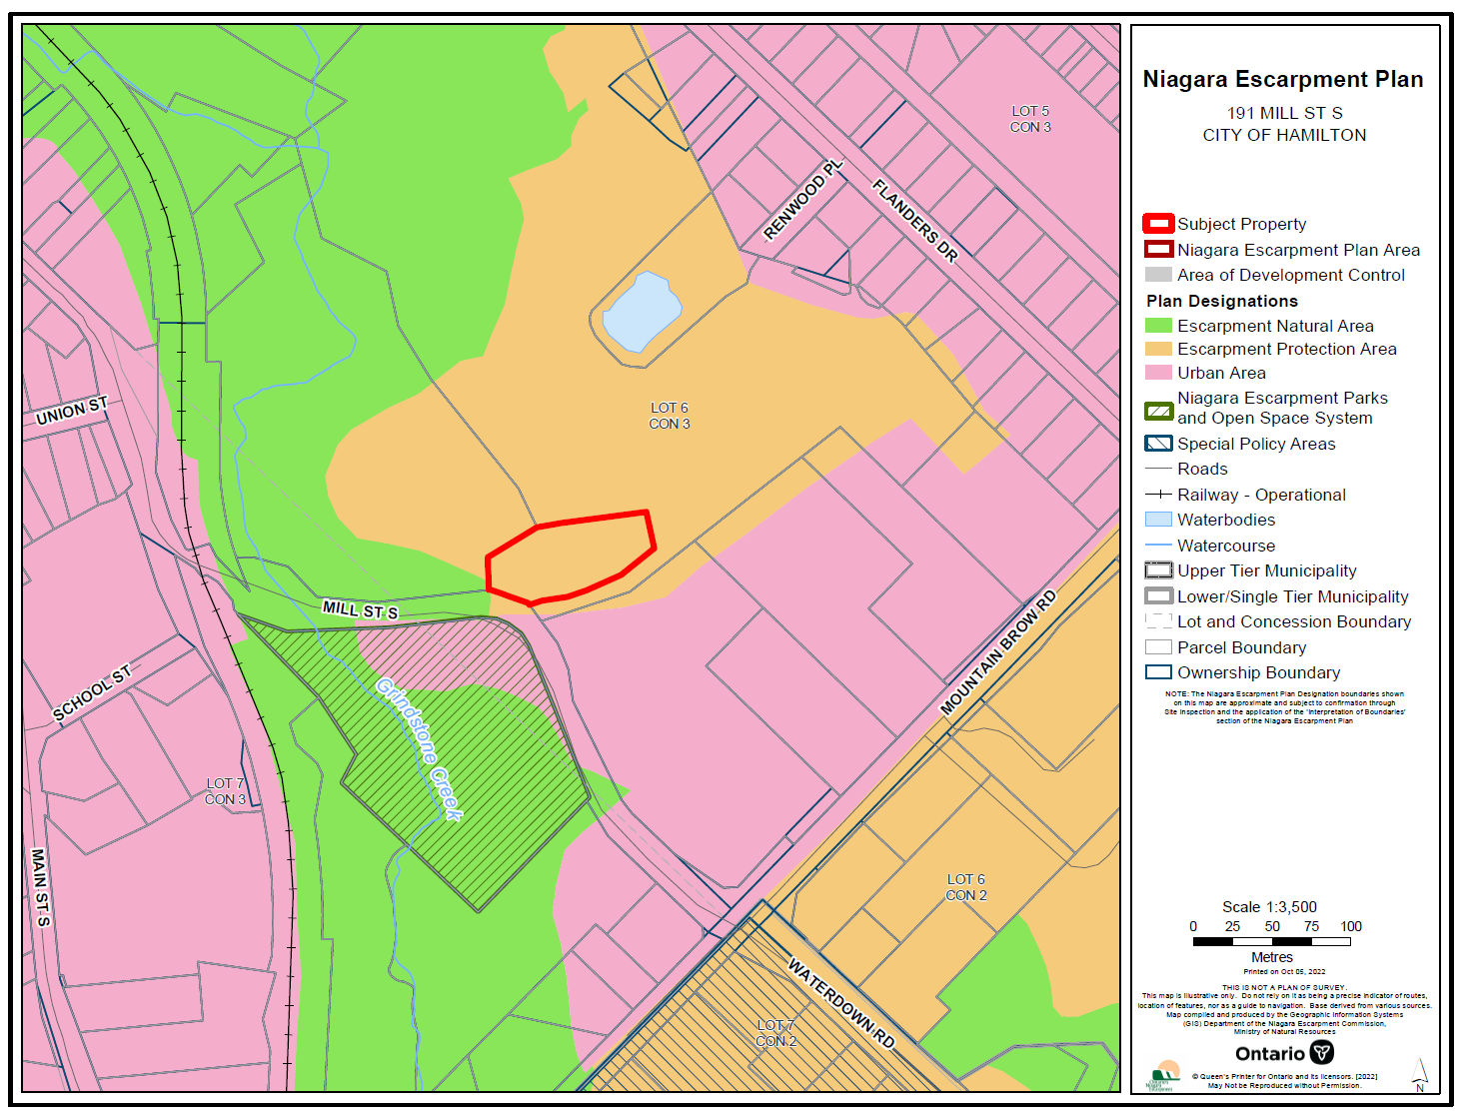

APPENDIX 2
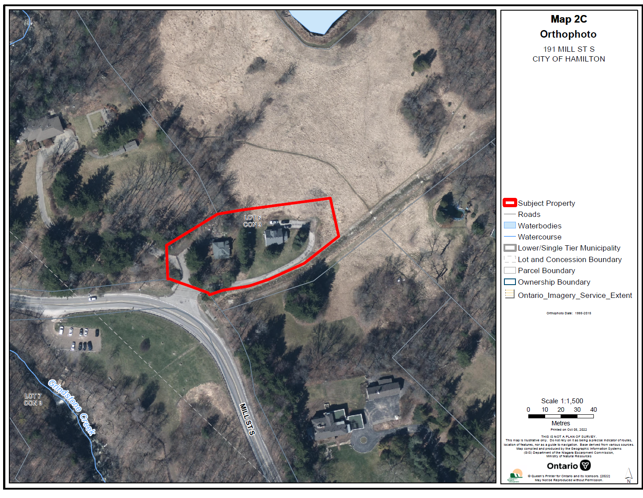

APPENDIX 3

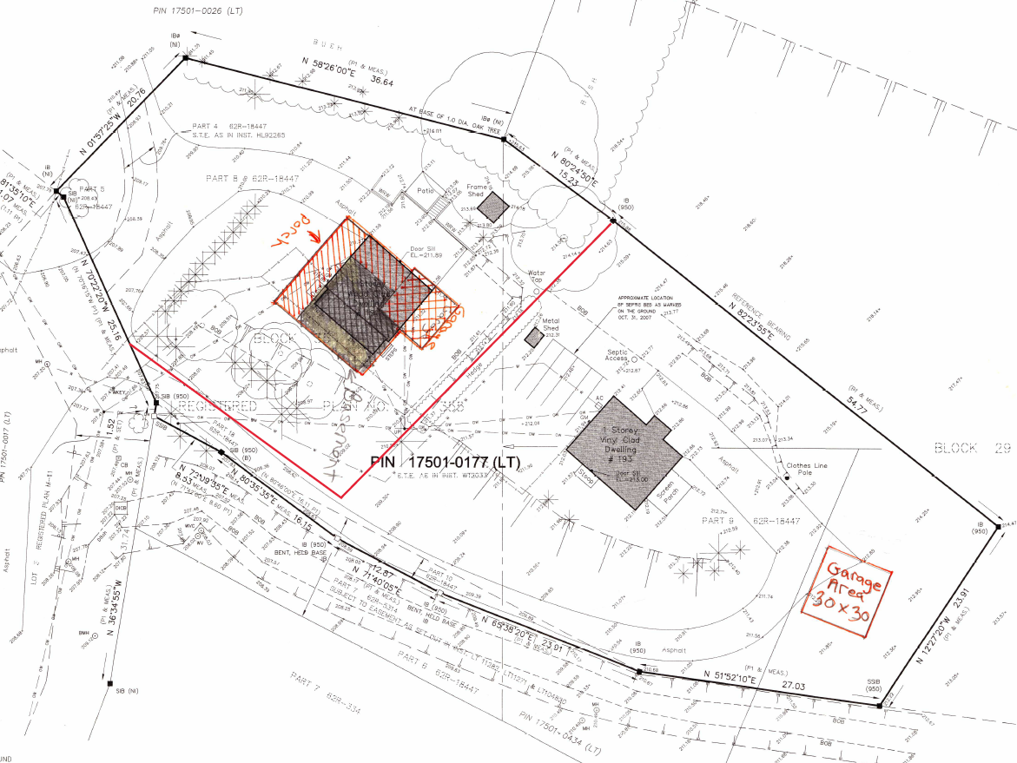

APPENDIX 4
CONDITIONS OF APPROVAL W/R/2021-2022/416
- Development shall occur in accordance with the Terms and Conditions of the Development Permit.

- The Development Permit shall expire three (3) years from the date it has been issued or once the development has been completed in accordance with the Development Permit.

- No site alteration of the existing contours of the property including the placement or stockpiling of fill (i.e., excess or imported soil) on the property is permitted with the exception of that identified within the development envelope in accordance with the Final Site Plan.

- No vegetation shall be cut or removed from the development envelope except for that identified within the development envelope in accordance with the Final Site Plan.

- If development has commenced under this Development Permit, any/all disturbed areas of land or soil shall be re-vegetated and stabilized to the satisfaction of the Niagara Escarpment Commission on or before the date of expiry of the Development Permit.

- Each dwelling shall contain only one dwelling unit.

- The accessory structure shall not be used as a dwelling unit, as a short or long-term rental unit, or for commercial, industrial or livestock purposes.

- Prior to the issuance of a Development Permit by the Niagara Escarpment Commission, an accurate and detailed Final Site Plan prepared by a qualified person shall be submitted for Niagara Escarpment Commission approval. The following stipulation shall be included directly on the Plan:

  - All drawings submitted must be drawn to scale (bar scale shown), reference the application number and address of the proposal, be dated (revisions as well), and include the name of the relevant individual or consultant who prepared the drawing;
  - Outline of the approved development envelope / extent of all disturbed areas;
  - Location of all existing and proposed structures, municipal servicing, driveway, construction access / haul routes, exterior lighting, etc. showing setbacks from the property lines, any watercourses or water features, top / bottom of slope, wooded areas, etc.;
  - Grading, drainage, and fill management details including the areas of excavation and temporary or permanent fill placement. The type, quantity, quality and source location of any imported fill material must be accurately identified;
  - Notes as to how the recommendations in Section 8 of the Cultural Heritage Impact Assessment prepared by Bright Past Heritage Consulting Inc., dated August 2022, have been achieved;
  - The location and design of erosion and sediment control measures (e.g., fencing, blankets, rip-rap, temporary mulch / seeding), and limit-of-work construction or eco-protection fencing.

- Prior to the issuance of a Development Permit by the Niagara Escarpment Commission, the landowner shall submit for the approval of the Niagara Escarpment Commission, Final Construction Details for the proposed development, including exterior elevations, floor plans, height to roof peak from lowest grade, and any exterior lighting. The Final Construction Details shall also note how the recommendations in Section 8 of the Cultural Heritage Impact Assessment prepared by Bright Past Heritage Consulting Inc., dated August 2022, have been achieved. Development shall proceed in accordance with the details of the approved Final Construction Details.

- Prior to the issuance of a Development Permit by the Niagara Escarpment Commission, a Final Tree and Vegetation Protection Plan shall be prepared by a qualified person, for the approval of the Niagara Escarpment Commission and the City of Hamilton. The Plan shall address vegetation protection and mitigation requirements and shall include but not be limited to a detailed inventory, assessment, protection and mitigation measures in accordance with the standard practices of the implementing authority. The Plan shall include the following stipulations:

  - Prior to commencement of any construction, protective fencing shall be installed and inspected by a qualified person and confirmation of this shall be provided to the Niagara Escarpment Commission.
  - Any vegetation noted for protection and damaged from the construction process shall be reported and replaced; trees 150mm and over DBH (diameter at breast height) shall be replaced on a per caliper basis. Replacement shall be to the satisfaction of the Niagara Escarpment Commission.
  - Once the development has been completed, including all required mitigation measures, a letter certifying that the work has been completed in accordance with the approved Plan shall be provided to the Niagara Escarpment Commission by a qualified professional.
Development shall proceed in accordance with the details of the approved Tree and Vegetation Protection Plan.
- Prior to the issuance of a Development Permit by the Niagara Escarpment Commission, a Final Landscape Plan shall be prepared by a qualified person, for Niagara Escarpment Commission and City of Hamilton approval. The Plan shall address all vegetation retention and planting requirements in accordance with the standard practices of the implementing authority. The following stipulations shall be included directly on the Plan:

- All new tree and shrub species (including seed mixes) shall be native to Ontario except where otherwise approved by the Niagara Escarpment Commission. Plant material shall be sourced from local plant nurseries; bush dug plant material is not acceptable.
- Planting and the rehabilitation of all disturbed areas shall be completed on or before the date of expiry of the Development Permit to the satisfaction of the Niagara Escarpment Commission.
- All plant material shall be guaranteed for 24 months following installation. All plant material found during this time to be dead or dying must be replaced with a size and species to the satisfaction of the Niagara Escarpment Commission.
- Once the development has been completed, a letter certifying the landscaping / planting work has been completed in accordance with the approved Landscape Plan shall be provided to the Niagara Escarpment Commission by a qualified person.

Development shall proceed in accordance with the details of the Final Landscape Plan.

- Prior to the issuance of a Development Permit by the Niagara Escarpment Commission, acceptance of the Archaeological Report dated October 27, 2022 into the Ontario Public Register of Archaeological Reports. The applicant shall provide a letter to the Niagara Escarpment Commission with confirmation that the Ministry of Heritage, Sport, Tourism and Culture Industries has reviewed and accepted the report

- Prior to the commencement of any development, erosion and sediment control measures (e.g., fencing, blankets, rip-rap), and/or vegetation protection fencing shall be implemented and maintained as shown on the Final Site Plan until all disturbed areas are stabilized. It is the responsibility of the landowner to implement, monitor and maintain all erosion and sedimentation control measures and vegetation protection fencing in good condition until vegetative cover has been successfully established and the development is completed.

- Prior to the commencement of any development, including any site disturbance, the landowner shall obtain a Consent to sever under the Planning Act for the proposed lot configuration in accordance with this Development Permit, and, provide proof of registration/establishment of the new lot to the Niagara Escarpment Commission.

- All waste materials generated from the demolition shall be completely removed from the property and taken to an authorized receiving site (e.g., municipal landfill site, salvage / reclamation facility, re-used / recycled elsewhere) and not stored or buried on-site. All disturbed areas shall be immediately stabilized / rehabilitated as per the Final Site Plan.

- Conditions 8, 9, 10, 11 and 12 must be fulfilled within eighteen months (1.5 years) from the date of confirmation of the Commission’s decision or this conditional approval shall lapse and a Development Permit will not be issued.

Advisory Notes:
- A Development Permit does not relieve the landowner/permit holder from the requirements of any other required approval, licence or certificate under any statute (e.g., Ontario Building Code, Planning Act, Conservation Authorities Act, etc.). The Niagara Escarpment Commission Development Permit is required prior to the issuance of any other applicable approval, licence or certificate.

- The applicant is advised that specific delineation of the stable top of bank may be required prior to final approval from the Niagara Escarpment Commission, and prior to the issuance of a “no objections” letter from Conservation Halton.

- The property owner must provide the City of Hamilton with 60 days notice of intent to demolish or remove a building or structure on the property.

- The Niagara Escarpment Commission supports the protection of the night sky from excessive lighting and recommends the applicant obtain information on the use and operation of appropriate lighting fixtures in keeping with dark sky approaches.

- Should deeply buried archaeological materials be found on the property during any of the above development activities the Ministry of Tourism, Culture and Sport should be contacted for guidance at archaeology@ontario.ca. The Funeral, Burial and Cremation Services Act, 2002, S.O. 2002, c.33 requires that any person discovering human remains must cease all activities immediately and notify the police or coroner.

