January 19, 2023

A2: STAFF REPORT

Development Permit Application:

N/R/2022-2023/75
4743 Fly Road
Part Lot 14, Concession 6
Town of Lincoln, Region of Niagara

Proposal:
To remove an existing one-storey 95.10 sq m (1,023.6 sq ft) temporary mobile home trailer with a height of 3 m (9.8 ft), and to construct a two-storey, permanent ± 413.9 sq m (4,452.9 sq ft) single dwelling to accommodate farm labourers, with a maximum height to peak of ± 7.08 m (23.2 ft), and to install a new private sewage disposal system, on an existing 19.49 ha (48.18 ac) lot.

Received:
May 2, 2022

Source:
Steve Greenwood (applicant); Tawse Family Vineyard Inc (owner)

Designations:
Escarpment Rural Area

Issue:
The proposed development is being interpreted as a permanent (not temporary) dwelling unit accessory to an agricultural use (to accommodate farm labour), rather than a single dwelling. The proposed dwelling unit for farm labour would be considered a single dwelling (i.e., principal farmhouse) if such a time occurs where accommodation for farm labour is no longer required.

Recommendation:
Approve subject to the conditions listed on the Appendix 1.

Reasons:
Given there is no permanent dwelling existing on the property, NEC staff interpret that the proposed accommodation for farm labour still meets the intent of the NEP Part 2.8.5, and that it could later be considered as a single dwelling, which is a permitted use in Escarpment Rural Area.

Related Files:

N/A/2005-2006/229
A development permit application was submitted to the NEC on November 2, 2005. The application proposed to permit the placement of a temporary 1-storey, ± 74 sq m (± 800 sq ft) mobile home, for use as accommodation for farm help, on an existing 19.4 ha (48 ac) lot supporting a vineyard and an accessory barn.
The development permit was issued on May 12, 2006. The temporary mobile home is still present on the property.

N/F/2005-2006/334
A development permit application was submitted to the NEC on March 1, 2006. The application proposed to permit the grading of a 4.04 ha (10 ac) area of land, in preparation for vineyard planting, on an existing 19.4 ha (48 ac) lot.
The development permit was issued on August 14, 2006.

Site Description:
The proposed development is located on a 19.4 ha lot, on the north side of Fly Road and the west side of Quarry Road (See Appendix 2 for Orthophoto) The subject lands are entirely within the Niagara Escarpment Plan (NEP) area and the Niagara Escarpment Commission’s (NEC) Area of Development Control. The subject lands are designated in the NEP as Escarpment Rural Area (See Appendix 3 for NEP Map). The lots abutting the west and east boundaries of the subject lot are also designated as Escarpment Rural Area, abutting the limit of the NEP boundary to the south. The lot abutting the north boundary is designated as Escarpment Protection Area as it is in closer proximity to the Escarpment Brow.
The subject lot currently supports three structures. Those structures that make up the farm cluster, located toward the front portion of the subject lands, include the following:
- An existing one-storey 95.10 sq m (1,023.6 sq ft) temporary mobile home trailer with a height of 3 m (9.8 ft) (to be removed).
- An existing one-storey 221.92 sq m (2,388 sq ft) agricultural building with a height of 6 m (19.6 ft).
- An existing one-storey 4.3 sq m (46.2 sq ft) shed with a height of 2.8 m (9.1 ft).
The property is accessed by a driveway from Fly Road, on the southern portion of the property. There is also a secondary access point from Quarry Road, on the eastern portion of the property.

Background:
A Development Permit Application (DPA) was received on May 2, 2022, to remove the existing one-storey temporary mobile home trailer, and to construct a permanent two-storey single dwelling. A single dwelling is a permitted use, but it is intended to house farm labour associated with the vineyard. The NEP includes as permitted uses a single dwelling and agricultural uses (including accommodation for farm labour when the size and nature of the operation requires additional employment), as separate uses. Given that the proposed permanent dwelling-like structure will accommodate farm labour in a dormitory-type arrangement, NEC staff is looking to the Commission to assist in interpreting that the proposed development is a permitted use, even though Development Criteria in Part 2.8.5 of the NEP requires that accommodation for farm labour be temporary.
All agency comments have been received and addressed. A site visit was conducted on August 11, 2022.

Planning Analysis:

Niagara Escarpment Plan (NEP) (2017)

Part 1 Land Use Designation and Permitted Uses

The subject land is designated as Escarpment Rural Area (1.5). The objectives of the Escarpment Rural Area designation include but are not limited to, the maintenance of scenic resources of lands in the vicinity of the Escarpment and the open landscape character of the Escarpment, to provide compatible rural land uses, and to encourage agriculture and protect agricultural lands and prime agricultural areas.

Part 2.2 General Development Criteria

Part 2.2 (General) of the NEP provides general development criteria that need to be considered for all development permit applications, with the objective of permitting reasonable enjoyment by the owners of all lots that can sustain development.
The proposed development location is on an existing lot of record. Additionally, the proposed development is not located in a hazardous area, however, a grading plan is being requested to ensure that the proposed dwelling unit accessory to agricultural use and private sewage disposal system are appropriately located.
Part 2.2.7 states that “only one single dwelling is permitted on each existing lot of record.” There is currently no primary (permanent) single dwelling on the lot, therefore, the proposed farm labour accommodation could be considered the one single dwelling permitted by Part 2.2.7 even though its proposed use is to accommodate farm labour. Although the floor plan proposes a dormitory-style layout, it could easily be converted to a more conventional single dwelling should at some point in the future, the farm labour accommodation no longer be required.
Given this, and the draft site and floor plans provided to date, NEC staff are sufficiently satisfied that the site can support the proposed development and that Part 2.2 has been met.

Part 2.7 Development Affecting Natural Heritage

Part 2.7 (Natural Heritage) of the NEP provides development criteria that need to be considered for development within or near natural heritage features, with the objective to protect and where possible enhance natural heritage features and functions, in order to maintain the diversity and connectivity of the continuous natural environment.
The proposed development is more than 30 metres away from any natural heritage feature, and more than 120 metres from a key natural heritage feature, posing no concern to sensitive habitats or the natural heritage connectivity. Additionally, a standard search of the Natural Heritage Information Centre database identified a potential for Species at Risk (SAR) in the area, however, there are no concerns, given the location of the proposal on site is within an already disturbed area. The listed species prefer wooded areas and areas near water and as such the development site would not provide suitable habitat. There is no expected impact to natural heritage features and the proposal meets Part 2.7.

Part 2.8 Agriculture

Part 2.8 (Agriculture) of the NEP provides development criteria that need to be considered for agricultural uses, agriculture-related uses, and on-farm diversified uses. The objective of Part 2.8 is to encourage agricultural uses in agricultural areas, especially in prime agricultural areas, to permit uses that are compatible with farming, and to encourage accessory uses that directly support continued agricultural uses.
The subject land falls within a Prime Agricultural Area, and more specifically a Speciality Crop Area, along with all surrounding lands, which vary in size. As noted, Part 1.5.3 of the NEP permits both single dwellings and agricultural uses in Escarpment Rural Area. The definition of agricultural use in Appendix 2 of the NEP includes “accommodation for full-time farm labour when the size and nature of the operation requires additional employment.”
All permitted uses must also meet the applicable development criteria in Part 2 of the NEP. With specific reference to dwelling units accessory to agricultural uses, Part 2.8.5 states the following:
Dwelling Units Accessory to Agricultural Uses
5. A temporary dwelling unit(s) for farm labour may be permitted on the same property as the principal farmhouse, subject to the following criteria:
a) additional farm labour is required on a full-time or seasonal basis;
b) the dwelling unit(s) shall be mobile or portable, without a basement; or the dwelling unit(s) may be permitted within an existing farm building or structure on a temporary basis, where justified (e.g., barn);
c) the dwelling unit(s) should be located within the existing farm building cluster, and the existing farm lane access is to be used where possible; and
d) the dwelling unit(s) shall be temporary and shall be removed within a period set out in the Development Permit when the dwelling unit is no longer required.
Given the permanency of the dwelling unit accessory to an agricultural use, the proposed development is not supported by the NEP Development Criteria Part 2.8.5 b), which requires such uses to be temporary (mobile or portable in nature). This policy is based on an assumption of a “principal farmhouse” being present on an agricultural property. The policy does not consider a scenario where there is no primary single dwelling on the property.
The requirement for farm labour accommodations in the NEP Area to be temporary (mobile or portable, without a basement), assists in preventing the cumulative intensification of development through additional permanent dwellings, and therefore better reflects the Purpose and Objectives of the NEP and the Niagara Escarpment Planning and Development Act (NEPDA), which require that the open landscape character of the Niagara Escarpment be maintained insofar as possible, by such means as compatible farming or forestry and by preserving the natural scenery. Requiring such uses to be temporary also removes the potential for severances. In addition, the requirement for temporary structures better adapts to the changing labour needs of the farm operation over time (i.e., when the farm help is no longer needed).
However, given that there is no permanent dwelling established on the property, staff interprets that the permanent dwelling proposed to accommodate farm labour still meets the general intent of the NEP Part 2.8.5. Staff is proposing an agreement-on-title to ensure that the dwelling will not be used for commercial purposes (given the dwelling will only be used seasonally to accommodate farm labour) and will also serve to ensure an understanding that the dwelling, while being used as a dwelling unit accessory to an agricultural use (farm labour accommodation), will constitute the only permanent single dwelling permitted on the subject lands. The applicant has confirmed the owner’s willingness to add an agreement-on-title. A second permanent single dwelling would not be permitted on this property. However, an application for the establishment of an additional temporary dwelling unit accessory to the agricultural use on the property could be considered, provided the proposal was in accordance with Part 2.8.5 (including adequate justification for the additional farm labour).
Part 2.8.2 requires compliance with minimum distance separation calculations. There are six farm properties containing livestock facilities with 750 metres of the proposed development. A Minimum Distance Separation (MDS) 1 report was prepared and submitted by Attema Consulting Service Inc. (on behalf of the applicant). Calculations were completed for all six farm properties (broiler barns). All six farm properties met the MDS requirements, with the actual distances from the proposed dwelling exceeding the minimum distance required for each barn.
NEC staff interprets that the proposed development meets the intent Part 2.8.

Part 2.13 Scenic Resources and Landform Conservation

The objective of Part 2.13 (Scenic Resources and Landform Conservation) is to ensure that development preserves the natural scenery and maintains Escarpment-related landforms and the open landscape character of the Escarpment.
The subject land is within an area ranked as Low by the Landscape Evaluation Study. The proposed dwelling unit will be cited within the existing farm cluster, near the existing barn and shed. No negative visual impact is expected from the proposed dwelling, meeting Part 2.13.

Provincial Policy Statement (PPS) (2020)
Section 2.3 of the PPS provides for the protection and long-term agricultural use of Prime Agricultural Areas, with Specialty Crop Areas given the highest priority for protection. The proposal is not removing quality farming land from production and will not hinder surrounding agricultural operations. NEC staff are satisfied that the proposed development is consistent with Section 2.3 of the PPS.

Agency Consultations:

Town of Lincoln
Town staff have no objections to the approval of this application. Town staff have noted that the proposed dwelling is to be used to accommodate farm help but will constitute the single detached dwelling on the lot. Town staff have requested that at least one parking space be provided for the occupants. Additionally, Development Engineering staff have requested that the applicant obtain an approved lot grading plan from the Town.
Furthermore, Town staff noted that if the NEP designation did not apply to the subject lands, it would likely be designated as Specialty Agricultural in the Town of Lincoln’s Official Plan (OP). This designation implements the Province of Ontario’s Greenbelt Plan and recognizes the importance of specialty croplands for their unique ability to produce certain crops and for their importance in the Provincial, Regional and Town economies.

Region of Niagara
Regional staff have no objections to the approval of this application, provided the owner applies for the required permit to construct the private sewage system. Furthermore, Regional staff note that the proposed development is a single dwelling that will accommodate farm help. The proposed development is a permitted use with no new municipal services required.
NOTE: Through correspondence with Regional staff, the following policy was provided, adopted in the new Niagara Regional Official Plan (2022):
Policy 4.1.7 A Resilient Agricultural Economy 4.1.7.1 – The Region encourages the continued operation and expansion of agricultural infrastructure including irrigation and drainage systems as shown in Appendix 1.
- 4.1.7.2 – Temporary accommodation for seasonal or full-time farm labour may be permitted where:
- the size and/or nature of the agricultural operations make the employment of such help necessary;
- such temporary accommodation does not have a significant effect on the tillable area of the agricultural operation or its viability; and
- the severance of a temporary accommodation for seasonal or full-time farm labour is not permitted

Niagara Peninsula Conservation Authority (NPCA)
No comments or objections received.

Summary
In reviewing the proposal, NEC staff took into consideration the use of the proposed development, concluding the use to be a permanent dwelling unit accessory to agricultural use rather than a single dwelling. While dwelling units accessory to agriculture are permitted by the NEP, they must be temporary, not permanent, and be removed at such time when the dwelling unit is no longer required. However, in this instance, the farm labour dwelling would become a single dwelling if such a time occurs where the dwelling unit is no longer required to accommodate farm labour. Given there is no permanent dwelling existing on the property, staff interprets that the permanent dwelling proposed to accommodate farm labour still meets the intent of the NEP Part 2.8.5. An agreement-on-title will be required to ensure that the dwelling will not be used for commercial purposes (given the dwelling will only be used seasonally to accommodate farm labour), and will ensure an understanding that the dwelling, while being used as a dwelling unit accessory to an agricultural use, will constitute the only permanent dwelling unit permitted on the subject lands.

Recommendation:
The proposal be approved subject to the conditions listed on Appendix 1.

Prepared by:

Original signed by:
______________________
Rameez Sadafal
Policy and Program Intern

Original signed by:

______________________
Lisa Grbinicek, RPP, MCIP
Senior Strategic Advisor

Approved by:
Original signed by:

_______________________
Kim Peters, RPP, MCIP
Manager

Attachments:
Appendix 1 – Conditions of Approval
Appendix 2 – Orthophoto
Appendix 3 – NEP Map

APPENDIX 1
4743 Fly Road
CONDITIONS OF APPROVAL N/R/2022-2023/75

- Development shall occur in accordance with the Terms and Conditions of the Development Permit.

- The Development Permit shall expire three (3) years from the date it has been issued or once the development has been completed in accordance with the Development Permit.

- Site alteration of the existing contours of the property including the placement or stockpiling of fill (i.e., excess or imported soil) on the property is NOT permitted with the exception of that identified within the development envelope in accordance with the Final Site Plan. All required erosion and sediment control fencing shall be maintained in good standing until the development envelope has been re-vegetated.

- No vegetation shall be cut or removed from the development envelope except for that identified within the development envelope in accordance with the Final Site Plan.

- If development has commenced under this Development Permit, any/all disturbed areas of land or soil shall be re-vegetated and stabilized to the satisfaction of the Niagara Escarpment Commission on or before the date of expiry of the Development Permit.

- Prior to the issuance of a Development Permit by the Niagara Escarpment Commission, an accurate and detailed Final Site Plan shall be submitted for Niagara Escarpment Commission approval. The following stipulation shall be included directly on the Plan:

- The Final Site Plan shall be prepared by a qualified professional;
- All drawings submitted must be drawn to scale (bar scale shown), reference the application number and address of the proposal, be dated (revisions as well), and include the name of the relevant individual or consultant who prepared the drawing;
- Outline of the approved development envelope / extent of all disturbed areas;
- Location of all existing and proposed structures, sewage disposal system, well/cistern, driveway, construction access / haul routes, exterior lighting, etc. showing setbacks from the property lines, any watercourses or water features, top / bottom of slope, wooded areas, etc.;
- Grading, drainage, and fill management details including the areas of excavation and temporary or permanent fill placement. The type, quantity, quality and source location of any imported fill material must be accurately identified.
- The location and design of erosion and sediment control measures (e.g., fencing, blankets, rip-rap, temporary mulch / seeding), and limit-of-work construction or eco-protection fencing;
- Identify the areas of existing vegetation to be retained, areas of vegetation to be removed, and the location of proposed plantings.

- Prior to the issuance of a Development Permit by the Niagara Escarpment Commission, the landowner shall submit for the approval of the Niagara Escarpment Commission, final constructions details for the proposed development, including exterior elevations, total floor area, floor plans, height to roof peak from lowest grade, and any exterior lighting.

- Prior to the issuance of a Development Permit by the Niagara Escarpment Commission, the Landowner shall enter into an Agreement under Section 24(2.1) of the Niagara Escarpment Planning and Development Act, in a form acceptable to the Niagara Escarpment Commission. The agreement shall be registered on the title of Part Lot 14, Concession 6, 4743 Fly Road, Town of Lincoln, Region of Niagara, at the Landowner’s expense. The Agreement is to state that the dwelling to be used as a dwelling unit accessory to an agricultural use will constitute the one single dwelling permitted on the subject lands, and shall not be used for commercial, short-term rental, institutional or industrial uses, and that the Landowner under this Development Permit is the owner of the lands at the time of registration. The Landowner shall provide proof satisfactory to the Niagara Escarpment Commission that the agreement has been registered against the lands [i.e., copy of the parcel registry extract and a letter from the Landowner’s solicitor that the registration is complete].

- Prior to the commencement of any development, erosion and sediment control measures (e.g., fencing, blankets, rip-rap), and/or vegetation protection fencing shall be implemented and maintained as shown on the Final Site Plan until all disturbed areas are stabilized. It is the responsibility of the landowner to implement, monitor and maintain all erosion and sedimentation control measures and vegetation protection fencing until vegetative cover has been successfully established.

- The existing temporary mobile dwelling shall be completely removed from the property, and the site rehabilitated as per the Final Site Plan, within ninety (90) days of issuance of an Occupancy Permit by the Chief Building Official for the new dwelling unit accessory to an agricultural use. The landowner shall notify the Niagara Escarpment Commission in writing immediately upon receipt of an Occupancy Permit and shall provide a copy of the Occupancy Permit shall to the Niagara Escarpment Commission.

- All waste materials generated from the demolition shall be completely removed from the property and taken to an authorized receiving site (e.g., municipal landfill site, salvage / reclamation facility, re-used / recycled elsewhere) and not stored or buried on-site. All disturbed areas shall be immediately stabilized / rehabilitated as per the Final Site Plan.

- Conditions 6, 7, and 8 shall be fulfilled within eighteen (18) months from the date of confirmation of the Commission’s decision or this conditional approval shall lapse, and a Development Permit will not be issued.

ADVISORY NOTES:

- A Development Permit does not relieve the permit holder of any other permission (e.g., Ontario Building Code, Conservation Authorities Act, Endangered Species Act, Town of Niagara-on-the-Lake Urban Tree By-law, etc.). A Niagara Escarpment Commission Development Permit is required prior to the issuance of any other permission.

- The Niagara Escarpment Commission supports the protection of the night sky from excessive lighting and recommends the applicant obtain information on the use and operation of appropriate lighting fixtures in keeping with dark sky approaches.

- Should deeply buried archaeological remains/resources be found during construction activities, all activities impacting archaeological resources must cease immediately, and the proponent must notify the Archaeology Programs Unit of the Ministry of Tourism, Culture and Sport (416-212-8886) and contact a licensed archaeologist to carry out an archaeological assessment in accordance with the Ontario Heritage Act and the Standards and Guidelines for Consultant Archaeologists.

In the event that human remains are encountered during construction, all activities must cease immediately and the local police as well as the Cemeteries Regulation Unit of the Ministry of Government and Consumer Services (416-326-8800) must be contacted. In situations where human remains are associated with archaeological resources, the Ministry of Tourism, Culture and Sport should also be notified to ensure that the site is not subject to unlicensed alterations which would be a contravention of the Ontario Heritage Act.

APPENDIX 2

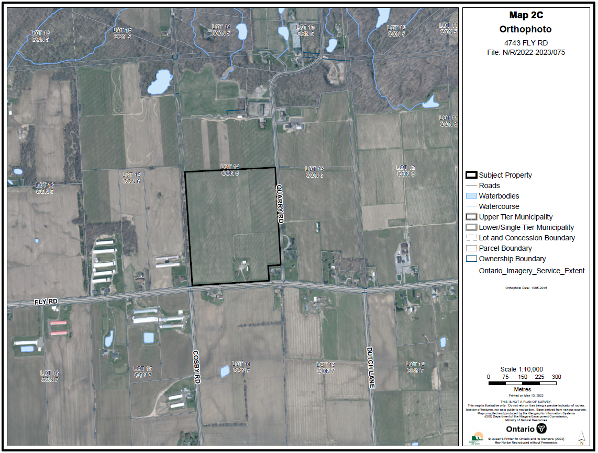

APPENDIX 3

