March 9, 2023

A1: STAFF REPORT

DEVELOPMENT PERMIT APPLICATION:

G/R/2021-2022/757
West ½ Lot 23, Concession 2 (Euphrasia)
ARN 420839000207900
Municipality of Grey Highlands, Grey County

PROPOSAL:
To construct a two storey ± 232.5 m² (2,500 ft²) single dwelling, having a maximum height of ± 8 m (26 ft), install a private sewage disposal system and a well on a ± 18 ha (44.5 ac) proposed lot from an existing 143.5 ha. (354.5 ac) lot consisting of multiple parcels that are merged on title.

RECEIVED:
February 6, 2022

SOURCE:

REDACTED – Owner / Applicant

DESIGNATIONS:
Escarpment Protection and Natural

ISSUE:
A decision from the Commission is required because staff is recommending refusal. The NEC Director does not have the delegated authority to refuse a development permit application.

RECOMMENDATION:
Refusal

REASONS:
The creation of a new lot requires the proposal to conform to the provisions of Part 1, applicable Part 2 policies, official plans and, where applicable, zoning by-laws that are not in conflict with NEP. The proposal does not meet the applicable lot creation policies found in Part 1 of the NEP that apply to lot creation in the Escarpment Protection Area.

RELATED FILES:
Development Permit #9270/G/R/2018-2019/9022 was issued in September 2018 to reduce a 40.5 ha (100 ac) property to approximately 19 ha (48 ac) by adding approximately 21 ha (52 ac) to the adjacent eastern agricultural property. The permit also approved the construction of a 1 – 2 storey 232.5 m² (2,500 ft²) single dwelling having a maximum height of 8 m (26 ft), the installation of a private sewage disposal system and a driveway on the 19 ha (48 ac) remnant lot.

SITE DESCRIPTION:
The subject property consists of multiple parcels, some of which have merged on title, totalling 143.5 ha (354.5 ac) both in and outside of the NEP Area. The Municipal Property Assessment Corporation parcel mapping shows all of the holdings under the applicant’s name (outlined in black on Map 1). Map 2 shows the ownership of the lands that are the subject of this application (Lot 23, Concession 2, Euphrasia), the west half of which is in the NEP Area. Whereas the MPAC assessment mapping shows three different parcels on Lot 23, the ownership mapping indicates they are all held in common ownership and have merged on title.
The property is located in the north-eastern portion of the Beaver Valley, west of Heathcote, in the Municipality of Grey Highlands. The surrounding area is comprised of agricultural uses (e.g., livestock, crop cultivation), rural-residential uses and vacant wooded lots. The area has rolling topography that includes several unnamed tributaries of the Beaver River. From the existing lot configuration, approximately 40.5 ha (100 ac) is located within the NEC’s area of development control (see Map 3), which includes the area of the proposed lot creation. The remaining 103.5 ha (255 ac) merged holdings are located outside of the NEP area. The lot area outside of the NEP is predominately used to support an active agricultural operation operated by the landowner / applicant.
Within the NEP area, the property is bisected by a watercourse and valley feature that separates the primary agricultural operation in the easterly portion of the lot from the remainder of the lot to the west. The area proposed for lot creation is located along the southwestern portion of the lot and includes both the Escarpment Protection Area and Escarpment Natural Area designations. The Escarpment Natural Area includes a meandering watercourse and woodlands within the low-lying valley feature. The Escarpment Protection Area is located upland, at an elevated topography, and consists of actively used agricultural fields. The proposed lot configuration generally follows the boundary between the Escarpment Natural and Protection Areas on the east side of the watercourse. The retained lot would retain any viable agricultural lands with the existing operation east of the Escarpment Natural Area. The severed/remnant lot would have approximately 50 metres of frontage along 3rd Line D. Prior to considering the lot creation proposal that is the subject of this application, it is important to understand the lot creation history of the subject lands.

BACKGROUND:
In September 2018 the NEC issued Development Permit #9270/G/R/2018-2019/9022 as described above. The development application was reviewed with the understanding that the existing configuration for lot A was the western half of the original township lot (Lot 23, Concession 2) totalling 40.5 ha in size and that the eastern half of Lot 23 (labelled as lots B and D) was a separate lot also totalling 40.5 ha in size. This is illustrated on Map 1. The permit approved the reduction of Lot A through a lot line adjustment consent of 21 ha by adding it to the eastern half of the original township lot (lots B and D) so that the final lot sizes would be 19.5 ha on the western half and 61.5 ha on the eastern half. During the initial review, it was understood that both halves of the township lot were existing lots of record that were held under distinct and separate ownership from all abutting lots. The general configuration of the lots following the proposed lot line adjustment is shown on Map 5, where the dashed line indicates the adjusted lot line between the proposed 19.5 ha lot (west half) and the 61.5 ha lot on the east half. The parcel on the west half of the original township lot, totalling 19.5 ha, included the Escarpment Natural Area lowlands. The Development Permit also approved the construction of a single dwelling including a well and private sewage disposal system on the east 19.5 ha lot, within the Escarpment Protection Area in the northwest corner of the remnant lot.
The consent approved under this development permit was permitted as a lot line adjustment, or a lot addition. In the Escarpment Protection Area, lot additions are permitted provided the lot line adjustment or lot addition does not result in a new building lot. Essentially, there were two separate and distinct lots before the proposed consent, and there would still be only two lots after the consent. Lots B and D contained an existing single dwelling and agricultural structure. The policies in Part 1 of the NEP were met as the lot addition and construction of a single dwelling and accessory uses qualified as permitted uses, and because the western lot, reduced to 19.5 ha, was buildable lot both before and after the lot line adjustment. The review also considered the applicable Part 2, Development Criteria, policies and NEC staff determined that the proposal was in conformity with the relevant policies. The proposal received Director approval and there were no appeals during the Notice of Decision period. The NEC permit was subsequently issued.
After the NEC Development Permit was issued, the applicant received a consent from the Committee of Adjustment in the Municipality of Grey Highlands. The consent application, B18.2019, was approved in June 2019. The approval required the applicant to fulfil all the applicable conditions of the consent within one year of the approval date (June 2020). The conditions were not fulfilled within the one-year timeframe and the approval lapsed. The applicant was further advised from Grey Highlands planning staff that they would need to recommence the approval process by applying for another consent application.
The applicant submitted a new consent application in the Spring of 2021. The NEC permit was valid until September 2021 and the applicant did not require a new NEC permit at that time. During the review of the new application, Grey Highlands planning staff noted that the proposed consent could not be considered as previously approved as several of the lots had merged on title. According to Grey Highlands planning staff, lots A, B, C & D (Map 1) were merged on title and the actual lot configuration was approximately 143.5 ha as shown on Map 2. NEC staff reviewed internal information and verified that Lots A, B, C & D are merged on title and considered one lot.
As the lots are merged, the severance can no longer be considered through as a lot line adjustment or lot addition. To sever the 18 ha lot proposed in this application from the existing 143.5 ha configuration, the proposal qualifies as lot creation as opposed to a lot line adjustment or lot addition and different policies within the NEP apply. The applicant has re-applied to the NEC and the updated application accounts for the changes in lot configuration from the lots merging on title. The updated lot configuration and area proposed for severance is illustrated on Map 6. The current proposal does not meet the lot creation policies within the NEP and a staff recommendation of refusal is required.

PLANNING ANALYSIS:

Niagara Escarpment Plan (NEP):
As noted above, the original permit (#9270/G/R/2018-2019/9022) approved a consent for a lot addition, also referred to as a lot line adjustment.
The NEP defines a lot as the following: ‘A parcel of land capable of being conveyed legally in accordance with the Planning Act.’
Part 1.4.4.2 of the NEP states the following: ‘Notwithstanding Part 1.4.4.1, provided no new building lot(s) is created, a severance may be permitted:
- for the purpose of correcting conveyances, provided the correction does not include the re-creation of merged lots;
- for the purpose of enlarging existing lots;
- as part of, or following, the acquisition of lands by a public body; or as part of, or following, the acquisition of lands by an approved conservation organization for the purpose of establishing a nature preserve.’
For the current proposal, a lot enlargement (as per Part 1.4.4.2 b) is not possible as the lots have merged. Additionally, Part 1.4.4.2 a of the NEP prohibits the re-creation of merged lots to their original configuration prior to the merger.
However, Part 1.4.4.1 of the NEP states the following: ‘A lot may be created by severing one original township lot or original township half lot, from another original township lot or original township half lot, provided there have been no previous lots severed from one of the affected original township lots or original township half lots. Such severances shall only occur along the original township lot line.’ In this case, the merger re-established an intact original township under single ownership. Based on the 81 hectares being intact, it could be argued that there is the potential for severing the east half of the original township lot (40.5 ha) from the west half (40.5 ha) in accordance with Part 1.4.4.1 of the NEP. However, given that Part 1.4.4.2 disallows a consent that un-merges merged lots, (N.B. note the “notwithstanding Part 1.4.4.1” language), it must be interpreted that the allowance for a severance of an intact original township half lot is not permitted when the township lot was composed of lots that merged on title.
If the creation of two equal 40.5 ha lots were permissible under the NEP, it does not meet the applicant’s interests as he has proposed a configuration that retains as much viable agricultural land as possible under his ownership to maintain a viable farming operation. This approach is consistent with NEC policies related to encouraging and protecting agriculture in that it avoids unnecessary fragmentation of contiguous agricultural lands. The proposed configuration is also desirable from the perspective of not fragmenting ownership of the natural heritage features (valleylands and watercourse).
Regardless of the above, the proposed lot configuration (as shown on Map 6) does not comply with the policies under Parts 1.4.4.1 and 1.4.4.2 of the NEP. The proposed lot (18 ha) would be lesser in size than half of the original township lot (40.5 ha) and the severance would not result in two halves of the original 80.5 ha original township lot. Additionally, Part 1.4.4.2 a does not allow for the re-creation of merged lots. Due to the non-conformity with these policies, a staff level recommendation of refusal is required.

Provincial Policy Statement (PPS, 2020)
Section 3.1 of the PPS directs development away from hazardous lands and hazardous sites. The proposed lot creation includes a portion of hazardous lands associated with the flood and erosion potential of the watercourse and valley feature. Future development would have to be directed to areas outside of the hazardous areas. If the severance were allowed to proceed as proposed, there is sufficient area on the severed lot to accommodate a single dwelling and accessory uses outside the hazardous lands. The proposal is consistent with Section 3.1 of the PPS.
Section 2.3 identifies the permitted uses within prime agricultural areas and directs the long-term viability of agricultural operations. Lot creation in prime agricultural areas is discouraged and may only be permitted for limited uses related to agriculture. The Canada Land Inventory identifies the majority of the property as having Class 5 soils, which is not considered to be prime agricultural land as defined by the PPS. A prime agricultural area is defined by the PPS as areas where prime agricultural lands predominate. To qualify as a prime agricultural area, the review and mapping must be completed in accordance with provincial standards. The County of Grey does not designate prime agricultural areas within the NEP Area. As such, the property is not within a prime agricultural area in accordance with provincial standards. For rural lands outside of prime agricultural areas, sections 1.4.4.4 and 1.1.5.2 of the PPS allow for growth and development (including lot creation) where locally appropriate, although section 1.1.4.2 directs that rural settlement areas shall be the focus of growth and development in rural areas.

Agency Consultations:

County of Grey
The subject lands are designated ‘Niagara Escarpment Plan’ and ‘Agricultural’ in the County’s Official Plan (OP). Staff understand that the subject lands are composed of several parcels that have merged on title and currently create an irregularly shaped lot. The proposed severed lot would be entirely within the NEC designation and would have frontage on 3rd Line D, while the proposed retained parcel would be within the NEC and Agricultural designation and would have frontage on Old Mail Road. The retained lands would be farm-sized (greater than 40 ha). Provided positive comments are received by NEC and Grey Highlands, and that lands in Agricultural designation remain intact, staff have no concerns.
The subject lands contain several mapped watercourses and are adjacent to ‘significant woodlands’, per Appendix B of the OP. It is recommended that further comments be received from the Conservation Authority.
Any new lot creation shall meet Minimum Distance Separation (MDS) criteria.
County staff have no further comments on the subject application.

Municipality of Grey Highlands:
The applicant is to be advised that only 50 meters of frontage on the proposed severance lies within an opened and maintained road allowance. Future applications for entrance permits will only be considered within the opened and maintained portion of 3rd line D. If an entrance is requested on a portion of 3rd Line D that is deemed unopened the applicant will be required to obtain Council support to enter into a Development Agreement with the Municipality to extend the opened portion of the roadway. This agreement will include requirements of the resident to construct the roadway to the Municipal Road Construction Minimum Standards.
The applicant is to be advised that any future development will require building permits and must conform to the Ontario Building Code and applicable law in place at the time of permit submission.
Municipality of Grey Highlands planning staff indicate that they do not have any concerns with the proposal. The proposed severance meets the policies of the Grey County and Municipality of Grey Highlands Official Plan policies

Grey Sauble Conservation Authority (GSCA)
A portion of the subject property is regulated under Ontario Regulation 151/06: Regulation of Interference with Wetlands and Alterations to Shorelines and Watercourses. The regulated area is associated with the watercourses and valley features that traverse the property. These regulations would be present on both the retained and proposed severed parcels. Any future proposals for development or site alteration on the lots impacted by GSCA regulations should be forwarded to GSCA’s office for review, and permits may be required.
The natural hazards present on the subject lands include the flood and erosion potential associated with the watercourse and valley features present on the subject lands. Through GSCA’s review of the current proposal to sever an approximately 18 ha-hectare lot from the existing property, the proposed severed lot would represent creation of a new lot that may be subject to development in the future. All development and site alteration on the retained and severed lots must be located outside of the natural hazard features. GSCA is of the opinion that there is suitable space on the proposed severed lot for development to occur outside of the currently mapped natural hazard feature. As such, GSCA is of the opinion that the subject application is consistent with Section 3.1 policies of the PPS.

SUMMARY:
NEC staff are recommending that the development proposal be refused. The proposal does not meet the lot configuration required in the applicable policies in Parts 1.4.4.1 and 1.4.4.2 of the NEP. The NEP’s lot creation policies are intended to mitigate further fragmentation of lands in the NEP Area to protect the Escarpment’s open landscape character, avoid fragmentation of natural heritage features, and ensure lot sizes allow for the viability of agriculture. However, despite the reasonableness of the proposed severance to allow from an agricultural and natural heritage perspective, the fact that the applicant’s land holdings have merged on title removes the opportunity for any creation of a new lot.

RECOMMENDATION:
That the application be refused for the following reason:
- The proposal does not meet the policies in Parts 1.4.4.1 and 1.4.4.2 of the NEP, which address the circumstances under which new lots can be created within the Escarpment Protection Area designation.

Prepared by:

Original signed by:

Nick Hayward
Senior Planner

Approved by:

Original signed by:

Kim Peters, MCIP, RPP
Manager
Appendix 1 – Mapping of Existing and Proposed Lot Configuration
Appendix 1: Mapping of Existing and Proposed Lot Configuration
Map 1: NEP Land Use Designation and Merged Lot Configuration
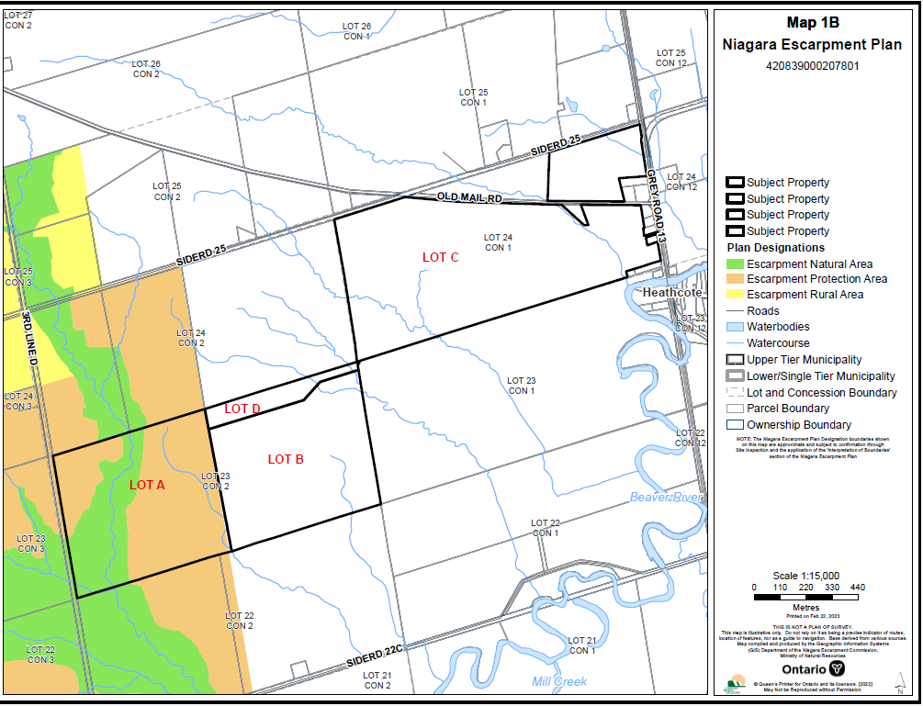
Map 2: Ownership Map (Showing Merged Ownership of Concession 2, Lot 23)
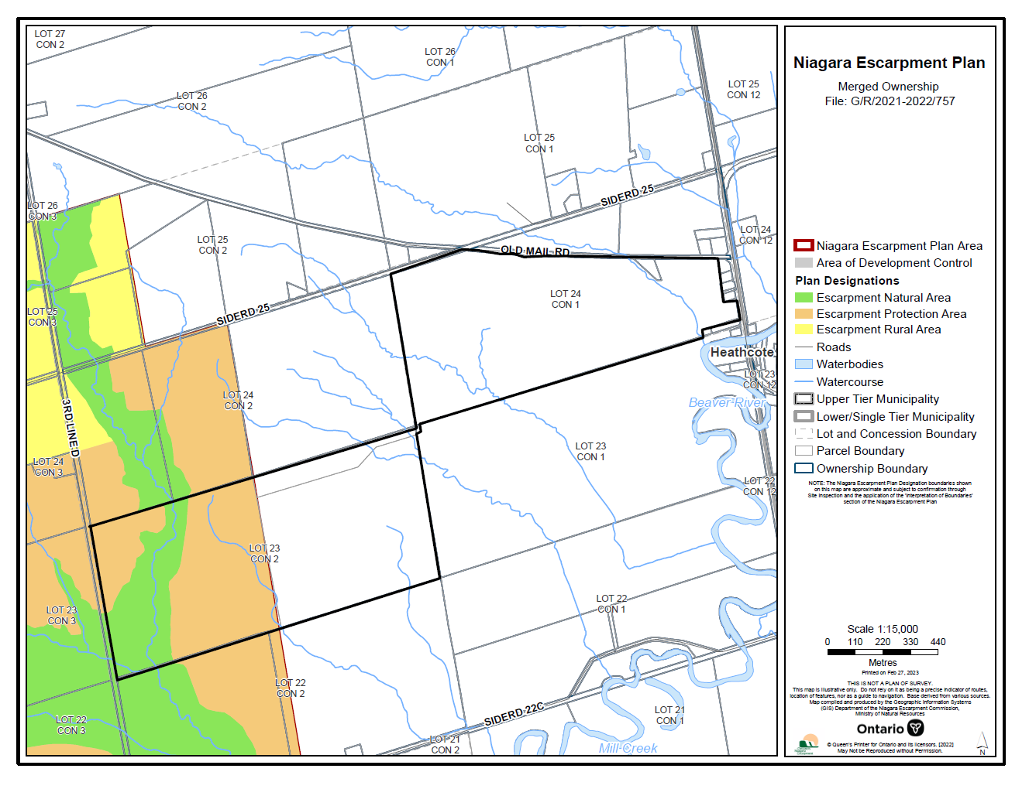
Map 3: Area of Development Control

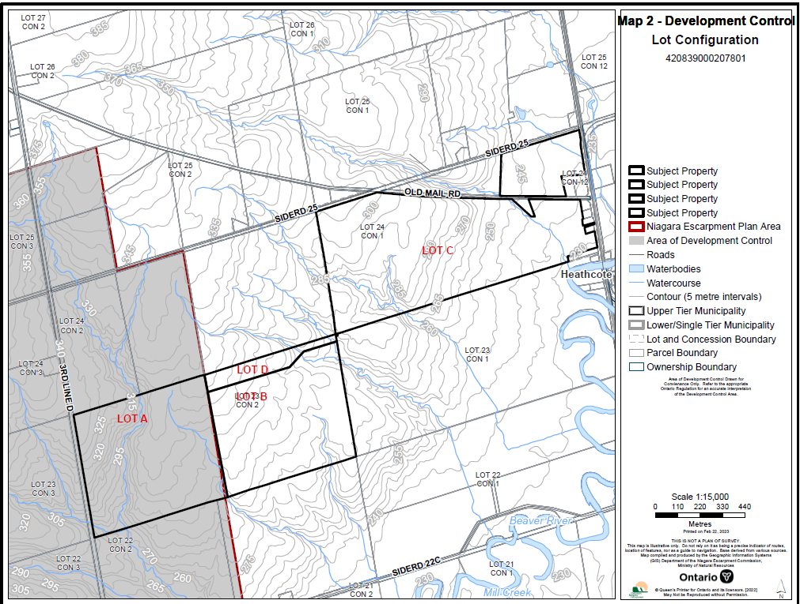
Map 4: Lots A, B & D – Original Township Lot Configuration (Concession 2, Lot 23)

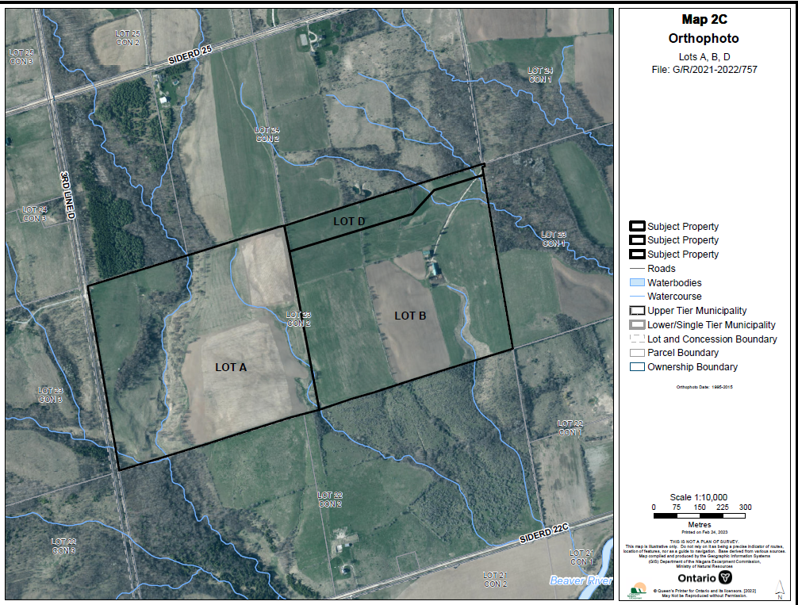

Map 5: NEC Development Permit #9270/G/R/2018-2019/9022 (Lot configuration)

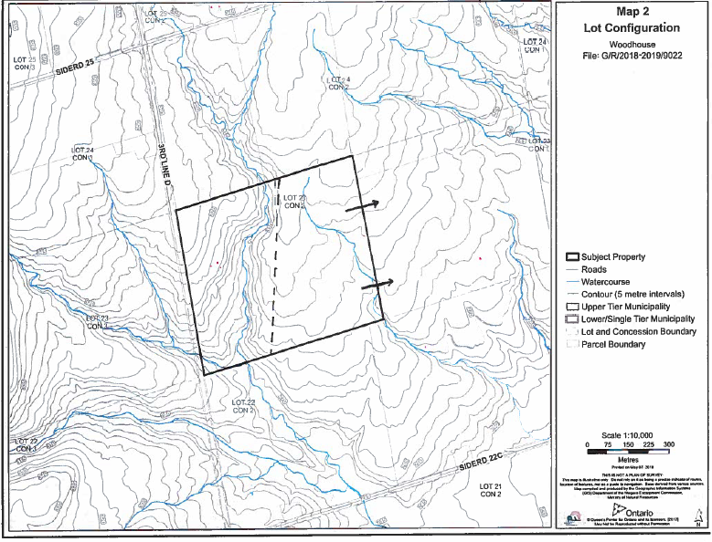

Map 6: Proposed Lot Configuration

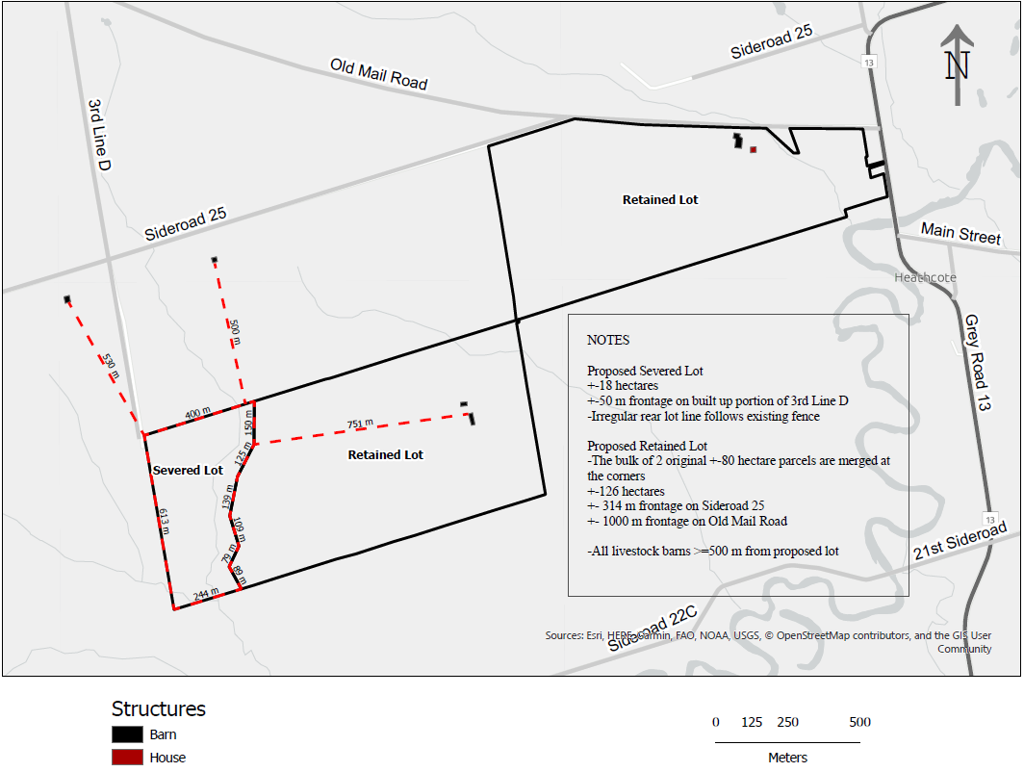

Severance is broadly interpreted here to mean “consent,” which would include a severance (i.e., creation of a new lot) as well as lot line adjustments or lot additions.

