March 9, 2023

STAFF REPORT

DEVELOPMENT PERMIT APPLICATION:

W/I/2022-2023/188
88 Highway 5 West,
Part Lot 23, Concession 3, West Flamborough
City of Hamilton

SUMMARY

PROPOSAL:
To undertake the following on an existing 0.22-hectare (0.55 acre) lot that supports a single dwelling and accessory structure with municipal water servicing and a private sewage system:
- To demolish an existing one-storey 87.05 square metre (937 square feet) accessory structure with a height to peak of 4.75 metre (15.58 feet) and construct a 1.5 storey ± 124.4 square metre (1,339 square feet) accessory structure with a height to peak of ± 8.92 metre (29.25 feet) on the same footprint, with a ± 6.6 square metre (71 square feet) deck with a height to peak of ± 3.1 metre (10.17 feet)
- To establish a home industry (cat kennel) within a ± 25 square metre (269.1 square feet) portion of an existing 217.39 square metre (2,340 square feet) single dwelling and a ± 100 square metre (1,076.39 square feet) portion of a proposed ± 124.4 square metre (1,339 square feet) accessory structure
- To construct a 1.5 storey ± 78.87 square metre (849 square feet) accessory structure (storage building) with a height to peak of ± 8.91 metre (29.25 feet) for the purposes of personal storage
- To extend the asphalt driveway by ± 33.16 square metre (357 square feet)

DESIGNATIONS:
Escarpment Protection Area

ISSUE:
The policies in the Niagara Escarpment Plan (NEP) require that a proposed home industry meet the policies and standards of municipal official plans. The proposal is not consistent with the municipal official plan policies and does not meet the minimum standards set out in the municipal zoning bylaw. The proposal conflicts with Part 2.2.10 of the Niagara Escarpment Plan (NEP).

RECOMMENDATION:
Refusal.

RECEIVED:
June 22, 2022 (revised application received July 18, 2022)

SOURCE:
REDACTED (applicant)
REDACTED (owners)

PROPOSAL:
The applicant is proposing to establish a home industry on the subject property. The proposal includes the demolition of the existing accessory structure (detached garage) and the construction of two, 1.5 storey accessory structures (124 square metres and 78 square metres) as illustrated in Appendix 1. The intention is to dedicate 100 square metres of one of the proposed accessory structures and 25 square metres of the existing single dwelling to the proposed home industry which consists of a cat boarding facility known as The Cat’s Castle. This is a business that boards cats for short term intervals. The facility will require an area to house the cats, up to two employees and the homeowners to care for the cats, and driveway access to facilitate the pickup and drop off. The facility is expected to operate from 10:00am to 8:00pm. The accessory structure located in the southern portion of the property is intended to be used as personal storage. The proposal also includes a 33 square metre driveway extension to provide access to the proposed accessory structure. The existing services (municipal water supply and private sewage system) will be utilized to support the proposed development.

SITE DESCRIPTION:
The subject property is a 0.22-hectare lot located on the south side of Highway 5, approximately one kilometre southwest of the intersection of Highways 5 and 6. The subject property is designated as Escarpment Protection Area and is fully within the NEC’s Area of Development Control as illustrated in Appendix 2. The Escarpment brow is approximately 475 metres southeast of the property.
The property consists of relatively flat topography and is accessed by a driveway from Highway 5 along the northern lot line. The lot currently supports a single dwelling and a detached garage. These structures are located in the central and southern portions of the lot. The single dwelling was constructed circa 1911 and is of cultural heritage interest. The property is included in the City of Hamilton’s Inventory of Heritage Properties. There are no natural heritage features on the lot.

PLANNING ANALYSIS:

Niagara Escarpment Plan

Part 1 – Land Use Designations and Permitted Uses
The site is located in the Escarpment Protection Area. Accessory uses and home industries are considered permitted uses within this designation (Part 1.4.3). The proposal will not have an impact on key natural heritage or hydrological features and will not have an impact on the scenic resources and open landscape character of the Escarpment. As such, the proposal is consistent with the objectives of this designation.

Home Industry
The NEP defines home industries as:

A use, providing a service primarily to the rural or farming community and that is accessory to a single dwelling or agricultural operation, performed by one or more residents of the household on the same property. A home industry may be conducted whole or in part in an accessory facility and may include an animal kennel, carpentry shop, a metal working shop, a welding shop, an electrical shop or blacksmith’s shop, etc., but it does not include an auto repair shop or paint shop, or furniture stripping facility.

The applicant is proposing to establish an animal kennel (cat boarding facility) as a home industry. NEC staff are satisfied that the proposed kennel is consistent with the definition of a home industry. The additional accessory structure is permitted as a use accessory to a single dwelling.

Part 2.2.10 Home Occupations and Home Industries

Part 2.2.10 of the NEP contains policies related to home occupations and home industries. Home industries located within the Escarpment Protection Area are required to meet the following criteria:
Part 2.2.10 the following provisions apply to home occupations and home industries:
- in the Escarpment Natural Area designation, home occupations shall be located in the single dwelling or in an addition to the dwelling;
- in the Escarpment Protection Area, home occupations and home industries shall be located in the single dwelling or in an addition to the dwelling, unless the need to locate it within an accessory facility can be justified;
- home occupations or home industries should normally be limited to one per lot;
- where the home industry is located within a single dwelling, not more than 25 percent of the total floor area including any addition to the dwelling, shall be devoted to the use, to a maximum of 100 square metres;
- where a home industry is located in an accessory facility, not more than 100 square metres of the building shall be devoted to the use;
- in no instance shall there be more than 125 square metres devoted to the uses, where the home industry is located within the single dwelling or in an addition to the dwelling and an accessory facility;
- where there is more than one home occupation or home industry on a lot, the total floor area of all home occupations and home industries cannot exceed the maximum sizes set out in the aforementioned criteria;
- where the home industry is located in an accessory facility, the accessory facility must share a common driveway and where possible must share residential services with the single dwelling;
- home industries shall:
  - be secondary to the primary residential or agricultural use on the lot;
  - be operated by residents of the household on the lot; and
  - be located in a manner that considers potential land use compatibility, issues, such as noise, odour and dust, with adjacent more sensitive uses.
- municipal official plan policies and standards must be met.
The applicant is proposing to establish a cat boarding facility in a portion of the proposed accessory structure (100 square metres) and a portion of the single dwelling (25 square metres). There is a need to place the facility within an accessory structure due to potential issues that may arise from noise and smell that may impact the residents of the single dwelling. The floor area dedicated to the proposed home industry does not exceed the maximum sizes set out in policies c) to g). Furthermore, the accessory facility will be accessory to the primary residential use and will share a common driveway and services shared with the single dwelling. The residents of the property along with two more employees will operate the facility. The facility will be located near a busy highway and is set back over 150 metres from the nearest single dwelling. NEC staff are of the opinion that the proposal meets parts a) to i).Part 2.2.10 j) of the NEP requires that proposed home industries meet the policies and standards of the municipal official plan. Based on the comments received from the City of Hamilton the proposal does not conform with the Rural Hamilton Official Plan and Zoning Bylaw. As such, there is a policy conflict with part j).
Part 2.10 Cultural Heritage
The objective of Part 2.10 of the NEP is to conserve the Escarpment’s cultural and built heritage resources. The subject property is comprised of a circa 1911 singe dwelling and a circa 1970s detached accessory structure. The property is also included in the City of Hamilton’s Inventory of Heritage Properties. NEC staff have recommended the use of natural materials that are compatible with the historical building materials of the existing dwelling. We have not received any architectural plans of the proposed accessory structures thus far. NEC staff are of the opinion that the cultural heritage value of the dwelling will not be negatively impacted if the proposed structures are designed to be compatible with the existing dwelling. Since staff is recommending refusal, no further demonstration that this policy has been met has been asked of the applicants.

Part 2.13 Scenic Resources
The objective of Part 2.13 is to ensure that development maintains the open landscape character of the Escarpment in order to protect the scenic resources of the Escarpment. When looking south towards the Escarpment from Highway 5, there is very little development that obscures views across the Dundas Valley to the Escarpment brow in Hamilton. Since the proposed buildings will be clustered together with the existing dwelling and will not exceed the height of the existing dwelling, there is no visual impact of concern to NEC staff. NEC staff are of the opinion that the proposed accessory structures will not have any additional negative visual impact.

NEC Dog Kennel Guideline

The Niagara Escarpment Commission has a Dog Kennel Guideline (approved September 15, 2010) that applies to this application (refer to Appendix 3). The guidelines are intended to apply to all lands located in the NEC Development Control Area. They are intended to apply to new or expanded dog kennels, including instances where dogs and other household pets, such as cats, are boarded on the same property in conjunction with a single dwelling. It is important to note that these guidelines do not differentiate between dogs and other household pets. The guideline seeks to ensure that dog kennels are not established on any property that is less than 10 hectares in size. Furthermore, setbacks of 60 metres from any property line to the proposed kennel and 150 metres from the proposed kennel to the nearest dwelling on a separate lot are required. The subject property is 0.2 hectares in size and does not meet the minimum lot size guideline. The proposed cat boarding facility does not meet the suggested 60 metre lot line setback as the proposed setback to the western lot line is 4.7 metres. The nearest dwelling on a separate lot is setback over 150 metres from the proposed facility as such, the proposal meets this guideline. The intent of the recommended setbacks is to mitigate the noise and smell that can be associated with pet boarding facilities, but in most cases those nuisances are associated with dogs, not cats. The guideline also requires that the municipal official plan policies and standards are met. It also requires that the proposal demonstrate compliance with a municipal kennel bylaw where such a bylaw is more restrictive. The proposal does not conform to the Rural Hamilton Official Plan and zoning bylaw, which City staff has provided for comparative purposes (see comments below).

Provincial Policy Statement 2020 (PPS)

Part 1.1.4 of the PPS promotes healthy, integrated and viable rural areas through the diversification of the economic base and employment opportunities. Furthermore, Part 1.1.5.2 permits home occupations and home industries on Rural Lands. The proposal is consistent with the PPS.

AGENCY CONSULTATIONS:

City of Hamilton
The subject lands are designated “Rural” in the Rural Hamilton Official Plan. Kennels are permitted within the Rural designation, however, only if they are accessory to an agricultural use. There is no active agricultural use on the property, as such, a kennel is not permitted. Furthermore, kennels are required to meet limitations of the area of the site and setbacks from adjacent land uses that are established in Hamilton’s zoning bylaw (05-200). The zoning by law defines a kennel as:
“The use of land, building or structure, or part thereof, for the breeding, raising, training, sheltering or boarding of dogs, cats and other domestic animals…”
It is evident that the proposed cat boarding facility is consistent with the definition of a kennel. The proposal does not conform with the zoning bylaw requirements of a kennel which is a minimum of 60 metres from any lot line and a minimum lot area of 2 hectares. (NEC staff note: zoning bylaws do not apply in the NEC’s Area of Development Control; however, City staff use their zoning bylaw for commenting purposes to ensure consistency across the City, regardless of NEP policies.)
Ultimately, City staff recommended that the application be denied as it does not conform with the Rural Hamilton Official Plan policies on the location of kennels.

Halton Conservation Authority (HCA)
The property does not fall within the conservation authority’s regulated area, as such, the HCA provided no comments.

SUMMARY:
The proposal seeks to establish a home industry (cat boarding facility) on the property. The scale and intensity of the home industry has been reviewed extensively by the City of Hamilton and NEC staff. The proposal does not conform to the policies of the municipal official plan and the minimum standards within the municipal zoning bylaw. Although the proposal is permitted under Part 1 of the NEP, the proposal does not conform to the Development Criteria in Part 2.2.10 and the NEC’s Dog Kennel Guidelines; however, the guidelines are primarily intended to deal with the nuisances associated with dogs, not cats. The City of Hamilton is objecting to the approval of this application. Based on the analysis above, NEC staff recommend the application be refused.

RECOMMENDATION:
That the Development Permit Application be refused.

Prepared by:

ORIGINAL SIGNED BY:
______________________
Andrej Obradovic
Senior Planner

Approved by:

ORIGINAL SIGNED BY:
______________________
Kim Peters, MCIP, RPP
Manager

Appendix 1 – Site Plan
Appendix 2 – Niagara Escarpment Plan Designations
Appendix 3 – Niagara Escarpment Commission Dog Kennel Guidelines

APPENDIX 1 – SITE PLAN
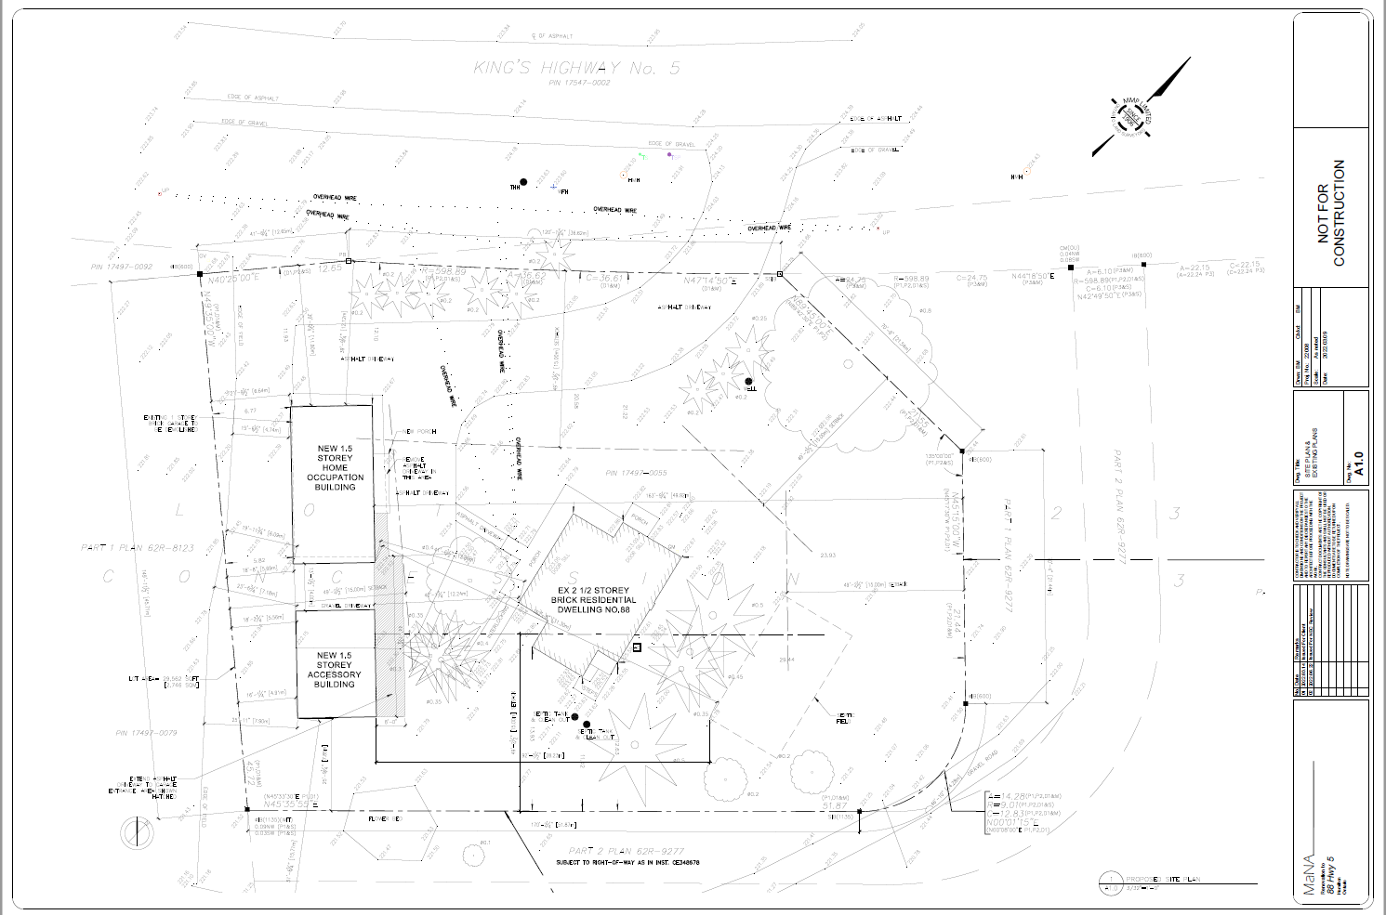

APPENDIX 2 – NIAGARA ESCARPMENT PLAN DESIGNATION

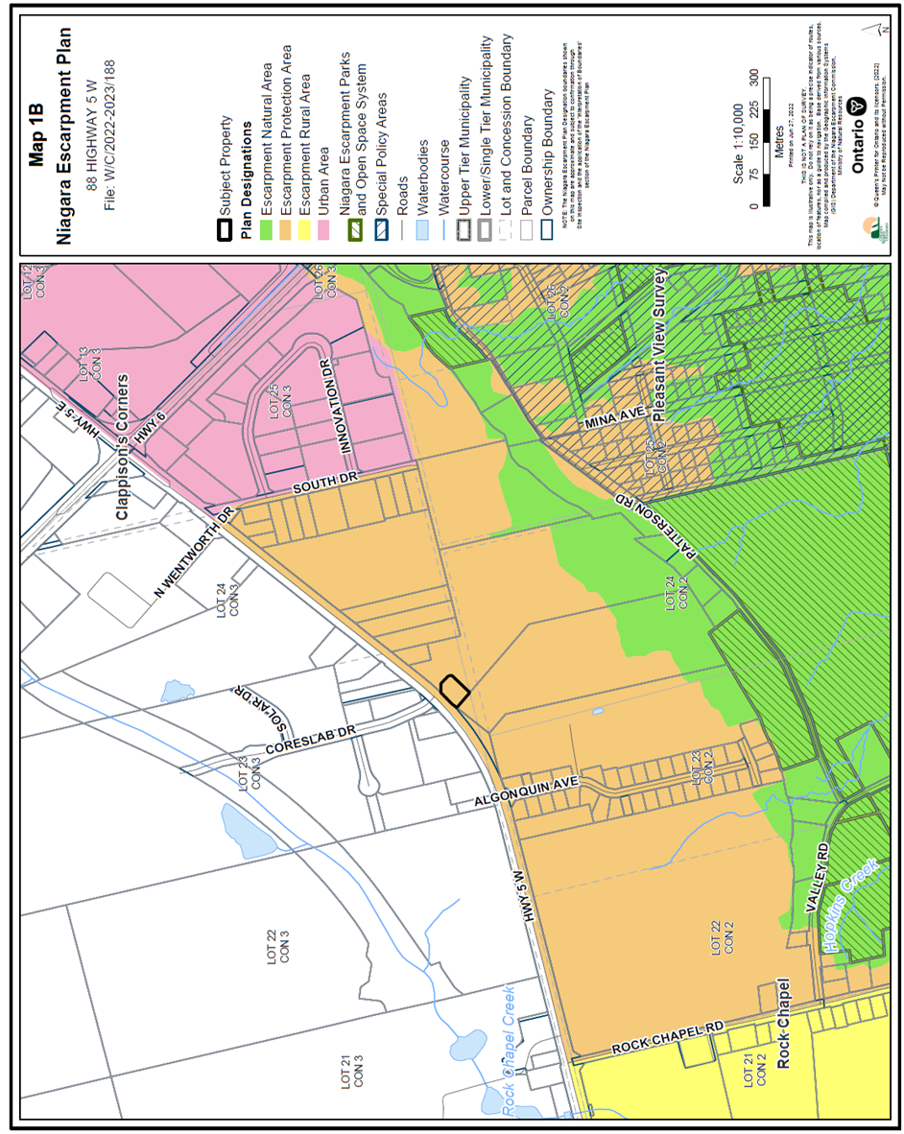

APPENDIX 3 – NEC DOG KENNEL GUIDELINES

