March 9, 2023

A4 COMPLIANCE STAFF REPORT

ORDER TO DEMOLISH/RESTORE #2023.001
REDACTED
5408 Derry Road, Milton, ON
Town of Milton, Halton Region

ALLEGED VIOLATION(S)

- Placement of a modular home (3rd dwelling) in absence of an approved Development Permit from the Niagara Escarpment Commission (NEC)

REASONS FOR ORDER

- The placement of a modular home on the subject property has been observed by NEC staff as early as March 2022 and remains on site as of February 2023.
- The subject property contains an original dwelling, a farm help trailer, and now a modular home making it the 3rd dwelling on site.
- The placement and use of a modular home is considered “development” under the Niagara Escarpment Planning and Development Act (NEPDA).
- Development noted above was undertaken without a Development Permit from the Niagara Escarpment Commission (NEC) and would not be supported through the submission of an As-Built Development Permit Application.
- The placement of a modular home (3rd dwelling) is not a permitted use in the applicable land use designation.
- The owner of the modular home has failed twice to submit a development permit application with proper authorizations from the landowners.

RELEVENT LEGISLATION

- Subsection 24(1) of the Niagara Escarpment Planning and Development Act, R.S.O. 1990, c. N.2 (NEPDA) states:

Despite any other general or special Act, if an area of development control is established by regulation made under subsection 22, no person shall undertake any development in the area unless such development is exempt under the regulations or unless the development complies with a development permit issued under this Act.

- Subsection 24(6) of the NEPDA states:

Where any person undertakes any development that is in contravention of subsection (1), the Minister may order such person to demolish any building or structure erected in connection with the development or to restore the site to the condition it was in prior to the undertaking of the development, or both, within such time as the order specifies.

The issuance of Demolition/Restoration Orders has been delegated to the Commission and is the subject of this staff report.

RELATED FILES

A search of the NEC Development Permit database confirmed that no Development Permits have been issued to the landowner that would authorize the recent placement of the modular home, the last permit issued for this property dates to the 1980s:

H/A/1983-1984/293 – Issued to REDACTED
- To place a 88.4 sq. m (952 sq. ft) mobile home and install a septic system accessory to the agricultural operation on a 19.2 ha (48 ac.) farm. The mobile home would be the second dwelling unit on the lot, and is required to house the applicant’s REDACTED who is a part-time farmer. The applicant’s REDACTED rents approximately 60ha (200 ac.) of farmland in the area.

SUBJECT PROPERTY DESCRIPTION

The subject property (5408 Derry Road, Milton (“the property”)) is within the NEP and is designated exclusively Escarpment Rural Area. The property is entirely contained within the NEC’s Development Control Area, as defined by Ontario Regulation 826/90.

Municipal Property Assessment Corporation (MPAC) information profiles the property as being 45.93 acres (18.59 hectare), a farm with residence and a commercial/industrial operation.

The property is the site of a commercial business named “REDACTED”, described as a third-generation family farm growing organic produce since 2000, with a retail store on the farm open to the public.

The dwelling and commercial business are located on the front portion of the property, where an on-line pond is also located. The modular home has been placed in this vicinity, directly to the side of the main driveway. The placement of the modular home is visible from Google Earth imagery. The features on the property are illustrated on the mapping in Appendix B. Imagery and photographs are also included as Appendix C and D respectively.

INSPECTION AND OBSERVATIONS

On December 31st 2021, NEC planning staff notified the compliance team of an anonymous phone call reporting that a modular home was to be delivered to the subject property in absence of a development permit from the NEC. Subsequently, three voicemails were left on the NEC general line, all of which reported an illegally parked trailer on the subject property. One of the calls mentioned a propane tank had been connected to the trailer. The calls were dated March 2nd, 14th, and 30th 2022 and no contact information was provided.

NEC staff conducted a roadside inspection at 5408 Derry Road on March 14th 2022. Observations confirmed a modular home had been placed near the main entrance of the subject property. On March 24th, 2022, a Notice of Violation (NOV) was sent to the subject property addressed to REDACTED, one of the owners registered on title for the property. The NOV notified the landowner that the placement of a modular home (third dwelling) was considered development, that the NEC had not issued a permit for the development, that the development would fail to meet the policies of the Niagara Escarpment Plan as it is not permitted within the Escarpment Rural Area designation. To gain voluntary compliance, NEC staff requested that the modular home be removed from the subject property by May 16, 2022.

REDACTED, REDACTED of REDACTED, emailed to NEC compliance staff on May 13, 2022 a scanned handwritten note explaining the circumstances behind the need for a third dwelling on site. The note asserted that REDACTED who lives on site has a long-term debilitating medical condition that requires 24-hour care and that his elderly parents also require assistance both personally and on the farm. REDACTED requested consideration of the above and for a delay to on any enforcement action being taken by the NEC.

As a result of the above and in consultation with management, REDACTED was invited to submit an as-built Development Permit Application (DPA) to recognize the placement of the modular home. REDACTED was requested via email to submit a DPA by June 8, 2022, justifying the need for the modular home. Staff explained that the DPA would ultimately be a recommended refusal and that he would have the opportunity to explain the family’s circumstances to the Commission.

A DPA was received on June 10, signed by owner REDACTED and REDACTED acting as the applicant. The NEC manager notified the applicant that all three landowners (REDACTED) had to authorize the application, and that because only one of the registered landowners had signed, the application could not be processed.

On July 19, 2022, a legally-executed, signed affidavit was signed by two of the three registered owners, REDACTED and REDACTED. The affidavit asked for the application to be withdrawn as it did not have the support of all three property owners. The signed affidavit is included as Appendix E (REMOVED FOR WEBSITE VERSION).

On August 9, 2022, the NEC manager informed REDACTED that the application would not be processed and again requested that the trailer be voluntarily removed. A second NOV was subsequently sent on August 24, requesting the trailer be removed by the 30th of November 2022.

The trailer remained on site after the set deadline, at which point compliance staff reached out to REDACTED. REDACTED informed NEC staff that one of the three registered owners, REDACTED, had passed away, and that he is now part owner of the farm, and his parents and himself would like to re-apply for the modular home, this time on a temporary basis. REDACTED was given until January 23, 2023 to submit a new application authorized by the surviving registered landowners and the estate of the deceased. In the absence of a properly authorized application, REDACTED was advised further enforcement action would be taken.

A drive-by of the property completed on January 26, 2023 and February 23, 2023, confirmed that the trailer remains on site.

SUMMARY

The unauthorized development outlined above is development for which no Development Permit has been obtained nor has a properly authorized application for a Development Permit been made. The placement of a modular home as a third dwelling is not exempt under Ontario Regulation 828/90 nor is it a permitted use under the property’s land use designation.

NEC staff have not been provided any reasonable evidence that REDACTED is a legal owner of the property, and a new development permit application has not been received by NEC staff. The two surviving registered owners of the property have provided a legally-sworn affidavit stating they do not want the third trailer on the property (REMOVED FOR WEBSITE VERSION). The unauthorized development continues to remain on site against the landowners’ wishes. On multiple occasions. NEC staff have unsuccessfully attempted to address the above concerns through voluntary compliance. The individual named in this order has failed to meet the requests of NEC compliance staff and has allowed timelines associated with such requests to expire. The proposed approach to achieving compliance is outlined below.

COMPLIANCE APPROACH

The intent of the compliance approach is to ensure the lands of the Niagara Escarpment are developed only in accordance with the NEPDA and its regulations and policies. Significant efforts have been made by the NEC staff to seek voluntary compliance on this site. The appropriate next step to address this situation is through the issuance of an Order to Demolish/Restore under the NEPDA. The intent of the Order to Demolish/Restore is to have the unauthorized development promptly removed from the property and to restore the disturbed area to as close to its original condition as possible within a reasonable timeframe. The Order will also have the effect of acting as a deterrent against possible future non-compliance.

RECOMMENDATION

Based on the reasons outlined above, and pursuant to section 24(6) of the NEPDA, NEC compliance staff are seeking the NEC’s endorsement of Order to Demolish/Restore #2023.001 and conditions thereto that are attached.

Prepared by: Approved by:

Original signed by: Original signed by:
__________________________
Eric Griffin Kathy Woeller
Compliance Program Supervisor (A) Director
Provincial Offences Officer (Badge #006)

TABLE OF CONTENTS

APPENDIX A – ORDER TO DEMOLISH/RESTORE (Page 7-9)

APPENDIX B – MAPPING (Page 10-13)

APPENDIX C – AERIAL IMAGERY (Page 14-15)

APPENDIX D – PHOTOS (Page 16-17)

APPENDIX E – SIGNED AFFIDAVIT (Page 18-20) (REMOVED FOR WEBSITE VERSION)

APPENDIX (A)

Order to Demolish/Restore # 2023.001

Pursuant to section 24(6) of the
Niagara Escarpment Planning and Development Act, Chapter N.2, R.S.O. 1990

THIS ORDER is directed to:

REDACTED
5408 Derry Road
Town of Milton, ON
L9T 2X6

WHEREAS development consisting of:

Placement of a modular home as reflected in the Appendices to this Order

Has occurred on the property described as:

Part Lot 10, Concession 7 (Nelson – New Survey)

RP PLAN BR57 PT PART 1;EXP PLAN HR1336563 PARTS 3;TO 5
ARN: 240907030217700
REDACTED
5408 Derry Road
Town of Milton, Halton Region (“the subject property”)

AND WHEREAS the purpose of the Niagara Escarpment Planning and Development Act (the Act), as set out in Section 2, is to provide for the maintenance of the Niagara Escarpment and land in its vicinity substantially as a continuous natural environment and to ensure only such development occurs as is compatible with that environment;

AND WHEREAS Development Control is a land use control mechanism put in place to help fulfill the purpose of the Act;

AND WHEREAS Subsection 24(1) of the Act states: “Despite any other general or special Act, if an area of development control is established by regulation made under section 22, no person shall undertake any development in the area unless such development is exempt under the regulations or unless the development complies with a development permit issued under this Act”;

AND WHEREAS the subject property is entirely located within the Area of Development Control as defined in Ontario Regulation 826/90 made under the Act;

AND WHEREAS staff have confirmed by roadside inspections and gathered information that the described development has taken place on or about March 2022 to February 2023 on the subject property in the absence of a Development Permit;

AND WHEREAS the described development is not exempt pursuant to Ontario Regulation 828/90 made under the Act from the requirement for a Development Permit;

AND WHEREAS Part 1.5.3 of the Niagara Escarpment Plan does not permit a third dwelling unit (modular home) on a lot in Escarpment Rural Area;

AND WHEREAS staff through roadside inspection and gathered information have confirmed that the Orderee is associated with the unauthorized placement of a modular home on the subject property;

AND WHEREAS the registered landowners of the property have, by sworn affidavit, indicated they do not want the modular home and have not authorized its placement on the subject property;

NOW, THEREFORE, in accordance with Subsection 24(6) of the Act, THE PERSON TO WHOM THIS ORDER IS DIRECTED IS ORDERED TO COMPLETE THE FOLLOWING WORKS:

- No later than June 30, 2023 remove the modular home from the subject property, including safe detachment of all services currently connected to the modular home; and

- Within 4 weeks of the removal of the modular home from the subject property, replacement vegetation shall be planted and established in all areas disturbed by the placement of the modular home. This shall be affected by way of seeding with a native seed mix satisfactory to the Niagara Escarpment Commission.

AND FURTHER TAKE NOTICE THAT failure to comply with this Order may result in further enforcement action being taken against you by the NEC.

FAILURE TO COMPLY with this Order is a contravention under section 24(7.1) of the Act and upon conviction may incur penalties including a fine of not more than $10,000 a day or part of a day on which the contravention continued. Corporations convicted under section 24(7.2) of the NEPDA may incur penalties including a fine of not more than $25,000 a day or part of a day on which the contravention continued.

IN ADDITION and in accordance with section 24(7) of the Act, failure to comply with this Order may lead the NEC to cause the necessary works to be done and charge you with the costs thereof, and the costs of doing said works would be a debt due by you to the Crown, recoverable with costs in any court of competent jurisdiction.

Dated this 9th day of March, 2023.

To be signed once authorized by the Commission
______________________________
Rob Nicholson, Chair
Niagara Escarpment Commission

APPENDIX (B) – MAPPING

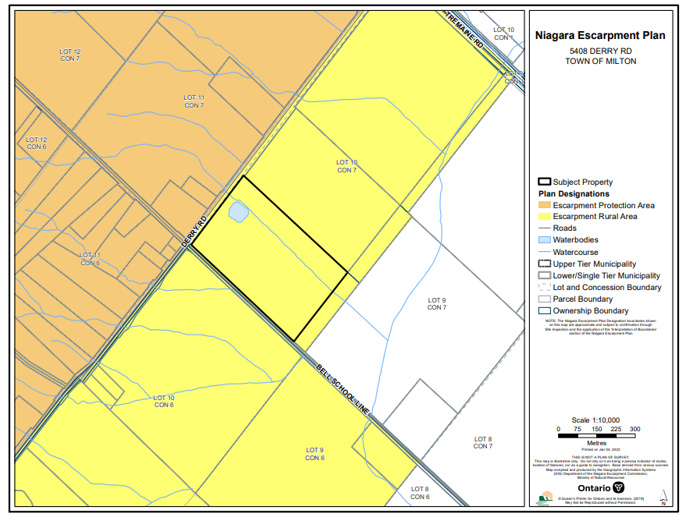
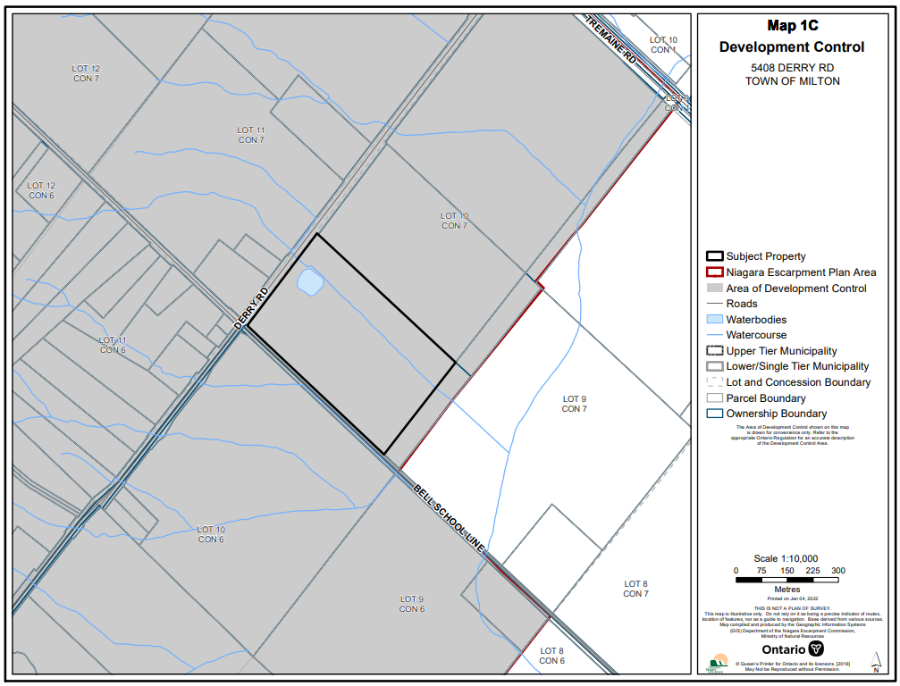

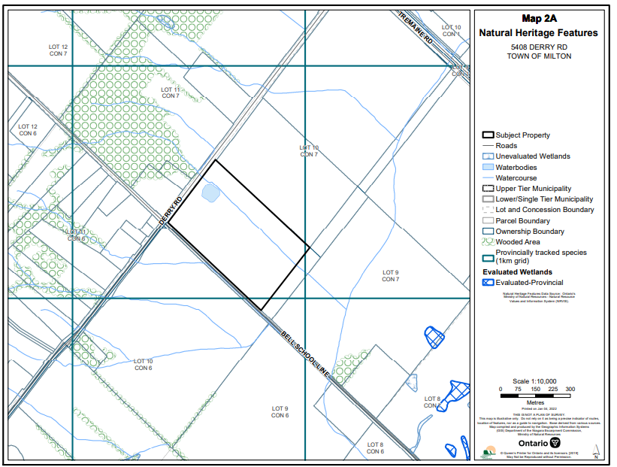

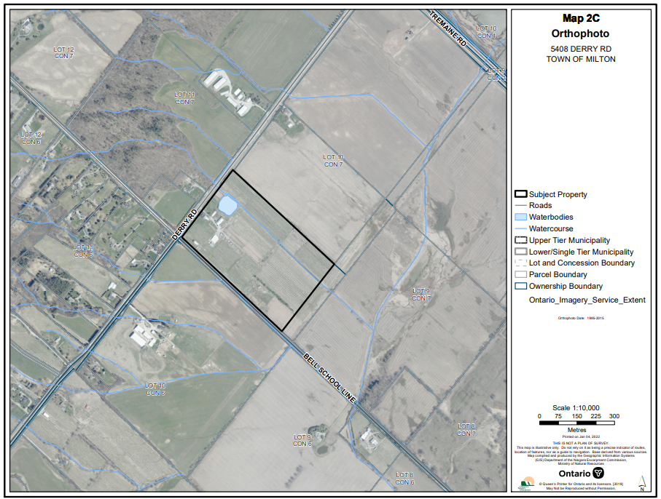

APPENDIX (C) – AERIAL IMAGRY

Google Earth Imagery – October 2022

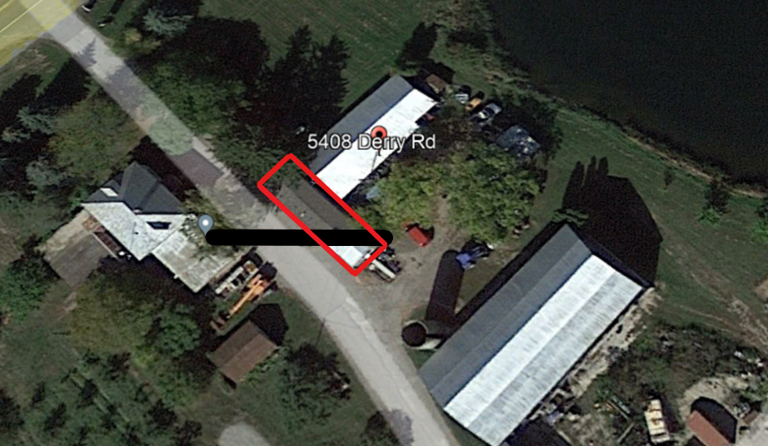

Red: Area subject to restoration order.

Land Information Ontario Imagery – July 2020.

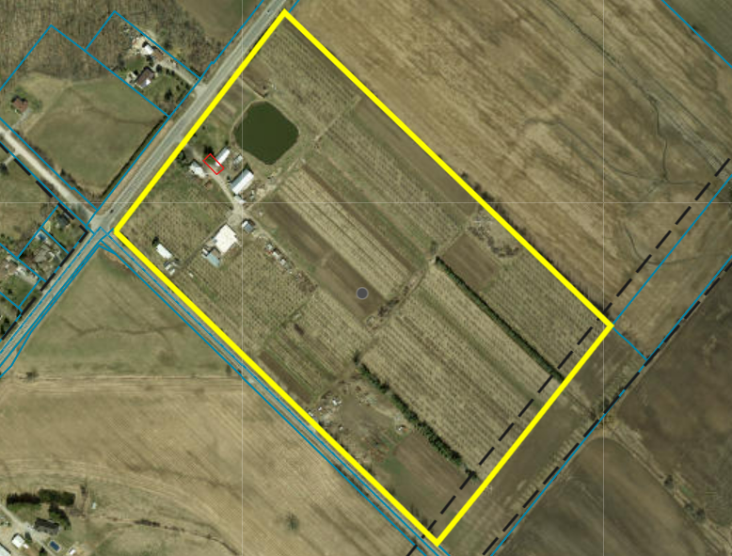

Red: Area subject to restoration order.

APPENDIX (D) - PHOTOS

Eric Griffin – March 10th, 2022, modular home placed to left of main driveway

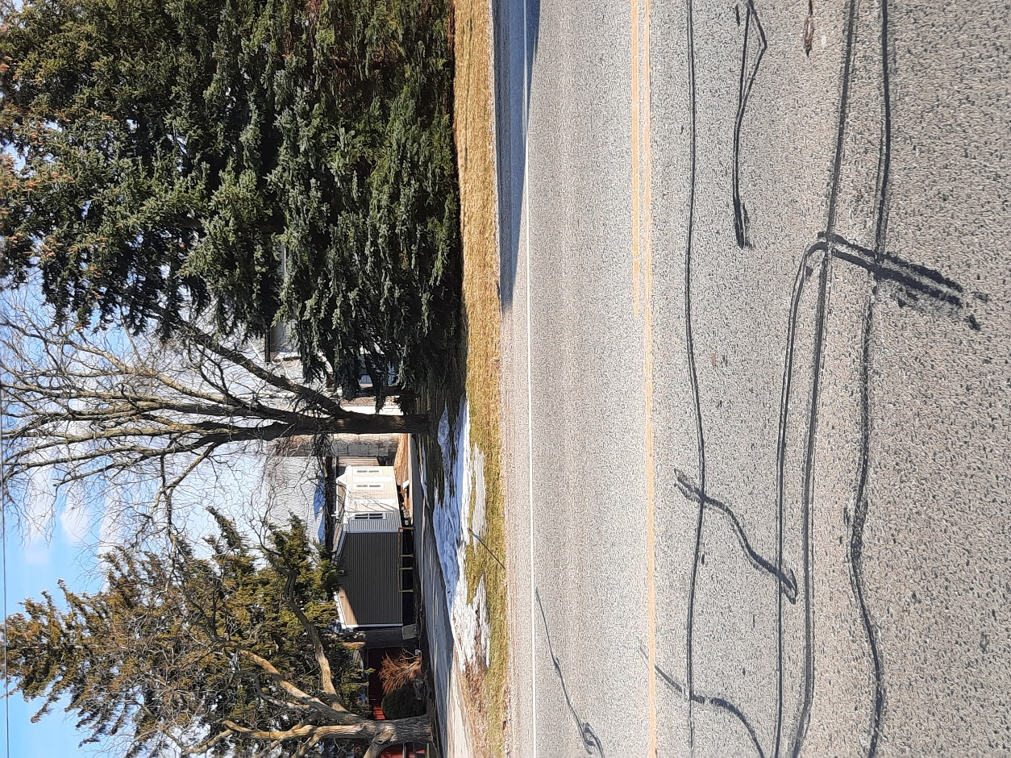
Eric Griffin – January 26th 2023, modular home remains to left of main driveway.

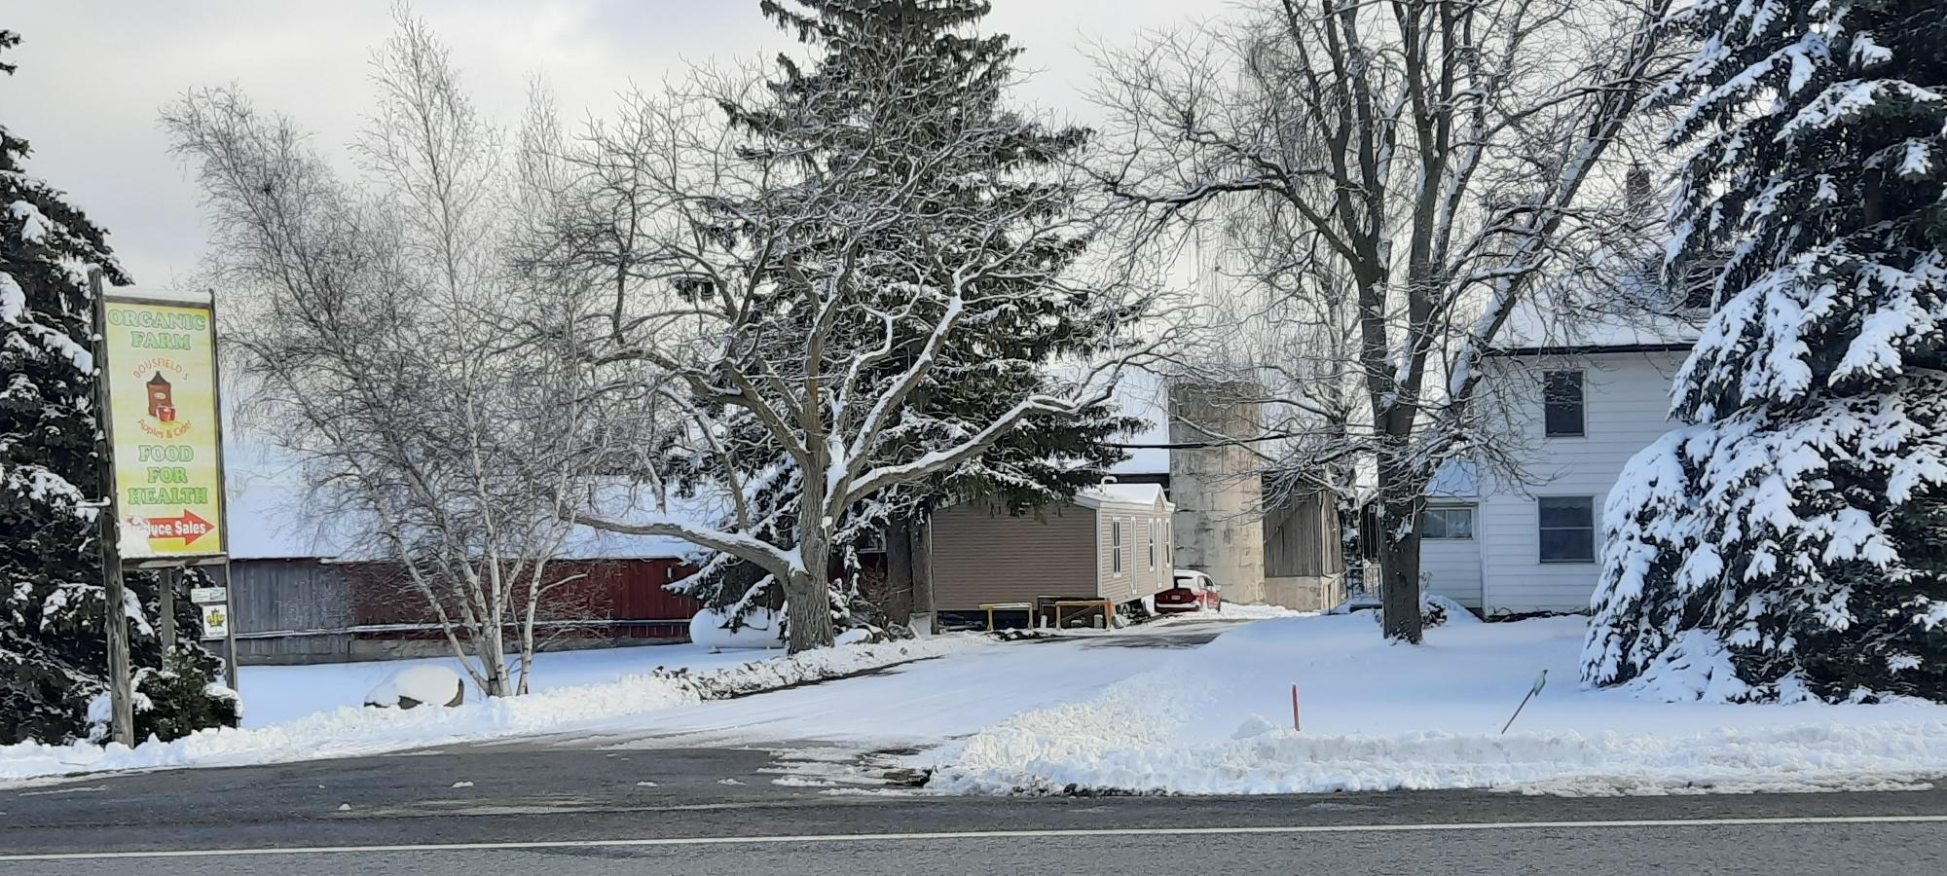

Eric Griffin, February 23rd 2023; modular home remains on site

