May 25, 2023

A1: Staff Report

Development Permit Application:
H/C/2022-2023/200

4240 Derry Road
Part Lot 10, Concession 5 NS, Part 1 Plan 20R-2659
City of Burlington, Region of Halton

Proposal:
To recognize the operation of a home industry (construction), including outdoor parking and storage of construction vehicles and equipment, and to construct a ±139.4 sq m (±1500 sq ft) outdoor parking pad for this purpose on an existing 2.04 ha (5.04 ac) lot that supports a single dwelling, accessory structure for personal storage and private servicing.

Received:
June 17, 2022

Source:
Owner / Applicant

Designations:
Escarpment Rural Area

Recommendation:
Refusal

Reasons for Refusal:
Industrial uses are not permitted in the Escarpment Rural Area, unless they meet the definitions and policies relating to home occupations and home industries or on-farm diversified uses under the Niagara Escarpment Plan. The proposed use is not supported by consulted agencies: it is not consistent with the City of Burlington Official Plan; and it is not consistent with Region of Halton Official Plan.

Related Files:
Occurrence File No.16-1109 pertains to the unauthorized construction of an accessory structure. At that time the structure was only partially built and was subsequently removed, thus resolving any violation-related concerns. The occurrence file was closed.
Development Permit Application, under file No. H/R/2016-2017/430, was submitted on February 23, 2017 (revised July 23, 2018) to construct a 1 storey, ± 128.2 sq m
(± 1380 sq ft) accessory building (Quonset-type structure for personal storage) with a maximum height of ± 4.9 m (± 16 ft). The NEC Development Permit (#11537) was issued on October 17, 2018 and included the condition that the accessory structure shall not be used for human habitation (i.e., living space), as a dwelling or apartment unit, or for commercial, institutional, home business, industrial or livestock purposes.
Occurrence File No. 21-1028 pertains to unauthorized use of the property to park commercial vehicles and commercial use of accessory structure.
Occurrence File No. 22-1194: a Notice of Violation was issued on May 17, 2022, for the operation of a business without an approved NEC Development Permit. The current Development Permit Application was submitted to address this violation.

Site Description:
The subject property is a long and narrow 2.04 ha (5.04 ac) rural residential lot located on the south side of Derry Road between Walkers Line and Appleby Line. It is situated almost directly below and approximately a half kilometre from the Pinnacle Lookout at Rattlesnake Point. Adjacent properties fronting Derry Road are rural residential lots surrounded by agricultural fields and farming operations. Tributaries of Bronte Creek are located in proximity to the property but on adjoining lots: one situated close to the northeast lot corner of the subject property and the other is near the west boundary of the lot.
Based on the latest aerial imagery, the rear portion of the lot consists of open field and a small orchard. The front yard area includes a small grove of mature trees (conifer and deciduous). Existing structures on the lot includes a single dwelling and a storage building (metal Quonset hut approved under H/R/2016-2017/430 for personal storage). Both buildings are located in the front quarter of the property. A high board fence extends along the front and side lot boundaries. According to the Municipal Property Assessment Corporation (MPAC), the property is taxed as “land owned by a non-farmer improved with a non-farm residence with a portion being farmed.” It is not known if the landowner has a Farm Business Number.

Background:
The current owner purchased the rural residential property in 2015. In May 2020 the NEC received emails from the neighbours complaining about the property being used to operate a construction business, which included large construction equipment and vehicles driving in and out of the property and being parked on site. NEC compliance staff reviewed the occurrence as a possible breach of the condition of a NEC development permit issue under H/R/2016-2017/430, which approved construction of an accessory structure for personal storage.
In March 2022 the NEC again received emails from the neighbours complaining about the property being used to operate a construction business. The neighbours alleged that the property was being used to park or store industrial equipment, with up to eight trucks working out of the property and that the accessory structure (metal Quonset hut) was being used to repair and service industrial and construction equipment.
NEC compliance staff determined that the property owner owns a construction business, called World Quality Construction. The company website shows the 4240 Derry Road as its company address.
In March 2022 NEC compliance staff conducted a site visit (see photos in Appendix 6). At that time, NEC compliance staff encouraged the landowner to voluntarily resolve this issue. Alternatively, a Development Permit Application could be submitted to consider a change in use for the property. NEC issued a Notice of Violation on May 17th, 2022.
On June 17th, 2022, the property owner submitted the current Development Permit Application to recognize the change in use to allow storage of commercial vehicles and equipment and to construct an outdoor parking pad for this purpose.
Up-to-date photos taken by NEC staff on April 3, 2023, from the roadside, are included in Appendix 7.

Planning Analysis:

Niagara Escarpment Plan (NEP) (2017)

Part 1.5.3 Permitted Uses (Escarpment Rural Area)
The subject property is entirely located in the Escarpment Rural Area of the NEP. Based on Canada Land Inventory mapping, approximately one-third of the property (the rear portion) is classified as Class 1 soils, and the remainder of the property is classified as Class 3 soils, thus prime agricultural land, and is designated by the Region of Halton as being within an Agricultural Area (i.e., a prime agricultural area). The properties along Derry Road are generally rural residential lots with agricultural fields behind them.
The subject property, at 2.04 ha (5.04 ac), is considered to be a rural residential lot and residential use. The existing single dwelling and accessory structure (metal Quonset hut for personal use) are permitted uses under Part 1.5.3 of the NEP.
Although a home business, a home industry, and an on-farm diversified use are permitted uses under Part 1.5.3 of the NEP, it is NEC staff’s opinion that the industrial business use on the property does not conform to the relevant definitions in the NEP, and cannot meet the development criteria in Part 2 of the NEP. The following provides an analysis of the use against relevant permitted uses under Part 1.5.3, and the definitions of those permitted uses in Appendix 2 of the NEP.
Home industries: The NEP defines home industries as:
• a use, providing a service primarily to the rural or farming community and that is accessory to a single dwelling or agricultural operation, performed by one or more residents of the household on the same property. A home industry may be conducted in whole or in part in an accessory facility and may include an animal kennel, carpentry shop, a metal working shop, a welding shop, an electrical shop or blacksmith’s shop, etc., but does not include an auto repair or paint shop, or furniture stripping facility.
World Quality Construction does not appear to be linked to, nor does it provide a service to, the neighbouring rural or farming community. The bulk of the construction business operation is conducted off-site, not on the same property as required by the definition. By extension, the storage of machinery used to conduct work offsite is not permitted. Any repair and maintenance of construction equipment in the Quonset hut (similar to an auto repair shop) is not permitted as per the definition. Operating a construction business from the property generally, and the storage of construction vehicles on site specifically, does not meet the definition for a home industry.

On-farm diversified uses: The NEP and PPS define on farm diversified uses as:
• a use that is secondary to the principal agricultural use of the property and is limited in area. On-farm diversified uses include, but are not limited to, home occupations, home industries, agri-tourism uses, and uses that produce value-added agricultural products.
Due to the small size of the property at 2.04 ha (5.04 ac) and the small-scale farming that may be occurring, an on-farm diversified use (OFDU) is not supportable. Therefore, the introduction of the industrial use would not be permitted as an on-farm diversified use on this property. More analysis is provided below.

Accessory use: The NEP defines accessory uses as:
• the use of any land, building, structure or facility that is naturally and normally incidental, subordinate, and exclusively devoted to the principal use located on the same lot.
In October 2018, NEC issued a permit for the construction of a 1-storey, accessory structure (a metal Quonset-type structure) to be used for personal storage. Permit #11537/H/R/2016-2017/430 included the condition that the accessory structure shall not be used for human habitation (i.e., living space), as a dwelling or apartment unit, or for commercial, institutional, home business, industrial or livestock purposes.

Any current commercial or industrial use of this accessory structure is contrary to the conditions of the NEC permit. Additionally, staff do not consider the outdoor storage of construction vehicles and equipment associated with the owner’s construction business to be naturally incidental to the primary established residential use on the property.

Given the above analysis, the storage of construction-related vehicles and equipment on the property as part of the owner’s construction business fails to meet any of the above listed definitions of uses that may be permitted under Part 1.5.3 of the NEP for Escarpment Rural Areas.
Other Considerations:
Usually, Part 2 Development Criteria do not require review when development is not a permitted use. However, to provide additional evidence that the proposal is not permitted by the NEP, staff has provided a summary analysis below.

Part 2.2 General Development Criteria
Conservation Halton did not provide comment on the proposed location of the parking pad. Based on NEC staff review of Conservation Halton mapping, it appears that the parking pad may be located within the flooding and erosion hazards associated with a tributary of Bronte Creek. As such the location of the proposed parking lot does not meet Part 2.2.2, which requires that development avoid areas prone to hazards.
Furthermore, Part 2.2.1 speaks to cumulative impacts: the Escarpment environment shall be protected, restored and where possible enhanced for the long-term having regard to single, multiple or successive development that have occurred or are likely to occur. The proliferation of industrial uses on rural residential properties is an increasing concern to NEC staff, especially when there are clear zoning bylaws limiting such uses elsewhere in a municipality. However, these zoning bylaws do not apply in the NEC’s Development Control Areas. Increasingly, NEC staff is encountering situations where the NEP is being interpreted in a manner that is less restrictive than local zoning bylaw and official plan policies. This is concerning when Part 1.1.1 of the NEP indicates that the NEP is “not intended to limit the ability of municipal official plans, secondary plans and by-laws to set standards and policies that are more stringent than the requirements of the NEP.” The cumulative impacts of such development erode the purpose and objectives of the NEP, in terms of protecting the open landscape character and natural scenery of the Niagara Escarpment, as well as in terms of supporting municipalities in their exercise of planning functions.
Part 2.2.10 of the NEP establishes parameters for home occupations and home industries within the NEP Area. At ±139.4 sq m (±1500 sq ft) for an outdoor parking pad and ±128.2 sq m (±1380 sq ft) for the Quonset hut, either one of these areas would exceed the total area of 125 sq m which may be devoted to a home occupation or home industry under Part 2.2.10(f). Thus, even if the industrial use met the definition of a home industry, it would still be refusable based on not meeting the development criteria related to home industries.

Part 2.6 Development Affecting Water Resources
The subject property lies between two tributaries of Bronte Creek. Of particular concern is a watercourse that appears to run along the east boundary of property and is less than 25 m from the proposed parking lot. No grading plan has been provided, nor is there a vegetation protection zone proposed to prevent deleterious substances from the parking pad from entering the watercourse. Insufficient information is provided to know if the proposed development meets Part 2.6 of the NEP. Given that the development is not a permitted use, staff did not request technical studies from the applicant.

Part 2.7 Development Affecting Natural Heritage
The Region of Halton identifies portions of the property as being within the Regional Natural Heritage System (RNHS), including the proposed parking pad. However, there are no key natural heritage features on site. There are records of species at risk within the general area, but the subject property is unlikely to be habitat for these species. The impact of the proposed parking pad on a grove of trees on the property is unknown. Staff did not request technical studies (e.g., a tree protection plan) from the applicant given that the industrial use does not meet other NEP policies.
Part 2.8 Agriculture
The objective of Part 2.8 is to encourage agricultural uses in agricultural areas, especially in prime agricultural areas, to permit uses that are compatible with farming, and to encourage accessory uses that directly support continued agricultural uses.
Part 2.8.7 provides criteria for on-farm diversified uses (OFDUs). The small orchard is not intensive enough to be considered an active agricultural use, nor can an industrial use be considered secondary to a principal agricultural use on the property, as required under Parts 2.8.7 (a) and (b). Furthermore, the industrial use does not maintain the agricultural/rural character of the area, as required under Part 2.8.7 (e).
Therefore, the change in use and the associated parking pad for storage of commercial vehicles is not consistent with the Part 2.8 of the NEP.

Part 2.13 Scenic Resources and Landform Conservation
The Land Evaluation Study identifies the front portion the property, where the parking pad is proposed, as “Attractive”. The remainder of the property is identified as “Average”. Industrial equipment is visible from the public roadway, even with the high fence across the front of the property. Although fencing is usually exempt under O. Regulation 828/90 (but still subject to municipal bylaws), NEC staff notes that it is disruptive to the open landscape character and unusually high for fencing along the front of a property. NEC staff has requested that the City of Burlington confirm whether the fencing complies with applicable municipal bylaws. Appendix 7 includes photographs of the fencing. Additionally, the property is located almost directly south, and within approx. 500 m, of Pinnacle Lookout at Rattlesnake Point. The property is visible from the lookouts at Rattlesnake Point. Staff are of the opinion that the proposal does not meet the overall objective of Part 2.13 to ensure that development preserves the natural scenery and maintains and enhances the open landscape character of the Escarpment.

Halton Region Official Plan
The industrial use is not a permitted use within either the Regional Natural Heritage System or Agricultural Area designation in the Region’s Official Plan.

City of Burlington Official Plan
The proposed storage of construction vehicles, equipment and machinery on the property (including a proposed new outdoor parking area) is not permitted by the Official Plan.

Provincial Policy Statement (PPS) (2020):

Part 2.3 of the PPS addresses land uses in prime agricultural areas. Permitted uses include agriculture, agriculture-related uses, and on-farm diversified uses.

Although a home industry or OFDU could be permitted by the PPS, the development does not meet the more specific policies of the NEP. The PPS states that it must be read in conjunction with the provincial land use plans, and that the more specific policies of the provincial plan satisfy the more general requirements of the PPS. Thus, the PPS provides direction that land use planning decisions must be consistent with a provincial plan, i.e., the NEP, and for that reason the development is not consistent with the PPS.

Agency Consultations:

Region of Halton: Does not support application
Regional staff commented that proposal does not appear to be a permitted use within either the Regional Natural Heritage System or Agricultural Area designation in the Region’s Official Plan, and therefore do not to support the application.
Regional staff noted that the existing storage shed (metal Quonset hut) is located in a designated Agricultural Area and that the principal use of the subject property is residential. As such considered its use under the relevant Regional Official Plan polices related to accessory structures and incidental uses within the Agricultural Area designation. Under both policies the existing storage shed is permitted for personal use and storage as accessory or incidental to the residential use of the property but not for a commercial operation. Additionally, the use is not supported under the ROP, which prohibits non-agricultural uses within Prime Agricultural Areas.
Regional staff further noted that the subject lands are partially designated as Regional Natural Heritage System (RNHS), and contain or are adjacent to identified Key Features, including candidate significant woodlands, potential habitat of endangered or threatened species, potential significant wildlife habitat and watercourse and floodplain areas regulated by Conservation Halton (CH). Given the current location of the proposed works in relation to the RNHS, an Environmental Impact Assessment (EIA) would be required.

City of Burlington: Does not support application
City of Burlington planning staff reviewed the materials submitted and is of the opinion that the storage of commercial and industrial equipment and machinery on the property (including a proposed new outdoor parking area) is not permitted by the Official Plan. Staff is of the opinion that the proposed development will not maintain the general intent and purpose of the City’s Official Plan.
Site engineering staff noted that further permits may be required. The building department noted that a building permit is required for any construction and that a change of use permit may be required.

Conservation Halton: No Objection to the change in use
Conservation Halton (CH) staff noted that subject property is adjacent to lands traversed by tributaries of Bronte Creek and contains flooding and erosion hazards associated with those watercourses.
CH staff advised that comments provided on March 24, 2017, for a previous application, NEC # H/R/2016-2017/430, for the construction of an accessory structure (Quonset hut for storage) remain applicable for consideration of the proposed change in use. CH staff did not provide comments on the proposed location of the parking pad, although their mapping indicates that the parking pad would be located within the floodplain.

Discussion:
NEC staff are recommending that this application, for an industrial use on a primarily residential property, be refused. The industrial use on the subject property fails to meet the NEP policies and definitions related to home industries, OFDUs, and accessory uses. The use is not supported by consulted agencies and is not consistent with the City of Burlington Official Plan or the with the Region of Halton Official Plan. Additionally, the proposed location may negatively impact water resources and related hazards. Evaluation of the impact on water resources and natural heritage was not requested of the applicant given that the proposed development is not consistent with other policies in the NEP.

Recommendation:
That the Niagara Escarpment Commission refuse the proposed use of the property for industrial and commercial purposes.

Prepared by:

ORIGINAL SIGNED BY:

___________________
Rosi Zirger
Senior Planner

Approved by:

ORIGINAL SIGNED BY:

_______________________
Kim Peters, MCIP, RPP
Manager

Attachments:
Appendix 1 – Reasons for Refusal
Appendix 2 – NEC Location Map
Appendix 3 – NEC Designation Map
Appendix 4 – Orthophoto
Appendix 5 –Site Plan
Appendix 6 – Site Photos (March 2022)
Appendix 7 – Site Photos (April 3, 2023)

APPENDIX 1

REASONS FOR REFUSAL H/C/2022-2023/200
- The proposed development is not a permitted use in the Escarpment Rural Area.

- The subject proposal is contrary to the purpose and applicable objectives of the NEP.

- The proposed industrial use is not supported by the City of Burlington or the Regional Municipality of Halton.

Appendix 2 – NEC Location Map

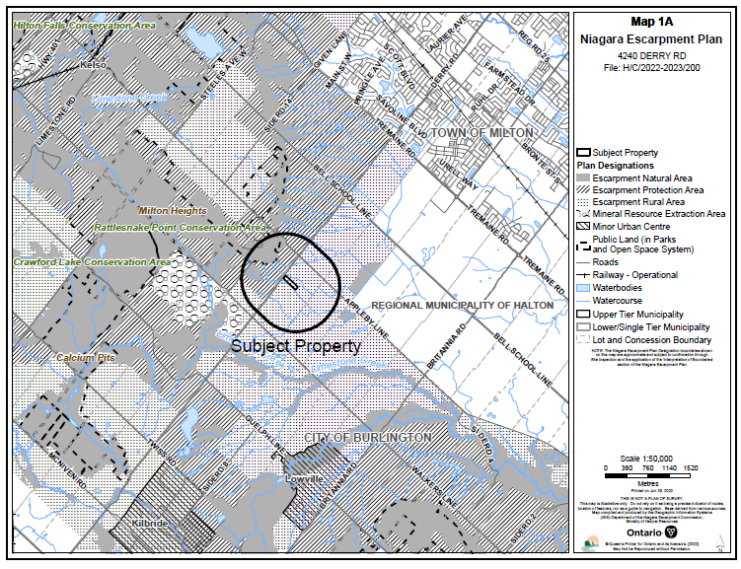

Appendix 3 – NEC Designation Map

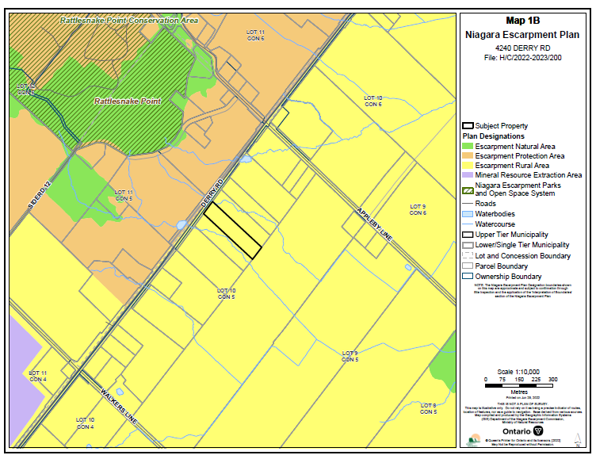

Appendix 4 – NEC Orthophoto

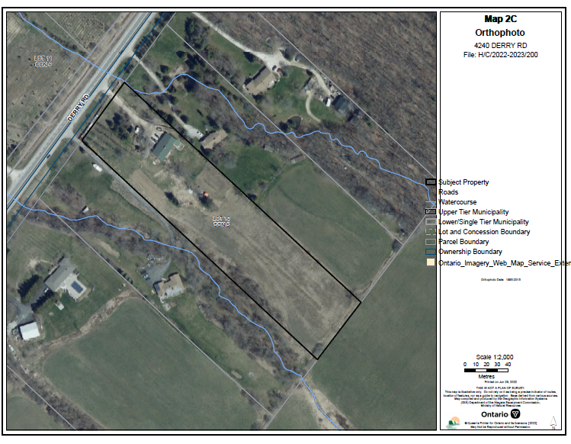

Appendix 5 – Site Plan
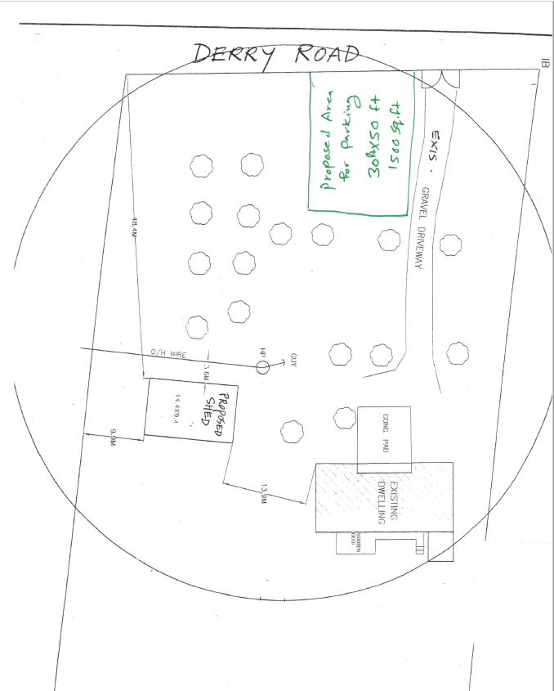

Appendix 6 – Site Visit Photos March 2022
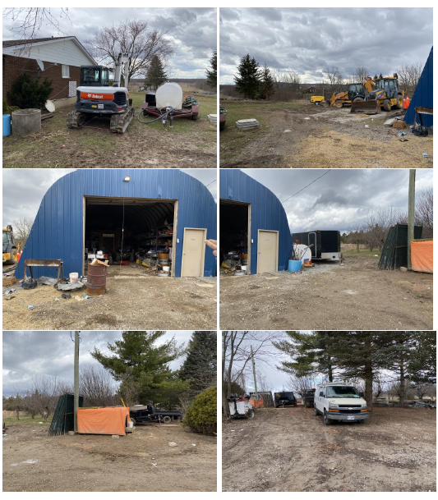

Appendix 7 – Site Photos (from Public Roadway) April 3, 2023

