October 19, 2023

A6 Amendment Referral Report

RE: PROPOSED Niagara Escarpment Plan Amendment PP 213 18

Development Permit Applications P/E/2017-2018/408 &

P/E/2023-2024/291
Blueland Farms Ltd. (McCormick Pit)
17736 Heart Lake Road and 17679 Kennedy Road
East Part of Lot 12, Concession 2 EHS
West Part Lots 11 and 12, Concession 2 EHS
Town of Caledon, Region of Peel

Proposed Amendment:
- To amend the Niagara Escarpment Plan (NEP) designation of Escarpment Rural Area to Mineral Resource Extraction Area to permit mineral aggregate resource extraction (gravel pit) both above and below the water table within a 26-hectare area on a 40.5-hectare property located at 17736 Heart Lake Road (East Part Lot 12, Concession 2 East of Hurontario Street), Town of Caledon, Region of Peel.
- To add a special policy under Part 1.9.3 of the NEP to allow for the transport of materials from 17736 Heart Lake Road onto the property located at 17679 Kennedy Road (West Part Lots 11 and 12, Concession 2 East of Hurontario Street), Town of Caledon, Region of Peel.

Development Permit Applications:
- Development permit application (DPA) P/E/2017-2018/408 proposes the establishment of a new 25.97-hectare aggregate extraction operation (gravel pit) on a portion of a 40.5-hectare property located at 17736 Heart Lake Road in the Town of Caledon (Region of Peel). Aggregate is to be extracted from above and below the water table to a maximum of 750,000 tonnes annually.
- DPA P/E/2023-2024/291 proposes to allow for the transport of up to 750,000 tonnes (annually) of extracted aggregate from 17736 Heart Lake Road to an aggregate operation at 17679 Kennedy Road in the Town of Caledon. Common boundary setbacks will also be removed and a coordinated rehabilitation approach undertaken to create a larger lake feature and associated landforms.

Received:
April 28, 2017

Applicant:
Blueland Farms Limited

Owner:
882527 Ontario Limited

Agent:
MacNaughton, Hermson, Britton, Clarkson (MHBC) Planning, Ltd.

Summary:
The purpose of this report is to recommend that the Commission refuse the DPAs and refer the proposed amendment to the Ontario Land Tribunal (OLT) for a hearing. The referral to the OLT is necessary because there are objectors to the amendment. In the absence of an approved amendment, the DPAs cannot be supported and must therefore be refused. The amendment proposes to change the land use designation and establish a special policy in the NEP, whereas the DPAs consider the operational aspects of the proposed pit.
Eleven written objections were received from local residents, and one objection was received from PitSense, a community-based organization concerned with the number of aggregate operations in the Town of Caledon. The Town of Caledon and Region of Peel did not support the application earlier in the process, and have not taken a position more recently as peer reviews of the technical studies remain under review. The applicant has appealed the non-decision of the Town of Caledon’s official plan amendment to the OLT.
In accordance with section 10(3) the Niagara Escarpment Planning and Development Act (NEPDA), an application to amend the NEP must be referred for a hearing if written objections to the amendment are received. From a procedural perspective, the refusal of the DPAs allows the proponent to appeal the decision and request that the amendment and DPAs be consolidated into one hearing together with other required approvals (i.e., Town of Caledon official plan amendment, Aggregate Resources Act licence).
While refusal of the DPAs is recommended, the Commission is not being asked to take a position on the amendment at this time. There is outstanding information necessary to determine whether the proposed aggregate operation is consistent with the purpose and objectives of the NEP and NEPDA. NEC staff will continue to work with the applicant, municipalities, conservation authority and MNRF to advance understanding of the proposal in the lead-up to the hearing. NEC staff will report back to the Commission to seek further instruction as necessary.

Recommendations:
That the Niagara Escarpment Commission:
- Receive this report while taking no substantive position at this time on NEP amendment PP 213 18;
- Ask the OLT to appoint one or more hearing officers to hold a hearing pursuant to Section 10(3) of the NEPDA as there are written objections to the proposed amendment;
- Refuse DPAs P/E/2017-2018/408 and P/E/2023-2024/291 so that they can be appealed to the OLT concurrently with the proposed amendment and possibly consolidated with the hearing of other related approvals;
- Support the consolidation of the proposed NEP amendment and DPAs with the related Planning Act and Aggregate Resources Act appeals;
- Direct NEC staff to continue to work with the applicant, municipalities, conservation authority, MNRF and others to obtain outstanding information necessary to fully assess the proposed amendment and DPAs;
- Instruct NEC staff to report back to the Commission before taking any final positions on the proposed amendment and DPAs.

Process History:
At its meeting on June 21, 2018, the Commission decided to initiate and circulate the proposed amendment for comment. A sixty-day commenting period spanning April to June 2019 was advertised through a posting on Ontario’s Environmental Registry, newspaper notices in the Caledon Enterprise and Orangeville Banner newspapers, and direct mail to Mississaugas of the Credit First Nation and landowners within 120 metres of the subject property. Upper and lower tier municipalities and Credit Valley Conservation (CVC) were also notified. In addition to the NEC’s notification efforts, the Town of Caledon hosted a public meeting in fulfillment of Planning Act requirements on April 6, 2021.
In January 2021, NEC staff provided an update report to the Commission given that almost three years had passed since the amendment application was received. The report included an analysis of MNRF’s direction on how significant woodlands were to be assessed. This is discussed further below.
Throughout 2021 and 2022, a municipal-led peer review of the technical studies, including noise, air quality and hydrogeology assessments was undertaken. Given that the NEC has staff expertise in visual impact, an internal review of the visual impact assessment was undertaken. Initial comments on a natural heritage report were received from CVC; however, with the limiting of conservation authorities’ mandates to exclude natural heritage issues in December 2022, CVC cannot provide a review of the additional information submitted. Several issues remain outstanding as a result of these reviews; these are discussed further below.
When the application for the proposed amendment was initially received, it proposed only to redesignate the lands at 17736 Heart Lake Road (McCormick Pit) to Mineral Resource Extraction Area, and DPA P/E/2017-2018/408 proposed the site and operational plans for the proposed pit. As part of staff’s analysis, it was determined that the amendment needs to include provisions to allow for the transport of aggregates onto the adjacent Caledon Sand and Gravel (CSG) property at 17679 Kennedy Road, since extracted material will need to cross the CSG site to access processing facilities at the James Dick Pit at 18075 Hurontario Street, and to exit onto Hurontario Street (Highway 10). Map 2 illustrates the locations of the affected properties.
An additional DPA is also required to accommodate transport of aggregate onto the CSG property and to revise the site plan accordingly. The previous DP issued for operations on this site (P/E/1991-1992/037) does not include provisions for the transporting of off-site materials. The proposed rehabilitation plan under the old permit also does not contemplate the merging of the CSG and McCormick ponds and the elimination of setbacks at the property lines. Thus, DPA P/E/2023-2024/291 is also under consideration.
Very recently, the proponent requested that the matter be referred to the OLT since the Town of Caledon was not able to make a decision on the proposed official plan amendment (OPA) within the timeline prescribed in the Planning Act. A licence must also be issued for McCormick Pit under the Aggregate Resources Act. The Consolidated Hearings Act allows for all approvals to be considered as part of a consolidated hearing, through which a “Joint Board” makes a decision on the various applications. In the time since the referral was requested, a case management conference was held on May 24, 2023 and another is planned for December 5, 2023. NEC counsel has already requested party status at the hearing. So far, there has not been any effort to scope issues or engage in mediation in advance of a hearing. Staff anticipates there will be multiple case management conferences and other meetings before a hearing is scheduled.

Site Description:
The proposed pit (McCormick Pit) is located at 17736 Heart Lake Road in the Town of Caledon, approximately 1.5 km east of Caledon Village. It is adjacent to an existing gravel pit operation (CSG) fronting on Kennedy Road. (See Map 2). The subject property currently contains a dwelling, shed and metal-clad barn used for storage, as well as several hay fields. The remains of an old barn stone foundation are also present on the property. Photos of the property are contained in Appendix 1.
On the northern portion of the property and on the property to the northeast, agriculture is occurring (field crops), and the subject property is identified as being a Candidate Area within the Greater Golden Horseshoe Agricultural System. The property is also surrounded on three sides by the Star Provincially Significant Wetland Complex. There are two small pockets of wetland associated with this complex on the subject property; however, they are outside of the area proposed for re-designation and extraction (see Map 2).
The proposed licensed area is 25.97 hectares, with approximately 20.75 hectares designated for extraction. The proposed gravel pit will extract material from both above and below the groundwater table. The maximum annual tonnage limit is proposed to be 750,000 tonnes. The intent is that the proposed pit be operated as an extension of the CSG and James Dick operations at 17679 Kennedy Road at 18075 Hurontario Street, where aggregate will be processed and shipped to market via the established road access to Highway 10 (Hurontario Street). The ARA licences associated with CSG allow for 1.8 million tonnes of aggregate to be extracted and processed on an annual basis. The 750,000 tonnes proposed for McCormick Pit will be counted as part of the 1.8 million tonnes allowed to CSG. By combining the two operations, there will be no net increase in the amount of aggregate being extracted and processed on the combined sites, but the lifespan of the operation will be extended.

Objections:
As noted above, 11 comments from the public were received in opposition to the proposed sand and gravel pit. A comment was also received by PitSense in opposition to the proposed pit. Summaries of the comments are contained in Appendices 2 and 3.

Outstanding Matters:
Following the submission and review of a Planning Justification Report and technical studies in support of the application, the following issues require additional discussion and analysis prior to staff being able to take a position on the amendment in lead up to the hearing:

1. Natural Heritage
The significance of the woodlands on the subject lands is still subject to confirmation by an independent, third-party reviewer. The Natural Heritage Technical Report submitted by the applicant provides an analysis that included stem densities, width of, and gaps between wooded features and concluded that there are no significant woodlands proposed for removal. This is an important consideration in the context of the NEP because Part 2.9.1(b) prohibits aggregate extraction in significant woodlands that are not young plantation or early successional habitat. The NEP also directs that the significance of a woodland is to be identified using criteria established by MNRF.
In July 2020, the NEC was directed by MNRF to use the Region of Peel’s policies regarding significant (“core”) woodlands and aggregate extraction to assess this amendment. The Region of Peel’s policies state that any woodland of 30 hectares or less, regardless of whether it meets the technical criteria for significance, can be removed to allow for aggregate extraction. Technical criteria for significance would include factors such as size, species composition, habitat for species at risk, etc. In staff’s opinion, technical criteria should stand as measurable indicators that can be objectively observed or quantified. Policy exceptions should not be confused with technical criteria. Currently there are no technical criteria specific to the NEP Area by which NEC staff can make a determination of significance.
Staff’s concern about technical criteria is shared with the Public Interest Advisory Committee (see below), who have also requested an update from MNRF on whether the NEP will have similar technical criteria as other parts of the Greenbelt.
Although MNRF has reviewed the Natural Heritage Technical Report from the perspective of the Aggregate Resources Act, the NEC and municipalities have lost the expertise of CVC and are now required to engage a third-party reviewer to confirm the natural heritage fieldwork and resulting conclusions are acceptable, and whether they agree with municipal and NEP policies. Prior to the loss of their role in assisting municipalities with natural heritage review, CVC noted the following concerns:
- The woodland assessment and appropriate woodland buffers should be discussed in an addendum to the Natural Heritage Technical Report;
- The progressive rehabilitation plan requires further discussion on ecological function and the proposed offsetting significant wildlife habitat loss;
- Additional information is needed on the presence of endangered eastern small-footed bats, and other significant wildlife habitat such as eastern wood pewee.
An addendum to the Natural Heritage Technical Report was received in November 2022. Discussions are underway as to how a peer review of the report and addendum should proceed in the absence of CVC’s expertise.

2. Species at Risk Habitat
Part 2.7.8(b) of the NEP requires development in Escarpment Rural Area and Mineral Resources Extraction Area to comply with the Endangered Species Act (ESA). The ESA prohibits the damage and destruction of threatened and endangered species and their habitats. The Natural Heritage Technical Report identified several species of bats on the subject lands. The NEC will require confirmation from the Ministry of Environment, Conservation and Parks that the destruction of bat habitat can meet the provisions of the ESA. It is staff’s understanding that this is still under review.

3. Hydrogeological Impacts
To prevent negative impacts to Warnock Lake (part of the Star wetland complex), the applicant is recommending ongoing groundwater monitoring and the construction of a hydraulic barrier, should monitoring indicate that one is required. The barrier would mitigate any potential groundwater table changes that could negatively impact Warnock Lake. The applicant’s consultant noted that a hydraulic barrier wall was installed between Warnock Lake and the Caledon Sand and Gravel Pit to the southwest. Monitoring has indicated that the existing barrier is effective in maintaining the required water balance.
Staff does not support the issuing of a development permit without additional information on the hydraulic barrier. It has not been confirmed that it is required, and no information has been provided on its design, other than what is in place adjacent to Caledon Sand and Gravel.

4. Visual Impact Assessment
The visual impact of the proposed pit during and after extraction was assessed by NEC staff. An undulating berm with plantings along Heart Lake Road is the main visual mitigation strategy to be employed during extraction. The berms will also provide noise attenuation. Post-extraction, the berm will be removed, but plantings between the berm and Heart Lake Road will be retained. From within the site, the post-rehabilitation landscape will be characterized by a large pond with naturalized side slopes. The McCormick Pit pond will be contiguous with the post-rehabilitation pond proposed on the CSG lands. While initial findings indicated acceptable screening and post-extraction rehabilitation, staff requires accurate photo simulations and a planting and monitoring plan for the berms.

5. Air Quality
Comments from the public and the peer reviewer express concern about the lack of ongoing monitoring of air quality and groundwater. Although there will be no net increase in the amount of aggregate leaving the CSG site, extraction has been expanded to include an area not previously exposed. Further details and review of strategies for managing fugitive dust are required in a best management practices plan. Although the NEP does not contain policies related specifically to air quality, Part 2.9.3(g) requires that a proposal for a new pit or quarry must minimize negative impacts on surrounding land uses. The peer reviewer of the air quality assessment report has noted these and other deficiencies. NEC staff would look to the peer reviewer and municipalities to be satisfied prior to advising the Commission that Part 2.9.3(g) was appropriately addressed.

Public Interest Advisory Committee:
The Public Interest Advisory Committee (PIAC) is a committee established by the Minister pursuant to section 4(1) of the NEPDA. PIAC comprises persons that the Minister determines are broadly representative of the people and interests in the Niagara Escarpment Planning Area, to make recommendations to the NEC and the Minister on amendments proposed to the NEP. PIAC’s recommendations must be considered by the NEC, hearing officers and the Minister when a decision is being made. Membership in PIAC currently consists of representatives of Ontario Nature, the Ontario Stone, Sand and Gravel Association, Ontario Snow Resorts Association, the Ontario Federation of Agriculture, and the Ontario Real Estate Association.
The PIAC convened on August 30, 2023, where the proposed amendment was presented by NEC staff. Quorum requires that three of five PIAC members be present, which was achieved. Prior to the meeting, PIAC members attended a site visit hosted by the applicant’s consultants and staff from CSG.
The motion of the PIAC was:
- That the Commission refer the amendment and development permit application to the Ontario Land Tribunal for a consolidated hearing.
- That PIAC is unable to make a recommendation on the amendment and development permit application currently due to outstanding information on cumulative impacts on air quality and groundwater.
- That criteria for significance of woodland should be based on measurable, technical criteria that can be applied across the entirety of the Niagara Escarpment Plan Area. PIAC requests an update from the Ministry on the status of technical criteria for woodland significance in the NEP Area, similar to what is in place for the Greenbelt and Oak Ridges Moraine.
- That PIAC recognizes the benefits of using the adjacent Caledon Sand and Gravel lands to limit the impact of new aggregate extraction on the surrounding area.
The motion passed, all in favor.

Discussion
As per Section 10(3) of the NEPDA, when there are written objections to a proposed Amendment, the NEC is required to refer the matter to the OLT to appoint one or more hearing officers to hold a public hearing.
The referral of a proposed amendment to the OLT is usually accompanied by a Summary Position Report to the Commission. However, as noted above, there is outstanding information required for staff to make a recommendation on the amendment.
The outstanding issues listed in this report are not final. Further review and analysis may reveal additional concerns that could impact whether the proposed amendment can be supported. As per the recommendations, staff intends to return to the Commission to seek instructions as necessary.

Recommendations:
That the Commission:
- Receive this report while taking no substantive position at this time on NEP amendment PP 213 18;
- Ask the OLT to appoint one or more hearing officers to hold a hearing pursuant to Section 10(3) of the NEPDA as there are written objections to the proposed amendment;
- Refuse DPAs P/E/2017-2018/408 and P/E/2023-2024/291 so that they can be appealed to the OLT concurrently with the proposed amendment and possibly consolidated with the hearing of other related approvals;
- Support the consolidation of the proposed NEP amendment and DPAs with the related Planning Act and Aggregate Resources Act appeals;
- Direct NEC staff to continue to work with the applicant, municipalities, conservation authority, MNRF and others to obtain outstanding information necessary to fully assess the proposed amendment and DPAs;
- Instruct NEC staff to report back to the Commission before taking any final positions on the proposed amendment and DPAs.

Prepared by:
Original signed by:
_______________________
Kim Peters, MCIP, RPP
Manager, Planning

Approved by:
Original signed by:
_______________________
Kathy Woeller
Director

Attachments:
Map 1: Natural Heritage Features
Map 2: Land Use Designations

Appendix 1: Photos

Appendix 2: Summary of Public Comments Received
Appendix 3: PitSense Comments

Map 1: Natural Heritage Features

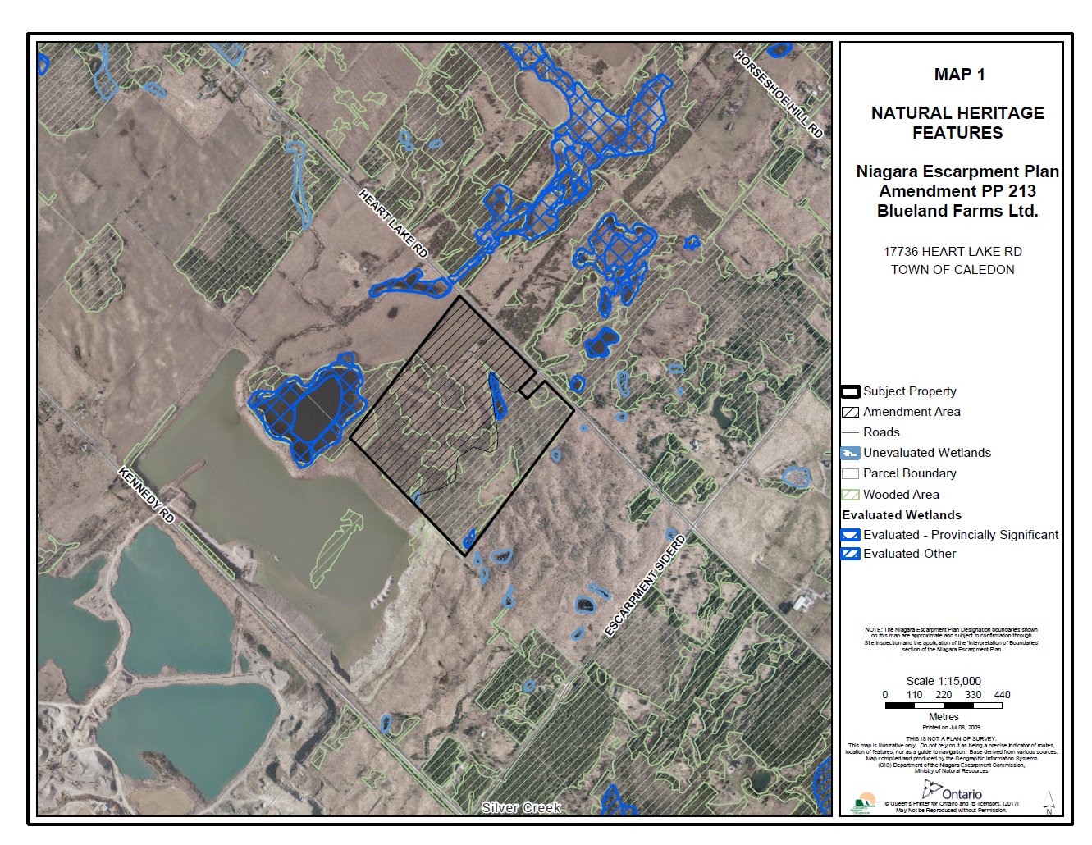

Map 2: Land Use Designations
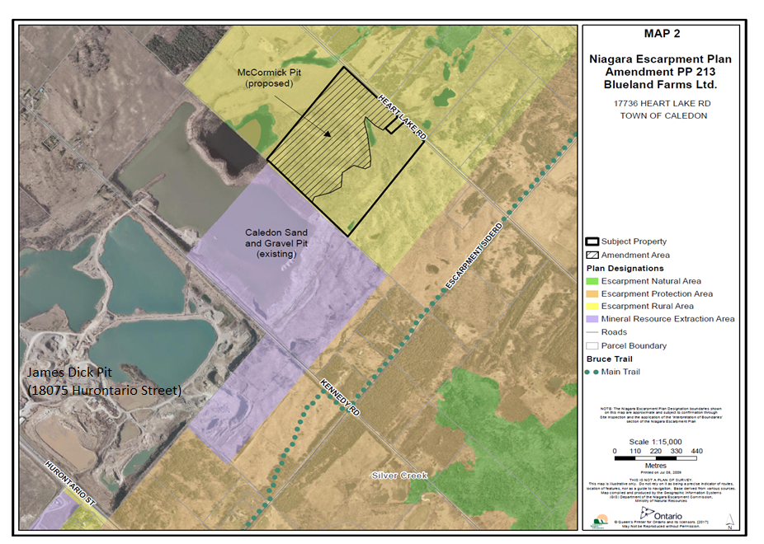
Appendix 1: Site Photos
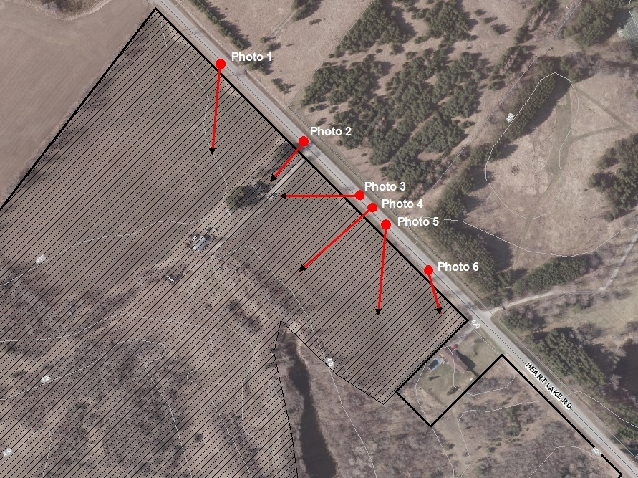
Photo Locations

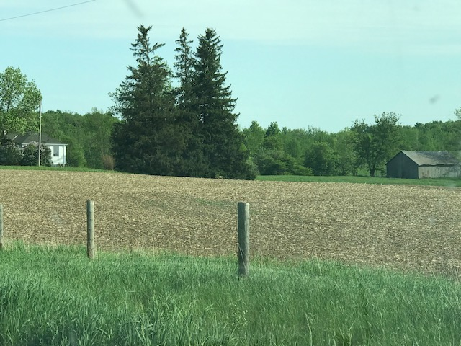
Photo 1: View to the south, from Heart Lake Road, dwelling and barn visible
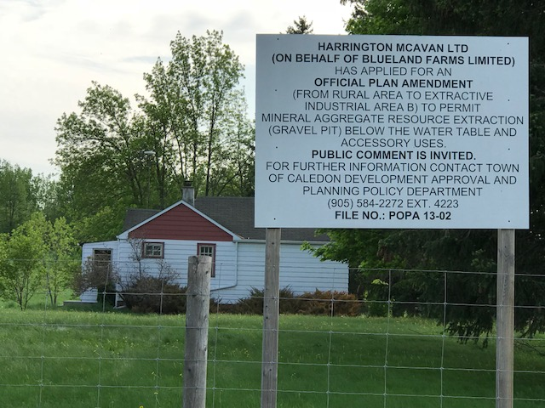
Photo 2: Existing dwelling, view to southeast from Heart Lake Road

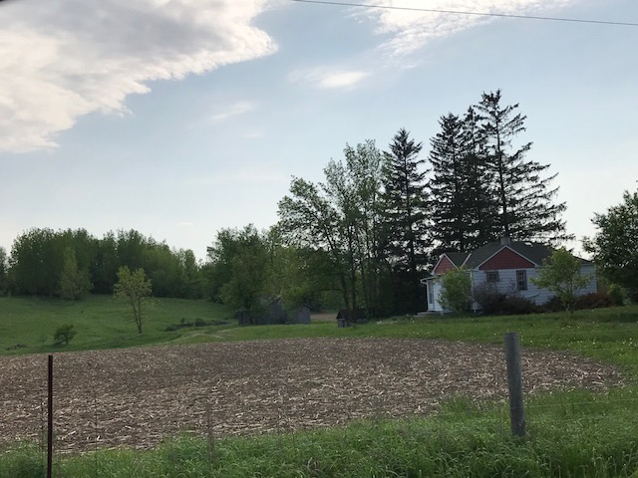
Photo 3: View to north east. Existing dwelling.
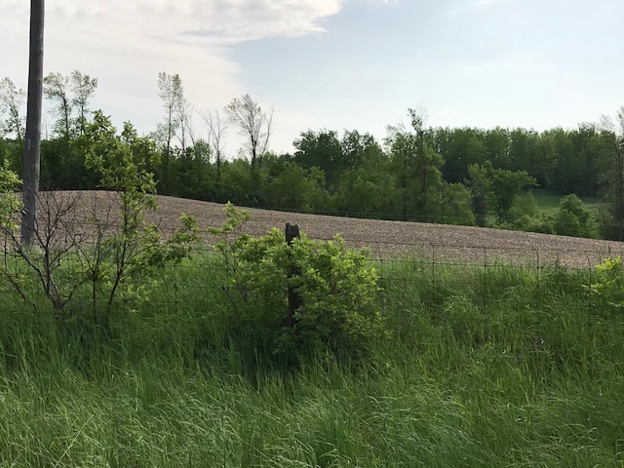
Photo 4: View to southwest, from Heart Lake Road

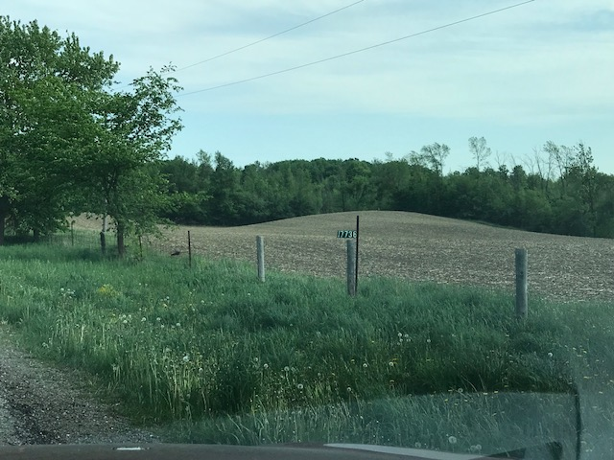
Photo 5: View to south. Note: forested area is outside of amendment area

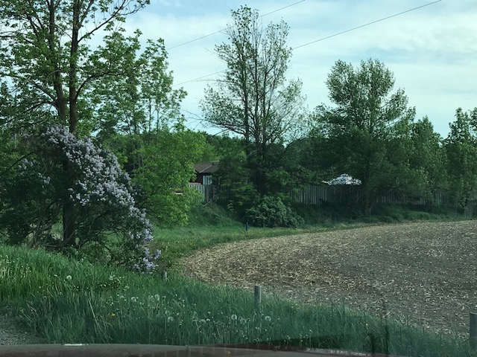
Photo 6: View to Neighbouring property to southeast

Appendix 2: Summary of Public Comments Received
Issue | Objection
Air quality | - The extraction of aggregate produces large amounts of dust, and worse, fine particulate matter that contributes to breathing issues in people without pre existing respiratory issues and will drastically aggravate problems experienced by sufferers of asthma and other respiratory ailments. This same fine particulate matter will cover buildings, vehicles, and fields. The discussed health issues will apply to animals as well. We are concerned about horses and other animals in immediate areas of pit.  - Despite a request several years ago (2014) from Peel Region Medical Officer of Health, Dr. David Mowat, recommending air testing (Appendix1), no action was taken. No proper air quality testing has been done at the local level to establish the types of contaminants present or whether the local ambient levels of contaminants are within provincial criteria. Similarly there have been no studies done regarding the CUMULATIVE effects of such contaminants. A very recent report prepared by Neil Morris identifies quite a number of flaws and deficiencies in the applicant’s Air Quality Assessment prepared by Arcadis Consultancy. The bottom line is that the speculative computer-modeled conclusions by Arcadis are wholly inadequate to provide a basis for deciding that this pit is environmentally safe, ‘acceptable’ and represents the ‘public interest’. As recommended by Mr. Morris, Dr. Mowat, Dr Thannikkotu, and others, we MUST insist on real-time, on-going local monitoring to establish both baseline and cumulative data, and rigorous enforcement in order to ensure that our community will not be subject to the well-known preventable health risks. It has been suggested that there is no risk because there have been “no emergency department visits, hospitalizations or deaths associated with “pneumoconiosis due to dust containing silica” (ICD-10 code J62.8) reported in Caledon …). The problem with this assertion is that the ONLY way to determine the presence of PM2.5 particulates as a possible cause of health problems is via a forensic autopsy! We therefore object to ANY additional production capacity in this Heart Lake Rd. location unless and until comprehensive local testing has been completed over a suitable time frame, under a suitable variety of weather conditions, in suitable locations, and including health data comparisons of potentially affected people, in order to reveal the nature and extent of the health hazards that undoubtedly exist. Hollow promises of ‘mitigation’ will not suffice.  - PM2.5 and PM10 particulates are VERY harmful to human health, therefore there should be NO additional extraction activity unless and until there is a PROVEN need for such. Furthermore, the additional truck traffic that recycling would entail has not been considered. If there may also be any future on-site recycling of asphalt and concrete or other demolition debris at this pit the 2-way traffic flows associated with this potential activity must be considered in the traffic analysis. That potential appears to be ignored. Is there, or is there not, ANY future potential ‘recycling’ in this location? If there is any future such possibility it must be planned for in the noise study, air study and traffic study. To not include those issues jeopardizes the legitimacy and adequacy of the consultant reports, rendering them untrustworthy.  If rigorous analysis and true numbers, including potential recycling, are not presented, then the potential for recycling activity should be specifically and permanently banned from any industrial status of this property.
Water quality and quantity | - There could be enormous amounts of water that will be used to wash aggregates and for operations purposes. This will affect our immediate aquatic environment.  - We are concerned that there might be toxins allowed to seep into the ground water. On top there is beautiful water creek on neighbouring property that might be affected. Who will monitor the effects? Who will remedy damages done? There is a need for strict monitoring and adherence to ensure that our air and water quality is safe.  - There is a high risk that the approval of a license to excavate aggregate from below the water table could affect the supply of water to nearby wells, as well as the natural lakes and springs in the area. Is there an alternative town water supply for the community if the wells fail as a result of this license being approved? We will potentially be left without water for a long period of time. The negative impact and everlasting adverse effect will impact everyone within the community. Is there a contingency plan in place to ensure a safe water supply for the community? Who is accountable to ensure our water source is not negatively impacted or adversely effected? Who pays for the tests to ensure that residents have safe drinking water? Should contamination occur who is burdened with the financial costs and liabilities? Clean water is essential for our survival. Without clean water, the adverse effects are immediate.  - There are residential drinking water wells local to the proposed site that are already complaining of silt and negative impacts of extraction. Our planet is facing a severe water scarcity and it is earths most precious resource with only 1% reachable and suitable for human consumption. Why then is digging below the water table line even a consideration? There is plenty of sand and gravel available without going below the water table. Even though more could be extracted below the water table I ask at what cost?  - CVC’s policy for some years now has been that any specific site application to mine for aggregates below the water table in an environmentally sensitive area should be subject to a watershed level analysis coupled with an Environmental Implementation Report. These requirements are based on Integrated Watershed Management (IWM) which is a central policy plank in the Natural Heritage System Study recently completed by CVC. IWM is a holistic model that should inform any comprehensive analysis of risks to the ecosystem in this application. Such an analysis has not been done or attempted in this application. The Groundwater Science Corp.’s assessment focuses on local site impacts with scant attention to wider environmental interactions. The possibility of these wider impacts is raised largely in order to dismiss them out of hand.  - The subject site is not within any Wellhead Source Protection Area: this is misleading because the subject site is an extension of the James Dick (JDSG)operations to the West. In fact ownership of the subject lands passed to JDSG in 2017 according to the application form submitted with this proposal. These operations have been identified as a threat to the aquifer and therefore to the nearest municipal well. Indeed the aquifer supplying the municipal well most threatened by the James Dick operations is now classified by the SPC as “highly vulnerable” due to the stripping of the sand and gravel overburden that used to protect the aquifer. The specific threat identified is from “DNAPLs” (Dense Non-Aqueous Phase Liquids) under O. Reg. 287/07of the Clean Water Act, 2006 . This threat is of particular concern in the context of the current proposal since the McCormick Pit application refers to several accessory uses including asphalt recycling. Asphalt is known to contain a variety of toxic substances that can migrate into the water table via surface and groundwater transport pathways including several heavy metals, such as nickel, vanadium, lead, chromium, mercury, arsenic and selenium . The threat posed by these poisons would be in addition to the existing threat posed by DNAPLs.  - The hydrogeology report asserts that there will be no aggregate washing on the McCormick Pit site. However, the extracted material will have to be washed somewhere and that somewhere is likely to be on James Dick’s adjacent site to the West. If that is so, then water taking is an issue, contrary to the assertion. The level of permitted water taking for aggregate washing already represents a major impediment to extraction of water for other purposes by other actual and potential users including those proposing further residential and commercial development within the Caledon Village Settlement area. No estimate is given of the additional draw on the aquifer that would be required to wash the additional 750,000 tonnes of aggregate per year extracted from the McCormick site.  - While there is an estimate of the amount of water required for dust abatement (up to 86,400 litres per day) there is no indication of where this water will come from. Will it require a new well or will onsite lagoons created by below water table mining be used?
Wetlands | - The proposed extraction is immediately adjacent to an on-site wetland, a bordering property with both a Provincially Significant Wetland (PSW) and Warnock Lake sharing a common border. Judging by the consultant’s report some undesirable impacts are foreseen but vague remedial measures are to be attempted. I do not have any confidence that these areas will be adequately protected and/or that such negative consequences can or will be properly remedied. An Adaptive Management Plan (AMP) must be in place to deal with any undesirable outcomes. Until there is concrete evidence that monitoring and remediation is both possible and likely to occur I object to this application being approved.  - The subject site is within the Star Wetland Complex and the hydrogeology report comments at length about anticipated effects of the proposed mining operation upon it. What it does not draw our attention to however, is the fact that the Star Wetland Complex and the Speer Wetland Complex to the east of the subject site are known to be hydrologically connected. The relevance of this connection is that the Speer Wetland Complex is now classified by CVC as a Centre for Biodiversity in its Natural Heritage System Report . Given the now ecologically accepted view that everything is connected to everything else at a watershed and subwatershed level it is misleading to omit the predicted impact of the proposed McCormick Pit on the Speer Wetland Complex as part of a broader assessment of risk at a landscape level. It is important to note that complex wetland interactions and surface water/ground water interactions are a subject of ever increasing scientific investigations, the net result of which is arguably “don’t invade systems that you don’t properly understand and where the risks of doing so are unpredictable.  - The proposed use of a hydraulic buffer is a mitigative measure. Why use mitigative measures to compensate for an environmental harm that should not be done in the first place? That said, there is considerable controversy over the short and long term efficacy of hydraulic barriers, documentation of which has been offered as evidence by objectors in hearings related to the Hidden Quarry proposed by James Dick in Rockwood, Ontario. Currently, even with such mitigative measures in place, the anticipated reduction in recharge to the McCormick Pit site is estimated at 15%. Such a loss of recharge functionality seems in itself unwarranted in the context of ominous climate change predictions.
Cumulative impacts | - Effectively the Blueland application would be an extension of the 3,084 existing acres of aggregate licences. I object to the approval of this aggregate licence application because the consolidated acreage is significant, and the cumulative impacts of the consolidated sites are unknown.  - The medical knowledge we have today about sub-particulate matter and the related health conditions warrants updated requirements for establishing and enforcing limits on toxic emissions from Pit operations in our community. Furthermore, the cumulative impact from all pit operations in the neighborhood must be considered. This application cannot be approved without a thorough Air Quality and Water impact study of the new pit as well as the cumulative impact of ALL the operational pits in this community. These decisions directly impact our health and well-being.  - Comprehensive, unbiased studies are required to fully understand and establish these impacts prior to approval of any new activities that may further damage the natural environment and wildlife surrounding us, while factoring in and accounting for the cumulative impact of another gravel pit in the area which is extending existing pits.  - A review of the most recent maps of the combined aggregate activities in the area speak - and shout - louder than any requests for changes to official plans and piecemeal by-laws, that many hundreds of acres are already licenced but still have aggregates available for mining and processing.  - The connectivity observations (groundwater, watercourses and wetlands) are related to the issue of cumulative effects. The NEC has weighed in on this subject in Vasarinsh v. Niagara Escarpment Commission 2010/2011 where the hearing officer was able to determine that an application should be denied in the form in which it was presented because the City of Burlington had underestimated the cumulative impact on the environment of its serial development proposals. In the Blueland Farms McCormick Pit case, the feasibility and practicality of the present application is so closely dependent on the adjoining James Dick Construction Ltd. operations (without benefit of which it would not be viable at all) that it should be considered part of them, so allowing the NEC to review the cumulative effects of the aggregate operations to the east of Caledon Village as a whole since they are in effect the works of a single directing mind: the subject property has been recently acquired by a James Dick company, Caledon Sand and Gravel Ltd.
Climate change | - Climate change – for whatever reasons – is upon us and we can expect more droughts and extreme temperature events in the future that will place even greater stress on our water supplies. This fact should be alerting those who propose mining for aggregates below the water table to the need for moderation of their demands. In the McCormick Pit situation this should result in abandonment of the proposal to go below the water table.
Woodland impacts | - The property is treed. Trees are a necessary buffer to the local area to offset the noise and dust pollution caused by the existing aggregate operations. As an Ontarian, I am proud of the world biosphere designation – a tribute to an area that demonstrates a balanced relationship between humans and the biosphere, and I do not condone destruction of that balance.
Species at risk | - Redside dace are found in the same subwatershed. What will the impacts be?
Noise and vibration | - The industrial noise and vibration created by gravel pit operations and of trucks travelling haul routes will greatly interfere with enjoyment of property and may cause health effects overtime.  - I've heard from homeowners living near existing pits that the beeping from trucks reversing begins early in the morning and continues throughout the day and is distressing to the point that they want to move from their homes. That's very upsetting... Noise pollution is a definite concern and there should be guidelines in effect to prevent such noise levels. Obviously current noise guidelines are not sufficient for people living near pits if the noise is driving people from their homes.
Poor rehabilitation | - “Interim” Land Use Questionable: there is a significant financial incentive to revive or extend the life of existing pits close to the GTA. Extending pit boundaries, extending years of operation, or quarrying beneath the water table, for example, are relatively cost-effective ways of extracting more resources.” I object to this application because weakness in the current Aggregate Resources Act would allow this pit to continue without an end in sight.  - After-uses are inappropriate: aerodromes, urban development, landfill sites.
Enforcement | - Cost and Stress on Existing Provincial and Municipal Resources. Additional truck traffic will require additional Police and MTO Officers or MNR Resources. It will place increased work load on Existing overburdened personnel that are tasked with enforcing our laws, maintaining transportation safety, or ensuring that our natural resources are protected. In Caledon during a 2014 truck safety blitz, 50 % of inspected trucks were taken out of service. That's only trucks that were inspected during short time. That is concerning information. Additional costs arise when road and highway costs are factored in.  - The MNR survey of compliance in the Oak Ridges Moraine of 121 pits showed 82% of operations were not in compliance. There is so little oversight that the Vice-Chair of the OMB at the Rockfort quarry hearing stated: “There was nothing in the evidence of REDACTED or her colleague REDACTED that gives the Board any certainty that even if it decided that it would be appropriate for MNR to take on the responsibilities assigned to it in the AMP (adaptive management plan), that MNR has the resources to deal adequately with those responsibilities.” Numerous examples exist where this ‘self-reporting’ is insufficient to identify proper compliance, and MNR’s ability to investigate and enforce the provisions of the ARA is inadequate. The methods of ‘evaluation’ by the MNR are unclear. Until such time as these inadequacies are properly addressed, I object to any additional applications being considered or approved, particularly in a municipality that already has excess production capacity.  - Nothing can be done if aggregate trucks deviate from approved haul routes. Aggregate trucks are allowed off approved haul routes for “local deliveries” and aren’t questioned. Aggregate companies admit that they have little control over non-employee drivers. I object to the approval of this aggregate licence application because trucks regularly go off haul routes for short-cuts, adding to road maintenance costs, noise and dust issues, while local residents have no recourse. There are roughly 6,500 pits and quarries in Ontario. The aggregate industry has operated on a self-inspection basis since 1997. The Ministry of Natural Resources and Forestry (MNRF) has a target to review 20% of the sites annually and otherwise relies on complaints to catch problems. In reality, the MNRF only has the resources to follow-up  with 10%-12% so a site might be visited once in 5+ years. I object to establishment of this new aggregate resource since the Ministry of Natural Resources and Forestry is already stretched beyond capacity offering little to no oversight or law enforcement.  - The gravel companies pay very little property taxes in relation to the impact they have on a community. They have won significant property tax reduction victories recently, effectively passing on these taxes to residents of the community. For example, the common community costs supported by property tax include the construction and maintenance of many roads. Overloaded gravel trucks often travel down roads that were never intended for heavy commercial use, especially when the commercial scales are in use. Specific example: When scales on Highway 10 are in use, truck traffic increases down side roads that are not built to carry heavy loads.
Property values/ community character | - We simply don't want to witness that our property values and natural beauty of protected land and lives of many in the community will be devastated by extraction and operation of the Gravel Pit on levels Below local water table.  - The Region of Peel and the Credit River watershed are one of the fastest growing regions in Canada. Caledon is a rural area struggling to deal with growing urbanism. Caledon Village is already surrounded by aggregate sites on two sides and should be thinking long term for the future of residents. There are 10 active aggregate sites in the area. does Caledon Village really need another aggregate operation?  - We are currently surrounded by Gravel Pit operations in the Village of Caledon. The lands surrounding us are pock-marked with the assault from past and current pits allowed to operate indefinitely with very few parameters and accountability. True rehabilitation has never really happened, and pits remain open and operational endlessly. Juxtaposed to this devastation is the surrounding Niagara Escarpment, a UNESCO designated World Biosphere Reserve. Adding new pits and extending existing ones is irresponsible. We need to do things differently to protect and restore these negative impacts before any additional pits can be approved.  - property owners near gravel pits experience significant losses in their property values and have a difficult time selling their homes. Nobody willingly wants to live next to an industrial operation. In our case, the pit application came after we had settled in and made significant investments in developing plans to build in the new lot. We are facing major financial losses while these ‘new neighbors’ are in it for major financial gains. Where is the equity? Why is there no attempt to change this paradigm with compensation built into the business case for the pit operators? Why should we have to pay the price for their encroaching into our community and making huge profits while devastating the residents who peacefully live there and dutifully pay their share of taxes? Who is advocating on our behalf in the approval process? I object to approving this licence application because aggregate companies are not committed to local communities and propagate a boom/bust economic cycle while shouldering as little of the tax burden as possible.
Ancillary uses | - operations other than extraction, such as importation of off-site materials, recycling, grinding, screening, blending with imported materials, storage of potentially contaminated materials, etc. Such Class III Industrial operations should be specifically banned from ever being done on the site or on the adjacent JDCL sites. Such ancillary uses are NOT compatible with the purposes of the Niagara Escarpment Plan. It is bad enough that there are at least 64 licensed sites currently located within the NEP Area occupying 3335.55 hectares (8242.32 acres) and more NEP amendment applications pending for aggregate extraction on approximately 137 hectares (572 acres) of additional land. The addition of recycling operations to any or all of these pits and quarries will unjustifiably add significantly to the risks of contamination of air, water, and species of this World Biosphere Reserve.
Need for aggregate | - We should not be unnecessarily exposing our community to the risks and hazards associated with the proliferation of such sites. According to a May 2012 submission made to the ARA Review Committee by Dr. L. Jensen, Phd. Geoscience, “… it will take ... 208 years at present rates of consumption, to consume all the sand and gravel reserves under license in 2010. No doubt this 208 year supply has considerably increased with the additional 200 licenses and permits added to the inventory during the past 2 years.” There are LARGE STOCKPILES OF RECYCLABLE AGGREGATE MATERIALS from construction and demolition that are not being properly (see image below) recycled. Appropriate processing (in appropriately zoned areas) and re-use of this material is technically and economically feasible and would further lessen the need for virgin aggregates. The primary impediments to the exploitation of this recyclable resource appear to be specifications imposed by end-users and the lack of standards, protocols, and facilities for processing the materials safely, consistently, and without negative environmental or social impacts.  - I object to the establishment of this new aggregate resource until the Aggregate Resources Act, 1990 has been amended or replaced to realize today’s values, and a provincial master plan to guide future growth and development of aggregate has been  established.  - The Aggregate Resources Act does not require that the prospective site owner should prove “need” for aggregate. Such blind demand coupled with low royalty fees for consumption of virgin aggregate gives virgin product a distinct edge over expensive recycled product. This advantage is compounded further by the inconvenience and cost of establishing new processes, procedures, and sales programs to market the recycled product to clients. Aggregate is a non-renewable resource and we have a responsibility to ensure that we use it to its fullest capacity. I object to establishment of this new aggregate source because opening a new pit does not give the market the incentive to develop and use recycled product.  - Is there a real need for gravel, and sourcing it close to marketplace or is that the rhetoric that has been propagated to-date? An unbiased needs assessment prior to approval is necessary since pit operations have the potential to negatively impact the  community for generations. Existing pits are impacting our community today, how will this be different?

Appendix 3 –PitSense Comments
PitSense is a community of people organized to respond to proposals for further increases in the number and size of aggregate operations in Caledon. PitSense is opposed to the continuing 'Domino Effect' growth of open pit mines and quarries in the agricultural and rural residential areas of the Niagara Escarpment and other threatened areas across Ontario.
PitSense objects to the proposed amendment, due to:
Air quality: health risks associated with PM2.5 and PM10 and lack of monitoring/measures on an on-going basis
Traffic: documented haul route and load violations in surrounding area
Noise: health and quality of life impacts for surrounding residents, six days per week.
Habitat destruction: lack of transparency regarding species at risk, impacts on wetlands, doubts about net habitat gains post-extraction
Need for aggregate: the proponent should be required to demonstrate need, and provincial policy should be changed to require this; no consideration of sustainability in terms of the wise use of a non-renewal resource
‘Close to market’ is not a valid concern: there is no tracking of the source of aggregate or requirement that it be sourced and used locally; pits should not displace locally-sourced food and agriculture
Post-extraction commercial filling: concerned about the risk of the empty pit becoming a receiving site for excess soil following extraction
Rehabilitation: concerns regarding the control of groundwater levels and how the contiguous lake between JDCL and McCormick Pit will be regulated
Amalgamation of licensed areas: no consideration of MNRF policies regarding the amalgamation of pits (JDCL pit and McCormick Pit)
Recycling: concerns about allowing recycling of aggregates on site and the proximity of a Class 3 industrial activity in proximity to sensitive land uses
Property values: nearby landowners should be compensated for loss in property value
Social impacts: insufficient documentation of before and after conditions and impacts on health, emotional stress, tranquility,, risks to private wells, safety
Extension of active pit operations: the opening of McCormick Pit extends the operations of JDCL to the west as truck traffic and processing will continue on that site. This is contrary to aggregate extraction being an interim land use
Alternative land uses: local residents have proposed alternative land uses for McCormick Pit; they should be considered

