# A3 Compliance Staff Report

**Order to Demolish/Restore 2025.001**

**14713737 Canada Inc et al.**

**7372 Guelph Line,**

**Town of Milton, Regional Municipality of Halton**

## Executive Summary

Niagara Escarpment Commission (NEC) staff have been aware of compliance concerns at 7372 Guelph Line (“the subject property”) since March of 2023. Since that time, several roadside and on-site inspections have been conducted to assess compliance with the *Niagara Escarpment Planning and Development Act* (NEPDA) due to public concerns regarding the operation of a commercial vehicle storage yard. NEC compliance staff have spoken with the landowner in an attempt to build understanding of the NEPDA, its associated Regulations, and to seek voluntary compliance with the Act.

A variety of approaches have been used over the previous year to address the non-compliance and resulting impacts. During this time, NEC staff gave directions including a Notice of Violation, to address unauthorized expanded storage of transport trucks and trailers on the property.

The landowner has made multiple verbal and written commitments to limit the site to a use which is more compatible with the requirements of the Niagara Escarpment Plan (NEP). However, little progress has been made in this regard. The NEC continues to receive complaints related to the activities occurring on the subject property.

## Staff Recommendation

That the Niagara Escarpment Commission endorse Order to Demolish/Restore #2025.001 and the provisions thereto, which are attached to this report as Appendix A.

## Alleged Unauthorized Development / Violations

1. Unauthorized expansion of an existing use (Increased storage of commercial vehicles).

## Reasons for Order

* A search of NEC records confirmed that no Development Permits have been issued to the landowners that would authorize the expansion of use.
* The expanded industrial use consisting of increased storage of transport trucks and trailers was first observed by NEC staff in May 2023 and continues to be an on-going activity.
* Expansion of an existing use requires a Development Permit before it is undertaken.
* In October 2023, NEC staff issued the landowners a Notice of Violation (“NOV”) letter, informing them that the increased amount of transport trucks and trailers being stored is an unauthorized expansion of use and that it is considered development without a permit, which is a violation under the NEPDA). The Notice of Violation requested the landowner voluntarily cease the expanded storage of transport trucks and trailers by removing stored vehicles in excess of existing conditions.
  + To-date, the un-permitted development of concern to this order has intensified despite direction provided in the NOV.
* NEC staff have attempted to work with the landowner to work towards voluntary compliance. Due to a lack of progress in our attempts to find a voluntary and collaborative solution, NEC staff are seeking the Commission’s endorsement of the attached draft Restoration Order to address the situation.

## Relevant Legislation

* Subsection 24(1) of the NEPDAstates:

*Despite any other general or special Act, if an area of development control is established by regulation made under subsection 22, no person shall undertake any development in the area unless such development is exempt under the regulations or unless the development complies with a development permit issued under this Act.*

* Subsection 24(6) of the NEPDA states:

*Where any person undertakes any development that is in contravention of subsection (1), the Minister may order such person to demolish any building or structure erected in connection with the development or to restore the site to the condition it was in prior to the undertaking of the development, or both, within such time as the order specifies.*

The issuance of Demolition/Restoration Orders has been delegated to the Commission and is the subject of this staff report.

## Landowner Information

Municipal Property Assessment Corporation (“MPAC”) information identifies the landowner of the subject property as 14713737 Canada Inc, an active federal company, whose directors are identified in a corporate profile report as REDACTED (“the landowners”). A Geowarehouse property report dated December 2, 2024, confirms the property continues to be owned by this corporation.

## Subject Property Description and History

7372 Guelph Line, Milton (“the subject property”) is located entirely within the NEC’s development control area as defined by R.R.O 826, 1990. The subject property is designated by the Niagara Escarpment Plan as “Escarpment Protection Area” and “Escarpment Natural Area”, with the developments of concern located in the “Escarpment Protection Area” (see appendix B). The subject property contains an Environmentally Sensitive Area as defined by the Region of Halton’s Official Plan, several Areas of Natural and Scientific Interest and a provincially significant wetland, though the development in question is located outside these features (see appendix B).

MPAC information profiles the property as being 142 acres (57.46 hectare) and lists it as a “Farm with residence – with commercial/industrial operation.”

The north-eastern quadrant of the property is the location of the commercial vehicle storage area. No new buildings or structures appear to have been constructed during the possession of the current landowner.

Prior to the establishment of the NEP in 1985, the subject property was used as a place of business for “Stonehaven Farms”. Stonehaven Farms was operated on the property uninterrupted between 1957 and 2023. Stonehaven Farms’ main business was the growing, processing and shipment of produce, which included mainly berries and corn. The property also operated as a family farm and market, offering pick-your-own berry and pumpkin patch experiences. As a part of the existing use of this property, NEC staff recognize that there is evidence of an established limited industrial use which was subordinate and connected to the principal agricultural use. The site contains a warehouse for produce processing and cold storage, as well as previously stored a limited number of commercial vehicles which were associated with the shipping of produce processed on-site. A review of historical aerial imagery, historical permits and an interview with the previous landowner, has found that this commercial vehicle storage did not exceed the storage of 7 trailers and 4 cabs at a given time. It is important to note that the NEC does not have any record of any independent industrial uses occurring at the subject property, and the only uses that can be deemed existing would be industrial uses which are subordinate and connected to the principal agricultural use of the property.

A prosecution precedent (R v. Schaefer (1991)) demonstrates that increasing the number of commercial vehicles stored under an existing use from one to two and sometimes three constitutes development and requires a permit. The NEPDA also states that development includes a change in use, and under S.24(1) development requires a permit. Therefore, to be operating in conformity of the existing site conditions, any future landowner must:

1. Be operating the existing use at the same intensity.
2. Be operating the existing use in the same manner. (i.e., cannot change the use by converting a subordinate use to a principal use.)
3. Be operating the existing use within the same physical area (i.e., cannot change the use of a field used for agriculture to a field used as a truck storage yard)

The previous owner of Stonehaven Farms retired in March of 2023, and subsequently sold the property to the new landowner owner who is the subject of this order.

The landowner purchased the property in May of 2023. Shortly after purchase, the landowner began storing an increasing number of commercial vehicles without the benefit of a Development Permit authorizing such increase in storage. Most of the vehicles have graphics advertising “AMG Global”, a trucking and logistics company based in Mississauga which shares a director (REDACTED) with the landowning corporation of the subject property. The NEC received the first of 4 complaints around this time, and subsequently provided the landowner with written correspondence outlining staff’s understanding as to what the existing use of the site includes, and requested the landowner to ensure the use of the property is in-keeping with the outline.

By late 2024, the use intensified to the point where 16 trucks/trailers began to be stored at the subject property. A sign advertising “AMG Global” also appeared at the front of the property around this time. According to the landowner, the reason for placing this sign was not to signal the establishment of an unrelated truck yard, but rather the farm is now called “AMG Global”. NEC staff requested via a Notice of Violation that the landowner remove the excess commercial vehicles and unpermitted signage. This signage was removed following NEC direction; however, we to-date have not observed a reversal of the expansion of the trucking use.

This intensity of the trucking use continues to-date of writing, where NEC staff have observed between 9-16 trailers visible from a public vantage point. According to observations made by NEC staff, the total amount of commercial vehicles stored at the property has increased around 81%.

## Detailed Compliance Timeline

### April 2023:

* April 25, 2023: NEC staff received a complaint forwarded by the Town of Milton concerning the establishment of a truck yard at the subject property. The complainant was concerned with potential ground water contamination from the establishment of the truck yard.
* April 29, 2023: NEC staff conducted a roadside inspection of the subject property and observed the storage of 13 commercial vehicles and 2 City buses on the property.

### July 2023:

* July 26, 2023: NEC staff met with the landowner on the property and observed 10 trailers and two city buses being stored on the property. At the meeting, a landowner, REDACTED, stated the intent behind the increased storage of commercial vehicles is to support an increased agricultural production of the farm. When asked why a large portion of commercial vehicles bear graphics advertising AMG Global, the landowner stated that he is borrowing them from his other company.

### September 2023:

* September 12, 2023: NEC staff provided written correspondence to the landowner explaining the existing uses of the site. The letter outlined the existing uses to include a limited industrial use to support the principally agricultural use on the site, and limited storage of commercial vehicles associated with this subordinate industrial use. In this letter, it was outlined to the landowner that the extent of the commercial vehicle storage under the existing use is limited to 7 trailers and 4 truck cabs. The letter stated that an increase in storage is an expansion of an existing use which may require a Development Permit.
* September 26, 2023: NEC staff conducted a roadside inspection of the property and observed from the public vantage point 13+ trailers being stored on the property. Staff also observed two new signs placed at the front of the property advertising “AMG Global”, who’s website advertises it as a trucking and logistic company based in Mississauga.

### October 2023:

* October 4, 2023: NEC staff issued a Notice of Violation letter to the landowner requesting that the landowner cease the expansion of use by removing the excess commercial vehicles and requesting the landowner remove all unpermitted signage.
* October 6, 2023: NEC staff received an email from the landowner acknowledging receipt of the Notice of Violation and requesting an on-site meeting to discuss paths forward for the property.
* October 17, 2023: NEC compliance staff met with landowner on-site and discussed activities occurring at the property. At this meeting, NEC staff reiterated to the landowner that the activities occurring required a Development Permit to be undertaken as it is considered an expansion of an existing use which is considered development under the NEPDA. NEC staff asked the landowner about the increased storage of commercial vehicles, and the landowner stated he intends to increase the output of the farm and requires storage of 20 commercial vehicles to facilitate increased produce shipments. NEC staff informed the landowner such an increase requires a Development Permit. The landowner stated they understood they were outside of the compliance date illustrated in the NOV and requested additional time to move the commercial vehicles. The landowner invited NEC staff to view the property, wherein staff found 10 trailers were stored as well as additional signage advertising “AMG Global” and “Vineet Kaushal Immigration & Criminal Lawyer”. NEC staff provided an extension to the deadline identified in the NOV. The landowner committed to removing the signs and excess commercial vehicles ASAP and removing the city buses by November 10, 2023.
* October 18, 2023: NEC staff receive email correspondence from the landowner which stated: “the bus will be removed November 10th as well as both signs. We will also ensure that the extra trailers will be removed as well.” [sic]

### November 2024:

* November 11, 2024: NEC staff receive an additional complaint concerning excess storage of trucks at the property.
* November 21, 2024: NEC staff conduct a roadside inspection and observe the continued expansion of commercial vehicle storage, from a public vantage point. NEC staff observed 2 city busses, 16 trailers and 7 trucks visible from the roadside.

## Summary

The development described above is unauthorized, meaning no NEC Development Permit has been issued nor are they exempted under R.R.O 1990, Regulation 828.

The expansion of an existing use is not exempt from requiring a Development Permit under R.R.O. 1990, Regulation 828.

The landowner was offered an opportunity to voluntarily restore the property by ceasing the expanded storage use but, as of November 21, 2024, there is no evidence of compliance with the actions required by the NoV nor has any indication of any future intent to comply been received.

The landowners were informed that these unauthorized uses would have required a Development Permit from the NEC prior to being undertaken.

The landowners have not acted on formal and informal requests made by NEC staff to cease undertaking unauthorized development.

It is appropriate that the Commission issue this restoration order to ensure that a proper and timely restoration of the property can be undertaken. The individuals named in this order, the landowners, have failed to voluntarily comply with the NEC’s requests and have allowed timelines identified for compliance to expire.

The Restoration Order will serve as general and specific deterrence to prevent the continued proliferation of unpermitted truck yards within the Niagara Escarpment Plan Area.

The proposed approach to achieving compliance is outlined below.

## Compliance Approach

The intent of the compliance approach is to ensure the subject property is developed only in accordance with the NEPDA and the regulations and policies of other regulatory agencies. Efforts have been made by NEC staff to seek voluntary compliance on this site, however NEC staff have exhausted all voluntary compliance approaches and tools along the compliance spectrum.

The appropriate next step to address this situation is through the issuance of an Order to Demolish/Restore under the NEPDA. The intent of the Order to Demolish/Restore is to have the unauthorized development promptly removed from the property and to restore the disturbed areas to as close to their original conditions as possible within a reasonable timeframe and under professional supervision. The Order will also have the effect of acting as general and specific deterrence against possible future non-compliance.

**Prepared by:**

Maxamillion Morris

Compliance Program Supervisor

Provincial Offences Officer (Badge #008)

**Approved by:**

Shawn Carey

Director, Niagara Escarpment Commission

# Appendices Table of Contents

APPENDIX A – Order to Demolish / Restore (Page 9-11)

APPENDIX B – Mapping (Page 12-15)

APPENDIX C – Inspection Photos (Page 16-18)

# APPENDIX A

### Order to Demolish/Restore # 2025.001

#### Pursuant to section 24(6) of the

***Niagara Escarpment Planning and Development Act*, Chapter N.2, R.S.O. 1990**

**THIS ORDER is directed to:**

**14713737 Canada Inc**   
REDACTED

**REDACTED**

**REDACTED**

**REDACTED**

**REDACTED**

**WHEREAS unauthorized development consisting of:**

* Unauthorized expansion of an existing use (Increased storage of commercial vehicles).

**Has occurred on the properties described as:**

NELSON CON 3 PT LOTS 12 TO;14 RP 20R21144 PARTS 1 9 TO;12  
  
ARN: 240907030103910

7372 Guelph Line

Town of Milton, Regional Municipality of Halton  
  
HEREAFTER, the above noted property is described as “the subject property”.

AND WHEREAS the purpose of the *Niagara Escarpment Planning and Development Act* (“the Act”), as set out in it at Section 2, is to provide for the maintenance of the Niagara Escarpment and land in its vicinity substantially as a continuous natural environment and to ensure only such development occurs as is compatible with that environment.

AND WHEREAS Development Control is a land use control mechanism put in place to help fulfill the purpose of the Act.

AND WHEREAS Subsection 24(1) of the Act states: “Despite any other general or special Act, if an area of development control is established by regulation made under section 22, no person shall undertake any development in the area unless such development is exempt under the regulations or unless the development complies with a development permit issued under this Act”.

AND WHEREAS the subject property is entirely located within the Area of Development Control as defined in Ontario Regulation 826/90 made under the Act.

AND WHEREAS the subject property was purchased by the Orderees on March 27, 2023

AND WHEREAS the Commission has reasonable grounds to believe that the Orderees have been undertaking the described development at the subject property from on or about April 10, 2023, to present.

AND WHEREAS the described development is not exempt from the requirement for a Development Permit, pursuant to Ontario Regulation 828/90 made under the Act.

**NOW, THEREFORE,** in accordance with Subsection 24(6) of the Act, THE PERSONS TO WHOM THIS ORDER IS DIRECTED ARE JOINTLY AND SEVERALLY ORDERED TO COMPLETE THE FOLLOWING WORKS:

1. **Cessation of Unauthorized Expansion of Use** – No later than **March 14th, 2025**, cease the expansion use by;
   1. Removing or causing to be removed all transport trucks and trailers stored at the subject property in excess of the existing conditions of seven trailers and four trucks, which are only to be used as accessory to the existing Agri-industrial operation, and
   2. Refraining thereafter from storing additional transport trucks or trailers on the subject property in excess of the existing conditions level set out in subsection 1(a) above unless such storage is in accordance with a Development Permit issued by the NEC.

AND FURTHER, TAKE NOTICE THATfailure to comply with this Order may result in further enforcement action being taken against you.

FAILURE TO COMPLY with this Order is a contravention under section 24(7.1) of the *Niagara Escarpment Planning and Development Act* (NEPDA) and upon conviction may incur penalties including a fine of not more than $10,000 a day or part of a day on which the contravention continued. Corporations convicted under section 24(7.2) of the NEPDA may incur penalties including a fine of not more than $25,000 a day or part of a day on which the contravention continued.

IN ADDITION, and in accordance with section 24(7) of the Act, failure to comply with this Order may lead the NEC to cause the necessary works to be done and charge you with the costs thereof, and the costs of doing said works would be a debt due by you to the Crown, recoverable with costs in any court of competent jurisdiction.

Dated this 20th of February 2024.

*To be signed once authorized by the Commission.*

______________________________

Rocco Vacca, Chair

Niagara Escarpment Commission

## APPENDIX B - MAPPING

### Map of Development ControlMap illustrating the property is within development control

### NEP Map

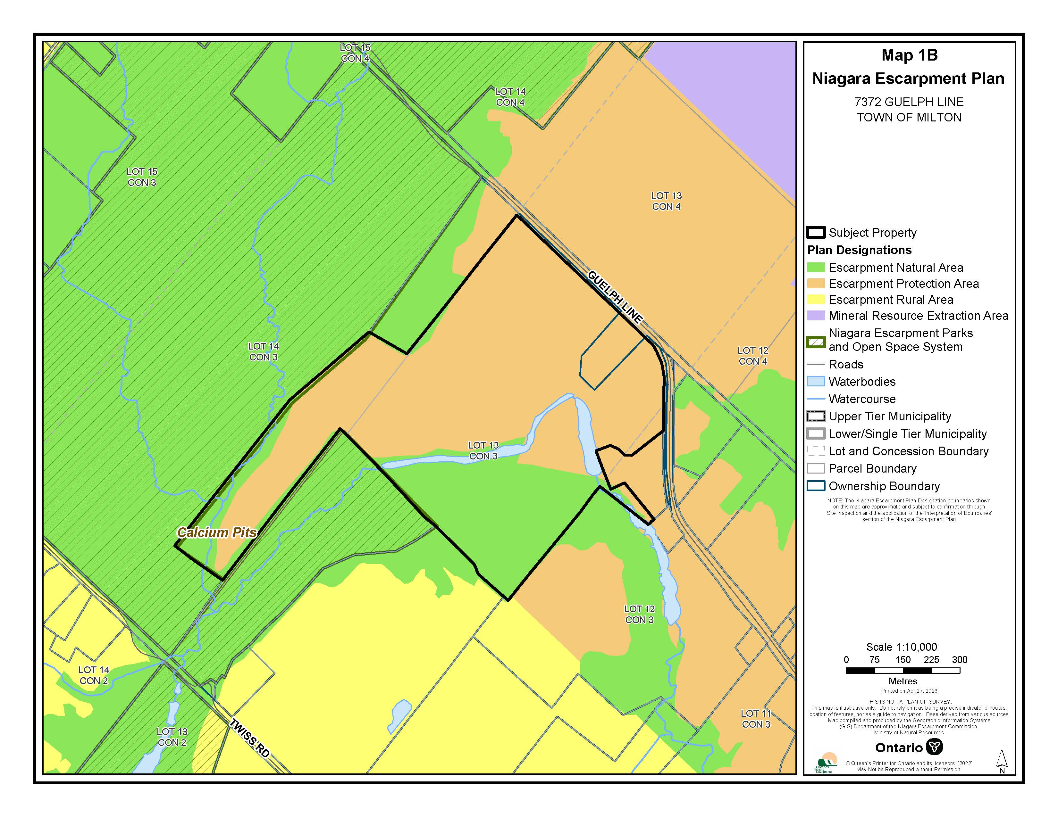

### Natural Heritage Map

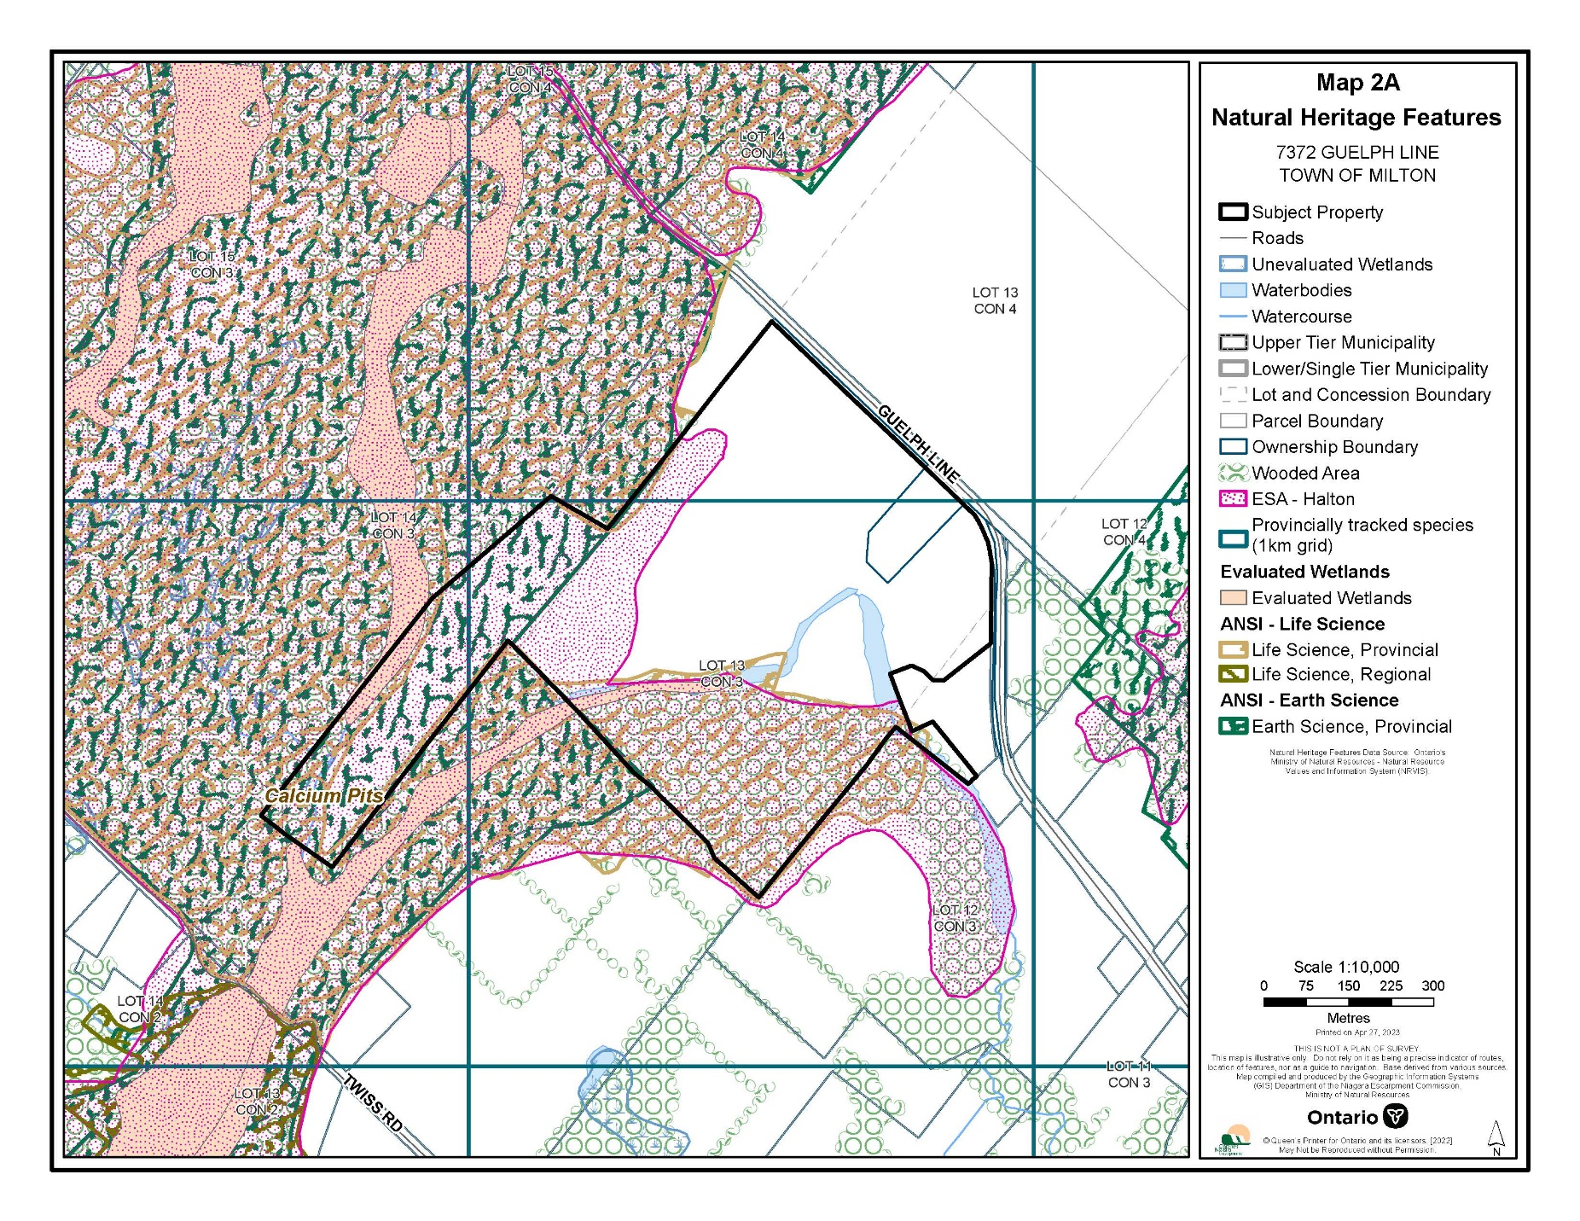

### Orthophoto

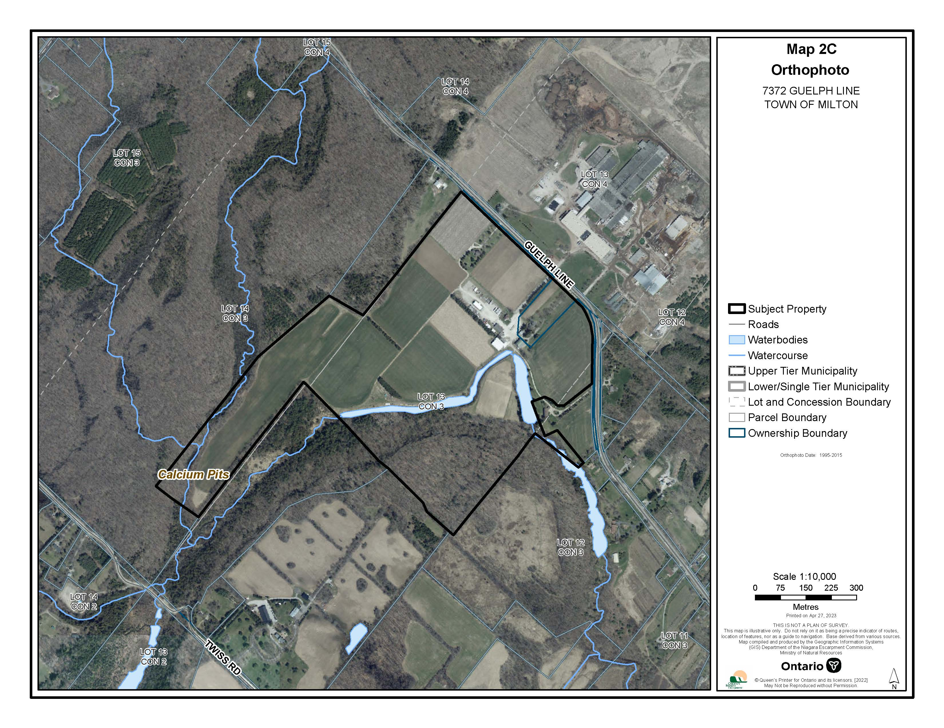

## APPENDIX C – INSPECTION PHOTOS

### Appendix C.1 – Photos taken September 26, 2023, by A/Compliance Program Supervisor Maxamillion Morris

|  |  |  |
| --- | --- | --- |
| 1 | Photo of unauthorized development – Sign at front of property adveritisng AMG Global | *Photo of unauthorized development – Sign at front of property advertising AMG Global* |
| 2 | Photo of unauthorized development – Storage of 12+ trailers and one truck | *Photo of unauthorized development – Storage of 12+ trailers and one truck* |

### Appendix C.2 – Photos taken November 21, 2024, by Compliance Program Supervisor Maxamillion Morris

|  |  |  |
| --- | --- | --- |
| 1 | Photo of unauthorized development – 7 transport trucks and 14+ trailers parked on the property | *Photo of unauthorized development – 7 transport trucks and 14+ trailers parked on the property.* |

## Appendix D: Aerial Imagery

### Appendix D.1 – Aerial Imagery Captured Oct 4 2022 – Via Google Earth

|  |  |
| --- | --- |
| 1 | Aerial imagery captured October 4 2022 via Google Earth illustrating 3 trailers stored at the subject property. |
| Aerial imagery captured October 4 2022 via Google Earth illustrating 3 trailers stored at the subject property. | |

### Appendix D.2 – Aerial Imagery Captured April 9, 2024 – Via Google Earth

|  |  |
| --- | --- |
| 1 | Aerial imagery captured April 9, 2024 via Google Earth illustrating 17 trailers, 6 trucks and 2 city busses stored at the subject property. |
| Aerial imagery captured April 9, 2024 via Google Earth illustrating 17 trailers, 6 trucks and 2 city busses stored at the subject property. | |