January 18, 2024

A1 Amendment Summary Report

RE: PROPOSED NIAGARA ESCARPMENT PLAN AMENDMENT PP 226 22
Brampton Brick Limited
14504 Mississauga Road
Part Lots 29 and 30, Concession 5 West of Centre Road (Former Township of Chinguacousy), Town of Caledon, Region of Peel.

Applicant: Brampton Brick, Limited

Owners: Brampton Brick Limited

Agent: MacNaughton, Hermson, Britton, Clarkson (MHBC) Planning Ltd.

Received: October 20, 2022

NEP Designation: Escarpment Protection Area (existing)

Executive Summary

Brampton Brick Limited has applied for a Niagara Escarpment Plan Amendment to redesignate 14.68 ha of land from Escarpment Protection Area (EPA) to Escarpment Rural Area (ERA) to enable a subsequent application to amend the lands to Mineral Resource Extraction Area (MREA) and to apply for a development permit to establish and operate a quarry on the site. The applicant submits that the lands better meet the criteria for ERA and that they have erroneously been designated EPA. NEC staff have reviewed and evaluated the proposal through an analysis of the designation criteria as they related to the subject property and have determined that the lands are correctly designated as EPA. Staff recommend that the Commission send a recommendation directly to the Minister of Natural Resources and Forestry that the amendment not be approved because the subject lands are appropriately designated EPA.

Proposed Amendment
To amend the Niagara Escarpment Plan (NEP) by redesignating 14.68 ha (36.3 ac) of lands described as Part Lots 29 and 30, Concession 5 West of Centre Road, Town of Caledon, Region of Peel from EPA to ERA.

Background
The Cheltenham Quarry was licensed in 1989 under the Aggregate Resources Act (ARA). A Niagara Escarpment Planning and Development Act (NEPDA) Development Permit was issued in 1990 to establish a phased mineral resource extraction operation. The quarry licence consists of approximately 99.2 ha, divided into three operational phasing areas (Map 1, Appendix 1).
Extraction is completed on the northern most Phase 1 area, adjacent to Mississauga Road along the MREA’s northern boundary. While rehabilitation is largely complete in this area, access to the active Phase 2 extraction area is through the Phase 1 area, onto Mississauga Road. Phases 1 and 2 are both located to the west of an abandoned rail corridor, now converted to a multi-use trail. Phase 3 forms the southernmost component of the Cheltenham Quarry MREA, bounded to the south by Heritage Road, to the north and west by Escarpment Natural Area (ENA) and to the east by the multi-use trail. The multi-use trail forms the western boundary of Cheltenham, a Minor Urban Centre within the NEP. Phase 3 is separated from Phase 2 by the valley of a minor tributary of the Credit River, which is designated ENA. Extraction has not yet been initiated in Phase 3, however, the lands are licensed and approved for extraction and the approved ARA site plan includes an approved transportation route across this ENA corridor to access the Phase 3 component of the quarry from the Phase 2 area.
Brampton Brick recently acquired the property abutting Phase 1 to the north and west which is comprised primarily of EPA and encompasses a cluster of buildings and open agricultural fields currently used for row-crops. The application is to redesignate the open field portions of this property, herein referred to as the ‘subject lands’, from EPA to ERA (Map 2, Appendix 1). The applicant has indicated that this would be the first of two amendment applications; should this amendment be approved, a second application will be made to redesignate the lands from ERA to MREA. This two-step process to seek approval for an aggregate operation is required because the NEP only allows an application for redesignation to MREA where the subject lands are currently designated ERA (Part 1.2.2.1).

Site Description
The subject property is located on the west side of Mississauga Road, to the north of the existing licensed Brampton Brick / Cheltenham quarry operation. The property is mostly designated EPA, with a small portion of ENA (Map 2, 3, Appendix 1). Most of the property consists of open agricultural fields (a north field and a south field), with a cluster of farm buildings in the centre. There is an early-successional thicket and forest community in the north portion of the property and a band of forested area at the rear (southwest portion) of the property. The property is bounded by a large contiguous area of ENA to the west and north including the Terra Cotta Forest Conservation Area, which is a property listed within the Niagara Escarpment Parks and Open Spaces System (NEPOSS) and another substantial parcel owned by the Ontario Heritage Trust. Adjacent and nearby natural heritage values include the provincially significant Caledon Mountain Area of Natural and Scientific Interest (ANSI), elements of the Provincially significant Caledon Mountain Wetland Complex, significant woodland and a regionally designated environmentally significant area (Map 4, Appendix 1).
The subject property is located on the Escarpment slope, with the brow located to the west and the toe to the east. The property provides for vistas downslope from the northeast to the southeast, and upslope to the brow.
Within the lands proposed to be redesignated, the north field (facing Mississauga Road) slopes towards the Escarpment toe and the south field (at the rear of the subject lands) generally slopes towards a ravine on adjacent lands to the south. The south field contains interesting topography with several well-defined “drumlin-like” landform features or small knolls.

Public, Agency and Indigenous Consultation

Consultation with the public was carried out as required under Section 10 of the NEPDA, including direct notices to Indigenous communities, agencies and stakeholders; and an advertisement in the Caledon Enterprise. These notices provided for a 60-day comment period that ended on August 21, 2023.

A notice was also posted on the Environmental Registry of Ontario (ERO) from June 8 to August 8 inviting comments, with a link to the active amendment page on the NEC website. In addition, although not required for an amendment, adjacent landowners within 120 m were notified of the proposal.

A meeting of the Public Interest Advisory Committee (PIAC) was conducted on November 29, 2003, which included a site visit to the subject property.

A total of seven comments were received on the proposed amendment; six comments received directly by the NEC, and one received through the ERO. The following sections provide a general summary of comments received. The full text of all comments is provided in Appendix 1.

Agency Comments
Three agencies provided comments on the proposed amendment. The Region of Peel and the Town of Caledon both responded indicating their preference that the current and potential subsequent application (to redesignate the lands to MREA) be considered concurrently in conjunction with an application to amend the current ARA license to remove the phase 3 extraction area. They also indicated that those applications should include the appropriate studies supporting justification for expansion into the subject lands. In addition to these comments, they both provided comments and considerations with respect to the potential subsequent application for mineral resource extraction and the considerations of that application as they would apply to their respective official plans. Note that the NEC is unable to allow for a concurrent application to MREA because an application cannot be made for MREA where lands are not currently designated Escarpment Rural (part 1.2.2.1).
The Ministry of Citizenship and Multiculturalism responded indicating no concerns but noted that should a subsequent application be made to consider a redesignation to MREA that there would be additional requirements.

Public Comments
Three comments were received from individual members of the public indicating that they did not support a quarry on the subject lands. These comments did not include any consideration on the question of redesignation.
The last public comment was from the Board of Directors of Poltawa Country Club, indicating support for the application. The Poltawa Country Club includes 106 permanent residents located immediately east of the lands identified as the current phase 3 of the Cheltenham quarry. The country club supports the application because if approved, it could ultimately result in surrender of the aggregate licence for the phase 3 lands, relocating operations to the new property which is much further away.

Indigenous Comments
No formal comments from Indigenous communities were received, however, Six Nations of the Grand River have confirmed through discussions that they are not objecting at this time but would have significant interest in a potential subsequent application.

Public Interest Advisory Committee
At the November 29, 2023 PIAC meeting, members toured the property subject to the application and then were briefed on the proposal and provided with a summary of Indigenous, agency and public comments. The full minutes of the PIAC meeting are included in Appendix 2. Key points of discussion included:

- Members felt strongly that the site was a significant component of the landscape unit, and that the site was in fact prominent in the landscape with substantial views to and from the site. In addition, the site is clearly located between the toe and brow with clear view of the brow.
- PIAC felt strongly that the lands proposed for redesignation clearly met criteria 1.4.2.1 and 1.4.2.2 (EPA) and that they did not clearly meet 1.4.2.3, although they noted that the property itself did include these [environmentally significant] areas and that these areas would be immediately adjacent to the area being redesignated and eventually the subject of an application for aggregate extraction.
- The property is part of a band of properties designated EPA that are serving to buffer between the large ENA that includes lands above and below the brow and lands designated ERA, which are generally located on the east side of Mississauga Road.
- Members agreed that it was difficult to separate the current proposal for redesignation with the knowledge that should the application be approved, the applicant will then apply to redesignate the lands to MREA. Members felt that it was unfortunate that they could not consider the long-term plans, including potential surrender of the current phase 3 as part of the current application.
After discussion on the matter, PIAC passed the following motion (all in favour):
- That PIAC finds that the lands subject to the application are in fact properly designated EPA in that they contain Escarpment slopes and Escarpment Related Landforms and are visually (and prominently) part of the landscape unit, that the lands provide an important buffer to the adjacent prominent Escarpment features (including the brow) and that the property includes environmentally significant features immediately adjacent to the area proposed for amendment;
- That the Commission recommend that the Minister not approve the application to re-designate the lands to ERA;
- That PIAC echoes concerns of Peel Region.

Planning Analysis

Although the applicant has indicated that their long-term objectives for the subject property would be to seek approvals for aggregate extraction, the current application relates only to the application to redesignate the lands from EPA to ERA. Essentially, the decision of the Commission is whether the subject lands are appropriately designated as EPA or that they have been erroneously designated as EPA and are more appropriately designated as ERA. Consideration of the subject lands for mineral extraction are inappropriate at this time because the lands are currently designated EPA.
Criteria for each land use designation are found within Part 1 of the NEP within the section for the respective land use designations. Criteria for EPA are located in Part 1.4.2 and for ERA in Part 1.5.2, both of which are copied here:
1.4.2 Criteria for Escarpment Protection Area Designation
- Escarpment slopes and Escarpment Related Landforms where existing land uses have significantly altered the natural environment (e.g., agricultural lands or residential development).
- Areas in close proximity to Escarpment slopes that are visually part of the landscape unit.
- Areas of Natural and Scientific Interest (Life Science), or environmentally sensitive or environmentally significant areas identified by municipalities or conservation authorities.
1.5.2 Criteria for Escarpment Rural Area Designation
- Minor Escarpment slopes and Escarpment Related Landforms.
- Lands in the vicinity of the Escarpment necessary to provide an open landscape character.
- Lands in the vicinity of the Escarpment which are of ecological importance to the Escarpment environment.
- Lands that have potential for enhanced ecological values through natural succession processes or due to their proximity to other ecologically sensitive lands, areas or features.
The applicant submitted a number of studies in support of the application. The following is a list of the reports submitted and which land use designation criteria they address.
- Natural Environment Report by Golder and Associates
  - 1.4.2.3, 1.5.2.3 and 1.5.2.4
- Geology Report by Golder and Associates
  - 1.4.2.1 and 1.5.2.1
- Visual Impact Report by MHBC
  - 1.4.2.1, 1.4.2.2, 1.5.2.1, 1.5.2.2
- Cultural Heritage Screening and Evaluation Report by MHBC
  - NEC staff are of the opinion that this report does not address any of the designation criteria and was therefore not considered any further.
- Planning Justification Report (summary of all reports and a planning analysis to support the application) by MHBC.

The NEC Staff planning analysis considers information provided in the various reports as it relates to the designation criteria, as well as site visits, field investigations and other analysis conducted by NEC staff. Portions of the reports discussing the advantages to redesignation and the comparison of the existing Phase 3 lands with the adjacent property were not considered as they do not relate to consideration of whether the subject lands are appropriately designated.
The analysis below is organized by the various designation criteria and will include information and conclusions provided by the applicant, and then analysis and conclusions of NEC staff.

Natural Environment - Criteria 1.4.2.3, 1.5.2.3 and 1.5.2.4
This discussion relates to environmental criteria for designation.
      - (EPA) Areas of Natural and Scientific Interest (Life Science), or environmentally sensitive or environmentally significant areas identified by municipalities or conservation authorities.

      - (ERA) Lands in the vicinity of the Escarpment which are of ecological importance to the Escarpment environment.

      - (ERA) Lands that have potential for enhanced ecological values through natural succession processes or due to their proximity to other ecologically sensitive lands, areas or features.
The Natural Environment Report by Golder concluded that environmentally sensitive or significant areas do not exist within the subject lands and NEC staff concur with this conclusion. EPA criterion 1.4.2.3 is not satisfied.
Golder also concluded that the subject lands meet ERA criterion 1.5.2.4. NEC staff submit that this criterion would only be satisfied if there was a proposal to cease all agricultural (or other) activities and allow the property to naturally succeed, which there is no indication of. As such, NEC staff submit that this criterion is also not satisfied.
MHBC also concluded in the Planning Justification Report that the property meets ERA criterion 1.5.2.3 due to its proximity to the Caledon Mountain Slope Forest Life Science ANSI and the Caledon Mountain Provincially Significant Wetland. NEC staff submit that the criterion is not about whether there are nearby ecological features, but that the lands in question are ecologically important on their own (in ways other than as required in 1.4.2.3), or that they support adjacent ecological values. As the subject lands are active agricultural fields, NEC staff submit that the subject lands do not provide any ecological support to [immediately] adjacent natural features and do not have ecological value on their own, and as such, do not concur with Golders’ conclusion.
Based on analysis, the subject lands do not meet the EPA criterion 1.4.2.3, nor the ERA criterion of 1.5.2.3 and 1.5.2.4, and thus do not meet any of the environmental criteria. With respect to environmental considerations, no change to the designation is justified.

Escarpment Slope and Related Landforms - Criteria 1.4.2.1 and 1.5.2.1
This discussion pertains to whether the subject lands are more appropriately characterized as Escarpment slope or Minor Escarpment slope.
      - (EPA) Escarpment slopes and Escarpment Related Landforms where existing land uses have significantly altered the natural environment (e.g., agricultural lands or residential development).

      - (ERA) Minor Escarpment slopes and Escarpment Related Landforms.
In the geology report, Golder considered these two criteria from the perspective of whether or not the subject property was characterized by a steep gradient (slope) which is a part of the definition of Escarpment slope in the NEP. They found that the subject lands had a flat or gently undulating topography with a typical ground slope of less than 5 degrees and a maximum observed slope of less than 10 degrees. Based on these findings, they characterized the property as having minor slopes, better fitting the ERA designation. In the visual impact report, MHBC concluded that the gently sloping land and open field character was more similar to ERA lands in the vicinity.
NEC staff do not agree with these conclusions. Firstly, the subject lands contain unique and identifiable landform features that are consistent with a larger Escarpment slope system that includes both vegetated and cleared lands. Secondly, the subject lands meet the NEP definition of Escarpment slope. Lastly, the subject lands are visually part of the Escarpment slope (which will be discussed in the next section of the report).
NEC staff observed gentle to moderate slopes and a complex slope pattern with the series of mounds that comprise a ridge-like feature through the centre of the subject lands. Mounds at the margins of fields have been cut into over time by agricultural activity and indicate that the undulating landform pattern continues beyond the subject lands onto immediately adjacent lands as confirmed by topographic mapping. See Map 5 Landform in Appendix 1.
This topography is part of a continuous, repetitive landform pattern of large mounds and ravines that extends across the south face of Caledon Mountain as far as Winston Churchill Boulevard. Lands within this area are typically wooded with some open pockets that were cleared for other land uses in the past. The land use designations reflect this character – ENA for the wooded lands, and EPA for the cleared lands. The current EPA designation on the subject lands, which are cleared, appropriately follows this same pattern.
The NEP definition states that Escarpment slopes are usually (not always) characterized by a steep gradient, and then the definition goes on to say “where the rise occurs in the form of a series of steps, the slope also includes the terraces between the steps”. The subject lands are located between the brow and the toe on the east-facing side of the Caledon Mountain, which is a highly visible, dominant Escarpment landform feature. In this area, the Escarpment slope is stepped. Between the brow and the toe, there is a steep drop to a gently-sloping terrace, then another steep drop to a second, gently-sloping terrace, then a long slope to the base of the Credit River Valley (toe). The subject lands are located on the second terrace and straddle a notable break in slope, where the lands drop away towards the river valley. See Photos 1-2 in Appendix 1.
Escarpment Rural Areas generally comprise the less sensitive and less prominent areas of the Escarpment. While they are recognized as valuable buffers, they do not contain the more identifiable features or functions of the ENA or EPA, hence the reference to minor Escarpment slopes and Escarpment Related Landforms in ERA criterion 1.5.2.1. Given the identifiable landform features of the subject lands and the prominence of Caledon Mountain, the subject lands do not meet ERA criterion 1.5.2.1 (minor slopes) and do meet EPA criterion 1.4.2.1 (Escarpment slopes and Escarpment Related Landforms where existing land uses have significantly altered the natural environment). As such, the lands are appropriately designated as EPA.

Landscape Character and Scenic Resources – Criteria 1.4.2.2 and 1.5.2.2
This discussion pertains to whether the subject lands are visually part of the landscape unit or provide open landscape character.
      - (EPA) Areas in close proximity to Escarpment slopes that are visually part of the landscape unit.
      - (ERA) Lands in the vicinity of the Escarpment necessary to provide an open landscape character.
In their visual impact report, MHBC concludes that the subject lands are more appropriately designated ERA because the lands are not visually prominent, not within close proximity to Escarpment slopes or visually part of the landscape unit; and that the remaining treed portion of the property (to the southwest) would appropriately buffer the Escarpment slope.
NEC staff do not agree with those conclusions. First, the lands are prominent in both close-range and long-range views. See Map 7 Views in Appendix 1.
In long range views (such as views from King Street or views from Mississauga Road looking towards the Cheltenham Brick Works), the subject lands are visible, in profile, on the side of Caledon Mountain in an elevated position above the existing quarry. Various features of the subject lands including mounding topography, vegetation, and the old barn are identifiable in these views. See Photos 1-2 in Appendix 1.
In close range views (such as from the property frontage on Mississauga Road), the north field of the subject lands are in the immediate foreground of the public view from the road and in sharp focus. Because the viewer is inferior in this location (lower than the land), the landscape is dominant and imposing in the view. The slope aspect permits a full view of the land as it slopes up to the central ridgeline and old homestead. See Photos 3-5 in Appendix 1.
There are filtered views from the Bruce Trail on the Escarpment brow overlooking the west portion of the subject lands and there are occasional views from the Caledon Trailway.
Secondly, the subject lands are, indeed, within close proximity to Escarpment slopes and are visually influenced by the Escarpment. Caledon Mountain is a prominent feature in the landscape. Its wooded slopes form a continuous backdrop in views of the subject lands. On site, the Escarpment slopes are perceived as directly adjacent and wrapping around two sides of the subject lands. The wooded slopes and brow are sufficiently close to permit clear views of trees on the brow (approximately 450 metres away). See Photos 6-8 in Appendix 1.
In contrast, the ERA lands in the area (primarily located on the east side of Mississauga Road) are not visually influenced by the Escarpment. Mississauga Road creates a strong visual break in the landscape. The ERA lands are visually disconnected from the Escarpment slopes due to their lower elevation, longer distance from the brow, and hedgerows and other vegetation that screen views to the slopes. See Photo 3 in Appendix 1.
‘Landscape unit’ is defined in the NEC Landscape Evaluation Study (LES) as an area of land that reflects a homogeneity or uniformity of landform features (NEC LES, 1976, pg. 10). The Niagara Escarpment Planning Area was divided into a series of principally landform-defined landscape units. Each landscape unit provides a quality of uniformity that distinguishes one area from another. The subject lands are situated in the Caledon Mountain landscape unit #102 (Attractive). The Caledon Mountain landscape unit is one of several Attractive units that extend from Glen Williams along the Escarpment and the Credit River Valley through Cheltenham to Forks of the Credit. The Caledon Mountain unit encompasses the south and east-facing slopes of the Escarpment extending from the brow to the toe of slope. The landscape is characterized as hilly and dissected by small stream valleys with a mixed vegetative cover pattern of both large forested and open areas. See Map 6 Landscape Evaluation Study in Appendix 1.
The subject lands are situated well within the boundaries of this landscape unit in an elevated position on the Escarpment slope. The undulating, open fields of the subject lands are consistent with the characterization of the Caledon Mountain vegetation and terrain, and the lands are visually an integral part of the landscape unit in views to and from the Escarpment, as follows:
- In views to the Escarpment (e.g., views from King Street and Mississauga Road), the subject lands are in the middle ground of the view appearing part-way up the side of the Mountain. The Escarpment rises to the brow in the background and slopes down towards the Cheltenham Brick Works and Credit River. The Brick Works is a unique cultural heritage feature that figures prominently in these views and the subject lands are in the immediate backdrop of these culturally-significant and scenic views. See Photos 1-4 in Appendix 1.
- In views from the Escarpment (e.g., Bruce Trail filtered view), the subject lands appear to be perched on the Escarpment slope with the land falling away in the background.
- In views from the subject lands, there is a strong visual connection to the adjacent wooded slopes and ravine and a vista overlooking the lower Escarpment slopes and Credit River valley. See Photos 6-8 in Appendix 1.
Escarpment Protection Areas are delineated based on topography, vegetation and visual landscape units and are often visually prominent. Despite being modified by land use activities, they still exhibit scenic qualities, and, as such, function to maintain and enhance the scenic resources and open landscape character of the Escarpment. NEC staff submit that the subject lands are an integral part of the Caledon Mountain landscape unit, contributing to its characteristic scenery and scenic ranking and buffering it from visual impact. The subject lands also provide a scenic backdrop to the character-defining viewshed of the Cheltenham Brick Works. NEC staff conclude that the EPA criterion 1.4.2.2 is met.
Escarpment Rural Areas, on the other hand, do not contain the more identifiable features of the EPA or ENA lands but continue to maintain the open landscape character of the Escarpment. As noted above, the subject lands are more significant scenic resources. ERA criterion 1.5.2.2 is, therefore, not met.

Summary of Criteria Assessment
Based on the above analysis, the following is a summary of which designation criteria are met.
1.4.2 Criteria for Escarpment Protection Area Designation
- Escarpment slopes and Escarpment Related Landforms where existing land uses have significantly altered the natural environment (e.g., agricultural lands or residential development). MET
- Areas in close proximity to Escarpment slopes that are visually part of the landscape unit. MET
- Areas of Natural and Scientific Interest (Life Science), or environmentally sensitive or environmentally significant areas identified by municipalities or conservation authorities. NOT MET
1.5.2 Criteria for Escarpment Rural Area Designation
- Minor Escarpment slopes and Escarpment Related Landforms. NOT MET
- Lands in the vicinity of the Escarpment necessary to provide an open landscape character. NOT MET
- Lands in the vicinity of the Escarpment which are of ecological importance to the Escarpment environment. NOT MET
- Lands that have potential for enhanced ecological values through natural succession processes or due to their proximity to other ecologically sensitive lands, areas or features. NOT MET
Based on the above summary, it is apparent that the subject property meets two of the EPA criteria, and none of the ERA criteria.

Discussion
This application by Brampton Brick Ltd. asks only to amend the NEP to redesignate the subject lands from EPA to ERA, however, the applicant has been transparent in their future intentions. Should the application be successful, Brampton Brick will make application to further amend the designation of the subject property to MREA and apply for a Development Permit to allow for aggregate extraction.
This two-step approach has been taken because the NEP does not allow for an application (or even consideration) to amend EPA to MREA. This policy exists because it has been determined that lands designated EPA are not appropriate for aggregate extraction purposes. The EPA land use designation is more restrictive than the ERA designation and is used to protect features and values that are more sensitive or more important to the Escarpment environment than those normally included in lands designated ERA. EPA lands are also intended to maintain and enhance the scenic resources and open landscape character of the Escarpment and to provide a buffer to prominent Escarpment features (EPA Objectives 1.4.1.1 and 1.4.1.2).
Although the long-term intentions of the applicant are known, NEC staff have reviewed the application only with respect to whether the lands are appropriately designated. If they are appropriately designated as EPA, then there can be no consideration of aggregate extraction and as such, the long-term plans of the applicant are not a consideration. This ensures that lands designated as ENA and EPA are protected from inappropriate development, including aggregate extraction, because there can be no consideration of these uses unless the lands are appropriately designated as ERA.
The process of assigning lands to their appropriate land use designations starts by first considering if the site meets any of the criteria for the most important and sensitive designation - ENA. The satisfaction of any one of the ENA criteria results in the lands being designated as ENA. If the site does not meet any of the ENA criteria, then it is assessed against the EPA criteria. Again, if the site meets any of the EPA criteria, then the lands are designated as such. Remaining lands will generally meet the criteria of ERA. This approach means that where lands meet the criteria for EPA, there can be no consideration of whether or not the lands also meet the criteria for ERA. The subject property was initially designated EPA, and the review and analysis conducted by NEC Staff found that two of the three EPA criteria were met, confirming that the lands are properly designated.
Applications to change land use designations are quite rare; only five applications (Appendix 4) have ever been made to re-designate EPA to ERA, all of which were in the 1980’s and 90’s. Two of these were to enable aggregate extraction, one to enable a severance, and two to enable creation of a subdivision. One of these applications was withdrawn (for a subdivision) and the Commission recommended refusal on the rest. A single application (for aggregate purposes) was approved by the Lieutenant Governor in Council which was required because the Minister did not agree with the Commission’s recommendation (for refusal).
In that case, the application was referred to a hearing and the hearing officer’s recommendation to approve the application was based on the relatively small size of the extension, the similarity of ERA lands in the vicinity, the perceived lack of impact on the ENA and the conclusion that the property would seem to have “no visual impact on the Escarpment landscape”. The Commission did not agree with the hearing officers’ recommendation because the lands did meet the criteria for EPA, and that consideration of relative size or impact is not justification to amend the NEP.

Goals and Objectives of the NEP
Part 1.2.1 of the NEP stipulates that land use designations may be changed as long as the Purpose and Objectives of the NEPDA and the NEP are met.
The Purposes of the NEPDA and NEP is to provide for the maintenance of the Niagara Escarpment and land in its vicinity substantially as a continuous natural environment, and to ensure only such development occurs as is compatible with the natural environment.
Objective 4 of the NEP is to maintain and enhance the open landscape character of the Niagara Escarpment in so far as possible, by means as compatible farming or forestry and by preserving the natural scenery.
Lands may only be considered for redesignation to MREA where the lands are designated ERA. This is because lands designated EPA or ENA are not appropriate for aggregate extraction due to factors such as their environmental values or scenic resources, both of which are part of the Escarpment environment. EPA lands are important because of their visual prominence, which are in some cases, more visually prominent than areas designated ENA. The redesignation of lands that clearly meet EPA criteria could result in impacts to these scenic resources (should they be further redesignated to MREA) effectively violating the Purpose and Objective 4 of the NEP.

Other Provincial Plans and Policies
Staff have prepared this report with consideration only to the policies of the NEP. As no physical development is proposed through this application, and the application relates only to a proposed change in land use designations under the plan, no other provincial policies apply including the Growth Plan, Greenbelt Plan or the Provincial Policy Statement.

Next Steps
Section 10(3) of the NEPDA requires that when written objections are received (during the formal comment period) in response to a proposal to amend the NEP, that the Commission shall, and if there are no written objections received during the comment period, the Commission may appoint one or more hearing officers for the purposes of conducting one or more hearings on the matter.
No written objections were received for this proposed amendment and thus the Commission is not required to refer the matter to a hearing regardless of what the Commissions’ position is with respect to the proposal. The Commission may refer the matter to a hearing, however, if they wanted to consider the outcome of the hearing prior to making their recommendation to the Minister.
As noted above, NEC staff are recommending that the proposed amendment not be approved. If the Commission concurs, then NEC staff also submit that it is unlikely that a hearing would result in better information or a more informed position on the matter. The NEC, itself, is in the best position to determine the most appropriate land use designation for a particular property in the Plan Area. As such, NEC staff do not recommend referring the matter to a hearing, and instead, recommend that the Commission make a recommendation to the Minister to refuse the application.

Recommendation
That the Commission recommend to the Minister of Natural Resources and Forestry that application PP 226 22 to amend the Niagara Escarpment Plan to redesignate the subject lands from Escarpment Protection Area to Escarpment Rural Area not be approved because the subject lands are appropriately designated as Escarpment Protection Area, and redesignating them ERA would be contrary to the Goal of the NEPDA and NEP, as well as Objective 4 of the NEP.
Prepared by:

Original signed by: Original signed by:

___________________________________________
Sandy Dobby Karen Bannister
Senior Strategic Advisor Landscape Architect

Approved by:

Original signed by:

_______________________
Trevor Griffin,
A/Director

Appendices
Appendix 1: Maps and Photos
Appendix 2: Agency and Public Comments
Appendix 3: Minutes of the Public Interest Advisory Committee Meeting
Appendix 4 NEP Escarpment Natural or Protection Area to Rural Area
Amendment Applications

APPENDIX 1
Maps and Photos

Map 1 Cheltenham Quarry Phasing Plan
Map 2 Niagara Escarpment Plan
Map 3 Orthophotography
Map 4 Natural Heritage Features
Map 5 Landform
Map 6 Landscape Evaluation Study
Map 7 Views
Photos of Caledon Mountain and the Subject Lands
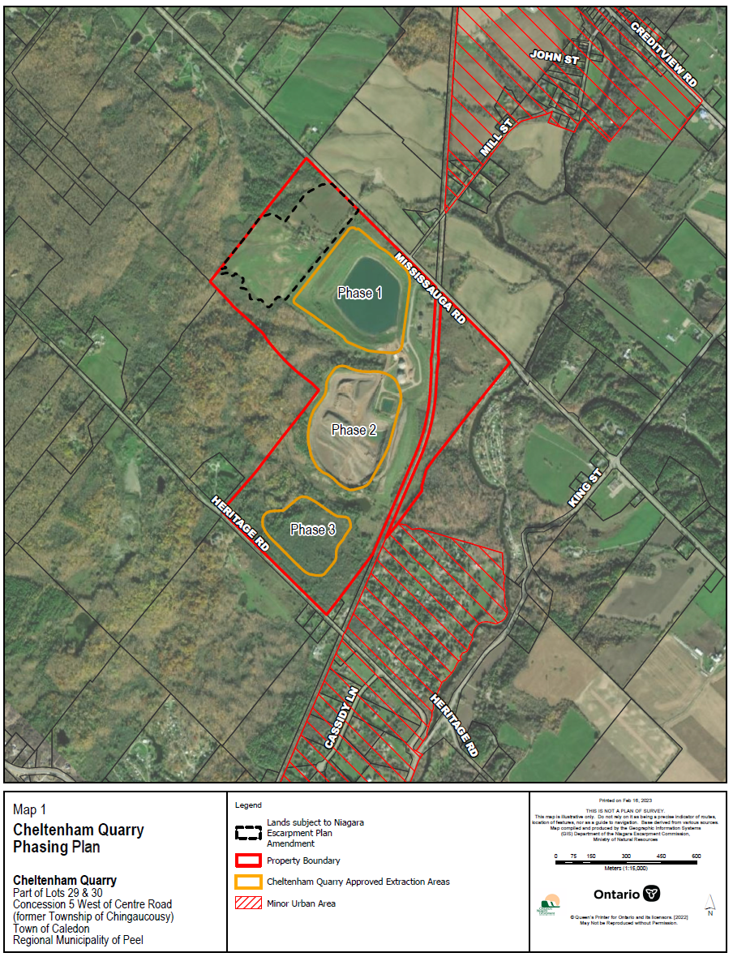
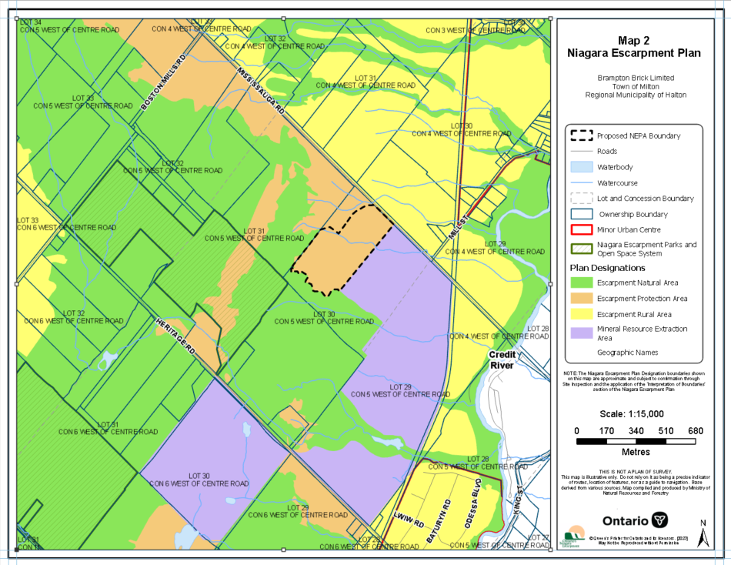
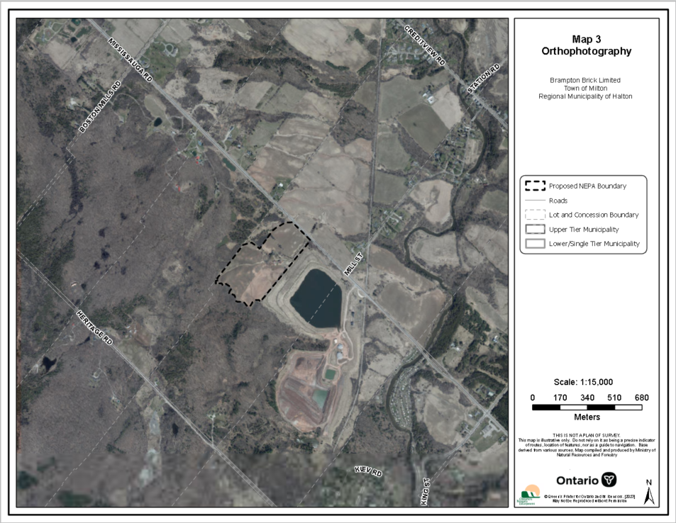
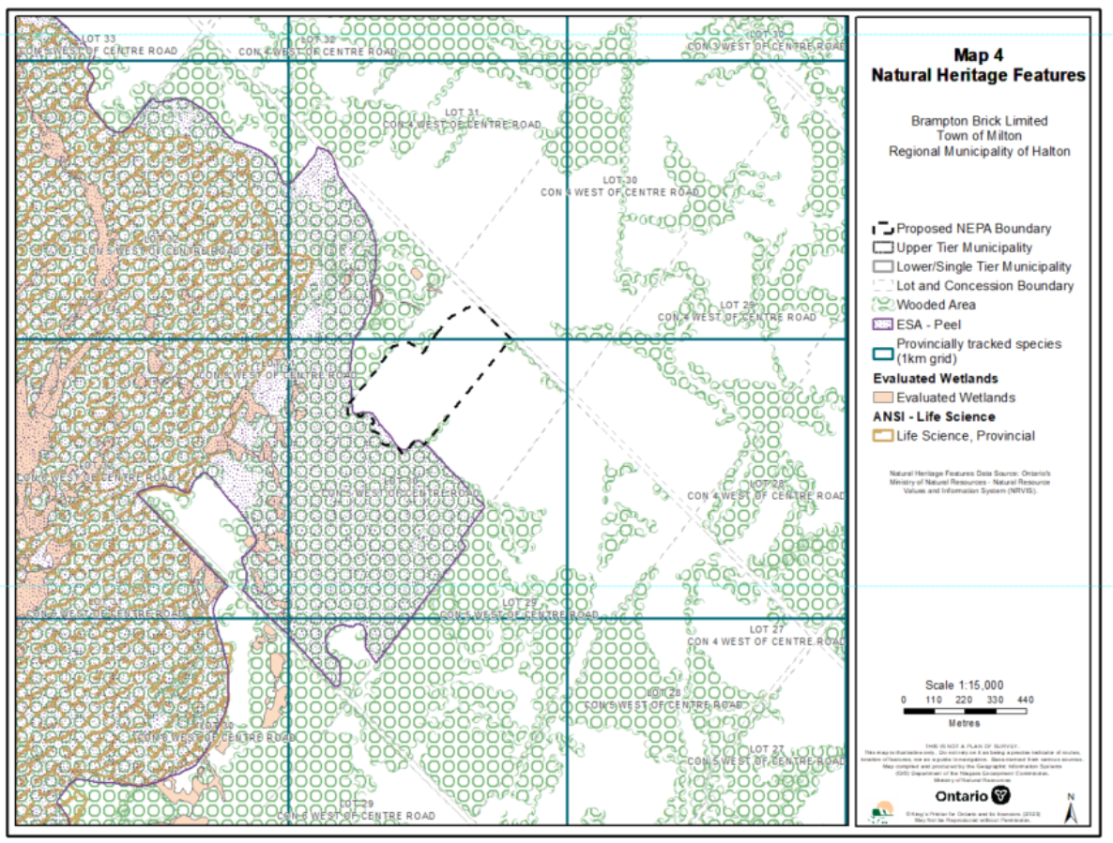
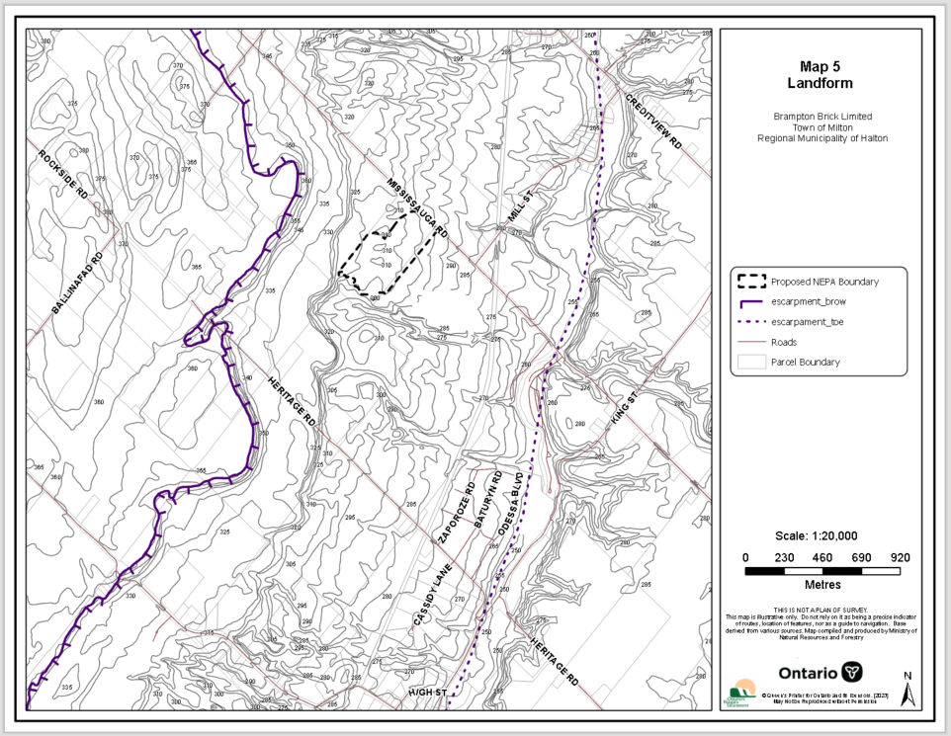
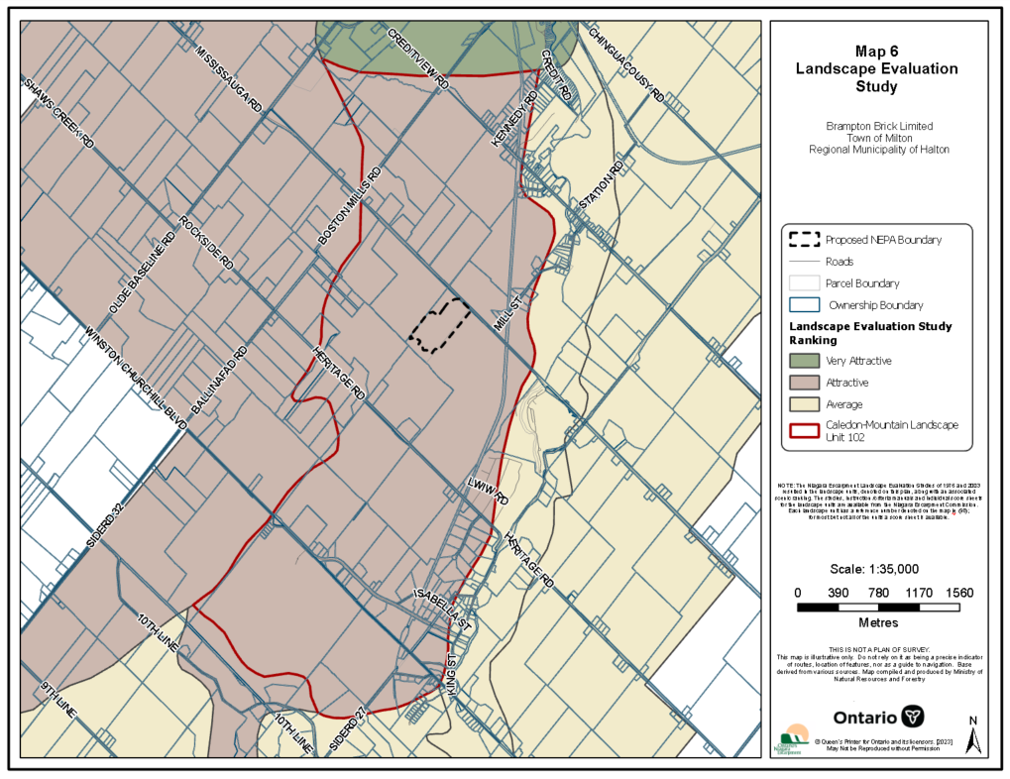
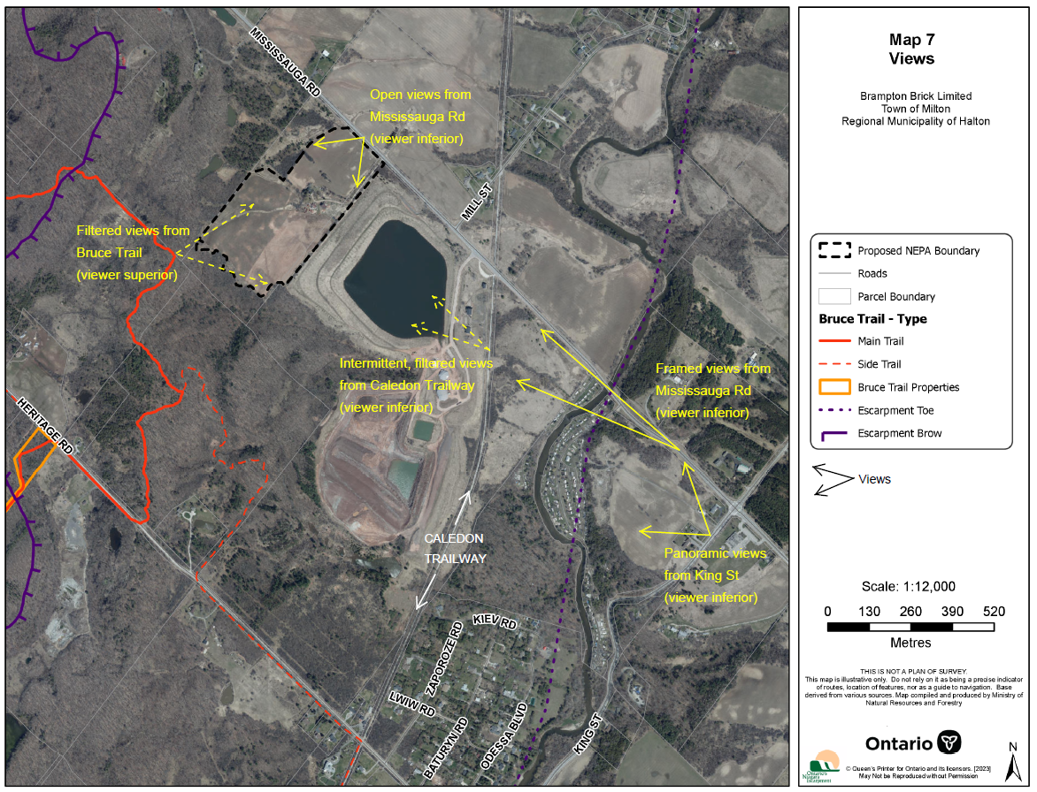
PHOTOS OF CALEDON MOUNTAIN AND THE SUBJECT LANDS
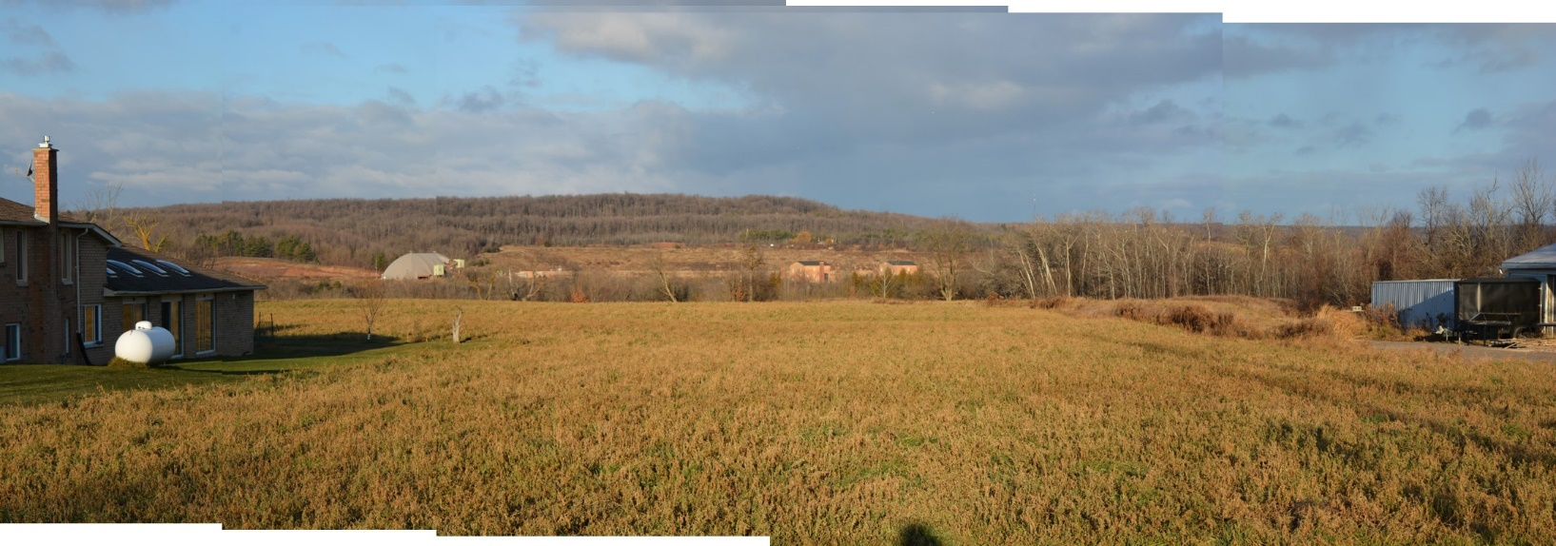
Photo 1. Looking north over the Credit River valley to the Caledon Mountain from King Street. Subject lands are visible directly above the red Brickworks buildings and grassed slope of the existing quarry. Steps in the Escarpment slope are also visible.
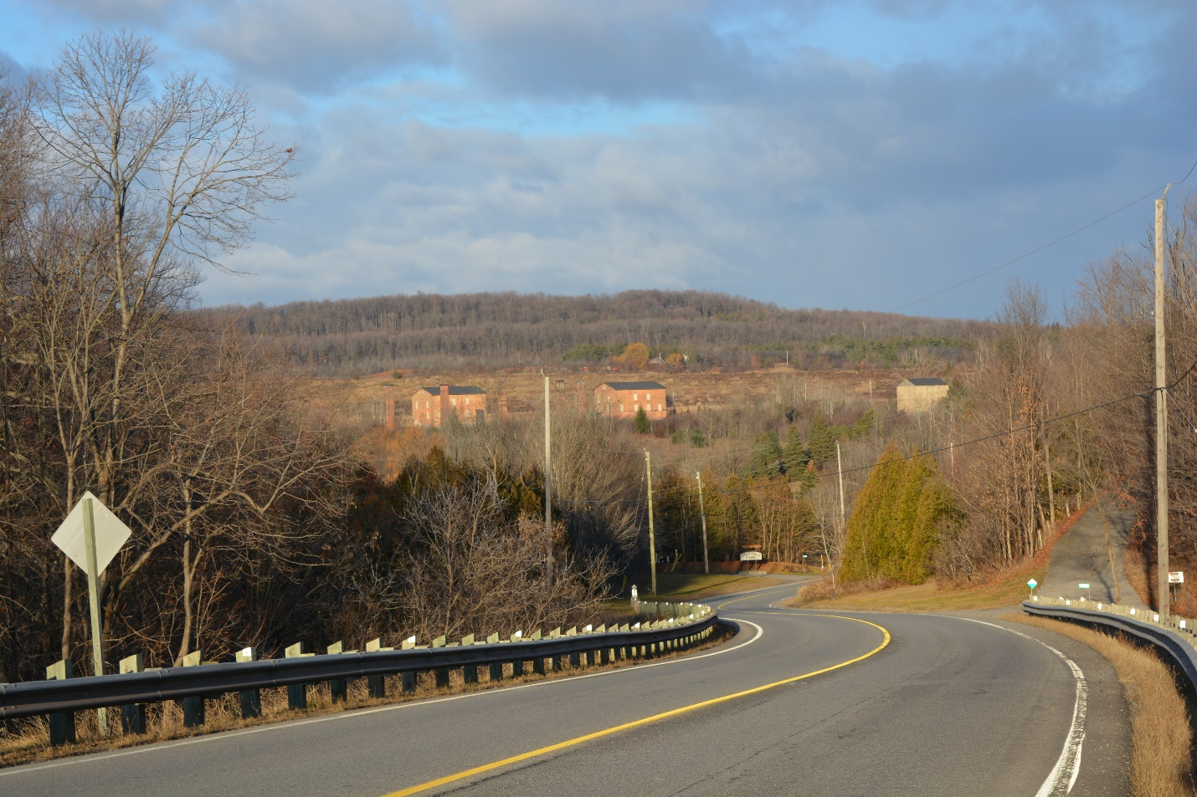
Photo 2. Looking northwest to the Brickworks from Mississauga Road. Subject lands are visible directly above red Brickworks buildings and the grassed slope of the existing quarry. This viewshed is identified as a ‘character-defining element’ of the Cheltenham and Brickworks cultural heritage landscape (Cultural Heritage Landscapes Inventory, www.caledon.ca). Steps in the Escarpment slope are also visible.
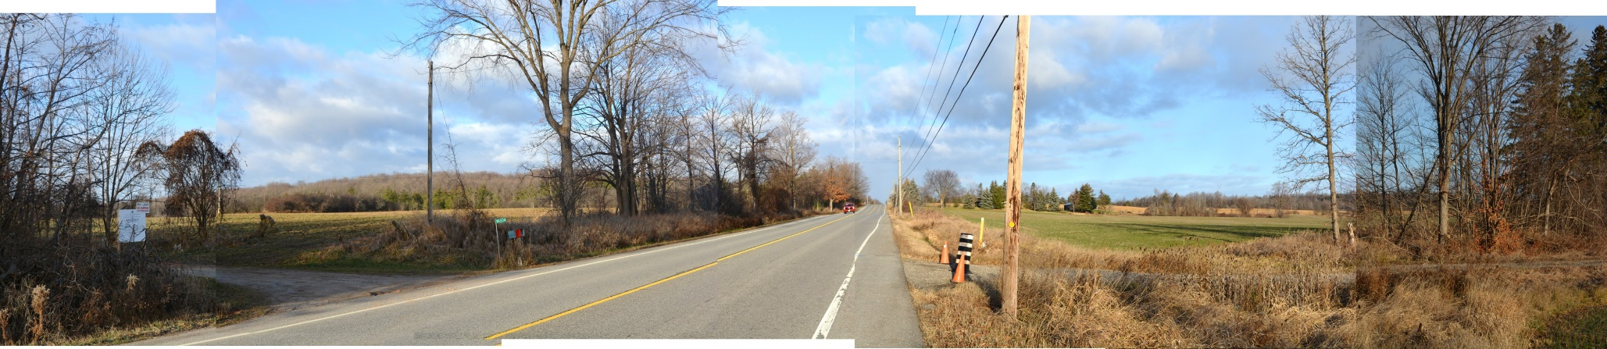Photo 3. Looking north along Mississauga Road. Subject lands are visible on the left sloping up from the road with Caledon Mountain in the immediate background. Lands on the right are designated Escarpment Rural Area (ERA) and are not visually influenced by the Escarpment.
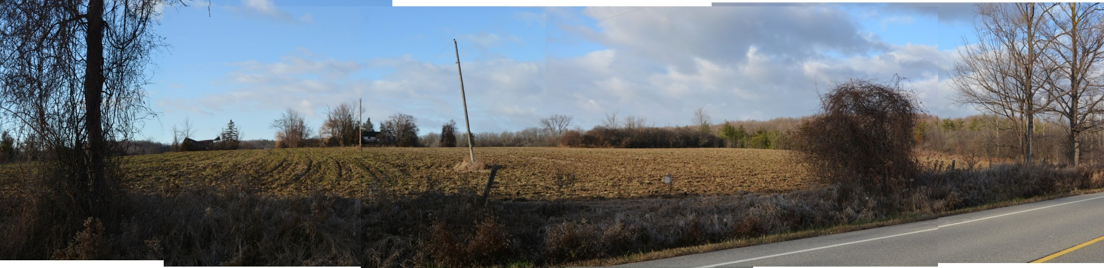
Photo 4. Looking west across subject lands to Caledon Mountain from Mississauga Road. The Escarpment ridges and brow form a continuous backdrop in this view from left to right.
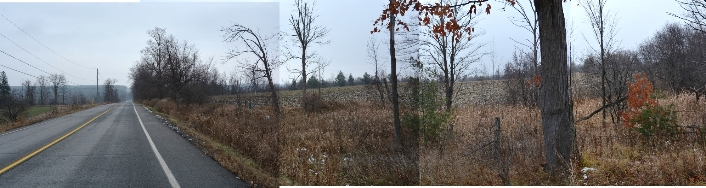
Photo 5. Looking south along Mississauga Road. Subject lands are visible on the right sloping up from the road.
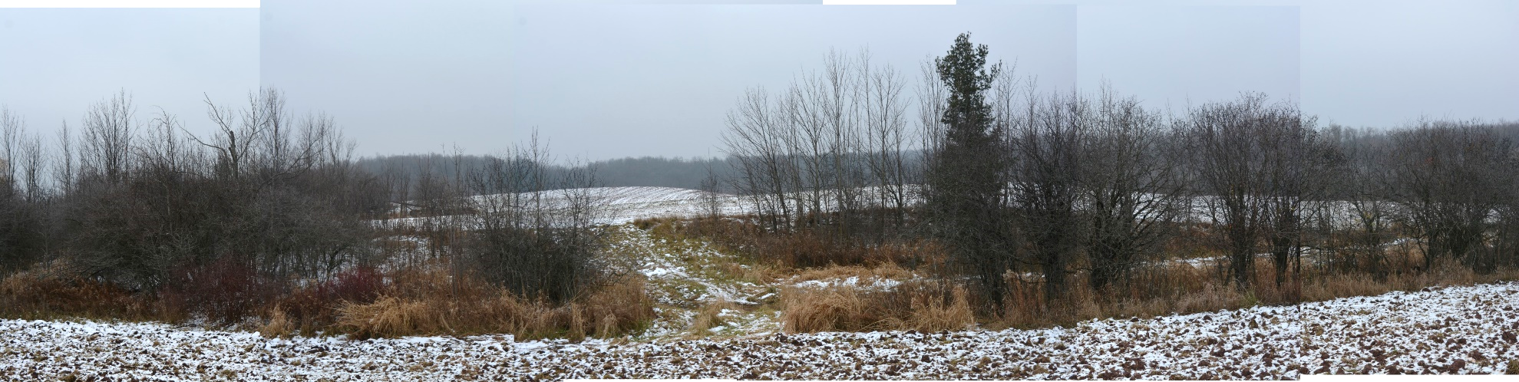
Photo 6. Looking west from front field of the subject lands towards the Escarpment brow. Escarpment ridges and brow form a continuous backdrop. Rolling topography of the rear field is visible.
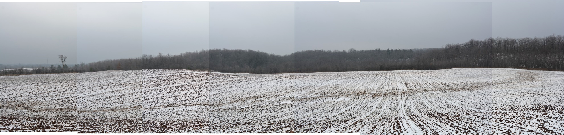
Photo 7. Looking west from rear field of the subject lands towards the Escarpment brow. Wooded Escarpment ridges and brow form a continuous backdrop which surrounds the site to the west and north.
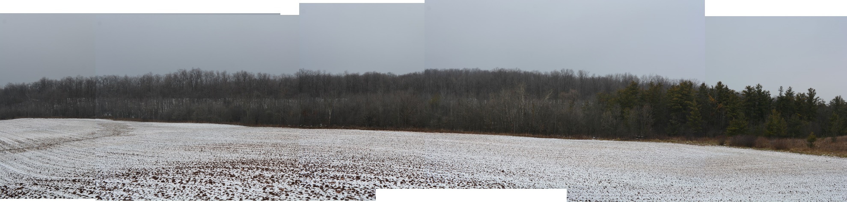
Photo 8. Looking north from the rear field of the subject lands towards the Escarpment brow. Visible in the background are the wooded steps that comprise the Escarpment slope on this face of the Caledon Mountain.
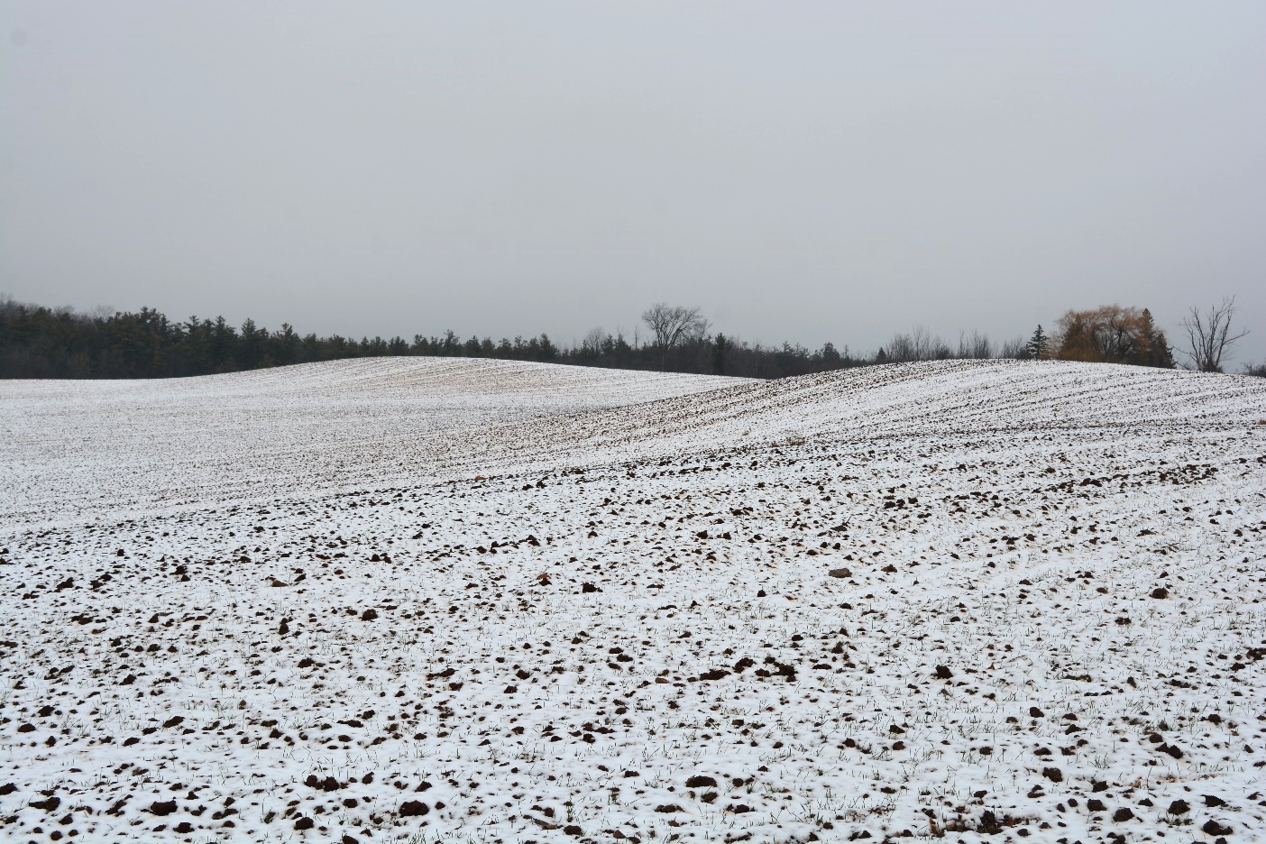
Photo 9. Looking north from rear field of the subject lands. Rolling topography is evident.

APPENDIX 2
Agency and Public Comments

Public Comments (four comments)

Public Comment #1
We are not opposed to the current extraction operations as permitted by the Niagara Escarpment Commission, provided they comply with all stated conditions of their permit and the site is completely re-habilitated in a timely manner.
However, we do not support the proposed redesignation of the subject lands from Escarpment Protection Area to Escarpment Rural Area (PH 226 22), or the likely second application to redesignate the Escarpment Rural to Mineral Resource Extraction Area for the following reasons:
- It is my understanding that the Niagara Escarpment Commission has approved only one application redesignation of Escarpment Protection Area (16&17/S/86 McKean), and this application was granted over 35 years ago. The community in 2023 is more acutely aware of the environment and the protection it requires. Granting this approval could greatly undermine the NEC Natural and Protected Areas within the plan. This approval may set a negative precedence for lands within the Niagara Escarpment plan area.
- The Niagara Escarpment Commission has an official plan review ever 10 years with the last in 2017. It is my understanding Brampton Brick Limited has never formally requested their lands (Part Lots 29 and 30, Concession 5 West of Centre Road, Town of Caledon) removed from their current designation.
- Niagara Escarpment Commission initial staff report dated March 9, 2023 “Extraction is complete on the easternmost Phase 1 area, adjacent to Mississauga Road along its eastern boundary. While rehabilitation is largely complete in this phase.” Phase 1 is over 30 years old and Brampton Brick Limited has been asked to complete its rehabilitation numerous times since the end of extraction. If Brampton Brick proposes to expand operations to other areas of the site, the rehabilitation of Phase 1 should be complete, not merely ‘largely complete’
- Development Permit Application /P/E/09-10/242 was refused by the commission in July, 2013. It is my understanding the primary reasons for refusal was excessive truck traffic over multiple years and not being able to control the quality of fill. This new proposal includes further excavation along the north face of Phase 1, extending quarrying activities instead of proceeding with the complete rehabilitation of the Phase 1 lands. Brampton Brick should be required to complete the previously approved rehabilitation rather than resume quarrying activities in a partially rehabilitated area and should be permitted to place fill into the Phase 1 lands beyond what is required for the approved rehabilitation plan.
- The “Visual Impact” of the proposed site is significant. The higher elevation of the new site will be visible from King Road from the east and west, as well Mississauga Road. The approved site 3 is not visible from any approaching roads. Credit View Public School has been changed to a cultural centre for Indigenous students. The proposed site will be visible from their location.
- Brampton Brick had a open house for the community to put forth their proposal. During the meeting they expressed a benefit of this application being a greater separation to the village of Terra Cotta. The proponent had no concern of the significant effect to the village of Cheltenham. The prevailing winds are from the west, and therefore all the dust will fall in Cheltenham.
- In the past Cheltenham has been impacted from the dust of Phase 1. The approved phase 3 will have little effect on Terra Cotta or Cheltenham.
- Brampton Brick Limited has the right to move into Phase 3 without any amendment required. They have also said they would relinquish there aggregate extraction of Phase 3. We and many of our neighbours believe this is a ploy by Brampton Brick to extract the new area and them come back in 20 years and request opening phase 3, similarly to how they now propose to redesignate the existing Escarpment Protected Area lands
- Brampton Brick has described its products as being needed for the construction of new buildings in Ontario. Although brick is a traditional building material in Southern Ontario, it is now used as a largely decorative veneer and is not vital to construction of new homes and businesses. The need for brick as a decorative product should be balanced with the need to preserve the environment of the Niagara Escarpment.

We live within the zone of influence and did not receive any formal notice of this application. Our neighbors also did not receive formal notice. Due to insufficient notice to all affected nearby properties and the communities, we believe the date of August 21st should be extended to provide time for residents of Cheltenham to formally comment on this application.
Public Comment #2
We wish to submit a comment to the amendment that Brampton Brick is proposing to the Cheltenham Quarry.
Phase 1 is complete, phase 2 is in progress and phase 3 is currently licenced and approved for extraction.
We feel they should complete phase 2 and then proceed to phase 3 before pursuing future mineral aggregate extraction in the proposed northern location.
Since the prevailing winds are from the northwest, this will cause much more dust and noise pollution to the urban centre of Cheltenham and surrounding areas.
We would appreciate being kept informed as to the progress of this proposed amendment by Brampton Brick.
Public Comment #3

Dear Joe Muller, Niagara Escarpment Commission
Assuming Brampton Brick Limited complies with all said conditions of their permit and the site is completely re-habilitated in a timely manner. We are not opposed to the current extraction operations as permitted by the Niagara Escarpment Commission.
However, we do not support part one or two of this application ( PH 226 22) for the following reasons.
1. The community is aware of the Environment and the protection it requires, it is surprising to us that the NEC would grant this approval. Its effect would compromise the NEC Natural and Protected Area’s within the plan.
2. In July,2013 Development Permit Application /P/E/09-10/242 was refused by the commission to amend the approved progressive rehabilitation of phase 1 because of not being able to control the quality of fill to recreate the pre-quarry topography. Will this new proposal further delay complete rehabilitation of the excavated north face of phase 1.
3. The Niagara Escarpment Commission has an official plan review every 10 years with the last in 2017. It is not correct that Brampton Brick Limited has never formally requested these lands (Part Lots 29 and 30, Concession 5 West of Centre Road, Town of Caledon) to be removed from their current designation.
4. “Extraction is complete on the easternmost Phase 1 area, adjacent to Mississauga Road along its eastern boundary. While rehabilitation is largely complete in this phase.” What does this mean? Should this not be complete by now. Brampton Brick Limited has been asked to complete its rehabilitation numerous times since the end of extraction.
5. Brampton Brick Limited has the right to move into phase 3 without any amendment required. Why doesn’t Brampton Brick want to start extraction from phase 3? If approval of this application is granted, then Brampton Brick must relinquish their rights to aggregate extraction of phase 3 and reapply for NEC approval.
6. Brampton Brick had an open house for the community to put forth their proposal. They emphasized that this application would provide a greater separation to the village of Terra Cotta, however not indicating the impact that it would have on the village of Cheltenham. The prevailing winds are from the west, and therefore all the dust will fall in Cheltenham. In the past Cheltenham has been impacted as a result of the dust of phase 1. The approved phase 3 will have little effect on Terra Cotta or Cheltenham.
7. The “Visual Impact” of the proposed site is significant. The higher elevation of the new site will be visible from King Road from the east and west, as well as Mississauga Road. The new Indigenous Cultural Centre at the corner of King St and Mississauga Rd. will have direct view of the proposed site. The approved site 3 is not visible from any approaching roads. We live within the zone of influence and did not receive any formal notice of this application. Also our neighbors did not receive formal notice. The date of August 21st should be extended to provide time for residents of Cheltenham to formally comment on this application.

Public Comment #4

The Board of Directors of Poltawa Country Club is fully supportive of Brampton Bricks application to redesignate a portion of its Cheltenham quarry property from Escarpment Protection Area to Escarpment Rural area. The Board represents the 106 members of the Club most of whom are permanent residents at Poltawa. The members were presented with the proposal at a town hall meeting at the Terra Cotta Community Centre. The full proposal was also emailed to all members for their review and comment. At present, phase 3 of the quarry operations as approved would directly impact the residents of Poltawa as we are located directly south of the site. Our community is continuing to grow and any efforts to mitigate noise, dust and other construction/extraction irritants would be welcomed. We are attaching a formal letter of support.

Sincerely

Walter Mudyk – Chairman

Summary of Agency Comments

The full letters from the three agencies are attached as a separate document, titled Appendices 2 to 4, under Item A2.

Comments received from:
Region of Peel
Town of Caledon
Ministry of Citizenship and Multiculturalism

APPENDIX 3
Minutes of the Public Interest Advisory Committee Meeting

Wednesday, November 29, 2023, 10:30 AM – 2:30 PM
Niagara Escarpment Commission Offices Georgetown
Niagara Escarpment Plan Amendment (NEPA) Application:
PH 226 22 – Cheltenham Quarry – Brampton Brick

Attendance
PIAC Members
Susan Robertson (Chair) Ontario Nature
Karen Cox Ontario Real Estate Association
Kevin Nichol Ontario Snow Resorts Association
Regrets
Drew Spoelstra Ontario Federation of Agriculture
Melanie Horton Ontario Stone, Sand and Gravel Association
NEC Staff
Sandy Dobbyn Senior Strategic Advisor
Shazia Khan Policy and Program Intern (virtual)
Karen Bannister Landscape Architect

10:30 AM – 11:00 AM: Site Visit, Brampton Brick Property, 14504 Mississauga Road, Part Lots 29 and 30, Concession 5 West of Centre Road (Former Township of Chinguacousy), Town of Caledon, Region of Peel.
- In attendance, Sandy, Susan, Karen, Kevin as well as Ellen Ferris (MHBC) and Kyle Halfyard (Brampton Brick)
- Members and staff introduced themselves.
- Members met with the proponent and their agent and toured the site.
- Members were able to ask questions of the proponent and NEC.
11:00 AM – 11:30: Travel to meeting location
11:30 AM: Convene at Georgetown Offices
Staff background overview
- Sandy presented information for proposed NEPA 226 – Cheltenham Quarry (site info: e.g., location, natural heritage features, proposed land use designations; policy: e.g., NEP 1.2.1, 1.4.2, 1.5.2; NEPDA 6.1)
- The application proposes to amend the Niagara Escarpment Plan (NEP) designation of Escarpment Protection Area to Escarpment Rural Area for the un-forested portion of the property. The proponent has submitted various reports supporting the re-designation suggesting that the site is most appropriately designated rural.
- The applicant has indicated that should they be successful in the application to redesignate the site to Escarpment Rural Area, that they would subsequently submit an application to amend the plan to redesignate the site as Mineral Resource Extraction Area, seek Official Plan amendments from the municipality and region to re-designate the lands, apply for a Development Permit to conduct aggregate extraction and seek a license under the Aggregate Resources Act (ARA).
- The application to redesignate the lands to Escarpment Rural is being made because the Niagara Escarpment Plan does not allow for an application to redesignate lands within Escarpment Protection Area to Mineral Resource Extraction Area.
- The applicant has also suggested that should the amendments be successful and that they are ultimately issued a licence under the ARA, that they would surrender the licence for the current phase 3 and redesignate the lands to an appropriate land use designation within the NEP.
- The group discussed at length what was actually under consideration. Although it is known that the long-term goal of the applicant is to apply for mineral resource extraction, the decision currently before PIAC and ultimately the Commission, is whether the site best fits within the Escarpment Protection or Escarpment Rural land use designation, or effectively, were the lands inappropriately designated as Escarpment Protection which prevents an application for aggregate extraction.
- Sandy provided a background of comments received through agency, public and Indigenous consultation, noting that there are no formal objections at this point because the application is only to redesignate the lands from EPA to ERA and not for an amendment to MREA and application for aggregate extraction, which is likely to result in formal objections.
- Sandy provided a summary of the criteria for designation for both Escarpment Protection Area (Part 1.4.2) and Escarpment Rural Area (Part 1.5.2) and outlined that any one site may not fit perfectly within one designation, but that a decision has to be made with respect to the best fit.
- Sandy then provided a summary of the reports submitted by the applicant and the conclusions of the applicants’ consultants with respect to whether the lands best meet the criteria for Escarpment Protection or Escarpment Rural.
PIAC Discussion
- PIAC discussed the designation criteria at length, particularly as they related to Escarpment landforms, the location of the site on the Escarpment slope, and whether the site is visually part of the landscape unit.
- Karen provided context with respect to landforms, landscape units and visual considerations and answered questions of the members to help clarify how the designation criteria are applied from a visual perspective.
- Members felt strongly that the site was a significant component of the landscape unit, and that the site was in fact prominent on the landscape with substantial views to and from the site. In addition, the site is clearly located between toe and brow with clear view of the brow.
- Members asked about environmentally sensitive or significant areas (per 1.4.2.3) and whether they only had to be located on the property or whether they needed to be on the site (portion of the property proposed for re-designation). The committee noted that there were significant environmentally designated areas close to (including an ANSI), and adjacent to (including significant woodland) and even as a part of, the subject property immediately abutting lands proposed for re-designation.
- PIAC felt strongly that the lands proposed for redesignation clearly met criteria 1.4.2.1 and 1.4.2.2 (Escarpment Protection) and that they did not clearly meet 1.4.2.3 although they noted (as above) that the property itself did include these areas and that these areas would be immediately adjacent to the area being redesignated and eventually the subject of an application for aggregate extraction.
- PIAC also considered the objectives for Escarpment Protection Area with respect to Parts 1.4.1.1 and 1.4.1.2 and asked to view mapping of adjacent land use designations. This revealed that this property is part of a band of properties with substantial areas of Escarpment Protection Area that are serving to buffer between the large Escarpment Natural Area that includes lands above and below the brow and lands designated Escarpment Rural Area, which are often located across the road.
- Members agreed that it was difficult to separate the current proposal for redesignation with the knowledge that should the application be approved, the applicant will then apply to redesignate the lands to Mineral Resource Extraction Area. Members felt that it was unfortunate that they could not consider the long-term plans, including potential surrender of the current phase 3 as part of the current application.
PIAC recommendation
- That PIAC finds that the lands subject to the application are in fact properly designated Escarpment Protection Area in that they contain Escarpment slopes and Escarpment Related Landforms and are visually (and prominently) part of the landscape unit, that the lands provide an important buffer to the adjacent prominent Escarpment features (including the brow) and that the property includes environmentally significant features immediately adjacent to the area proposed for amendment;
- That the Commission recommends the Minister not approve the application to re-designate the lands to Escarpment Rural Area;
- That PIAC echo’s concerns of Peel Region.
Unanimous (3) vote, all in favour.

Original signed by Susan Robertson
______________________________ __________________________
Susan Robertson Date
Chair, Public Interest Advisory Committee

APPENDIX 4

NEP Escarpment Natural or Protection Area to Rural Area
Amendment Applications

File number | Type of Amendment | Status
16 & 17/S/86 McKean | Re-designation of Escarpment Protection lands to enable quarry expansion | approved
18/86 Sydenham | Re-designation from Escarpment Protection Area to Escarpment Rural for subdivision | refused
51/H/89 Cohoon | Re-designation from Escarpment Protection Area to MREA to allow wayside pit | refused
61/89 Gibson | Re-designation change from Escarpment Protection to Escarpment Rural for severance | refused
84/91 | Re-designation Change from Natural and Protection to Protection and Rural to enable severances for housing lots | withdrawn

