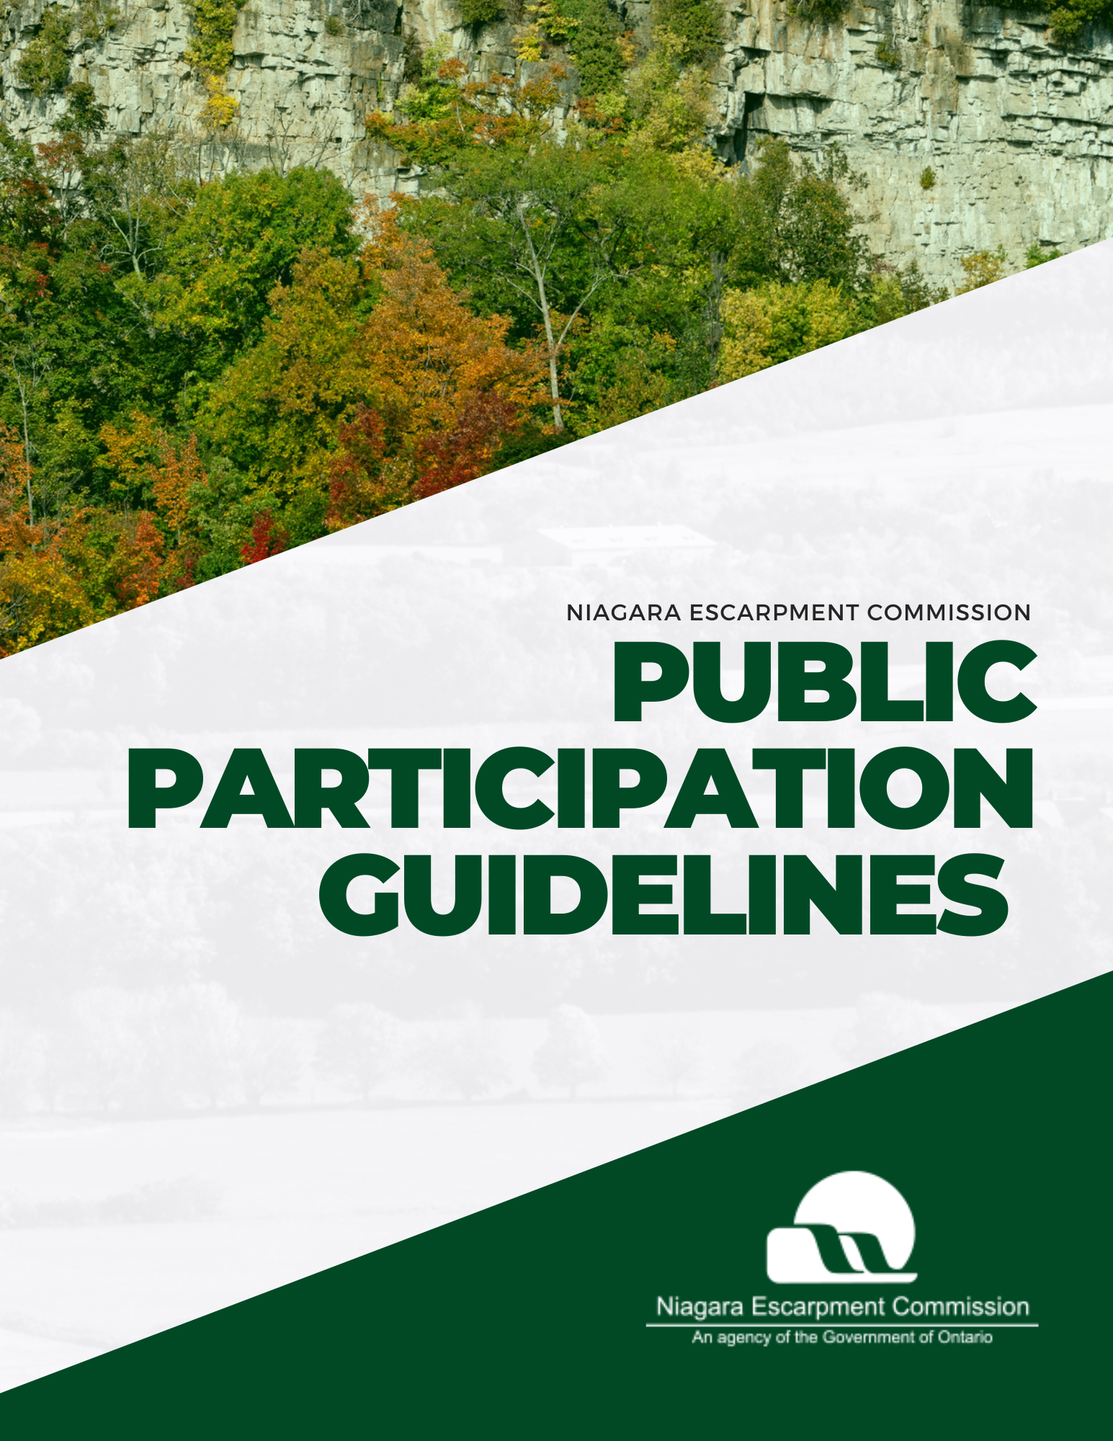

Table of Contents

Accessibility and accommodations 4

Services en français (French language services) 4

Part I: General Information and Pre-Meeting Preparation 5

Overview 6

Commission Meeting Purpose 6

Meeting Schedule and Location 6

Meeting Attendance & Participation 7

Participation & Delegations to the Commission 8

Written Submissions 8

Public Commenting Period 8

Delegations related to an agenda item 9

Delegations related to miscellaneous issues 9

Note to Delegates 9

Recommendations for a successful delegation 10

Delegation Topic 10

Delegation Runtime 10

Public Comment Runtime 10

Supplementary Materials 11

Part II: Commission Meeting Information and Participant Expectations 13

Code of conduct 14

Meeting etiquette 14

Arrival 14

Meeting procedures 14

How to join a Commission meeting remotely 15

Technical support 17

Part III: Information on Notice of Decision and the Appeals Process 18

Area of Applicability 19

Notice of Decision 19

Appeal Period 19

Issuance of a Development Permit 19

Refusal of permit application 19

Appeal process 20

How to file an appeal 20

How an appeal is processed 20

Questions and inquiries 20

Appendix A: Content and format guidelines for delegation materials 21

File length, size, type, and name 22

Font type, size, colour, and accessibility 22

Content restrictions 23

How to convert a file to a PDF 23

Word document to PDF 23

PowerPoint presentation to PDF 23

**Figures**

Figure 1: Map of NEC Georgetown Office 8

Figure 2- Commission Meeting Timeline for Delegates 13

# Accessibility and accommodations

As an agency of the Government of Ontario, the Niagara Escarpment Commission (NEC) is committed to ensuring that the Commission’s information and services are accessible to all Ontarians. The NEC strives to provide services and programs that people with disabilities can use and benefit from equally and in a manner that respects their dignity and independence.

The [Ontario Public Service Accessible Customer Service policy](https://www.ontario.ca/page/ontario-public-service-ops-accessible-customer-service-policy) outlines the Ontario Government’s responsibilities and legal obligations for providing accessible customer service to persons with disabilities. For more information, please visit the policy webpage by clicking the link above.

NEC staff will be on site to assist with in-person accommodations during Commission meetings.

To notify the NEC of an accommodation, request alternative formats and communication supports, or for related inquiries, please call 905-877-5191 or send an email to the Executive Services Administrator at [nec@ontario.ca](mailto:nec@ontario.ca).

# Services en français (French language services)

Ce document peut être traduit sur demande. Pour obtenir des renseignements en français, veuillez communiquer avec la Commission de l’escarpement du Niagara (CEN) par téléphone à 905-877-5191 ou par courriel à [nec@ontario.ca](mailto:nec@ontario.ca).

# Part I: General Information and Pre-Meeting Preparation

## Overview

This document is intended to provide information on the processes and guidelines for delegations and public participation at Niagara Escarpment Commission meetings.

## Commission Meeting Purpose

The Commission is comprised of a Commission Chair and 16 Commissioners. To learn more about the Commissioners, please read their individual biographies at: [Commissioner Biographies - Niagara Escarpment Commission (NEC)](https://escarpment.org/inside-commission/about-our-commissioners/).

Commission meetings encompass the Niagara Escarpment Commission’s formal procedure to put forth current and emerging issues, discuss matters of urgency, and make decisions on land-use and development applications.

Typical agenda items brought forward during Commission meeting sessions include:

* Development Permit Applications that do not meet the policies of the Niagara Escarpment Plan and require a policy interpretation from the Commission,
* Development Permit Applications that have received objections from the public,
* Development associated with a critical service,
* Items related to a Niagara Escarpment Plan Amendment,
* Items related to an Order to Restore or Demolish,
* Items related to an appeal or litigation.

## Meeting Schedule and Location

Commission meetings occur on the third Thursday of every month or as determined by the Chair; however, meetings dates may be adjusted occasionally. An up-to-date schedule of Commission meeting dates, as well as agendas and minutes for past meetings are available on the NEC website at <https://escarpment.org/meeting-documents/.>Meetings are hosted in-person at the NEC Georgetown office located at [232 Guelph Street, 3rd floor, Georgetown, ON, L7G 4B1](https://goo.gl/maps/bW2hrdbS59qfF47V6) (see map below). Please note the entrance to the NEC Georgetown office is located off of Mountainview Road.

A key operated elevator is located to the right of the entry and can be accessed by the public upon request. A public telephone box is located on the outside of the elevator. To reach the NEC office, dial code 301 on the control panel. Alternatively, you may reach NEC staff by calling 905-877-519 on a personal device. An NEC staff member will assist in operating the lift.

Tittle: NEC Georgetown Office Map 
Description: Map of the intersection of Guelph Street and Mountainview Road south Georgetown Ontario. Map include location of Georgetown within South Eastern Ontario and an image of ground level entrance to the Office. Figure 1: Map of NEC Georgetown Office

## Meeting Attendance & Participation

Commission meetings are open to the public. The NEC offers the following options for attending a Commission meeting:

* **In person attendance:** meetings are hosted in-person at the NEC Georgetown office.
* **Remote (virtual) attendance:** participants who wish to attend virtually must pre-register by identifying their interest in observing a meeting via email to [nec@ontario.ca](mailto:nec@ontario.ca). Registered meeting participants are provided a Microsoft Teams meeting link via email in advance of the meeting, to support remote attendance.
* **Observation:** Individual(s) who may or may not be associated with an agenda item may observe a Commission meeting.
* **Written Submission:** A Resident of Ontario may submit written materials in advance of the Commission meeting.
* **Public Comment:** On the day of the Commission meeting a Resident of Ontario may provide brief in-person comment to the Commission regarding matters on the agenda during public comment period.
* **Delegation:** In advance of the Commission meeting Resident of Ontario may register as a delegation to the Commission. Delegations will be added to the meeting agenda. Delegations must be associated with an agenda item unless prior approval has been obtained by the Commission.

The individuals or groups listed below automatically receive an invite to the scheduled Commission meeting. This includes,

* + The applicant, landowner and/or their agent for a Development Permit Application or Plan Amendment that is being addressed at a Commission meeting,
  + An agency that was consulted during a Development Permit or Plan Amendment application assessment stage,
  + A Resident of Ontario who has been in previous contact with the NEC and has requested an invite to observe or delegate regarding a specific Development Permit application or Plan Amendment,
  + A named individual on an Order to Restore or Demolish (e.g., the landowner of a property that is the subject to the Order) or their agent, and / or
  + An individual who has registered a complaint related to a property that is the subject of an Order to Restore or Demolish.

It is the responsibility of the recipient to respond to the invite and confirm with NEC staff by **12:00 p.m. EST** (i.e., noon)**, seven (7) business days** prior to the scheduled Commission meeting and must indicate if they wish to attend as an observer or as a delegate.

If not among the previously mentioned parties, an interest in observing or delegating in a Commission meeting may be identified to the Commission via email at [nec@ontario.ca](mailto:nec@ontario.ca). Any Resident of Ontario can submit a request.

Participants will receive an email confirming registration and the scheduled time slot for the agenda item/delegation, and a Microsoft Teams meeting link at least **five (5) business days** prior to the meeting.

## Participation & Delegations to the Commission

### Written Submissions

Residents of Ontario can make a written submission to the Commission. All written submissions should be sent to [nec@ontario.ca](mailto:nec@ontario.ca). Written submissions must be received by **12:00 pm Eastern Standard Time (EST)** (i.e., noon)**, five (5)** **business days** prior to a Commission meeting.

### Public Commenting Period

NEC provides opportunity for Residents of Ontario to provide **verbal** comments on matters included on the agenda during the in-person public commenting period portion of a Commission meeting. Should you not be able to attend in person you are encouraged to submit written materials to the Commission.

Public comments must be addressed to the Chair. Individuals providing comment will be asked to provide their first and last name and are encouraged to indicate a specific interest in the agenda item and any key points they would like the commission to consider.

Be advised that, comments and views expressed during the public commenting period are not the view of the Commission, the Ministry of Natural Resources, or the Government of Ontario. Although, it is stressed as an agency of the Government of Ontario, the Niagara Escarpment Commission will not tolerate any form of racism, discrimination, or harassment. For more information on meeting etiquette and code of conduct, please refer to Part II of this document.

### Delegations related to an agenda item

Individuals or parties who are interested in appearing as a delegation related to an agenda item must confirm their interest with NEC staff by **12:00 p.m. EST** (i.e., noon)**, seven (7) business days** prior to the scheduled Commission meeting. Any supplemental materials to be used during the delegation must be submitted to the NEC by **noon (12 p.m.)** **five (5) business days** prior to the meeting. Please see the Supplemental Materials section on page 13 of this document for more information.

If a situation arises where there is a high number of delegations that cannot be accommodated by the agenda, the Chair, in consultation with the Commission, will determine if a special meeting would be required to hear all delegations. Delegates may be asked to defer their comments to a special meeting. Delegations outside the subject matter and jurisdiction of the Commission will be refused.

### Delegations related to miscellaneous issues

Requests to delegate to the Commission on an item that is not on the agenda must receive approval from the Commission. Please note requests related to active compliance matters will not be accepted unless an Order to Restore or Order to Demolish is before the Commission. To make a delegation request, please submit a delegation request to the Chair by emailing [nec.chair@ontario.ca](mailto:nec.chair@ontario.ca).

In your email, please include your name and the subject of your delegation. The Chair will discus your request with the Commission at the next scheduled meeting. The Commission will finalize their decision on hearing the delegation and the meeting date on which the delegate is invited to speak.

### Note to Delegates

All delegates are requested to join the meeting 30 minutes in advance of their scheduled agenda time.

If you have any questions, please call 905-877-5191 or email the Executive Services Administrator at [nec@ontario.ca](mailto:nec@ontario.ca).​

## Recommendations for a successful delegation

### Delegation Topic

Please note that Commissioners receive a copy of the staff report associated with agenda items in advance of the meeting and will be familiar with the information presented in the reports associated with the item. Delegates are encouraged to express their point of view in a clear, concise, and specific manner using information that was provided to NEC staff (Development Permit application, studies and reports, etc.) prior to the Commission meeting.

It is at the discretion of the Commission to defer an item and reschedule a delegation should new information be introduced by delegations that otherwise was not provided to NEC staff. This is to provide ample time for NEC staff, the Chair and Commissioners to review new information.

Delegations cannot not refer to personnel matters, litigation or potential litigation or planning matters that have already had a public meeting or any item considered confidential.

### Delegation Runtime

If you are the Development Permit applicant, landowner and/or their agent or a named individual on an Order to Restore / Demolish registered as a delegate on an agenda item, your delegation must be **10 minutes or less**.

If you are an agency, municipality, Indigenous community, or a member of the public registered as a delegate on an agenda item, your delegation must be **5 minutes or less**.

As we want to provide an equal opportunity for all individuals to address the Commission, any delegation exceeding the above runtimes may be cut short. Questions and discussion periods are not included in your speaking time.

### Public Comment Runtime

If you are a member of the public offering comments on an agenda item during the public comment period, your delegation must be **3 minutes** or less.

As we want to provide an equal opportunity for all individuals to address the Commission, public Comment exceeding the above runtimes may be cut short.

### Supplementary Materials

Supplementary materials such as a PowerPoint presentation may be used to support delegation presentations. The use of supplementary materials is **optional** and is **not required** to address the Commission. In addition, Residents of Ontario may provide written submission. For recommendations on the content, formatting, and technical requirements, please see Appendix A.

Please note supplementary materials are not permitted during the public comment period. Public offering comment may **optionally** provide written submission separate to providing public comment.

If you choose to use supplementary materials during your delegation or choose to provide a written submission, materials must be submitted by **noon (12 p.m.)** **five (5) business days** prior to the meeting (typically the Thursday prior to the meeting). Materials can be submitted to the Executive Services Administrator by email at [nec@ontario.ca](mailto:nec@ontario.ca). **This deadline is firm** and ensures that the Commission has ample time to review and understand your position.

If you do not submit your materials by the deadline, you may not be able to share them during your delegation. However, you can still make your delegation during the assigned time slot. **Files submitted on the day of the meeting will not be accepted.**

Please note that **any materials submitted will be shared** with the Commission and all impacted parties (e.g., applicant/agent, other delegates, the landowner, etc.). Private information will be redacted, as required by current privacy laws.

Title: Commission Meeting Timeline for Delegates 
Description: Timeline communicating key steps and deadlines associated with delegations presenting to the Commission. 

Figure 2- Commission Meeting Timeline for Delegates

Part II: Commission Meeting Information and Participant Expectations

## Code of conduct

The Ontario Public Service is committed to fostering an environment that is inclusive, anti-racist, accessible, respectful, and free from harassment and discrimination. As an agency of the Government of Ontario, the Niagara Escarpment Commission shares this commitment and will not tolerate any form of racism, discrimination, or harassment. The Commission requests that all guests ensure that their words and actions align with this commitment. The Commission will ensure everyone is held to account with this commitment.

Meeting etiquette  
Meeting etiquette is a standard set of behaviours expected from participants during meetings. It encourages participants to create a professional environment with mutual respect and ensures that the Commission meeting is organized, timely, and effectual. The NEC follows Roberts Rules of Order for meeting procedures, and participants are expected to adhere to the following the guidelines:

* Individuals must address their remarks to the Chair rather than to the meeting. E.g., “Through you, Mr. Chair…”
* Individuals must raise their hand to share their remarks and wait for the Chair to call on them before speaking.
* Only one person may speak at a time.
* Those found interrupting another participant’s comments without being called upon will be held to account accordingly.
* The use of any recording device during the meeting is prohibited. All participants must have their phones switched off during the session.

## Arrival

If attending the meeting in person, please arrive a minimum of 30 minutes before your agenda item is scheduled to begin. There is no charge for parking at the NEC Georgetown or Owen Sound offices. Parking is available on both sides of the Georgetown office. If attending the meeting virtually, please see the section below on how to join a Commission meeting remotely.

## Meeting procedures

During the session, the Chair will call for a motion to open discussion on an agenda item. They will first hear the NEC staff report related to the agenda item. Upon its conclusion, the Chair will invite you to begin your delegation to the Commission. After your delegation, you can remain in the meeting while the Commission conducts its discussion. If you are attending virtually, we ask that you mute your microphone to avoid disrupting the meeting.

When the Commission has heard the staff presentation and all requested delegations related to the matter, they will discuss the agenda item. Upon conclusion of the discussion, the Chair will call a vote on the motion. The Commission may approve, amend, refuse, or defer the file based on their discussions, the NEC staff report, and the information presented in your delegation. For more information on Commission decisions and Notices of Decision, see Part III: Post-Meeting Information.

## ****How to join a Commission meeting remotely****

Please join the meeting at least 30 minutes before your agenda item is scheduled to begin, using the Microsoft Teams link and password provided to you via email.

Microsoft Teams is a video conferencing tool. To join a Commission meeting remotely, a telephone or a built-into-the-device audio system on a desktop computer, tablet or mobile device is required. **You do not need a Microsoft Teams account to join a meeting.**

##### Step 1:

If you wish to watch or listen to a hybrid Commission meeting, you must register via email. Please send a message to [nec@ontario.ca](mailto:nec@ontario.ca) requesting access. Once your registration has been confirmed, you will be emailed a link containing an invite to the meeting.

##### Step 2:

Open your email invite and click **Join the meeting.**



##### Step 3:

On your browser, you will be asked how you want to join the Teams meeting:



* 1. If you have downloaded, installed, and previously used the application, you can click “Open your Teams app” to access the meeting.
  2. You can access the meeting through your browser by clicking “Continue on this browser.”Please be aware the connection may lag, causing the audio/video to become distorted on occasion.
  3. Alternatively, you can “Download the Windows (or Mac) app” and install the application. **Please note that** you need to have, or will need to create, a Microsoft account (@outlook, @hotmail, or Office365).

##### Step 4:

A pop-up box will appear, and Microsoft Teams will ask you for permission to access your microphone and camera, click **“Allow.”**

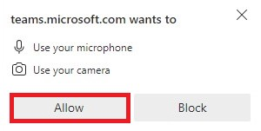

##### Step 5:

You will be directed to the preview screen. Before proceeding to the meeting, please **enter your name and turn off the camera and microphone by sliding the button to the left.**

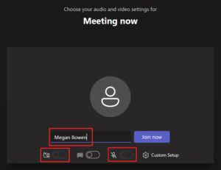

##### Step 6:

Click **Join Now**(blue/purple button above)**.**You will now be entered into the meeting.

Please keep your camera turned off and your microphone muted during the meeting unless or until invited to speak by the Commission Chair.

## Technical support

If you experience technical difficulties during a Commission meeting and require assistance, please email [nec@ontario.ca](mailto:nec@ontario.ca) or call 905-877-5191.

# Part III: Information on Notice of Decision and the Appeals Process

## Area of Applicability

Please note that the following information pertains only to decisions the Commission has made regarding a Development Permit application.

Decisions related to Orders to Restore / Demolish are final and have no option for appeal.

## Notice of Decision

When the Commission has made a decision to approve or refuse a Development Permit application, a Notice of Decision is sent to the permit applicant, all agencies consulted during the application assessment stage, and neighbouring landowners within 120 metres of the subject property via mail. The Notice of Decision provides a description of the proposal and the conditions of approval orthe reasons for refusal. The Notice of Decision is sent within 2 business days following the meeting.

### Appeal Period

When the Commission decides to approve a permit application or an application for Plan amendment, stakeholder parties who receive a Notice of Decision regarding the file can appeal the Commission’s decision to the Ontario Land Tribunal (OLT) within 14 days from the mailing date of the Notice of Decision.

When the Commission decides to refuse a Development Permit application or application for Plan Amendment, the applicant or their approved agent may appeal the Commission’s decision within 14 days from the mailing date of the Notice of Decision.

Additional details on the appeal process can be found below. Please note that the Commission cannot address or comment on applications that have proceeded to the OLT or another board, tribunal, or court.

### Issuance of a Development Permit

Development permits are processed after the 14-day appeal period closes. If no appeals regarding the decision are received, an applicant will receive their Development Permit from the NEC via email. Once the Development Permit has been issued and received, applicants are permitted to proceed with their development.

### Refusal of permit application

If the Commission has decided to refuse a permit application, and the applicant does not appeal the decision, they may choose to submit a new, **modified** Development Permit application to the NEC; however, the development activities outlined in a new application must be sufficiently different from the previous application for the Commission to be able to consider it.

**Please note that once a formal vote has taken place and a decision is made by the Commission, the decision is final and there is no opportunity to re-open or reconsider the application unless it is through a new Development Permit application or an appeal to the OLT.**

Deferred and referred applications do not fall under this restriction, as they have not been formally voted on by the Commission due to factors such as inadequate information.

## Appeal process

Anyone who receives a copy of the Notice of Decision from the NEC may appeal the decision. An appeal must be made in writing and must be received within 14 days of the mailing date for the Notice of Decision.

### How to file an appeal

Individuals must complete an appeal form and submit it to the Niagara Escarpment Commission within the 14-day notice period. More information is available on the NEC website at [Appeal an NEC decision on a Development Permit Application - Niagara Escarpment Commission (NEC)](https://escarpment.org/permits/appeal-of-a-development-permit-application/). Appeals may be submitted via:

* Mail: 232 Guelph Street, 3rd floor, Georgetown, ON, L7G 4B1
* Email: [nec@ontario.ca](mailto:nec@ontario.ca)

### How an appeal is processed

When an appeal is received, it is forwarded to the Ontario Land Tribunal (OLT), which appoints a Hearing Officer to process the appeal. The Hearing Officer makes a report to the Minister of Natural Resources within 30 days after the conclusion of the Hearing or within such longer period as Minister may permit. Find out more information about the OLT [here](https://olt.gov.on.ca/).

Please note that the Commission cannot address or comment on applications that have proceeded to the OLT or another board, tribunal, or court.

### Questions and inquiries

For questions and inquiries regarding your appeal or the appeal process, please contact the OLT through the [contact channels listed on this webpage](https://olt.gov.on.ca/contact-us/) or your appeal case coordinator.

# Appendix A: Content and format guidelines for delegation materials

To accommodate accessibility needs and align with the Government of Ontario’s Digital First initiative, the NEC requests that all delegation materials be submitted in a digital format.

## File length, size, type, and name

All delegation materials, including presentation slides and supporting documents, must no more than **ten (10) pages** in length. More than one file may be submitted to support a delegation, but each file must meet this page limit. Files that do not meet this page limit may not be accepted.

To reduce technical limitations during a delegation, the NEC requests that the size of each file shared must be no more than **five (5) megabytes (MB)**. Files that exceed this size limit may not be accepted. To reduce a file’s size, please minimize the use of photos and embedded files or images. If photos are required, please reduce the size of the image file before inserting it into a PowerPoint or Word document.

If more than one files is being submitted, please save them using the file number assigned to the related agenda item and a short phrase which describes what the file contains, separated by an underscore symbol. This is to ensure that files can be presented in an efficient and organized manner during a delegation. An example of an acceptable file name is 21354_Site_Plan_Map.jpeg.

The NEC recommends saving files in a format compatible with the Microsoft Office programs, such as DOCX or PPTX files, or as a PDF. This recommendation is to mitigate technical limitations during a delegation, such as a delay in the materials being cast on other electronic devices and ensure compatibility with the Ontario Public Service’s Microsoft Office digital ecosystem.

For assistance in converting DOCX and PPTX files to a PDF, please see the section How to convert a file to a PDF.

## Font type, size, colour, and accessibility

To ensure legibility and clarity for Commissioners and provide an accessible experience for all individuals, the NEC recommends that the following guidelines be referred to when preparing delegation materials:

* Use Arial font.
* Use black or “automatic” font colour on a white background for your text content.
* Use 12-pt or greater font size for body text and 14-pt or greater font size for headings.
* Use a combination of upper and lowercase letters.
* Use alternative text, also known as “Alt-text”, for photos or images. Alt-text describes the appearance or function of an image on a page and is read aloud by screen readers for visually impaired users.
* To add alt-text, right-click on the photo, select “Edit alt-text,” and type a description of the image.

## Content restrictions

Please ensure that files do not contain the following:

* Audio and video
* Personal information and identifiers, such as names or email addresses
* Photographs containing faces of people
* Offensive or discriminatory wording or images.

If the above content is detected, NEC staff will modify the file to redact or exclude the content from a delegation. The owner of the delegation materials will be informed of these changes via email.

Please note that delegates cannot make changes to their submission after it is sent to the Commission.

## How to convert a file to a PDF

### Word document to PDF

1. Go to File > Save As.
2. Choose the desired location to save your file.
3. Choose PDF (*.pdf) from the dropdown “Save as type” menu.
4. Click Save.

### PowerPoint presentation to PDF

1. Go to File > Save As.
2. Choose the desired location to save your file.
3. Choose PDF (*.pdf) from the dropdown “Save as type” menu.
4. Click Save.