A1 Staff Report

Date: July 17, 2025

File: W/R/2022-2023/54

# Accessibility

The Niagara Escarpment Commission is committed to ensuring that the Commission’s information and services are accessible to all Ontarians. If you require this document in an alternate format, please call 905-877-5191 or email [nec@ontario.ca](mailto:nec@ontario.ca).

# Services en français / French language services

Ce document peut être traduit sur demande. Pour obtenir des renseignements en français, veuillez communiquer avec la Commission de l’escarpement du Niagara (CEN) par courriel à [nec@ontario.ca](mailto:nec@ontario.ca).

# Development Permit Application:

REDACTED, Owner

Raj Kehar and Ed Fothergill, Agents

W/R/2022-2023/54  
820 Sulphur Springs Road  
Part lot 40 & 41, Concession 1 Ancaster  
City of Hamilton (formerly Town of Ancaster)  
ARN 251814012036800

# Executive Summary

The application is proposing to decommission an existing single dwelling and driveway, and to construct a new single dwelling, detached accessory building, private sewage treatment system and driveway.

The subject property is very complex due to the key natural heritage (KNHF) and key hydrologic features (KHF) that have been identified on the property. In addition to these features, Hamilton Conservation Authority (HCA) has identified that portions of the property are subject to flooding and erosion hazards including the location of the existing driveway. As a result, to ensure that development is not prone to natural hazards a new driveway has been proposed within the significant woodlands which will bisect an intermittent watercourse and will be adjacent to the identified spring. There are no alternative driveway locations that would be outside of the identified features and not be prone to natural hazards.

NEC staff are recommending that the application be refused by the Commission because it does not conform with the Niagara Escarpment Plan, 2017 (NEP) and is not consistent with the Provincial Planning Statement, 2024 (PPS) for the following reasons:

* NEP Parts, 2.6.3(c) and 2.6.4: the proposed grading for the driveway appears to extend into the spring and the Natural Heritage Evaluation did not identify a recommended vegetative protection zone (VPZ) for it.
* NEP Part 2.7.5: the proposal does not provide a minimum 30 metre VPZ from core areas of the Natural Heritage System, as required in the more restrictive City of Hamilton’s Rural Official Plan (OP) natural heritage policies.
* NEP Part 2.10.2: the applicant has not completed a Heritage Impact Assessment for the existing single dwelling, known as Farewell House.
* PPS 4.1.5: it conflicts with the City’s OP natural heritage policies, and thus NEP Part 2.7.5.

This application is being referred to the Commission for a decision because:

* The City of Hamilton has objected to its approval, and,
* Staff are recommending refusal because the proposed development does not comply with the NEP.

# Recommended Motion

That the Development Permit Application be refused on the grounds that the proposed development does not conform to the City of Hamilton’s Rural Official Plan (2019), that the proposed development conflicts with the NEP (2017) and is not consistent with the Provincial Planning Statement (2024).

# Proposal

On an existing 22.3 ha (55.18 ac) lot:

* To decommission an existing two-storey 128 sq m (1,377.8 sq ft) single dwelling (listed in City’s heritage inventory) and to convert it into an accessory building (storage),
* to construct a two-storey (plus basement), ± 600 sq m (6,460 sq ft) single dwelling with a maximum height to peak of ± 11.5 m (37.7 ft),
* to construct a one-and-a-half storey, ± 186 sq m (2,002 sq ft) accessory building (detached garage with storage above) with a maximum height to peak of ± 8.3 m (27.2 ft),
* to decommission the existing driveway and to construct a new driveway with an associated culvert, and,
* to install a new septic system and well.

# 2.0 Niagara Escarpment Plan Designation

Escarpment Natural Area and Escarpment Protection Area. A map showing the NEP designations is included as **Appendix 2**.

# 3.0 Site Description

The 22.3 ha irregular-shaped subject property is located within Dundas Valley on the western side of Sulphur Springs Road between Mineral Springs Road and Governor’s Road. The Hamilton to Brantford Rail Trail is located directly adjacent to the northern property line while Dundas Valley Conservation Area (NEPOSS Park) abuts the property to the south and east. The Bruce Trail main trail is located on the eastern property within Dundas Valley Conservation Area. The property currently supports a single dwelling which is listed on the City of Hamilton’s Inventory of Heritage Buildings (for having cultural value or interest), and a private driveway along Sulphur Springs Road. Several walking trails have been established and maintained on the property for the landowners’ private use.

The subject property is designated as Escarpment Natural Area (ENA) and Escarpment Protection Area (EPA) by the 2017 NEP. The existing development (single dwelling and driveway) are currently located within the ENA. The subject property contains the following KNHFs:

* Environmentally Sensitive Area; across the entire property.
* Significant woodlands; throughout the majority of the property with the exception of two small pockets of cultural meadow/savannah.
* Watercourses; Sulphur Creek is located on the property as well as an intermittent stream.
* Unevaluated wetlands; along the frontage north of the existing driveway as well as south of the existing single dwelling;
* Seep/spring; along the north-eastern portion of the site.
* Fish habitat; within Sulphur Creek (seven species).
* Significant wildlife habitat: throughout the property which include deer winter areas, bat maternity colonies, old growth forests, amphibian breeding habitat, and habitat for Special Concern Species
* Habitat of endangered species and threatened species: throughout the subject property.

A Life Science Area of Natural and Scientific Interest (ANSI) is located on the east side Sulphur Springs Road within the Dundas Valley Conservation Area but is not located on the subject property.

# 4.0 Background

The application proposes to convert the existing single dwelling which is listed within the City’s heritage registrar into a detached accessory building, to decommission the existing driveway, and to construct a new single dwelling, detached accessory building on private servicing to be accessed via a new driveway. The existing single dwelling was damaged in a fire in 2020/2021 and is not currently being occupied.

The application has submitted several studies to address concerns relating to natural heritage features, archaeological resources, slope stability, and natural hazards concerns. Summaries of the studies are below. A site plan for the subject property is included as **Appendix 3**.

## 4.1 Natural Heritage Evaluation (North-South Environmental Inc., last revised April 2024)

A natural heritage evaluation (NHE) was completed in support of the application that assessed the KNHFs on site through background review, field investigations (vegetation, birds, surface and groundwater, amphibians, wildlife, fish, and trees), review of significant KNHFs, evaluation of the proposed development including alternatives, review of direct and indirect impacts, recommended mitigations (vegetation buffers and enhancement planting) and a summary with conclusions. The study was revised four times to address concerns raised by the City of Hamilton and NEC staff and to incorporate the findings of the other completed studies. Consultation occurred with the Ministry of the Environment, Conservation, and Parks (MECP), the Ministry of Natural Resources, City of Hamilton, and Hamilton Conservation Authority. The surveys indicated that three endangered/threatened fauna species have potential habitat on-site. Appropriate buffers from these features have been identified in accordance with MECP.

The study assessed development alternatives including re-using the existing dwelling and envelope. The study indicates that the existing dwelling is not suitable for habitation and that the area is closer in proximity to the nearby wetlands, and old growth forest. It instead proposes utilizing the existing cultural meadow as it is further from the above-noted sensitive features and would allow for a greater VPZ. Although the driveway will encroach directly within the KNHFs the single dwelling and accessory facilities are proposed to have a 10 m VPZ.

## 4.2 Archaeological Assessment (Detritus Consulting Ltd., February 24, 2023)

A stage 1 and 2 archaeological assessment was completed for the proposed development envelope which included the driveway and new location of the single dwelling and accessory building. No archaeological resources were discovered during the assessment and therefore the archaeologist recommended that no further assessments were required.

## 4.3 Floodplain Analysis Report (S. Llewellyn & Associated Limited, last revised November 8, 2023)

A floodplain analysis was undertaken to assess the regional flood plain limits on the subject property associated with Sulphur Creek. This assessment was completed in consultation with Hamilton Conservation Authority. The analysis shows that the southern portion of the site, including the current driveway location, is prone to flood and erosion hazards during a regional storm event. The flood plain analysis demonstrates that the proposed driveway, single dwelling, detached garage, and private sewage treatment system will be outside of the area prone to the flooding hazard. A floodplain map is included in **Appendix 4**.

## 4.4 Geotechnical Investigation Report (Bennet Mechanical Installations, last revised March 30, 2022)

A geotechnical assessment was completed for the location of the proposed single dwelling, accessory building, private sewage treatment system and driveway. The study primarily focused on the location of the proposed driveway access, the topographical changes in elevation, a gully feature along the front of the entrance, and the single dwelling development envelope. The proposed entrance is up-grade from the existing entrance so that it will not be prone to the regional storm event. No concerns were raised with the suitability of the development envelope, but the study did provide several recommendations during construction.

**4.5 Planning and Justification Report (Fothergil Planning and Development Inc, last revised November 2024)**

A planning justification report (PJR) was completed providing site details, a development synopsis, review of the applicable planning policies, review of the above-noted studies, and conclusions recommending that the application be approved. NEC staff note that a revised PJR was submitted to address the changes to the proposed driveway. It should be noted that the PJR does not address the specific policy conflict raised by the City of Hamilton which are discussed later in this report, although it does conclude that in the opinion of the author the Rural Hamilton Official Plan (RHOP) policies have been met.

# 5.0 Related Files

There are no related NEC files for this property.

# 6.0 Summary of Agency Comments

Note that a complete transcript of agency comments is provided in **Appendix 5**.

## 6.1 City of Hamilton:

The City of Hamilton **objects** to the approval of the application.

* The property is designated as ‘Rural’ in Schedule D of RHOP. Within this designation one dwelling is permitted per lot. City staff note that the existing dwelling will need to be de-commissioned (removal of plumbing).
* Core Areas of the Natural Heritage System have been identified on the property that are associated with the Dundas Valley Environmentally Significant Area, Significant Woodlands, and a Significant Watercourse. Additionally, unevaluated wetlands and significant wildlife habitat have been identified on the property.
* The intent of the RHOP policies are to preserve and enhance core areas. To accomplish this a minimum VPZ of 30 metres from the identified features is required. Any development or site alteration adjacent to Core Areas shall not negatively impact their environmental features or ecological functions.
* City staff are concerned that the development will negative impact the Core Areas and their functions by removing canopy cover, fragmenting features, creating a new edge, decreasing biodiversity, removing wildlife habitat, and creating further human disturbance.
* The NHE that was submitted for the application has not been approved by the City. However, should the application be approved by NEC, City staff recommend requiring the following: a tree protection plan, landscape plan, invasive species management plan, vegetation protection zone planting plan, restoration monitoring plan, woodland enhancement plan, and the installation of wildlife exclusion fencing.
* The property comprises the Sulphur Spring Fountain (constructed 1855) and the Farewell House (constructed between 1830-1860). The property is included within the City’s Inventory of Heritage Properties. Although not formally recognized under the *Ontario Heritage Act* through registration or designation the property has potential for cultural heritage value. City staff request that a Cultural Heritage Impact Assessment be completed.

## 6.2 Ministry of the Environment, Conservation, and Parks (MECP):

No objections.

* An information gathering form has been completed by the proponent of the project with the conclusions that the *Endangered Species Act*, 2007 (ESA) will not be contravened.
* MECP notes that North-South Environmental Inc. has committed to mitigation measures being implemented as part of the project to ensure that unanticipated impacts do not occur. MECP encourages that these mitigations are undertaken.
* MECP is confirming that all vegetation removal should occur March 1st – September 30th in order to avoid active seasons of birds, amphibians, and bats.

## 6.3 Hamilton Conservation Authority (HCA):

No objections.

* The proposed development is within the HCA’s regulated area and will require a Permit from HCA.
* HCA would not be in a position to support the proposal if the use of the existing driveway is proposed, given no safe access is available for the existing driveway at Sulphur Springs Road.
* HCA is satisfied that the proposed house is located within the confined valley system associated with Sulphur Creek. HCA recognizes the location of the proposed house is on a relatively large tableland terrace area within the broader valley. The geotechnical work submitted in support of the application has demonstrated the proposed development is not expected to have an impact on the stability of slopes or erosion. The location of the proposed development is also located outside of the regulatory floodplain.
* HCA staff are satisfied that the proposed development is not likely to affect the control of flooding or erosion.

# 7.0 Planning Analysis

## 7.1 NEP: Purpose and Objectives

Part 1 of the NEP provides the overall Objectives of the Plan

***Objective 7*** *To support municipalities within the Niagara Escarpment Plan Area in their exercise of the planning functions conferred upon them by the Planning Act.*

The intent of Objective 7 of the NEP is to support municipalities with respect to exercising their own planning functions. Municipal official plan policies that do not conflict with the NEP are in effect and must be considered by land use agencies, including the NEC, when making decisions.

***1.1.1*** *For greater certainty, this Plan is not intended to limit the ability of municipal official plans, secondary plans and by-laws to set standards and policies that are more stringent than the requirements of the Niagara Escarpment Plan, unless doing so would conflict with the Niagara Escarpment Plan.*

NEC staff’s interpretation of this policy is that if there are no conflicts between the NEP and an approved OP which is in effect, the OP can be more restrictive. In the opinion of NEC staff, the intent of the NEP is not to be less restrictive than local OPs and thereby allow for exclusions to OP policies that would otherwise be in place. The local OP policies should be considered in consultation with the NEP to inform decision-makers in making complete planning decisions. As discussed further in Section 7.3.4 below, NEC staff are of the opinion that the proposal does not meet the City of Hamilton’s more restrictive OP natural heritage policies.

## 7.2 NEP Part 1: Permitted Uses

The subject property is designated as ENA and EPA by the 2017 NEP. Single dwellings and accessory uses are permitted within both the ENA and EPA designations.

## 7.3 NEP Part 2: Development Criteria

NEC staff have reviewed the application in accordance with the applicable Development Criteria (DC) of Part 2 of the NEP. It should be noted that development can only be supported by NEC staff provided all of the applicable DC have been met.

**7.3.1. Part 2.2 General**

Part 2.2.1 of the NEP provides a general policy for ensuring that development does not result in any negative cumulative impacts.

**2.2.1** The Escarpment environment shall be protected, restored and where possible enhanced for the long-term having regard to single, multiple or successive development that have occurred or are likely to occur.

The NHE has provided mitigation measures to minimize negative impacts to the surrounding features, as well as provided two locations for woodland enhancements. These enhancement areas are proposed west of the existing single dwelling, as well as within a clearing on the north-side of the driveway. NEC staff are satisfied that Part 2.2.1 of the NEP would be met, as there are no anticipated long-term impacts to development provided appropriate mitigations are in place prior to development.

**2.2.2** The site shall not be prone to natural hazards, and the development will not impact the control of these natural hazards including flooding hazards, erosion hazards, or other water-related hazards and hazard events associated with unstable soil or unstable bedrock.

The existing driveway is prone to the regional storm event and as such has been relocated to the north along Sulphur Springs Road. The proposed single dwelling and accessory facilities will not be prone to the regional storm event. Studies have been submitted to support the application and to confirm that the access over the gully is not prone to hazards. HCA have reviewed the proposed development including the submitted studies and have no outstanding concerns or objections.

Part 2.2.5 directs development to the least restrictive designation on a property which in this case would be the EPA; however, majority of the proposed work will be located within the ENA given the frontage of the property is almost entirely designated ENA. HCA staff have indicated that the existing driveway is not supportable given its highly susceptible to a flood event. Thus, the application was revised to pull all development out of flood prone areas and was thereby pushed into an undisturbed portion of the site that is designated as ENA. The second clause of the policy allows for development to be located in a more restrictive designation where doing so would minimize impacts to the Escarpment environment. Given that the portions of the site that are designated EPA are towards the rear of the property and would require additional tree removal or bisecting flood prone areas NEC staff are of the opinion that there is merit in locating the proposed development within the ENA.

**7.3.3. Part 2.6 Water Resources**

Part 2.6 of the NEP provides policies to protect KHFs and their functions which include the quality, quantity and character of surface and groundwater. Several KHFs have been identified on the property including permanent and intermittent watercourses, a spring, and unevaluated wetlands. The proposed driveway will be immediately adjacent to the spring, approximately 75-metres from the unevaluated wetlands, will bisect the intermittent stream, and will be approximately 150-metres from Sulphur Creek.

**2.6.2.** Development is not permitted in key hydrologic features with the exception of the following, which may be permitted subject to compliance with all other relevant policies of this Plan:

a) accessory facilities to a single dwelling outside of a wetland on an existing lot of record, provided that the disturbance is minimal and where possible temporary;

The proposed bridge/culvert are considered accessory facilities to the single dwelling as they would be directly supporting the use by providing access. Staff note that the use still must meet the test of having a minimal disturbance and be temporary where possible. No concerns were raised in the NHE and there are no objections from HCA for this work. The proposed access would be permanent, but staff do not anticipate negative impacts to the intermittent watercourse as a result of its construction/use.

**Part** **2.6.3**. of the NEP permits NEC staff to request a KHF evaluation when development is within 120 m of a KHF and staff anticipate a potential negative impact. These features and the proposed impacts were evaluated through the NHE that was submitted by North-South Environmental Inc. The NHE has proposed mitigation measures including erosion and sediment control (ESC) fencing and silt socks to prevent erosion into the identified features.

The unevaluated wetlands were evaluated and determined to be fed via surface run-off but groundwater connection is also possible. NEC staff note that there does appear to be a connection between the intermittent stream and the eastern wetlands through surface run-off. Thus, the ESC measures for the proposed culvert are integral for ensuring no negative impacts to the wetlands.

The study assessed the intermittent stream associated with the gully and determined that it is fed through surface run-off and drains out into the municipal ditch to the south. Water was seen pooling in depressions during site surveys, but the report concludes that the stream likely conveys water only during large storm events and the spring freshet. The bridge crossing and driveway is proposed to be 6-metres wide to accommodate emergency vehicles. The primary impacts to the feature are through erosion and sedimentation during construction which are proposed to be mitigated through the ESC measures.

NEC staff note that the spring is defined in the NHE as covering an area of approximately 2 m2 and drains to the south but is not connected to a wetland feature or watercourse. NEC staff have reviewed the mapping and note that the proposed grading for the driveway appears to extend into the location of the spring. The NHE evaluation indicates that the spring has been avoided and that further mitigation measures will occur during detailed design (e.g. use of porous gravel to ensure permeability); however, NEC staff are not in agreement that the feature has been avoided due to the proximity of the associated grading. The study does not provide a recommended VPZ for the feature, which in the opinion of NEC staff, it should.

**2.6.4.** A vegetation protection zone shall:

a) be of sufficient width to protect the key hydrologic feature and its functions from the impacts of the proposed change and associated activities that may occur before, during, and after construction, and where possible, restore or enhance the feature and/or its function; and

b) be established to achieve and be maintained as natural self- sustaining vegetation.

Thus, NEC staff are of the opinion that the study has not fully addressed Parts 2.6.3.(c) and 2.6.4 as it is required detail the ecological function of the spring and provide an appropriate VPZ setback in order to ensure its long-term protection.

Sulphur Creek is a cold-water stream which contains fish habitat. The private sewage treatment system is the closest portion of the development to the creek and will be setback approximately 50-metres. This setback does not conflict with **Part 2.6.8** of the NEP which requires a minimum 30-metre setback from private sewage treatment systems to all KHFs.

**7.3.4. Part 2.7 Natural Heritage**

Part 2.7 of the NEP provides policies to protect and where possible enhance natural heritage features and their functions and to maintain their overall diversity and connectivity. The subject property contains a highly complex system of KNHFs including: unevaluated wetlands, habitat of endangered and threatened species, fish habitat, significant valleylands, significant woodlands, significant wildlife habitat, the habitat of special concern species and is adjacent to a life science ANSI.

The City of Hamilton, MECP, and HCA were circulated the application; however, MNRF was also directly consulted by the applicant and the federal *Fisheries Act* (1985) was considered in the NHE report.

**Part 2.7.2 (a)** of the NEP permits the development of a single dwelling within KNHFs, outside of a wetland, provided the impact is minimal and where possible temporary. Staff are interpreting the meaning of ‘minimal’ as having a negligible effect on surrounding KNHFs so that there are no negative impacts. All of the proposed development will be located outside of the wetlands identified on-site. In the opinion of NEC staff, many of the proposed impacts of the development are associated with the driveway as it will require the removal of approximately 87 trees, grading, and will be bisect a watercourse and be adjacent to a spring. Additionally, all of the development will be within the 300-metre dispersal habitat of amphibians associated with the wetlands. Although the proposed driveway will not be temporary, it has been designed to minimize tree removal and grading where possible.

**Part 2.7.6** of the NEP allows NEC staff to request a NHE should development within 120-metres of a KNHF have the potential to result in negative impacts. As noted earlier, a NHE was submitted by North-South Environmental Inc. in support of the application. The application reviews the above-identified KNHFs and provides mitigations which in the opinion of the author, provide adequate mitigations to result in no negative impacts.

**Part 2.7.3** requires the diversity and connectivity between KNHFs and KHFs shall be maintained, and where possible, enhanced. The City of Hamilton staff have indicated that the proposal will result in fragmentation of the natural heritage features. NEC staff are not in agreement. Although the proposed driveway will bisect the woodlands, the driveway will not be wide enough to result in holes in the overall woodland canopy. Further, MECP staff have reviewed the mitigations and have no concerns regarding SAR habitat or their dispersion. The proposed development will not degrade the interconnectivity between the KNHFs and KHFs. Lastly, the NHE proposes to enhance two sections of the property which have been identified as being good candidates for tree planting. NEC staff are satisfied that Part 2.7.3 has been met.

**Part 2.7.5** of the NEP states that where other public bodies policies related to KNHFs exceed the NEP policies, the most restrictive policies apply. NEC staff consulted with the City of Hamilton staff to assess whether the development as proposed could meet the intent of the RHOP. The City has formally objected to the application on the basis that the proposal does not meet the RHOP natural heritage policies, which requires a minimum 30 metre VPZ) from core areas of the natural heritage system and does not permit development within them. The City has indicated that there are no provisions to reduce this VPZ setback. See Section 7.5 below for further information on the RHOP natural heritage policies. The NHE has provided a 10-metre setback from the identified sensitive features for the single dwelling, detached accessory building and private sewage system; however, the driveway will be entirely located within the significant woodlands, within SAR habitat, will bisect an ephemeral watercourse, and will be adjacent to a spring. City staff have indicated that they are of the opinion that the intent of the policies have not been addressed and that they neither accept the location of the driveway within the significant woodlands nor the reduced 10-metre VPZ for the single dwelling and accessory facilities.

NEC staff note that given the significant number of KNHFs and KHFs on the property a 30-metre setback from all of the identified features is not possible. The existing development does not have a 30-metre setback from these features and although the existing single dwelling does not appear prone to natural hazards, the existing driveway is and as such its continued use is not supported by HCA.

Although the NEP would permit the construction of a single dwelling and accessory facilities within a KNHF, provided no negative impact, the RHOP appears to be more restrictive. As discussed earlier in this report, Objective 7 and Part 1.1.1 of the NEP appear to support municipalities should they wish to be more restrictive than the NEP. Thus, NEC staff are of the opinion that the proposal conflicts with Part 2.7.5 of the NEP.

MECP has reviewed the information gathering form (IGF) which was completed by the proponent which details the proposed work, surrounding SAR habitat, and proposed mitigation measures. MECP accepted the conclusions of the IGF which indicated that the ESA would not be contravened. NEC staff are satisfied that the proposed development will not conflict with **Part 2.7.8** of the NEP which protects the habitat of endangered and threatened species.

NEC staff note that this provision of the NEP provides criteria for development within woodlands (both significant and not). In the opinion of NEC staff, the driveway has been designed in order to minimize tree removal as there do not appear to be any other viable pathways to the rear cultural meadow. The NHE provides mitigation measures for protecting the trees and vegetation to be retained and the associated geotechnical studies have considered vegetation removals on the areas of the property which include steep slopes. Provided the tree cutting avoidance windows provided by MECP are adhered to, NEC staff do not anticipate any conflicts with **Part 2.7.12** of the NEP.

**7.4.5. Part 2.10 Cultural Heritage**

The goal of Part 2.10 is to conserve built heritage resources, cultural heritage landscape, and archaeological resources.

An archaeological assessment was completed for the application which consisted of Stage 1 and 2 assessments. No archaeological resources were discovered on-site and therefore no additional work was recommended by the archaeologist. City of Hamilton staff have reviewed the report and agree with its findings that no further work is required.

A Heritage Impact Assessment (HIA) has been requested by the City of Hamilton to assess the existing single dwelling on site known as Farewell House. The property is included within the City’s Inventory of Heritage Properties but is not protected through a designation under the *Heritage Act*. NEC staff note that the structure is not being demolished, but internal changes to the structure are proposed to decommission it as a dwelling. NEC staff are of the opinion that a HIA is warranted given that internal changes are proposed to the structure. Given that a report has not been submitted, NEC staff are of the opinion that this is still outstanding and are therefore not satisfied that all of the DC of Part 2.10 have been met.

**7.4.6. Part 2.13 Scenic Resources and Landform Conservation**

The subject property is ranked as ‘Very Attractive’ in the Landscape Evaluation Study. This is the second highest designation. NEC staff note that the existing development is not visible along Sulphur Springs Road due to the significant and dense mature vegetation that exists. Further, NEC staff do not anticipate that the proposed single dwelling will be visible due to its low-profile and being further distanced from Sulphur Springs Road. The single dwelling is proposed on a portion of the site that staff would classify as being a plateau. The property continues to rise in elevation to the north. NEC staff do not anticipate any negative visual impacts as a result of the proposed development.

## 7.5 Official Plan: Rural Hamilton Official Plan (2019)

NEC staff have reviewed the applicable RHOP policies that have been cited by the City of Hamilton as being in direct conflict with the proposal. The City of Hamilton’s defines VPZs as, “a vegetated buffer area surrounding a KNHF or KHF within which only those land uses permitted within the feature itself are permitted”. Thus, VPZs must remain un-developed and vegetated. The City of Hamilton’s 2015 Environmental Impact Study Guidelines state that, “grading and site alteration are generally not permitted within VPZs. VPZs must be maintained as natural, self-sustaining vegetation.”

***2.4.11*** *Where vegetation protection zones have not been specified by watershed and sub-watershed plans, Secondary or Rural Settlement Area Plan policies, Environmental Assessments and other studies, the following minimum vegetation protection zone width objectives shall be evaluated and addressed by Environmental Impact Statements:*

*a) Permanent and intermittent streams: 30-metre vegetation protection zone on each side of the watercourse, measured from beyond the stable top of bank;*

*b) Wetlands: 30-metre vegetation protection zone. The Environmental Impact Statement shall also take into consideration adjacent upland habitat that is required by wetland species for breeding, foraging, dispersal, and other life processes;*

*c) Fish habitat: 30-metre minimum vegetation protection zone measured from beyond either side of the top of bank or meander belt allowance;*

*d) Woodlands: 15-metre minimum vegetation protection zone measured from the drip line of trees at the woodlands edge;*

*e) Significant Woodlands: a minimum 30-metre vegetation protection zone measured from the drip line of trees at the woodlands edge;*

*f) Areas of Natural and Scientific Interest (ANSIs): a minimum 30-metre vegetation protection zone.*

*g) Designated valley lands: 15-metre minimum vegetation protection zone measured from top of bank; and*

*h) Lakes: 30-metre vegetation protection zone, measured from the stable slope of the shoreline.*

The City of Hamilton staff have indicated that 2.4.11 of RHOP is in effect which sets out a minimum setback standard from KNHFs and KHFs. City of Hamilton staff have indicated that they are not in support of reducing the impacts for the proposed development and have formally objected to the approval of the application.

## 7.6 Provincial Planning Statement (2024)

The 2024 Provincial Planning Statement (PPS) came into effect on October 21, 2024. Section 4.1.1 of the PPS sets out to protect natural features and their area for the long-term. Section 2.2.5 of the PPS states that development shall not be permitted within significant woodlands in Ecoregion 7E unless it has been demonstrated that there will be no negative impacts to the natural features or their ecological functions. Section 4.1.5. of the PPS does not permit development in significant woodlands unless there will be no negative impacts on the natural features or their ecological functions. Given that the City has objected to the application because it conflicts with their natural heritage policies, NEC staff are of the opinion that the PPS has not been met. The PPS includes high-level policies regarding natural heritage features, whereas, the NEP and Hamilton RHOP provide more specific policies on how to achieve the test of ‘no negative impact’. When specific natural heritage policies cannot be met, like in this instance for the RHOP VPZ, than Staff are unable to satisfy the more general natural heritage policies of the PPS. Provided the policies concerns referenced in both the NEP and RHOP were met, then staff would be of the opinion that the PPS would also be met.

# 8.0 Issues and Summary

The subject property is highly complex due to the composition of KNHFs and KHFs that are present in addition to the natural hazard restrictions. Substantial work has occurred by the landowner to address the outstanding natural heritage and hazard policies of the NEC, City, and HCA. The current access is prone to natural hazards and its continued use is not supported by HCA; however, by decommissioning the existing driveway and constructing a new driveway to resolve the hazard issues has resulted in conflicts with the identified natural heritage policies.

NEC staff have identified a few areas where the NHE study has not sufficiently demonstrated that the policies of the NEP have been met. Specifically, in regards to providing an appropriate VPZ for the spring on-site and for not meeting the RHOP policies regarding minimum setbacks to KNHFs. NEC staff are of the opinion that it is likely that the outstanding issues for the spring could be resolved through additional revisions/review; however, it does not appear that the VPZ issues raised by the City of Hamilton can be adequately addressed as there are no location on-site that would allow for the construction of a driveway and single dwelling that could comply with a 30 metre VPZ. NEC staff note that the policies of the NEP may permit development within KNHFs or KHFS provided the disturbance is minimal or temporary and there are no negative impacts. The City’s RHOP does not appear to provide this latitude. Given the natural heritage policies of the City’s RHOP have not been met, NEC staff are of the opinion that that the proposal has not demonstrated consistency with the PPS.

Staff note that in addition to the concerns relating to natural heritage, a HIA is still outstanding for the application to demonstrate no negative impacts to the built resources on the property. That being said, NEC staff do not anticipate a negative impact to the built heritage attributes on the property given the existing single dwelling is proposed to be retained. There will be changes to the inside of the structure, but given the building was damaged by a fire, NEC staff have no concerns.

# 9.0 Additional Considerations

NEC staff have reviewed the application and are of the opinion that there is not a development envelope on-site that is outside of the identified KNHFs and KHFs and is not prone to natural hazards. The NEP natural hazard policies do not allow for any flexibility, whereas the natural heritage policies do, provided the test of no negative impacts can be met. This makes logical sense as development that is prone to hazards poses a real risk to human life and should be avoided.

Normally, NEC staff would try to continue to work with the landowner to resolve the outstanding concerns (primarily identifying an appropriate VPZ from the proposed driveway to the spring), but given the City’s objection to the location of the proposed driveway and single dwelling and there being no other alternative that would satisfy their RHOP policies, NEC staff are bringing the application to the Commission for a decision. Again, Part 2.7.5 of the NEP states that the more restrictive natural heritage policies must be met which are the City of Hamilton’s in this case.

Should the Commission wish to support the application in principle, NEC staff recommend that they defer the decision to a future meeting so that prior to approval further impact mitigations for the spring can be considered within the NHE (including discussion of an appropriate VPZ) and to allow for the completion of a HIA to satisfy the cultural heritage policies of Part 2.10 of the NEP.

# 10.0 Recommendation

That the application be refused for the reasons listed within Appendix 1.

# Prepared by:

Original signed by

Brandon Henderson

Senior Planner, RPP, MCIP

# Approved by:

Original signed by

Jessica Isaac

Planning Manager

Original signed by

Shawn Carey

Director

# Attachments:

Appendix 1 – Reasons for Refusal

Appendix 2 – Mapping: Niagara Escarpment Plan

Appendix 3 – Mapping: Site Plan

Appendix 4 – Mapping: Floodplain Extent

Appendix 5 – Agency Comments

Appendix 1 – Reasons for Refusal

1. The City of Hamilton has objected to the approval of the application as it does not conform to the Rural Hamilton Official Plan.
2. The proposed development conflicts with Parts, 2.6.3(c), 2.6.4, 2.7.5, and 2.10.2 of the Niagara Escarpment Plan.
3. The proposed development is not consistent with Part 4.1.5 of the Provincial Planning Statement.

Appendix 2 – Mapping: Niagara Escarpment Plan

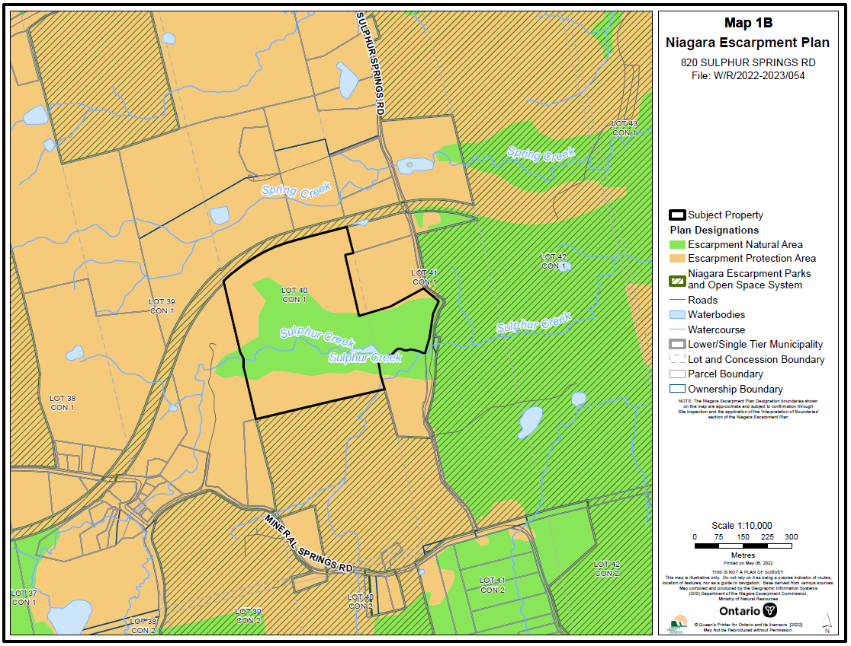

Appendix 3 – Mapping: Site Plan

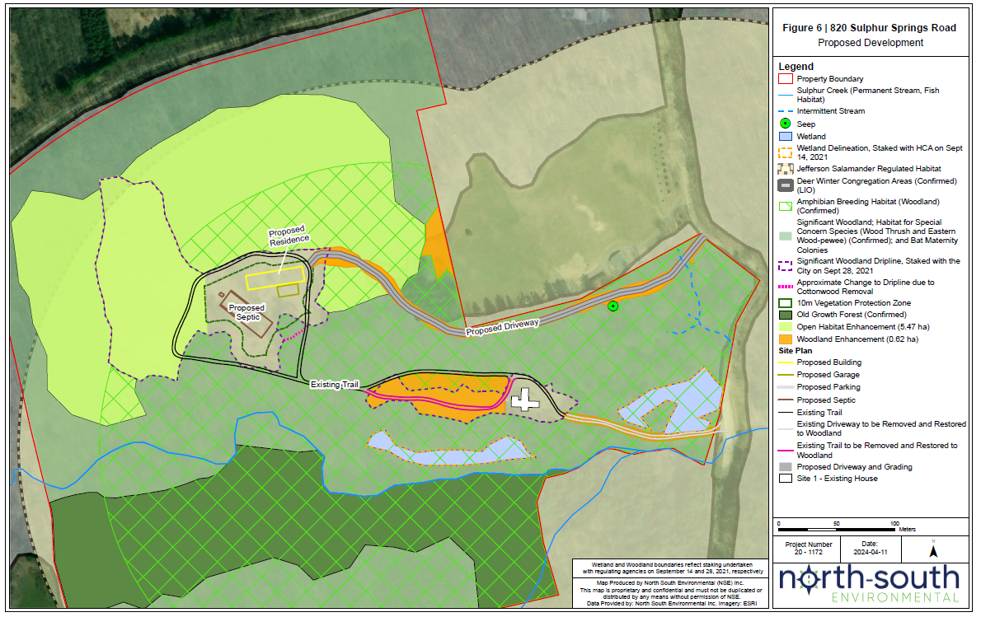

Appendix 3 – Mapping: Floodplain Extent

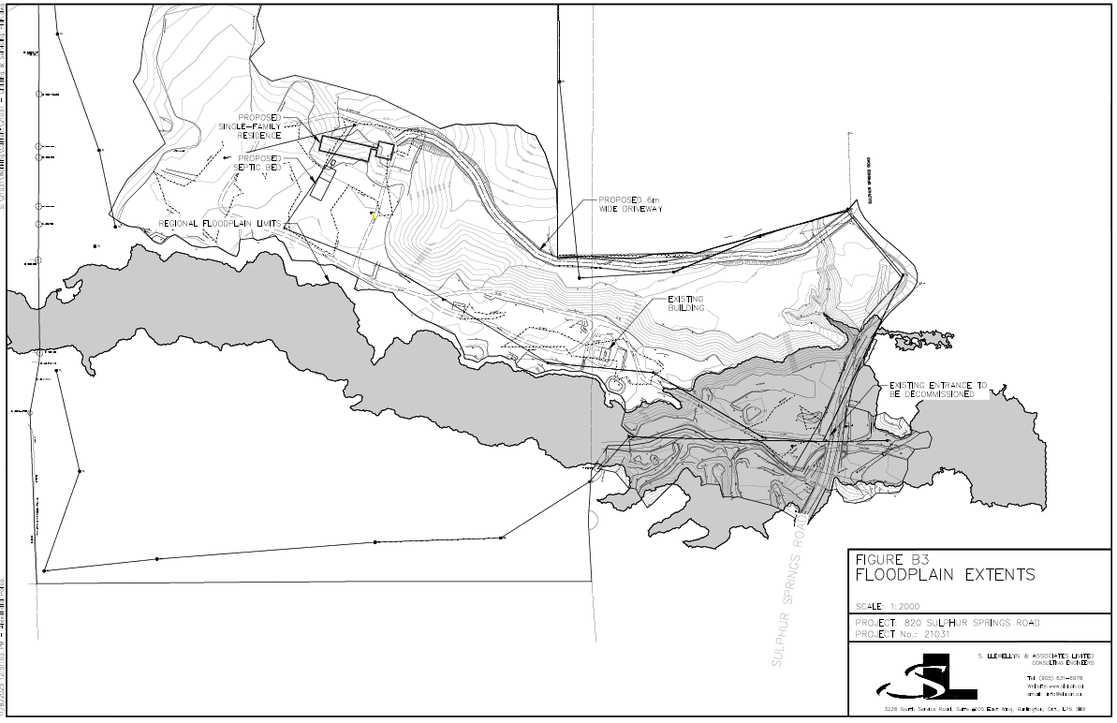

Appendix 4 - Agency Comments

Please see PDF attachments.