A2 Addendum Staff Report
Date: November 20, 2025
File: W/R/2022-2023/054

Accessibility
The Niagara Escarpment Commission is committed to ensuring that the Commission’s information and services are accessible to all Ontarians. If you require this document in an alternate format, please call 905-877-5191 or email nec@ontario.ca.

Services en français / French language services
Ce document peut être traduit sur demande. Pour obtenir des renseignements en français, veuillez communiquer avec la Commission de l’escarpement du Niagara (CEN) par courriel à nec@ontario.ca.

Development Permit Application:
REDACTED, Owner
Raj Kehar and Ed Fothergill, Agents
W/R/2022-2023/54
820 Sulphur Springs Road
Part lot 40 & 41, Concession 1 Ancaster
City of Hamilton (formerly Town of Ancaster)
ARN 251814012036800

Executive Summary
The Development Permit Application (DPA) is proposing to decommission an existing single dwelling and driveway, and to construct a new single dwelling, detached accessory building, private sewage treatment system and driveway.
This Staff Report serves as an addendum to a previous report presented to the Commission on July 17, 2025, recommending refusal of the application, as it does not conform with the Niagara Escarpment Plan, 2017 (NEP) and is not consistent with the Provincial Planning Statement, 2024 (PPS), for the following reasons:
- NEP Part 2.7.5: the proposal does not provide a minimum 30 metre Vegetation Protection Zone (VPZ) from core areas of the Natural Heritage System, as required in the more restrictive City of Hamilton’s Rural Official Plan (OP) natural heritage policies.
- NEP Part 2.10.2: the applicant has not completed a Heritage Impact Assessment for the existing single dwelling, known as Farewell House.
- PPS 4.1.5: it conflicts with the City’s OP natural heritage policies, and thus NEP Part 2.7.5.
The July 2025 Staff Report that includes more details on the proposed development and policy recommendations is included in Appendix A.
NEC staff referred the application to the Commission for a decision due to the City of Hamilton’s objection and staff’s recommendation for refusal, citing non-conformity with the NEP and inconsistent with the PPS Natural Heritage policies. At the time when the application was presented to the Commission, a Heritage Impact Assessment (HIA) had not been completed. A HIA was necessary in assessing if the Part 2.10 Cultural Heritage policies were satisfied. Staff had advised deferring the preparation of an HIA in light of the clear policy conflicts that already existed to avoid the applicant undertaking potentially unnecessary work and expense should the Commission concur with staff’s recommended refusal.
Following Commission deliberation, the members proposed and unanimously passed the following motion:
“That the Commission support the application in principle and defer its decision to allow the applicant an opportunity to complete a Heritage Impact Assessment for the Farewell House.”
Following the Commission meeting a HIA was prepared and submitted. As a result of the Commissions deferral, this Staff Report is presented to the Commission as an update on the HIA review.
While the natural heritage policy conflicts remain, staff are satisfied that the HIA demonstrates fulfillment of the Part 2.10 Cultural Heritage policies. However, due to the outstanding policy conflicts and an objection from the City of Hamilton, NEC staff maintain their recommendation for refusal.
Given that the Commission has expressed support of the application in principle, staff have prepared conditions for permitting, for the Commission’s consideration, should it choose to approve the application. These conditions have been prepared in advance to avoid delays in the decision-making process and to ensure that enforceable requirements are in place if approval is granted.

Recommended Motion
That the Development Permit Application, W/R/2022-2023/54, be refused on the grounds that the proposed development does not conform to the City of Hamilton’s Rural Official Plan (2019), that the proposed development conflicts with the NEP (2017) and is not consistent with the Provincial Planning Statement (2024).

Development Proposal
On an existing 22.3 ha (55.18 ac) lot:
- To decommission an existing two-storey 128 sq m (1,377.8 sq ft) single dwelling (listed in City’s heritage inventory) and to convert it into an accessory building (storage),
- to construct a two-storey (plus basement), ± 600 sq m (6,460 sq ft) single dwelling with a maximum height to peak of ± 11.5 m (37.7 ft),
- to construct a one-and-a-half storey, ± 186 sq m (2,002 sq ft) accessory building (detached garage with storage above) with a maximum height to peak of ± 8.3 m (27.2 ft),
- to decommission the existing driveway and to construct a new driveway with an associated culvert, and,
- to install a new septic system and well.

2.0 Niagara Escarpment Plan Designation
The subject property is designated as Escarpment Natural Area (ENA) and Escarpment Protection Area (EPA) by the 2017 NEP.

3.0 Site Description
The 22.3 ha irregular-shaped subject property is located within Dundas Valley on the western side of Sulphur Springs Road between Mineral Springs Road and Governor’s Road. The property currently supports a single dwelling (that was damaged by fire), and sulphur spring that have been identified by the City of Hamilton as having potential cultural heritage value or interest.
The existing single dwelling, driveway and sulphur spring are currently located within the more restrictive ENA designation on the property.

4.0 Background
The subject property is complex because of the confirmed presence of key natural heritage features (KNHF) and key hydrologic features (KHF) on the property and include significant woodlands, watercourses, unevaluated wetlands, seep/spring, fish habitat, significant wildlife habitat, and habitat of endangered species and threatened species. In addition, Hamilton Conservation Authority (HCA) has identified that portions of the property are subject to flooding and erosion hazards.
The application was brought before the Commission following a formal objection from the City of Hamilton because of policy conflicts with the Rural Hamilton Official Plan (RHOP), as well as additional policy conflicts with both the NEP and PPS.
The primary source of policy conflict arises from the City of Hamilton’s determination that the proposed development does not conform with the RHOP policies. Specifically, Section 2.4.11 of RHOP requires a 30-metre vegetation protection zone (VPZ) from KNHFs on the property, in this case, a significant woodland. The City has requested that the application be revised to meet the setback requirement.
For clarity, a VPZ is a naturalized buffer area between development and KNFHs, within which no development, site alteration or grading can occur. The new single dwelling is proposed to have a 10-metre VPZ, while the new driveway is proposed to be entirely located within the KNHFs – significant woodland. A new driveway is proposed because the existing driveway is located within a natural hazard area and is not supported for use by HCA, as it does not provide safe access to the property.
Initially, NEC staff noted a VPZ policy conflict with the NEP because the proposed driveway and associated grading appeared to extend into a spring feature. Part 2.6.3(c). and 2.6.4 of the NEP require a VPZ setback from key hydrologic features. However, at the July Commission meeting, NEC staff confirmed that a recommend 5-metre setback had been proposed and concluded this would satisfy the requirements of NEP policies Part 2.63 (c) and 2.6.4.
Despite this resolution, regarding the NEP setbacks for a VPZ, a policy conflict remains with NEP policy Part 2.7.5, which states that where the policies of other public bodies (City of Hamilton) are more restrictive, those policies shall prevail.
Additionally, the proposal conflicts with the Section 4.1.5. of the PPS which prohibits development in significant woodlands unless it can be demonstrated that there will be no negative impacts on the natural features or their ecological functions. As the City objected because it conflicts with their natural heritage policies, NEC staff are of the opinion that the PPS test of ‘no negative impact’ has not been satisfied. This determination is based on the hierarchical relationship between the PPS and more detailed local and provincial plans. While the PPS provides high-level direction regarding natural heritage feature protection, the RHOP and NEP provide more specific policies for evaluating impacts. When the specific natural heritage policies cannot be met, such as the RHOP’s 30 metre - VPZ, then the more general PPS policy also cannot be met.
NEC staff recognize that, based on site conditions and the need to protect existing features while avoiding hazards, the currently proposed development has been sited with consideration of minimizing impacts on the existing landscape, while still allowing for the establishment of a new single dwelling outside areas of flood and erosion risk. This consideration is particularly relevant given that the existing dwelling, damaged by fire, is located within a hazard area regulated by HCA, and is now proposed to be retained as an accessory structure to conserve its cultural heritage. The establishment of a driveway within a significant woodland feature cannot be avoided due to the presence of the feature adjacent to the property’s road frontage. If the development proposal were required to meet the 30-metre VPZ setback, a driveway would not be achievable, effectively preventing access into the property and eliminating the ability to re-establish a dwelling.
In addition to the policy conflicts above, a HIA had not been prepared to confirm Part 2.10 policies had been satisfied.
As a result of the Commission’s deliberation a motion was approved to support the application in principle and defer its decision to allow the applicant an opportunity to complete a HIA, which was done and the review of it is summarized below.

4.1 Heritage Impact Assessment (MacNaughton Hemson Britton Clarkson Planning, August 28, 2025)
The subject property is included in the inventory for the City of Hamilton’s Built Heritage Inventory Strategy based on its historic connection to the neighbouring Hermitage Estates. The property contains an existing single dwelling known as the ‘Farewell House’ and a water fountain referred to as ‘Sulphur Spring Fountain,’ both of which contribute to its cultural significance. Although not formally recognized under the Ontario Heritage Act, through registration or designation, its inclusion in the City’s Inventory of Heritage Properties indicates potential cultural heritage value warranting consideration in the context of the proposed development.
Farewell House
The existing single dwelling on the property is presumed to have been constructed sometime after 1855 as an accessory dwelling possibly to house staff associated with the Hermitage Estate lands established by the Leith family. The Hermitage Estates is a known heritage landmark with historic significance to the Ancaster area.
The Farewell House sustained fire damaged in 2020/2021 and is not currently occupied. Stabilization work has occurred on the building, including a roof and concrete reinforcement to preserve the remaining structure.
NEC staff note that the Farewell House is not being demolished. Instead, the application proposes to convert the building into a detached accessory structure that will not be used for human habitation. The intent is to retain what remains of the original structure in situ, with alterations limited to the installation of windows and doors within the original building openings. Additionally, a one-storey addition is proposed to be reconstructed based on available photographic evidence of the original building.
Although the original laneway is not proposed to serve as the driveway for the new single dwelling, it will remain visually intact as a contributing element to the historical landscape associated with the existing Farewell House.
Sulphur Spring Fountain
The subject property contains a natural sulphur spring historically accessed through a public fountain dating back to the 1850s. The spring was valued for its perceived health benefits and is directly associated with the mineral spa culture of the mid-19th century. Although the original fountain no longer exists, the feature has been replaced multiple times over the years. Most recently the fountain was destroyed in 2023. The fountain remains a recognized local landmark and is closely linked to the natural sulphur spring.
A new fountain is currently being developed on the property near the road right-of-way for Sulphur Spring Road, with the intention of maintaining public access to the spring. This supports the continuation of a longstanding cultural tradition and reinforces the property's significance as a cultural heritage landscape.
In accordance with NEP Part 2.10, which seeks to conserve built heritage resources, cultural heritage landscapes, and archaeological resources, a HIA was prepared. The HIA concludes that the inventoried heritage features on the property, specifically the Farewell House and the Sulphur Spring Fountain, will be retained and maintained. The proposed new single dwelling is located approximately 200 metres from these features and is not anticipated to result in adverse impacts. See Appendix 2 for location of inventoried heritage features in relation to the proposed new single dwelling.
An archaeological assessment was completed for the application which consisted of Stage 1 and 2 assessments. No archaeological resources were discovered on-site and therefore no additional work was recommended by the archaeologist.
As the cultural heritage resources are being conserved, NEC staff do not anticipate adverse impacts to the built heritage features or conflicts with Part 2.10 policies of the NEP.

5.0 Summary of Agency Comments

5.1 City of Hamilton:
The City of Hamilton was circulated the HIA for review and comment; however, no comments were received prior to the deadline for preparation of this report. The city was provided with a review period of over one month. NEC staff determined that waiting for the City’s comments would delay the application’s return to the Commission until 2026. To avoid this postponement, staff proceeded to bring the application forward for decision-making.

6.0 Provincial Planning Statement (2024)
The 2024 Provincial Planning Statement (PPS) came into effect on October 21, 2024. Section 4.6 of the PPS sets out to conserve-built heritage resources. Given that the Farewell House and public access to a fountain for Sulphur Spring will be preserved, NEC staff are of the opinion that the PPS has been met.
While the Provincial Policy Statement (PPS) has been satisfied with respect to the heritage resource, as noted earlier in this report, the proposal does not meet the requirements of Section 4.1.5 of the PPS, which prohibits development within significant woodlands unless it can be demonstrated that there will be no negative impacts on the natural features or their ecological functions.

7.0 Summary
As identified in the Staff Report presented in July, NEC staff have noted that the proposed development does not conform with the City of Hamilton’s RHOP policies regarding the required 30-metre VPZ adjacent to the significant woodland. In accordance with Part 2.7.5 of the NEP, where policy conflicts exist, the more restrictive policy must be satisfied. As such, the policies of the NEP have not been met. This conflict also results in the proposal not demonstrating consistency with the PPS policy 4.1.5. Due to these unresolved policy conflicts, NEC staff continue to recommend refusal of the application.
Under the Delegation of Authority associated with adherence to the Niagara Escarpment Planning and Development Act, where there is both a recommended refusal of a Development Permit and an objection from a public commenting agency, the application must be brought before the Commission for final decision-making.
The Commission has expressed support for the application in principle at their July 17, 2025, Commission meeting.
Considering the above, should the Commission choose to approve the application, NEC staff have prepared draft conditions for a Conditional Approval for consideration to ensure appropriate and enforceable conditions are in place. See Appendix 3 for drafted conditions. Staff are recommending a Conditional Approval because two key drawings still need to be finalized to confirm the detailed aspects of the proposed development and ensure they are appropriately reflected in the permitting process. The draft conditions are separated into Conditions of Approval, and Permit Terms and Conditions. Conditions of Approval include requirements that must be fulfilled for a permit to be issued (i.e., submit final drawings within 18 months). Permit Terms and Conditions are also provided that illustrate standard permitting requirements of development.
It is important to note, that the preparation of conditions by staff does not imply support for the development application. NEC staff continue to recommend refusal of the application, because of the outstanding policy conflicts.

10.0 Recommendation
That the application be refused for the following reasons:
- The City of Hamilton has objected to the approval of the application as it does not conform to the Rural Hamilton Official Plan.
- The proposed development conflicts with Part 2.7.5 of the Niagara Escarpment Plan.
- The proposed development is not consistent with Part 4.1.5 of the Provincial Planning Statement.

Prepared by:
Original signed by
Janet Sperling
Acting Senior Strategic Advisor

Approved by:
Original signed by
Jessica Isaac
Planning Manager

Attachments:
Appendix 1 – Staff Report A1, July 17, 2025
Appendix 2 – Mapping: Location of Heritage Resources
Appendix 3 –Conditions

Appendix 1 – Staff Report A1, July 17, 2025

Report is included in the separate attachment to this file.

Appendix 2 – Mapping: Location of Heritage Resources
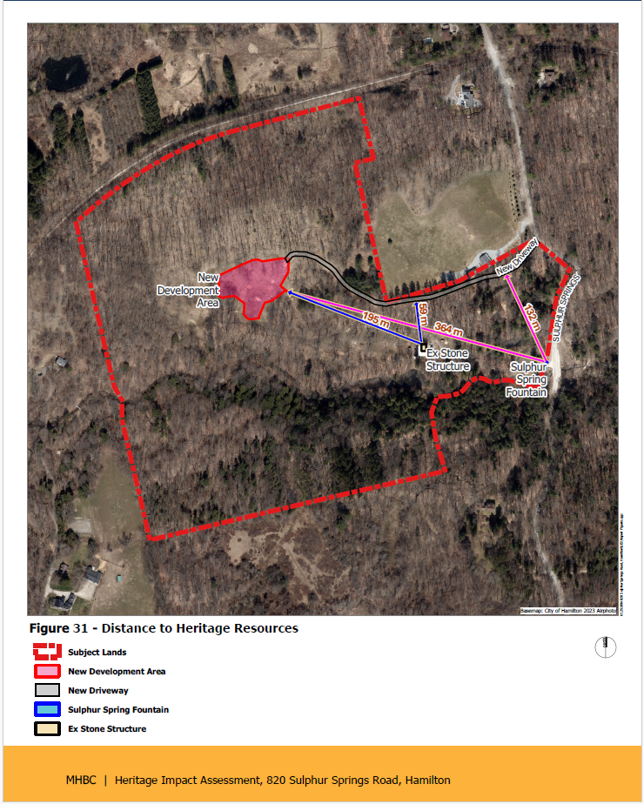

Appendix 3 – Conditions

Proposed Conditions of Approval
- Prior to the issuance of a Development Permit by the Niagara Escarpment Commission, an accurate and detailed Final Grading and Erosion Control Plan shall be submitted for Niagara Escarpment Commission approval.

- Prior to the issuance of a Development Permit by the Niagara Escarpment Commission, a Final Restoration and Enhancement Plan shall be prepared by a qualified person, for Niagara Escarpment Commission approval. The following stipulations shall be included directly on the Plan:

- All new tree and shrub species (including seed mixes) shall be native to Ontario except where otherwise approved by the Niagara Escarpment Commission. Plant material shall be sourced from local plant nurseries; bush dug plant material is not acceptable.
- Planting and the rehabilitation of all disturbed areas shall be completed on or before the date of expiry of the Development Permit to the satisfaction of the Niagara Escarpment Commission.

- Conditions I and II must be fulfilled within 18 months from the date of confirmation of the Commission’s decision or this conditional approval shall lapse, and a Development Permit will not be issued.

Proposed Permit Terms and Conditions
- Development shall occur in accordance with this Development Permit.
- This Development Permit shall expire three (3) years from the date it has been issued unless the development has been completed in accordance with this Development Permit.
- No site alteration of the existing contours of the property including the placement or stockpiling of fill (i.e., excess or imported soil) on the property is permitted with the exception of that identified within the development envelope in accordance with the Final Site Plan.
- No vegetation shall be cut or removed from the development envelope except for that identified within the development envelope in accordance with the Final Site Plan.
- If development has commenced under this Development Permit, any disturbed areas of land or soil shall be re-vegetated and stabilized to the satisfaction of the Niagara Escarpment Commission on or before the date of expiry of the Development Permit.
- Development shall proceed in accordance with the Approved Final Site Plan prepared by Rockside Campbell Inc. and dated August 28, 2025.

- Development shall proceed in accordance with the details of the approved Final Construction Details for both the single dwelling unit and the accessory structure, identified as drawings A2-A13 prepared by Rockside Campbell Inc. and dated August 28, 2025.

- Development shall proceed in accordance with the details of the approved Tree Protection Plan, identified on Map 1-3, prepared by North-South Environmental and dated March 14. 2023.

- Development shall proceed in accordance with the Approved Final Grading and Erosion Control Plan (prepared by and date information to be added).

- Development shall proceed in accordance with the Approved Final Restoration and Enhancement Plan (prepared by and date information to be added).

- The accessory structures (garage, former Farewell House) shall not be used for human habitation (i.e., living space), as a dwelling, apartment unit, for short or long-term rental accommodation or for commercial, institutional, home business, industrial, or livestock purposes.

Advisory Notes
- A Development Permit does not relieve the landowner/permit holder from the requirements of any other required approval, licence or certificate under any statute (e.g., Ontario Building Code, Planning Act, Aggregate Resources Act, Conservation Authorities Act, Endangered Species Act), including but not limited to:
  - Obtaining a Building Permit under the Ontario Building Code
  - Obtaining a Permit from the Hamilton Conservation Authority
  - Protection of habitat for endangered, threatened, and special concern species under the Endangered Species Act
- The Niagara Escarpment Commission supports the protection of the night sky from excessive lighting and recommends the applicant obtain information on the use and operation of appropriate lighting fixtures in keeping with dark sky approaches.
- Should previously undocumented archaeological resources be discovered, they may be subject to Section 48 (1) of the Ontario Heritage Act. Cease activities immediately and contact the Ministry of Citizenship and Multiculturalism (archaeology@ontario.ca). The Funeral, Burial and Cremation Services Act, 2002, S.O. 2002, c.33 requires that any person discovering human remains notify police immediately.
- Development has the potential to impact wildlife at any time of the year, however, site preparation and/or vegetation removal has a much higher likelihood of harm when work is conducted between March 1 and September 30 of any given year. Any harm to birds, mammals, reptiles or amphibians as a result of development could result in violation with various federal and provincial legislation including (but not limited to) the Migratory Birds Convention Act, the Fish and Wildlife Conservation Act and the Endangered Species Act. Comments received from Ministry of Environment, Conservation and Park recommend avoiding vegetation removal during this sensitive timing window.

It is the responsibility of the permit holder to ensure that harm will not come to wildlife. This risk to wildlife can be reduced by ensuring that the best available information is obtained related to the presence of sensitive species, by seeking advice from a qualified person or agency and by conducting site preparation and vegetation removal between October and February.

