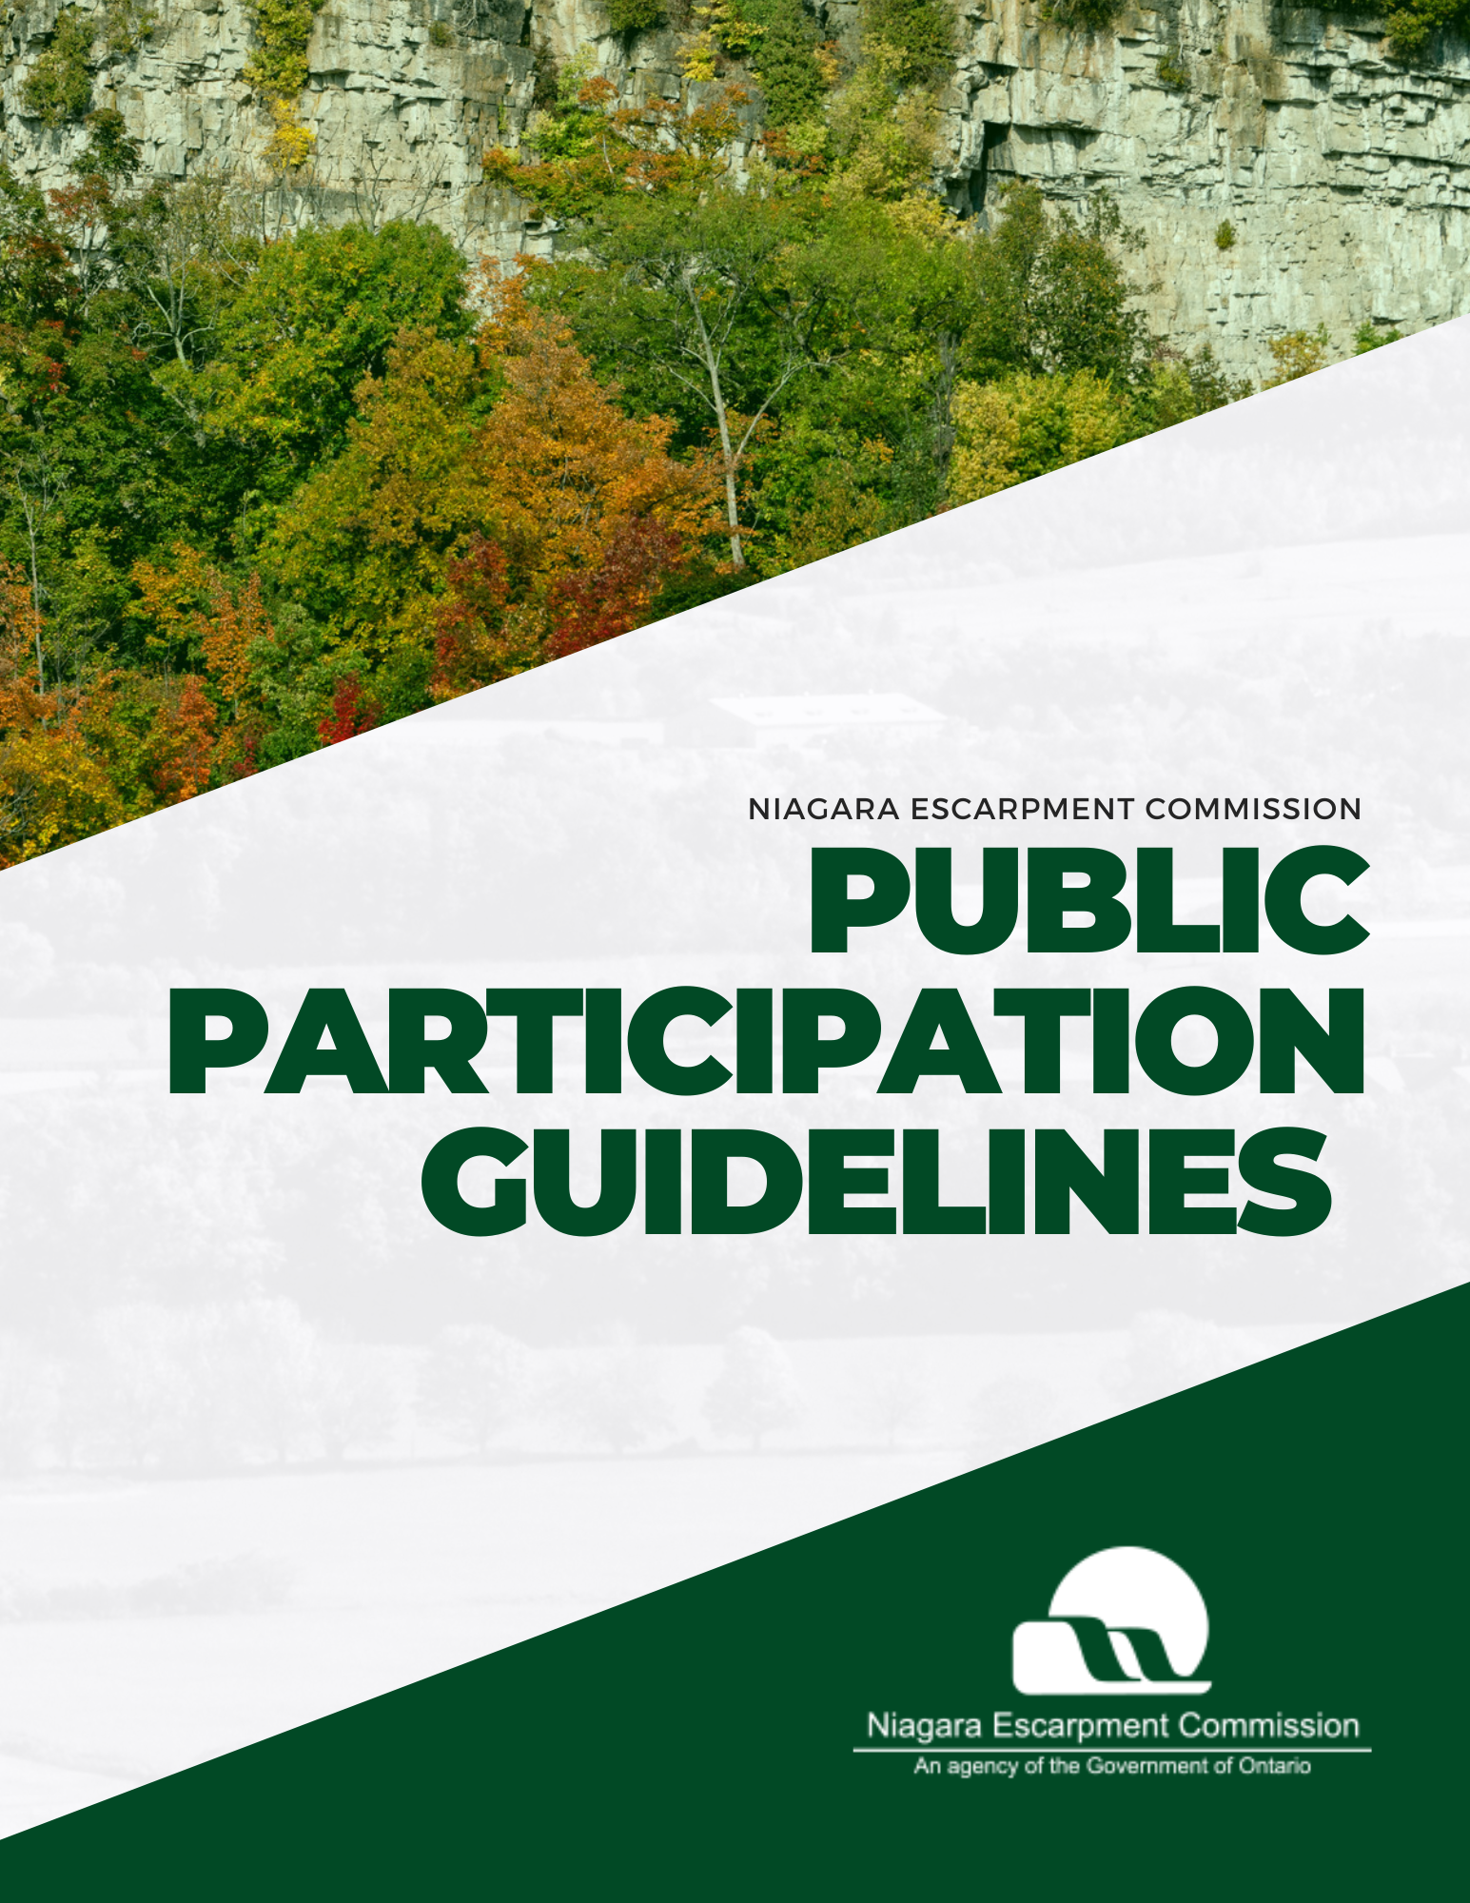
Table of Contents
Accessibility and accommodations 4
Services en français (French language services) 4
Part I: General Information and Pre-Meeting Preparation 5
Overview 6
Commission Meeting Purpose 6
Meeting Schedule and Location 6
Meeting Attendance & Participation 7
Participation & Delegations to the Commission 8
Written Submissions 8
Public Commenting Period 8
Delegations related to an agenda item 9
Delegations related to miscellaneous issues 9
Note to Delegates 9
Recommendations for a successful delegation 10
Delegation Topic 10
Delegation Runtime 10
Public Comment Runtime 10
Supplementary Materials 11
Part II: Commission Meeting Information and Participant Expectations 13
Code of conduct 14
Meeting etiquette 14
Arrival 14
Meeting procedures 14
How to join a Commission meeting remotely 15
Technical support 17
Part III: Information on Notice of Decision and the Appeals Process 18
Area of Applicability 19
Notice of Decision 19
Appeal Period 19
Issuance of a Development Permit 19
Refusal of permit application 19
Appeal process 20
How to file an appeal 20
How an appeal is processed 20
Questions and inquiries 20
Appendix A: Content and format guidelines for delegation materials 21
File length, size, type, and name 22
Font type, size, colour, and accessibility 22
Content restrictions 23
How to convert a file to a PDF 23
Word document to PDF 23
PowerPoint presentation to PDF 23

Figures
Figure 1: Map of NEC Georgetown Office 8
Figure 2- Commission Meeting Timeline for Delegates 13

Accessibility and accommodations
As an agency of the Government of Ontario, the Niagara Escarpment Commission (NEC) is committed to ensuring that the Commission’s information and services are accessible to all Ontarians. The NEC strives to provide services and programs that people with disabilities can use and benefit from equally and in a manner that respects their dignity and independence.
The Ontario Public Service Accessible Customer Service policy outlines the Ontario Government’s responsibilities and legal obligations for providing accessible customer service to persons with disabilities. For more information, please visit the policy webpage by clicking the link above.
NEC staff will be on site to assist with in-person accommodations during Commission meetings.
To notify the NEC of an accommodation, request alternative formats and communication supports, or for related inquiries, please call 905-877-5191 or send an email to the Executive Services Administrator at nec@ontario.ca.

Services en français (French language services)
Ce document peut être traduit sur demande. Pour obtenir des renseignements en français, veuillez communiquer avec la Commission de l’escarpement du Niagara (CEN) par téléphone à 905-877-5191 ou par courriel à nec@ontario.ca.

Part I: General Information and Pre-Meeting Preparation

Overview
This document is intended to provide information on the processes and guidelines for delegations and public participation at Niagara Escarpment Commission meetings.

Commission Meeting Purpose
The Commission is comprised of a Commission Chair and 16 Commissioners. To learn more about the Commissioners, please read their individual biographies at: Commissioner Biographies - Niagara Escarpment Commission (NEC).
Commission meetings encompass the Niagara Escarpment Commission’s formal procedure to put forth current and emerging issues, discuss matters of urgency, and make decisions on land-use and development applications.
Typical agenda items brought forward during Commission meeting sessions include:
- Development Permit Applications that do not meet the policies of the Niagara Escarpment Plan and require a policy interpretation from the Commission,
- Development Permit Applications that have received objections from the public,
- Development associated with a critical service,
- Items related to a Niagara Escarpment Plan Amendment,
- Items related to an Order to Restore or Demolish,
- Items related to an appeal or litigation.

Meeting Schedule and Location
Commission meetings occur on the third Thursday of every month or as determined by the Chair; however, meetings dates may be adjusted occasionally. An up-to-date schedule of Commission meeting dates, as well as agendas and minutes for past meetings are available on the NEC website at https://escarpment.org/meeting-documents/.Meetings are hosted in-person at the NEC Georgetown office located at 232 Guelph Street, 3rd floor, Georgetown, ON, L7G 4B1 (see map below). Please note the entrance to the NEC Georgetown office is located off of Mountainview Road.
A key operated elevator is located to the right of the entry and can be accessed by the public upon request. A public telephone box is located on the outside of the elevator. To reach the NEC office, dial code 301 on the control panel. Alternatively, you may reach NEC staff by calling 905-877-519 on a personal device. An NEC staff member will assist in operating the lift.
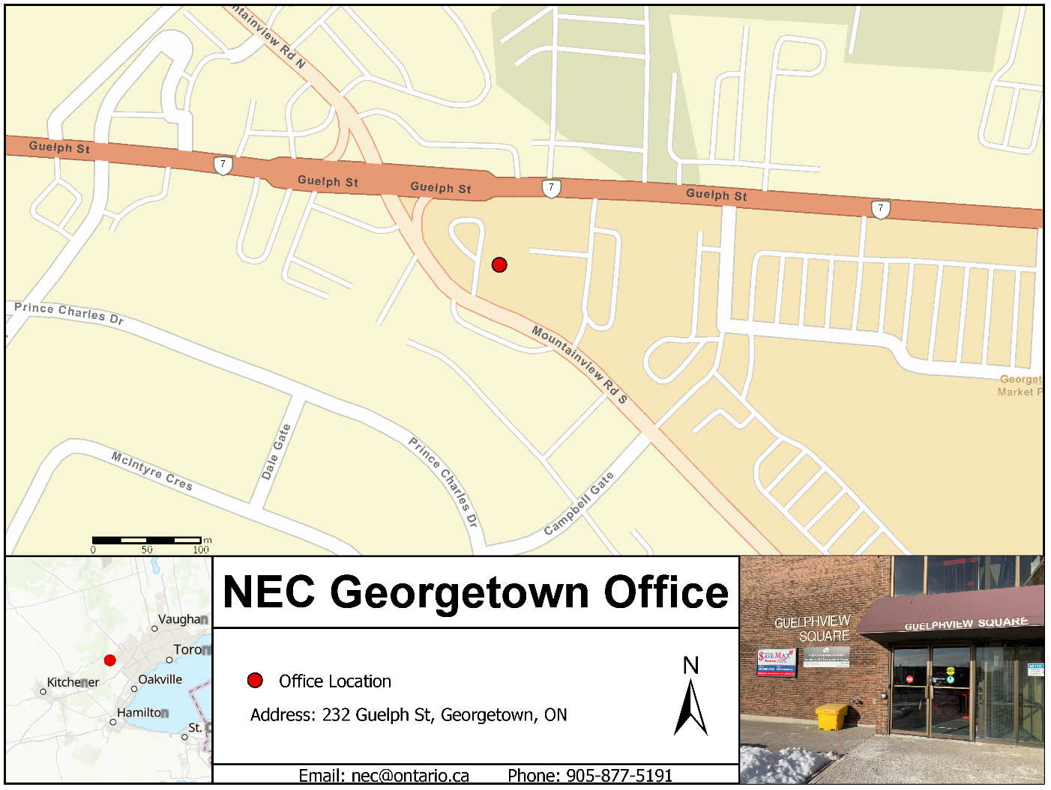Figure 1: Map of NEC Georgetown Office

Meeting Attendance & Participation
Commission meetings are open to the public. The NEC offers the following options for attending a Commission meeting:
- In person attendance: meetings are hosted in-person at the NEC Georgetown office.
- Remote (virtual) attendance: participants who wish to attend virtually must pre-register by identifying their interest in observing a meeting via email to nec@ontario.ca. Registered meeting participants are provided a Microsoft Teams meeting link via email in advance of the meeting, to support remote attendance.
- Observation: Individual(s) who may or may not be associated with an agenda item may observe a Commission meeting.
- Written Submission: A Resident of Ontario may submit written materials in advance of the Commission meeting.
- Public Comment: On the day of the Commission meeting a Resident of Ontario may provide brief in-person comment to the Commission regarding matters on the agenda during public comment period.
- Delegation: In advance of the Commission meeting Resident of Ontario may register as a delegation to the Commission. Delegations will be added to the meeting agenda. Delegations must be associated with an agenda item unless prior approval has been obtained by the Commission.
The individuals or groups listed below automatically receive an invite to the scheduled Commission meeting. This includes,
  - The applicant, landowner and/or their agent for a Development Permit Application or Plan Amendment that is being addressed at a Commission meeting,
  - An agency that was consulted during a Development Permit or Plan Amendment application assessment stage,
  - A Resident of Ontario who has been in previous contact with the NEC and has requested an invite to observe or delegate regarding a specific Development Permit application or Plan Amendment,
  - A named individual on an Order to Restore or Demolish (e.g., the landowner of a property that is the subject to the Order) or their agent, and / or
  - An individual who has registered a complaint related to a property that is the subject of an Order to Restore or Demolish.
It is the responsibility of the recipient to respond to the invite and confirm with NEC staff by 12:00 p.m. EST (i.e., noon), seven (7) business days prior to the scheduled Commission meeting and must indicate if they wish to attend as an observer or as a delegate.
If not among the previously mentioned parties, an interest in observing or delegating in a Commission meeting may be identified to the Commission via email at nec@ontario.ca. Any Resident of Ontario can submit a request.
Participants will receive an email confirming registration and the scheduled time slot for the agenda item/delegation, and a Microsoft Teams meeting link at least five (5) business days prior to the meeting.

Participation & Delegations to the Commission

Written Submissions
Residents of Ontario can make a written submission to the Commission. All written submissions should be sent to nec@ontario.ca. Written submissions must be received by 12:00 pm Eastern Standard Time (EST) (i.e., noon), five (5) business days prior to a Commission meeting.

Public Commenting Period
NEC provides opportunity for Residents of Ontario to provide verbal comments on matters included on the agenda during the in-person public commenting period portion of a Commission meeting. Should you not be able to attend in person you are encouraged to submit written materials to the Commission.
Public comments must be addressed to the Chair. Individuals providing comment will be asked to provide their first and last name and are encouraged to indicate a specific interest in the agenda item and any key points they would like the commission to consider.
Be advised that, comments and views expressed during the public commenting period are not the view of the Commission, the Ministry of Natural Resources, or the Government of Ontario. Although, it is stressed as an agency of the Government of Ontario, the Niagara Escarpment Commission will not tolerate any form of racism, discrimination, or harassment. For more information on meeting etiquette and code of conduct, please refer to Part II of this document.

Delegations related to an agenda item
Individuals or parties who are interested in appearing as a delegation related to an agenda item must confirm their interest with NEC staff by 12:00 p.m. EST (i.e., noon), seven (7) business days prior to the scheduled Commission meeting. Any supplemental materials to be used during the delegation must be submitted to the NEC by noon (12 p.m.) five (5) business days prior to the meeting. Please see the Supplemental Materials section on page 13 of this document for more information.
If a situation arises where there is a high number of delegations that cannot be accommodated by the agenda, the Chair, in consultation with the Commission, will determine if a special meeting would be required to hear all delegations. Delegates may be asked to defer their comments to a special meeting. Delegations outside the subject matter and jurisdiction of the Commission will be refused.

Delegations related to miscellaneous issues
Requests to delegate to the Commission on an item that is not on the agenda must receive approval from the Commission. Please note requests related to active compliance matters will not be accepted unless an Order to Restore or Order to Demolish is before the Commission. Requests will not be accepted if related to an open development permit application. To make a delegation request, please submit a delegation request to the Chair by emailing nec.chair@ontario.ca. Requests must be submitted to the Chair at least 10 business days in advance of the next scheduled meeting. Any requests received after that time will be moved to the following meeting for a decision.
In your email, please include your name and the subject of your delegation. The Chair will discus your request with the Commission at the next scheduled meeting. The Commission will decide on the delegation request and will advise following the meeting if the delegation will be permitted or denied, if permitted the Commission will advise the meeting date on which the delegate is invited to speak. Requestors will be advised of the Commission’s decision within 5 to 10 business days following the meeting.

Note to Delegates
All delegates are requested to join the meeting 30 minutes in advance of their scheduled agenda time. Delegates will need to complete a CAPTCHA to confirm they are not a robot before being permitted into the meeting if attending virtually.
If you have any questions, please call 905-877-5191 or email the Executive Services Administrator at nec@ontario.ca.​

Recommendations for a successful delegation

Delegation Topic
Please note that Commissioners receive a copy of the staff report associated with agenda items in advance of the meeting and will be familiar with the information presented in the reports associated with the item. Delegates are encouraged to express their point of view in a clear, concise, and specific manner using information that was provided to NEC staff (Development Permit application, studies and reports, etc.) prior to the Commission meeting.
It is at the discretion of the Commission to defer an item and reschedule a delegation should new information be introduced by delegations that otherwise was not provided to NEC staff. This is to provide ample time for NEC staff, the Chair and Commissioners to review new information.
Delegations cannot not refer to personnel matters, litigation or potential litigation or planning matters that have already had a public meeting or any item considered confidential.

Delegation Runtime
If you are the Development Permit applicant, landowner and/or their agent or a named individual on an Order to Restore / Demolish registered as a delegate on an agenda item, your delegation must be 10 minutes or less.
If you are an agency, municipality, Indigenous community, or a member of the public registered as a delegate on an agenda item, your delegation must be 5 minutes or less.
As we want to provide an equal opportunity for all individuals to address the Commission, any delegation exceeding the above runtimes may be cut short. Questions and discussion periods are not included in your speaking time.

Public Comment Runtime
If you are a member of the public offering comments on an agenda item during the public comment period, your delegation must be 3 minutes or less.
As we want to provide an equal opportunity for all individuals to address the Commission, public Comment exceeding the above runtimes may be cut short.

Supplementary Materials
Supplementary materials such as a PowerPoint presentation may be used to support delegation presentations. The use of supplementary materials is optional and is not required to address the Commission. In addition, Residents of Ontario may provide written submission. For recommendations on the content, formatting, and technical requirements, please see Appendix A.
Please note supplementary materials are not permitted during the public comment period. Public offering comment may optionally provide written submission separate to providing public comment.
If you choose to use supplementary materials during your delegation or choose to provide a written submission, materials must be submitted by noon (12 p.m.) five (5) business days prior to the meeting (typically the Thursday prior to the meeting). Materials can be submitted to the Executive Services Administrator by email at nec@ontario.ca. This deadline is firm and ensures that the Commission has ample time to review and understand your position.
If you do not submit your materials by the deadline, you may not be able to share them during your delegation. However, you can still make your delegation during the assigned time slot. Files submitted on the day of the meeting will not be accepted.
Please note that any materials submitted will be shared with the Commission and all impacted parties (e.g., applicant/agent, other delegates, the landowner, etc.). Private information will be redacted, as required by current privacy laws.
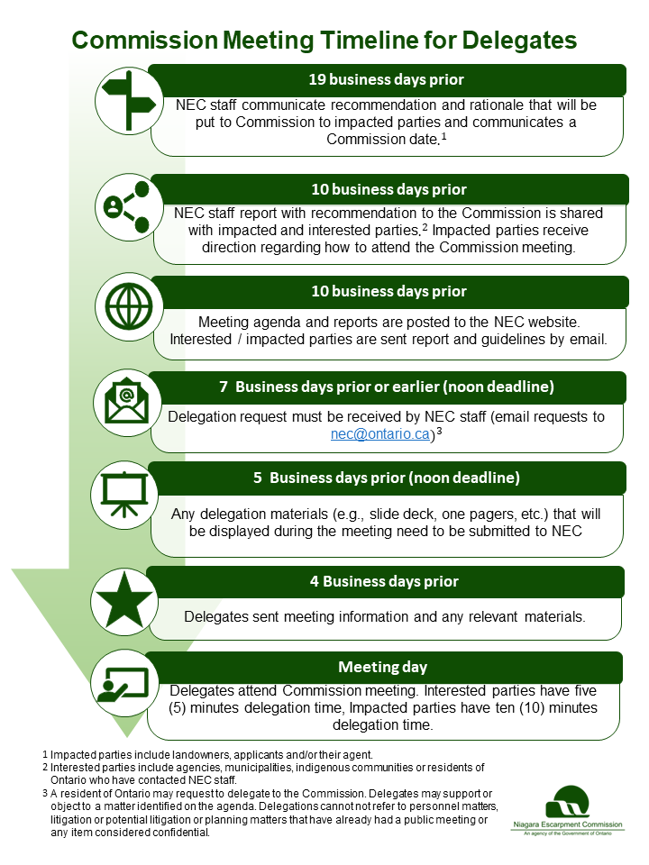
Figure 2- Commission Meeting Timeline for Delegates
Part II: Commission Meeting Information and Participant Expectations

Code of conduct
The Ontario Public Service is committed to fostering an environment that is inclusive, anti-racist, accessible, respectful, and free from harassment and discrimination. As an agency of the Government of Ontario, the Niagara Escarpment Commission shares this commitment and will not tolerate any form of racism, discrimination, or harassment. The Commission requests that all guests ensure that their words and actions align with this commitment. The Commission will ensure everyone is held to account with this commitment.
Meeting etiquette
Meeting etiquette is a standard set of behaviours expected from participants during meetings. It encourages participants to create a professional environment with mutual respect and ensures that the Commission meeting is organized, timely, and effectual. The NEC follows Roberts Rules of Order for meeting procedures, and participants are expected to adhere to the following the guidelines:
- Individuals must address their remarks to the Chair rather than to the meeting. E.g., “Through you, Mr. Chair…”
- Individuals must raise their hand to share their remarks and wait for the Chair to call on them before speaking.
- Only one person may speak at a time.
- Those found interrupting another participant’s comments without being called upon will be held to account accordingly.
- The use of any recording device during the meeting is prohibited. All participants must have their phones switched off during the session.

Arrival
If attending the meeting in person, please arrive a minimum of 30 minutes before your agenda item is scheduled to begin. There is no charge for parking at the NEC Georgetown or Owen Sound offices. Parking is available on both sides of the Georgetown office. If attending the meeting virtually, please see the section below on how to join a Commission meeting remotely.

Meeting procedures
During the session, the Chair will call for a motion to open discussion on an agenda item. They will first hear the NEC staff report related to the agenda item. Upon its conclusion, the Chair will invite you to begin your delegation to the Commission. After your delegation, you can remain in the meeting while the Commission conducts its discussion. If you are attending virtually, we ask that you mute your microphone to avoid disrupting the meeting.
When the Commission has heard the staff presentation and all requested delegations related to the matter, they will discuss the agenda item. Upon conclusion of the discussion, the Chair will call a vote on the motion. The Commission may approve, amend, refuse, or defer the file based on their discussions, the NEC staff report, and the information presented in your delegation. For more information on Commission decisions and Notices of Decision, see Part III: Post-Meeting Information.

How to join a Commission meeting remotely
Please join the meeting at least 30 minutes before your agenda item is scheduled to begin, using the Microsoft Teams link and password provided to you via email.
Microsoft Teams is a video conferencing tool. To join a Commission meeting remotely, a telephone or a built-into-the-device audio system on a desktop computer, tablet or mobile device is required. You do not need a Microsoft Teams account to join a meeting.

Step 1:
If you wish to watch or listen to a hybrid Commission meeting, you must register via email. Please send a message to nec@ontario.ca requesting access. Once your registration has been confirmed, you will be emailed a link containing an invite to the meeting.

Step 2:
Open your email invite and click Join the meeting.


Step 3:
On your browser, you will be asked how you want to join the Teams meeting:

  - If you have downloaded, installed, and previously used the application, you can click “Open your Teams app” to access the meeting.
  - You can access the meeting through your browser by clicking “Continue on this browser.” Please be aware the connection may lag, causing the audio/video to become distorted on occasion.
  - Alternatively, you can “Download the Windows (or Mac) app” and install the application. Please note that you need to have, or will need to create, a Microsoft account (@outlook, @hotmail, or Office365).

Step 4:
A pop-up box will appear, and Microsoft Teams will ask you for permission to access your microphone and camera, click “Allow.”
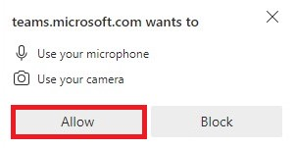

Step 5:
You will be directed to the preview screen. Before proceeding to the meeting, please enter your name and turn off the camera and microphone by sliding the button to the left.
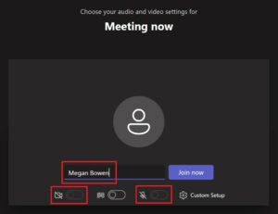

Step 6:
Click Join Now (blue/purple button above).
Then a CAPTCHA window should pop up:

After entering the letters shown on the CAPTCHA, click ‘submit’, you will be entered into the meeting.
If the letters are not clear to you, you can click refresh to get a new set of letters or verify with audio instead.
To verify with audio, make sure your speaker is turned on. Once the word is pronounced, enter the word and click ‘submit’, you will be entered into the meeting.
Please keep your camera turned off and your microphone muted during the meeting unless or until invited to speak by the Commission Chair.

Technical support
If you experience technical difficulties during a Commission meeting and require assistance, please email nec@ontario.ca or call 905-877-5191.

Part III: Information on Notice of Decision and the Appeals Process

Area of Applicability
Please note that the following information pertains only to decisions the Commission has made regarding a Development Permit application.
Decisions related to Orders to Restore / Demolish are final and have no option for appeal.

Notice of Decision
When the Commission has made a decision to approve or refuse a Development Permit application, a Notice of Decision is sent to the permit applicant, all agencies consulted during the application assessment stage, and neighbouring landowners within 120 metres of the subject property via mail. The Notice of Decision provides a description of the proposal and the conditions of approval or the reasons for refusal. The Notice of Decision is sent within 2 business days following the meeting.

Appeal Period
When the Commission decides to approve a permit application or an application for Plan amendment, stakeholder parties who receive a Notice of Decision regarding the file can appeal the Commission’s decision to the Ontario Land Tribunal (OLT) within 14 days from the mailing date of the Notice of Decision.
When the Commission decides to refuse a Development Permit application or application for Plan Amendment, the applicant or their approved agent may appeal the Commission’s decision within 14 days from the mailing date of the Notice of Decision.
Additional details on the appeal process can be found below. Please note that the Commission cannot address or comment on applications that have proceeded to the OLT or another board, tribunal, or court.

Issuance of a Development Permit
Development permits are processed after the 14-day appeal period closes. If no appeals regarding the decision are received, an applicant will receive their Development Permit from the NEC via email. Once the Development Permit has been issued and received, applicants are permitted to proceed with their development.

Refusal of permit application
If the Commission has decided to refuse a permit application, and the applicant does not appeal the decision, they may choose to submit a new, modified Development Permit application to the NEC; however, the development activities outlined in a new application must be sufficiently different from the previous application for the Commission to be able to consider it.
Please note that once a formal vote has taken place and a decision is made by the Commission, the decision is final and there is no opportunity to re-open or reconsider the application unless it is through a new Development Permit application or an appeal to the OLT.
Deferred and referred applications do not fall under this restriction, as they have not been formally voted on by the Commission due to factors such as inadequate information.

Appeal process
Anyone who receives a copy of the Notice of Decision from the NEC may appeal the decision. An appeal must be made in writing and must be received within 14 days of the mailing date for the Notice of Decision.

How to file an appeal
Individuals must complete an appeal form and submit it to the Niagara Escarpment Commission within the 14-day notice period. More information is available on the NEC website at Appeal an NEC decision on a Development Permit Application - Niagara Escarpment Commission (NEC). Appeals may be submitted via:
- Mail: 232 Guelph Street, 3rd floor, Georgetown, ON, L7G 4B1
- Email: nec@ontario.ca

How an appeal is processed
When an appeal is received, it is forwarded to the Ontario Land Tribunal (OLT), which appoints a Hearing Officer to process the appeal. The Hearing Officer makes a report to the Minister of Natural Resources within 30 days after the conclusion of the Hearing or within such longer period as Minister may permit. Find out more information about the OLT here.
Please note that the Commission cannot address or comment on applications that have proceeded to the OLT or another board, tribunal, or court.

Questions and inquiries
For questions and inquiries regarding your appeal or the appeal process, please contact the OLT through the contact channels listed on this webpage or your appeal case coordinator.

Appendix A: Content and format guidelines for delegation materials
To accommodate accessibility needs and align with the Government of Ontario’s Digital First initiative, the NEC requests that all delegation materials be submitted in a digital format.

File length, size, type, and name
All delegation materials, including presentation slides and supporting documents, must no more than ten (10) pages in length. More than one file may be submitted to support a delegation, but each file must meet this page limit. Files that do not meet this page limit may not be accepted.
To reduce technical limitations during a delegation, the NEC requests that the size of each file shared must be no more than five (5) megabytes (MB). Files that exceed this size limit may not be accepted. To reduce a file’s size, please minimize the use of photos and embedded files or images. If photos are required, please reduce the size of the image file before inserting it into a PowerPoint or Word document.
If more than one files is being submitted, please save them using the file number assigned to the related agenda item and a short phrase which describes what the file contains, separated by an underscore symbol. This is to ensure that files can be presented in an efficient and organized manner during a delegation. An example of an acceptable file name is 21354_Site_Plan_Map.jpeg.
The NEC recommends saving files in a format compatible with the Microsoft Office programs, such as DOCX or PPTX files, or as a PDF. This recommendation is to mitigate technical limitations during a delegation, such as a delay in the materials being cast on other electronic devices and ensure compatibility with the Ontario Public Service’s Microsoft Office digital ecosystem.
For assistance in converting DOCX and PPTX files to a PDF, please see the section How to convert a file to a PDF.

Font type, size, colour, and accessibility
To ensure legibility and clarity for Commissioners and provide an accessible experience for all individuals, the NEC recommends that the following guidelines be referred to when preparing delegation materials:
- Use Arial font.
- Use black or “automatic” font colour on a white background for your text content.
- Use 12-pt or greater font size for body text and 14-pt or greater font size for headings.
- Use a combination of upper and lowercase letters.
- Use alternative text, also known as “Alt-text”, for photos or images. Alt-text describes the appearance or function of an image on a page and is read aloud by screen readers for visually impaired users.
- To add alt-text, right-click on the photo, select “Edit alt-text,” and type a description of the image.

Content restrictions
Please ensure that files do not contain the following:
- Audio and video
- Personal information and identifiers, such as names or email addresses
- Photographs containing faces of people
- Offensive or discriminatory wording or images.
If the above content is detected, NEC staff will modify the file to redact or exclude the content from a delegation. The owner of the delegation materials will be informed of these changes via email.
Please note that delegates cannot make changes to their submission after it is sent to the Commission.

How to convert a file to a PDF

Word document to PDF
- Go to File > Save As.
- Choose the desired location to save your file.
- Choose PDF (*.pdf) from the dropdown “Save as type” menu.
- Click Save.

PowerPoint presentation to PDF
- Go to File > Save As.
- Choose the desired location to save your file.
- Choose PDF (*.pdf) from the dropdown “Save as type” menu.
- Click Save.

